Crossroads International Church Singapore Dr. Rick Griffith
15 October 2017 Message of 7 of 12
NLT 60 Minutes
Be Steadfast
Title
Judges

Topic: Consistency
Subject: Why must you be steadfast in having God as your king?
Complement: Make God king—not relativism and the idolatry of sin cycles.
Purpose: The listeners will trust God instead of idols.
Meditation:
Reading:
Song: Speak, O Lord & The Perfect Wisdom of Our God

Introduction

Interest: Our world tempts us to trust anything or anyone but God. Yet God provides rare examples of those who are steadfast in their faith. Dr. E. N. Poulson was such an example.
Platform
Steadfast
Pulpit

He arrived in Singapore from the USA on 17 March 1953 as a missionary to Indonesia. The plan was to apply for his visa from Singapore, then invest his life in Indonesia. A full 64 years later, he was still ministering in Singapore until the Lord called him home on 13 October 2017.
Dates

Dr. P, as he was affectionately known, established the School of Theology (English) at Singapore Bible College in 1958—the year I was born!

He actually served for 5 years at SBC before that, ironically, teaching the Chinese how to speak Indonesian. Such is the way God works. He brought an Ang Mo to Singapore to teach them the indigenous language of the island!

Dr. P served at SBC until 1988—a full 36 years. I often told him that one of my life goals was to beat his 36 years of service to the college. That will happen if I am able to continue until I am age 70.

He never intended to retire, so he never did. He taught a Tuesday night Bible Study to SS teachers at Grace Baptist all the way until three days before his home going.
Sitting

Dr. P mentored me as my pastor at GBC for our first ten years in Singapore, but stayed in touch the 17 years since then. He was a model to me of one whose goal was to “be steadfast” in putting his trust in the Lord.

Need: Where are you putting your trust? Do you have an immovable trust in God?
Push Rock

How much money do you need to feel secure? One SBC student about 20 years ago said she was called to mission but needed to build up her bank account first. My colleague asked her how much she felt she needed in the bank before she left. With a straight face she noted, “Just 1$ million.”

Does your self worth come from your occupation, social standing, or national identity?

Do you place faith in scientists, philosophers, media personalities, or wealthy people—or in God?

Who is the real king or boss in your life that is worth your trust? I suggest that you be steadfast to trust God above all else.
Webster

Being “steadfast” means to be immovable from your place (Webster).

Subject: Why must you be steadfast in having God as your king? What is so bad about having relative standards?
Subject

Background: The Israelites struggled to be steadfast, and today we will see why they trusted idols instead of trusting God.
Land Settled

Israel had completed the conquest and settled the majority of Canaan, and then Joshua died (book of Joshua).
Allotments

God had kept his promise to give them every place where they set their foot—yet still much of the land was still not cleared.

By this time in the OT story, they have two written sources of God’s will—the Books of Moses and the Book of Joshua. Now, what would they do with them?
5 Books + Joshua

The Levites were spread throughout the land to provide teachers close to each of the tribes—now would they teach the people the truth of God’s Word?
Levites

Preview: Today we will see three reasons to place God as king. These we’ll find in the three major divisions of Judges (explain chart).
Chart

Text: We’ll survey the entire book of Judges.
Sub
(What’s the first reason you must be steadfast in having God as your king?)

I. Incomplete obedience plants the seeds for failure (1–2).
MP
[Rejecting God’s lordship through disobeying him as king leads to trouble.]

Israel's incomplete occupation of Canaan led to the need for judges (1:1–2:5).
SP
(3 slides)

Israel's political-military failure to finish the conquest shows that they did not trust God to clear the entire land (Judges 1).
Jud 1
(6 slides)
SP
(4 slides)

Israel's religious-spiritual failure from the incomplete conquest led to the need for human deliverers (2:1-5).
Jud 2
(3 slides)

Disobeying the LORD as king leads to trouble.

Incomplete obedience shows that we trust something other than God.

God then seeks to earn our trust by allowing difficulty in our lives.
MPI
Sub
MP
(What’s the second reason you must be steadfast in having God as your king?)
Jud 3
(3 slides)

II. Relativism leads to cycles of sin (3–16).
[We go in circles when we follow our rules instead of God’s absolute standards.]

Judges tried to stop Israel’s cycles of sin to show that God’s absolute standards were better than Israel’s relative standards (2:6–16:31).
Cycles
(2 slides)
SP

The introduction previews God's repeated provision of judges even though Israel broke the covenant after Joshua’s death (2:6–3:6).

Cycle 1: Othniel (Caleb's nephew) delivered southern Israel from the Mesopotamians (3:7-11).

Cycle 2: Ehud delivered southeastern Israel from the Moabites by killing the fat King Eglon (3:12-30).
Ehud
(3 slides)

Cycle 3: Deborah and Barak delivered northern Israel from the Canaanites and sang a song of victory (Judges 4–5).
Jud 4-5
(6 slides)

Cycle 4: Gideon delivered north-central Israel from the Midianites (6:1–8:32).
Jud 6-8
(9 slides)

Cycle 5: An unnamed woman delivered central Israel from Abimelech's vicious rule of fellow Israelites (8:33–9:57).
Jud 9-10
(5 slides)
Band-Aids
Signs
Jud 13-16
(26 slides)

Cycle 6: Jephthah delivered eastern Israel from the Ammonites (10:6–12:7).
Jephthah
(9 slides)

Cycle 7: Samson delivered southwestern Israel from the Philistines (Judges 13–16).

We go in circles when we make up the rules.
SP

Repeated cycles tell us that the only thing we learn from history is that we don’t learn from history.
Moral Relativism

Is your commitment to Christ cyclical?

When someone gets a wound from a gun, it is very serious and requires immediate surgery to prevent bleeding and later infection. How silly to simply place a small adhesive strip over it such as a Band-Aid rather than carefully taking the bullet out, but this is candid way that we often view sin today. We have serious problem with sin, but we typically lack a serious solution, thinking that a simple prayer or confession would heal the issue. Of course, this only gives time for an infection to occur, so that a serious problem gets even more problematic. How can you stop the cycles? Go back to the Source daily.
Transition
(3 slides)

(What’s the third and final reason you must be steadfast in having God as your king?)

III. Relativism leads to idolatry (17–21).
MP
[Whims instead of wisdom worships a different god.]

Israel's religious and moral failures showed they needed a righteous king instead of their relativism (Judges 17–21).
Jud 17-18
(6 slides)
SP
(3 slides)

Israel's religious failure in a Levite priest who blessed Dan's ungodly migration shows they needed a godly king (Judges 17–18).

Israel's moral failure in the Benjamite murder of a concubine and national retaliation shows they needed a godly king (Judges 19–21).
Jud 19-21
(10 slides)

Be guided by wisdom instead of whims that worship a different god.
SP
(2 slides)

Replacing God’s wisdom with personal whims is idolatry. That means “making a good thing the ultimate thing.” It applies, for example, to making sex the most important thing in your life.
Idolatry
(2 slides)

Interestingly, that can even apply to marriage. Jesus said that no one could serve two masters—God and money—but he also said that we need to love him even more than our spouse!
Rings
Subj
(Why must you be steadfast in having God as your king?)

Conclusion

Make God king—not relativism and the idolatry of sin cycles (Main Idea). Be steadfast with God as king so you don’t have to fail over and over (restatement).
MI

Why be steadfast in having God as king (Main Points)?
MPI

Incomplete obedience plants the seeds for failure (1–2).
MPII
MPIII

Relativism leads to cycles of sin (3–16).

Relativism leads to idolatry (17–21).

How is our day like the judges period?

Relativism: "Save the whales" but kill humans
• Relative

Secularism: "I don't let my religion affect my politics"
• Relative

Promiscuity: "What that leader does in his bedroom is his business and not mine"
• Relative

Relativism is seen in atheism where anything can be written on their pamphlets.
Cartoon

Applications
Application

Be steadfast.
Steadfast
Think

Think about it:

Who is the real boss of your life?

How can you enthrone God as your true king?
1 Cor 15:58

1 Cor 15:58 sums up God’s plan for us as believers.

Prayer
Prayer

Preliminary Questions

Verses Questions

Context: What did the author record just prior to this passage?

Israel had completed the conquest and settled the majority of Canaan, and then Joshua died (book of Joshua).

God had kept his promise to give them every place where they set their foot.

Purpose: Why is this passage in the Bible?

We tend to think that we have the wisdom to navigate through life on our own wisdom.

However, history shows that we are far better off to follow God’s Word. Where the Bible has gone…

Slavery was eventually abolished.

Women’s rights were upheld.

Freedom of religion resulted.

Nations prospered.

Background: What historical context helps us understand this passage?

By this time in the OT story, they have two written sources of God’s will—the Books of Moses and the Book of Joshua. Now, what would they do with them?

The Levites were spread throughout the land to provide teachers close to each of the tribes—now would they teach the people the truth of God’s Word?

Questions

How could the people stray from the Lord so quickly in only one generation after Joshua’s death?

Why did they need to have so many cycles of sin without ever learning their lessons?

Tentative Subject/Complement Statements

Be immovable in your trust in God.

Possible Illustrations That Apply

"Steadfast has held its ground in English for many centuries. Its Old English predecessor, stedefæst, combined stede (meaning "place" or "stead") and fæst (meaning "firmly fixed"). An Old English text of the late 10th century, called The Battle of Maldon, contains our earliest record of the word, which was first used in battle contexts to describe warriors who stood their ground. Soon, it was also being used with the broad meaning "immovable," and as early as the 13th century it was applied to those unswerving in loyalty, faith, or friendship. Centuries later, all of these meanings endure (“steadfast,” https://www.merriam-webster.com/dictionary/steadfast, accessed 13 Oct 2017).

Sign God’s blank contract (Juan Carlos Ortiz, Disciple)

There exist several reasons idols appeal to people (Life Application Bible).

We tend to think that we have the wisdom to navigate through life on our own wisdom, but history shows that we are far better off to follow God’s Word. Where the Bible has gone…

Slavery was eventually abolished.

Women’s rights were upheld.

Freedom of religion resulted.

Nations prospered.

OT Survey Judges Class Notes

The reason Israelites failed under the theocracy and had to submit to their new kings was because they rejected God’s lordship, followed God’s deliverers instead of God’s word, and replaced God’s wisdom with the idolatry of personal whims.

Israel's incomplete occupation of Canaan resulted in the failure of the theocracy and the need for deliverance since they had rejected God’s lordship (1:1–2:5).

Israel's political-military failure to finish the conquest shows that they did not trust God to claim his promise of the entire land (Judges 1).

Israel's religious-spiritual failure from the incomplete conquest shows that they would need human deliverers (2:1-5).

Israel's deliverance by God through twelve judges who tried to avert its seven cycles of sin shows God's mercy despite Israel’s relative standards instead of God’s absolute standards (2:6–16:31).

The introduction to the twelve judges previews God's repeated provision of judges to deliver Israel from the remaining nations even though Israel broke the covenant after Joshua’s death (2:6–3:6).

Israel's deliverance through twelve judges in a downward moral spiral in seven cycles shows God's mercy when they repent from idols so God cannot be blamed for the theocracy’s failure (3:7–16:31).

Cycle 1: Othniel (Caleb's nephew) delivered southern Israel from the Mesopotamians as God's merciful provision after the nation turned from idols to the LORD (3:7-11).

Sin: Israel forgot the LORD and served the Baals and Asherahs (3:7).

Servitude: God punished the nation's idolatry for eight years through Cushan-Rishathaim, King of Mesopotamia (3:8).

Supplication: The nation cried out to the LORD for deliverance from its enemies (3:9a).

Salvation: Othniel (Caleb's nephew) delivered southern Israel from the Mesopotamians as God's merciful provision for the nation (3:9b-10).

Silence: The nation had peace for 40 years until Othniel died (3:11).

Cycle 2: Ehud delivered southeastern Israel from the Moabites by killing the fat King Eglon as God's merciful provision after the nation turned from idols to the LORD (3:12-30).

Sin: Israel again did evil before the LORD (3:12a).

Servitude: God punished the nation's disobedience for 18 years through King Eglon of Moab (3:12b-14).

Supplication: The nation cried out to the LORD for deliverance from its enemy (3:15a).

Salvation: Ehud delivered southeastern Israel from the Moabites by killing the fat King Eglon as God's merciful provision for the nation (3:15b-29).

Silence: The nation had peace for 80 years (3:30).

Shamgar delivered southwestern Israel from the Philistines by killing six hundred men as God's merciful provision for the nation during the lifetime of Ehud (3:31).

Cycle 3: Deborah and Barak delivered northern Israel from the Canaanites and sang a song of victory as God's merciful provision after the nation turned from idols to the LORD (Judges 4–5).

Sin: Israel again does evil before the LORD (4:1).

Servitude: God punished the nation's disobedience for 20 years through Jabin, a king of Canaan (4:2-3a).

Supplication: The nation cried out to the LORD for deliverance from its enemies (4:3b).

Salvation: Deborah and Barak delivered northern Israel from the Canaanites and sang a song of victory as God's merciful provision for the nation (4:4–5:31a).

Silence: The nation had peace for 40 years (5:31b).

Cycle 4: Gideon delivered north-central Israel from the Midianites as God's merciful provision after the nation turned from idols to the LORD (6:1–8:32).

Sin: Israel again did evil before the LORD (6:1a).

Servitude: God punished the nation's disobedience through the Midianites, Amalekites, and other eastern peoples who ravage the land for seven years (6:1b-6).

Supplication: The nation cried out to the LORD for deliverance from its enemies (6:7-10).

Salvation: Gideon delivered north-central Israel from the Midianites as God's merciful provision for the nation (6:11–8:27).

The pre-incarnate Christ calls, tests, empowers, and encourages Gideon to lead Israel against the Midianites, Amalekites, and other eastern peoples (6:11-40).

God called Gideon to lead Israel (6:11-24).

God tested Gideon whether he would obey by destroying Baal's altar (6:25-32).

God empowered Gideon for service as the Midianites, Amalekites, and other eastern peoples camped opposite Israel for war (6:33-35).

God encouraged Gideon by confirming his call through a wet and dry fleece (6:36-40).

Gideon delivered north-central Israel from the Midianites as God's merciful provision for Israelites by keeping his promise to protect them when they obey (7:1–8:21).

Gideon judged the people when they made a golden ephod and worshipped it (8:22-27).

Silence: The nation experienced peace for 40 years (8:28-32).

Cycle 5: An unnamed woman delivered central Israel from Abimelech's vicious rule of fellow Israelites as God's merciful provision after the nation turned from idols to the LORD (8:33–9:57).

Sin: Israel sinned against the LORD by prostituting itself before the Baals (8:33-35).

Servitude: The nation broke the covenant by oppression though one of its own—Gideon's son Abimelech—who murdered 69 of his half-brothers (9:1-49).

Supplication (Absent): Israel never asked God for deliverance from Abimelech.

Salvation: Though not specifically designated a judge, an unnamed woman of Thebez delivered Israel from Abimelech by killing him with a millstone in Shechem (9:50-57).

Silence (Absent): Since no judge delivered Israel from Abimelech, no time period of peace is recorded and the account continues with Tola.

Tola delivered central Israel from unknown oppressors as God's merciful provision (10:1-2).

Jair led eastern Israel as God's merciful provision for the nation (10:3-5).

Cycle 6: Jephthah delivered eastern Israel from the Ammonites as God's merciful provision after the nation turned from idols to the LORD (10:6–12:7).

Sin: Israel sinned against the LORD by serving the gods of many nations (10:6).

Servitude: The nation's breaking of the covenant in Gilead led to oppression by the Philistines and Ammonites for 18 years (10:7-9).

Supplication: The people cried out to God in repentance and rid themselves of idols (10:10-16).

Salvation: Jephthah delivered eastern Israel from Ammonites in God's mercy but fulfilled a foolish vow by executing his daughter and 42,000 Ephraimites for their jealousy (10:17–12:6).

* For views on the fate of Jephthah’s daughter, see page Error! Bookmark not defined..

Silence: Jephthah ruled the land for six years (12:7).

Izban led southeastern Israel as God's merciful provision for the nation (12:8-10).

Elon led northwest Israel as God's merciful provision for the nation (12:11-12).

Abdon led central Israel as God's merciful provision for the nation (12:13-15).

Cycle 7: Samson delivered southwestern Israel from the Philistines as God's merciful provision for the nation even though it never turned from evil to God (Judges 13–16).

Sin: Israel again did evil before the LORD (13:1a).

Servitude: God punished the nation's disobedience through the Philistines for 40 years (13:1b).

Supplication (Absent): Israel never cried out to the LORD for deliverance from its enemy.

Salvation: Samson delivered southwestern Israel from the Philistines as God's merciful provision for the nation (13:2–16:31).

Samson's miraculous birth identifies him as God's merciful provision for Israel (13:2-25).

Samson killed 30 Philistines after being deceived at his sinful wedding feast with a Philistine woman as God's agent for vengeance against the Philistines (Judges 14).

Samson burned Philistine fields for giving his wife to his wedding attendant and killed 1000 Philistines after the murder of her and her father as God's vengeance (Judges 15).

Samson's downfall by succumbing to Delilah's nagging leads to death with 3000 Philistines as his final act of vengeance on Israel's enemy (Judges 16).

Silence (Absent): Israel lacked a time of peace after Samson's 20-year rule.

Israel's religious and moral failures seen in two Levites show the need for a righteous monarchy to replace the failed theocracy (Judges 17–21).

The religious failure of Israel in the hiring of a Levite pagan priest who blesses Dan's ungodly migration shows the need for a righteous monarchy to replace the failed theocracy (Judges 17–18).

Micah's idolatry and hiring of a Levite as pagan priest exemplifies the personal religious apostasy in Israel to show that a righteous monarchy must replace the failed theocracy (Judges 17).

The Levite's pagan blessing upon the godless Danite migration plan reveals the tribal religious apostasy in Israel to show that a righteous monarchy must replace the failed theocracy (Judges 18).

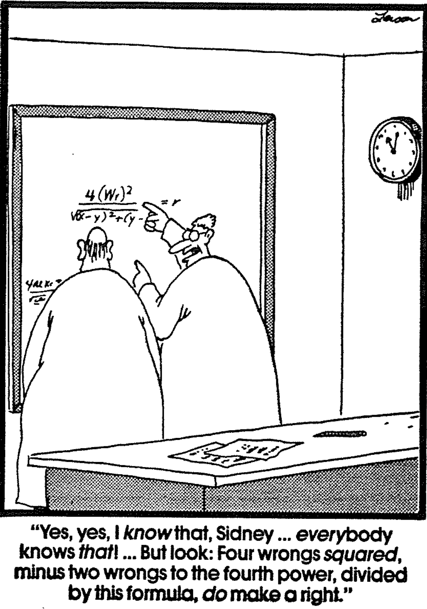
The moral failure of the people in the Benjamite murder of a Levite's concubine and the national retaliation shows the need for a righteous monarchy to replace the failed theocracy (Judges 19–21).

Benjamites in Gibeah rape and kill a traveling Levite’s concubine, whose body pieces are sent to each tribe in Israel to show the rampant immorality in the failed theocracy (Judges 19).

The 400,000 warriors of the other eleven tribes destroy 26,100* of the 26,700 Benjamites as well as all the women and children, and thus nearly destroy the entire tribe except 600 men who fled into the desert (Judges 20).

* The 25,100 killed (20:35) exclude 1000 Benjamites killed on days 1 & 2 of the battle.

Israelites preserve the Benjamite tribe by providing wives for the 600 living Benjamites by killing everyone in Jabesh Gilead except 400 virgins and stealing 200 virgins at a festival at Shiloh—both godless attempts to undo their wrong (21:1-24).

The closing statement of relativism as the people’s ethical standard reiterates the moral failure of the people to show the need for a righteous monarchy to replace the failed theocracy (21:25).

Be Steadfast
Judges

Exegetical Outline (Steps 2-3)

Exegetical Idea: The reason Israelites failed under the theocracy and had to submit to their new kings was because they rejected God’s lordship, followed God’s deliverers instead of God’s word, and replaced God’s wisdom with the idolatry of personal whims.

Israel's incomplete occupation of Canaan resulted in the failure of the theocracy and the need for deliverance since they had rejected God’s lordship (1:1–2:5).

Israel's political-military failure to finish the conquest shows that they did not trust God to claim his promise of the entire land (Judges 1).

Israel's religious-spiritual failure from the incomplete conquest shows that they would need human deliverers (2:1-5).

Israel's deliverance by God through twelve judges who tried to avert its seven cycles of sin shows God's mercy despite Israel’s relative standards instead of God’s absolute standards (2:6–16:31).

The introduction to the twelve judges previews God's repeated provision of judges to deliver Israel from the remaining nations even though Israel broke the covenant after Joshua’s death (2:6–3:6).

Israel's deliverance through twelve judges in a downward moral spiral in seven cycles shows God's mercy when they repent from idols so God cannot be blamed for the theocracy’s failure (3:7–16:31).

Cycle 1: Othniel (Caleb's nephew) delivered southern Israel from the Mesopotamians as God's merciful provision after the nation turned from idols to the LORD (3:7-11).

Cycle 2: Ehud delivered southeastern Israel from the Moabites by killing the fat King Eglon as God's merciful provision after the nation turned from idols to the LORD (3:12-30).

Shamgar delivered southwestern Israel from the Philistines by killing six hundred men as God's merciful provision for the nation during the lifetime of Ehud (3:31).

Cycle 3: Deborah and Barak delivered northern Israel from the Canaanites and sang a song of victory as God's merciful provision after the nation turned from idols to the LORD (Judges 4–5).

Cycle 4: Gideon delivered north-central Israel from the Midianites as God's merciful provision after the nation turned from idols to the LORD (6:1–8:32).

Cycle 5: An unnamed woman delivered central Israel from Abimelech's vicious rule of fellow Israelites as God's merciful provision after the nation turned from idols to the LORD (8:33–9:57).

Tola delivered central Israel from unknown oppressors as God's merciful provision (10:1-2).

Jair led eastern Israel as God's merciful provision for the nation (10:3-5).

Cycle 6: Jephthah delivered eastern Israel from the Ammonites as God's merciful provision after the nation turned from idols to the LORD (10:6–12:7).

Izban led southeastern Israel as God's merciful provision for the nation (12:8-10).

Elon led northwest Israel as God's merciful provision for the nation (12:11-12).

Abdon led central Israel as God's merciful provision for the nation (12:13-15).

Cycle 7: Samson delivered southwestern Israel from the Philistines as God's merciful provision for the nation even though it never turned from evil to God (Judges 13–16).

Israel's religious and moral failures seen in two Levites show the need for a righteous monarchy to replace the failed theocracy (Judges 17–21).

The religious failure of Israel in the hiring of a Levite pagan priest who blesses Dan's ungodly migration shows the need for a righteous monarchy to replace the failed theocracy (Judges 17–18).

The moral failure of the people in the Benjamite murder of a Levite's concubine and the national retaliation shows the need for a righteous monarchy to replace the failed theocracy (Judges 19–21).

Purpose or Desired Listener Response (Step 4)
The listeners will trust God instead of idols.

Homiletical Outline (Cyclical inductive form)

Introduction

Interest: Our world tempts us to trust anything or anyone but God.

Need: Where are you putting your trust?

Subject: Why must you be steadfast in having God as your king?

Background: The Israelites struggled to be steadfast, and today we will see why they trusted idols instead of trusting God.

Preview: Today we will see three reasons to place God as king.

Text: We’ll survey the entire book of Judges.

(What’s the first reason you must be steadfast in having God as your king?)

I. Incomplete obedience plants the seeds for failure (1–2).

Israel's incomplete occupation of Canaan led to the need for judges (1:1–2:5).

Israel's political-military failure to finish the conquest shows that they did not trust God to clear the entire land (Judges 1).

Israel's religious-spiritual failure from the incomplete conquest led to the need for human deliverers (2:1-5).

Disobeying the LORD as king leads to trouble.

Incomplete obedience shows that we trust something other than God.

God then seeks to earn our trust by allowing difficulty in our lives.
(What’s the second reason you must be steadfast in having God as your king?)

II. Relativism leads to cycles of sin (3–16).

Judges tried to stop Israel’s cycles of sin to show that God’s absolute standards were better than Israel’s relative standards (2:6–16:31).

The introduction previews God's repeated provision of judges even though Israel broke the covenant after Joshua’s death (2:6–3:6).

Cycle 1: Othniel (Caleb's nephew) delivered southern Israel from the Mesopotamians (3:7-11).

Cycle 2: Ehud delivered southeastern Israel from the Moabites by killing the fat King Eglon (3:12-30).

Cycle 3: Deborah and Barak delivered northern Israel from the Canaanites and sang a song of victory (Judges 4–5).

Cycle 4: Gideon delivered north-central Israel from the Midianites (6:1–8:32).

Cycle 5: An unnamed woman delivered central Israel from Abimelech's vicious rule of fellow Israelites (8:33–9:57).

Cycle 6: Jephthah delivered eastern Israel from the Ammonites (10:6–12:7).

Cycle 7: Samson delivered southwestern Israel from the Philistines (Judges 13–16).

We go in circles when we make up the rules.

(What’s the third and final reason you must be steadfast in having God as your king?)

III. Relativism leads to idolatry (17–21).

Israel's religious and moral failures showed they needed a righteous king instead of their relativism (Judges 17–21).

Israel's religious failure in a Levite priest who blessed Dan's ungodly migration shows they needed a godly king (Judges 17–18).

Israel's moral failure in the Benjamite murder of a concubine and national retaliation shows they needed a godly king (Judges 19–21).

Be guided by wisdom instead of whims that worship a different god.
(Why must you be steadfast in having God as your king?)

Conclusion

Make God king—not relativism and the idolatry of sin cycles (Main Idea).

Why be steadfast in having God as king (Main Points)?

Incomplete obedience plants the seeds for failure (1–2).

Relativism leads to cycles of sin (3–16).

Relativism leads to idolatry (17–21).

We tend to think that we have the wisdom to navigate through life on our own wisdom, but history shows that we are far better off to follow God’s Word. Where the Bible has gone…

Slavery was eventually abolished.

Women’s rights were upheld.

Freedom of religion resulted.

Nations prospered.

Think about it:

Who is the real boss of your life?

How can you enthrone God as your true king?

Prayer

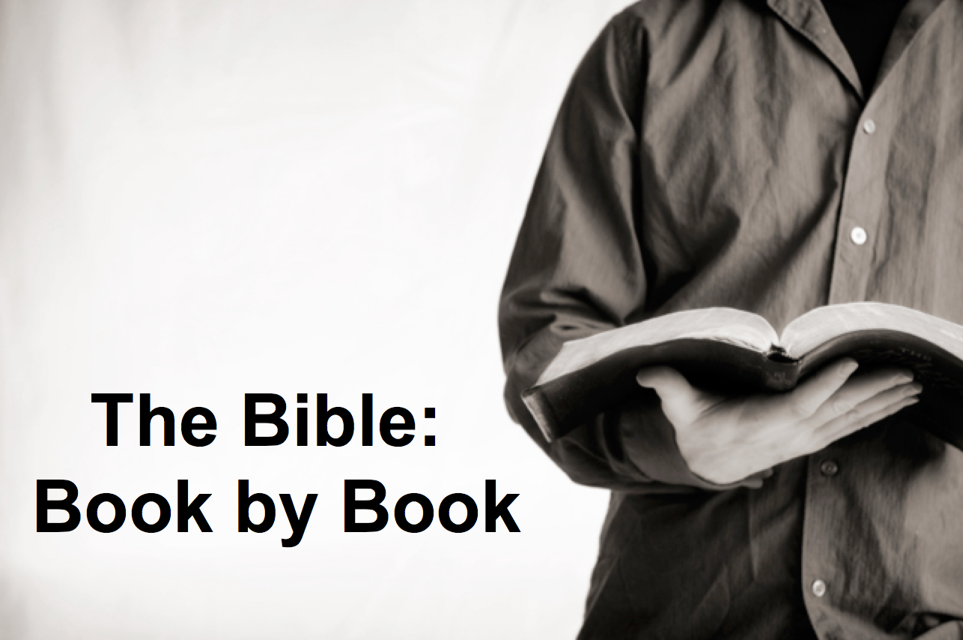
Rick Griffith
15 October 2017
Message 7 of 66

Be Steadfast
Judges

Introduction

Some servants of the Lord have learned to be steadfast.

Why must you be _________________________ in having God as your king?

I. Incomplete obedience plants the seeds for _______________________ (1–2).

Israel's incomplete occupation of Canaan led to the need for judges (1:1–2:5).

Disobeying the LORD as king leads to trouble.

II. Relativism leads to ____________________ of sin (3–16).

Judges tried to stop Israel’s cycles of sin to show that God’s absolute standards were better than Israel’s relative standards (2:6–16:31).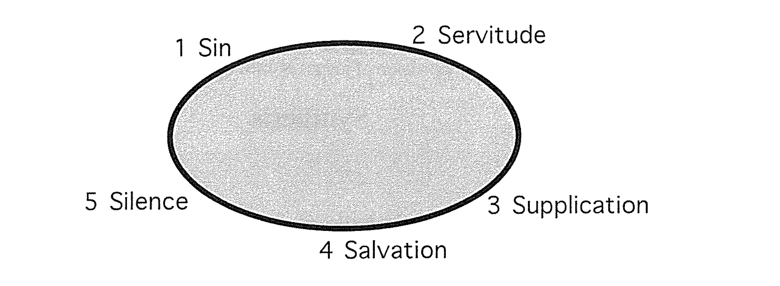

We go in circles when we make up the rules.

III. Relativism leads to __________________ (17–21).

Israel's religious and moral failures showed they needed a righteous king instead of their relativism (Judges 17–21).

Be guided by wisdom instead of whims that worship a different god.

Conclusion

Make God king—not relativism and the idolatry of sin cycles (Main Idea).

Think about it:

Who is the real boss of your life?

How can you enthrone God as your true king?

Download this sermon PPT and notes for free at BibleStudyDownloads.org/resource/old-testament-preaching/
Listen to this message online at cicfamily.com/sermon-listing/

Judges

Failure Under the Theocracy

Incomplete Occupation |  | Deliverance by Judges |  |  |  |  |  |  | Need for Monarchy
1:1–2:5 |  | 2:6–16:31 |  |  |  |  |  |  | 17–21
Deterioration |  | Discipline |  |  |  |  |  |  | Depravity
Causes  of the Cycles |  | Curse  of the Cycles |  |  |  |  |  |  | Conditions  in the Cycles
Living with  the Canaanites |  | War with  the Canaanites |  |  |  |  |  |  | Living Like  the Canaanites
Military Disobedience  1 | Spiritual Disobedience  2:1-5 | Intro  2:6-3:6 | South  3:7-  3:31 | North  4:1–  5:31 | Central  6:1–  10:2 | East  10:3–  12:7 | North  12:8-  12:15 | West  13:1–  16:31 | Religious  Depravity  17–18 | Moral  Depravity  19–21
Canaan

c. 341 Years (1390-1049 BC)

Key Word: Failure

Key Verse: “In those days Israel had no king; everyone did as he saw fit [what was right in his own eyes]” (Judges 21:25)

Summary Statement:
Israel’s failure under the theocracy due to faithless disobedience is contrasted with God's merciful care in disciplining and delivering Israel through judges to exhort submission to its new, divinely appointed kings in a righteous monarchy.

Applications:

Rejecting God’s lordship (incomplete obedience) plants the seeds for failure (1–2).

Following relative standards instead of God’s absolute standards leads to cycles of sin (3–16).

Replacing God’s wisdom with personal whims ultimately leads to idolatry (17–21).

