Crossroads International Church Dr. Rick Griffith
12 July 2015 Message 1 of 10
NLT 30 Minutes
Genesis Matters
Title
Genesis 1–2

Topic: Morality
Subject: Why does Genesis matter?
Complement: Evolution and millions of years are destructive lies.
Purpose: The listeners will see that Genesis is foundational to all doctrine in the Bible.
Reading: Psalm 19:1-6
Song: How Great Thou Art

Introduction

Report: I just returned from seven weeks reporting to churches in the USA and visiting family, including performing my second son’s wedding.
Summer
(15 slides)

Interest: The Supreme Court changed the legal definition of marriage on 26 June 2015.

The redefinition abolished all state definitions of marriage between a man and woman, supported by the White House.
Court
(5 slides)

The fallout is yet to be seen, but will certainly include more redefinitions and persecution.
Court
(9 slides)

Need: How could this happen?
Isa. 5:20

Isaiah 5:20 warns against calling evil “good.”
Common Sense

We lack common sense because we lack a foundation in Scripture nowadays.

Main Idea: Genesis matters! This is the central teaching of the ministry that I partner with called “Answers in Genesis.”
Answers in Genesis

Background: Answers in Genesis has been proclaiming this message for decades, but I haven’t addressed this from the pulpit in a series until now.

Preview: For ten Sundays we will discuss “Genesis, Science and the Authority of Scripture.”

Today is on the “Question of Origins—Why It Matters” by Dr. Terry Mortenson, used and adapted with his permission.

Subject: But why does Genesis matter?

The USA has the most Christian ministries of any country but is becoming less Christian every day.
Decline
(3 slides)
Truth
(3 slides)

Few believe in absolute truth.

Most young adults abandoned their faith while still at home in middle and high school, even though they were still attending church.
Reason
(4 slides)

(Why does Genesis matter? Because foundations matter!)

I. Genesis is foundational to all other biblical doctrines.
MP

Psalm 11:3

Genesis is foundational to marriage, modesty in clothing, 7-day week, origin of nations, prophecies about the Messiah, etc.
Foundation
(9 slides)

II. Genesis is foundational to the doctrine of death.
MP

Why is there death?
Death
(3 slides)

The Bible teaches that death came at man’s Fall.

Pre-Fall world: man and animals were vegetarians (Gen. 1:29-30).
Arrow Diagram
Veggies
(4 slides)

In the Bible, plants are not living souls (Hebrew: nephesh chayyah) and do don’t “die” in the same sense as animals and people do.

Nephesh chayyah is never used of plants in the OT.

Plants don’t really die (Job 14:7-12; John 12:24).
Sad Results

The Fall (Gen. 3:14-18; Rom. 8:19-22)

Serpent judged physically (Gen. 3:14)
Animals
Serpent

Animals cursed (Gen. 3:14)

Eve judged physically: increased pain in childbirth (Gen. 3:16)
Childbirth

Ground was cursed (Gen. 3:17; 5:29)
Ground

Adam & Eve began to die physically (Gen. 3:19; Rom. 5:12; 1 Cor. 15:21-22)
Physical Death

Implied death: sacrificed animals to make coats of skin (Gen 3:21)
Implied

Creation in bondage to corruption (Rom. 8:19-23)
Bondage

Problems with the fossil record
Fossil Problems

Fossil thorns in rock layers date at 360-408 million years old while Genesis says thorns came after man.
Thorns

Cancer in dinosaur bones shows that man and death came before dinosaurs.
Cancer

Human fossils with disease “date” far older than any acceptable date for Adam.
Modified
(2 slides)

Mass extinctions go against the idea of gradual decay
Masses
(2 slides)

Fossil graveyards support a worldwide Flood.
Noah

Two histories of death are diametrically opposed.
2 Histories

III. Genesis is foundational to the doctrine of God.
MP

God declared the original creation very good (Gen. 1:31).
• Very Good

God cared for creation after the Fall (Ex. 23:12; Deut. 25:4; Matt. 12:11-12; Prov. 12:10).

So how could God spend millions of years creating and then destroy creatures before He created man?
Where fit millions?

God is clear in Exodus 20:11 that he made the earth in six days.
Ex. 20:11
Genesis
• Death X

So if we doubt what he says in Genesis, we doubt what he says about death.

IV. Genesis is foundational to the gospel.

Gen. 3:15 shows that Christ (the seed of Eve) will crush Satan (the seed of the serpent).
Gen. 3:15
MP

The Luke 3 genealogy stems back to a real person, Adam. If we eliminate Adam as historical, we destroy the parallel to Christ as a literal person.
Geneal.
(2 slides)

1 Cor. 15:22, 45 link the first man (Adam) to the last man (Christ).
1 Cor 15

Often atheists like Frank Zindler understand the connection between evolution and the need for a savior better than Christians understand.
Zindler
(2 slides)

If you discredit Genesis, you discredit the gospel.
Genesis X Gospel X

V. Genesis is foundational to morality.

William Provine is a godless professor who sees the link between Genesis and ethics.
Provine
(2 slides)

The choice is a divine or relative morality.
Choices
MP

Humanism has sadly chosen a relative morality with terrible results. At the same time that humanists destroy our foundation in creation, we shoot at their morality.
Balloons
(2 slides)

That morality of humanism evangelizes through many avenues. They dominate our media, books, parks, museums, textbooks, and academic websites.
Avenues
(6 slides)

VI. Genesis is foundational to the reliability and authority of Scripture.
MP

Instead of being ready to defend Scripture as 1 Peter 3:15 commands, we allow the secular media and education to evolutionize our kids.
Kids to Skeptics

Sadly, even our Christian colleges undermine our children’s faith in Genesis 1–11.
Chr. Colleg
(2 slides)
Castles

Instead, we must focus our attack at the foundation of evolution which is in man’s word.
Answers in Genesis
(Why does Genesis matter? Because foundations matter!)

Conclusion

Evolution and millions of years are destructive lies (Main Idea).
Main Idea

Main Points (read four key ideas)
Church on Book

Please come to each of our ten messages in this series. Let’s nail our Genesis 1–11 “thesis” on the church door like Martin Luther did, but let’s do it with a biblical foundation.

Prayer
Prayer

Preliminary Questions
Title

Verses Questions

Context: What did the author record just prior to this passage?

Purpose: Why is this passage in the Bible?

Background: What historical context helps us understand this passage?

Questions

Tentative Subject/Complement Statements

Text

Possible Illustrations

Text

Possible Applications

Text

Genesis Matters

“Genesis, Science and the Authority of Scripture”
Jackson Hole Bible College, 2-6 Feb. 2015

The Question of Origins—Why It Matters
Dr. Terry Mortenson, Answers in Genesis
Used and Adapted with Permission

- Introduction

- Foundations matter: Psalm 11:3

Genesis is foundational to all other biblical doctrines.

Genesis is foundational to marriage, modesty in clothing, 7-day week, origin of nations, prophecies about the Messiah, etc.

- Genesis is foundational to the doctrine of death.

Why is there death?

Key biblical verses on the subject:

Pre-Fall world: man and animals were vegetarians (Gen. 1:29-30).

In the Bible, plants are not living souls (Hebrew: nephesh chayyah) and do don’t “die” in the same sense as animals and people do.

Nephesh chayyah is never used of plants in the OT.

Plants don’t really die (Job 14:7-12; John 12:24).

The Fall (Gen. 3:14-18; Rom. 8:19-22)

Serpent judged physically (Gen. 3:14)

Animals cursed (Gen. 3:14)

Eve judged physically: increased pain in childbirth (Gen. 3:16)

Ground was cursed (Gen. 3:17; 5:29)

Adam & Eve began to die physically (Gen. 3:19; Rom. 5:12; 1 Cor. 15:21-22)

Implied death: sacrificed animals to make coats of skin (Gen 3:21)

Creation in bondage to corruption (Rom. 8:19-23)

  - Problems of the fossil record

      - Fossil thorns in rock layers dated to be 360-408 million years old.

      - Cancer in dinosaur bones

      - Disease in fossil humans “dated” to be much older than any acceptable date for Adam

      - Mass extinctions

      - Fossil graveyards

    - Two histories of death

- Genesis is foundational to the doctrine of God.
  - God declared the original creation very good (Gen. 1:31).

  - God’s care of creation after the Fall (Ex. 23:12; Deut. 25:4; Matt. 12:11-12; Prov. 12:10).

  - So, how could God spend millions of years creating and then destroy creatures before He created man?

- Genesis is foundational to the gospel.
  - Gen. 3:15

  - Luke and Matthew genealogies
  - 1 Cor. 15:22, 45

- Genesis is foundational to morality.

- Genesis is foundational to the reliability and authority of Scripture.

- Resources (available from AiG web store)
  - Ken Ham, The Lie: Evolution/Millions of Years
  - Terry Mortenson, “Darwinian Evolutionism: Religion of Death” DVD
  - Ken Ham and Britt Beamer, Already Gone (2009)
  - Ken Ham, Britt Beamer and Greg Hall, Already Compromised (2011)—about the compromise of Genesis is Christian colleges.
  - Ken Ham, Foundations Curriculum (6-lecture DVD series with teacher’s guide and student workbooks)

Genesis Matters
Genesis 1–2

Exegetical Outline (Steps 2-3)

Exegetical Idea:

I.

II.

III.

Purpose or Desired Listener Response (Step 4)
The listeners will see that Genesis is foundational to all doctrine in the Bible.

Homiletical Outline (Cyclical inductive form)

Introduction

Interest: The Supreme Court changed the legal definition of marriage on 26 June 2015.

Need: How could this happen?

Main Idea: Genesis matters!

Subject: But why does Genesis matter?

Background: Answers in Genesis has been proclaiming this message for decades, but I haven’t addressed this from the pulpit in a series until now.

Preview: For ten Sundays we will discuss “Genesis, Science and the Authority of Scripture.” Today is on the “Question of Origins—Why It Matters” by Dr. Terry Mortenson, used and adapted with his permission.

(Why does Genesis matter? Because foundations matter!)

I. Genesis is foundational to all other biblical doctrines.

Psalm 11:3

Genesis is foundational to marriage, modesty in clothing, 7-day week, origin of nations, prophecies about the Messiah, etc.

II. Genesis is foundational to the doctrine of death.

Why is there death?

The Bible teaches that death came at man’s Fall.

Pre-Fall world: man and animals were vegetarians (Gen. 1:29-30).

In the Bible, plants are not living souls (Hebrew: nephesh chayyah) and do don’t “die” in the same sense as animals and people do.

Nephesh chayyah is never used of plants in the OT.

Plants don’t really die (Job 14:7-12; John 12:24).

The Fall (Gen. 3:14-18; Rom. 8:19-22)

Serpent judged physically (Gen. 3:14)

Animals cursed (Gen. 3:14)

Eve judged physically: increased pain in childbirth (Gen. 3:16)

Ground was cursed (Gen. 3:17; 5:29)

Adam & Eve began to die physically (Gen. 3:19; Rom. 5:12; 1 Cor. 15:21-22)

Implied death: sacrificed animals to make coats of skin (Gen 3:21)

Creation in bondage to corruption (Rom. 8:19-23)

Problems with the fossil record

Fossil thorns in rock layers date at 360-408 million years old while Genesis says thorns came after man.

Cancer in dinosaur bones shows that man and death came before dinosaurs.

Human fossils with disease “date” far older than any acceptable date for Adam.

Mass extinctions go against the idea of gradual decay

Fossil graveyards support a worldwide Flood.

Two histories of death are diametrically opposed.
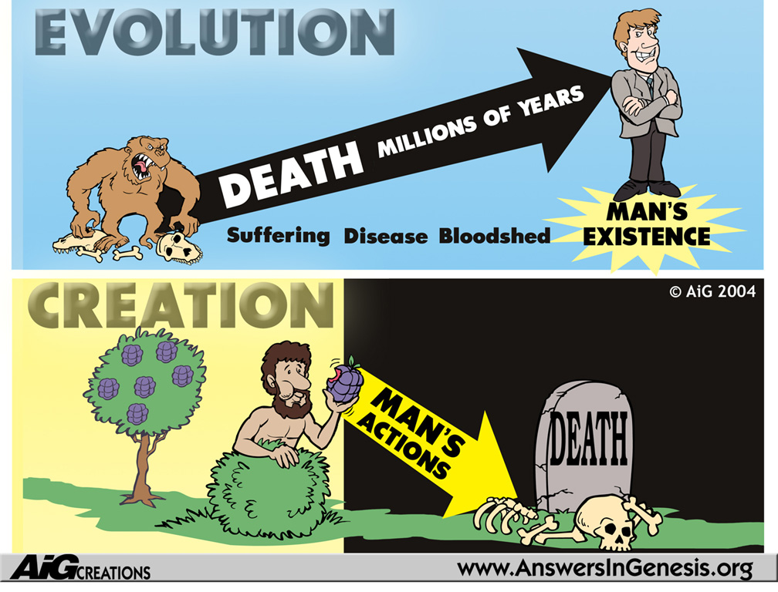

III. Genesis is foundational to the doctrine of God.

God declared the original creation very good (Gen. 1:31).

God cared for creation after the Fall (Ex. 23:12; Deut. 25:4; Matt. 12:11-12; Prov. 12:10).

So how could God spend millions of years creating and then destroy creatures before He created man?

IV. Genesis is foundational to the gospel.

Gen. 3:15

The Luke 3 genealogy stems back to a real person, Adam.

1 Cor. 15:22, 45

V. Genesis is foundational to morality.

VI. Genesis is foundational to the reliability and authority of Scripture.

(Why does Genesis matter? Because foundations matter!)

Conclusion

Evolution and millions of years are destructive lies (Main Idea).

Main Points

Please come to each of our ten messages in this series.

Rick Griffith
12 July 2015
Message 1 of 10

Genesis Matters!
“Question of Origins—Why It Matters” by Dr. Terry Mortenson,
used and adapted with permission

Introduction

The Supreme Court changed the legal definition of marriage on 26 June 2015.

How could this happen?

Genesis matters! But why does Genesis matter?

I. Genesis is foundational to ________ other biblical doctrines.

Psalm 11:3

Genesis is foundational to marriage, modesty in clothing, 7-day week, origin of nations, prophecies about the Messiah, etc.

II. Genesis is foundational to the doctrine of _______________.

Why is there death?

The Bible teaches that death came at man’s Fall.

Pre-Fall world: man and animals were vegetarians (Gen. 1:29-30).

In the Bible, plants are not living souls (Hebrew: nephesh chayyah) and do don’t “die” in the same sense as animals and people do.

Nephesh chayyah is never used of plants in the OT.

Plants don’t really die (Job 14:7-12; John 12:24).

The Fall (Gen. 3:14-18; Rom. 8:19-22)

Serpent judged physically (Gen. 3:14)

Animals cursed (Gen. 3:14)

Eve judged physically: increased pain in childbirth (Gen. 3:16)

Ground was cursed (Gen. 3:17; 5:29)

Adam & Eve began to die physically (Gen. 3:19; Rom. 5:12; 1 Cor. 15:21-22)

Implied death: sacrificed animals to make coats of skin (Gen 3:21)

Creation in bondage to corruption (Rom. 8:19-23)

Problems with the fossil record

Fossil thorns in rock layers date at 360-408 million years old while Genesis says thorns came after man.

Cancer in dinosaur bones shows that man and death came before dinosaurs.

Human fossils with disease “date” far older than any acceptable date for Adam.

Mass extinctions go against the idea of gradual decay

Fossil graveyards support a worldwide Flood.

Two histories of death are diametrically opposed.

III. Genesis is foundational to the doctrine of ______________.

God declared the original creation very good (Gen. 1:31).

God cared for creation after the Fall (Ex. 23:12; Deut. 25:4; Matt. 12:11-12; Prov. 12:10).

So how could God spend millions of years creating and then destroy creatures before He created man?

IV. Genesis is foundational to the ___________________.

Gen. 3:15

The Luke 3 genealogy stems back to a real person, Adam.

1 Cor. 15:22, 45

V. Genesis is foundational to ____________________.

VI. Genesis is foundational to the reliability and authority of ________________________.

Conclusion

Evolution and millions of years are destructive lies (Main Idea).

Please come to each of our ten messages in this series.

