New Testament Chronology
Dr Rick Griffith, Singapore Bible College, 2019

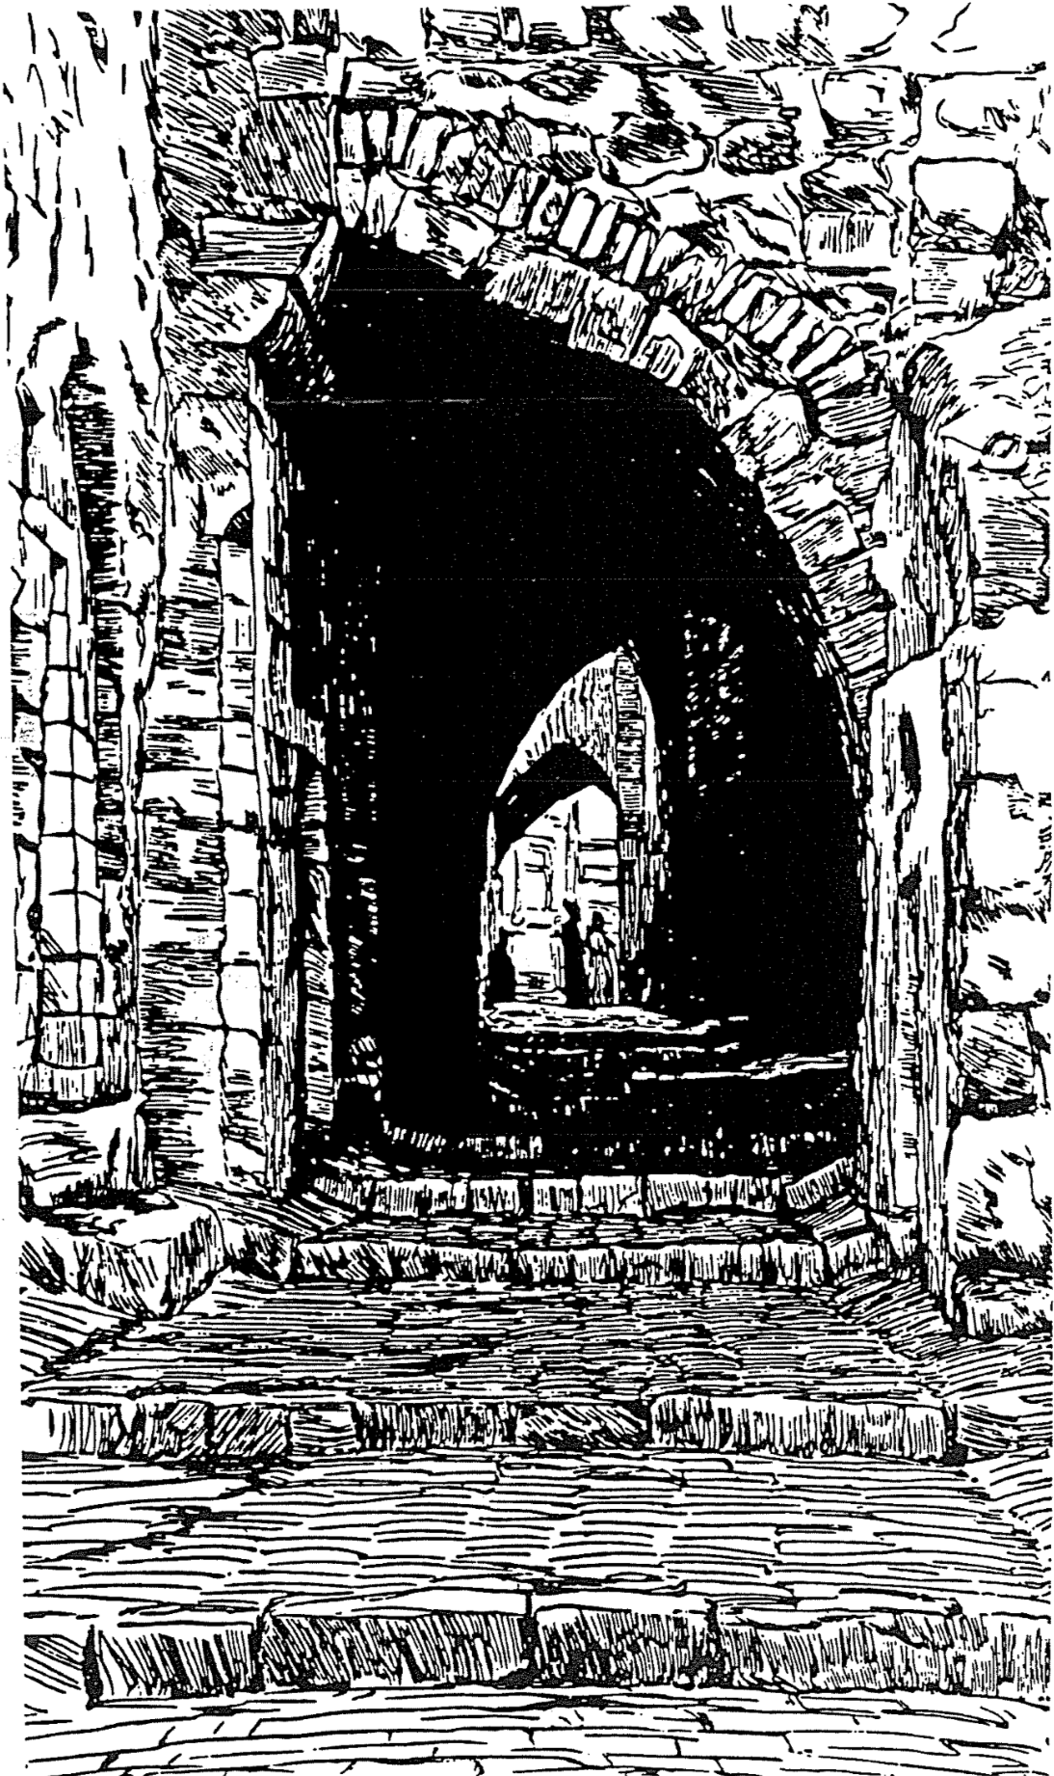
Integration of the New Testament

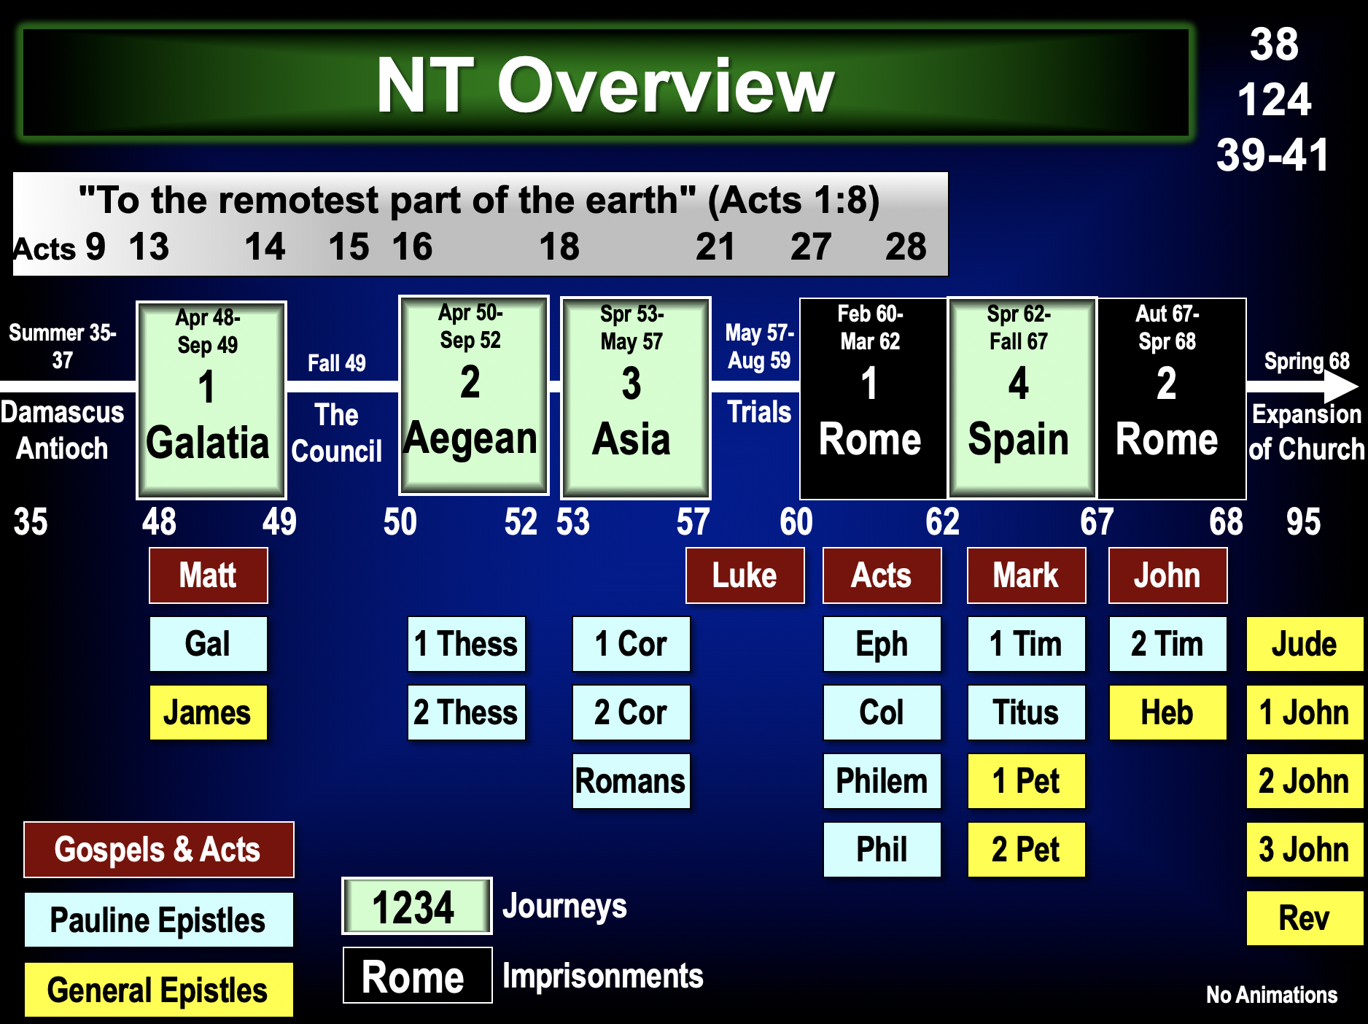

What general observations can you make about the structure and timeline of the NT?

Chronology of Christ

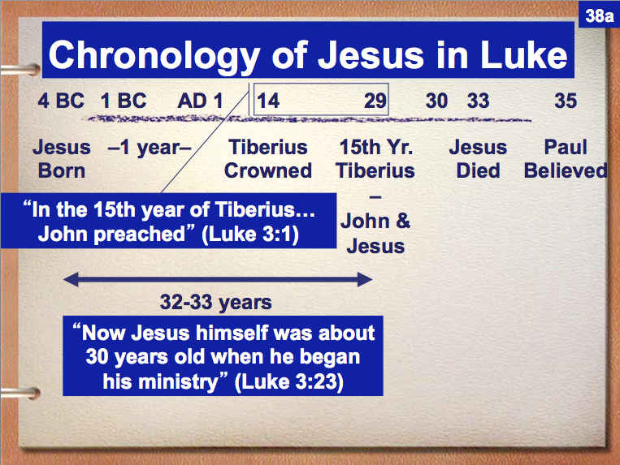

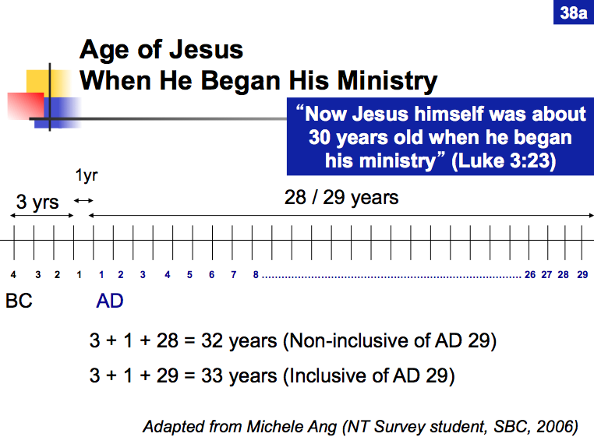

New Testament Chronology
Adapted from Harold W. Hoehner, “A Chronological Table of the Apostolic Age,” ThD Diss., Dallas Theological Seminary, 1964, rev. 1972

Book Written | Date | Paul’s Life | Church/Jews/Rome | Acts
 | 30 BC~AD 14 | Birth of Paul | Augustus emperor in Rome
 | 25 Dec. 5 BC |  | Birth of Christ
 | AD 14-37 | Jerusalem Training | Tiberius emperor in Rome
 | fall 29-3 April 33 | Cilicia Training | Christ’s 3.5 yr. ministry | 1:1
 | Monday, 30 March 33 |  | Triumphal Entry
 | Friday, 3 April 33 |  | Crucifixion (36 yrs. old) | 1:3a
 | Sunday, 5 April 33 |  | Resurrection | 1:3b
 | Thursday, 14 May 33 |  | Ascension | 1:4-11
 | 24 May 33-early 35 |  | Evangelizes Jews | 2:4–6:7
 | Sunday, 24 May 33 |  | Pentecost (Church Born) | 2:1-41
 | 24 May 33-April 35 |  | Evangelize Jews only | 2:1–8:1
 | summer 33 |  | Peter with Sanhedrin #1 | 3:1–4:31
 | 33~34 |  | Ananias & Sapphira die | 4:32–5:11
 | 34~35 |  | Peter with Sanhedrin #2 | 5:12-42
 | late 34~early 35 |  | “The Seven” selection | 6:1-7
 | April 35-April 48 |  | Evangelizes Samaritans | 6:8–8:40
 | April 35 | Assists Stephen’s death | Stephen martyred | 6:8–7:60
 | April-summer 35 | Persecutes church | Church scatters | 8:1, 3; 9:1a
 | summer 35 | Philip, Peter, & John | Evangelize in Samaria | 8:5, 14, 25
 | summer 35 | Conversion | Church fears Paul | 9:1b-19a; Gal. 1:15
 | summer 35-37 | Damascus & Arabia |  | 9:19b-25; Gal. 1:17
 | summer 37 | Jerusalem visit #1 | Barnabas introduces Paul | 9:26-29; Gal. 1:18
 | fall 37-43 | Tarsus, Syria, Cilicia |  | 9:30; Gal. 1:21
 | 37-41 |  | Caligula emperor in Rome
Matthew | 40’s |  | Church still Jewish
 | 40–62 | Expansion of the Church | Evangelizes Gentiles | 10:1–28:31
 | 40~41 |  | Peter & Gentile Cornelius | 10:1–11:18
 | 41 |  | Antioch church planted | 11:19-24
 | 41-54 |  | Claudius emperor in Rome
 | 43 | Antioch | Barnabas recruits Paul | 11:25-26
James | 44~47 |  | Jewish church is carnal
 | spring 44 |  | Agrippa I kills James | 12:1-2
 | spring 44 |  | Peter escapes prison | 12:3-19a
 | late 44? |  | God kills Agrippa I | 12:19b-24
 | fall 47 | Jerusalem visit #2 | Antioch’s famine relief | 11:27-30; Gal. 2:1
 | Fall 47-April 48 | Antioch
 | April 48-Sept. 49 | Missionary Journey #1 | Evangelizes Galatia | 13:1–14:26
 | Sept. 49-April 50 | Antioch furlough #1 |  | 14:27-28
 | fall 49 | Antioch: rebukes Peter | Still “anti-Gentile” | Gal. 2:11-16
Galatians | fall 49 | Writes from Antioch | Galatian heresy stopped
 | fall 49 | Jerusalem visit #3 | Jerusalem Council | 15:1-29
 | winter 49-50 | Returns to Antioch | Antioch Gentiles rejoice | 15:30-35
 | April 50 | Barnabas disagrees | Barnabas disciples Mark | 15:36-39
New Testament Chronology

Book Written | Date | Paul’s Life | Church/Jews/Rome | Acts
 | April 50-Sept. 52 | Missionary Journey #2 | Evangelizes Greece | 15:40–18:22
 | April 50-May 51 | Antioch to Athens | Macedonia churches planted | 15:40–17:34
1 Thess. | early summer 51 | Writes from Corinth | Corinthian church planted | 18:1-17
2 Thess. | summer 51 | Writes from Corinth |  | 18:1-17
 | mid Sept. 52 | Cenchrea, Ephesus |  | 18:18-21
 | late Sept. 52 | Jerusalem visit #4 |  | 18:22
 | winter 52-53 | Antioch furlough #2 |  | 18:23a
 | spring 53-May 57 | Missionary Journey #3 | Evangelizes Asia | 18:23b–21:16
 | spring-Sept. 53 | Antioch to Ephesus | Apollos at Ephesus | 18:23b-28
 | Sept. 53-May 56 | Ephesus | School of Tyrannus | 19:1-41
 | October 54-June 68 |  | Nero emperor
1 Cor. | early spring 56 | Writes from Ephesus | Corinthians divided | 19:1-41
 | May-June 56 | Troas to Macedonia | Corinthian visit #2 | 20:1; 2 Cor. 2:1
2 Cor. | fall 56 | Writes from Macedonia | Minority unrepentant | 20:2a
 | mid-late Nov. 56 | Macedonia to Corinth | Corinthian visit #3 | 20:2b
Romans | winter 56~57 | Writes from Corinth |  | 20:3a
 | late Feb.-27 May 57 | Corinth to Caesarea |  | 20:3b–21:16
 | 27 May-5 June 57 | Jerusalem visit #5 | Jerusalem Church | 21:17–23:32
 | 28 May 57 | Meets with James | is still ethnocentric | 21:17-25
 | 29 May-1 June 57 | Purification rites done | Church satisfied | 21:26-32
 | 2 June 57-Feb. 60 | Pre-Rome Imprisonments |  | 21:33–28:31
 | 2-4 June 57 | Jerusalem Imprisonment |  | 21:33–23:22
Luke | June 57-August 59 | Caesarean Imprisonment | Luke collects data | 23:23–26:32
 | 4-5 June 57 | Jerusalem to Caesarea |  | 23:23-32
 | 5-9 June 57 | Waiting for accusers |  | 23:33-35
 | 9 June 57 | Trial by Felix |  | 24:1-23
 | late June 57 | Trial by Felix and Drusilla |  | 24:24-26
 | June 57-July 59 | Waiting for Felix’s verdict |  | 24:27
For numbers | July 59 | Trial by Festus |  | 25:1-12
below see the | early August 59 | Trial by Agrippa |  | 25:13–26:32
map on p. 142  ↓ | Aug. 59-late Feb. 60 | Voyage to Rome to  evangelize Nero (27:24) |  | 27:1–28:29
 | Feb. 60-March 62 | First Rome Imprisonment |  | 28:30-31
Ephesians | fall 60 | House arrest letter | Jew-Gentile conflict | 28:30-31
Colossians | fall 61 | House arrest letter | Syncretistic heresy | 28:30-31
Philemon | fall 61 | House arrest letter |  | 28:30-31
Philippians | early spring 62 | House arrest letter |  | 28:30-31
Acts | 62 |  | Luke finishes Acts
 | spring 62-fall 67 | Missionary Journey #4 | Evangelizes West | After Acts
1 | spring 62 | Ephesus | James (Lord’s bro.) killed
 | 62 |  | Peter goes to Rome
2 | spring-summer 62 | Ephesus and Colosse | Timothy left at Ephesus | Philem. 22
3 | summer-winter 62/63 | Macedonia (Philippi) |  | Phil. 2:23-24
1 Timothy | fall 62 | Writes from Macedonia | False teaching | 1 Tim 1:3
4 | spring 63-spring 64 | Asia Minor
1 Peter | early 64 | Asia Minor | Christians despised in
2 Peter | early spring 64 | Asia Minor | Rome for separatism
 | spring 64 | Asia Minor | Peter crucified in Rome
5 | spring 64-spring 66 | Spain with Titus | Church reaches Spain | Rom. 15:24, 28
New Testament Chronology

Book Written | Date | Paul’s Life | Church/Jews/Rome | Acts
Mark | 19 July 64-9 June 68 |  | Nero burns Rome,  persecutes, dies
 | 66-73 |  | Jewish revolt in Palestine
6 | summer-fall 66 | Crete then Asia Minor | Titus left at Crete | Tit. 1:5
Titus 7 | summer 66 | Miletus | False teaching | 2 Tim 4:20
 | winter 66/67-fall 67 | Macedonia, Nicopolis, Corinth | Tit. 3:12
 | fall 67-spring 68 | 2nd Rome Imprisonment
2 Tim 8-9 | fall 67 | Arrested, prison letter | Heresy/apostasy increasing
Hebrews | 67~68 |  | Persecution in Israel
 | spring 68 | Death by beheading |  | 2 Tim 4:6
 | 68-96 | After Paul’s life | Late First Century Events
 | 68-69 |  | Galba, Otho, Vitellius emperors
 | 69-79 |  | Vespasian emperor (no persecution)
John | before 2 Sept. 70 | (cf. John 5:2; Jos.War 6.10.1) | Jerusalem destroyed & false teaching
 | April~May 73 |  | Jews commit mass suicide at Masada
Jude | 75 |  | False teaching intensifies
 | 79-81 |  | Titus emperor (no persecution)
 | 81-96 |  | Domitian emperor (persecution later)
1-3 John | 85~95 |  | Itinerant teachers amid false teaching
Revelation | 95~96 |  | External persecution by Domitian;  Internal compromise and heresy
 | 96-100? |  | John dies a natural death in Ephesus

Other New Testament Chronologies

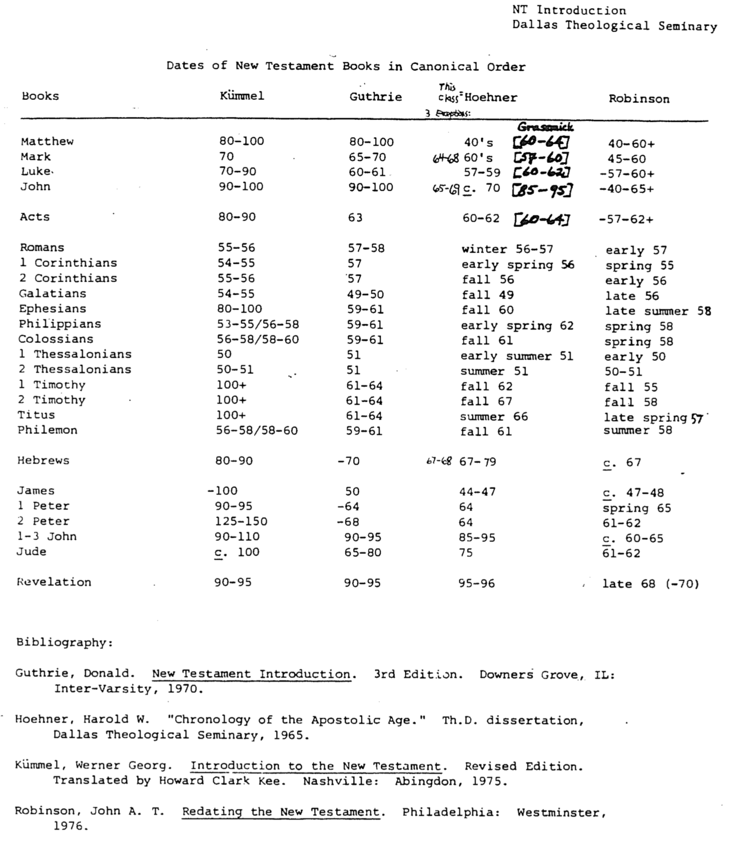

Other New Testament Chronologies (2 of 5)

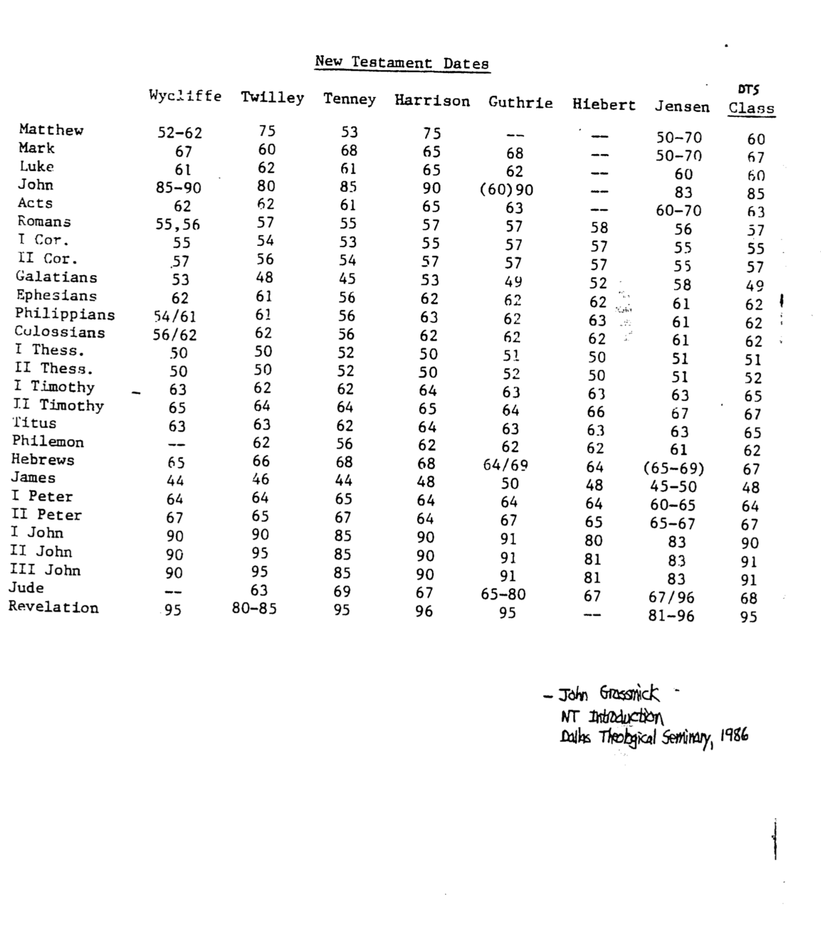
Other New Testament Chronologies (3 of 5)

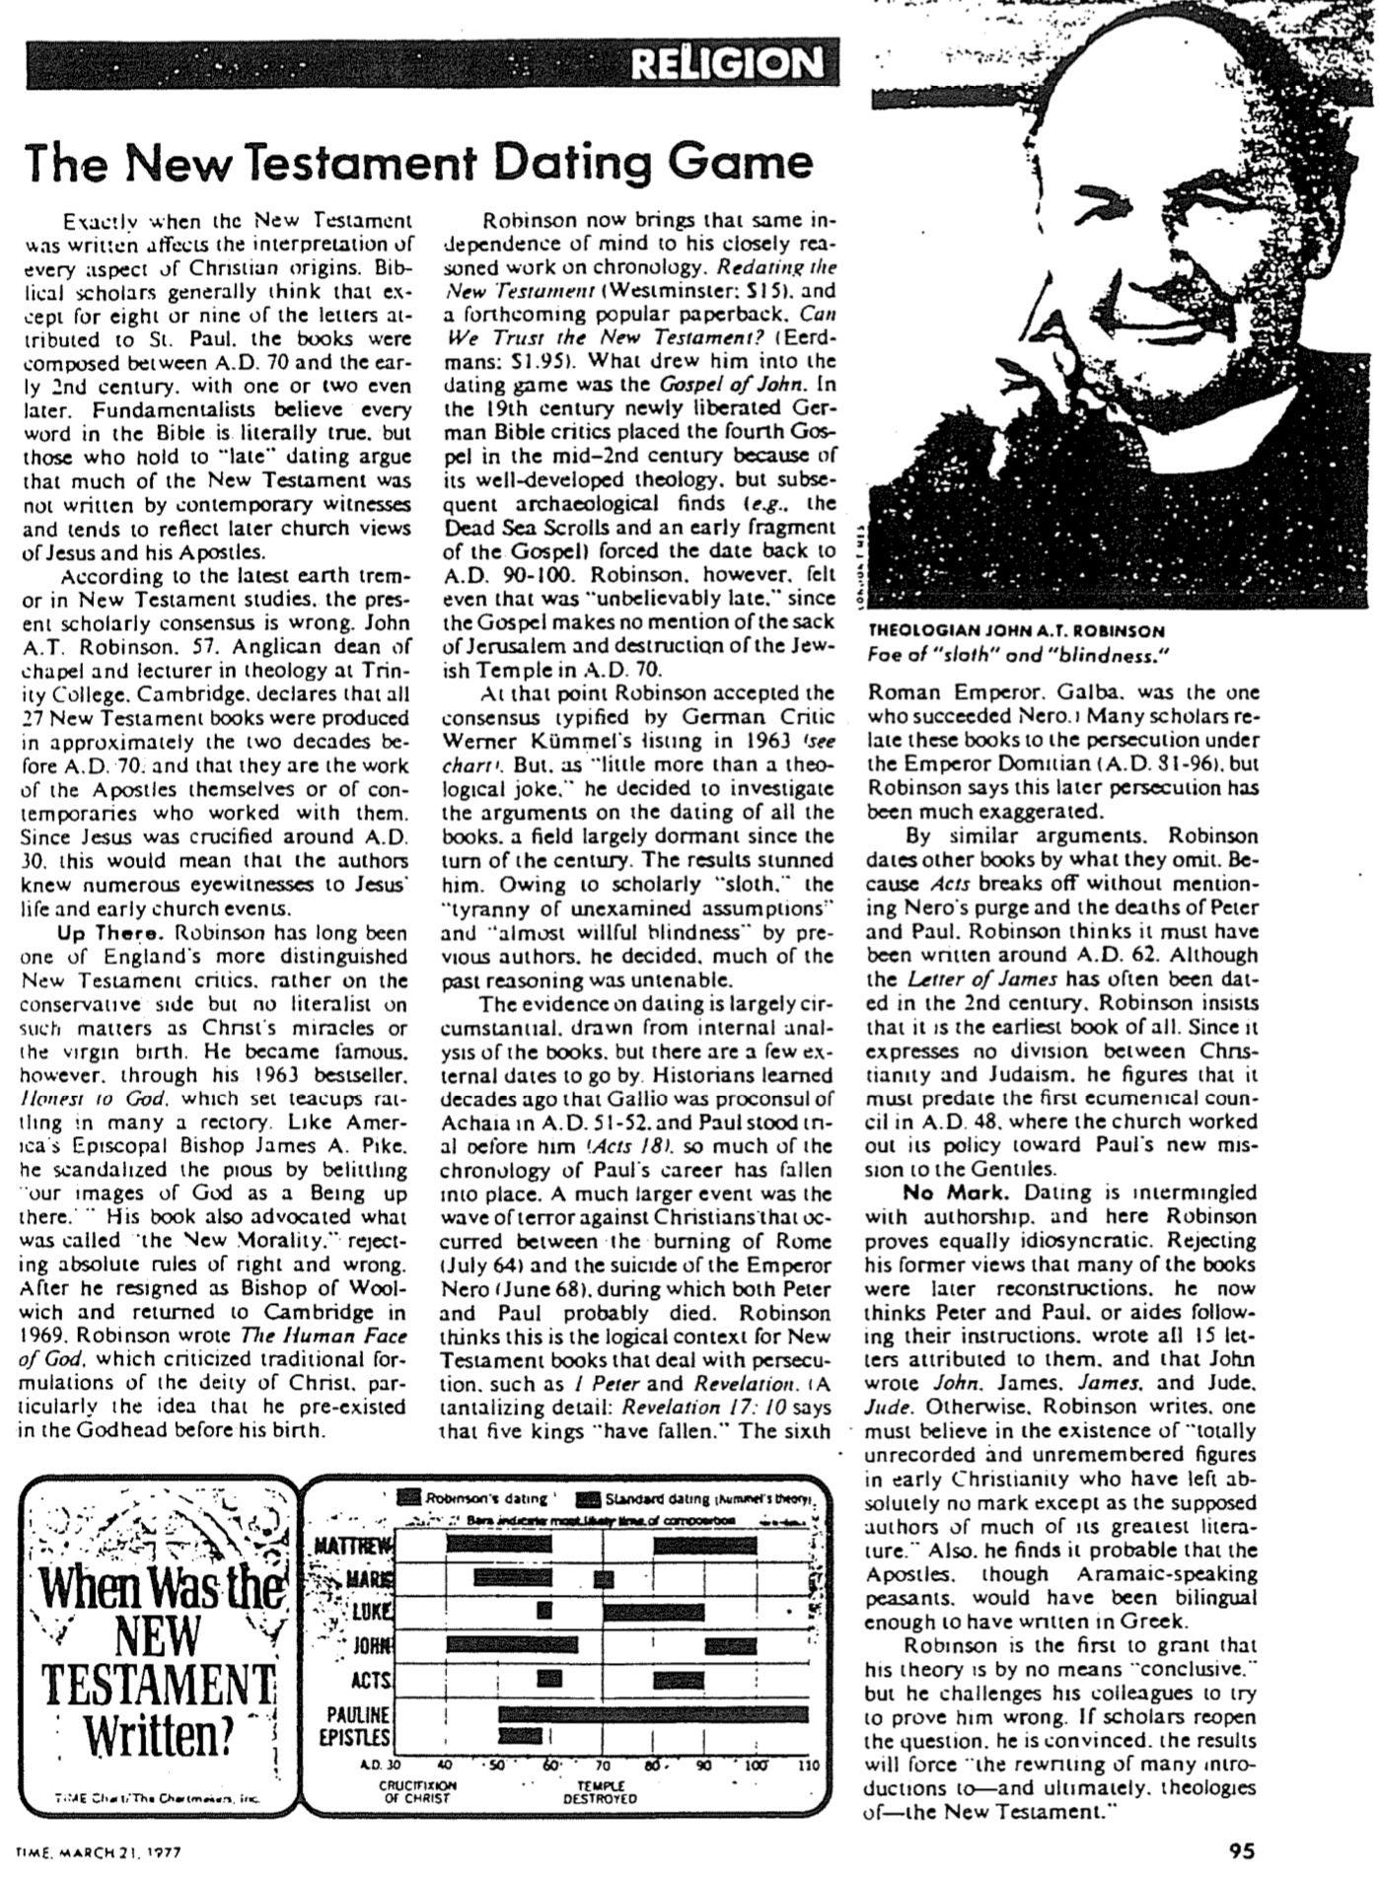
Other New Testament Chronologies (4 of 5)

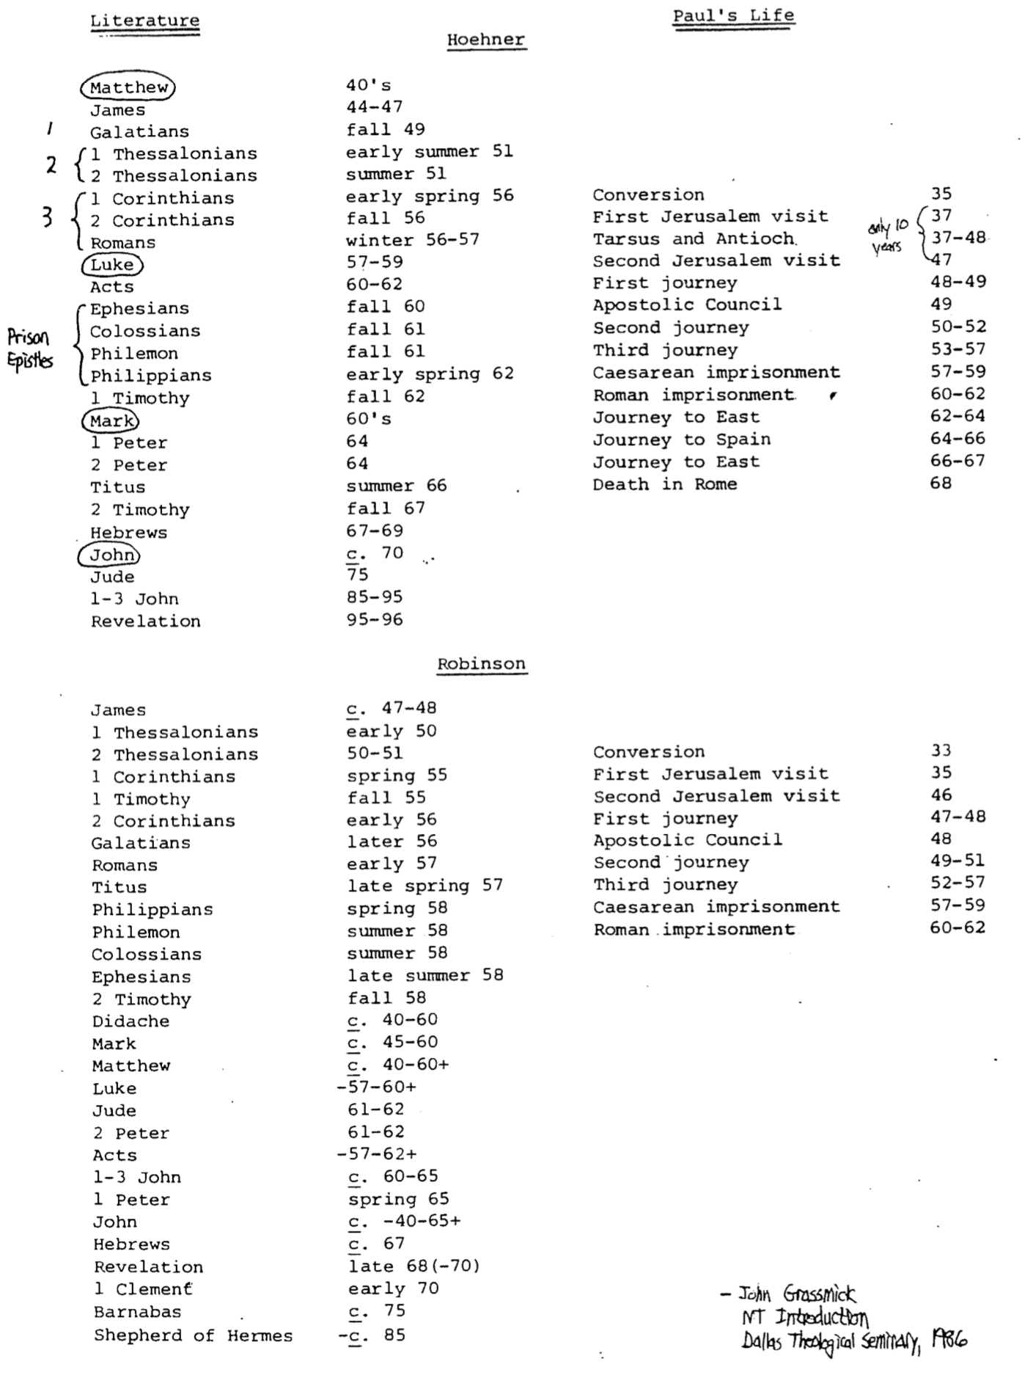
Other New Testament Chronologies (5 of 5)

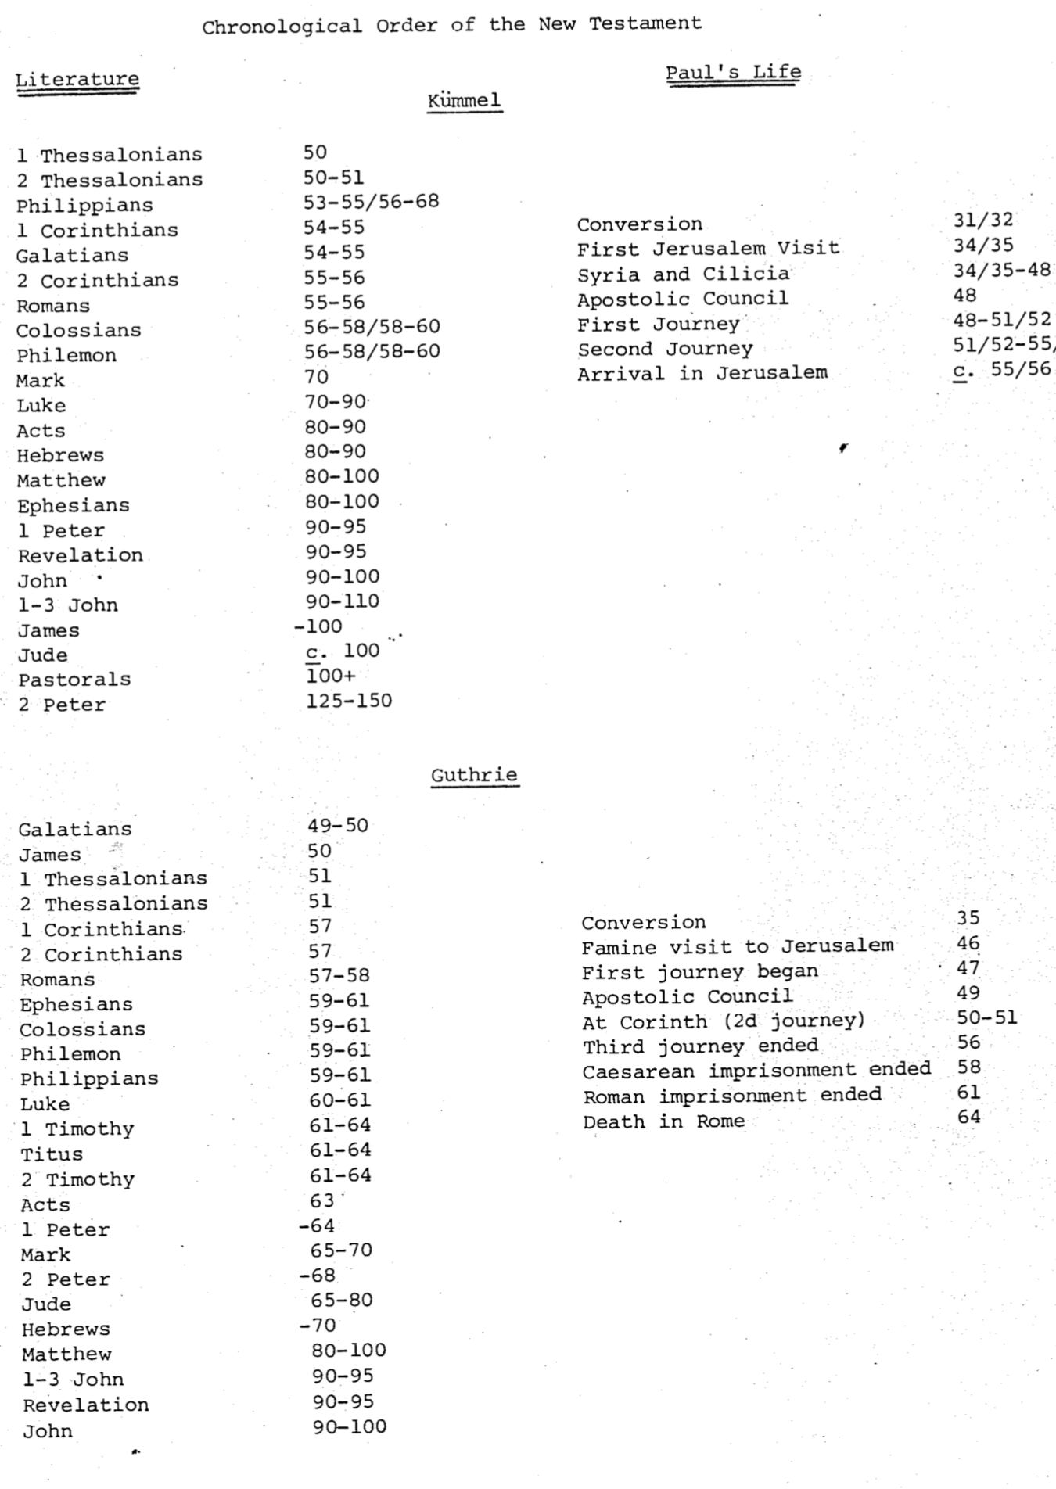

The Date of Christ’s Death

Even though Pilate ruled Judea from AD 26-36, scholars have proposed dates for the death of Christ ranging from AD 21 to AD 36. Since this is the most significant death in history, it is worthy of our time to discern when the crucifixion of Christ took place. This study compares the two dates evangelicals hold most (AD 30 & AD 33) by summarizing the two books below.

Contrasts Between the Main Dates Proposed

Issues | AD 30 | AD 33
Beginning of John’s Ministry in Tiberius’ 15th year (Luke 3:1-2) | No satisfactory solution yields the required AD 25-26 date for John’s ministry start in order to arrive at an AD 30 crucifixion of Christ. | Adding 15 years to Tiberius’ coronation in AD 14 yields AD 28/29 for the start of John’s ministry, so Christ’s 3.5-year ministry that started later gives AD 33 as the date of Christ’s death (Hoehner, 100).
Passover (Nisan 14) on a Friday (John 19:28) | Nisan 14 fell on a Friday in AD 30, which satisfies John’s account (Synoptics followed a different calendar). | Astronomy shows that Nisan 14 fell on a Friday in AD 27, 30, 33 and 36.
46-year temple construction (John 2:20) | The “temple” began to be constructed by Herod in 19 BC and continued to AD 27. | Jews referred to the sacred building (nao,j John 2:20)—not the whole temple area with their courts (i`ero,n John 5:14; 7:14, etc.). The building took 1.5 years to build, being completed in 18/17 BC. Thus the building had stood for 46 years by AD 29/30. “Therefore, the Jews were asking Jesus how He would be able to raise in three days the temple edifice which had stood for forty-six years” (Hoehner, 42).
About 30-years old at start of His ministry (Luke 3:21-23) | Beginning his ministry in AD 26 brings Christ’s birth back to 4 BC at latest—probably 6 BC for Christ to be 32 years old. | Beginning his ministry in AD 29 brings Christ’s birth back to 4 BC exactly, so that Jesus was 32-33 years old when he began his ministry.
Proponents | Elwell & Yarbrough | Hoehner

Conclusion

Issues 2, 3, & 4 above seem inconclusive for both the AD 30 and the AD 33 views. However, based on the clear reference to the 15th year of Tiberius (issue #1), it appears that the AD 33 date has the most merit. This would argue that Jesus was crucified on Friday, 3 April, AD 33.

A tilda (~) means one point within a range of dates, but a hyphen (-) means all the dates between dates noted.
Galatians 1:17 implies that the Arabia visit was brief so most of this time Paul ministered in Damascus.
Paul was trained in Jersulem, so the visits on this chart refer only to those after his belief in Christ. This “first” Jerusalem visit was to establish contact with Peter and lasted only 15 days (Gal. 1:18-19). However, a problem exists here: did he see only Peter and James (Gal. 1:18-19) or all the apostles (Acts 9:27)?
Paul was ministering in Antioch for an entire year (Acts 11:25-26) prior to the famine visit (vv. 27-30).
Luke uses the general statement “It was about this time…” (12:1) as he does not follow a strict chronology here. Chronologically, Acts 12 (in Jerusalem) actually precedes Acts 11 (the famine visit from Antioch to Jerusalem).
A problem with this chronology is reconciling Paul’s 14-year lapse from visiting Jerusalem a second time (Gal. 2:1). If this second visit is the famine visit (Acts 11:27-30), this would be either: (a) 13 years since his conversion in AD 35 (more likely) or (b) 10 years since his first post-conversion Jerusalem visit in AD 37. Neither case adds up to 14.
Harold W. Hoehner, Chronological Aspects of the Life of Christ (Grand Rapids: Zondervan, 1977), 95.
See several sources cited by Hoehner, 100, n. 34.
Josephus Ant. 15.11.5
Walter A. Elwell and Robert W. Yarbrough, Encountering the NT, 2d ed. (Grand Rapids: Baker, 2005), 119.
See footnote 7 above.

