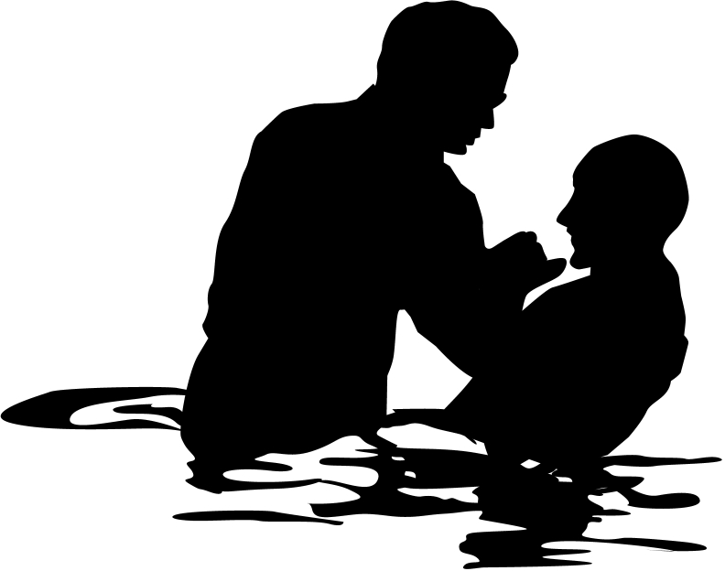
Christian Baptism

To really “hear out” an issue—especially one with such emotion as baptism—it is wise to present arguments from both sides. We think believer’s baptism has stronger support, but we present both views here.

 | Infant | Believer’s
Adherents  Who does it? | Catholic, Lutheran, Presbyterian, Reformed, Anglican, Methodist, some Evangelical Free Church | Baptist, Bible, Brethren, Mennonite, Pentecostal, some Evangelical Free Church, most independent churches
Purpose  Why do they do it? | Three Views:  1. Catholic: Means of saving grace apart from the faith of the baptized (baptismal regeneration)  2. Lutheran: Means of saving grace assuming faith by those baptized (baptismal regeneration)  3. Others: Not a means of saving grace but Reformed churches see it as a seal and sign of the covenant while the Methodists see it as a form of membership in the church family | Unified View:  Baptism is a symbol of salvation: an outward sign of the inward reality of justification received in Christ with no external efficacy (A. Oepke, “bapto, baptizo…” TDNTabr., 93).
Supports for Above Stated Purpose: | Baptismal regeneration is taught in many verses (Mark 16:16; John 3:5; Acts 2:38; Tit. 3:5; 1 Pet. 3:21).  (Baptismal regeneration is refuted by Ronald K. Y. Fung, The Epistle to the Galatians, NICNT, 173-74) | Baptism and salvation are indeed linked, but not directly so that baptism causes salvation. This would contradict the clear NT teaching of salvation by faith alone (John 3:16; Rom. 10:9-10; Eph. 2:8-9). In NT times, baptism often occurred on the day of one’s conversion. This close association between salvation and baptism was viewed as a single event, yet baptism was not always commanded with conversion (Acts 3:19; 16:31).
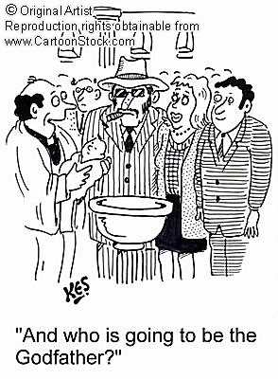 | Baptism is the sign of the covenant (Col. 2:12).  It thus signifies the recipient’s initiation into the community of God. | The sign of the new covenant is not baptism but the Lord’s Supper (1 Cor. 11:25).  Colossians 2:11-12 associates baptism not with physical circumcision but with “spiritual” circumcision, or salvation.  Also, Scripture never connects water baptism with an OT covenant such as the Abrahamic Covenant. The argument at the left is an argument from silence, as Colossians mentions no covenant relating to baptism.
 | Baptism is the seal of the covenant (Acts 15:1; 21:21; Gal. 2:3-5). | The verses at the left prove only that circumcision is not required in the present age; they say nothing about baptism.  The seal of the new covenant is not baptism but the Spirit (Eph. 1:13-14).

 | Infant | Believer’s
Purpose  (continued) | The central idea associated with baptism is purification from sin (Col. 2:11-12). | Baptism signifies forgiveness of sin but also identification with Christ in His death and resurrection (Rom. 6:1-7).
 | Assigning to baptism only a symbolic purpose shows a low view of baptism in light of the many NT references. | This outward sign of an inward reality is supported in that all NT baptisms were performed on believers. To the contrary, to perform it only on Christians is to show a high view of baptism–especially since it is so often associated with salvation. The statement at the left assumes that a symbol cannot be important, but this is exactly what we have in the Lord’s Supper.
 | The thief on the cross lacked a chance to be baptized so he is not a good example of requisites for salvation. Christ may have made an exception in his case. | Concerning Catholic and Lutheran views requiring baptism for salvation, Christ promised the repentant thief on the cross salvation without baptism (Luke 23:40-43).
Subjects  Who can be baptized? | Infants who have no personal faith in Christ can be baptized. | Believers alone should be baptized, which excludes infants and the unsaved.
Support for Above Stated Subjects | Baptism is parallel to circumcision, and circumcision was done to infants. Therefore, baptism should be performed on infants as well. | The logic at the left is faulty in its first premise—that baptism and circumcision are parallel (see above under Col. 2:12). Also, only boys can be circumcised.
 | Infant baptism more powerfully illustrates the grace of God. Children were included in the old covenant. Since the new covenant supersedes the old, the new covenant should surely include children. Even animals are included in God’s covenant of redemption (Gen. 9:10), let alone children, who are definitely more precious to Him. | How is God’s grace towards a baby who has never consciously sinned greater than His grace towards one who has repeatedly rebelled against Him? Grace towards adults is the greater marvel. Children under the old covenant were not saved by circumcision but by faith (Gen. 15:5). Likewise, under the new covenant we are accepted by faith—not by baptism (Rom. 4:1-25). Besides, how is denying baptism for infants a sign of the priority of animals over humans? Since animals are not baptized, the comparison cannot be made.
 | Entire households were baptized in the NT, which almost certainly included infants (Acts 10:47-48; 16:15; 18:8; 1 Cor. 1:16). | Each of the household texts declare that the households believed before baptism; that infants were baptized is an assumption that is counter to the stated fact that people believed before baptism.
 | Infant baptism has been practiced throughout the history of the church from earliest times. | The earliest non-scriptural baptism instructions (early second century) requires fasting of 1-2 days prior to baptism, thus implying only adult baptism (Didache 7:4 in J. B. Lightfoot, Apostolic Fathers, 153)

 | Infant | Believer’s
Subjects  (continued) | Christ blessed little children–probably even infants (Mark 10:13-16); this indicates His approval to baptize them. | Blessing children and baptizing them are wholly different. The argument at the left is valid only if the NT shows Christ baptizing children, which it does not.
 | Infant baptism is not prohibited in the NT and therefore is allowed. | Silence does not necessarily argue for approval (e.g., we cannot argue for baptism of the dead simply because the NT does not prohibit it). NT support for believer’s baptism automatically prohibits infant baptism since infants cannot believe.
 |  | The order in the Great Commission is first to make disciples, then to baptize them (Matt. 28:19-20). So only believers are to be baptized, which excludes infants.
 |  | Baptism points back to the believer’s becoming united with Christ in His death (Rom. 6:1-11); this cannot be said of infants who have yet to believe.
 |  | All subjects of baptism in the NT are clearly believers; one must have very good reason to deviate from this norm (Acts 2:38, 41; 8:12, 36-38; 9:18; 10:47; 16:14-15, 33; 18:8; 19:5). These texts show that repentance preceded baptism in a sequence of “hearing...believing...being baptized.”
Mode | Scripture does not specify any particular mode of baptism, thus allowing both sprinkling and pouring. It is not method that counts, but the sincerity of the one baptized. | The only scriptural mode is immersion, so how can we say mode is unimportant? While it is true that mode is less important than heart attitude, this does not then imply that mode is irrelevant.
Support for the Above Stated Mode | Baptism by pouring has been practiced throughout the history of the church from earliest times. | Pouring is first stated in the early second century–and only as an exception when immersion in running water or cold water should/could not be used (Didache 7:1-3 in J. B. Lightfoot, Apostolic Fathers, 153).
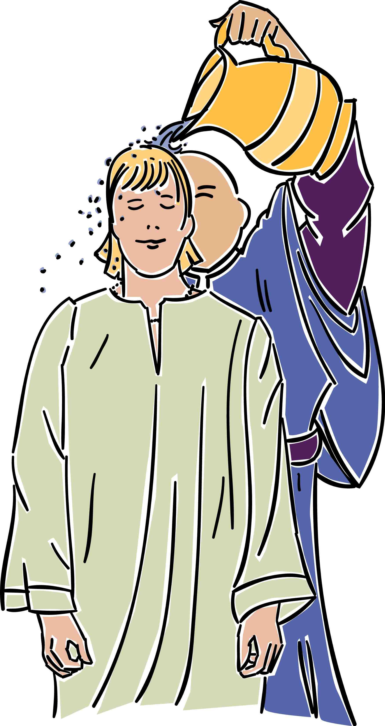 | Baptism by pouring is mentioned often in the NT (1 Cor. 6:11; Eph. 5:26; Heb. 9:10; 10:22; Tit. 3:5). | None of these verses refer to baptism and none refer to pouring. They refer in each case to spiritual cleansing from sin by faith in Christ (“washing”) or to Jewish ceremonial washings that were performed numerous times on the same persons (cf. Heb. 9:10). Hebrews 10:22 refers not to baptism but to “having our hearts sprinkled to cleanse us from a guilty conscience and having our bodies washed with pure water.”

 | Infant | Believer’s
 | Pouring best represents the outpouring of the Holy Spirit upon believers (Matt. 3:11; Acts 1:5; 2:3). | While implied similarities exist between baptism by pouring and the outpouring of the Spirit, the explicit symbolism in the NT is that baptism represents the believer’s dying to his old life and rising to a new one (Rom. 6:1ff.). So immersion is the explicit mode in the NT and pouring can be argued only by implication.
Mode  (continued) | Baptism by sprinkling is mentioned often in the Bible (Exod. 24:6-8; Num. 8:7; Ezek. 36:24-26; Heb. 9:13-14; 10:22). | None of these texts note baptism. They refer to purifying priests with sprinkled water (Num. 8:7), sprinkling vessels with blood (Exod. 24:6-8; Heb. 9:13-14), or the Spirit’s saving work (Ezek. 36:24-26; Heb. 10:22).
 | Practically speaking, Peter could not have immersed 3000 in a single day on the day of Pentecost (Acts 2:41). This baptism must have been by sprinkling or by pouring. | One wonders if he could have sprinkled or poured upon that many either, but the text does not say Peter did the baptizing. If one could immerse 100 people per hour (a distinct possibility), the 120 disciples there (Acts 1:15) could have immersed 12,000 in a single hour! Even if only the 12 baptized it would take less than three hours to baptize the 3000 (12 x 100 = 1200/hour).
 | The Philippian jailer would not have left his post for immersion, but could have momentarily for pouring or sprinkling (Acts 16:33b). | The text says he took time to listen to Paul’s preaching (v. 32) and to wash Paul and Silas’ wounds (v. 33a), which may have taken just as long. He obviously left his post to invite Paul and Silas to his home for a midnight meal (v. 34). Baptism takes less time than eating a full meal. The argument at the left also assumes that he guarded the jail alone and could not have delegated his responsibilities to others.  
 | Lexical meanings are not sufficient to establish theology. | The lexical meaning of the only word used for NT baptism (baptizo) means “dip, immerse…wash, plunge, sink, drench, overwhelm…soak” (BAGD 131c). Besides baptism, other literal uses include “to dip” (Luke 16:24; cf. LXX Judg. 2:14; Josh. 3:15; Lev. 4:6; 11:32) and “to dye” (Rev. 19:13). Also, baptism is likened to the Flood (1 Pet. 3:21). From the lexical data even Luther and Calvin both believed immersion to be the biblical mode.
 | Since sprinkling was practiced in the OT, John the Baptist probably sprinkled as well–especially since he was a Levite (Luke 1:5). | John the Baptist performed his baptisms in the Jordan River. Would sprinkling have required people to walk into the water with John? Besides, the type of baptism immediately preceding John’s historically was Jewish proselyte immersion (see next box below).

 | Infant | Believer’s
 | Baptisms preceding Christianity do not absolutely establish that Christian baptism followed the same pattern. | Baptizo (to dip) is used not only of NT baptism, but also of Jewish ritual washings (Mark 7:4; Luke 11:38), which were by immersion. Both pagan religious washings and Jewish proselyte baptism preceded Christian baptism, the latter being by self-immersion (A. Oepke, “bapto, baptizo…” TDNTabr., 92-93).
Mode  (continued) | Sprinkling and pouring also have OT and NT parallels (see above). | Immersion best signifies:  • identification with Christ’s death and  resurrection by going under the water and  out again (Rom. 6:3-5; Col. 2:12)  • subjection to Christ’s authority (Matt.  28:18-19; Acts 19:3-5; 22:16)  • obedience and a good conscience before  God (1 Pet. 3:21).
 | Baptism preceded the writing of Romans, so the immersion portrayed in Romans 6 could have been new. (No evidence prior to Romans indicates that baptism signified Christ’s death and resurrection.) | Only six NT books were written before Romans, so Romans was among the first NT books to be written (AD 56-57). It is quite problematic to argue an early and later form of Christian baptism given that there exists “one baptism” (Eph. 4:5).
 | The passages at the right argue only that baptism took place in water, but this still could have been by pouring or sprinkling while standing in the water. | All NT examples of baptism best allow for immersion: “plenty of water” (John 3:23), “coming up out of the water” (Mark 1:10), “went down into the water” (Acts 8:38). This last case concerns the Ethiopian eunuch who could have easily been baptized by pouring or sprinkling anywhere along the journey by using water in the caravan.
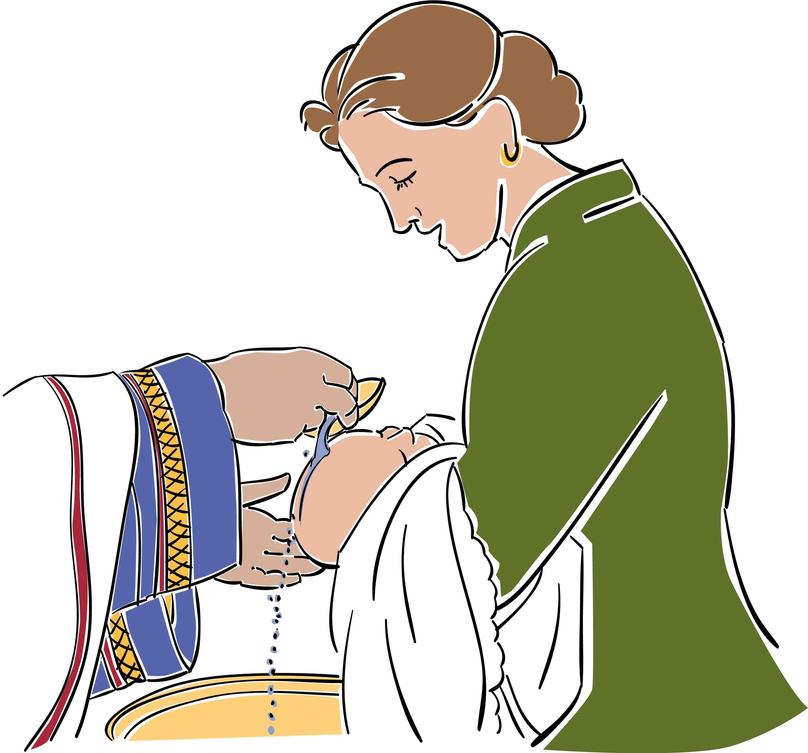
Please Note: Various persons holding to the infant baptism position above have proofread this column so that this study will accurately present this perspective. However, as with any view, there exists a spectrum of views on this topic.
Questions About Baptism

1. Should baptism be required of those who take the Lord’s Supper?

Response: Since 1 Corinthians 11:28 warns each believer to evaluate himself prior to taking the Lord’s Supper, our church does not act as judge for each participant. However, we do encourage people in our congregation to obey Christ in all ways, including baptism. If a person is informed about baptism but resists being baptized, one could ask if he can take the Lord’s Supper in a “worthy manner” (1 Cor. 11:27-32). Baptism was required of those partaking the Lord’s Supper as early as the second century (Didache 9:5 in J. B. Lightfoot, The Apostolic Fathers, 154), yet we see this as an individual decision.

2. Should those sprinkled as infants later be baptized following confession of salvation?

Response: The difference between infant sprinkling and adult baptism relates to more than simply the time of baptism. The whole purpose of baptism differs significantly in these two ceremonies. Infant sprinkling signifies the parents’ desire for their infant to be accepted into the community of God (Presbyterian view) and even serves as a means of saving grace in the Catholic and Lutheran views. However, as Scripture relates to baptism a symbolic purpose of looking back at one’s salvation, it would seem that one who has been saved would welcome the opportunity to testify to his or her salvation through baptism after salvation.

3. Should those sprinkled as believing adults be immersed once they see immersion’s NT support?

Response: Many churches will not admit persons for membership who have not been immersed after placing their faith in Christ, even if they have been sprinkled following salvation. This is not as serious of an issue as question “2” above, but there is a similar situation in Scripture that can help.

Here is where Acts 19:1-7 can help. In this passage Paul visited Ephesus and found twelve men to whom he ministered. A key question here is, “Were these men believers in Christ?” Some claim, “The fact that these men did not have the Spirit dwelling within was proof that they had never truly been born again,” but the following shows that, as much as possible, they had placed their faith in Christ:
a. They were already deemed “disciples” when Paul met them (19:1). It is clear they were disciples of John, but Luke uses this word “disciples” 31 other times in Acts—and every time he refers to believers in Christ (16:1 18:23, 27; 19:9, 30; 20:1, 7, 30 are the closest references).
b. Paul asked them “when they believed”—not “if they believed” (19:2), so he assumed that they had already placed their faith in Christ according to the teaching of Apollos (Acts 18:25). “The impression of verse 2 and its mention of their believing, however, is that their instruction is incomplete, not that Jesus is not a part of it at all.”
c. They had already repented of their sins in anticipation of the Messiah’s ministry.
d. They had already received the baptism of repentance (Matt. 3:2, 6, 8, 11; Mark 1:4-5; Luke 3:8).

So they were believers when Paul met them. However, for whatever reason, they were unlike the majority of John’s disciples who eventually met and followed Christ. Since they had a baptism (immersion) of repentance under John that was incomplete in picturing their faith in Christ, Paul rebaptized them in the Christian manner (immersion in the name of Christ). Paul felt it vital that their baptism accurately picture their faith in Christ. This is the only place in the NT that explicitly refers to anyone being rebaptized. As far as we know, neither Apollos nor the twelve apostles were rebaptized, but arguing the case either way would be an ineffective argument from silence.

The Acts 19 situation did not concern sprinkling followed later by immersion as in question “2” above. John immersed in the Jordan and the Jewish proselyte baptism that preceded him was also by immersion. Certainly, if Paul felt it necessary to supplement one form of immersion (John’s baptism of repentance) with another form of immersion (Christian baptism), it would be appropriate to supplement post-conversion sprinkling with post-conversion immersion. As in question “2” above, this ceremony gives believers another opportunity and privilege to testify of their faith in Christ.

Someone may ask, “Methodists and Presbyterians and others holding to infant baptism accept new adult members who have been immersed without them being sprinkled. Why then, can’t those holding to believers’ immersion accept the sprinkling of the other denominations?” This is a fair question, but the two situations are not parallel. Many who practice infant baptism such as Calvin and Luther admit that immersion is the scriptural mode, so it is certainly easy for them to accept those with scriptural baptism. However, those practicing immersion of believers do not see any scriptural support for sprinkling either adults or infants. Why should immersionists have to accept an unscriptural form of “baptism” just because those who sprinkle accept immersion as the scriptural form?

4. Should a church require immersion for those who seek to become members?

This question is even stickier than the preceding three questions as it asks not simply what should be done but what a church would require to be done. It is important since to require anything beyond what the Bible requires would be legalism; however, to require less than Scripture would be unscriptural.

Many people object to the requirement of immersion. These objections deserve a reasoned answer:

Objection 1: Why won’t you accept sprinkling as an alternate mode of baptism?

Response: The first recorded case of sprinkling was in AD 257 to someone on a sickbed. It started then as an exception to the rule and brought about fierce opposition from the whole church. Not until AD 757 did the church accept sprinkling in such sickbed cases of necessity. It wasn’t until AD 1311, when the Catholic council of Ravenna, declared that sprinkling was an acceptable substitute for immersion and from that time forward sprinkling replaced immersion in the Roman Catholic Church.

Objection 2: Such a strict requirement of immersion-only invalidates baptisms by sprinkling or pouring.

Response: Pouring emerged in the second century, followed by sprinkling in the third century. The requirement of immersion only acknowledges that a single form of baptism was practiced in the first century. It in no way invalidates sprinkling or pouring as public testimonies of one’s faith in Christ. There are many ways to testify of Christ that are not noted in Scripture: public profession, walking the aisle, sharing via television, fax, email, blogging, etc. Requiring immersion only notes that immersion is a biblical form of public testimony via the baptism that Christ commanded.

Objection 3: Is the rebaptism by immersion in Acts 19 really parallel since immersion after adult sprinkling today is a second public testimony of faith in Christ? Acts 19 required baptism of those who did not have Christian baptism until trusting in Christ at their second baptism. However, believers today who have been sprinkled as adults have not become Christians between their sprinkling and immersion.

Response: As noted above, believers who have not been immersed are actually quite parallel to those in Acts 19. In both cases, true believers publicly responded to what they knew about the Messiah—through John’s immersion then and through sprinkling or pouring today. Those in Acts were immersed twice. Why would not believers today who have never been immersed be immersed even for the first time?

Objection 4: Why have membership at all—especially with such a high standard like immersion?


Response: The NT church had certain lists—obviously for those in leadership (Acts 6:5) and even widows for church support (1 Tim. 5:9). The church in Jerusalem had 5000 in attendance within the various house churches, which must have had official lists of members.

What was required for membership? The NT pattern required two basics: (1) belief in Christ, and (2) immersion. Many churches add numerous other requirements to these two basics: several class sessions on membership, an interview by the pastor, etc. While these are not necessarily wrong, often these are required but the biblical requirement of immersion is neglected. Immersion is not a high standard. It was practiced immediately on thousands of believers upon their simple testimony of Christ as the One who saved them from sin.

Objection 5: Aren’t differing modes of baptism parallel to differing types of food in Communion? If we must follow the NT unleavened bread and wine, why do we use bread and grape juice today?

Response: The variances here are not parallel at all. The difference between wine and grape juice is marginal compared to the symbolism of immersion versus sprinkling or pouring. The latter do not picture the symbolism of immersion where a believer dies to his old life only to rise to a new life (Rom. 6). Similarly, differences between unleavened and leavened bread are inconsequential compared to pouring and sprinkling which have no NT baptismal significance as opposed to immersion’s symbolism.

Objection 6: In today’s international setting with many divergent backgrounds within a congregation, shouldn’t a local church be more accommodating to these views rather than require immersion?

Response: Romans 14 warns us not to put a stumbling block before weaker believers. However, this should never be done at the expense of following NT practices. When we must choose between accommodating various backgrounds and violating Scripture, we must choose to obey the Word. All NT believers in the book of Acts were immersed before being added to their particular fellowship:
- Peter commanded those at Pentecost to repent and 3000 were immersed (2:38, 41)
- Samaritans trusted Christ and were immersed (8:12)
- The Ethiopian eunuch “believed…[and was] immersed” (8:36-38)
- Paul believed and was immersed that same night (9:18)
- Cornelius “believed… [and was] immersed” (10:47)
- The Philippian jailer “believed… [and was] immersed” (16:14-15, 33)
- Crispus “believed… [and was] immersed” (18:8)
- John’s disciples “believed [and were] immersed” (19:5)

Almost all NT churches were international—except possibly the Jewish church at Jerusalem. Even Jerusalem likely had Jews from many nations worshipping together, if some of those saved at Pentecost remained at Jerusalem. The point is not the background from which people have emerged. Believers today and then are saved from a variety of backgrounds—including pagan religious roots as well as Christian roots of varying stripes. The point is to follow the NT patterns as closely as possible.

Actually, having different requirements for membership leads to confusion as to the biblical mode. Why require immersion for those baptized by our church, but allow sprinkling or pouring for others from other churches? If we have a biblical mode, then we should not be afraid to follow it.

Since God has given us such a beautiful, clear picture of the new life we have in Christ that all early church Christians practiced, should we not do so today?

Warren W. Wiersbe, The Bible Exposition Commentary (Wheaton, Ill.: Victor Books, 1996, c1989), Ac 19:1; cf. Lawrence O. Richards, The Bible Readers Companion, electronic ed. (Wheaton: Victor Books, 1991; Published in electronic form by Logos Research Systems, 1996), 726; Ben Witherington, The Acts of the Apostles: A Socio-Rhetorical Commentary (Grand Rapids: Eerdmans, 1998), 570 (cited by Bock’s commentary below) says that neither they nor Apollos were believers, given their lack of the Spirit, which Luke requires for true believers (e.g., Acts 11:17). However, given this narrow definition in the transitional book of Acts, one wonders how even the twelve apostles could be called believers prior to receiving the Spirit in Acts 2.
Others say that “disciples usually refers to Christians, but since these people had not received the Holy Spirit, it is more likely that they are to be regarded as disciples of John the Baptist, on ‘the Way’ but not very far along” (D. A. Carson, New Bible Commentary: 21st Century Edition, 4th ed. [Leicester, England; Downers Grove, Ill., USA: Inter-Varsity Press, 1994], Ac 19:1). Polhill notes that in Luke’s gospel, “disciples” can refer to John’s followers (Luke 5:33; 7:18-19; cf. J. B. Polhill, Acts, New American Commentary [Nashville: Broadman, 1992], 399). However, followers of John the Baptist essentially placed their faith in the coming Messiah. Therefore, since Jesus was the focus of John’s preaching, disciples of John believed in the Jesus that he proclaimed (19:4).
Darrell L. Bock, Acts, Baker Exegetical Commentary on the NT (Grand Rapids: Baker, 2007), 599. Bock also notes on the same page, “Most commentators understand disciples as being disciples of Jesus here…”
Stanley D. Toussaint, “Acts,” in The Bible Knowledge Commentary: An Exposition of the Scriptures, eds. John F. Walvoord, Roy B. Zuck and Dallas Theological Seminary (Wheaton, IL: Victor Books, 1983-c1985), 2:409.
A.T. Robertson, Word Pictures in the New Testament (Oak Harbor: Logos Research Systems, 1997), Ac 19:5.
See www.bible.ca/cath-overview-false-teaching.htm.

