An Examination of the Deacon Qualifications
1 Timothy 3:8-13

I. Outline of the Qualifications

A. Men: Specific Behavior (1 Tim 3:8-10)
B. Women: Specific Behavior (1 Tim 3:11)
C. Men: Family Life (1 Tim 3:12-13)

The elder qualification study (class notes, 224) noted that a man’s desire to be an elder must precede any official evaluation (1 Tim. 3:1a) since if he does not want to become an elder, it matters little whether he qualifies. Although not expressly stated in the following passage on deacon qualifications, obviously the same truth applies here as well. Thus, implicitly a man’s desire to be a deacon would have to precede or accompany any evaluation of his life.

As to the origin of the deacon office in the Church, this is not given in Scripture nor recorded for us in the extra-biblical writings. While the appointment of “the Seven” in Acts 6 in AD 34-35 may perhaps serve as model, nowhere are these seven men ever called deacons. In fact, over twenty years after their appointment (AD 57), Philip is still called one of “the Seven” (Acts 21:8), not “one of the Jerusalem deacons.” However, in AD 62 Paul addressed his letter to Philippi’s “elders and deacons” (Phil. 1:1) so the office was certainly known by this time.

As to the nature (i.e., responsibilities) of the office, this is also never laid out as with the elders (cf. Acts 20:28, 35; 1 Pet. 5:1-4). However, the term “deacon” means literally one who serves in a menial capacity such as waiting on tables, so these persons fulfilled a role subservient to the elders. Elders were responsible for teaching and hospitality, roles that were never required of deacons.

II. Examination of the Qualities Individually

A. Men: Specific Behavior (1 Tim 3:8-10)

1. Worthy of Respect (semnou,j v. 8) means “worthy of respect or honor, noble, dignified, serious” (BDAG 747a 1a). This quality was required of older men in general (Tit. 2:2). A respectable man shows maturity that avoids personal excesses that may offend others, especially weaker saints. The church whose leaders do not earn respect will have difficulty.

2. Sincere is the positive way of saying “not double-tongued” (mh. dilo,gouj v. 8; BDAG 198d; cf. NASB) and means one who is consistent in what he says. He is not a “double-talker” who says “one thing to one man and a different thing to the next” (Kelly, Pastoral Epistles, 81). Deacons, being responsible for many servant tasks, must be men who can keep a tight rein on the tongue backed by integrity of heart.

3. Not Indulging in Much Wine (mh. oi;nw| pollw/| prose,contaj v. 8; cf. elder qualification #9 “not addicted to wine” or “not (one who lingers) beside (his) wine” [mh. pa,roinon] in Tit. 1:7; 1 Tim. 3:3) means one who is not “occupying oneself with, devoted or applying oneself to” wine (BDAG 714d 1c; cf. 1 Tim. 4:13). Temperate (nhfa,lion 1 Tim. 3:2) has the same idea, “literally temperate in the use of alcoholic beverages, sober, clear-headed, self-controlled” (BDAG 538d). An alcoholic or heavy drinker must never be considered for the office of deacon. Ideally a deacon should be an abstainer and at the most one who drinks with great moderation.

4. Not Pursuing Dishonest Gain (mh. aivscrokerdei/j v. 8, is an alternate form of elder qualification #12 mh. aivscrokerdh/ Tit. 1:7) means “not fond for dishonest gain, greedy for money” (BDAG 25a). He makes an honest living and is upright in all his business dealings since he is “not given to filthy lucre” (KJV). Free from the Love of Money (avfila,rguron 1 Tim. 3:3b) used for elders describes this characteristic positively. A man who gambles, hoards his money, or pursues the deacon office for financial gain is clearly disqualified. Also, his giving record reveals whether he loves God or loves money. Deacons are often entrusted with large sums of money in the congregation (offerings, alms, etc.) and must show restraint here before appointment.

5. Keep[ing] Hold of the Deep Truths of the Faith with a Clear Conscience (e;contaj to. musth,rion th/j pi,stewj evn kaqara/| suneidh,sei v. 9) refers to adhering to “the mystery of the faith,” or doctrine received by special revelation (cf. Eph. 3:2-6). Today “mystery” denotes something concealed but in the NT, it meant a secret revealed. A deacon must be firmly grounded in the basic, revealed, scriptural teachings and living in harmony with them. He need not be “able to teach” as is required of an elder, but he must hold firm personal convictions. This disqualifies those who lack assurance of salvation or have doubts about inerrancy, Christ’s virgin birth, his substitutionary death, Christ’s resurrection, etc.

6. Tested to See if There is Nothing Against Them (dokimaze,sqwsan prw/ton v. 10; elder qualification #1 in 1 Tim. 3:2a; Tit. 1:6) means to be “proved…blameless” (KJV) or “irreproachable” (BDAG 64b) so that no one can point a finger at his character or behavior with an accurate accusation—not perfect, but has a good reputation. “Tested” means “to put to the test, examine” (BDAG 202c 1), but how to conduct this test is not specified. “Some have thought that a probationary period or a formal examination is envisaged, and either or both are possible” (Kelly, 83). Also, a candidate should have first proven himself responsible in other ministries in the church before being considered to be a deacon (cf. Matt. 25:21). This requirement to be blameless excludes one guilty of sin in his past that the church would need to discipline (e.g., divorce, immorality, criminal offenses) that would adversely affect his present reputation.

B. Women: Specific Behavior (1 Tim 3:11)

Verse 11 gives traits simply of women whose identity has long perplexed the Church, partly because the word here (gunaiko.j) can be legitimately translated as “women” or “wives.” At least six views on this phrase prevail: (1) women in general, (2) wives of both elders and deacons, (3) deaconesses with equal authority to male deacons, (4) a group functioning like deacons but ranking under them, (5) deacon wives, or (6) deacon wives who are called deaconesses.

The first view (women in general) contradicts the context that addresses qualifications for an office. The second (wives of both elders and deacons) is unlikely as verse 11 falls in the section on deacons (vv. 8-13). The third has weaknesses explained below while the fourth and fifth are most likely. The sixth view differs little from the fifth except for the name of these wives.

Some translations and scholars render the unclear word ambiguously as simply “women” (NASB, RSV, Amplified, TEB).

However, most English translations and scholars argue that they are deacon wives (view #5). I hold this view (or possibly view #4) for the following reasons:

• Verse 11 about women divides the male deacon qualifications in two sections (vv. 8-10 and 12-13), so it makes good sense that the women related very closely to the male deacons. Their wives would be the closest relationship possible, so they are the most likely referent.

• Deaconesses served the church around AD 115 (Pliny to Trajan Eps. 10.96-97; cf. others in Kelly, 84), but whether this happened in the first century is debatable (Earle, EBC, 11:368).

• Paul prohibited women to exercise authority over men (1 Tim. 2:12), so at best he advocated a group of women serving with equal authority as male deacons (view #3 above).

A few translations and many scholars give arguments that they are woman deacons (view #3):

1. It seems unusual for Paul to prescribe qualifications for wives of deacons but not for elders (who occupied a more influential position), so they probably are not deacon wives.

Response: While elders may be sworn to secrecy in private affairs of the church so that they would not even inform their wives, deacons often serve in conjunction with their wives; thus wives of deacons would need to have a tighter control of their tongue than wives of elders. Also, the mention of a quality for deacons but not for elders does not exclude it for elders as well (e.g., elders are not required to be “tested” as this is assumed).

2. Nothing about the office of deacon would exclude women (viz., they do not teach or exercise authority over men; cf. 1 Tim. 2:12).

Response: This argument from silence argues neither for nor against being deaconesses.

3. If deacon wives were meant Paul could have been clearer by writing either “having wives” (cf. “having children…” in v. 4) or “their wives” or at least “the women.”

Response: This also argues from silence and thus carries little weight. Adding either word would have cleared up the problem but evidently Paul felt he was already clear. Since it is in the context of deacons, he felt a qualifying word was unnecessary.

4. Phoebe is a biblical example of a women who was a deaconess (Rom. 16:1). The masculine form of the word is used there (dia,konoj diakonos) since no feminine form existed at the time. The masculine form was used of women as well.

Response: The word can simply mean “servant” rather than designate an office. The NT never clearly uses diakonos of women in the office of deacon, but it does refer to men having this role. Therefore, the clear texts should inform unclear ones such as Romans 16:1, not vice versa. In other words, we can be sure that men were deacons but we can’t be sure whether women held this position in the first century.

5. The word “likewise” in verse 8 set apart deacons as a different office from the preceding elder qualifications (vv. 1-7). In the same way, “likewise” reappears in verse 11 to indicate another class of persons. Thus, “Paul chose to introduce the women in a manner which set them parallel to the elders and deacons, implying a new, similar class of persons. He said, ‘Women, likewise…’” (Hurley, Man and Women in Biblical Perspective, 230).

Response: If Paul meant to set the women apart as a separate office, it would seem strange to do so in the middle of his deacon qualifications. The more natural sequence would be to finish the deacon qualifications first, then explain women deacon requirements.

Conclusion: One cannot be dogmatic about this difficult passage, but the two best views seem to indicate either deacon wives or women deaconesses not related to the deacons. While the deacon wives view may have the most to commend it, since women did not exercise authority over men in the church (1 Tim. 2:11-12), nothing would eliminate them from serving equally with men in servant roles in NT times. (However, in some modern churches the title “deaconess” refers to a woman in a helping role with no authority over men, but the NT never uses this term coined in the second century.) The best we can argue is that women served in capacities under the leadership of the elders, perhaps at the same level as male deacons but never over them.

However, let’s not “miss the forest through the trees.” The point of the verse is that proper conduct of women, not just men, is vital to the proper functioning of the church. Women are typically more relational than men, which has both advantages and disadvantages. One advantage is that they are more available to meet counseling needs in the church, but the disadvantage is that being trusted with such information requires respectable behavior and restraint of the tongue to prevent gossip.

Actually, whether women can have the title of “deaconess” is irrelevant. They can serve in the church in hundreds of ways without holding an office. Also, the guidelines in verse 11, while not directed at all women generally, are still a good model for any woman to pursue.

One final observation may be noteworthy: the four women qualifications closely parallel the first four requirements of deacons (cf. adapted from Hurley, 231):

Deacons (v. 8) Women (v. 11)
worthy of respect (#1) worthy of respect deacon quality #7
(semnous) (semnas—the feminine form of semnous)
not double-tongued (#2) not slanderers deacon quality #8
(me dilogous) (me diabolous)
not given to much wine (#3) sober/temperate deacon quality #9
(me oino pollo prosechontas) (nephalious)
not pursuing dishonest gain (#4) trustworthy in all things deacon quality #10
(me aischrokerdeis) (pistas en pasin)

“The qualifications are point for point parallel. The final item in each list has to do with trustworthiness. In the case of the deacon it looks to his business life. In the case of the women, it looks to their handling of daily affairs and relationships, perhaps because few women were involved in business affairs” (Hurley, 231). The significance of these parallel features is left up to the reader.

C. Men: Family Life (1 Tim 3:12-13)

11. The Husband of One Wife (mia/j gunaiko.j a;ndrej is equivalent to elder qualification #4; 1 Tim. 3:2; Tit. 1:6) emphasizes a man's control in sexual restraint and a faithful relationship to his wife. If he is not faithful in this second most important relationship in life, he should not be trusted in the affairs of the church. This qualification excludes any husband unfaithful to his wife or one guilty of pornography, homosexuality, incest, and other sins of the flesh. (See the detailed evaluation of this requirement prior to this study on deacon qualifications).

12. Must Manage His Children and His Household Well (te,knwn kalw/j proi?sta,menoi kai. tw/n ivdi,wn oi;kwn) is parallel to elder qualifications #5-6 where an elder is to “manage his household well, keeping his children under control with all dignity” (1 Tim. 3:4; cf. Tit. 1:6). No charge should exist against a deacon’s children for riotous living or insubordination, but rather they should be disciplined and restrained (able to accept authority). A deacon candidate whose children are rebellious or excessive (drugs, sex, drunkenness, etc.) should get his family under control before serving as a church leader (cf. 1 Tim. 3:5).

Two results of serving well as a deacon are provided in verse 13:

(1) A good reputation before people and God (perhaps “promotion” to pastor or elder is in view)

(2) Increased confidence in dealing with other people (Tom Constable, Dallas Seminary class notes, 24).

III. For Further Study

A. Dresselhaus, Richard L. The Deacon and His Ministry. Springfield, MO: Gospel Pub., 1977.

B. Green, Michael. Called to Serve. Philadelphia: Westminster, 1964.

C. Hiebert, D. Edmond. “Behind the Word ‘Deacon’: A New Testament Study.” Bibliotheca Sacra 140 (April-June 1983): 151-62.

D. Strauch, Alexander. The New Testament Deacon. Littleton. CO: Lewis & Roth, 1992. 192 pp. pb. US$10.
IV. Summary

To review, let’s compare and contrast the 20 traits required of elders with the 12 traits for deacons. Similar characteristics appear in parallel columns in the following chart. Trait numbers in parentheses correspond with the numbers in the preceding trait studies. For the third column, the elder trait translation and trait number appears first, followed by the deacon translation and trait number. Also, similar but not exactly parallel qualifications match horizontally across the chart (e.g., respected = blameless, children believe = children obey, teach = holds doctrines, and deacon wife traits 7-10 parallel deacon traits 1-4).

Unique to Elders | Unique to Deacons | Required of Both Offices
Respected by non-Christians (3) | Deacon Wife Qualities: | Blameless (1)/tested as above reproach (6)
Not a new believer (13) | Wife respectable (7) | Respectable (2/1)
Not quick-tempered (8) | Wife not a slanderer (8) | Not quarrelsome (11)/ not deceptive (2)
Self-controlled (19) | Wife temperate (9) | Temperate (9)/not addicted to wine (3)
Not a lover of money (12b) | Wife trustworthy (10) | Not pursuing dishonest gain (12a/4)
Children believe or faithful (5) |  | Children obey (6)/managed well (12)
Able to teach (20a) |  | Holds basic doctrines (20b/5)
Not self-willed (7) |  | Husband of one wife (4/11)
Gentle/not violent (10)
Hospitable (14)
Loves what is good (15)
Sensible/prudent (16)
Just/fair (17)
Devout/holy (18)

Observations

- More requirements apply to elders (20) than to deacons (12) since elders hold the higher office.

- Deacon traits in the third column fall into two basic categories: four parallel both wives and elders, plus four parallel elders alone.

- While no traits of elder wives are listed, four traits are given for deacon wives. This does not mean that an elder’s wife is unimportant; it probably indicates that whereas elder wives are not privy to information shared in elder meetings, deacons serve with their wives, so these women must hold similar traits as the men themselves. In fact, requirements of their wives are the only requisites expected of deacons that are not expressly required of elders.

- Nearly all traits address character rather than ability. Exceptions include both teaching ability and household management.
Qualifications for Elders and Deacons
Bible Visual Resource Book, 257

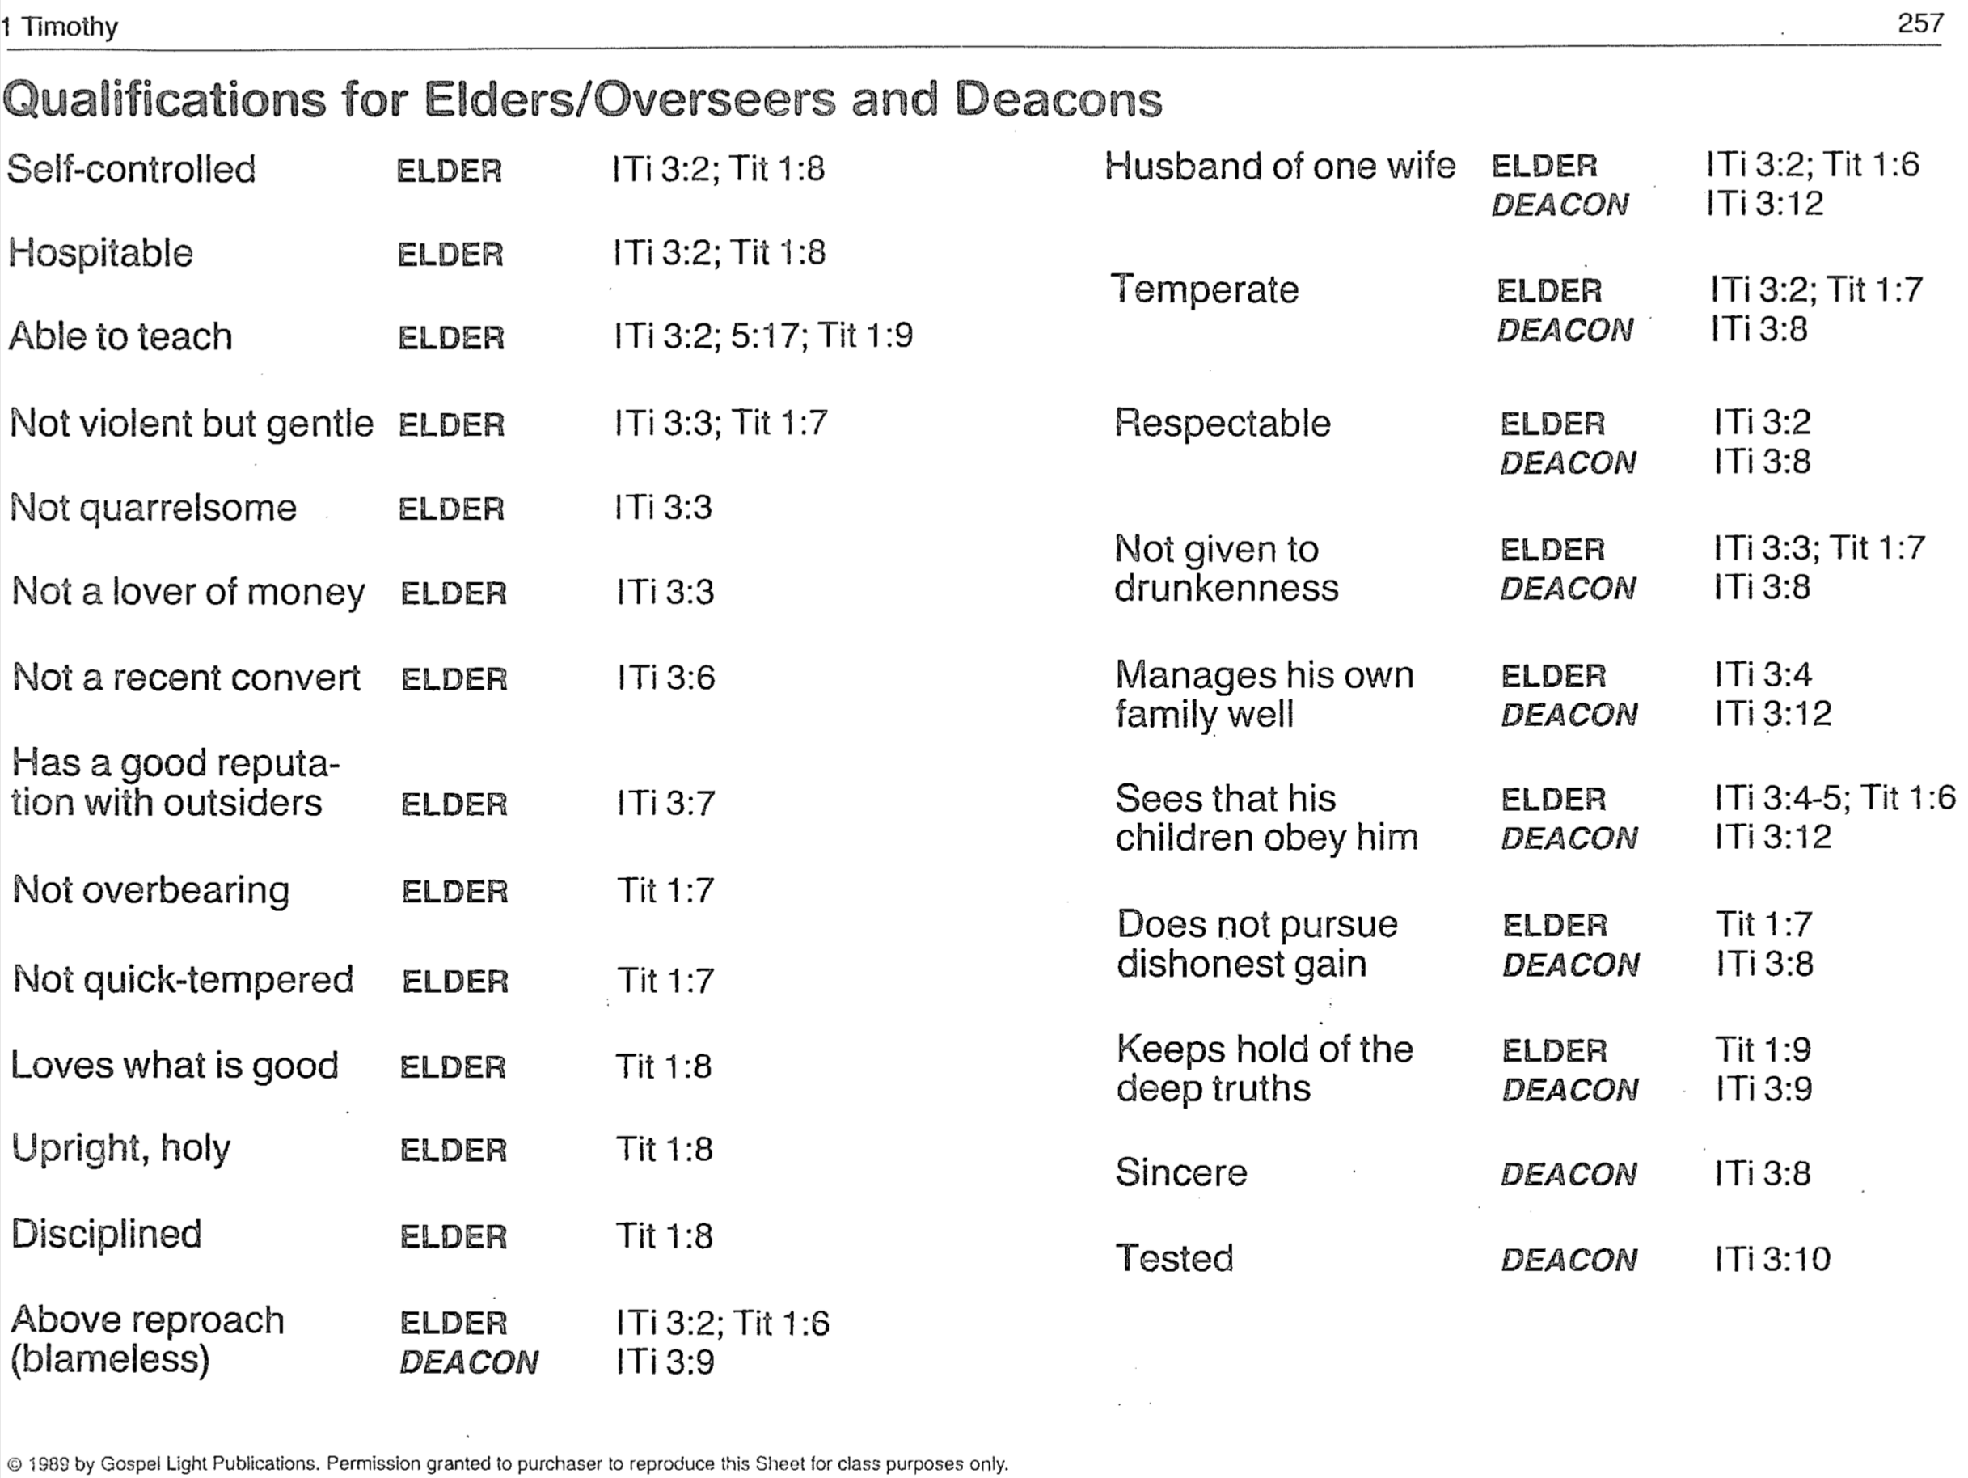

和合本。新國際版; NIV footnote, Williams; James B. Hurley, Man and Woman in Biblical Perspective, 229-33; J. N. D. Kelly, A Commentary on the Pastoral Epistles, Thornapple Commentaries (Grand Rapids: Baker, 1981), 83; Newport J. D. White, in Expositor’s Greek Testament, 4:115-16; J. H. Bernard, The Pastoral Epistles, 58-59; Walter Lock, A Critical and Exegetical Commentary on the Pastoral Epistles, ICC, 40-41.
“They are a group by themselves, not just the wives of the deacons nor all the women who belong to the church.… On the other hand, the fact that no special and separate paragraph is used in describing their necessary qualifications, but that these are simply wedged in between the stipulated requirements for deacons, with equal clarity indicates that these women are not to be regarded as constituting a third order in the church, the office of ‘deaconess,’ on par with and endowed with authority equal to that of deacons” (William Hendricksen, Pastoral Epistles, NTC, 346; cf. Donald Guthrie, Pastoral Epistles, 85).
NIV, KJV, NKJV, GNB, Beck, LB, Phillips; Wiersbe, 51-52; Earle, EBC, 11:368; Litfin, BKC, 2:238 says the view has a “slim advantage.”
Wiersbe, 52, cites this as a second possibility.

