Acts

Universal Savior Proclaimed in Sovereign Kingdom Progress

Jerusalem |  | Judea and Samaria |  | Uttermost Part
1:1–6:7 |  | 6:8–8:40 |  | Chapters 9–28
Jews |  | Samaritans  (mixed breeds) |  | Gentiles
AD 33-35  (2 years) |  | AD 35  (a few months) |  | AD 35-62  (27 years)
Peter |  | Stephen & Philip |  | Paul
Establishing Home Base |  | Nearby Outreach |  | Missionary Journeys
Established  1–2 | Expands  3:1–6:7 | Stephen  6:8–8:3 | Philip  8:4-40 | Damascus  9:1-31 | to Rome  10:1–28:31
Rome

AD 62
(completed after Paul’s house arrest)

Key Word: Sovereignty II

Key Verse: “But you will receive power when the Holy Spirit comes on you; and you will be my witnesses in Jerusalem, and in all Judea and Samaria, and to the ends of the earth” (Acts 1:8).

Summary Statement: The reason to witness everywhere is because God has directed the progress of the kingdom message to all people since early church history.

Application:
Is God extending his kingdom message through you?
How are you fitting into his overall purpose to spread the gospel throughout the entire earth?

Acts

Introduction

I. Title: The Greek title (Pra,xeij ’Aposto,lwn Actions/Deeds of Apostles) was added to this volume about the middle of the second century AD in the Anti-Marcionite Prologue. More proper than the English title, “The Acts of the Apostles,” may be “Some Acts of Some Apostles” since the book is not an exhaustive treatment of the history of all the apostles, but only Peter and Paul. Perhaps an even more accurate title might be “Some Acts of the Holy Spirit”! The book of Luke is the companion volume to Acts in that both address Theophilus (Luke 1:3; Acts 1:1).

II. Authorship

A. External Evidence: The Church Fathers from the latter half of the second century agreed that Luke, “the beloved physician” (Col 4:14), wrote Acts after writing Luke. Both books circulated together during the latter half of the first century until the beginning of the second century AD when Matthew, Mark, Luke, and John were gathered together and circulated as a fourfold gospel (Bruce, 15). The tradition for Luke as author is strong:

1. The earliest evidence for Lukan authorship stems from the Anti-Marcionite Prologue (AD 150-180) and the Muratorian Canon (AD 160-200).

2. Others cite Luke as the author such as Irenaeus (Against Heresies; ca. AD 185) and Clement of Alexandria (ca. AD 155-216; cf. Hiebert, 1:248-49).

Luke's name appears only three times in the NT (Col 4:14; 2 Tim 4:11; Philemon 24). Since Paul lists his companions as Jews (Col 4:10-11) then Gentiles (Col 4:12-14), and Luke's name appears in the latter group, he evidently was a Gentile, confirmed by his brilliant use of Greek. Tradition says that he came from Syrian Antioch, never married, and died at age 84 (TTTB, 327).

B. Internal Evidence: Support for Luke as author is in Acts itself, especially when compared with Luke.

1. Luke and Acts had the same author since: (a) both are dedicated to the same man, Theophilus, (b) Acts 1:1 refers to “the first account,” which most naturally refers to Luke's Gospel, (c) The language and style of the two books are remarkably similar, and (d) both books share many common interests (see “Characteristics” below; cf. Guthrie, 100).

2. Acts has four first person narratives often called the “we-sections” (16:10-17; 20:5-15; 21:1-18; 27:1–28:16) that show the author as Paul’s traveling companion. Of his traveling companions, only Titus and Luke are not mentioned by name in these sections and Titus has never been seriously considered as a candidate for the authorship of Acts (Hiebert, 1:119ff.).

III. Circumstances

A. Date: Acts is fairly easy to date, assuming that Luke wrote church history up to his time. It ends with Paul's two-year imprisonment (AD Feb. 60-Mar. 62; cf. Acts 28:30-31) and does not mention Nero’s persecutions (AD 64), Paul's ministry in the remaining years until his death (AD 62-68), nor the climactic destruction of Jerusalem (AD 70). Therefore, the most likely date of composition is AD 62.

B. Origin/Recipients: No one knows for certain where Luke wrote this account, nor does the book itself give any hint. Suggestions include Rome (since this is the location of the story at the end of the book), Antioch, Ephesus, Asia Minor, and Achaia. He clearly wrote to Theophilus (1:1), a man whose name means “lover of God.” The title of “most excellent” for Theophilus (Luke 1:3) indicates that he was probably an official in some capacity and as a man of high social standing he may have funded the publishing of Luke and Acts.

C. Occasion: Theophilus apparently thought Luke the physician a great source to write an orderly account of the life of Christ and the early history of the Church. He was detailed, well educated, an excellent historian, well acquainted with Paul, and as a single man able to travel and interview eyewitnesses. Luke probably wrote at Theophilus' request, but in any event, he purposed to strengthen the wealthy Christian's faith by showing that his faith rested on firm historical fact (Luke 1:3-4). Perhaps even more significantly, Luke sought to explain to his wider Gentile audience that God directed the progress of the kingdom message, not human ingenuity and skill.

IV. Characteristics

A. Different opinions exist for purpose of Luke-Acts:

1. Conciliation: to solve an opposition between Peter and Paul to show that Paul's credentials are equal to Peter's in order to defend Paul's apostleship of his letters (Baur and Tübingen School cited by Liefeld, EBC, 8:801). This view is speculative.

2. Soteriological/Evangelistic: to present Christ to non-Christian Gentile readers as the perfect Son of Man who “came to seek and to save that which was lost” (Luke 19:10; TTTB, 328). This view really explains only a purpose for the Gospel of Luke.

3. Instructional/Edification: to confirm Theophilus and other Gentile believers in their faith (Luke 1:4; TTTB, 328; Hiebert, 1:132-135). Longenecker (EBC, 8:217) believes the primary purpose of the book is kerygmatic (instructional) in that Acts emphasizes the continued confrontation of men and women by the Word of God through the church (4:29, 31; 6:2, 4, 7; 8:4, 14, 25; 10:36; 11:1, 19; 12:24; 13:7, 44, 46, 48-49; 14:25; 15:35-36; 16:6, 32; 17:11, 13; 18:5, 11; 19:10).

4. Apologetic: to show that Christianity was not a politically subversive sect but rather a universal movement (cf. Pilate's three announcements of Christ's innocence in Luke 23:4, 14, 22; TTTB, 328; the tracing of the movement from a primarily Jewish to a predominately Gentile membership, TTTB, 353).

5. Ecclesiastical: to “trace the development and distinction of the Church over and against Judaism” (Ellis, The Gospel of Luke, 60-62)

6. Historical Narrative: to preserve “the record of the origin and growth of the early church” (Fitzmyer cited by Liefeld, EBC, 8:800).

7. Kingdom: to explain how God has orderly and sovereignly directed the progress of the kingdom message from Jews to Gentiles to answer the natural questions of any Gentile unbeliever: (1) “How could a Jewish Savior be the Savior of the world?” (Book of Luke) and (2) “How does this 'little Jewish sect' relate to me?” (Book of Acts).

a. Luke answers question #1 by showing that Jesus was a universal Savior, not a Jewish Savior. Then he answers question #2 in that Christianity is not a Jewish sect but a divinely directed movement that began in Jerusalem but reached the center of the known world—Rome.

b. That this kingdom theme appears in Luke's Gospel is unquestionable as the phrase “kingdom of God” appears at least 27 times. In Acts it appears only eight times but the concept is throughout from the beginning (1:3, 8) to the end (28:31).

c. Sovereignty is emphasized in Luke through God's control of all events despite obstacles and in Acts with its emphasis on predestination (2:23; 4:28; 13:48).

d. Since Luke and Acts have the same author and the Gospel account has a strong kingdom emphasis, one would expect the same emphasis in Acts since it is a continuation of Luke's gospel. This emphasis does in fact exist.

e. Acts 1:8 shows that the kingdom message (cf. 1:3, 6) would expand into three different people groups in three ever-widening geographic circles: the witness in Jerusalem (1:1–6:7), Judea and Samaria (6:8–8:40) and the uttermost part (Acts 9–28).

f. This purpose for Acts is seen in several “progress reports” of the expanding kingdom message (2:47; 6:7; 8:40; 9:31; 12:24; 16:5; 19:20; 28:30-31; also possibly 2:41; 4:31; 5:42; 8:25, etc.; adapted from Toussaint, BKC, 2:352).

g. This view includes all the views above (except #1 and #2).

B. The Book of Acts is significant for several reasons (Toussaint, BKC, 2:349):

1. While the Bible contains four accounts of the life of Christ, Acts provides the only narrative of the early Church. Thus, it links the Gospels with the Epistles and provides invaluable insights into how the first century Church operated.

2. The chronological arrangement of the material enables a more accurate background for understanding of the Pauline and General Epistles.

3. The early saints’ zeal, faith, joy, commitment, and obedience in Acts exhorts us today.

C. Interpretive problems come when establishing doctrinal beliefs based only upon the Acts narrative. A proper understanding of Acts recognizes it as a transitional book not intended to set norms for the post-apostolic age. For example, note the transitional nature of speaking in tongues in Acts:

Speaking in Tongues in Acts (Toussaint, Bible Knowledge Commentary, 2:408, adapted)

Passage | Speakers | Audience | Related to Salvation | Purpose
2:1-4 | Apostles+ | Unsaved Jews at Pentecost | After salvation | Validate for Jews the fulfillment of Joel 2
8:14-17 | Samaritans | Saved Jews doubting God's plan (Peter+) | After salvation | Validate for Jews God's acceptance of Samaritans
10:44-47 | Gentiles (Cornelius+) | Saved Jews doubting God's plan (Peter+) | At salvation | Validate for Jews God's acceptance of Gentiles
19:1-7 | OT believers in Messiah | Jews needing gospel message confirmed | At salvation | Validate for Jews God's message through Paul

D. Luke wrote with superb style and structure. Luke-Acts contains the best Greek syntax in the New Testament, using over 700 words found nowhere else in the New Testament.

E. The universal message of the gospel is stressed (1:8; 28:30-31). In fact, Acts records over 80 geographical locations—more than any other New Testament book.

F. A large emphasis is the Holy Spirit and his ministries (Acts 2; cf. Acts 1:8).

G. Assuming the author of Hebrews was a Jew, the combined Luke-Acts remains the only book in the Bible written by a Gentile.

H. Luke's two-volume work is very comprehensive. Luke and Acts together comprise 2138 verses, or 28% of the New Testament. Since Paul wrote only 2033 verses, Luke wrote more than any other author of the New Testament (TTTB, 329).

I. Sermons play a very important role in the chronology with 24 of the 28 chapters including a sermon or portion of a sermon.

J. The Gospel of Luke contrasts with Acts as such:

Luke Acts
Chapters 24 28
Verses 1150 988
Verses per Chapter 48 35
Time Period Covered 5 BC-AD 33 (37 yrs.) AD 33-62 (30 yrs.)
Content Life of the Christ Life of the Church
Kingdom Message from… Jews to Gentiles Jews to Gentiles

K. Acts provides the framework of Paul’s missionary journeys. These enable us to understand the historical context of the epistles:

Paul's Missionary Journeys in Acts
(Furloughs in parentheses)

 | Area | Acts Texts | Dates | Yrs. | Letters | Men with Paul
1 | Galatia | 12:25–14:28 | April 48-Sept. 49 | 1.5 | Galatians | Barnabas, Mark
 |  |  |  | (.5)
2 | Aegean | 15:36–18:22 | April 50-Sept. 52 | 2.5 | 1, 2 Thess. | Silas, Timothy, Luke
 |  |  |  | (.5)
3 | Ephesus  &  Aegean | 18:23–21:16 | Spring 53-May 57 | 4 | 1, 2 Cor., Romans | Timothy, Luke, Titus, Erastus, Aristarchus, Sopater, Secundus, Gaius, Tychicus, Trophimus, Sosthenes
 |  |  |  | (0)
* | Jerusalem, Caesarea | 21:26–26:13 | May 57-Feb. 60 | 2.8 | None | Timothy, Luke
 |  |  |  | (0)
* | Rome | 27:1–28:31 | Feb 60-Spring 62 | 2.2 | Eph., Col., Phil., Philem. | Timothy, Luke
* These were imprisonments rather than missionary journeys.

L. Contrasting the beginning and the end shows the progress of the gospel in Acts:

 | Acts 1 | Acts 28
AD | 33 | 62
Church | Non-existent | Thriving
Composition of believers | 100% Jewish | Mostly Gentiles
Location | Jerusalem | Rome
Central Figure | Peter (narrow ministry) | Paul (broad ministry)

Argument

Luke's Gospel is written from a Gentile mind to the Gentile mind to confirm Theophilus' faith (Luke 1:3), but also to answer how the Jewish Savior could be a Savior for Gentiles. Luke continues this universal emphasis in Acts, tracing the progress of the kingdom message from its reception by Jews in Jerusalem (1:1–6:7) to Judeans and Samaritans (6:8–8:40) to Gentiles toward the uttermost part of the Roman Empire (Acts 9–28) to encourage believers that the responsibility for the growth of the Church is God's work, not man's. This divine responsibility for the task is clearly stated in Acts 1:8 as the key verse, which affirms that God gives the power to witness rather than people earning it.

However, Luke also notes how the early church was faithful to the task. This serves to encourage all believers everywhere to be faithful witnesses to their own locale (their “Jerusalem”), immediately outside this area (their “Judea and Samaria”), and throughout the globe (their “end of the earth”). Thus, Luke's purpose is to show both the divine and human roles in world evangelism, although God ultimately takes final responsibility for his Church (cf. Matt. 16:18).

Acts 1:8 has the preceding threefold outline where each section ends with a summary statement (“progress report”) to show the extent the kingdom message traveled up to that point (i.e., 6:7; 8:40; 28:31). Five more “progress reports” (2:47; 9:31; 12:24; 16:5; 19:20) end subsections within the major sections (adapted from Toussaint, BKC, 2:352).

Synthesis

Universal Savior proclaimed in sovereign kingdom progress

1:1–6:7 Jerusalem
1–2 Established
1 Preparations
1:1-5 Transition from Luke
1:6-8 Outline for Acts
1:9-11 Ascension
1:12-26 Prayer/Matthias
2 Church born
2:1-13 Spirit comes
2:14-41 Peter's sermon
2:42-47 Fellowship (Underlined numbers = progress reports)
3:1–6:7 Expands Opposition:
3:1–4:31 Temple beggar External
4:32–5:11 Barnabas/Ananias/Sapphira Internal
5:12-16 Healings reach immediate area
5:17-42 Peter's escape External
6:1-7 Food distribution Internal

6:8–8:40 Judea and Samaria
6:8–8:3 Stephen—cause
6:8–7:1 Jerusalem: Seized for miracles/preaching
7:2-53 Indicting sermon
7:54–8:3 Results
7:54–8:1a Martyrdom
8:1b-3 Persecution: scattered in Judea and Samaria
8:4-40 Philip—effect
8:4-25 Samaria—Simon the sorcerer
8:26-40 Judea—Ethiopian eunuch

9–28 Uttermost part
9:1-31 Damascus—Paul
9:32–12:24 Antioch/Samaria Gentiles
9:32–11:18 Peter—Samaria Gentiles (Cornelius)
11:19-29 Barnabas/Saul—Antioch
12:1-24 Peter escapes vs. Herod dies
12:25–16:5 Galatia
12:25–14:28 #1—Paul, Barnabas, minus John Mark
15:1-35 Jerusalem Council
15:36–16:5 #2 begins—Paul, Silas, plus Timothy
16:6–19:20 Aegean area
16:6-10 Macedonian call
16:11–19:20 Macedonia, Achaia, Ephesus
16:11–18:22 #2 ends—3 plus Luke
18:23–19:20 #3 begins—confirms Galatia, Phrygia, Ephesus
19:21–28:31 Rome
19:21–21:16 #3 ends—Aegean strengthened
21:17–28:31 Captivities (people reached in parentheses)
21:17–23:22 Jerusalem (Jews, commander, Sanhedrin)
23:23–26:32 Caesarea (Felix, Festus, Agrippa)
27:1–28:30-31 Rome (ship passengers, Malta inhabitants, Romans, Nero?)

Outline

Summary Statement for the Book
The reason to witness everywhere is because God has directed the progress of the kingdom message to all people since early church history.

We should witness to our own area first because God began the kingdom message expansion in Jerusalem (1:1–6:7).

The Spirit established the Jerusalem church by preparing the believers and Spirit baptism to teach us to trust the Spirit for witness (Acts 1–2).

Believers wait for the Spirit so they could witness until Christ’s return and prepared by prayer and leadership replacement (Acts 1).

Luke ties this account to his gospel by summing up Christ's ministry until his command to wait for baptism with the Holy Spirit (1:1-5).

Rather than focus on Israel’s restoration, Jesus commanded his disciples to witness everywhere starting in Jerusalem (1:6-8).

Jesus ascended to heaven with the promise of his return to the Mt. of Olives to exhort witnessing until he comes again (1:9-11).

The apostles and 120 believers prepared for the coming of the Spirit by prayer and by replacing Judas with Matthias (1:12-26).

The Spirit baptizes the 120 believers into the new Church and empowers Peter to bring 3000 more Jews into the faith, teaching and fellowship (Acts 2).

Progress Report #1: “And the Lord added to their number daily those who were being saved” (2:47b).

The Spirit expands the Jerusalem church to nearby towns by miraculous healings despite both external and internal opposition (3:1–6:7).

External opposition of the Sanhedrin after Peter and John heal a beggar enables witness to this highest religious body in Israel (3:1–4:31).

Internal opposition from Ananias and Sapphira’s deceit backfires to cause a fear of God needed for church growth (4:32–5:11).

Miraculous healings by the apostles expand the church beyond Jerusalem to people from nearby towns who bring others for healing (5:12-16).

External opposition of the Sanhedrin again persecutes the apostles so God could provide escape from jail and joy from suffering for Christ (5:17-42).

Internal opposition regarding food distribution is squashed by delegating seven managers to show God's commitment to his Church (6:1-7).

Progress Report #2: “So the word of God spread. The number of disciples in Jerusalem increased rapidly, and a large number of priests became obedient to the faith” (6:7).

We should witness outside our own locale because God expanded the kingdom message in all Judea and Samaria (6:8–8:40).

God uses Stephen’s martyrdom by the Sanhedrin to incite persecution that brings the kingdom message throughout Judea and Samaria (6:8–8:3).

Philip witnesses in Samaria to crowds and Simon the sorcerer and in Judea to an Ethiopian eunuch as God’s plan to witness in these two areas (8:4-40).

Progress Report #3: “Philip, however, appeared at Azotus [in Judea] and traveled about, preaching the gospel in all the towns until he reached Caesarea [in Samaria]” (8:40).

We should witness to all the world because God expanded the kingdom message to Rome to reach the end of the known world (Acts 9–28).

God saves Saul who preaches even beyond Judea and Samaria in Damascus of Syria as God's tool to reach Jews and especially Gentiles (9:1-31).

Progress Report #4: “Then the church throughout Judea, Galilee and Samaria enjoyed a time of peace. It was strengthened; and encouraged by the Holy Spirit, it grew in numbers, living in the fear of the Lord” (9:31).

God protects believers in Samaria and in Gentile cities of Caesarea and Antioch despite Jerusalem church racism as he is committed to the uttermost part (9:32–12:24).

Peter reaches Gentiles in Joppa, Lydda, and Caesarea [all in Samaria] despite racist Jerusalem believers as God’s kingdom message is for all (9:32–11:18).

The Gentile church in Antioch alleviates famine in the Jerusalem church to show God's blessing on its ministry (11:19-29).

God avenges Herod's murder of James and imprisonment of Peter at Jerusalem in Peter's miraculous escape and Herod's death by worms (12:1-24).

Progress Report #5: “But the word of God continued to increase and spread” (12:24).

God expands the church to Asia Minor in Paul and Barnabas’s two missionary journeys and the Jerusalem Council approves witness to Gentiles (12:25–16:5).

The first missionary journey of Paul and Barnabas extends the kingdom message to Cyprus and Asia Minor (12:25–14:28).

The Jerusalem Council decision not to require the Law for Gentiles is directed by God to expand the kingdom message through the Roman Empire (15:1-35).

The second missionary journey of Paul and Silas strengthens Asia Minor churches and Barnabas and John Mark go to Cyprus due to a ministry conflict (15:36–16:5).

(Note: Second Missionary Journey = Acts 15:36–18:22)

Progress Report #6: “So the churches were strengthened in the faith and grew in numbers” (16:5).

God extends the church to the Aegean area after keeping Paul from Asia so he can first evangelize Macedonia and Achaia (16:6–19:20).

Paul is called to Macedonia after Phrygia and Galatia but kept from Asia by the Spirit as God planned the kingdom message first to reach Europe (16:6-10).

The second missionary journey moves to the third as Paul, Silas, Luke, and Timothy extend the church into Macedonia, Achaia, and Ephesus by divinely directed events (16:11–19:20).

The end of the second missionary journey extends the church into Macedonia and Achaia (16:11–18:22).

Luke helps Paul plant churches in the Macedonian cities of Philippi, Thessalonica, and Berea (16:11–17:15).

Paul plants churches in Athens and Corinth in Achaia and then leaves Priscilla and Aquila in Ephesus while he returns to Antioch (17:16–18:22).

The third missionary journey begins by confirming churches in Galatia, Phrygia, and Ephesus with miracles and exorcisms (18:23–19:20).

(Note: Third Missionary Journey = Acts 18:23–21:16)

Progress Report #7: “In this way the Word of the Lord spread widely and grew in power” (19:20)

God extends the kingdom message to Roman rulers after Paul’s third missionary journey leads to his trip to Rome as a prisoner (19:21–28:31).

Paul’s third journey has Luke and starts no new churches but strengthens Aegean area believers, especially in Ephesus, until it ends in Jerusalem (19:21–21:16).

The uproar at Ephesus shows Christianity innocent of wrongdoing but idolatry useless (19:21-41).

Paul says farewell to the Ephesian church by exhorting the elders to care for the flock in light of future apostasy (20:1-38).

Paul continues to Jerusalem despite prophecies of suffering ahead of him (21:1-16).

Paul's journey to Rome has three captivities where God extends the kingdom message among rulers to Rome as a sending base to the end of the world (21:17–28:31).

Paul's Jerusalem captivity spreads the gospel to his own Jewish people, a Roman officer, and a new Sanhedrin with Roman protection to Caesarea (21:17–23:22).

Paul's Caesarean captivity extends the kingdom message to Governor Felix, Porcius Festus, and King Agrippa II all under Roman support (23:23–26:32).

Paul's captivity in Rome extends the gospel to Gentile passengers and Malta dwellers en route to Jews and Gentiles unhindered in Rome (Acts 27–28).

Progress Report #8: “For two whole years Paul stayed there [in Rome] in his own rented house and welcomed all who came to see him. Boldly and without hindrance he preached the kingdom of God and taught about the Lord Jesus Christ” (28:30-31).

And the story continued…

Expanding View of Acts
Terry Hall, Bible Panorama, 162

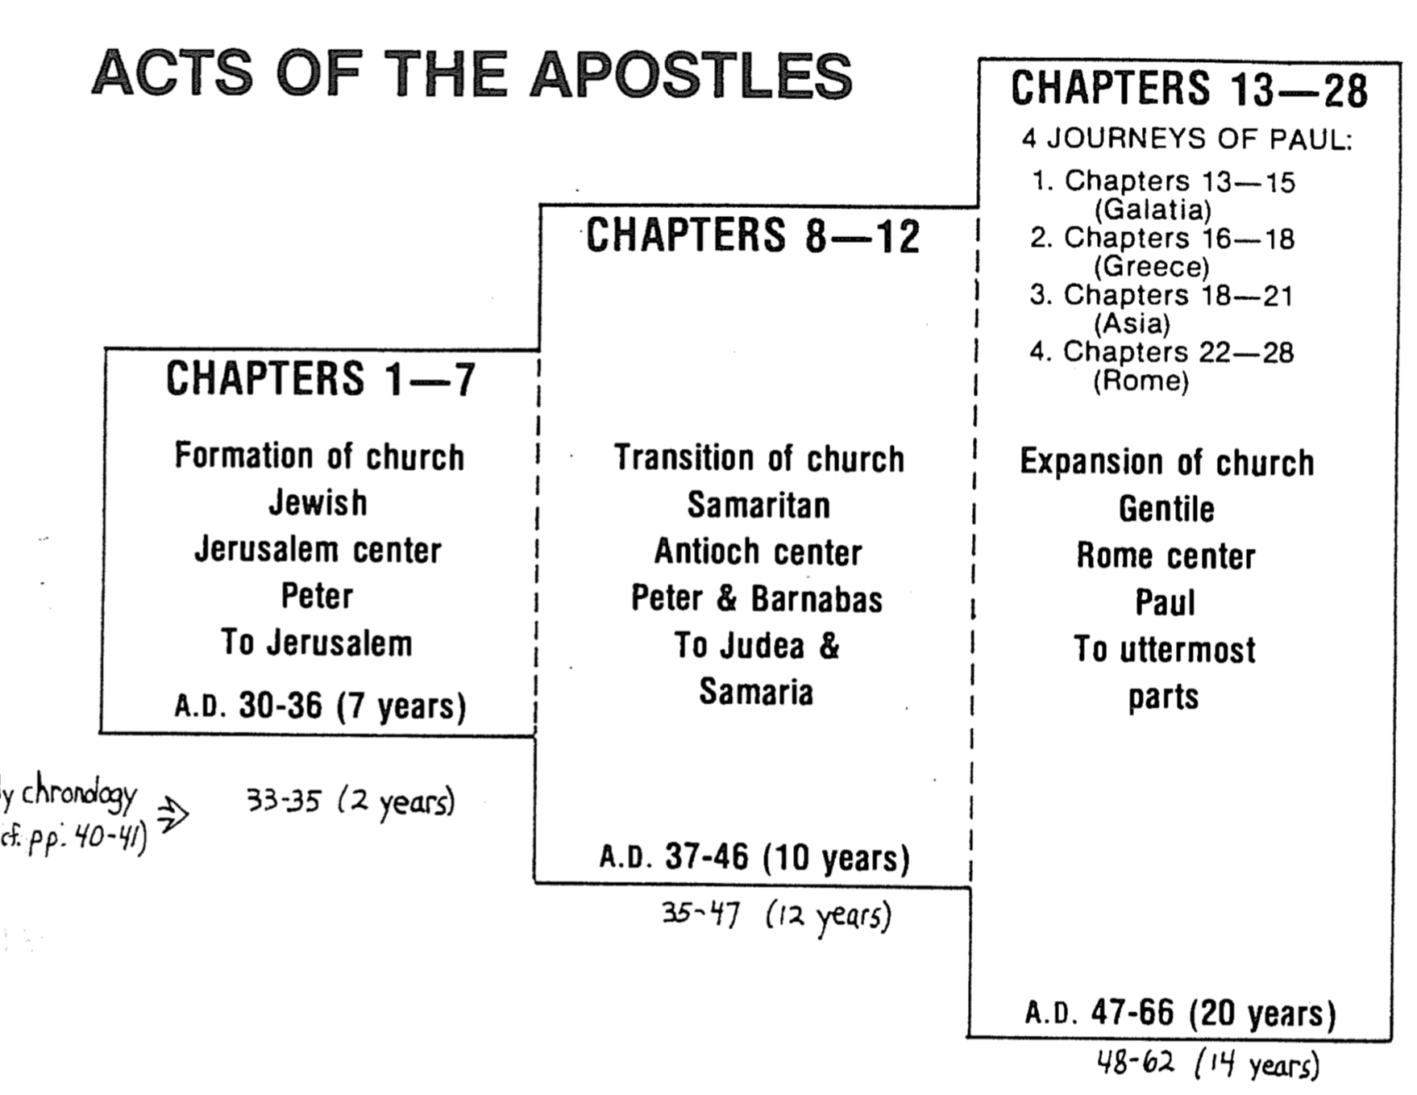
Chronology of the Book of Acts

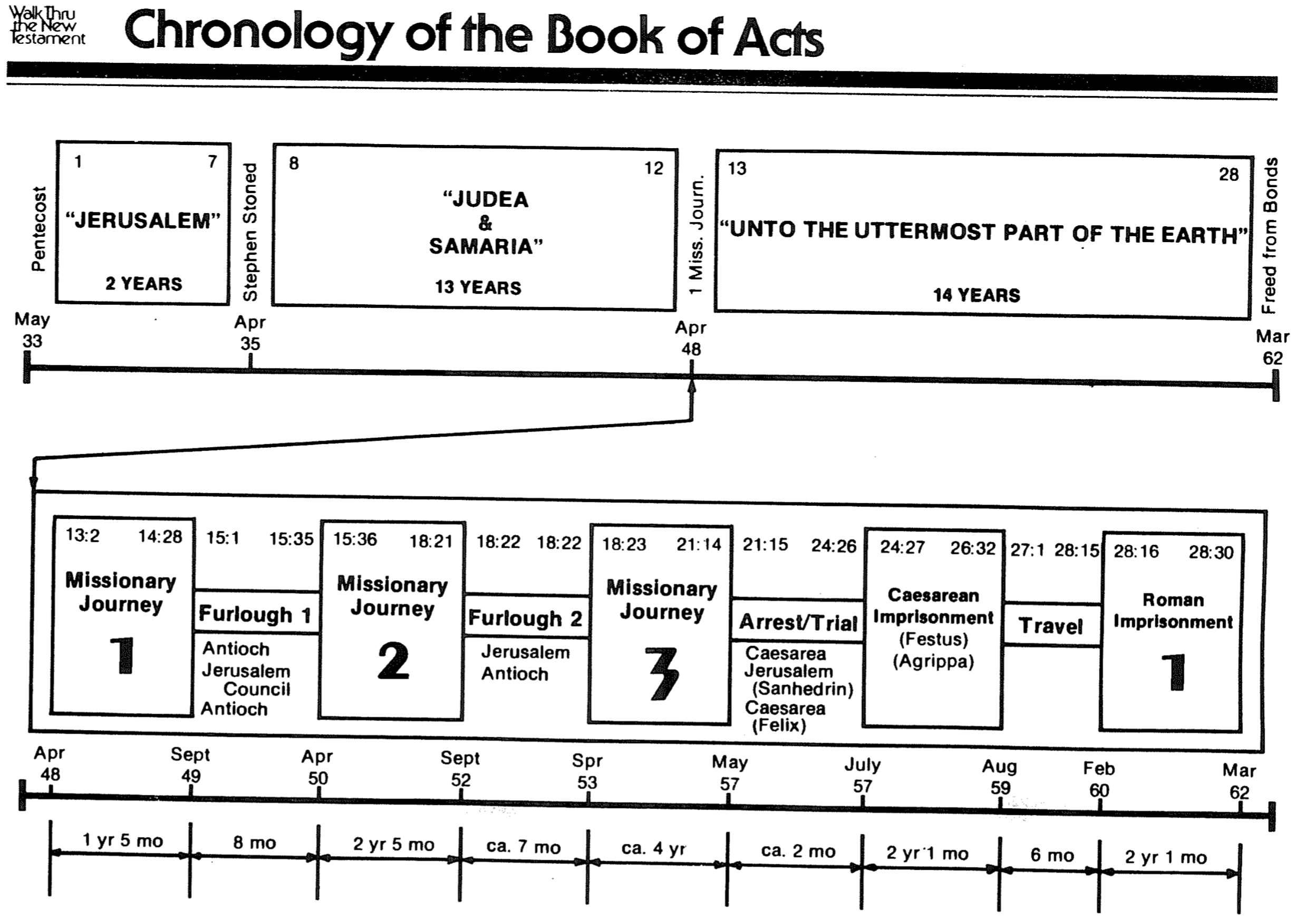

Questions on Acts 2

My friend Oliver sent me four questions that I attempted to answer below…

I have a question that was brought up during my Care Group's Bible study…

The question is the prophecy of Joel in Acts 2:17-21 (cf. Joel 2:28-32). We have the following points of which we are uncertain:

1. Who does "all mankind" in verse 17 refers to? All believers? Everybody, both believers and non-believers? Or the saved in the millennial kingdom?

Joel’s prophecy up to Joel 2:28 refers to the future time of judgment and restoration of Israel that we know also as Daniel’s seventieth week (cf. Dan. 9:27), or the seven-year Tribulation. “After” that time (2:28a), there will be a pouring out of the Spirit that the world has never seen when everyone will receive the Spirit regardless of sex (sons and daughters), age (young and old), or rank (even on my servants). Jeremiah spoke of the same time period that we know call the millennial age (cf. Rev. 20:1-6) when he said that everyone will know the Lord (Jer. 31:34). In other words, at the beginning of the millennium, every person on earth will believe in the Lord! Wow! Before Joel’s time the Spirit had come only on certain leaders to empower them for ministry—and that only for a limited time. But the Spirit indwelling now and in the future is eternal (John 14:16).

2. When does "those days" in verse 18 refers to? Pentecost and after? Or during the days when Christ returns?

Joel's prophecy details the coming of a "day of the LORD" which follows a recent locust invasion in Judah. The prophet's point is that while the people are concerned about the existence of their crops due to the locusts, even more serious "locusts" (eschatological armies) are coming which threaten the existence of their nation.

Then Joel declares that in the last days the LORD will pour out His Spirit on all flesh (all of Judah or all of the earth) so that young men will have dreams and old men see visions (2:28-32). This is a clear prophecy of the Holy Spirit’s coming and eschatological dimensions. In other words, deliverance in Joel’s time foreshadows deliverance in the end times.

When Peter and the apostles saw the coming of the Holy Spirit on the day of Pentecost, several unusual things also occurred. Each of the apostles praised God in new languages that could be understood by pilgrims to Jerusalem visiting at that time (e.g., from Pontus, Cappadocia, Rome, and other distant places). Further, tongues of fire appeared on their heads. With these new languages and strange fiery phenomena the accusation came that the apostles were drunk with wine. Peter refuted this claim by quoting Joel 2:28f. He declared that what they were witnessing was an actual fulfillment of Joel's prophecy of the giving of the Holy Spirit. This is clear in his designation, "This is that which was spoken…" (Acts 2:16) which leaves no question that the reception of the Spirit was what Joel had in mind.

However, Joel also prophesied strange events in the sky as well—the sun darkened and the moon turning blood red. Acts 2 records no such phenomena because the prophecy was left incomplete due to Israel’s unbelief. These certain elements are reserved for a future time when the nation will believe just prior to the return of Christ. (For a study of five views on this issue see Hobart Freeman, An Introduction to the OT Prophets, 154-56.)

But why does Peter apply this yet future event to his own age? This was because the Spirit was bestowed on all people even in his day, which announced that the “last days” had already arrived.

3. Does the "Day of the Lord" in verse 20 refer to the return of Christ?

The coming day of the LORD, a time of awesome judgment upon people who have rebelled against God, is the preeminent theme of Joel’s prophecy (1:15; 2:1, 11, 31; 3:14, 18). The day of the LORD theme pervades this prophecy perhaps more than any other with the possible exception of Zephaniah (e.g., Zeph. 1:14-18; chaps. 2–3) and finds mention throughout the Bible (cf. Amos 1:3–2:3; Zech. 12–14; Isa. 13:6, 9; 14:28-32; 17:1ff.; 20:1-6; 31:1-5; Jer. 46:10; Ezek. 30:3ff.; 1 Thess. 5:2, 4; 2 Thess. 2:2; 2 Pet. 3:10). Joel mentions this “day” several times (1:15; 2:1-2, 11, 31; 3:14, 18), indicating that it actually refers to a time period that “is to be a day of wrath and judgment upon the wicked and a day of salvation to the righteous” (Hobart E. Freeman, An Introduction to the OT Prophets, 146).

So the “glorious day of the Lord” noted here seems to refer to the latter part of this “day.” In other words, after the sun turns dark and moon turns red (during the judgment part of the “Day”) then the “great and glorious day…” will arrive when Christ rules.

4. Was the prophecy of Joel 2:28-32 fulfilled at the day of Pentecost or will it be fulfilled when Christ returns?

When is this day? The mention of apocalyptic phenomena such as wonders in the heavens (i.e., the sun being turned to darkness and the moon to blood; 3:20-21) indicate that while to some extent near judgment would strike Judah for disobedience, the ultimate judgment would befall the nation at Christ’s second advent (cf. Matt. 24:29-30). However, this will not just be a day of wrath upon the unbelieving but of blessing as well for the righteous (Joel 2:32; Zech. 14; Zeph. 3:8-20; Isa. 2, 11; 65–66; Amos 9:11-15; Ezek. 20:33-44, etc.; idem., 147). I think that Pentecost only put in place the events that will culminate at the return of Christ. Therefore, we have a partial fulfillment during Peter’s time but the full fulfillment will occur at Christ’s return.

I trust I didn’t confuse you more! Good questions!

Still learning with you,

Rick

Church Planting in Acts & Church History

Definitions

Acts 2 records how the Church began on the day of Pentecost in fulfillment of Acts 1:8, where Christ promised that witnesses will begin in Jerusalem and expand from there.

However, is it true that, following this first church plant, “churches should always be planted by other churches”? Was this true even in the book of Acts?

How Churches Began in Acts

Ethiopia saw its first church planted not by another church but by Philip, whom God used to share the gospel to one of Ethiopia’s highest officials (Acts 8:26-40). The church tradition in Ethiopia is that this official brought Christianity back to his nation.

Damascus had one of the first churches outside Jerusalem (9:19b). Did the Jerusalem church plant the Damascus church? Paul reached both Jews and Gentiles there (Gal. 2:11-16) but he had to defend himself before the Jerusalem church (9:26). The best we can tell is that it was the persecution in Jerusalem—not a church plant—that thrust out the disciples into places such as Damascus (Acts 8:1).

Antioch remains a superb example of a local church sending out missionaries like Paul and Barnabas into the harvest to plant churches (13:1-3). This support was not consistent, however, which resulted in Paul needing to support himself as a tentmaker while Corinth (Acts 18:3). One wonders whether it can accurately be said that the Antioch church really planted the church at Corinth.

Colossae and the other Asia Minor churches began in a way that is unknown to scholars. The best guess as to their origin is from Paul’s daily teaching at the school of Tyrannus in Ephesus. “This went on for two years, so that all the Jews and Greeks who lived in the province of Asia heard the word of the Lord” (19:10). While we may wish that the church of Ephesus planted these churches, such was not the case.

Rome also baffles experts of early church history. Paul wrote the Romans in AD 56 to an established church, yet no one knows how it started. Catholics claim Peter started it, but we have no evidence of Peter arriving in Rome until the AD 60s. Our best guess is that Jews who trusted Christ on the day of Pentecost brought the gospel back to Rome, as we know that some from Rome attended this important gathering (2:10b).

How Churches Began in Church History

European Christians who migrated to America in the 1600s were not sent by their churches at home in England and other European nations. Nevertheless, they still came, thrust out in large measure by Anglicans and other state churches that persecuted rather than supported them!

The modern missionary movement from Europe began in 1792 when William Carey left England for India. His own church refused to send him, so he established the first missionary society.

J. Hudson Taylor initially entered China backed by British churches. However, when his senders insisted that he stay in the coastal areas in missionary compounds and wear western dress, God called him otherwise. He moved inland and established the China Inland Mission. CIM missionaries were viewed as “renegade” since they adopted Chinese dress and integrated into society. However, this began a movement that lasts to this day in millions of Chinese believers, though it was not initiated by the local churches of Hudson Taylor’s day.

History records that Jesus Christ Himself built His church throughout the centuries, according to His promise (Matt. 16:18). Often He did this through the faithfulness of local churches that saw their responsibility to establish new congregations. However, as in the book of Acts, he continued to call individuals to faithfulness in establishing churches when their institutions failed to catch this vision.

Do You Agree or Disagree?
To explore your own ideas on this vital subject, please mark as A, U, or D beside each statement below to show whether you Agree, are Unsure, or Disagree with the teaching.

Other churches always planted churches in the book of Acts.

Other churches always planted churches in church history.

The only way to plant churches today is for churches to plant other churches.

Conclusion

God desires that churches plant other churches. But is this the only way that he works? Both in the book of Acts and throughout church history, churches often failed in this role. At these times, God raised up individuals who shared His heart with the lost, resulting in the establishment of new congregations.

This subject causes one to reconsider the identity of the bride of Christ. Is His “bride” the local church? If so, Jesus has many brides. The bride of Christ is His universal church that he washed, sanctified, and will present to Himself at his return (Eph. 5). Christ is adorning and expanding this bride through numerous strategies of church planting.

Contrary to popular belief, Scripture does not command church planting. The Great Commission is to make disciples—not to plant churches (Matt. 28:18-20). I believe in church planting and am involved in this endeavor myself with a church planting mission board and in my helping establish Crossroads International Church in Singapore. Disciple-making best occurs in the context of the local church, but God brings into being these local assemblies in a variety of ways—sometimes through faithful churches, but other times through His faithful individuals who obey God’s voice even when their institutions neglect to respond to the Spirit’s promptings.

Permanent or Temporary?
Ralph Covell & Marshall Shelly, Wherever magazine (Spring 1982)

How Do We Know Whether a Bible Passage Is “Culturally Conditioned”?
Dr. Roy Zuck, unpublished class handout, “Hermeneutics & Bible Study Methods”
(Dallas Theological Seminary, 1983)

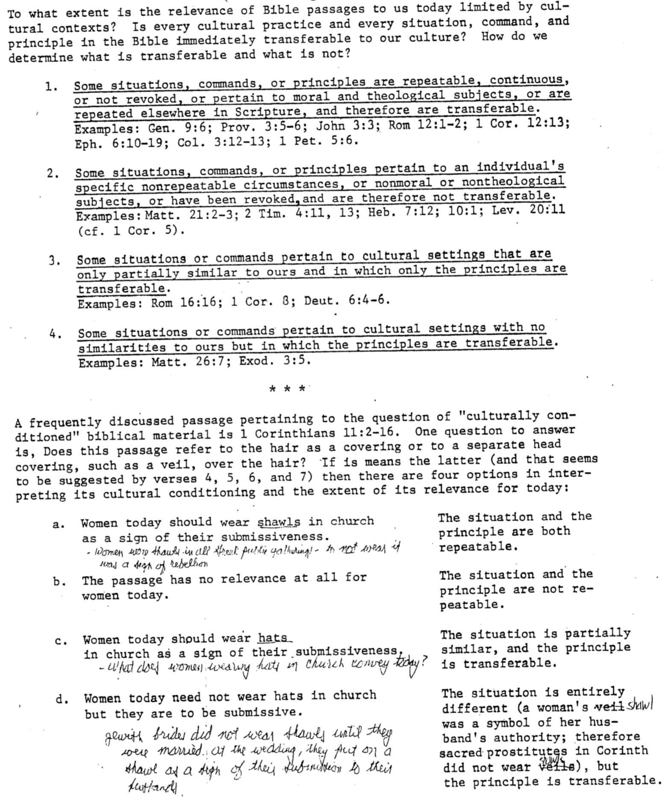

Pentecost Countries & Damascus
Bible Visual Resource Book, 215

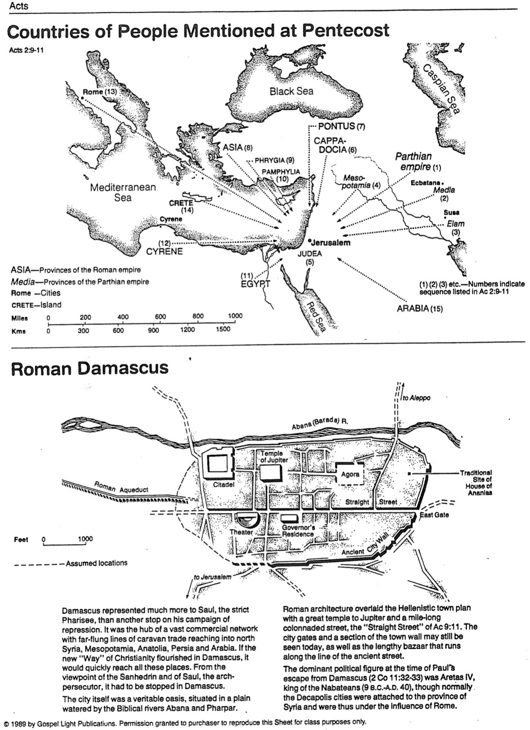
Philip’s and Peter’s Missionary Journeys
Bible Visual Resource Book, 223

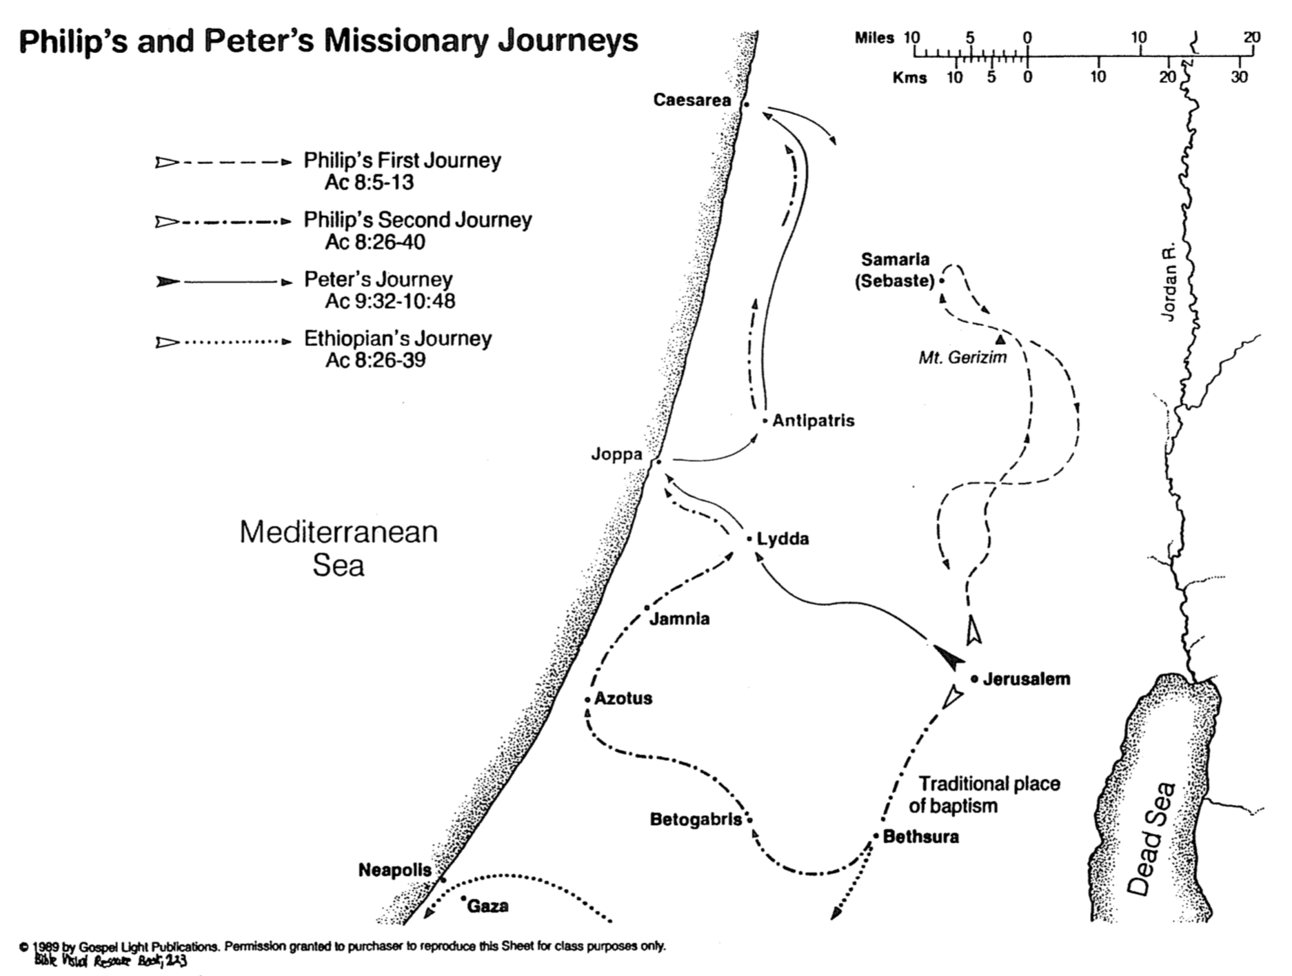

The Spread of the Gospel
Bible Visual Resource Book, 217
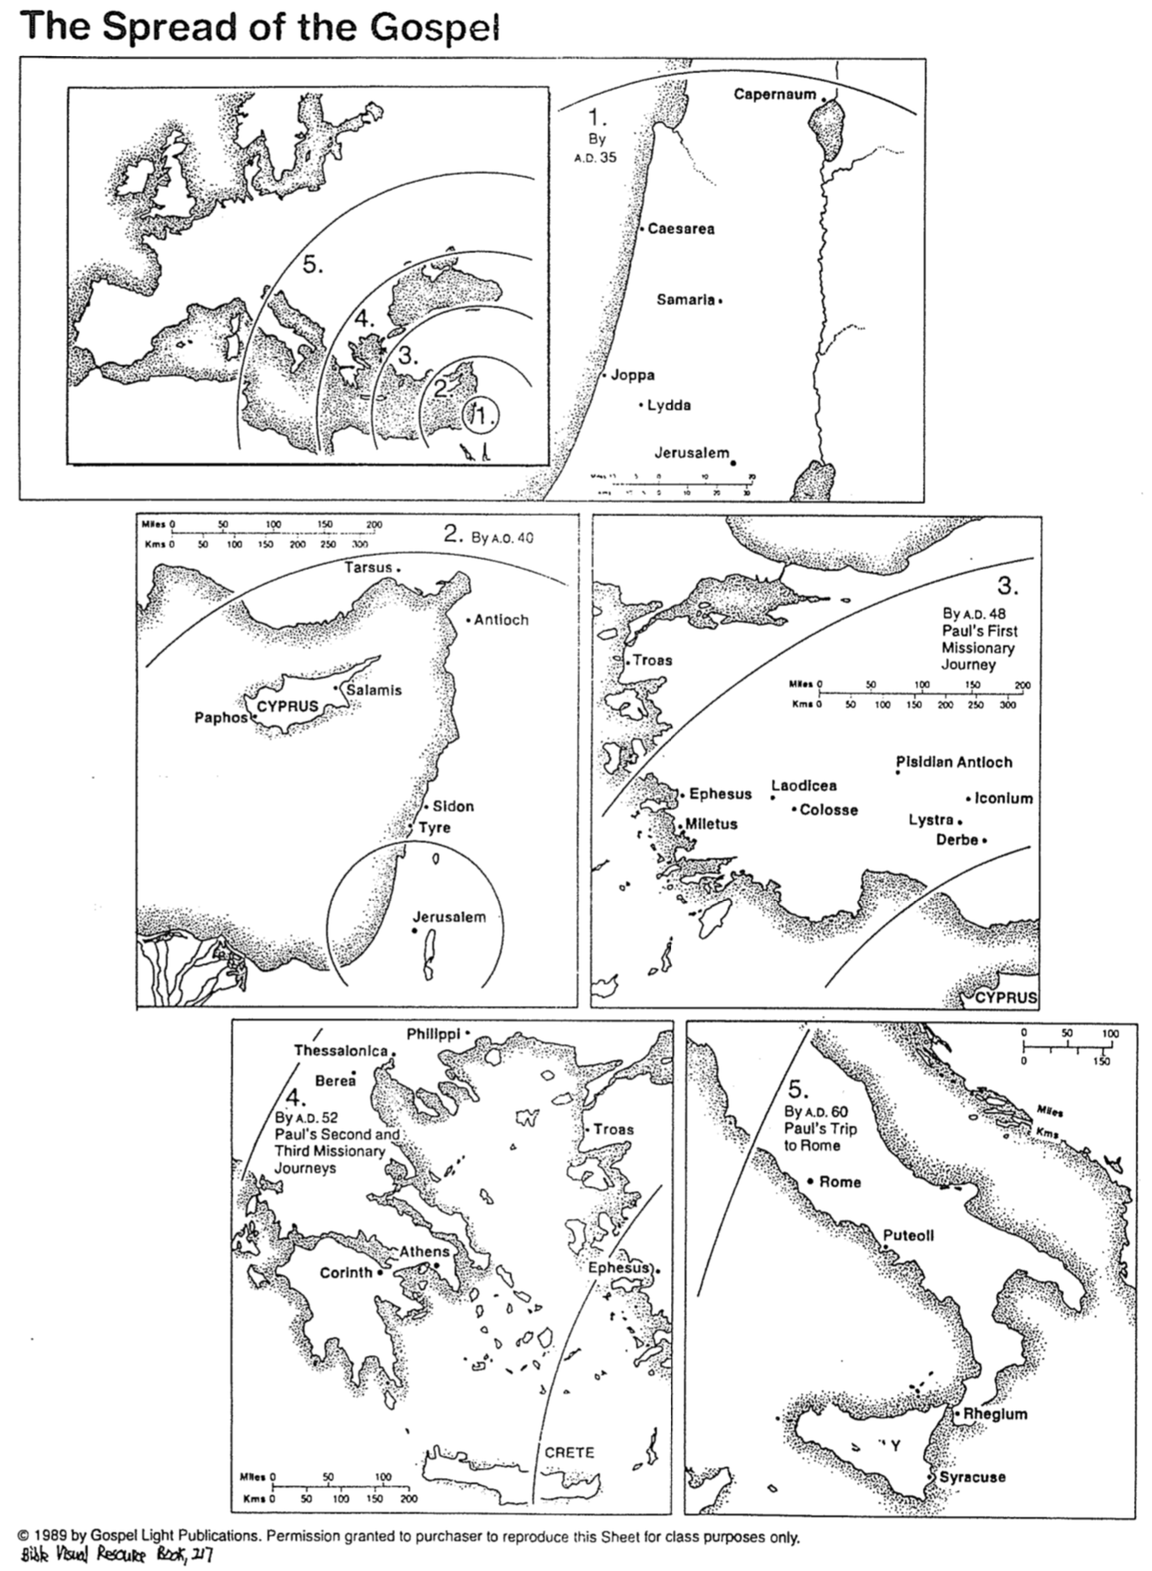

Two Important Issues in Acts
Dr. Walter Steitz, East Asia School of Theology (Singapore, 2005)

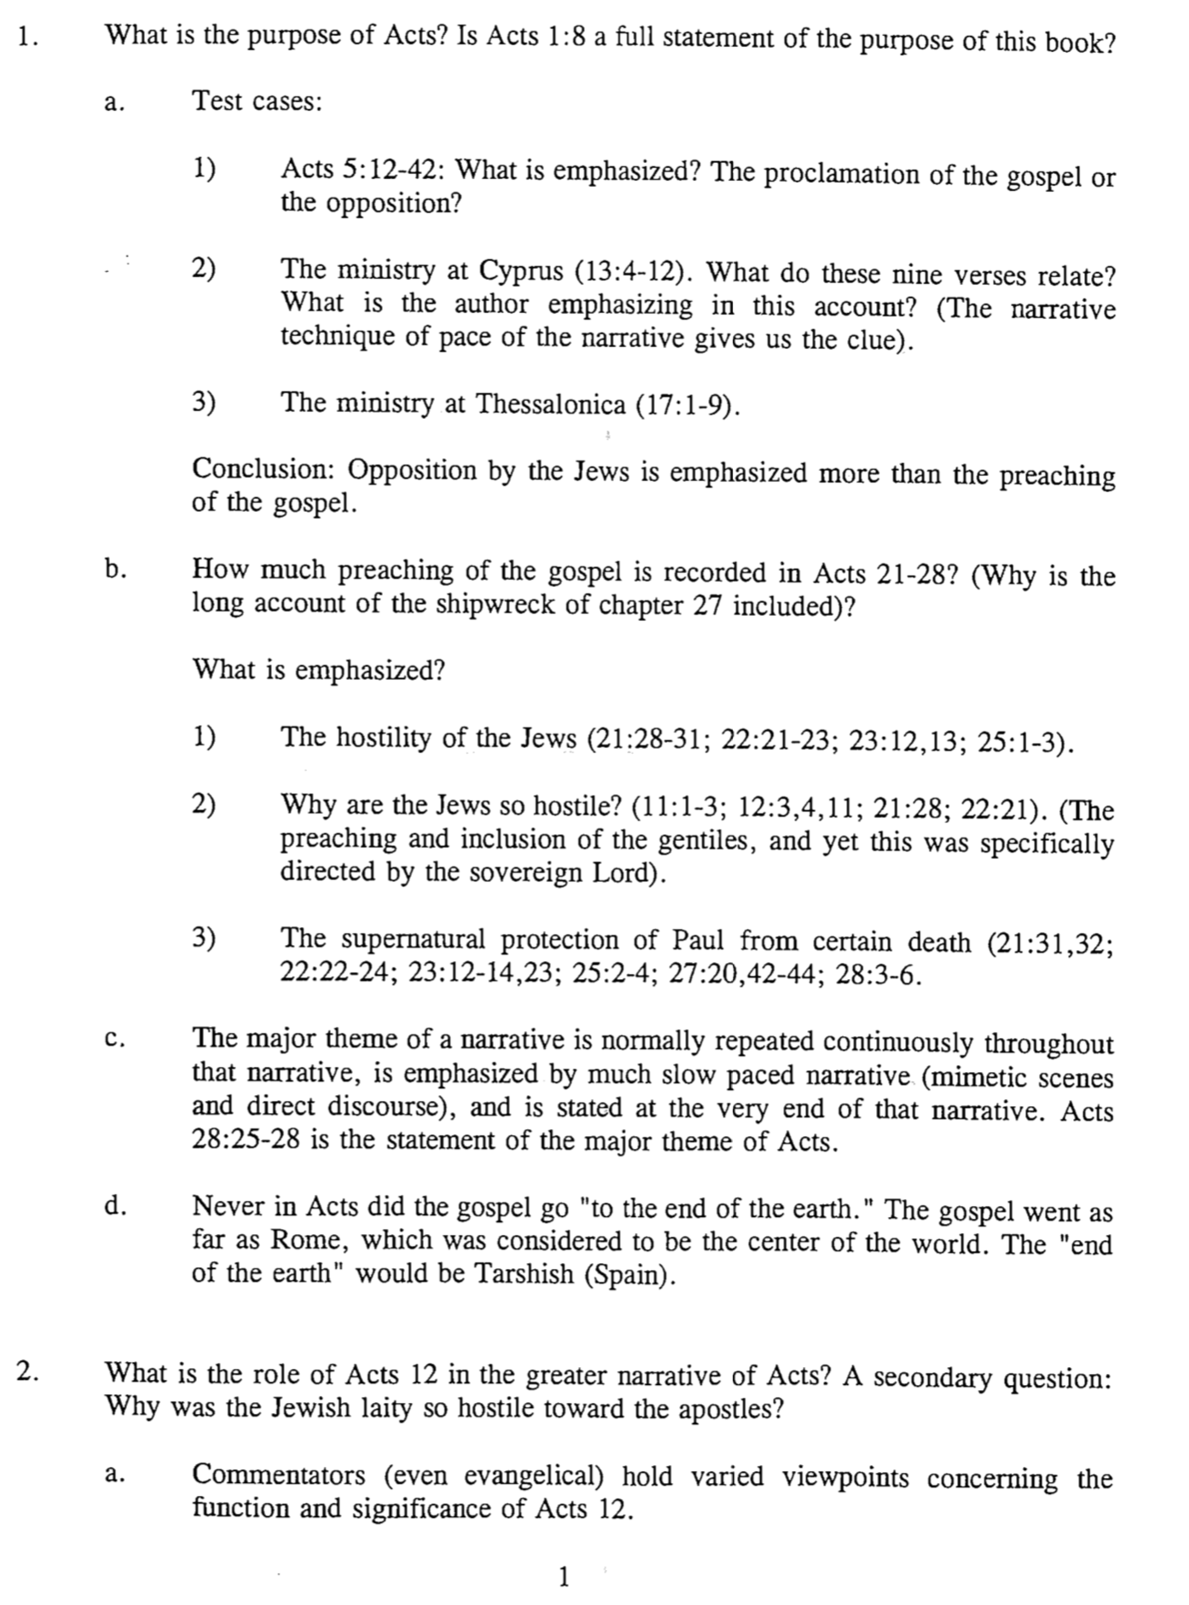

Two Important Issues in Acts (2 of 2)
Dr. Walter Steitz, East Asia School of Theology (Singapore, 2003)

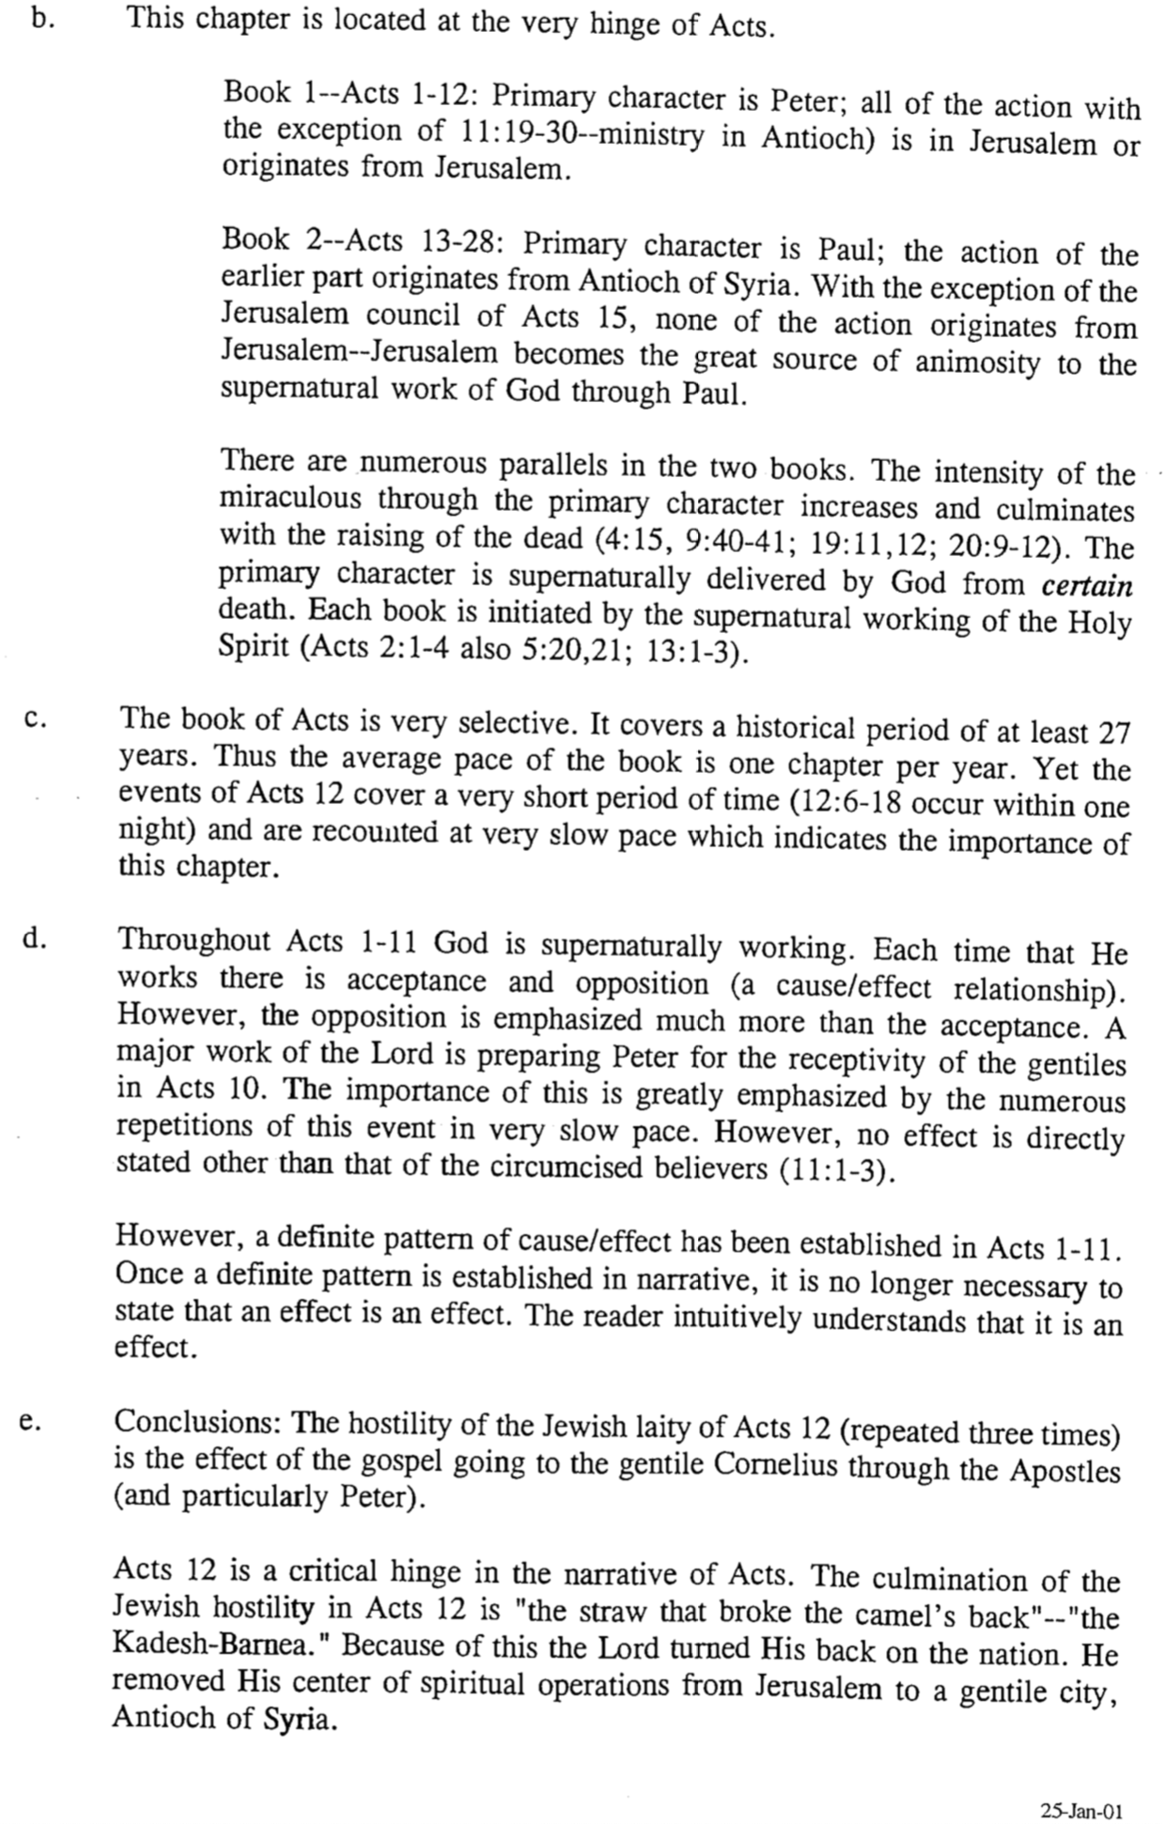

The Subject-Complement of Acts
Dr. Walter Steitz, East Asia School of Theology (Singapore, 2003)

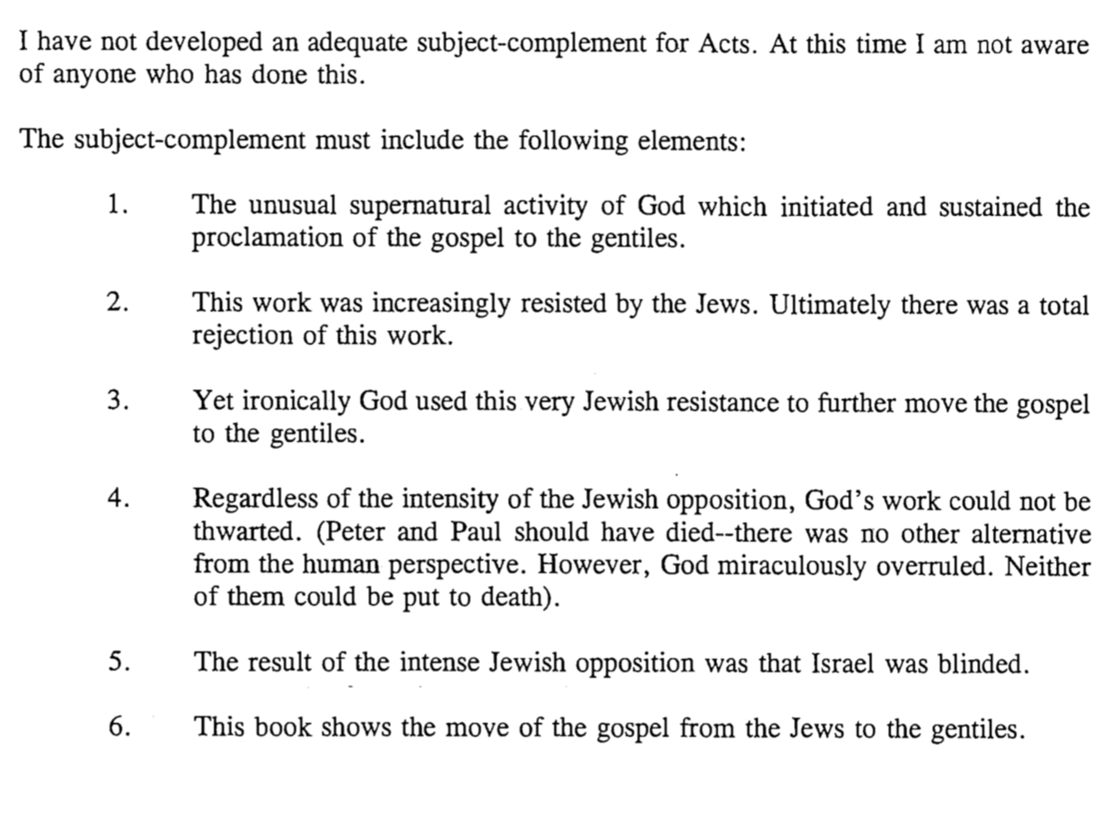

Saul and Paul

Probably one of the most dramatic conversions in the early church was that of Saul of Tarsus, who became Paul, the best missionary in the first century. God often takes persons of great passion like Saul and breaks them to use in his service. Notice the differences between the “two men”:

 | Saul | Paul
Meaning of Name | “to demand” | “little”
Citizenship | Roman citizen & Jew | Same—could preach in either Greek or Hebrew
Title | Pharisee, rabbi (orthodox) | Apostle, servant of Jesus Christ (orthodox)
Trainer/Place | Gamaliel in Jerusalem (22:3) | God in Arabia & Damascus  (Gal. 1:17)
Style of Education | Formal | Informal
Passion | Zealous for the Law (Phil. 3:5-6) | Zealous for Grace
Defended | Judaism | Christianity
Teaching Audience | Jews alone | Mostly Gentiles
Demeanor | Killed Christians (22:4) | Blessed all (23:1)
Opponents | Fought “heresy” called Christianity | Fought heresies of Judaizers, mystery religions, Stoics, Epicureans, etc.
Prayer | Others prayed for him (7:60–8:1) | He prayed for others
Oral Law | Authoritative 613 commands  (248 positive + 365 negative) | Matter of conscience (Rom. 14:1–15:13)

Do you know anyone who is so opposed to Christ that it seems impossible to envision that person as a Christian? I hope not after seeing Paul’s background! 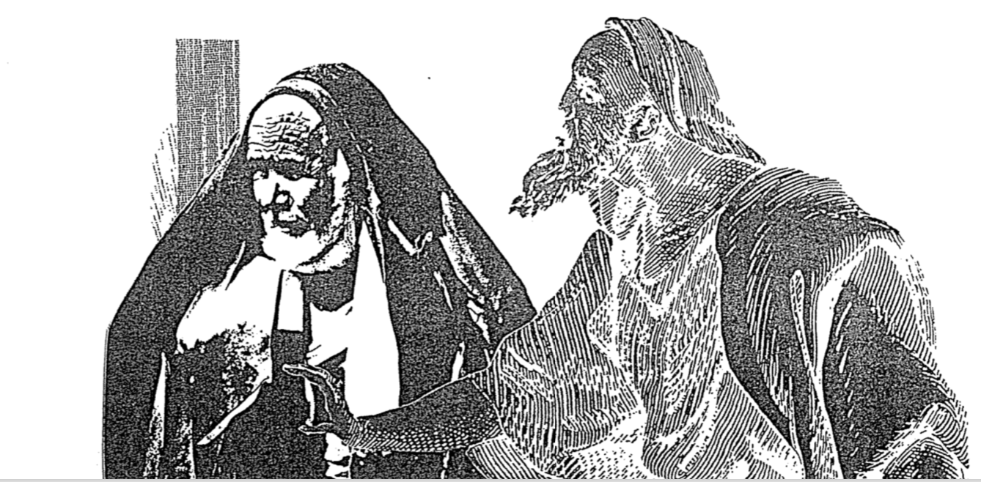

The Use of Amos 9 in Acts 15
Stanley D. Toussaint, “Acts,” in The Bible Knowledge Commentary, 2:394-95

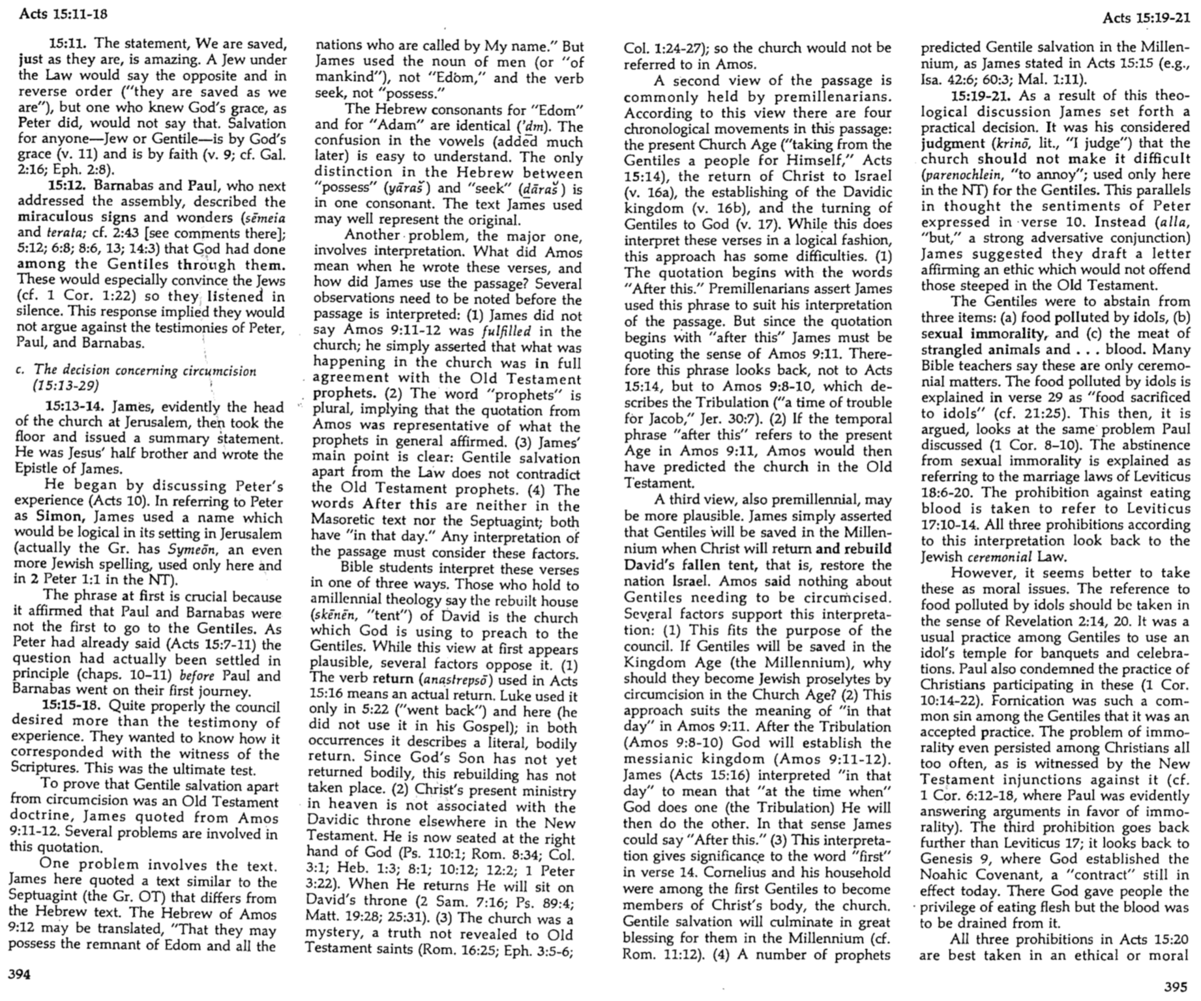

Interpreting Acts
How Does Luke Teach Theology Through His Narrative?
Dr. Tim Wiarda, Singapore Bible College (February 2005)

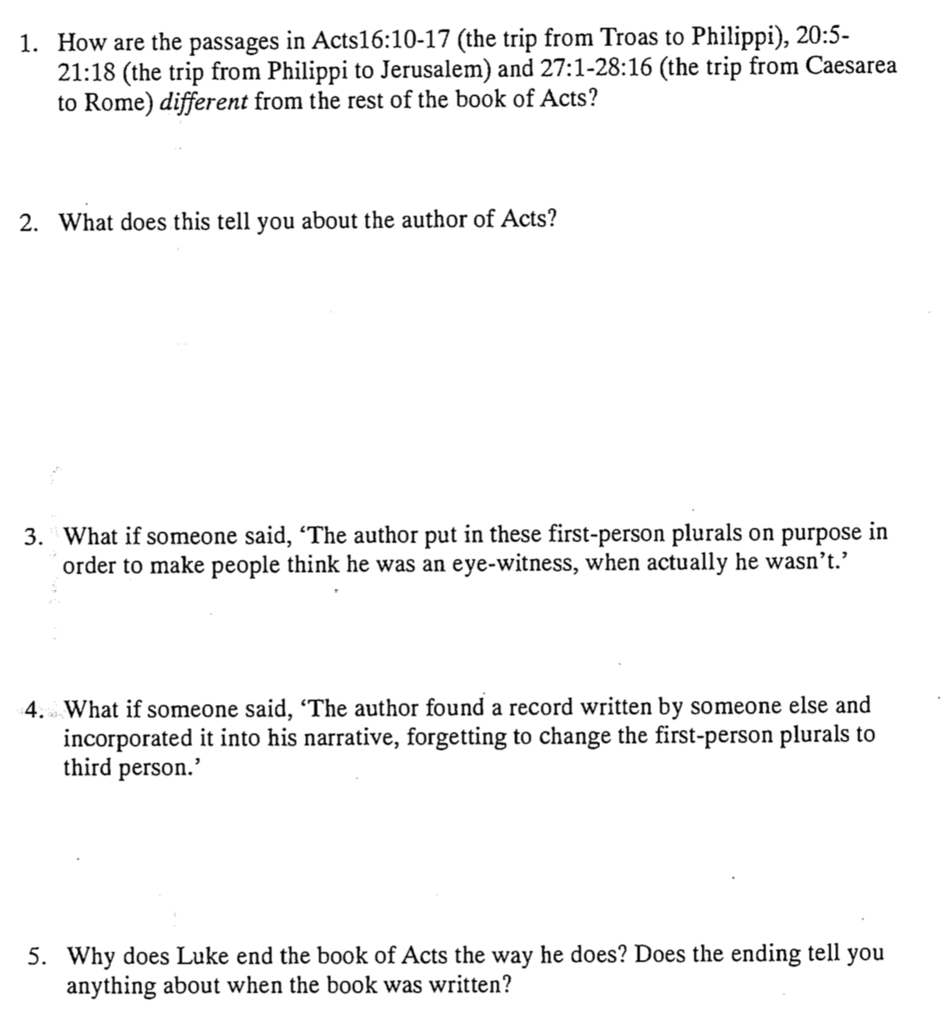

Interpreting Acts
How Does Luke Including Himself in Certain Accounts Affect the Theology?
Dr. Tim Wiarda, Singapore Bible College (February 2005) Page 2 of 2

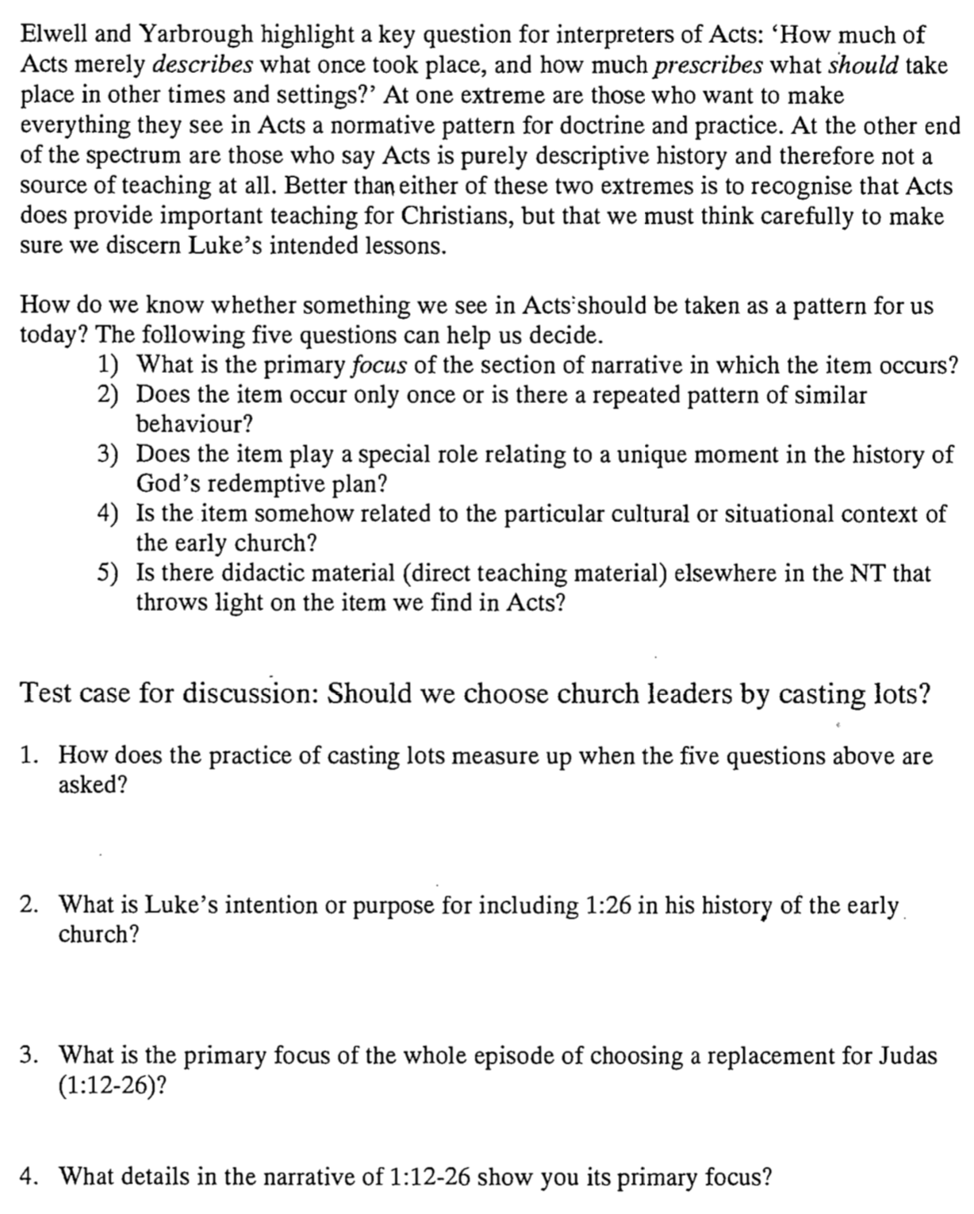

The Land of Acts and Letters Compared with the USA
Terry Hall, Bible Panorama, 144

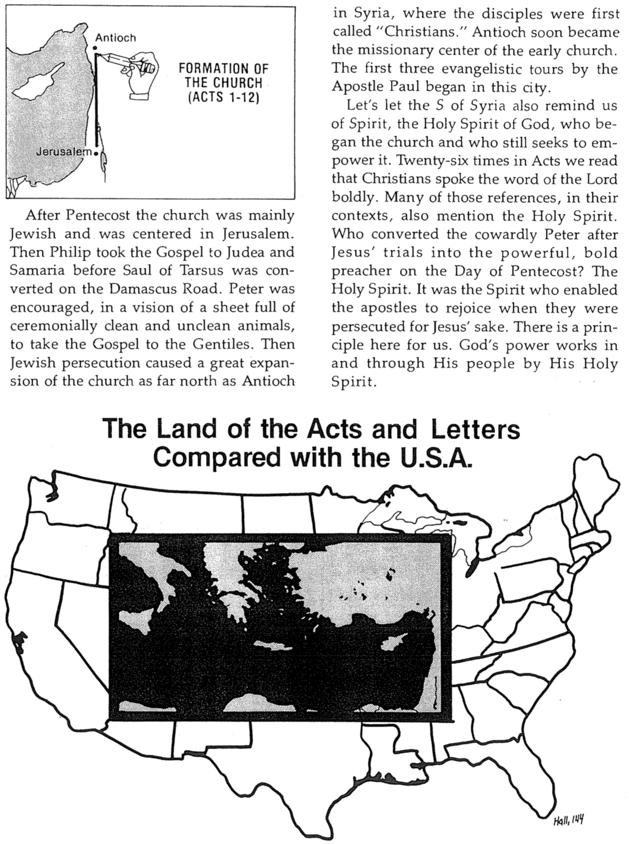
Sermons in the Book of Acts

Acts has numerous, abbreviated sermons. In fact, 24 of the 28 chapters include a sermon or sermon portion. This study contrasts three key sermons to discover some of the clues as to what made them so effective.

 | Acts 2:14-39 | Acts 13:16-41 | Acts 17:21-31
Speaker | Peter | Paul | Paul
Audience | Jews | Jews and God-fearing Gentiles | Pagan Gentiles
City | Jerusalem | Antioch | Athens
Place | House (v. 2) at the Temple (Luke 24:53)? | Synagogue | Aeropause Meeting
Type of Place | Religious | Religious | Secular
Time | Day of Pentecost | 1st Missionary Journey | 2nd Missionary Journey
Subject (theme) | The reason some Jews miraculously speak unknown languages | The fulfillment of Israel’s national history | The activities of the unknown God
Complement | is because God’s Spirit is poured out on them through Jesus, Israel’s resurrected Messiah | is in Jesus as our risen Savior who is worthy of our trust | are creation and judgment of man which makes idolatry unreasonable
Short MI | Jesus is Messiah (36) | Believe in Jesus (39) | Repent of idolatry (30)
Application Structure | Simple—application at the end (38-39) | Cyclical—application in centre (26) & end (38-41) | Simple—application at the end (30-31)
Main Idea Structure | Inductive (36) | Inductive (23)-Deductive (24-37) | Deductive (24)
Type | Topical-Biblical | Expositional | Topical-Secular
Style | Extemporaneous | Narrative | Reasoned polemic
Introduction  “Ho Hum!”  (How he gets attention) | Cites a recent event: Spirit baptism (14-15) | Tells a familiar story: Identifies with listeners by citing common history (16-22) | Notes local interest item: altar to an unknown god (22-23)
Thrust of Introduction | “Why do you think these people appear drunk?” | “I am an informed Jew who also has longed for the Messiah” | “I have been observing your town”
How the Speaker Draws in His Listeners | Raises curiosity about the miraculous speaking in other languages | Raises curiosity about how his Judaism differs from theirs | Raises curiosity about who the unknown God is
Body | “The Spirit descended from the risen Messiah Jesus” (16-36) | “Jesus is Israel’s risen Messiah” (23-37) | “Idolatry is incompatible with the living creator God” (24-28)
Illustration Sources | Scripture (Joel 2:28-32; Ps. 16:8-11; 110:1) | Scripture (Ps. 2:7; 16:10; Isa. 55:3; Hab. 1:5) | Secular (v. 28: poets Epimenides & Aratus)
Resurrection of Christ Noted | Extensive with scriptural support (24-32) | Extensive with scriptural support (30-37) | Brief & no mention of Jesus’ name (31)
Conclusion | Main Idea: Jesus is the Messiah (36) | Scripture: Habakkuk 1:5 quoted: “I will do something that you won’t believe” (41) | Burning questions: “Who will judge us?” and “Who is it who was raised?” (31)
Application | Indirect: Implications left to them: “How can we be saved?” (37) | Direct: “Forgiveness is offered to you” so “don’t be scoffers” (38, 40) | Direct: God “commands all people everywhere to repent [of idolatry]” (30)
Result | 3000 saved (41) | Invited to speak again, some believed, he turned to Gentiles (42-48) | Many believed but others sneered (32-34)

The Kerygma* of the Early Church
H. Wayne House, Chronological Charts of the NT

* Kerygma (Gr. kh,rugma) is a noun that means “what is preached, message, proclamation.”

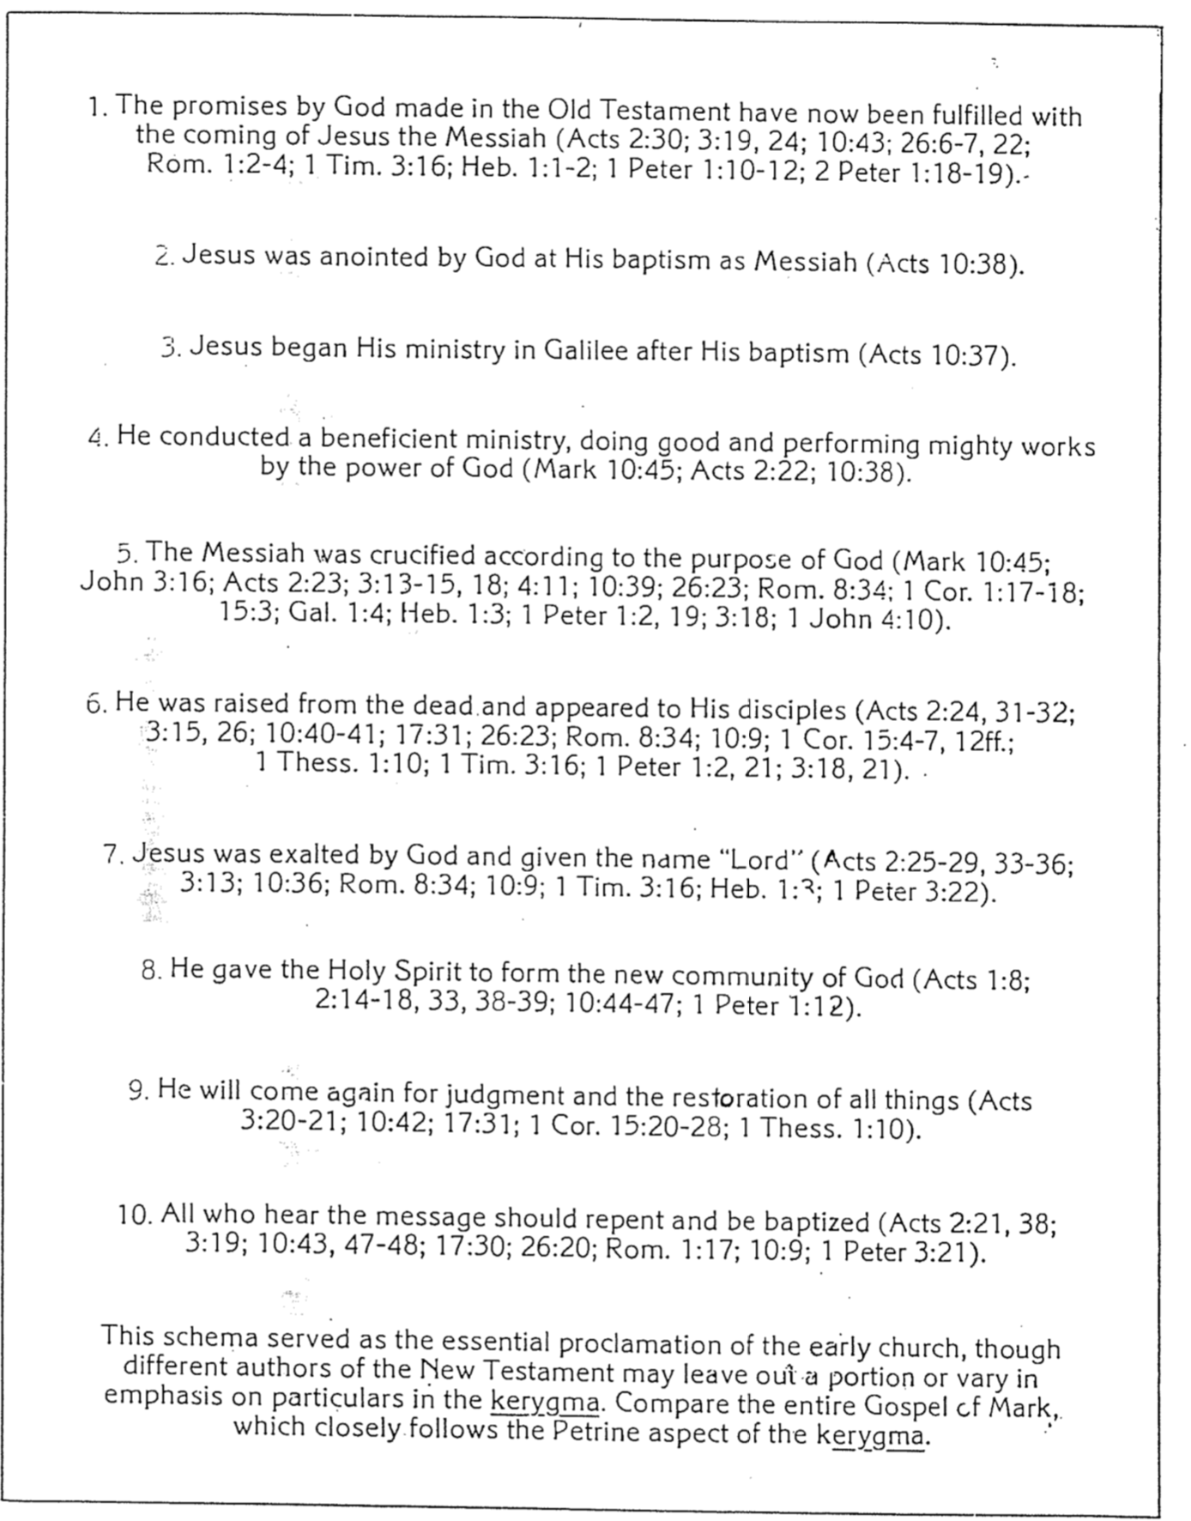
Key Characters in the A.D. Video

Religious life was complex during the time Paul wrote his epistles. Probably the most extreme differences came in the contrast between Roman religion and Judaism (and those Jews who had embraced Christ as Messiah). The conflicts are well portrayed in the film viewed in class entitled “A.D.” This 12-hour Vincenzo LaBella production cost US$30 million to produce and was filmed on location in Tunisia, Pompeii, Herculaneum, and Rome. It was broadcast in the USA during the 1984-85 television season. Gospel Films, Inc. (PO Box 455; Muskegon, Michigan 49443-0455) edited the version seen in class to a 6-hour series that I purchased from Christian Book Distributors (www.christianbook.com). The following characterizations are taken from the study guide that accompanies this 3-tape set on pages 7-9.

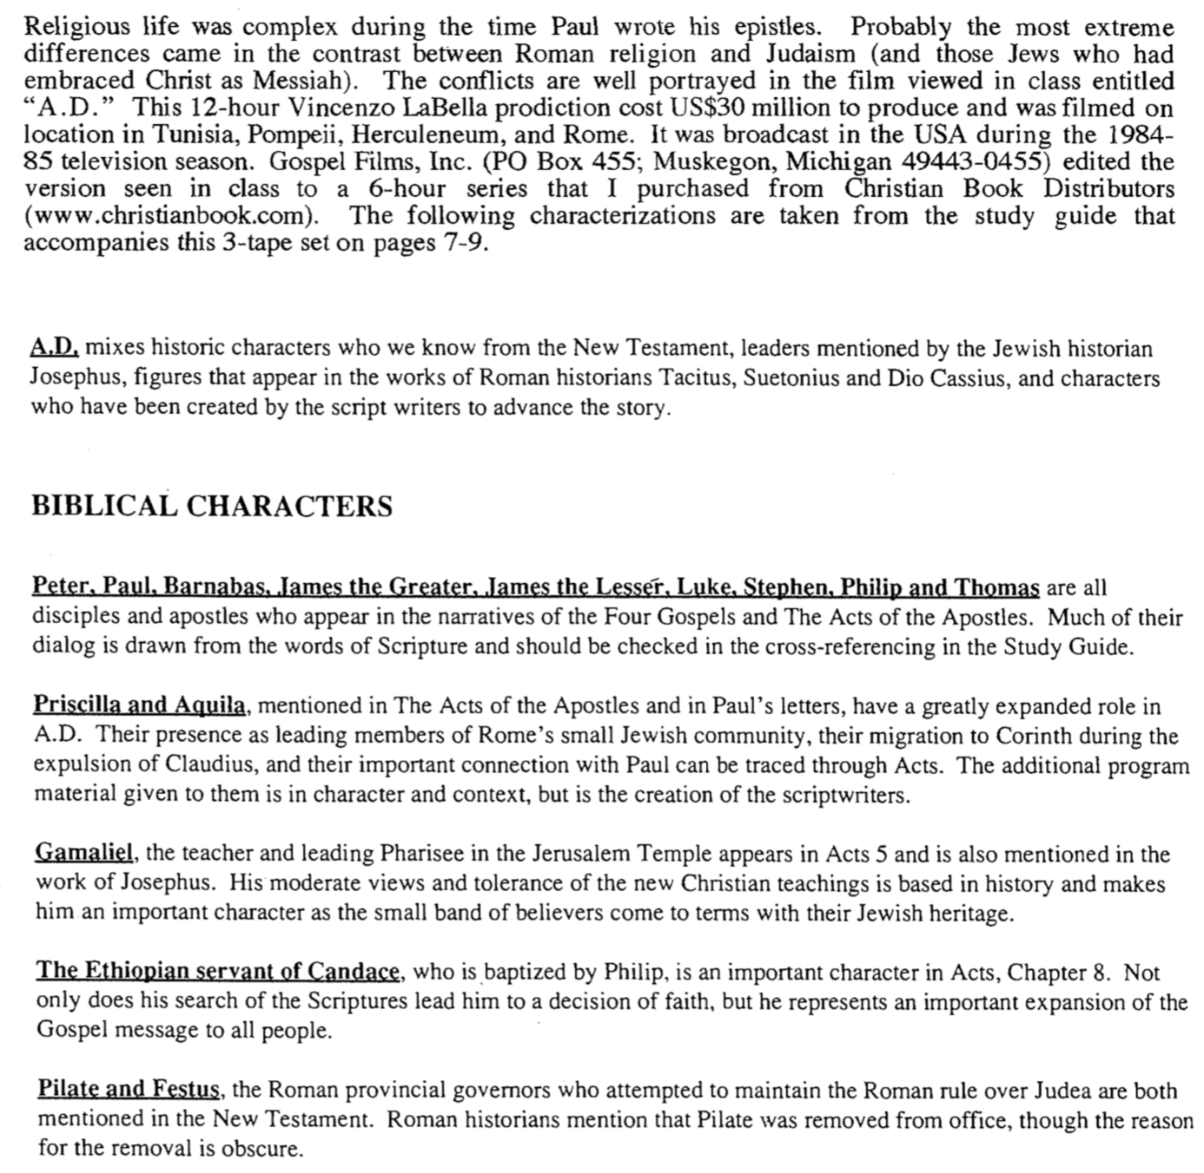

Thought Questions:

1—Contrast the reactions of Nero and his advisor with that of the senators and common people on the burning of Rome.

2—What are your feelings and thoughts about the Christians dying in the arena?

3—Valerius states after seeing the slaughter of Christians, “I am not a Roman soldier anymore. I will not serve a butcher and a pack of wolves… I renounce my rank. I renege my service to the Emperor, this city!” How did hearing this strike you? Have you ever heard something similar in your own experience or that of others?

Key Characters in the A.D. Video (2 of 2)

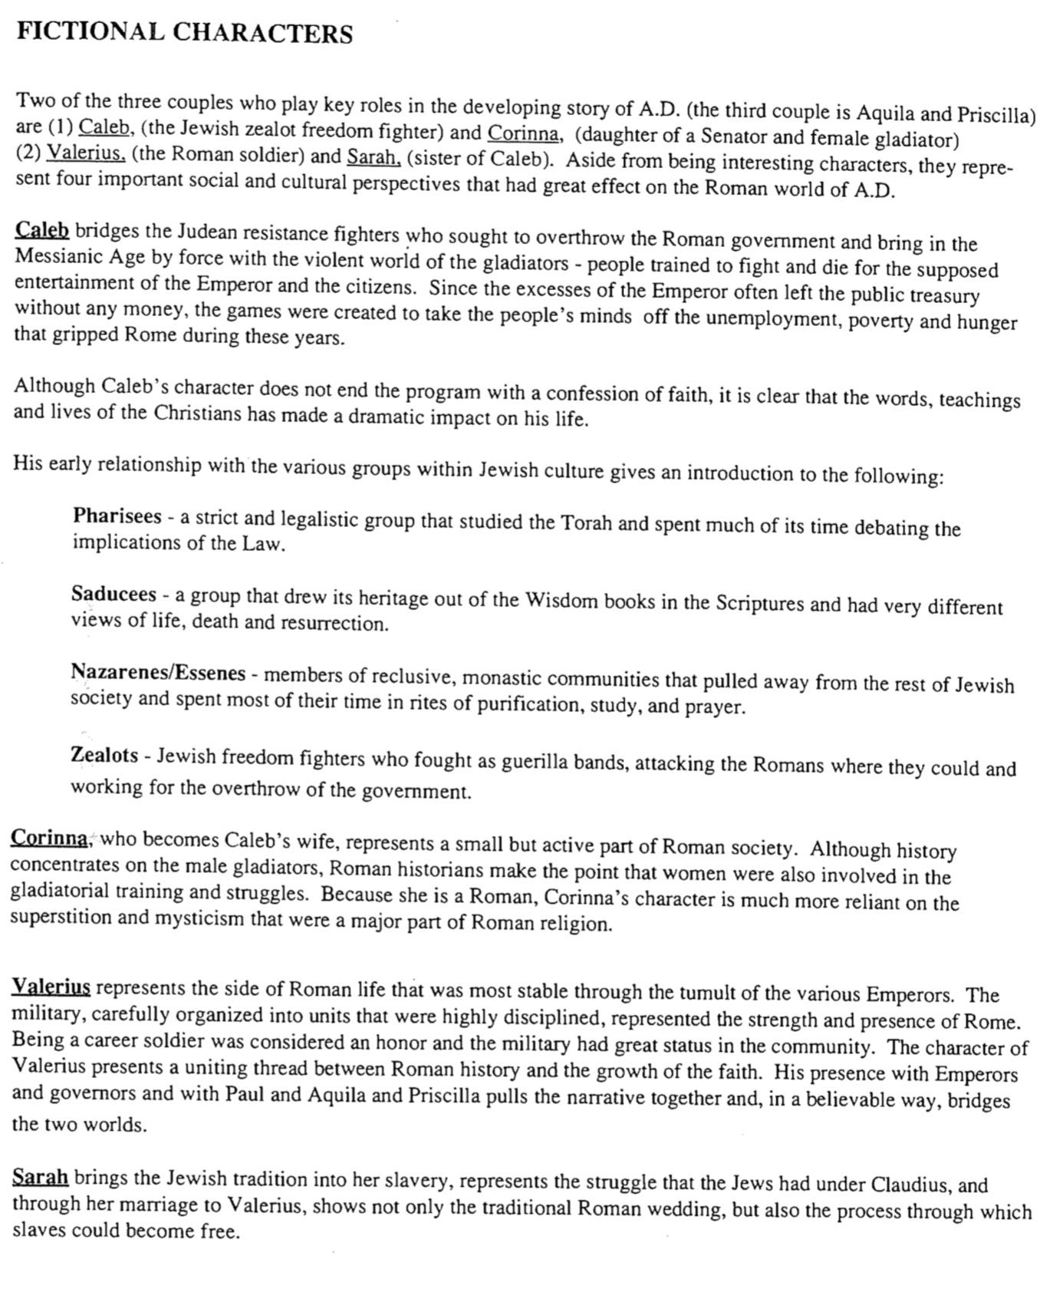

Paul’s First Missionary Journey

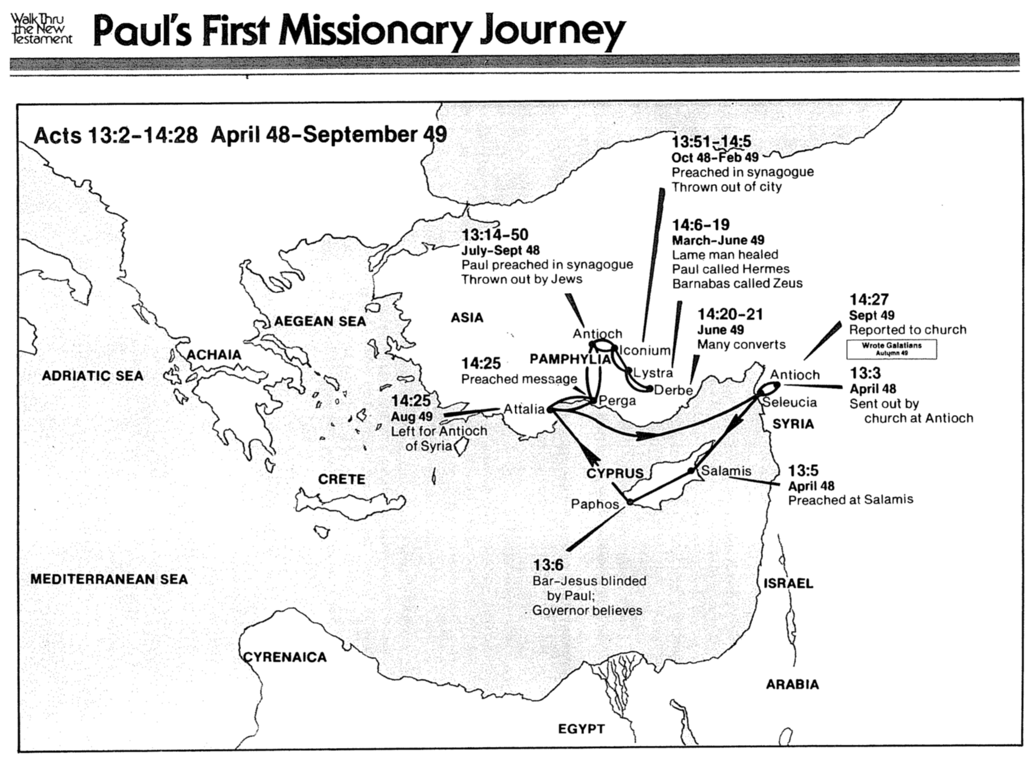
Paul’s Second Missionary Journey
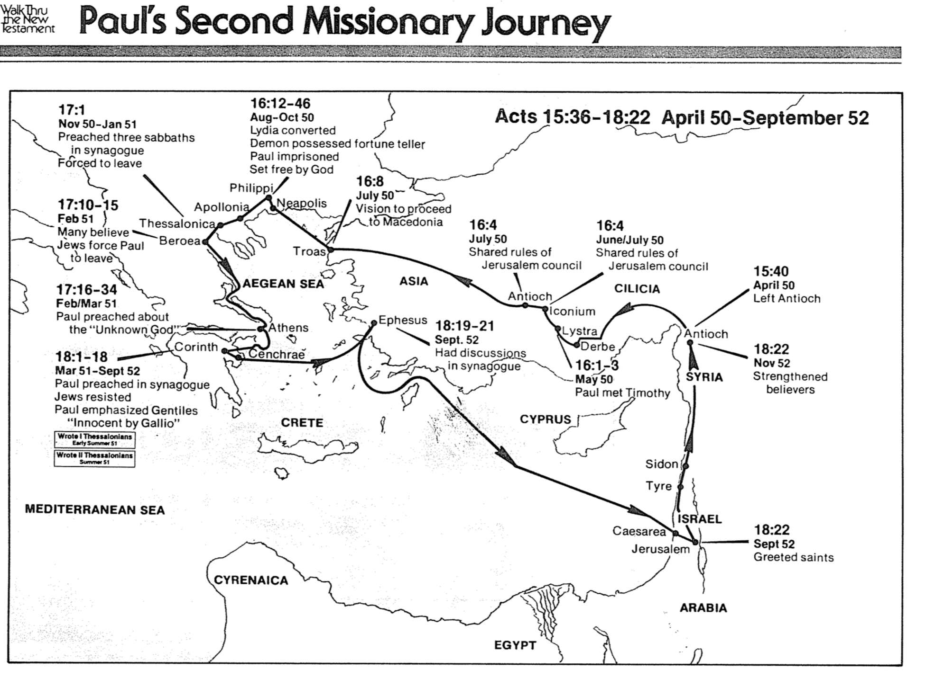
Paul’s Third Missionary Journey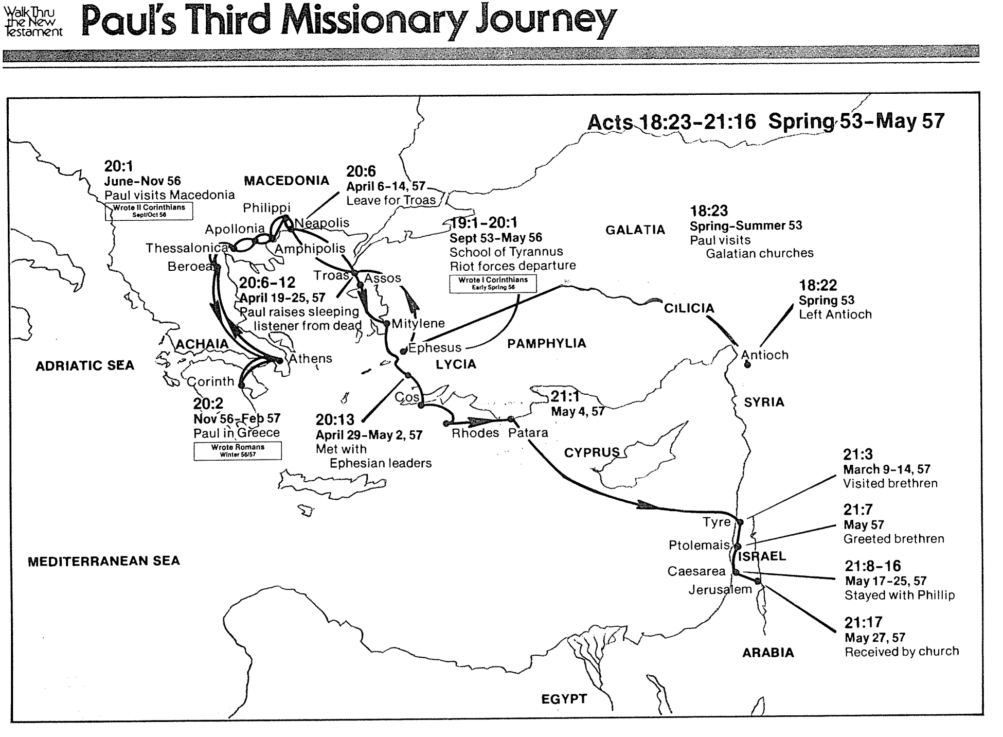

Paul’s Trials & Imprisonments
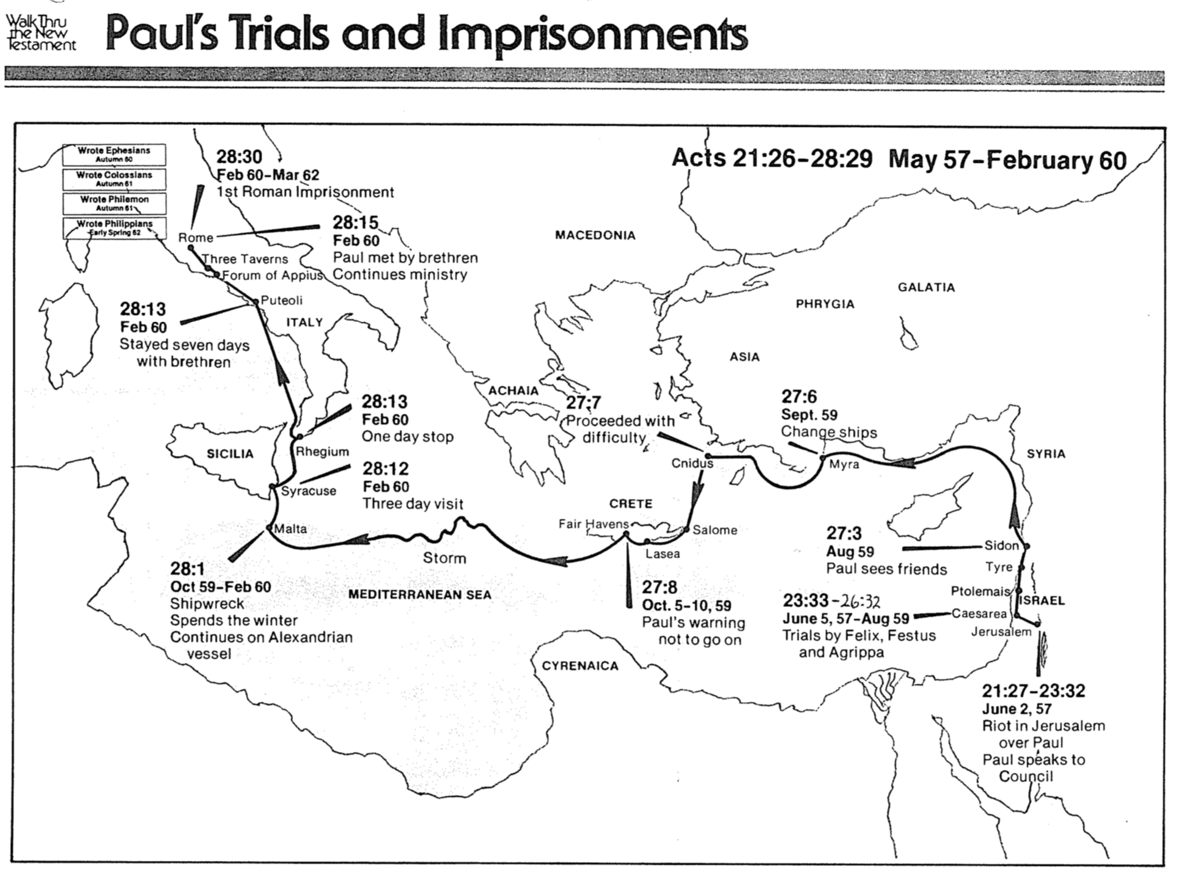
Paul’s Fourth Missionary Journey
Bible Visual Resource Book, 259 adapted

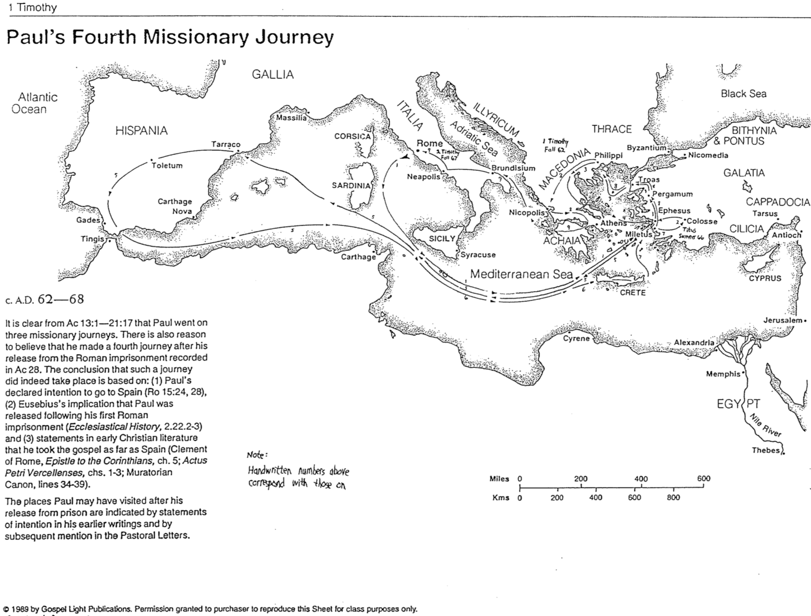

Walk Thru the Pauline Epistles

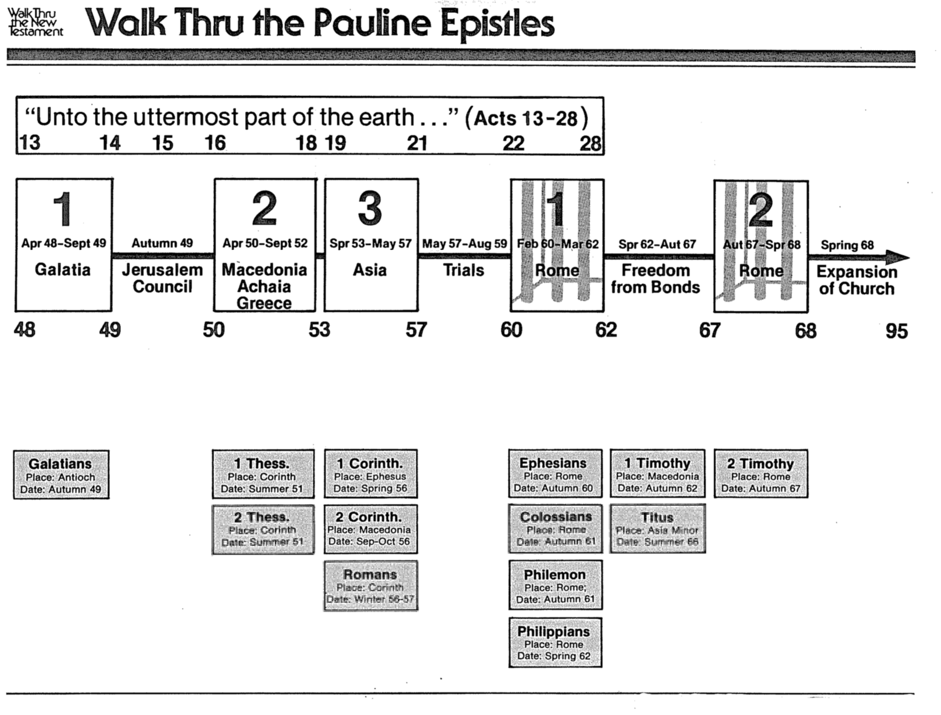

Walk Thru the General Epistles

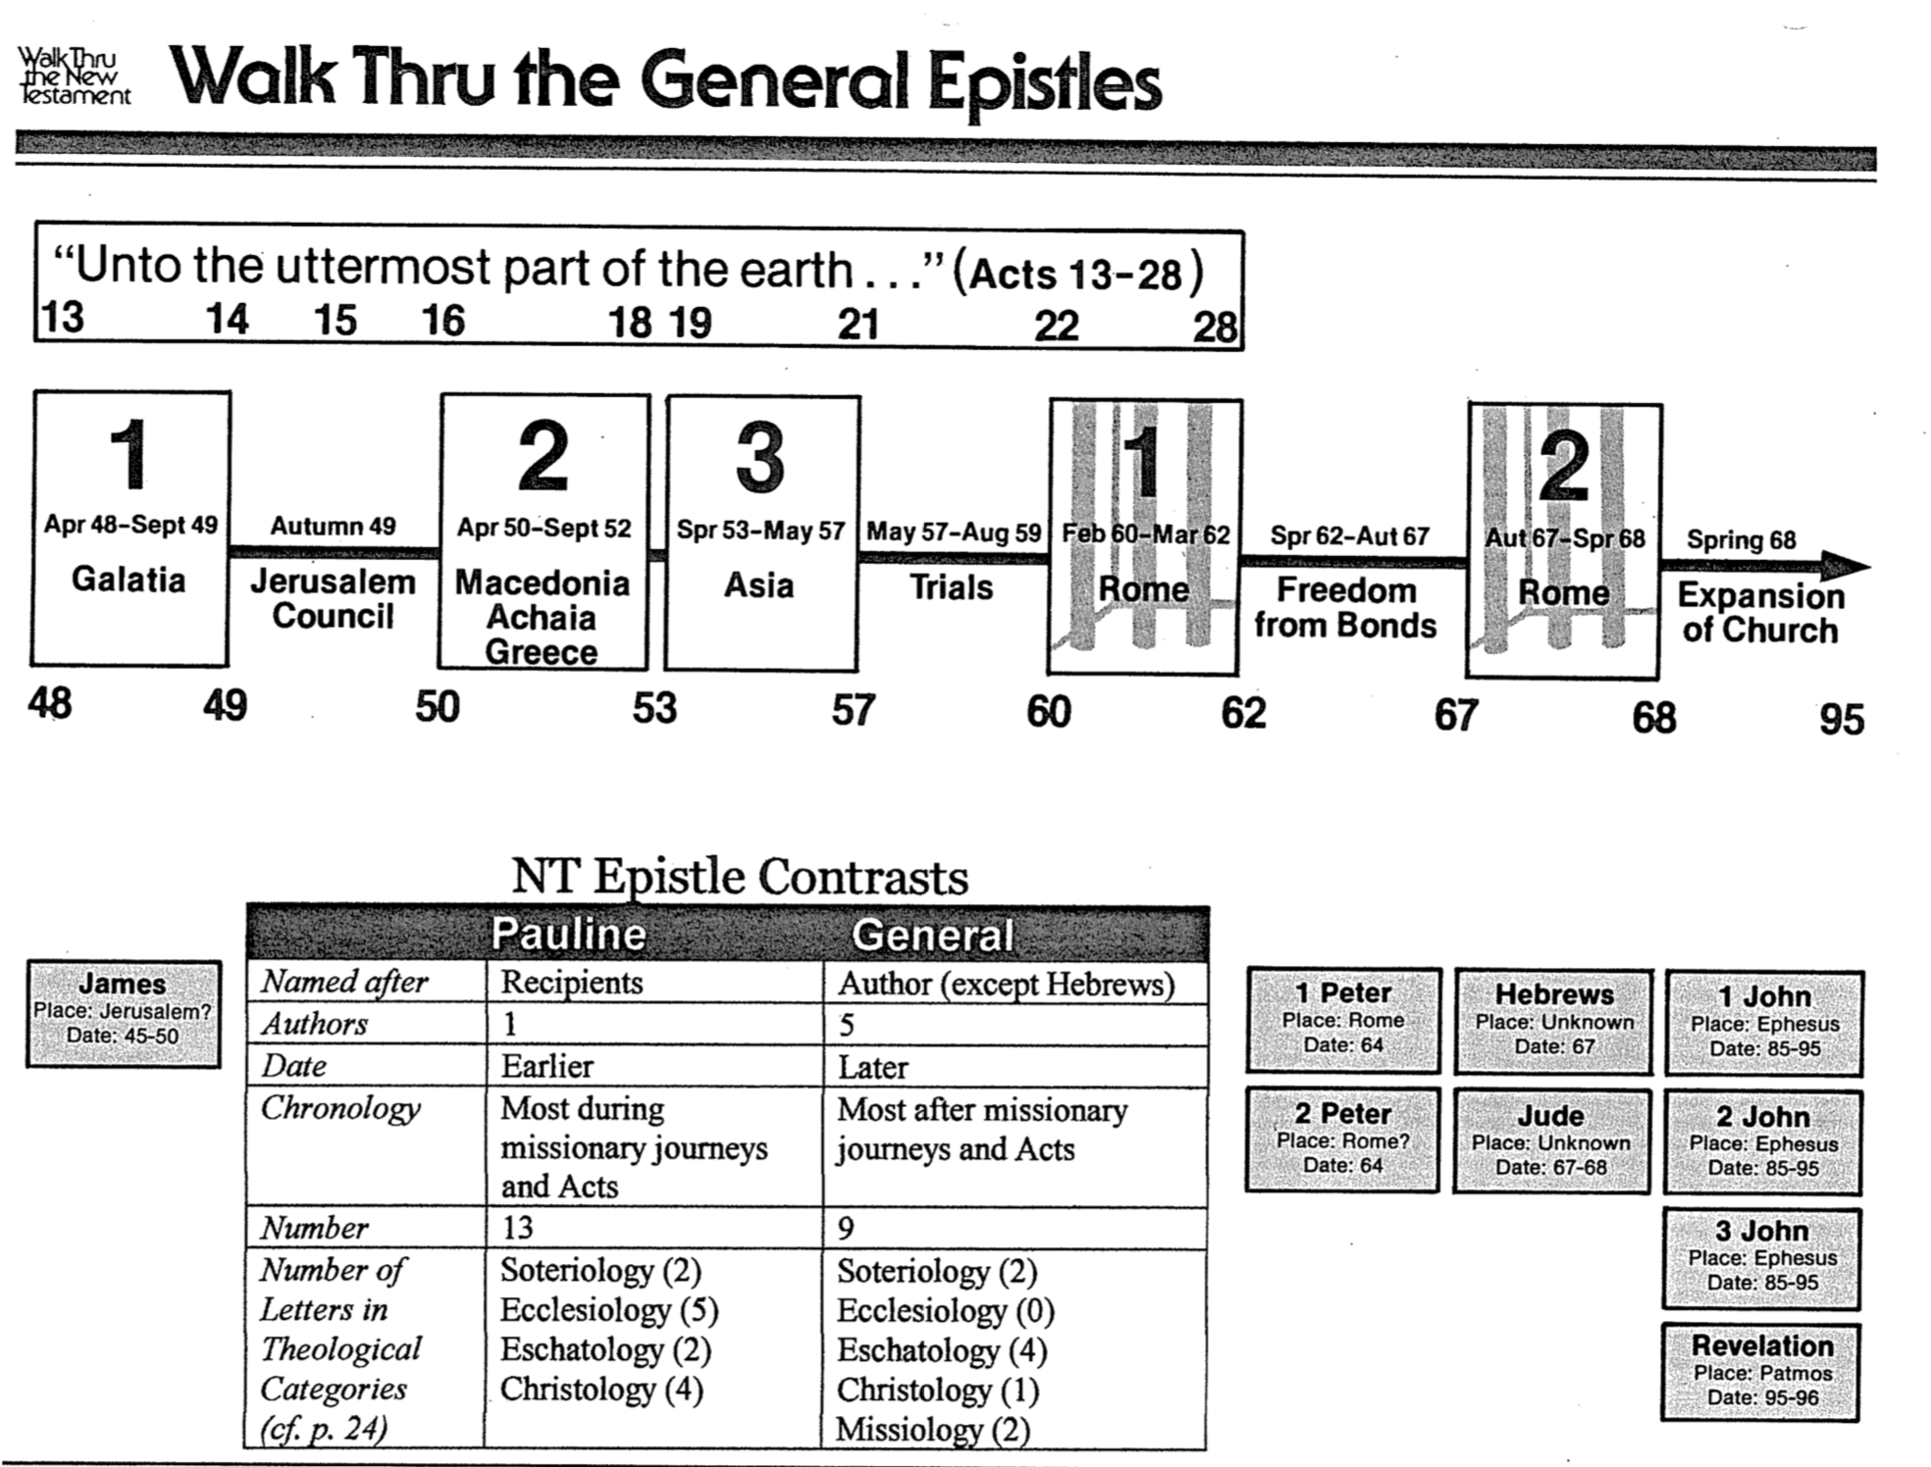

Timeline of Paul’s Life
Bible Visual Resource Book, 227

