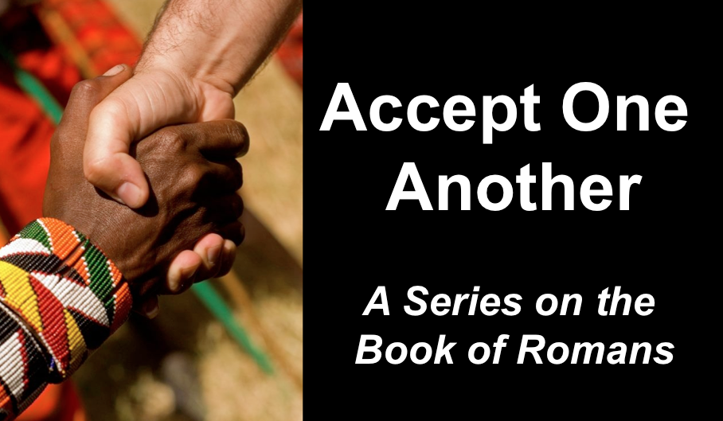
Law Intolerance
Romans 7:1–8:4
Andrew B. Spurgeon
Crossroads International Church, Singapore
Message 8 • 20 August 2017

Introduction:
- We are law-intolerant—we don’t keep the law
- So, what’s our relationship to the Law of Moses?

Grace of God:
- Our salvation rests in Jesus Christ who, a descendant of King David, died and resurrected for us: “He was handed over for our sins and raised for our righteousness” (Rom 4:25). God showed his love by Christ dying for us while we were sinners (Rom 5:8). Adam brought us sin and death, Jesus Christ brought us life and righteousness.
- So, shall we continue in sin? (Rom 6). No, because we are “dead to sin and alive to God and righteousness” (6:8).

The Theory:
- The marriage illustration portrays a Jew’s relationship with God as one under the Law of Moses. When Christ died, however, that relationship ended, esp. for the Jewish Christians who were under the law. They are in a new relationship, under the law of the Spirit, and can fulfill the righteous requirements of the law.

Examples:

Application:
God’s law is holy, righteous, and good. By our strength, we can’t observe it. But by the Spirit’s help, we’ll fulfill the righteous requirements of the law.

Download this sermon PPT and notes for free at BibleStudyDownloads.org/resource/new-testament-preaching/
Listen to this message online at cicfamily.com/sermon-listing/

