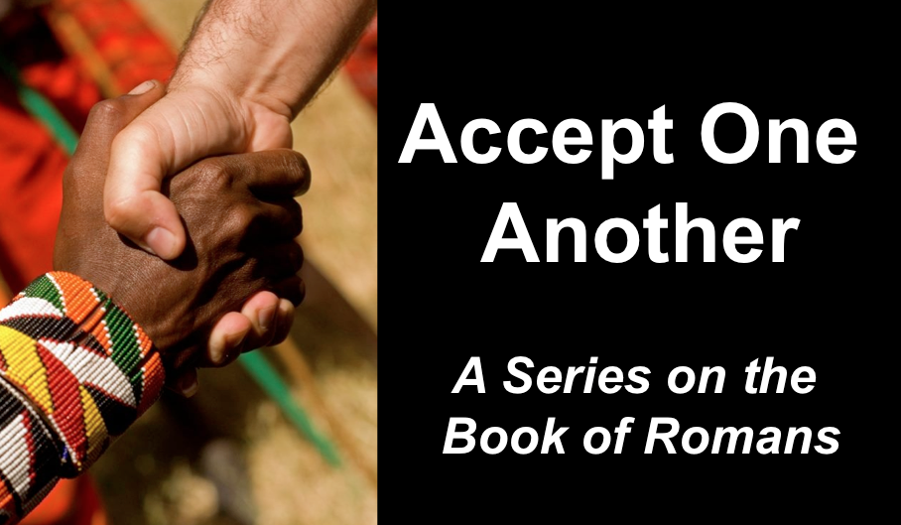
Crouching Sin & Hidden Victory
Romans 6
Andrew B. Spurgeon
Crossroads International Church Singapore
Message 7 • 6 August 2017

Introduction
- God said to Cain, “Why are you angry? Why is your face downcast? If you do what is right, will your offering be not accepted? But if you do not do what is right. Sin is crouching at your doors; it desires to have you, but you must master it” (Gen 4:1–12)
- Definition of sin: “Not doing what you certainly know is right to do” (Gen 4:7; Rom 14:23; Jam 4:17)

Grace of God
- Our salvation rests in Jesus Christ who, a descendant of King David, died and resurrected for us: “He was handed over for our sins and raised for our righteousness” (Rom 4:25).
- God showed his love for us in this way: “While we were sinners, Christ died for us” (Rom 5:8). Whereas the first Adam brought us sin and death, the second Adam brings us life and righteousness.

Question
- Since we have such a great “free” salvation, shall we stay in our sinful life? No!

Reasons
- We died to sin; how can we live in it? (Rom 6:2–14)

- We are slaves to righteousness (Rom 6:15–23)

Application

We master sin by committing to do what is right: love, joy, peace, patience, kindness, goodness, faith, gentleness, and self-control.

Download this sermon PPT and notes for free at BibleStudyDownloads.org/resource/new-testament-preaching/
Listen to this message online at cicfamily.com/sermon-listing/

