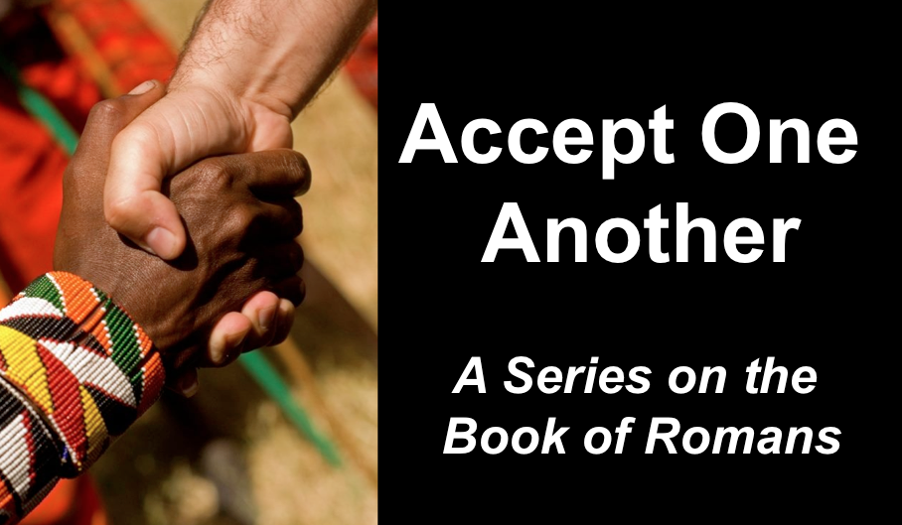
Privileged Need the Gospel
Romans 2:17–3:20
Andrew B. Spurgeon
Crossroads International Church Singapore
Message 3 • 12 March 2017

Context:
- Jewish pilgrims to Jerusalem during the coming of the Holy Spirit at Pentecost, returned to Rome and established the churches in Rome (Acts 2:10). They included Gentiles in their worship and congregation. But Emperor Claudius expulsed all the Jews from Rome (AD 44–49), the founders of the church in Rome left and the Gentile Christians filled the gap in the leadership. In AD 54, Emperor Claudius died, and Nero became the new Emperor. Jews, including Jewish Christians, returned. Tensions arose in the churches over customs. So Paul’s message to them was, “Accept one another just as Christ has accepted you, for the glory of God” (Rom 15:7).

Gospel:
- The gospel is a birth announcement and a victory announcement. (“The gospel . . . regarding his Son, who as to his earthly life was a descendant of David, and who through the Spirit of holiness was appointed the Son of God in power by his resurrection from the dead: Jesus Christ our Lord,” Rom 1:1–4).
- The gospel requires a response. (“For I am not ashamed of the gospel, because it is the power of God that brings salvation to everyone who believes: first to the Jew, then to the Gentile. For in the gospel the righteousness of God is revealed—a righteousness that is by faith from first to last, just as it is written: ‘The righteous will live by faith,’” Rom 1:16–17).

Objection 1:
- I don’t need the gospel because I am not a sinner — like a murderer or rapist.
- But God’s verdict is different, which Paul explains: “The wrath of God is showing from heaven upon all those who are “irreverent to God” and “un-straight-forward” people who suppress the truth in their “un-straight-forwardness” (Rom 1:18)
- The truth that they suppress is the Existence of God as evidenced by the creation!
- “Although they know God exists, they neither give glory to God nor thank him”; Instead, they worship gods they create
- Punishment
  - God gave them over to their own desires [epithumia] of their hearts; they worship creatures (1:24–25)
  - God gave them over to dishonorable passions [pathos]; they confuse gender relationships (1:26–28)
  - God gave them over to thoughtless minds [nous]; they commit acts of wickedness and approve those who practice them (1:26–32)

Objection 2:
- I don’t need the gospel because I am a saint!
- God says, “You who pass judgment on someone else, for at whatever point you judge another, you are condemning yourself, because you who pass judgment do the same things” (2:1); On the other hand, God’s judgment is based on truth (2:2); so those who judge others, but do the same act, will not escape God’s judgment (2:3)
Their crime is this: Showing contempt for God’s kindness; that is, instead of taking advantage of God’s kindness and repenting, they were being arrogant in their self-righteousness, not thinking of God or the need for God (2:4).

Objection 3:
- I don’t need the gospel because I am privileged because I have the law, God’s guidance to obedience.
- Their crime: They do the same things that they speak against (2:17–24).
- I don’t need the gospel because I have circumcision (privilege to God’s covenant with Abraham.”
- Their crime: Circumcision has value if you observe the law, but if you break the law, you have become as though you had not been circumcised (2:25–29)
- Question: Is there, then, no advantage of being a Jew, one privileged?
- Answer: Much in every way (3:1–9)

Objection 4:
- I don’t need the gospel because I am not totally depraved.
- Paul: “There is no one righteous; not even one; there is no one who understands, no one who seeks God. All have turned away . . . There is no fear of God before their eyes” (3:10–18)

Summary:
- God gave the law (something the Jews considered a privilege) in order to shut one’s mouth (i.e., hold one accountable of their crime).
- The Law only makes one aware of his/her sin; it can’t help one overcome sin. The answer to sin is in the gospel (concerning the Son).

Conclusion: Whether we are “sinners,” “saints,” “privileged,” or “mere human,” doesn’t matter: every one of us is in need of the Gospel (concerning the Son, who was born in the lineage of David and appointed as the Son of God by the resurrection from the dead—a message that has salvation to anyone who believes). But what did the Son do? Tune in next Sunday to hear it.

Download this sermon PPT and notes for free at BibleStudyDownloads.org/resource/new-testament-preaching/
Listen to this message online at cicfamily.com/sermon-listing/

