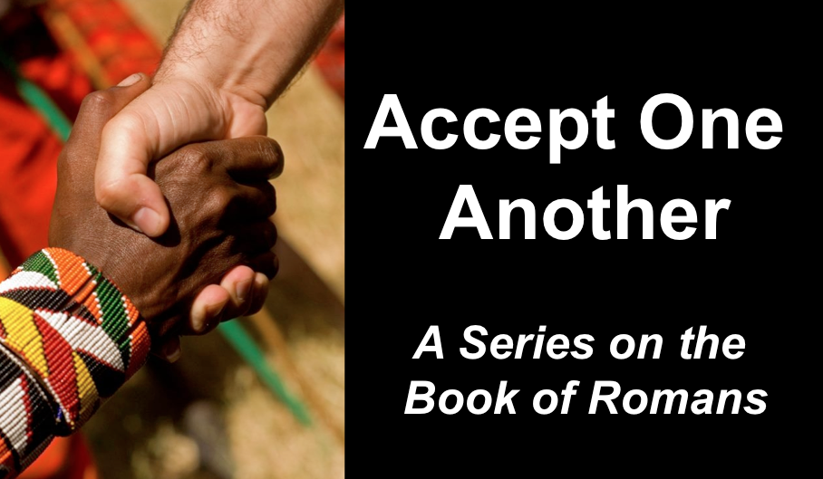
Paul’s Letter to the Romans
Romans 1:1-17
Andrew Spurgeon
Crossroads International Church Singapore
Message 1 • 12 February 2017

Early churches had humble beginnings:
- Fishermen from Galilee—Peter, James, and John—established the church in Jerusalem
- A purple cloth merchant (Lydia), her family, a slave girl who once possessed a demon, a jail-warden, and his family established the church in Philippi (Acts 16:11–40)
- People of low status (possibly slaves) and of limited means formed the majority of the church in Corinth (1 Cor 1:26–31)
- Similarly, early believers established the church in Rome (Acts 2:10)

Church in Rome:
- First had Jewish Christians, pilgrims to Jerusalem (Acts 2:10)
- They invited their friends, including non-Jews (Gentiles), and coped with cultural tensions (such as kosher food [Rom 14:2] and festivals [Col 2:16])
- Political change in Rome: Emperor Claudius expelled all the Jews from Rome (because of one named “Crestus”) and Jewish Christians too left Rome (e.g., Aquila and Priscilla, Acts 18:1–3), AD 41–54. When Claudius died and Nero became emperor (Oct 13, 54), the Jews returned one by one, including Jewish Christians
- While the Jews were away, the Gentiles (non-Jews) took over the leadership of the church; with their return, tensions built up (not great tensions as in Corinth, but significant nevertheless)

Paul, in the meantime:
- Finished his third missionary journey to Asia Minor (modern day Turkey), and Greece (Athens, Corinth, etc.), and was looking forward to go to Spain, the unreached harvest field (Rom 15:24, 28)
- For his mission to be a success, he needed a base in the west (possibly Rome) as he had one in the east (Antioch, Syria)
- If the Roman Christians weren’t in complete agreement with one another and behind Paul’s journey towards the west, his mission would fail
- But Paul didn’t establish the church in Rome and he had a policy of not interfering in someone else’s work (Rom 15:20); yet, as an apostle of the Lord Jesus Christ, he couldn’t remain silent and wrote this letter

Outline of Romans:
- Both Jews and Gentiles received the same gospel: “For I am not ashamed of the gospel, because [the gospel] is the power of God that brings salvation to everyone who believes: first to the Jew, then to the Gentile” (Rom 1:16).
- Both groups were equally sinful: the Gentiles by not honoring God as the creator and giving him thanks (Rom 1:18–32), and the Jews by judging others and by not keeping the law themselves (Rom 2:1—3:8). As a result, there was “trouble and distress for every human being who does evil: first for the Jew, then for the Gentile” and “Jews and Gentiles alike are all under sin” (Rom 2:9 and 3:9)
- Since both groups were equally guilty and sinful, God saved both groups apart from the law (so as not to give an advantage to the Jews who had and knew the law) and by the faithfulness of Jesus Christ since “there is no difference between Jew and Gentile” (Rom 3:22; italics added).
- Both groups were freed from sin (Rom 6:1–23) and fulfilled the requirements of the law with the help of the Holy Spirit (Rom 7:1—8:39).
- Salvation wasn’t bound by works or ethnicity; it was based on whom God called: “not only from the Jews but also from the Gentiles” since “there is no difference between Jew and Gentile—the same Lord is Lord of all and richly blesses all who call on him” (Rom 9:24 and 10:12).
- Both groups were to have the renewed mindset consisting of a pure love that was devoted to and honoring one another (Rom 12:9–10) and obeyed the government (Rom 13:1–14). Instead of passing judgment over personal, cultural, and cultic practices (Rom 14:1), the weak (those with restricted liberty) should accept the strong (those with much liberty) and the strong should accept the weak (Rom 14:2—15:6).
- They should accept one another because Christ had become a servant of the Jews in order to bring salvation to the Gentiles: “For I tell you that Christ has become a servant of the Jews on behalf of God’s truth, to confirm the promises made to the patriarchs so that the Gentiles may glorify God for his mercy” (Rom 15:8).

Writing the letter:
- Paul rested, at the end of his third missionary journey, in Athens for three winter months—where he was formulating this “evangelistic” letter (Acts 20:3)
- At the end, he visited Corinth (a third time) and stayed at Erastus’s house (Rom 16:23)
- Phoebe from the neighboring town of Cenchrea (8 miles south) was going to Rome
- So Paul gave this letter to Phoebe to hand deliver it to the Romans (Rom 16:1–2)

Theme: “Accept one another just as Christ accepted you for the glory of God” (Rom 15:7)

Section A: Jews and Gentiles are equal recipients of the gospel (1:1–17)
Section B: Jews and Gentiles are equally sinful and are in need of salvation (1:18—3:20)
Section C: Jews and Gentiles are equally offered the righteousness of God (3:21—5:21)
Section D: Jews and Gentiles are equally freed from sin and law, and are indwelt by the Holy Spirit (6:1—8:39)
Section E: Jews and Gentiles are equal saved by His calling and by His mercies (9:1—11:36)
Section F: Jews and Gentiles are equally transformed and are mandated to pursue unity, obedience, and acceptance of one another (12:1—15:13)

The gospel is a birth announcement and a victory announcement. (“The gospel . . . regarding his Son, who as to his earthly life was a descendant of David, and who through the Spirit of holiness was appointed the Son of God in power by his resurrection from the dead: Jesus Christ our Lord,” Rom 1:1–4).

The gospel requires a response. (“For I am not ashamed of the gospel, because it is the power of God that brings salvation to everyone who believes: first to the Jew, then to the Gentile. For in the gospel the righteousness of God is revealed—a righteousness that is by faith from first to last, just as it is written: ‘The righteous will live by faith,’” Rom 1:16–17).

Download this sermon PPT and notes for free at BibleStudyDownloads.org/resource/new-testament-preaching/
Listen to this message online at cicfamily.com/sermon-listing/

