Crossroads International Church Dr. Rick Griffith

Title

27 April 2014 Series on Revelation Message 19 of 20

NLT 40 Minutes

**Thy Kingdom Come**

***Revelation 20***

**Topic:** Kingdom

**Subject:** How will Christ mop up the world after his return?

**Complement:** Jesus will rule and judge all creation.

**Purpose:** The listeners will either trust Christ for salvation (unbelievers) or trust Christ to better rule with him later (believers)

**Meditation:** God who fulfills his promises

**Reading:** “The Lord’s Prayer” (Matthew 6:9-13)

**Song:** “This Kingdom”

# Introduction

### Interest: Great battles always have an epilogue—and sometimes it relates to you!

Epilogue

### Need: Do you know how *you* fit into the Bible’s epilogue after Christ’s victorious return? Do you know how that should affect you now?

Bible’s Epilogue

### The epilogue often includes a mopping-up operation—“a clean-up operation; the final stages in a project where the loose ends are taken care of” (dictionary.com).

Mopping up

### Background: In the past few months we have seen that…

Chronology of Rev

#### The seven-year Tribulation era is a yet future period with 21 judgments of seals, trumpets and bowls to motivate people to repent (Rev. 4:1—19:10).

• Seals  
• Trumps  
• Bowls

#### The entire Revelation led to the point where Christ returns and judges the earth in chapter 19. This is the focus of our series: Jesus Wins!

Jesus Wins!

### Subject: But now what? How will Christ mop up the world after his return?

Subject

### Preview: The millennium and judgment are two of the final three results of Christ’s victory. We will see the final one next week but today we will see stages 1 and 2 of the mop up.

Chronology  
• Millen.  
• GWTJ  
• Eternity

### Text: Revelation 20 provides two mop up operations for us to address today.

(The first mop up operation following the Second Coming of Christ is that...)

# I. You will rule the earth with Christ for 1000 years until Satan’s last stand (20:1-10).

MP

[We will reign with Jesus a full millennium that will fulfill many OT prophecies with Satan bound until sinners rebel afterwards.]

Clouds

Satan

Satan

1-3

## Satan won’t deceive people for 1000 years (20:1-3).

### Let’s read these three key verses…

### *When* is Satan bound (20:1-3)?

When?

#### Some think Satan is bound *now* from the first and second coming of Christ.

Amil bound now

##### Satan is seen as *restricted* from deceiving the nations like he did prior to Christ’s first coming.

##### True, but this text is not talking about preventing the spread of the gospel. It says he will not deceive nations.

• True, but…

##### Does Satan deceive nations now? Some say NO! [Explain animation.]

Does Satan deceive?

#### Also, the text says this period immediately follows the Second Coming of Christ (Rev. 19).

Future Benefits

#### We also know Satan must be bound in the future because there is no question that Satan deceives the nations today!

Media Deceive

Long History

### *What* does it mean for Satan to be bound?

Meaning of Bound

#### We must be watchful. Why? Satan is on the loose.

Why Be Watchful?

#### Satan deceives nations today.

Today?  
Yes!

#### Satan will not be just partially restricted as is true today. Notice that Satan is not simply *restricted* from deceiving the nations but he is TOTALLY locked and sealed. Some say that this is a present reality where Satan presently deceives individuals but not nations. My question is, "HOW MANY people within these nations are deceived by Satan?" Of course, the obvious answer is 100% (even though they say he can't deceive nations?!). It appears to me that ALL nations today are being deceived by this father of lies.

2-3a

#### Instead, he will be thrown into the bottomless pit, which is then shut and locked so he cannot deceive even one nation!

Dragon pit

## Saints will rule this earth for 1000 years (20:4-6).

Cloud

SP

### Let’s read 20:4-6…

5-6

4

1st & 2nd resurrect?

Diagram

We will rule too

Jesus will rule

### Jesus will rule.

### We will rule too!

### Verses 4-6 says repeatedly that we will rule for 1000 years.

### What are the first and second resurrections (20:5-6)?

#### The first resurrection is when saints “came to life” (20:4b-5a). A resurrection always refers to the *mortal body* becoming a *glorified body*—so we shouldn’t redefine “resurrection” here to mean a so-called “spiritual resurrection,” as this is a contradiction of terms. If something is spiritual, then it is not physical; if it’s a resurrection, then it’s not spiritual but literally relating to the body.

#### The second resurrection is clearly noted to be 1000 years later when the unrighteous dead are bodily resurrected. Shouldn’t the coming to life in the previous phrase have the same, clear meaning?

#### The NT scholar, Henry Alford, insightfully noted in 1861, “If, in a passage where *two resurrections* are mentioned… the first resurrection may be understood to mean *spiritual* rising with Christ, while the second means *literal* rising from the grave;—then there is an end of all significance in language, and Scripture is wiped out as a definite testimony to anything” (4:732).

Alford

#### We all should want to be in the first—*but not the second*—resurrection. Why? Verse 6 says, “Blessed and holy are those who share in the first resurrection. For them the second death holds no power, but they will be priests of God and of Christ and will reign with him a thousand years” (NLT).

Resurrection reunion

20:6

### Isn’t this what we have been praying for—that God’s kingdom will come on earth, as it is in heaven?

Matt 6

### “Thy Kingdom come” means we pray that God’s rule will be here on earth.

Thy Kingdom

### Our republic will give way to a monarchy! The tripartite government will then have Jesus as king, lawgiver, and judge—with us as his assistants!

Why needed?

Rep to Monarchy

### Why is the millennial era needed? It has at least five purposes:

#### We will judge angels (1 Cor. 6:2).

1 Cor 6:2

Judge angels

#### We will rule the earth (20:4-6; cf. 5:10).

Rule earth

5:10

#### God will restore the world to pre-Flood era. They lived hundreds of years then, but Isa. 65:20 says in the millennium long life will return!

Heart corrupt

Isa. 65:20

Pre-Flood

Gen. ages

#### God will show the human heart corrupt—more on that later in 20:7-10.

• AC

#### God will fulfill the Abrahamic Covenant (Gen. 12:1-3).

##### God made many promises to Israel and the Church that must be fulfilled on this very earth.

Kingdom & Cov Chart

##### Because God is faithful, he must fulfill these promises literally.

##### The Bible records over 7000 promises, over which about half have been fulfilled.

##### Those fulfilled have been fulfilled literally, so we should assume that those yet to be fulfilled will also be fulfilled literally.

### *When* will Jesus return in relation to the millennium—before or after it?

When return?

#### There are two main ways to interpret the Bible’s teaching on the millennium. The key question relates to when Jesus returns in relation to the millennium. Does he come before or after the 1000 years?

• Before  
• After

#### Our church is premillennial, meaning we see the church age going into the Tribulation, then the Second Coming comes before the millennium (thus the term, “premillennial”).

Premil

#### Another view is the amillennial view. It is called “amillennial” because “a” in front of a word negates the word—like “amoral.” Amillennialists don’t believe in a literal 1000 year millennium. They see it as the present church age. This puts Revelation 20 on the millennium chronologically before Revelation 19 when Jesus returns.

Amil

### *How* should we understand this 1000-year period—spiritually or literally (20:1-7)?

1000 Literal?

#### Amillennialists claim that numbers in the book of Revelation should not be taken in their normal sense. Therefore, “seven” means only a time of completion or perfection, etc.

Beale  
(8 slides)

#### My response would be, “Which number in Revelation doesn’t make sense if taken in its normal sense?” [explain 8 slides]

### *Who* will rule with Christ for 1000 years (20:4-6)? Verse 4 shows three groups ruling (Ryrie, *Revelation*, 115 with NAU):

• Church

Who Rules?

#### The Church (cf. 1 Cor. 6:2; 2 Tim. 2:12): “Then I saw thrones, and they sat on them, and judgment was given to them” (20:4a NAU).

#### Beheaded Martyrs: “And I *saw* the souls of those who had been beheaded because of their testimony of Jesus and because of the word of God, and…” (20:4b NAU).

• Martyrs

#### Tribulation Believers: “Those who had not worshiped the beast or his image, and had not received the mark on their forehead and on their hand; and they came to life and reigned with Christ for a thousand years” (20:4c NAU).

• Trib. Believers

### *Where* does the rule take place—earth or heaven?

Where rule?

#### That the rule is on earth is clearly indicated in Revelation 5:10.

• 5:10

#### The last place noted is when an angel comes down to earth from heaven (20:1). This shows the rule is on earth unless there is a change of location.

• 20:1

### *When* does the rule take place—earth or heaven?

Where rule?

#### That the rule is future is clearly indicated in Revelation 5:10.

• 5:10

#### It also says that we will (future) be priests… and will (future) reign 1000 years (20:6).

Anywhere else?

• 20:6

### Is the millennium anywhere else in the Bible?

#### Actually, this kingdom era is mentioned hundreds of times in Scripture!

#### Psalm 2 declares that the nations will plot against the Lord, but he will place his chosen king on Jerusalem’s throne.

Psalm 2

#### Daniel 2 records a succession of nations to follow Babylon—all the way to the kingdom of Antichrist. But Christ's Kingdom will attack the world's kingdoms and they will all topple, being replaced with Christ’s Kingdom.

Dan 2  
(3 slides)

#### Jesus told us in the Lord’s prayer to pray for this kingdom to come.

Thy Kingdom

#### Many passages repeatedly refer to the kingdom era. Walvoord, BKC, notes, “Many passages speak of the second coming of Christ being followed by a reign of righteousness on earth (Pss. 2; 24; 72; 96; Isa. 2; 9:6-7; 11-12; 63:1-6; 65-66; Jer. 23:5-6; 30:8-11; Dan. 2:44; 7:13-14; Hosea 3:4-5; Amos 9:11-15; Micah 4:1-8; Zeph. 3:14-20; Zech. 8:1-8; 14:1-9; Matt. 19:28; 25:31-46; Acts 15:16-18; Rom. 11:25-27; Jude 14-15; Rev. 2:25-28; 19:11-20:6).”

• Not new

Walvoord

#### Isaiah 11:6-9 has a peaceful animal kingdom when wolf will live with a lamb!

• 6a

Isa. 11

##### A little boy will even lead lions.

• 6b

Boy

##### How? Lions will eat straw like the ox.

• 7

Baby lion

##### Babies will even be able to play with cobras. This cobra in India is defanged, but God will make *every* cobra safe in the millennial kingdom!

• 8-9

Baby with cobra

#### After the Tribulation much rebuilding will be needed.

Rebuilding brings

#### But it will bring about a totally renewed earth!

A new earth!

#### Romans 8:19-21 says our world now cries out to be liberated—not destroyed!

Rom. 8

#### Isaiah 65:20 again teaches a period of long life when death still exists.

Isa. 65:20

#### Isaiah 2:3 teaches a period when the law will finally go out from Jerusalem like it was supposed to!

Isa. 2:3

#### The key addition to our knowledge of the kingdom in Revelation 20 is that this is the first place we see the *length* of the kingdom—six times as 1000 years.

1000

(So we are seeing that first mop up operation following the Second Coming of Christ is the millennium. It relates to Satan and saints. But it also relates to sinners. We saw in 19:19 that they fought against Christ before the millennium. Now we will see *after* the millennium once again...)

Millennium Stages

19:19

## Sinners will challenge Christ’s rule unsuccessfully (20:7-10).

1000 years later…

### Sinners of all nations win join Satan after his release to battle Israel like the war of Gog and Magog 1000 years earlier in the Tribulation (20:7-9a).

7-9a

#### Satan will be released from prison and will still be alive—as alive as an angry man just released from jail!

Satan

#### But how could people rebel against Christ after he has ruled justly for a millennium (20:7-10)?

How rebel?

##### To even *ask* this question is to greatly underestimate the wicked heart of man! People like us will have perfect bodies with no more sin nature.

Deceived

Perfect bodies

##### But many will be born in the millennium with a sin nature. If humans without a sin nature in Eden would rebel against God, is it so hard to fathom millennial mortals rebelling against a gracious ruler on the throne?

Sin nature

##### Man has consistently wanted to usurp God’s rightful rule of the universe. The millennium will show that, even under near ideal circumstances, man will still eventually rebel once again—by the millions!

Mortals & Immortal?

Mask

#### But could mortals and glorified people live together?

##### Some make fun of this idea.

Poke fun

Already  
(5 slides)

##### But it has already been done!

##### This is possible with a Pre-Trib Rapture.

Pre-Trib  
(3 slides)

#### Is the Gog and Magog here the same as the one in Ezekiel 38–39?

Who is Gog?

##### We know from Ezekiel 38–39 this was the prince opposing Christ.

When is Gog?

##### But there are many differences between these two “Gogs and Magogs,” including the time (Ezek. 38:16) and result (Ezek. 38:19-22).

Chart of Differences

##### It appears that Revelation uses similar language as the rebellion against God by forces 1000 years earlier.

Timeline

#### God will judge both Satan and his armies with fire (20:9b-10).

9b-10a

##### Fire from heaven will burn up the attacking armies (20:9b).

##### Fire in hell will eternally torment Satan with the Antichrist and False Prophet in the agony they will have had for 1000 years (20:10).

Horse

10b

##### So Jesus will win this final battle.

(This is the first mop up operation—the millennium where you will rule with Christ. Now the second mop up operation following the Second Coming of Christ is that...)

MPI

# II. Christ will judge all people and defeat his last enemy, death (20:11-15).

MPII

[Jesus’ judgment at the great white throne shows his just vengeance upon all who oppose him and his victory over death.]

11

## God will raise and judge all people (20:11-13).

### Will all people or only unbelievers appear at the great white throne (20:11-15)?

All or Only Unsaved?

#### Whether they are judged or not depends on whether their names are in the Book of Life.

12a

#### Life is in Christ, but I can’t say if anyone’s name *will* be found there. The text mentions only those whose names are *not* found in the Book of Life.

12b

### But how much they are judged depends upon the deeds they had done as found in the books. I think these books will indicate how severe their judgment will be.

13

## All unbelievers will be tormented in the lake of fire eternally (20:14-15).

15

14

### This is a difficult doctrine to handle, so we have less difficult traditions and many jokes about hell.

### But we need a biblical instead of traditional view of hell.

Tradition  
(4 slides)

(How will Christ mop up the world after his return?)

Mop Up

# Conclusion

### Jesus will rule and judge all creation (Main Idea).

MI

### Søren Kierkegaard wisely said, “There are two ways to be fooled. One is to believe what isn’t true; the other is to refuse to accept what is true.”

Kierkegaard

### Do you believe my two main points?

#### You will rule the earth with Christ for 1000 years until Satan’s last stand (20:1-10).

MPI

#### Christ will judge all people and defeat his last enemy, death (20:11-15).

MPII

### OK, but what should I do?

Do you trust Christ

Stand?

#### Unbelievers, *make sure you are in the Book of Life* by trusting Christ for salvation.

##### Will you stand?

##### Or sink?

Sink?

##### If you aren’t sure, just tell him now that you trust Christ’s payment for your sin on the cross.

Trust Him!

#### Believers, *get ready to rule* by serving faithfully now.

Jesus will reign

##### Jesus will reign.

You ready?

How ready?

##### Are you ready to join him?

##### How can you be ready?

##### Be faithful now.

Be faithful now

### Prayer

Black

# Preliminary Questions

**Verses Questions**

# Context: What did the author record just prior to this passage?

### The seven-year Tribulation era is a yet future period to motivate people to repent (Rev. 4:1—19:10).

### The 1000 years comes immediately after the Return of Christ (19:11-21).

# Purpose: Why is this passage in the Bible?

### God made many promises to Israel and the Church that must be fulfilled on this very earth.

### Because God is faithful, he must fulfill these promises literally.

# Background: What historical context helps us understand this passage?

### The Bible records over 7000 promises, over which about half have been fulfilled.

### Those fulfilled have been fulfilled literally, so we should assume that those yet to be fulfilled will also be fulfilled literally.

# Questions

### *When* is Satan bound (20:1-3)?

#### Some think Satan is bound *now* between the first and second coming of Christ. Satan is seen as *restricted* from deceiving the nations like he did prior to Christ’s first coming.

#### However, the text says this period immediately follows the Second Coming of Christ (Rev. 19).

#### Walvoord, BKC, notes, “Many passages speak of the second coming of Christ being followed by a reign of righteousness on earth (Pss. 2; 24; 72; 96; Isa. 2; 9:6-7; 11-12; 63:1-6; 65-66; Jer. 23:5-6; 30:8-11; Dan. 2:44; 7:13-14; Hosea 3:4-5; Amos 9:11-15; Micah 4:1-8; Zeph. 3:14-20; Zech. 8:1-8; 14:1-9; Matt. 19:28; 25:31-46; Acts 15:16-18; Rom. 11:25-27; Jude 14-15; Rev. 2:25-28; 19:11-20:6).”

#### We also know Satan is bound in the future because there is no question that Satan deceives the nations today!

### *What* does it mean for Satan to be bound?

#### Satan will not be just partially restricted as is true today.

#### Instead, he will be thrown into the bottomless pit, which is then shut and locked so he cannot deceive even one nation!

### Is the 1000-year period of Satan’s binding the same 1000-year period as the rule of the saints (20:4-6)?

#### Nearly all Bible scholars—no matter their persuasion— admit that the binding of Satan and the rule of the saints are the same time period.

#### This period is preceded and followed by resurrections (20:4b, 5b).

### *How* should we understand this 1000-year period—spiritually or literally (20:1-7)?

#### Some claim that numbers in the book of Revelation should not be taken in their normal sense. Therefore, “seven” means only a time of completion or perfection, etc.

#### My response would be, “Which number in Revelation doesn’t make sense if taken in its normal sense?”

### *Who* will rule with Christ during the 1000 years (20:4-6)? Verse 4 shows three groups ruling (Ryrie, *Revelation*, 115 with NAU):

#### The Church (cf. 1 Cor. 6:2; 2 Tim. 2:12): “Then I saw thrones, and they sat on them, and judgment was given to them” (20:4a NAU).

#### Beheaded Martyrs: “And I *saw* the souls of those who had been beheaded because of their testimony of Jesus and because of the word of God, and…” (20:4b NAU).

#### Tribulation Believers: “Those who had not worshiped the beast or his image, and had not received the mark on their forehead and on their hand; and they came to life and reigned with Christ for a thousand years” (20:4c NAU).

### *Where* does the rule take place—earth or heaven?

#### The last place noted is when an angel comes down to earth from heaven (20:1). This would indicate the rule is on earth unless there is a change of location.

#### That the rule is on earth is clearly indicated in Revelation 5:10.

### *What* will we do when ruling with Christ?

#### We will each have a measure of authority “on thrones” (20:4a).

#### We will reign with Christ (20:4b).

#### We will judge both people and angels (cf. 1 Cor. 6:2).

### Why is this millennial period needed? There exist at least five purposes of the millennium:

#### We will judge angels (1 Cor. 6:2).

#### We will rule the earth (20:4-6; cf. 5:10).

#### God will restore the world to pre-Flood era (e.g., long life of Isa. 65:20)

#### God will show the human heart corrupt (20:7-10).

#### God will fulfill the Abrahamic Covenant (Gen. 12:1-3).

##### God made many promises to Israel and the Church that must be fulfilled on this very earth.

##### Because God is faithful, he must fulfill these promises literally.

##### The Bible records over 7000 promises, over which about half have been fulfilled.

##### Those fulfilled have been fulfilled literally, so we should assume that those yet to be fulfilled will also be fulfilled literally.

### Is the millennial period spoken of anywhere else in the Bible?

#### Actually, this kingdom era is mentioned hundreds of times in Scripture!

#### We are instructed by Jesus in the Lord’s prayer to pray for this kingdom to come.

#### The OT prophets repeatedly refer to the kingdom era.

#### The only real addition to our knowledge in Revelation 20 is that this is the first place we see the *length* of the kingdom.

### What are the first and second resurrections (20:5-6)?

#### The first resurrection is when saints “came to life” (20:4b-5a). A resurrection always refers to the *mortal body* becoming a *glorified body*—so we shouldn’t redefine “resurrection” here to mean a so-called “spiritual resurrection,” as this is an oxymoron. If something is spiritual, then it is not bodily; if it’s a resurrection, then it’s not spiritual but literally relating to the body.

#### The second resurrection is clearly noted to be 1000 years later when the unrighteous dead are bodily resurrected. Shouldn’t the coming to life in the previous phrase have the same, clear meaning?

#### The great NT scholar of yesteryear, Henry Alford, noted with insight, “If, in a passage where *two resurrections* are mentioned… the first resurrection may be understood to mean *spiritual* rising with Christ, while the second means *literal* rising from the grave;—then there is an end of all significance in language, and Scripture is wiped out as a definite testimony to anything” (IV, 732; cited by Mounce, 356).

#### We all should want to be in the first—*but not the second*—resurrection. Why? Verse 6 says, “Blessed and holy are those who share in the first resurrection. For them the second death holds no power, but they will be priests of God and of Christ and will reign with him a thousand years” (NLT).

### How could people rebel against Christ after he has ruled justly for a millennium (20:7-10)?

#### To even *ask* this question is to greatly underestimate the wicked heart of man.

#### If humans without a sin nature in Eden would rebel against God, is it so hard to fathom millennial mortals rebelling against a gracious ruler on the throne?

#### Man has consistently wanted to usurp God’s rightful rule of the universe. The millennium will show that, even under near ideal circumstances, man will still eventually rebel once again—by the millions!

### Is the Gog and Magog here the same as the one in Ezekiel 38–39?

#### There are many differences between these two, including the time (Ezek. 38:16) and result (Ezek. 38:19-22).

#### It appears that Revelation uses similar language as the rebellion against God by forces 1000 years earlier.

### Will all people or only unbelievers appear at the great white throne (20:11-15)?

#### Whether they are judged or not depends on whether their names are in the Book of Life. Life is in Christ, but I can’t say if anyone’s name *will* be found there. The text mentions only those whose names are *not* found in the Book of Life.

#### But how much they are judged depends upon the deeds they had done as found in the books. I think these books will indicate how severe their judgment will be.

# Tentative Subject/Complement Statements

Get ready to reign!  
“Thy kingdom come” will include you!

# Possible Illustrations

### Text

### The transfer of Paradise will have brought it to Heaven. Now there is a transfer of Hades to Hell.

Transfer Paradise

RELATIVISM standard practice today

[Follow the Right Path](http://illustrationexchange.us2.list-manage.com/track/click?u=181c69bf3d2275e6dc9157a34&id=a26b3a9f12&e=aa849ca33b)

Contributor: [Andrew Wolfenbarger](http://illustrationexchange.us2.list-manage.com/track/click?u=181c69bf3d2275e6dc9157a34&id=0847dbf4b8&e=aa849ca33b)

Topics: [Followership](http://illustrationexchange.us2.list-manage1.com/track/click?u=181c69bf3d2275e6dc9157a34&id=b89995165c&e=aa849ca33b) - [Reward](http://illustrationexchange.us2.list-manage.com/track/click?u=181c69bf3d2275e6dc9157a34&id=6ccd26ca2a&e=aa849ca33b) - [Relativism](http://illustrationexchange.us2.list-manage2.com/track/click?u=181c69bf3d2275e6dc9157a34&id=ca2166e32b&e=aa849ca33b)

Dr. Paul Chappell of the Lancaster Baptist Church reminds us of an infamous case of misguided direction:

There were 128 runners in the field for the cross-country race at the 1993 NCAA Division II Track and Field Championships.

As they set out on the 6.2-mile run, they were following a course that had been marked for them by the race officials. Toward the end of the course, one of the runners in the middle of the group realized something was wrong. Mike Delcavo of Western State College in Colorado saw that the main pack had missed the turn. "I was waving for them to follow me and yelling 'this is the right way,'" he told an interviewer after the race.

Delcavo was right -- but only four other runners followed him. The rest continued on the shortcut, which allowed them to run a shorter distance and finish the race sooner. In a widely criticized decision, race officials allowed the abbreviated route to stand as the "official course" and Delcavo officially finished 123rd.

The *LA Times* reports Delcavo saying, "I'm upset. If I had stayed on the wrong course, I would have finished respectably. But when you read the official results, I'm 123 out of 128 runners."

**Application**:

Sometimes the world rewards those who take moral short cuts while punishing those who actually do the right thing. We should do the right thing anyway, knowing that it is from the Lord that we will receive the reward that really matters.

"Remember that the Lord will give you an inheritance as your reward, and that the Master you are serving is Christ" (Colossians 3:24, NLT). "Similarly, anyone who competes as an athlete does not receive the victor's crown except by competing according to the rules" (2 Timothy 2:5).

**Alternative Application**:

Have you ever noticed how the world determines the right path from the wrong path? It's whatever is chosen by the majority. What's considered the wrong path yesterday becomes "the official course" today, should enough people decide to take it. The moral direction of the world is ever changing and can only be anticipated by polls and surveys. Not true of God, or of the path that He calls us to take. God, the author of truth, is unchanging.

Don't follow the majority onto the wrong path expecting the way of the majority to change the rules in the end. If you do, you will be sorely disappointed at the outcome.

"You can enter God's Kingdom only through the narrow gate. The highway to hell is broad, and its gate is wide for the many who choose that way" (Matthew 7:13, NLT).

Illustration Exchange 19 March 2014

# Possible Applications

### Text

C. (Ch. 20) The Millennium will show Christ's sovereignty as Ultimate Victor over the earth, Satan, and death itself.

1. (20:1-6) The Millennium will fulfill many OT prophecies with Satan bound and believers ruling with Christ on earth for 1000 years.

#### (20:1-3) Satan is bound the entire length of the Millennium to prevent him from deceiving the nations for the 1000 years that Christ rules.

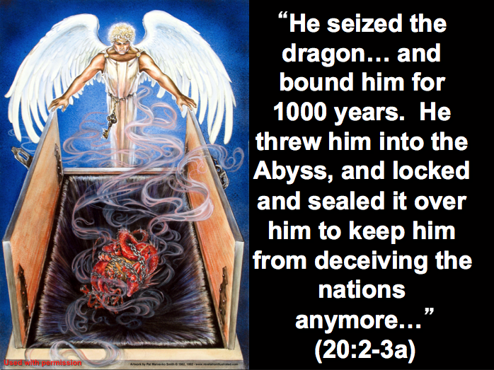

##### Does Satan deceive the nations now?

###### Amillennialists say “no.”

“For who is powerful enough to enter the house of a strong man like Satan and plunder his goods? Only someone even stronger—someone who could tie him up and then plunder his house” (Matt. 12:29)

[Jesus told the seventy-two disciples], "I saw Satan fall from heaven like lightning! 19Look, I have given you authority over all the power of the enemy, and you can walk among snakes and scorpions and crush them. Nothing will injure you"   
(Luke 10:17-18)

“The time for judging this world has come, when Satan, the ruler of this world, will be cast out” (John 12:31).

“In this way, [Christ] disarmed the spiritual rulers and authorities. He shamed them publicly by his victory over them on the cross” (Col. 2:15).

###### Premillennialists say “yes.”

The above verses show that Satan was ultimately defeated at the cross. However, none of them say that he has stopped tempting people today—and succeeding in deceiving them!

Satan is on the loose: “Stay alert! Watch out for your great enemy, the devil. He prowls around like a roaring lion, looking for someone to devour” (1 Pet. 5:8).

Others are succeeding over Satan: “Stand firm against him, and be strong in your faith. Remember that your Christian brothers and sisters all over the world are going through the same kind of suffering you are” (1 Pet. 5:9).

“Satan, who is the god of this world, has blinded the minds of those who don't believe. They are unable to see the glorious light of the Good News. They don't understand this message about the glory of Christ, who is the exact likeness of God” (2 Cor. 4:4).

“These people are false apostles. They are deceitful workers who disguise themselves as apostles of Christ. 14But I am not surprised! Even Satan disguises himself as an angel of light” (2 Cor. 11:14).

You used to live in sin, just like the rest of the world, obeying the devil—the commander of the powers in the unseen world. He is the spirit at work in the hearts of those who refuse to obey God. 3All of us used to live that way… (Eph. 2:2-3a).

Then they will come to their senses and escape from the devil's trap. For they have been held captive by him to do whatever he wants (2 Tim. 2:26).

By the way, name a country now that Satan is NOT deceiving right now…

#### (20:4-6) Christians, including believing Israel, will reign with Christ on earth for 1000 years to fulfill the Abrahamic Covenant and other promises about the kingdom of God.

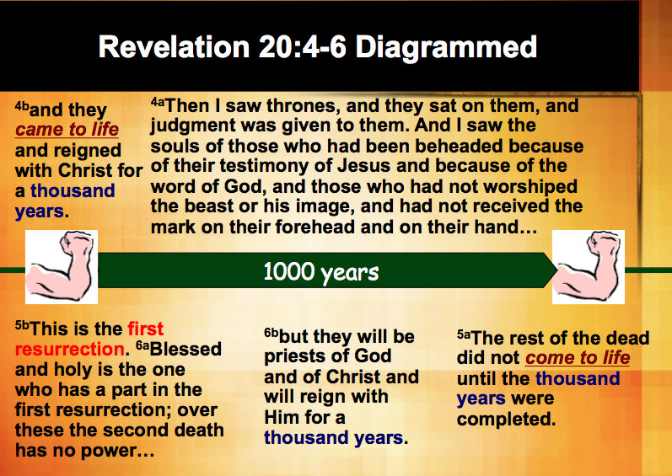

Purposes of the Millennium (20:1-6)

*Why must there be a 1000-year reign before the eternal state? Many reasons! Here are some:*

##### Believers will judge angels (Rev. 20:4a; cf. 1 Cor. 6:2-4).

##### Believers will rule the earth (Rev. 20:4b) to restore the rule originally God gave man (Gen. 1:26) that was lost in the fall (2 Cor. 4:4; cf. p. 9g top).

##### God will restore the world to pre-Flood conditions with longevity of life prior to eternity when death is no more (Rev. 21:4). Isaiah 65:20 says that death will still exist (among those with mortal bodies); however, those of us with glorified bodies will not be able to die and thus will live throughout the 1000 years.

##### Even without Satan tempting people, God will show the human heart corrupt so much that he will rebel against him and deserve judgment (Rev. 20:7-10).

##### God will fulfill His promises in the Abrahamic Covenant (Gen. 12:1-3; cf. p. 9g middle) and its unfolding covenants:

###### The *Land Covenant* will have Israel occupy its promised borders (Ezek. 37:8-28; Ezek. 47–48) with Jerusalem as the world’s capital (Isa. 2:1-5).

###### The *Davidic Covenant* will be fulfilled with Christ ruling over Israel and the world (Isa. 11) with the saints (Rev. 5:10).

###### The *New Covenant* will finally be fulfilled with a reunited, believing Israel with all who know the Lord (Jer. 31:31-34).

**Does 1000 years mean 1000 years?**

|  |  |
| --- | --- |
| **Amillennial (Beale)** | **Premillennial** |
| There is consistent figurative use of numbers elsewhere in Revelation (p. 995). | All of these are literal numbers :  • 7 churches (Rev. 2-3)  • 144,000 Jews (7:1)  • 200 million soldiers (9:16)  • 42 months (11:2)  • 1260 days (11:3)  • 75 lb. hailstones (16:21)  "The twelve apostles and the twelve tribes of Israel are literally twelve (21:12-14). The seven churches are in seven literal cities. Yet confirmation of a single number in Revelation as symbolic is impossible."[1] |
| The context has figures such as a chain, Abyss, dragon, serpent, locked, sealed, & beast. | The Abyss is a literal place (Luke 8:1) where demons are chained (2 Pet. 2:4) but can be unlocked (Rev. 9:1-2), so why can't they be *actually restrained* there?  Also, the designations at the left are literal *titles* for Satan and Antichrist. |
| The entire book has a predominantly figurative tone as in multiples of a thousand in the book (5:11; 7:4-9; 9:16; 14:1; 21:16; p. 973). | Each example cited are literal: "Thousands upon thousands" (5:11), the 144,000 (7:4-9; 14:1), 200 million troops (9:16), and the 12,000 stadia size of the new Jerusalem (21:16). None are figurative! |
| The OT contains figurative use of "1000"  (p. 995). | "With the LORD, a day is as a thousand years" (Ps. 90:4) has a symbolic use of the word "day" but makes no sense unless "thousand" is understood literally. |
| Jews and early Christians used "1000" years as a figure for the eternal blessings of the redeemed (pp. 1018-21). | In actuality, the 6000-year idea of rabbis and early Christians assumed a *literal* 1000 years as a "Sabbath." It was the *amillennial Augustine* who taught that the "eighth" day signified eternity.[2] |
| The first "came to life" is a "spiritual resurrection"  (20:4) but the second is a physical one (20:5). | • Why see the same verb *differently* in same text?  • "Came to life" *never denotes to* *a "spiritual resurrection"* in the Bible.  • "Resurrection" always denotes *physical* bodies.  • Believers are spiritually alive *now*, so no need! |
| The number "1000" is for the "fullness of time" and thus symbolizes an indefinite era as in Psalm 50:10 and 2 Peter 3:8. | Psalm 50:10 ("For all the animals of the forest are mine, and I own the cattle on a thousand hills") has nothing to do with time!  2 Peter 3:8 ("A day is like a thousand years to the Lord, and a thousand years is like a day") shows Beale reads it as a literal 1000 years! |

***All scholars before AD 300 were premillennial:***

* Clement of Rome
* Ignatius
* Papias
* *The Didache*
* *The Epistle of Barnabas*
* *The Shepherd of Hermas*
* Justin Martyr
* Melito of Sardis
* Theophilus of Antioch
* Apollinaris of Hierapolis
* Irenaeus
* Hippolytus
* Clement of Alexandria
* Tertullian
* Julius Africanus
* Cyprian
* Nepos
* Coracion
* Commodian
* Victorinus of Pettau
* Methodius
* Lactantius

After AD 300, the 1000 years began to be spiritualized by Augustine, Jerome, Theodoret and others. This non-literal view of the millennium lasted a literal millennium!

**Views on Revelation 20:1-6**

|  |  |  |
| --- | --- | --- |
|  | **Amillennial** | **Premillennial** |
| Selected Advocates | Anthony Hoekema, Leon Morris, William Hendrikson, John Gilmore | Herman Hoyt, John Walvoord, George Ladd, Robert Mounce |
| Outline of Revelation | Progressive Parallelism | Futuristic |
| Revelation 19–20 Timeline | Non-chronological  Millennium (Rev. 20) precedes Christ’s return (Rev. 19) | Chronological  Christ’s return (Rev. 19) precedes millennium (Rev. 20) |
| 1000 years  (six times in 20:1-6) | Non-literal | Literal (but some covenant premils such as Ladd say it is not literal) |
| Identity of Binding Angel (20:1-2) | Christ since: (1) He holds the keys of hades (1:5, 18; 3:7), (2) “angel” need not mean “angel” (cf. 2:1, 8, 12, 18; 3:1, 7, 14), and (3) Dan. 12:1 says the Messiah is Michael the archangel (Gilmore, 375-77). But Morris, 137 disagrees. | An angel since: (1) Christ could have given an angel the key, (2) Christ is called *“the* angel of the Lord” (Gen. 22:16 with Heb. 6:13; Gen. 22:11, 12 with Heb. 12:25), and (3) and Dan. 12:1 does not equate Michael and Christ. |
| Binding of Satan  (20:2-3) | Present: restricted from deceiving nations but can deceive individuals by being “denied full control” (Gilmore, 378; Matt. 12:29) | Future: deceives both individuals and nations now, inconsistent to say he can deceive one and not the other  (cf. 1 Pet. 5:8 says Satan is loose!) |
| Time of 20:4-6 rule | Present | Future (cf. Rev. 13:15 is future) |
| Place of 20:4-6 rule | Heaven | Earth (Rev. 20:1; cf. 5:10) |
| “Came to life” (e[zhsan in 20:4a) and “first resurrection” (ajnavstasi” hJ prwvth in vv. 5b-6a) | Spiritual: Believer’s *transition* from physical death to life in heaven with Christ *without* a resurrected body (Hoekema, 171): (1) this is the only time in the NT ajnavstasi” means other than a physical resurrection, (2) the root of e[zhsan (zavw) means being alive (3:1; 4:9, 10; 7:2; 15:7) | Physical: Believer’s bodily *resurrection* as: (1) this is the normal use of the terms, (2) the resurrections *precede* the 1000 years, (3) all are resurrected together, not individually, and (4) arguing from a root is fallacious and provides no real parallel passages |
| “Came to life”  (e[zhsan in 20:5) | A different meaning (physical resurrection here) than meant by the same phrase in verse 4 (spiritual there) | A consistent meaning of physical resurrection in both verses (which matches the physical meaning of the same Greek verb in 2:8) |
| Nature of the implied second resurrection | Believer’s bodily resurrection  (20:4-5) | Unbeliever’s resurrection  (20:12-13) |
| Number of Physical Resurrections  (20:4-6, 12-13) | One general resurrection | Several resurrections–4 groups in 3 time periods (cf. class notes, 160 but Ladd says 2 time periods) |
| Persons Judged at the Great White Throne (20:11-15) | All people | Unbelievers only (though another resurrection of believers from the millennium is also possible) |

**Questions on Revelation 20:1-6**

And I saw an angel coming down out of heaven, having the key to the Abyss and holding in his hand a great chain. **2**He seized the dragon, that ancient serpent, who is the devil, or Satan, and bound him for a thousand years. **3**He threw him into the Abyss, and locked and sealed it over him, to keep him from deceiving the nations anymore until the thousand years were ended. After that, he must be set free for a short time.

**4**I saw thrones on which were seated those who had been given authority to judge. And I saw the souls of those who had been beheaded because of their testimony for Jesus and because of the word of God. They had not worshiped the beast or his image and had not received his mark on their foreheads or their hands. They came to life and reigned with Christ a thousand years. **5** (The rest of the dead did not come to life until the thousand years were ended.) This is the first resurrection. **6** Blessed and holy are those who have part in the first resurrection. The second death has no power over them, but they will be priests of God and of Christ and will reign with him for a thousand years (NIV).

Where do the saints rule (20:4)?

***Amils often say in heaven***

***But Revelation says it is on earth***

• "And you have caused them to become a Kingdom of priests for our God. And they will reign *on the earth*" (5:10).

• *No change of location* is noted from verse 3 (on earth) to verse 4, so we should assume verses 4-6 also to be on earth.

When do the saints rule (20:4)?

***Amils claim it is now***

***But Revelation says it is future***

• "And you have caused them to become a Kingdom of priests for our God. And they *will reign* on the earth" (5:10).

• "…they *will* be priests of God and of Christ and *will* reign with Him for a thousand years" (20:6).

**The First Resurrection (20:4)**

Revelation 20:4-6 mentions two resurrections—the “first resurrection” before the 1000 years that enables the saints to reign (vv. 4, 6) and another resurrection of the “rest of the dead” after the 1000 years (v. 5). The *timing* of these two resurrections is different (before and after the 1000 years), but is the *nature* of them different too? In other words, are these both *physical* resurrections? Or is there even any *other* type of resurrection besides a physical one?

**Beale (amil) refuses to equate the two resurrections with** **"came to life" (e;zhsan) at the "first resurrection."**

**Beale says "came to life" (from za,w, "to live") can have three different meanings:**

* Physical resurrection (1:18; 2:8)
  + NLT Revelation 1:18 I am the living one. I died, but look—I am alive forever and ever! And I hold the keys of death and the grave.
  + NLT Revelation 2:8 "Write this letter to the angel of the church in Smyrna. This is the message from the one who is the First and the Last, who was dead but is now alive"
* Physical existence (16:3; 19:20)
  + NAU Revelation 16:3 The second angel poured out his bowl into the sea… and every living thing in the sea died.
  + NLT Revelation 19:20b … Both the beast and his false prophet were thrown alive into the fiery lake of burning sulfur.
* Spiritual existence (3:1; 7:17; 13:14)
  + NLT Revelation 3:1 "Write this letter to the angel of the church in Sardis…   
    “I know… that you have a reputation for being alive—but you are dead.”
  + NAU Revelation 7:17 for the Lamb in the center of the throne will… guide them to springs of the water of life…"

Seeing both as physical advocates *two* resurrections but this contradicts the amillennial system that teaches only *one general resurrection* after the millennium (viewed as the present age). Therefore, this third (spiritual) meaning is the one Beale, 1004, applies to the “first resurrection” but not to the second one.

**So which of these three nuances is best in 20:4? And how can we tell?**

1. "Resurrection" (avna,stasij) in the NT only means physical, bodily life into a glorified body:

NLT John 11:25 Jesus told her, "I am the resurrection and the life. Anyone who believes in me will live, even after dying.

NIV 1 Cor. 15:12 But if it is preached that Christ has been raised from the dead, how can some of you say that there is no resurrection of the dead?

The same physical resurrection nuance is in 1 Cor. 15:13, 21, 42

1. Physical resurrection is also the clear meaning of the same word "resurrection" (avna,stasij) in verse 5.

Would it *not* make sense to interpret the same *word* the same *way* in consecutive verses, especially since "resurrection" by definition refers to physical life?

1. However, Beale and other amillennialists view the passage inconsistently where…
2. "resurrection" (avna,stasij) in verse 4 as "spiritual"
3. "resurrection" (avna,stasij) in verse 5 as "physical"

**Beale, 1004-5 defends his inconsistent use of "resurrection" (avna,stasij) in verses 4-5:**

"Elsewhere in the NT avna,stasij and za,w (or the cognate noun zwh,, 'life') and synonyms are used interchangeably of both spiritual and physical resurrection *within the same immediate contexts*." For example…

NIV Romans 6:4 We were therefore buried with him through baptism into death in order that, just as Christ was raised from the dead through the glory of the Father, we too may live a new life.

**Rebuttals:**

1. Is this "both spiritual and physical resurrection"?

No. Only the first is a physical resurrection!

2. Are "resurrection" and "life" synonyms here?

No. But Christ's physical resurrection gives spiritual life.

**Beale, 1005 again defends his inconsistent interpretation of "resurrection" (avna,stasij) in verses 4-5:**

The "first death of believers… is physical and different in nature from the second death of unbelievers, which is spiritual."

NIV Rev. 20:4b They came to life and reigned with Christ a thousand years.

Rebuttals:

1. Is "came to life" = "the first death of believers"?

No. Coming to life does not refer to dying!

2. Are "first death" and "second death" in time (20:14)?

Of course, as 1000 years separates them!

3. Are these "two deaths" therefore "different in nature"?

No. There *is* no "first death"—only a "first resurrection"!

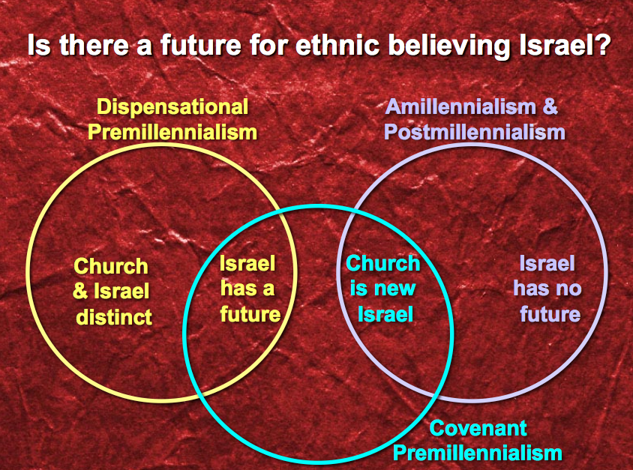**Is There a Future for Ethnic Believing Israel?**

The question of a future for Israel may seem like an irrelevant issue for those obsessed with theological trivia. However, this question relates intricately with who Israel really is today (her identity) and one’s answer here will determine the meaning of literally hundreds of verses in the Bible. The answer falls basically into three distinct camps or viewpoints as seen in the circle chart at the right.

**The Kingdom Diagrammed**

The word “kingdom” is used in a different sense in various texts of Scripture:

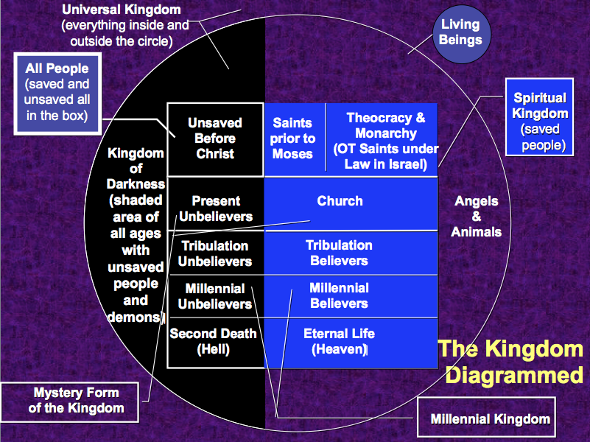

|  |  |  |
| --- | --- | --- |
| ***Aspect of the Kingdom*** | ***Description*** | ***Scripture*** |
|  |  |  |
| *Universal Kingdom* | All creation of every age | Ps. 145:13; 1 Chron. 29:12 |
| *Spiritual Kingdom* | All saved of every age (white above) | Heb. 12:22-24; Col. 1:13b |
| *Kingdom of Darkness* | All unsaved of every age (dark above) | Col. 1:13a |
| *Unsaved Before Christ* | Unbelievers prior to Christ’s death | Gal. 3:21-22 |
| *Saints Before Moses* | Those with faith in God (e.g., Noah) | Gen. 6:9; 15:6 (Abraham) |
| *Theocratic Kingdom* | God’s rule over Israel as mediators | Exod. 19:6 |
| *Mystery Form* | Present saved & unsaved | Matt. 13:24-30, 47-50 |
| *Church* | Saved between Pentecost & Rapture | Matt. 13:38 |
| *Present Unbelievers* | Unbelievers in Church Age | 2 Cor. 2:15 |
| *Millennium* | All people of the Millennium | Isa. 65:20 |
| *Tribulation Unbelievers* | Unsaved of the Tribulation | Rev. 16:10 |
| *Tribulation Believers* | Saved of the Tribulation | Rev. 20:4 |
| *Millennial Unbelievers* | Unsaved of the Millennium | Rev. 20:7-10 |
| *Millennial Believers* | Saved of the Millennium | Zech. 8:23 |
| *Second Death* | Unbelievers in Hell | Rev. 20:14 |
| *Eternal Kingdom* | Spiritual Kingdom in new creation | Dan. 2:44; Rev. 21–22 |

**Views on the Millennium**

**Definitions**

1. The word "millennium" means "a period of a thousand years" (Funk & Wagnalls Standard College Dictionary), stemming from the Latin *mille*, "thousand" and *annus*, "year."

2. Although the word "millennium" itself is not in the Bible, the term refers to the thousand year reign of Christ found six times in Revelation 20:2, 3, 4, 5, 6, 7. According to premillennialists it refers to the 1,000 year earthly reign of Christ in fulfillment of the Abrahamic (Gen. 12), Land (Deut. 30), Davidic (2 Sam. 7), and New (Jer. 31) Covenants.

3. The Millennium is also called “Your kingdom come” (Matt. 6:10) and “the kingdom of God (Luke 19:11), the kingdom of Christ (Rev. 11:15), the regeneration (Matt. 19:28), the times of refreshing (Acts 3:19), and the world to come (Heb. 2:5)" (Ryrie, Synopsis, 1953). The “Sabbath rest” (Heb. 4:9) also likely refers to the Millennium.

**Major Questions Addressed in the Millennial Views**

1. The millennial question generally concerns when Christ will come in relation to this millennium. Will He return before or after the millennium?

2. Also, “the millennial question asks what kind of Millennium there will be. That there will be a Millennium is a fact clearly taught in Revelation 20:1-6, but what *kind of* Millennium that will be is and has been strongly debated through the years” (Charles C. Ryrie, *What You should Know About the Rapture*, 10, emphasis mine).

**Major Questions Answered by the Millennial Views**

|  |  |  |  |
| --- | --- | --- | --- |
|  | **View** | **Time**  ***When* is the Millennium?**  ***Before/after* Christ’s Return?**  ***How long* is it?** | **Nature**  ***What kind* of Millennium?** |
| 1. | Amillennialism | • Between 1st & 2nd advents  • Before the Second Coming  • Indefinite length | • Spiritual kingdom of Christ  • The present age itself  • No future for national Israel |
| 2. | Postmillennialism | • No Specific Beginning Point  • Before the Second Coming  • Indefinite length (but a few say  it is a *literal* 1000 years, such as  Boettner & Chilton) | • Literal rule of the Church on  earth without Christ present  • Similar to the present age  (sin, marriage, birth & death  present but greatly reduced)  • No future for national Israel |
| 3. | Premillennialism | • Future  • After the Second Coming  • Literal 1000 years | • Literal rule of Christ on earth  • Similar to postmil except  Jewish elements, topographical  changes, etc.  • Future for national Israel |

**Diagrams of the Millennium**

Charles C. Ryrie, *What You should Know About the Rapture* (Chicago: Moody, 1981), 10-11

**Millennium Diagrams by RyrieKingdom Aspects**

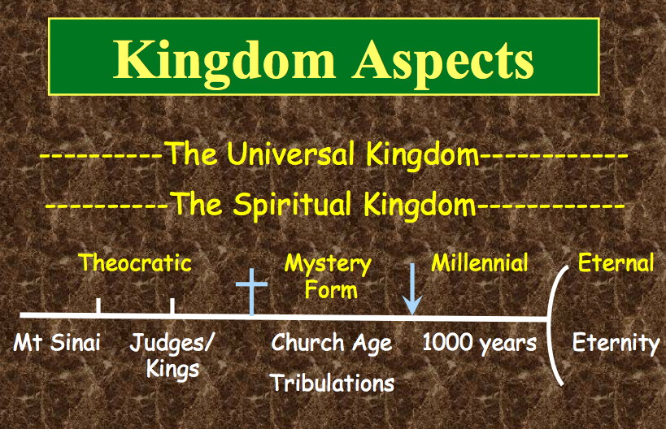

**Revelation 20:1-6 Chronology**

* **Satan bound 1000 years (1-3)**
* **Saints come to life = first resurrection (4b, 5b)**
* **Saints reign 1000 years (4a, 4c, 6b)**
* **Second resurrection (5, 13)**

**Why am I premillennial?**

* **The best hermeneutic is a normal, literal, historical, and grammatical reading of a text.**
* **Rev. 19 (Christ's return) is before Rev. 20 (Christ's rule)**
* **It is the most natural way to see the 1000 years (20:1-6)**
* **OT prophets saw a future time that is neither the present age nor heaven:**
* **Animal kingdom tamed (Isa. 11:6-9)**
* **Long life but still death (Isa. 65:20)**
* **Yearly observances after Messiah's return (Zech. 14:15-17)**

**Millennium Mortals**

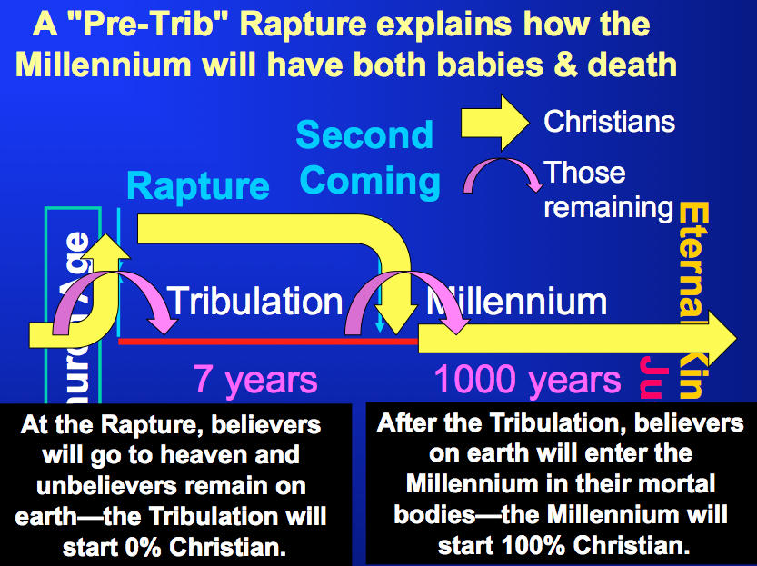

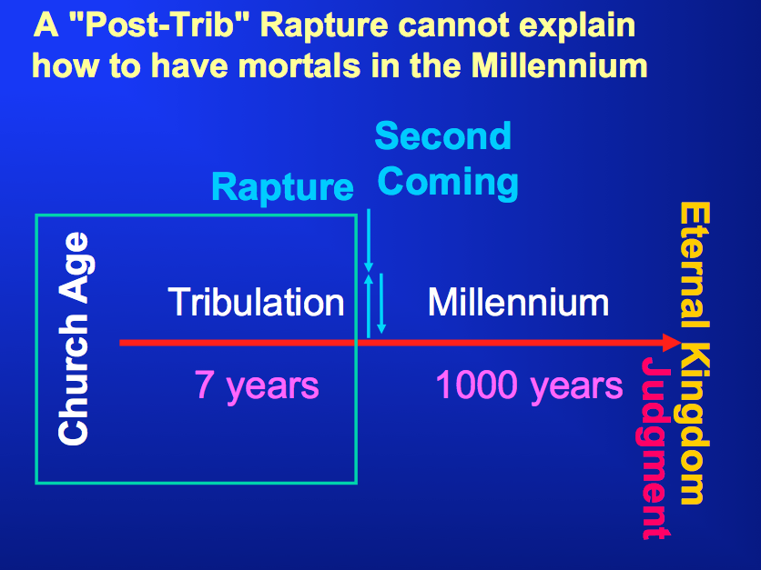

*Continued point “C” that began on page 421…*

2. (20:7-10) Satan's final torment in the lake of burning sulfur after his defeat by Christ at the Battle with Gog and Magog will show Christ's victory over His long-time enemy.



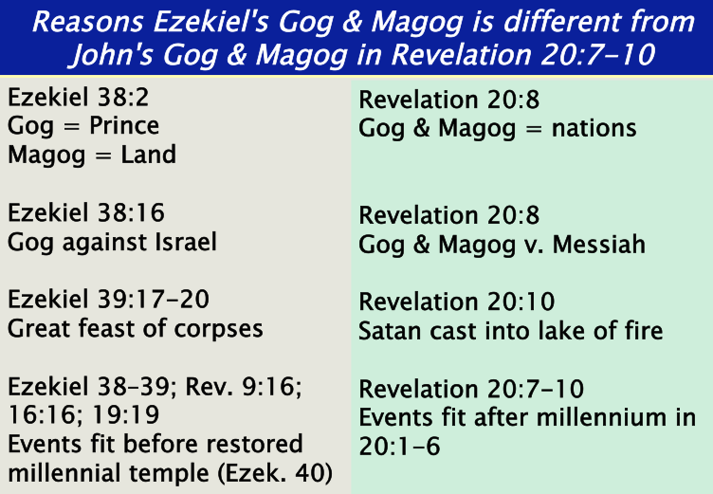

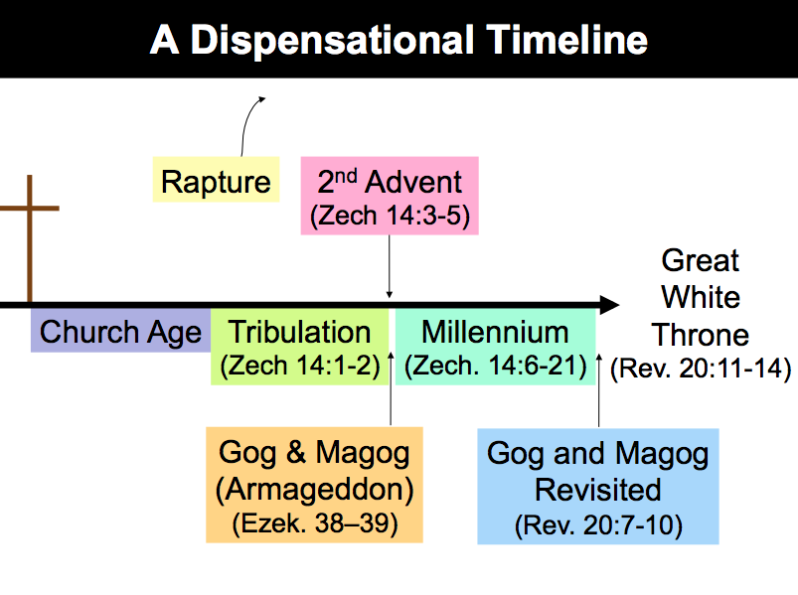

### (20:11-15) Judgment of unbelievers at the great white throne shows God's just vengeance upon all who opposed Him and His victory over the last enemy, death.

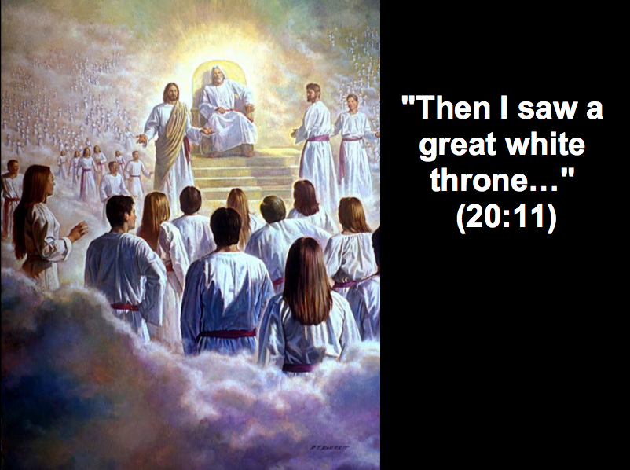

**Resurrections & Judgments in Revelation 20**

**I. Introduction**

A. Amillennarians teach from John 5:28-29 one resurrection of the saved and lost, but the Bible records at least *four* different resurrected groups in three separate time periods (see below).

B. It is inaccurate to speak of a single judgment day as Scripture records *seven* judgments.

C. Multiple judgments should not sound strange to our ears as there has already been multiple judgments in the past: Lucifer and angels (2 Pet. 2:4; Jude 6), Flood (Gen. 6–7), Babel (Gen. 11:1-9), Northern nation of Israel (2 Kings 17:1-6), Judah (2 Kings 25:1-12), Ananias and Sapphira (Acts 5:1-11), and even the present (Rom. 1:18).

D. Past judgments only applied to *some* people, but future judgments will apply to *all* people who have ever lived (Heb. 9:27). The general guide for severity of punishment will be: the greater the knowledge of the truth, the greater the judgment (Matt. 11:24; Luke 12:48).

**II. Chart of Resurrections and Judgments**

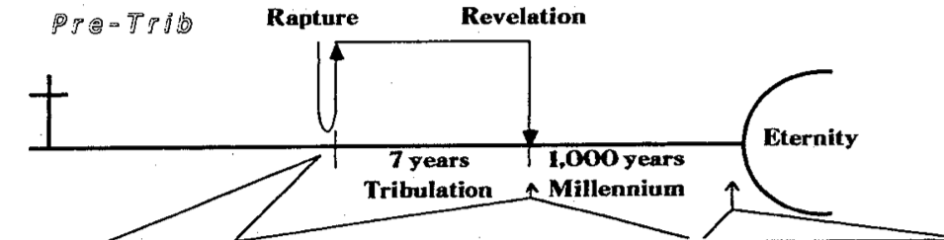

|  |  |  |  |  |  |  |  |
| --- | --- | --- | --- | --- | --- | --- | --- |
| Time | Rapture | Second Coming at End of the Tribulation | | | | End of Millennium | |
| Resurrection | Yes | Yes | Yes | No | No | No | Yes | |
| Judgment | Judgment Seat of Christ | Old Test. Saints | Tribulation Saints | Nation of Israel | Nations (Gentiles) | Satan and Fallen Angels | Great White Throne | |
| Persons | Believers of church age | Believers of OT times | Martyred Tribulation Believers | Jews who survive the Tribulation | Gentiles who survive the Tribulation | Satan and demons | Unbelievers of all times (except the Tribulation) + Millennium mortals | |
| Place | *Bema* of Christ (heaven) | Earth? | Earth? | Wilderness (Ezek. 20:35) | Valley of Jehoshaphat (Joel 3:1-2) | Angelic sphere? | Great White Throne in Heaven | |
| Basis | Works and walk of the Christian life | Faith in God | Faith in Christ | Faith in Christ shown in works (Mal. 3:2-3) | Faith in Christ shown in treatment of Israel (Matt. 25:40, 45) | Satan’s fall (Isa. 14:12-17; Ezek. 28:12-19); demons follow Satan | Rejection of God’s general revelation and/or special revelation in Christ | |
| Results | Rewards or loss of rewards | Rewards | Reign with Christ in the Millennium | Believers to kingdom; rebels sent to Hades | Believers to kingdom; rebels sent to Hades | Lake of Fire (hell) | Lake of Fire (hell) | |
| Scripture | 1 Cor. 3:10-15; 2 Cor. 5:10; 1 Thess. 4:13-18; 1 Cor. 15:20-54 | Dan. 12:1-3 | Rev. 20:4-6 | Ezek. 20:34-38; Matt. 25:1-30; Zech. 14:4 | Joel 3:1-2; Isa. 34:1-2; Matt. 25:31-46 | Matt. 25:41; 2 Pet. 2:4; Jude 6; Rev. 20:10 | Rev. 20:11-15 | |

**Questions on Resurrections and Judgments**

Question 1: Daniel 12:2 says, “Multitudes who sleep in the dust of the earth will awake: some to everlasting life, others to shame and everlasting contempt” (NIV). Daniel 12:1 places the resurrections during the time when believing Israel is delivered at the end of the tribulation period. However, a resurrection of the lost at this time provides them immortal bodies 1000 years before their ultimate end in the lake of fire (Rev. 20:14-15). The preceding chart shows Daniel 12:2 relating to Old Testament saints, but doesn’t it relate to *all* who are *saved* as well as those *unsaved?* And how could the unrighteous be raised at this point since Revelation 20:5 clearly states that they would not be raised until after the 1000-year period?

Answer: This text is not as problematic as it may at first appear:

1. Technically, this verse teaches only that both groups will be raised after the tribulation. It does not exclude a time period in between the two resurrections. In fact, this would not be unusual as OT prophets often include events together which we see now as separated by large time periods (e.g., Isa. 61:1-2).

2. The best reconciliation of the problem lies in questioning whether the above translation is correct. “Actually the Hebrew seems to separate sharply between the two classes of resurrection. Tregelles, following earlier Jewish commentators, translated verse 2, ‘And many from among the sleepers of the dust of the earth shall awake; these shall be unto everlasting life; but… the rest of the sleepers, those who do not awake at this time, shall be unto shame and everlasting contempt.’ Robert Culver defends this translation by finding support in commentaries by Seiss and Nathaniel West” (Walvoord, *Daniel*, 287-88).

3. Note that the text says “many” who sleep rather than “all.” This is deliberate and thus does not indicate a general resurrection of all people but only of believing Jews. Some amillenarians suggest that “many” really means “all,” and this is true in some parallel passages (Leupold cites Matt. 20:28; 26:28; Rom. 5:15, 16). But other amillennial scholars disagree, taking the text in its more natural sense (e.g., Young, Beven).

4. The passage goes on to record the nature of the righteous’ reward (v. 3) but says nothing of the punishment of the wicked. While this does not *prove* that both groups are not raised at this point, it nonetheless supports the concept that the righteous are raised here while the wicked are raised at a later point. Revelation 20:14-15 shows this later time to be 1000 years later.

_____________________

Question 2: Why do so many premillennialists insist that believers will not appear at the great white throne judgment (Rev. 20:11-15)? Many point out that Christians are not mentioned here, but this argument from silence seems weak.

Answer: I agree. I do not feel it is necessary to exclude all believers. What about those who will be born in mortal bodies during the millennium and then come to faith in Christ? Surely they must also appear for judgment to receive glorified bodies for eternity. While such persons could not technically be called members of the Church (since this exists only from Pentecost to the Rapture), they still must be judged to determine the extent of their rewards (not for salvation). A separate judgment of rewards for them is not mentioned in Scripture, but logically must occur for them.

**Traditional versus Biblical Views of Hell**

|  |  |
| --- | --- |
| **Traditions on Hell** | **The Bible on Hell** |
| Man dwells with the devil | Man is alone (Luke 13:28) |
| “At least my friends  will be there” | Yes, but you won’t see any of them  (Luke 13:28) |
| Bodies will suffer mild discomfort | Bodies will suffer from burning sulfur and consumption by worms (Mark 9:47-48; Rev. 21:8) |
| Satan is tormenter over all inn Hell | Satan in torment with those tormented (Rev. 20:10) |
| A place of solid earth | A lake of suffering (Rev. 20:10) |
| People alone suffer there | Demons as well as people suffer  (2 Pet. 2:4) |
| Satan rules with a pitchfork | Satan thrown into Hell without any emblems of dominion (Rev. 20:10) |
|  |  |

**Differences Between the Millennium and Heaven**

|  |  |  |
| --- | --- | --- |
|  | **Millennium** | **Heaven** |
| **Duration** | **1000 years (Rev. 20:1-6)** | **Eternal (Rev. 22:5)** |
| **Death** | **Possible (Isa. 65:20)** | **Impossible (Rev. 21:4)** |
| **Longevity of Life** | **“Never again will there be an infant who lives a few days. He who dies at a hundred will be thought a mere youth” (Isa. 65:20)** | **No aging (Rev. 21:4 implied)** |
| **Sin Nature** | **Active (Rev. 20:7-9)** | **Abolished (Rev. 21:27)** |
| **Inhabitants** | **Initially Christian, but later includes unbelievers –no living with angels? (Matt. 25:34; Rev. 20:7-9)** | **Saints and angels alone (Rev. 21:27)** |
| **Bodies** | **Mortal and immortal living together (Isa. 65:20; 1 Cor. 15:42-44)** | **Only immortal (glorified)**  **(1 Cor. 15:42-44)** |
| **Satan** | **Bound, but then released after 1000 years (Rev. 20:3, 7)** | **In lake of burning sulfur, never to be released again (Rev. 20:10)** |
| **Political &**  **Religious Centre** | **Jerusalem (Isa. 2:2-3; Micah 4:1-2, 7)** | **New Jerusalem (Rev. 21)** |
| **Place** | **Earth (Rev. 5:10)** | **New heavens and new earth (Rev. 21:1)** |
| **Key**  **Passages** | **Psalm 72; Isaiah 2; 11; 65–66; Revelation 20:1-6** | **Revelation 21–22** |

**Thy Kingdom Come**

***Revelation 20***

**Exegetical Outline (Steps 2-3)**

# *Exegetical Idea*: The purpose of the millennium will be to show Christ's sovereignty as Ultimate Victor over the earth, Satan, and death itself (Ch. 20).

# I. The millennium will fulfill many OT prophecies with Satan bound and believers ruling with Christ on earth for 1000 years until sinners rebel afterwards (20:1-10).

## Satan will be bound the entire length of the millennium to prevent him from deceiving the nations for the 1000 years that Christ rules (20:1-3).

## Saints will reign with Christ on earth for 1000 years to fulfill the Abrahamic Covenant and other promises about the kingdom of God (20:4-6).

## Sinners will fight Israel at the Battle with Gog and Magog after the 1000 years but Christ will defeat them and throw Satan into hell (20:7-10).

### Sinners of all nations win join Satan after his release to battle Israel like the war of Gog and Magog 1000 years earlier in the Tribulation (20:7-9a).

### God will judge both Satan and his armies with fire (20:9b-10).

#### Fire from heaven will burn up the attacking armies (20:9b).

#### Fire in hell will eternally torment Satan with the Antichrist and False Prophet in the agony they will have had for 1000 years (20:10).

# III. Judgment of unbelievers at the great white throne shows God's just vengeance upon all who oppose Him and His victory over the last enemy, death (20:11-15).

## God will raise and judge all unbelievers based on their faith not recorded in the Book of Life and their deeds *recorded* in other books (20:11-13).

## All unbelievers will be tormented in the lake of fire eternally (20:14-15).

**Purpose or Desired Listener Response (Step 4)**

The listeners will either trust Christ for salvation (unbelievers) or trust Christ to better rule with him later (believers)

**Homiletical Outline** (Cyclical inductive form)

# Introduction

### Interest: Great battles always have an epilogue—and sometimes it relates to you!

### Need: Do you know how *you* fit into the Bible’s epilogue after Christ’s victorious return?

### Subject: How will Christ mop up the world after his return?

### Background: The entire Revelation has led to the point where Christ returns and judges the earth in chapter 19. Now what?

### Preview: The millennium and judgment are two of the final three results of Christ’s victory.

### Text: Revelation 20 provides two mop up operations.

# I. You will rule the earth with Christ for 1000 years until Satan’s last stand (20:1-10).

## Satan won’t deceive people for 1000 years (20:1-3).

## Saints will rule this earth for 1000 years (20:4-6).

## Sinners will challenge Christ’s rule unsuccessfully (20:7-10).

### Sinners of all nations win join Satan after his release to battle Israel like the war of Gog and Magog 1000 years earlier in the Tribulation (20:7-9a).

### God will judge both Satan and his armies with fire (20:9b-10).

(The second mop up operation following the Second Coming of Christ is that...)

# II. Christ will judge all people and defeat his last enemy, death (20:11-15).

## God will raise and judge all people (20:11-13).

## All unbelievers will be tormented in the lake of fire eternally (20:14-15).

(How will Christ mop up the world after his return?)

# Conclusion

### Jesus will rule and judge all creation (Main Idea).

### Main Points

### OK, but what should I do?

#### Unbelievers, *make sure you are in the Book of Life* by trusting Christ for salvation.

#### Believers, *get ready to rule* by serving faithfully now.

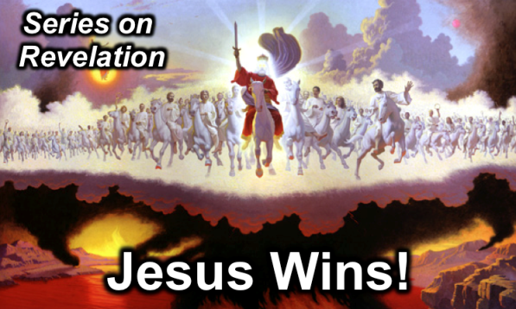

**Rick Griffith**

27 April 2014

Message 19 of 20

**Thy Kingdom Come**

***Revelation 20***

# Introduction

### Great battles always have an epilogue—and sometimes it relates to you!

### Do you know how *you* fit into the Bible’s epilogue after Christ’s victorious return?

### How will Christ _______ up the world after his return?

### The millennium and judgment are 2 of the 3 mop-up operations of Christ’s victory.

# I. You will ________ the earth with Christ for 1000 years until Satan’s last stand (20:1-10).

## Satan won’t deceive people for 1000 years (20:1-3).

## Saints will rule this earth for 1000 years (20:4-6).

## Sinners will challenge Christ’s rule unsuccessfully (20:7-10).

### Sinners of all nations win join Satan after his release to battle Israel like the war of Gog and Magog 1000 years earlier in the Tribulation (20:7-9a).

### God will judge both Satan and his armies with fire (20:9b-10).

(The second mop up operation following the Second Coming of Christ is that...)

# II. Christ will ________ all people and defeat his last enemy, death (20:11-15).

## God will raise and judge all people (20:11-13).

## All unbelievers will be tormented in the lake of fire eternally (20:14-15).

(How will Christ mop up the world after his return?)

# Conclusion

### Jesus will ___________ and ________________ all creation (Main Idea).

### But what should I do?

#### Unbelievers, *make sure you are in the Book of Life* by trusting Christ for salvation.

#### Believers, *get ready to rule* by serving faithfully now.

**Thought Questions:**

1. Read Revelation 20 aloud. Then look up these passages listed by John Walvoord and draw as many correlations as you can: “Many passages speak of the second coming of Christ being followed by a reign of righteousness on earth (Pss. 2; 24; 72; 96; Isa. 2; 9:6-7; 11-12; 63:1-6; 65-66; Jer. 23:5-6; 30:8-11; Dan. 2:44; 7:13-14; Hosea 3:4-5; Amos 9:11-15; Micah 4:1-8; Zeph. 3:14-20; Zech. 8:1-8; 14:1-9; Matt. 19:28; 25:31-46; Acts 15:16-18; Rom. 11:25-27; Jude 14-15; Rev. 2:25-28; 19:11-20:6).”
2. Is your name written in the Book of Life? How do you know?

Text

Text

1. What should you be doing *now* to better rule with Christ in the future?

Text

1. Robert L. Thomas, *Revelation 8–22: An Exegetical Commentary* (Chicago: Moody, 1995), 408-9.
2. Augustine, *Sermons on the Liturgical Seasons* 259.2; *City of God* 20.7.