Crossroads International Church Dr. Rick Griffith
Title
12 January 2014 Series on 7 Churches of Rev. 2–3 Message 6 of 7
NLT 40 Minutes
Mistreated Yet Missions Focused
Revelation 3:7-13

Topic: Evangelism
Subject: How does Jesus encourage us to reach out?
Complement: Jesus gives us both opportunities and rewards for witness.
Purpose: The listeners will step through one open door for them to share Christ.
Song: “He Knows My Name”

Introduction

Interest: [Each church has the danger of the “holy huddle.”]

One of the nicest parts of several different sports is the huddle. The team gets together in a circle to plan their strategy for the game and senses a spirit of unity and camaraderie.
Huddle

After all, who hates unity? No one.
Hates unity?

We certainly don’t at Crossroads. We work hard to be a united family, despite our 16 countries represented. What a joy to come together and worship the same Jesus, who stemmed from none of our nationalities here!
CIC unity

But huddles have an inherent danger. Huddles are designed to be temporary until the team goes back into the game. But what if the team never left the huddle?
Huddle

When this applies to churches it is has been sometimes called “Holy Huddle.” There is worship of the true God, unity of purpose and focus on holiness.
Holy Huddle

But there is also the danger of liking to be around everyone who looks like us, acts like us, sounds like us, smells like us. That’s not unity—its uniformity!
Masks
Ducks

That is dangerous! To accomplish uniformity we must all wear masks.

Need: Why do you like CIC? At times I have heard people say they like being in a church of 40-50 people. Small churches have their advantages, like being able to learn everyone’s name within a few weeks. This is when we “love the church” too much, as in our vision statement.
Love the church
Why like?

But do you want our church to remain small?
Small?

Do you fear us getting big where we lose our family atmosphere?

Do you fight growth?

Or do you enfold new people?

Do you invite others to church?
Jesus wants

Subject: More important than what we want is what Christ wants for us. He certainly wants us to reach out, but how does Jesus encourage us to reach out?
• Subject

Background: [The Asia Minor churches were under persecution to the extent that they were tempted to remain small.]

Recently we have been studying a small group of seven churches in the Roman province of Asia—and we’ve found that they aren’t too different from our churches in modern Asia.
7 churches study
Asia

All had internal problems and also were opposed by Rome at the end of the first century.
Internal
• External

Also, as we have seen in five letters to these churches so far, many were not faithful. The letters actually form a chiasm, or literary structure where previous elements are repeated in reverse order.
Chiasm

For example, the continued existence of the first church at Ephesus was threatened—but the same is said of the last church at Laodicea, as we will see next week.
• Threatened

The second church, Smyrna, in contrast, was faithful in persecution—and the same is said of the second-to-last church of Philadelphia.
• Persecuted

The three middle churches were a mixed bag.
•
Mixed bag

All of these churches were suffering some level of persecution—and difficulty has its natural way of making us hunker down rather than reach out.

Preview: But today we will see two ways that Jesus encourages us to reach out.
2 ways

Text: Revelation 3:7-13 shows us how Jesus encourages the church at Philadelphia—and us—to reach out.

(The first way that Jesus encourages us to reach out is that...)

I. Christ opens doors for witness (3:7-8).
MP
[We often fear evangelism, but it is none other than Jesus himself who brings us evangelistic occasions!]
Fear

Christ gave Philadelphia opportunities to witness (3:7-8).
Shine

Destination: Philadelphia (3:7a).

One scholar writes, “Philadelphia was founded either by Eumenes II, king of Pergamum, or his younger brother Attalus I [Philadelphus] I, who reigned from 159-138 B.C. Founded in honor of Attalus II, the name of the city means “lover of his brother.” This refers to Attalus’ loyalty to his brother in refusing to overthrow him, even amidst encouragement from advisors to do so.”
Photo

“Philadelphia was located on the junction of several important trade routes, earning it the nickname ‘gateway to the east.’ The city was intended to serve as a base for the spread of [Greek culture] to the recently-annexed territories of Lydia and Phrygia.”
Map

Description of Christ: He is holy, true and able to give opportunities for service (3:7b-c).
Circles

“Holy” means Christ is worthy to judge the spiritual life of the Philadelphia church.
Isa. 22:22
7b

This quotes Isaiah 22:22, where David’s court officer, Eliakim, had access to all of King David’s wealth. Likewise, Christ holds all spiritual treasures, including opportunities for service!
7c
• Key

Commendation: He gave them opportunities based on their faithfulness (3:8).
8

They were faithful, obedient, didn’t deny Christ, and endured.
Circles

So Christ gave them an open door for ministry—and you know what? Christian testimony continues in this city even to today!
Open door

Jesus has given our church many open doors for witness too.
• CIC open doors

We come from 16 nations, so we have doors to others in our nationalities right here in Singapore.
CIC Pics
CIC Map

We have open doors to love the nations by supporting missions.
Vision

Our third part of our vision statement is to love the nations.
11 nations

We give to about 11 countries now.
20%

We commit to give at least 20% of offerings overseas.

Last year we gave 28% of offerings outside of Singapore.
Trips

We have open doors in mission trips.

I have to do this to keep fresh, so I’ve had 52 trips to 12 nations the past 17 years that I’ve been training pastors in other nations outside Singapore.
My Trips

CIC has sponsored members on mission trips to Mongolia and Myanmar in recent years—plus our youth in China, Philippines, Mexico, Ethiopia, and India.
Myanmar (Lewis)
Mongolia

CIC has invitations to Bangkok and Yangon this year by CIC members living in Thailand and Myanmar.
Invitations
Jonathan

Jonathan Stone has asked for our help in Yangon.
Small group
Manik

Manik Corea is planting an international church in Bangkok and could use help.
Lakeside

We have open doors at Lakeside Family Services where Albina Chan serves to counsel youth, teach English, etc..
Prison

We have open doors in prison ministries, as we will see in the coming weeks.

Too often we use ineffective means to share Christ.
Bullhorn

Sometimes believers aren’t too enfolding either in our evangelism.
Cartoon

But we have open doors at our natural places such as our places of business.
Work

Just talk to people and you will discover there are more open doors than you ever imagined!
Just talk
MPI
Subj
(So Jesus encourages us to reach out in 2 ways. First, Christ opens doors for witness. What is the second way he encourages us to witness?)

II. Christ promises rewards for service (3:9-13).
MPII
[Jesus will not forget to bless us for serving him!]
Circles

Christ promised Philadelphia benefits for their perseverance (3:9-13).

He promised them honor before their enemies (3:9).
3:9

He promised them deliverance from the Tribulation (3:9-11a).
6 slides

He promised them rewards for their perseverance (3:11b). Lack of endurance leads to loss of rewards—not loss of salvation (cf. 2 John 8).
Crowns

He promised them strength and security (3:12a).
Star

“The word picture of the pillar would have had special significance for the inhabitants of a city plagued with earthquakes. Pillars were support for buildings; this is a picture of God’s solid nature and holy temple, compared with the fallen pillars of the pagan gods” (Bolen, slide 6)
Pillars
Acropolis

The Church of St. John later had immense pillars in memory of this verse!

He promised them the New Jerusalem (3:12b).
Star

“The name mentioned in the verse would have had significance in light of the city’s numerous name changes over the years.” I found at least four names for the city! Maybe there were more!

Bolen claims, “Naming is one way to claim possession; just as each emperor tried to claim dominion from the city by re-naming it, so God establishes His eternal dominion over the believers by giving them an eternal, unchanging name” (Bolen, slide 6).

Our name identifies our family. “Because believers have identified with Christ by faith, He will identify Himself with them” (Walvoord, BKC).

He warned the church to listen to the Spirit (3:13).
Our Rewards

Jesus will reward our service too.

Einstein said, “If people are good only because they fear punishment, and hope for reward, then we are a sorry lot indeed.”
Einstein

Really? It is not wrong to work for rewards. You do this at your job!
Wrong?

Christ knows that the reward of being one of his servant kings will motivate us.
Reign of Servant

In fact, The Reign of the Servant Kings is an entire book on the biblical view of rewards—subtitled a Study of Eternal Security and the Final Significance of Man. I’d be happy to loan it to you if interested.
Reign of Servant
Subject
(So how does Jesus encourage us to reach out?)

Conclusion

Christ opens doors for witness and promises rewards for service. In a word…
MPI
MPII

Jesus gives us both opportunities and rewards for witness (MI).
MI

Don’t stay in a holy huddle!
No Holy Huddle

What open doors has Christ given you for this year?
Our open doors

Did any of the mission trips seem like a fit for you?

How about local ministry to youth or prisoners?

God is bringing more young professionals here. Can you help gather them together?

Some love kids and babies, so there are open doors there too.

Ask God which door you should step through and write it on your notes there in your seat. Give your open hands to His open doors!
• Open hands

Prayer
Black

Preliminary Questions

Verses Questions

Context: What did the author record just prior to this passage?

Jesus is winding down his seven letters to the churches, having just finished the letter to Sardis to tell them to wake up from their slumber in service for him.

Purpose: Why is this passage in the Bible?

This text is a great reminder that Christ goes before us to open doors for ministry.

Background: What historical context helps us understand this passage?

The city of Philadelphia, meaning “brotherly love,” was another key cite of Asia Minor.

Questions

What is the significance of Jesus being the one with the “key of David” for the opening and closing of doors (7)?

Is the open door for the church one for evangelism (8)?

Are those “liars” belonging to Satan’s synagogue actual Jews in Philadelphia (9)?

When would these people bow down to the Philadelphian believers (9b)?

Is the protection from the worldwide tribulation conditional and based on perseverance (10)?

What does it mean to “hold on to what you have, so that no one can take away your crown” (11)?

I what sense will the believers become “pillars in the Temple of my God” (12)?

Tentative Subject/Complement Statements

Text

Possible Illustrations

Text

Possible Applications

Text

(3:7-13) Christ tells John to write the believers in Philadelphia to commend their endurance in evangelism despite opposition and to encourage them to persevere for reward (Mistreated Yet Missions-Minded Church: Modern Missionary Era [1795-early 1900's]).

(3:7a) Destination: Philadelphia

(3:7b) Description of Christ: He is the Holy One, the True One, who holds the key of David, who opens doors no one can shut, and shuts doors no one can open.

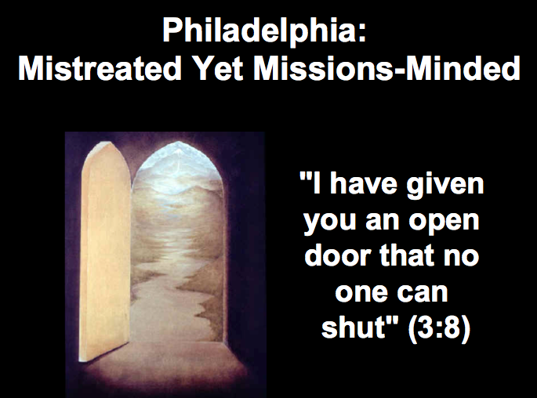
(3:8) Commendation: I know your deeds. Look! I have given you an open door that no one can shut. You have little strength, but have obeyed my word and kept my name.

(absent) Rebuke

(absent) Warning

(3:9-11a) Promise 1: I will make self-proclaimed Jews from Satan’s synagogue bow down at your feet and acknowledge that I have loved you. I will keep you out of (not “through”) the hour (time period) of the Tribulation. I am coming soon. (See the next two pages.)

(3:11b) Exhortation: Hold on to what you have so that no one can take away your crown.

(3:12-13) Promise 2: The one who conquers I will make a pillar in the temple of my God and write on him God's name and city and my new name as well.

Kept from the Hour of Trial (Rev. 3:10)

There are four key Greek prepositions used in relation to movement:

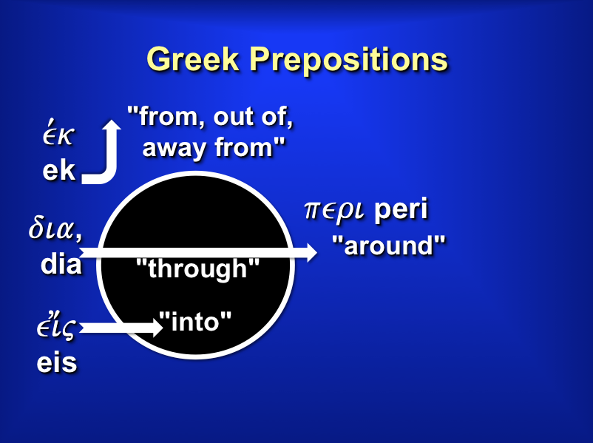

Of these four, which would one expect to indicate the believers and the Tribulation?

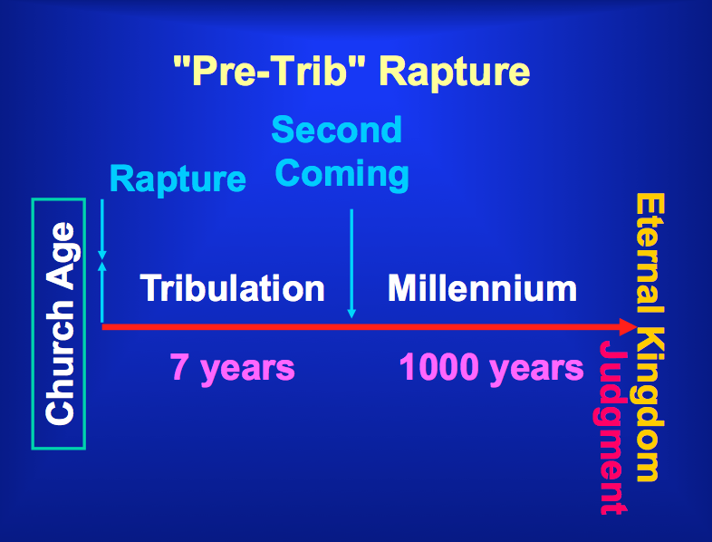

Not surprisingly, the one used is the preposition ek, meaning that Christians will be kept from that entire time of trial…

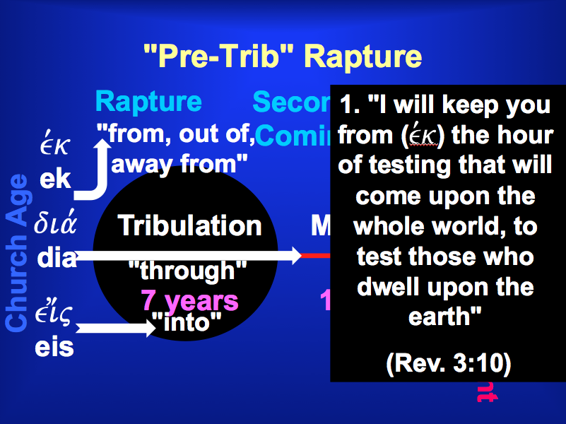

But how is the phrase “keep from” used in other NT passages? There exists only one passage…

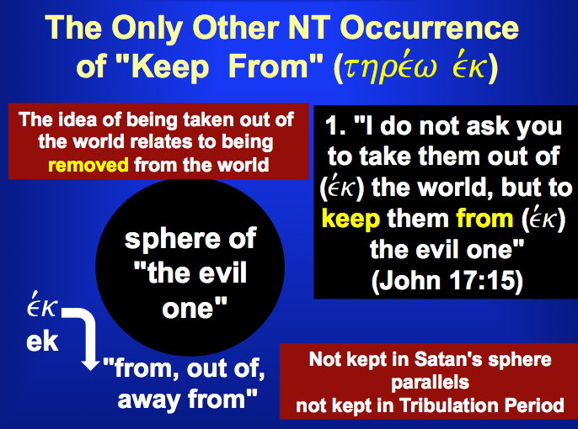

Mistreated Yet Missions Focused
Revelation 3:7-13
Exegetical Outline (Steps 2-3)

Exegetical Idea: The way Christ encouraged the believers at Philadelphia to reach out despite opposition was to promise them reward for perseverance.

I. The way Christ encouraged the church at Philadelphia to reach out was to grant them opportunities to witness (3:7-8).

Destination: Philadelphia (3:7a).

Description of Christ: He is holy, true and able to give opportunities for service (3:7b).

Commendation: He gave them opportunities based on their faithfulness (3:8).

II. The way Christ encouraged the church at Philadelphia to reach out was to promise rewards for their perseverance (3:9-13).

He promised them honor before their enemies (3:9).

He promised them deliverance from the Tribulation (3:9-11a).

He promised them rewards for their perseverance (3:11b).

He promised them strength and security (3:12a).

He promised them the New Jerusalem (3:12b).

He warned the church to listen to the Spirit (3:13).

Purpose or Desired Listener Response (Step 4)
The listeners will step through one open door for them to share Christ.

Homiletical Outline (Cyclical inductive form)

Introduction

Interest: Each church has the danger of the “holy huddle.”

Need: Do you want our church to remain small?

Subject: How does Jesus encourage us to reach out?

Background: The Asia Minor churches were under persecution to the extent that they were tempted to remain small.

Preview: Today we will see two ways that Jesus encourages us to reach out.

Text: Revelation 3:7-13 shows us how Jesus encourages us to reach out.

I. Christ opens doors for witness (3:7-8).
[It is none other than Jesus himself who beings us evangelistic occasions!]

Christ gave Philadelphia opportunities to witness (3:7-8).

Destination: Philadelphia (3:7a).

Description of Christ: He is holy, true and able to give opportunities for service (3:7b).

Commendation: He gave them opportunities based on their faithfulness (3:8).

Jesus has given us many open doors for witness too.

II. Christ promises rewards for service (3:9-13).

Christ promised Philadelphia benefits for their perseverance (3:9-13).

He promised them honor before their enemies (3:9).

He promised them deliverance from the Tribulation (3:9-11a).

He promised them rewards for their perseverance (3:11b).

He promised them strength and security (3:12a).

He promised them the New Jerusalem (3:12b).

He warned the church to listen to the Spirit (3:13).

Jesus will reward our service too.

Conclusion

Jesus gives us both opportunities and rewards for witness (MI).

What open doors has Christ given you for this year?

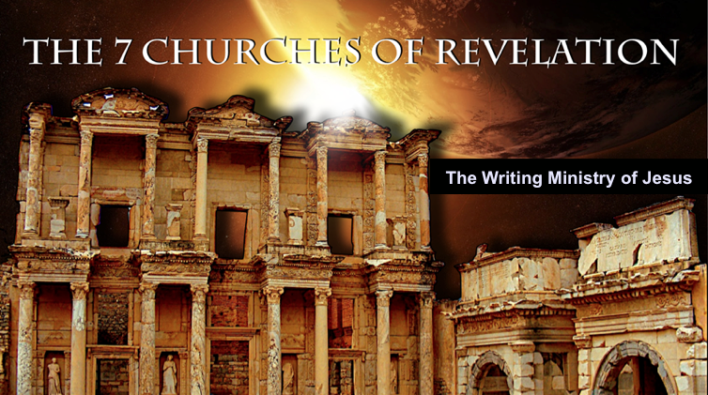
Rick Griffith
12 January 2014
Message 6 of 7

Mistreated Yet Missions Focused
Christ’s Letter to the Church of Philadelphia
Revelation 3:7-13

Introduction

Each church has the danger of the “holy huddle.”

How does Jesus encourage us to ________________ ________?

I. Christ ____________ doors for witness (3:7-8).

Christ gave Philadelphia opportunities to witness (3:7-8).

Destination: Philadelphia (3:7a).

Description of Christ: He is holy, true and able to give opportunities for service (3:7b).

Commendation: He gave them opportunities based on their faithfulness (3:8).

Jesus has given us many open doors for witness too.

II. Christ promises ________________ for service (3:9-13).

Christ promised Philadelphia benefits for their perseverance (3:9-13).

He promised them honor before their enemies (3:9).

He promised them deliverance from the Tribulation (3:9-11a).

He promised them rewards for their perseverance (3:11b).

He promised them strength and security (3:12a).

He promised them the New Jerusalem (3:12b).

He warned the church to listen to the Spirit (3:13).

Jesus will reward our service too.

Conclusion

Jesus gives us both _______________ and _____________ for witness (Main Idea).

What open doors has Christ given you for this year?

Thought Questions

- Read Revelation 3:7-13 aloud. List as many attributes of Christ as you can find.

- How can we as a church “hold on to what we have” (3:11)? What does this mean?

- What open doors have we not yet really considered as a church? How can we walk though them?

Todd Bolen, “Philadelphia,” BiblePlaces.com slide 2.

