Crossroads International Church Singapore Dr. Rick Griffith
17 Feb 2019 Message 46 of 66
NLT 50 Minutes
Be Responsive
Title
Book of 2 Corinthians

Topic: Responsibility
Subject: How can you be responsive to God’s heart for you?
Complement: Open your heart to your leaders, the needy and God.
Purpose: The listeners will respond to God’s comfort holistically.
Attribute: We worship the God of Comfort
Reading: 2 Cor 1:3-11
Benediction: 2 Cor 13:14
Song: Forever (start), The Lord is My Salvation (Getty), Holy Spirit Living Breath of God (Getty), Change My Heart O God (closing)

Introduction
Hi!

Interest: One of our cruelest responses to others is apathy. Once I knew someone who simply ignored me. He acted as if I did not exist. When I talked, he pretended not to hear. When I walked toward him in a hallway as he walked toward me, he wouldn’t greet me. When I was in the same room as him, he watched me in the corner of his eye to assure that he would sit on the other side of the room. I sat down with him and his wife some years ago to talk about it and see what I had contributed to this. He listed many vain imaginations of things I had done to spy on him, so he said that he was just trying to guard his privacy. The amazing thing about this is that I am the one responsible for sticking my neck out to help him find his calling in life.

Need: Maybe you can relate to my experience. You are open to people, but they are closed to you. One of our cruelest responses to others is apathy—or simply ignoring others—and you have seen this first hand.
Open
• Closed

Maybe your family background is far from ideal. Your father—or mother—neglected you growing up.

I find that here in Singapore many people struggle with apathy towards them at work. A worldwide survey was done some years back where people were asked, “Does your work energize you?” The USA had the highest score at 40%. The lowest country in the world was Singapore—only 2% said that their work energized them. When someone just looks at you like a robot to get work out of you, it is deflating.

What a wonderful thing to see that God is not apathetic about you! Hardly! Most of us are quite informed what God has done for us. Are we apathetic towards him in response?
God Not Apathetic

God has given us people who care about us—do we appreciate them?

God has given us more resources than we need—do we share them with others?

God rescued us from the pain of sin—do we thank him for being free from that slavery?

Subject: How can you be responsive to God’s heart for you? Instead of apathy, what is the right way to respond to the Lord for all he has done to save you, provide for you, purify you, restore you?
Subject

Background: Paul reached out to a church that was feeling conflicted and apathetic towards him—even though he started the church!
Backgrd

Imagine investing yourself into someone substantially—you help him or her get a job, you train the person with life skills that lead to success, or you even raise the person as your son or daughter. Despite all this, then that person turns against you! How would you feel? Certainly, this would hurt deeply.

This is what happened to Paul. He was kicked out of Thessalonica and Berea, then saw little success in Athens with no church planted, and finally came to the immoral city of Corinth. Against all odds, Paul gave birth to a struggling church. Yes, it was filled with many problems that he noted in 1 Corinthians—divisions, lawsuits, prostitution, selfishness in idolatry and the Lord’s Supper and spiritual gifts. But the church still made it! It was filled with problems, but it still was a beachhead in a city where Satan had victories for a long time. Let me survey my 1 Cor message (7 slides).
Different
(7 slides)
1 Cor Problems
Map

Occasion: Paul's planting the Corinthian church on his second missionary journey took about eighteen months from March AD 51-September AD 52 (1 Cor 3:6, 10; 4:15; Acts 18:1-17). Nearly four years later while in Ephesus on his third missionary journey he received disturbing reports from Chloe’s household about divisions in the church (1 Cor 1:10) and a letter from the church carried by three men (1 Cor 16:17) that requested Paul's opinion on certain issues (1 Cor 7:1; 8:1; 12:1; 15:1; 16:1). He answered the problem of divisions and gave the much-needed response to the church's questions in the letter of 1 Corinthians (he had already written a letter before this; cf. 1 Cor 5:9).
1 Cor Map

However, within a year of Paul's writing 1 Corinthians, false teachers infiltrated the church (2 Cor 11:20) and stirred up the people against him by accusing him of being proud (2 Cor 10:1), fickle (2 Cor 1:16f.), unimpressive in appearance and speech (2 Cor 10:10), dishonest (2 Cor 8:16), and unqualified to be an apostle (2 Cor 11:23; 12:6-7). Paul saw this threat as valid reason to visit the church personally, and he refers to this second visit as a “painful visit” (2 Cor 2:1; 12:14; 13:1). He anticipates this visit in 1 Corinthians 16:5-9.
2 Cor Map

After leaving the church this second time, Paul wrote a sorrowful letter (his third letter to the church) to urge the church to discipline the leader of the opposition (2 Cor 2:1-11; 7:8f.). Titus delivered the letter then met Paul in Macedonia with the good news that most of the Corinthians had repented of rebelling against Paul's apostolic authority (2 Cor 7:6-7). Nevertheless, Paul still felt it necessary to write the letter of 2 Corinthians to defend himself against the minority opposition (2 Cor 10–13). So, Titus turned right around and headed back to Corinth to deliver 2 Corinthians, accompanied by two other brothers (2 Cor 8:16-24). Later Paul made a third visit to the church, anticipated in 2 Corinthians 13:1; Acts 19:21 and recorded in Acts 20:2-3.
• Origin

Preview: Today we’ll see three ways to be responsive to all God’s heart for you.
3 ways

Text: This message will answer this question in an overview of the entire letter of 2 Corinthians.
Subject
(What’s the first way you can be responsive to God’s heart for you?)
MP

I. Open your heart to your leaders (2 Cor 1–7).
[Encourage those who lead you.]
2 Cor 1-7

Corinth should open their hearts to Paul since God cared for them through him (2 Cor 1–7).
2 Cor 1
(2 slides)

God comforted Paul while fleeing Asia, so they should support and pray for him (1:1-11).

God worked in Paul’s postponed visit and discipline of their sinning leader (1:12–2:17).
2 Cor 2
(2 slides)

His postponed visit when they doubted his care actually prevented Paul from overly rebuking them for not disciplining their leader who opposed Paul (1:12-24).

Their discipline of this leader should make Paul’s next visit a positive one so that Satan would not drive a wedge between Paul, this leader, and the church (2:1-11).

Instead of returning, Paul’s sending Titus will remind them to spread the sweet aroma of Christ to believers and warn unbelievers of their impending peril (2:12-17).

Paul’s new covenant ministry blessed Corinth—not the false teachers (3:1–6:10).
2 Cor 3
(2 slides)

His ministry is even greater than Moses's since the glory of the new covenant is greater than that of the Mosaic covenant (2 Cor 3).

He does not lose heart in suffering since he sees his trials from God's perspective (4:1–6:10).

Paul never gives up during suffering because God's power helps him to minister for their benefit (4:1-15).
2 Cor 4
(8 slides)

Paul retains courage in suffering because his motivation comes from an eternal view and a love that compels him in his ministry of reconciliation (4:16–6:2).
2 Cor 5
(7 slides)

Paul marks of a genuine ministry in his suffering does not discredit his ministry through offending others by requiring a comfortable lifestyle (6:3-10).
2 Cor 6
(6 slides)

They should open their hearts to him—not to unbelievers—as he did to them (6:11–7:16).
Arrows
2 Cor 7
(3 slides)

We should encourage our spiritual leaders also.

Think the best of them. (Corinth thought the worst of Paul.)

Give them new covenant latitude—not old covenant legalism.

How can we encourage our leaders?

Ask them!

Give them a break.

Tell them how they minister to you.
2 Cor 8-9
Subject
MP

(How else can you respond to God’s heart for you?)

II. Open your heart to those in need (2 Cor 8–9).
[Give generously to those who aren’t financially blessed like you.]

Corinth should respond to God’s care by giving to the Jerusalem saints (2 Cor 8–9).
2 Cor 8
(9 slides)

The Macedonians and Jesus gave selflessly so the richer Corinthians should too (8:1-9).

Giving helps all churches equally carry on their ministries in their times of need (8:10-15).
2 Cor 9
(8 slides)

Paul’s advance team will help them prove their generosity in giving (8:16–9:5).

Generosity blesses the givers and causes the recipients to thank God (9:6-15).
Open Your Heart

Use your money to distribute God’s money more equally among the churches.

The OT assumed that even the poorest Israelite could live on 90% of his income. Isn’t it still true today?

My colleague Chuck Lowe preached that the churches would equalize their bank balances!
MP
Subject
2 Cor 10-13
(What’s the third and last way you can be responsive to God’s heart for you?)

III. Open your heart to God (2 Cor 10–13).
[Don’t be your own boss but instead live under God’s authority.]

Corinth should respond to God’s care by submitting to his authority (2 Cor 10–13).

Paul was an apostle though some thought him timid, weak, and proud (2 Cor 10).
2 Cor 10
(4 slides)

Paul proved was an apostle so the church wouldn’t be deceived (11:1–12:18).
2 Cor 11
(3 slides)

His motive in making the following apostolic claims is to assure with a godly jealousy that the Corinthians not be deceived (11:1-6).

He proves his claim to be a genuine apostle of Christ (11:7–12:18).

His willingness to minister without pay supports his apostleship (11:7-15).

His sufferings support his apostleship (11:16-33).
2 Cor 12
(4 slides)

His visions and revelations, especially his revelation of Paradise that necessitated a thorn in the flesh, supports his apostleship (12:1-10).
2 Cor 13
(2 slides)

His miraculous signs and wonders support his apostleship (12:11-12).

His paternal love for the church supports his apostleship (12:13-18).

They must repent to show they submit to God’s authority (12:19–13:10).

They must submit to God’s authority by loving each other (13:11-14).
Hands Open

Do you offer your life to God with open hands and heart?

Juan Carlos Ortiz pictures this as signing a contract. Do you trust the Lord? Imagine God placing before you a piece of paper. He says, “Please sign at the bottom.” You say, “OK, Lord, what is this?” “It is my plan for your life,” God responds. “Wow, how fantastic!” you reply and then look at the paper. “But, Lord,” you observe, “This paper is completely blank. There isn’t a word on it!” “Yes,” he says, “But don’t you trust me?”

Would you sign such a contract?
Subject
(How can you be responsive to God’s heart for you?)

Conclusion
MI

Open your heart to your leaders, the needy and God (Main Idea).

Main Points
Open to…
• Leaders

Open your heart to your leaders (2 Cor 1–7).
• Needy

Open your heart to those in need (2 Cor 8–9).
• God

Open your heart to God (2 Cor 10–13).
Complete Sentence

Complete this sentence: I can best open my heart to God by…
Prayer

Prayer

Preliminary Questions

Verses Questions

Context: What did the author record just prior to this passage?

Imagine investing yourself into someone substantially—you help him or her get a job, you train the person with life skills that lead to success, or you even raise the person as your son or daughter. Despite all this, then that person turns against you! How would you feel? Certainly, this would hurt deeply.

This is what happened to Paul. He was kicked out of Thessalonica and Berea, then saw little success in Athens with no church planted, and finally came to the immoral city of Corinth. Against all odds, Paul gave birth to a struggling church. Yes, it was filled with many problems that he noted in 1 Corinthians—divisions, lawsuits, prostitution, selfishness in idolatry and the Lord’s Supper and spiritual gifts. But the church still made it! It was filled with problems, but it still was a beachhead in a city where Satan had victories for a long time.

Purpose: Why is this passage in the Bible?

Paul defends his apostleship, so this brings up how we should apply this today:

Respect spiritual leaders?

Be responsive

But we need to look deeper in terms of why Paul would defend himself.

Was it just because of his ego—his being offended?

Not at all. Paul realized that the opinion of the Corinthians about him was very much wrapped up in their view of God.

Background: What historical context helps us understand this passage?

Occasion: Paul's planting the Corinthian church on his second missionary journey took about eighteen months from March AD 51-September AD 52 (1 Cor 3:6, 10; 4:15; Acts 18:1-17). Nearly four years later while in Ephesus on his third missionary journey he received disturbing reports from Chloe’s household about divisions in the church (1 Cor 1:10) and a letter from the church carried by three men (1 Cor 16:17) that requested Paul's opinion on certain issues (1 Cor 7:1; 8:1; 12:1; 15:1; 16:1). He answered the problem of divisions and gave the much-needed response to the church's questions in the letter of 1 Corinthians (he had already written a letter before this; cf. 1 Cor 5:9).

However, within a year of Paul's writing 1 Corinthians, false teachers infiltrated the church (2 Cor 11:20) and stirred up the people against him by accusing him of being proud (2 Cor 10:1), fickle (2 Cor 1:16f.), unimpressive in appearance and speech (2 Cor 10:10), dishonest (2 Cor 8:16), and unqualified to be an apostle (2 Cor 11:23; 12:6-7). Paul saw this threat as valid reason to visit the church personally, and he refers to this second visit as a “painful visit” (2 Cor 2:1; 12:14; 13:1). He anticipates this visit in 1 Corinthians 16:5-9.

After leaving the church this second time, Paul wrote a sorrowful letter (his third letter to the church) to urge the church to discipline the leader of the opposition (2 Cor 2:1-11; 7:8f.). Titus delivered the letter then met Paul in Macedonia with the good news that most of the Corinthians had repented of rebelling against Paul's apostolic authority (2 Cor 7:6-7). Nevertheless, Paul still felt it necessary to write the letter of 2 Corinthians to defend himself against the minority opposition (2 Cor 10–13). So, Titus turned right around and headed back to Corinth to deliver 2 Corinthians, accompanied by two other brothers (2 Cor 8:16-24). Later Paul made a third visit to the church, anticipated in 2 Corinthians 13:1; Acts 19:21 and recorded in Acts 20:2-3.

Questions

What is the new covenant? How does it differ from the old?

Was it right for Paul to defend himself?

Why did Paul defend his apostleship? Wasn’t this arrogant?

Tentative Main Ideas

Be Respectful (too narrow as doesn’t include 2 Cor 8–9)
Be Steadfast (used for Judges)
Be Responsible
Be Responsive
Be Sincere

OLD Exegetical Idea Focusing More on Paul: The way to be responsive is to accept Paul as an apostle in his sincere and generous model of submission to God’s authority.
- Paul models responsibility in his sincerity to strength the church at Corinth (2 Cor 1–7).
- Generous giving will fulfill the church’s promise to the distressed Jerusalem saints (2 Cor 8–9).
- The church must submit to God’s authority by accepting Paul as an apostle (2 Cor 10–13).

Subject: How can you be responsive to all God’s heart for you?
- I. Accept your new covenant ministry (2 Cor 1–7).
- II. Give to the needy (2 Cor 8–9).
- III. Submit to God’s authority (2 Cor 10–13).

Illustrations That Apply

Ken Williams interview of Paul called “Paul on Stress” that shows how he still maintained his emotional health (NTS, 166a-b and later on this file)

New Testament Survey Notes

2 Corinthians

Defense of Apostolic Authority

Ministry Sincerity |  |  |  |  | Giving |  |  |  | Ministry Authority
Chapters 1–7 |  |  |  |  | Chapters 8–9 |  |  |  | Chapters 10–13
Defense of Paul’s  Motives |  |  |  |  | Defense of Paul’s  Worth |  |  |  | Defense of Paul’s  Traits
Character of Paul |  |  |  |  | Collection for Saints |  |  |  | Credentials of Paul
Greeting  1:1-11 | Defends Conduct  1:12–  2:17 | Defends Ministry  3:1–  6:10 | Restore Confi-  dence  6:11–  7:16 | Examples  8:1-9 |  | Purpose  8:10-15 | Arrange-  ments  8:16–  9:5 | Benefits  9:6-15 | Defense  10 | Offense  11:1–  12:18 | Warning  12:19–  13:10 | Closing  13:11-14
Macedonia

Fall AD 56

Key Word: Apostleship

Key Verse: “For we do not preach ourselves, but Jesus Christ as Lord, and ourselves as your servants for Jesus’ sake. For God, who said, ‘Let light shine out of darkness,’ made his light shine in our hearts to give us the light of the knowledge of the glory of God in the face of Christ” (2 Corinthians 4:5-6).

Summary Statement: The way the church should respond to God’s sincere care is to open their hearts to Paul, to Jerusalem saints, and to God himself.

Applications: Do you need to respond to God’s care in an area of your spiritual life that you have neglected?

For Church Lay People: Do you frequently criticize your spiritual leaders? (In other words, do you have a problem submitting to authority?)

For Spiritual Leaders: Are you fearful of defending your God-given spiritual authority?
2 Corinthians

Introduction

I. Title The earliest title for 2 Corinthians is Pro.j Korinqi,ouj b , (Second to the Corinthians). The b was obviously added later to distinguish this epistle from Paul's first letter to the same church.

II. Authorship

A. External Evidence: Even very creative critics uphold Paul as author as the patristic evidence is early. Early church writers upholding Paul include Polycarp (AD 105; To the Philippians 11), Irenaeus (AD 185; Against Heresies 4, 27, 45), and others, such as the Muratorian Fragment (2nd cent.).

B. Internal Evidence: The book argues strongly for Pauline authorship as it specifically claims to be written by Paul (1:1). Some critics have speculated that chapters 1–9 and 10–13 actually constitute two different letters (e.g., the letter of 2:4) because of their difference in tone (joy to concern and comfort to self-defense). However, the content of 10–13 never even mentions the offender of 2:5-11. Also, chapter 2 refers to a sorrowful tone that is lacking in the firm declarations of 10–13. Finally, no textual evidence, linguistic evidence, church fathers, or church tradition validates such an attack upon the unity of the book.

III. Circumstances

A. Date: Paul makes two comments concerning the Corinthians' giving which indicate that 2 Corinthians was written less than a year after 1 Corinthians (2 Cor 8:10; 9:2). That he was about to leave Ephesus (1 Cor 16:5-8) indicates that 1 Corinthians was written in May AD 56. The letter of 2 Corinthians followed later that year in fall AD 56.

B. Origin/Recipients: Paul addressed this second letter to the church at Corinth from the province of Macedonia that was north of Corinth.

C. Occasion: Paul's planting the Corinthian church on his second missionary journey took about eighteen months from March AD 51-September AD 52 (1 Cor 3:6, 10; 4:15; Acts 18:1-17). Nearly four years later while in Ephesus on his third missionary journey he received disturbing reports from Chloe’s household about divisions in the church (1 Cor 1:10) and a letter from the church carried by three men (1 Cor 16:17) that requested Paul's opinion on certain issues (1 Cor 7:1; 8:1; 12:1; 15:1; 16:1). He answered the problem of divisions and gave the much-needed response to the church's questions in the letter of 1 Corinthians (he had already written a letter before this; cf. 1 Cor 5:9).

However, within a year of Paul's writing 1 Corinthians, false teachers infiltrated the church (2 Cor 11:20) and stirred up the people against him by accusing him of being proud (2 Cor 10:1), fickle (2 Cor 1:16f.), unimpressive in appearance and speech (2 Cor 10:10), dishonest (2 Cor 8:16), and unqualified to be an apostle (2 Cor 11:23; 12:6-7). Paul saw this threat as valid reason to visit the church personally, and he refers to this second visit as a “painful visit” (2 Cor 2:1; 12:14; 13:1). He anticipates this visit in 1 Corinthians 16:5-9.

After leaving the church this second time, Paul wrote a sorrowful letter (his third letter to the church) to urge the church to discipline the leader of the opposition (2 Cor 2:1-11; 7:8f.). Titus delivered the letter then met Paul in Macedonia with the good news that most of the Corinthians had repented of rebelling against Paul's apostolic authority (2 Cor 7:6-7). Nevertheless, Paul still felt it necessary to write the letter of 2 Corinthians to defend himself against the minority opposition (2 Cor 10–13). So, Titus turned right around and headed back to Corinth to deliver 2 Corinthians, accompanied by two other brothers (2 Cor 8:16-24). Later Paul made a third visit to the church, anticipated in 2 Corinthians 13:1; Acts 19:21 and recorded in Acts 20:2-3.

IV. Characteristics (TTTB, 390, adapted)

A. This letter reveals Paul's character, motives, priorities, desires, and emotions more than any other NT writing. It notes events about Paul that would otherwise not be known: his persecutions and hardships not recorded in Acts (2 Cor 11:23-27), extra details of his escape from Damascus (11:32-33), God's revelation of Paradise to him in a vision (12:1-7), and his “thorn in the flesh” (12:7-10).

B. This is probably the least taught and least preached Pauline epistle in the church today. No doubt this is because pastors and teachers are reluctant to apply its message—that the church owes them respect because of their ministry for Christ full-time!

C. Second Corinthians is also probably Paul's most unsystematic epistle. The style is unique among Paul’s epistles in its many digressions, unusual constructions, mixed metaphors, broken sentences, and sudden shifts in feeling and tone. It has all the signs of having been written under extreme anguish of heart. Paul’s distress is that his entire eighteen-month's work at Corinth might be undermined by false teachers.

D. This letter expands upon Paul's former command for a contribution (1 Cor 16:1-4) in a passage offering the most extended teaching on giving in the New Testament (2 Cor 8–9).

Argument

Paul penned Second Corinthians to defend his apostolic authority against slanderous false teachers. This is accomplished by communicating the genuineness of his ministry so that the believers can really trust him (2 Cor 1–7) before they finish collecting the offering that they had pledged the year before (2 Cor 8–9), and through a defensive and offensive proclamation of the proofs of his apostleship (2 Cor 10–13). After investing eighteen months at Corinth, three letters, a painful visit and an anticipated visit, he was not about to let fake servants of Christ erode his foundation laid at Corinth. Therefore, this letter contains personal information necessary to uphold his integrity before the church so that it would not be lost to the enemy.

Synthesis

Defense of apostolic authority Answers allegations regarding:

1–7 Ministry sincerity Motives
1:1-11 Salutation
1:12–2:17 Defends conduct
1:12-24 Postponed visit
2:1-11 Disciplining opposer
2:12-17 Sending of Titus
3:1–6:10 Defends ministry
3 Superior to Mosaic
4:1–6:10 Suffering
6:11–7:16 Restore confidence

8–9 Giving Worth
8:1-9 Examples: Macedonians/Christ
8:10-15 Purpose
8:16–9:5 Arrangements
9:6-15 Benefits

10–13 Ministry authority
10 Defensive Traits
11:1–12:18 Offensive
11:1-6 Motive in making claims
11:7–12:18 Proofs of apostleship
12:19–13:10 Warning
13:11-14 Conclusion

Outline

Summary Statement for the Book
The way the church should respond to God’s sincere care is to open their hearts to Paul, to Jerusalem saints, and to God himself.

The church should respond to God’s sincere care for them by opening their hearts to Paul (2 Cor 1–7).

God comforted Paul while fleeing Asia, so the church should see his genuineness as an apostle and pray for him (1:1-11).

Paul defends his conduct in God’s blessing on his postponed visit and Paul’s discipline of their sinning leader (1:12–2:17).

His postponed visit when they doubted his care actually prevented Paul from overly rebuking them for not disciplining their leader who opposed Paul (1:12-24).

Their discipline of this leader should make Paul’s next visit a positive one so that Satan would not drive a wedge between Paul, this leader, and the church (2:1-11).

Instead of returning, Paul’s sending Titus will remind them to spread the sweet aroma of Christ to believers and warn unbelievers of their impending peril (2:12-17).

Paul defends his new covenant ministry and suffering so the church will respond to God rather than to their false teachers (3:1–6:10).

His ministry is even greater than Moses's since the glory of the new covenant is greater than that of the Mosaic covenant (2 Cor 3).

He does not lose heart in suffering since he sees his trials from God's perspective (4:1–6:10).

Paul never gives up during suffering because God's power helps him to minister for their benefit (4:1-15).

Paul retains courage in suffering because his motivation comes from an eternal view and a love that compels him in his ministry of reconciliation (4:16–6:2).

Paul marks of a genuine ministry in his suffering does not discredit his ministry through offending others by requiring a comfortable lifestyle (6:3-10).

The church should renew their confidence in Paul emotionally just as he opened his heart to them (6:11–7:16).

The church should respond to God’s sincere care for them by generously giving to the distressed Jerusalem saints (2 Cor 8–9).

The Macedonians and Jesus serve as examples of selfless giving so the richer Corinthians should fulfill their promise to help the suffering Jerusalem church (8:1-9).

The purpose for giving is for all the churches to assist one another in their times of need so that they all can equally carry on their ministries (8:10-15).

Paul sent Titus and two others with the letter to help the church prepare a generous gift so that Paul's boasting about the church's generosity may prove true (8:16–9:5).

Generosity benefits givers with continued blessing and causes its recipients to thank God (9:6-15).

The church should respond to God’s sincere care for them by submitting to God’s authority (2 Cor 10–13).

Paul defends his apostolic authority against charges of cowardice, weakness, and pride (2 Cor 10).

Paul proves his apostolic credentials so the believers are not deceived by his accusers (11:1–12:18).

His motive in making the following apostolic claims is to assure with a godly jealousy that the Corinthians not be deceived (11:1-6).

He proves his claim to be a genuine apostle of Christ (11:7–12:18).

His willingness to minister without pay supports his apostleship (11:7-15).

His sufferings support his apostleship (11:16-33).

His visions and revelations, especially his revelation of Paradise that necessitated a thorn in the flesh, supports his apostleship (12:1-10).

His miraculous signs and wonders support his apostleship (12:11-12).

His paternal love for the church supports his apostleship (12:13-18).

They must submit to God’s authority by repenting of sin before Paul comes so that he need not use his apostolic authority for disciplining when he arrives (12:19–13:10).

They must submit to God’s authority by loving another to show their positional sanctification (13:11-14).

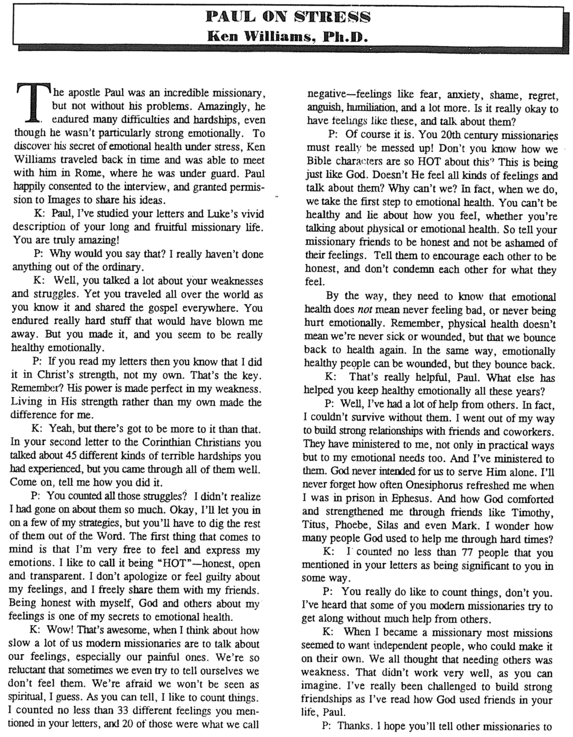
Paul on Stress
(1 of 2)

Paul on Stress (2 of 2)

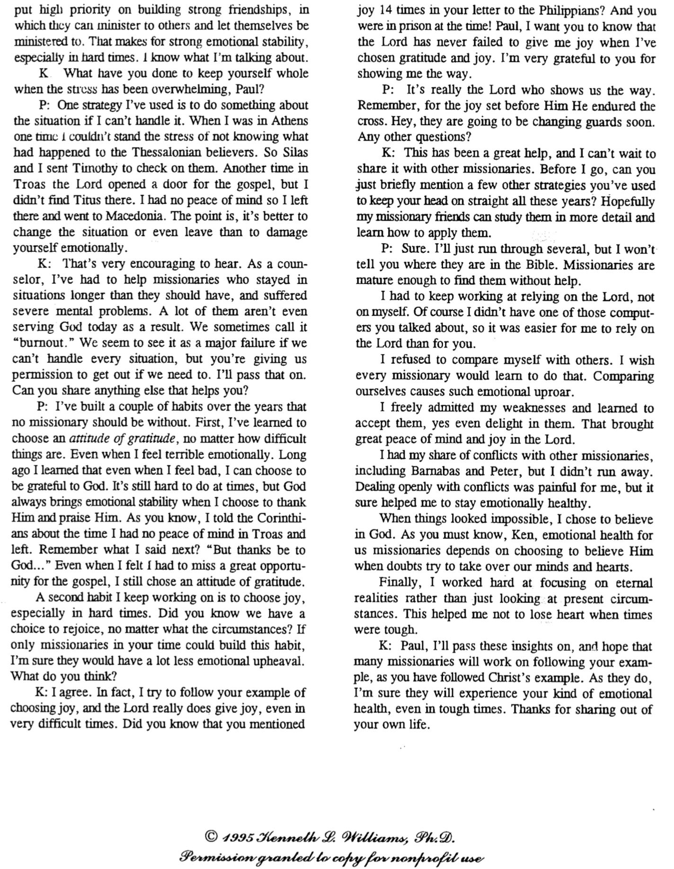
Contrasting the Old and New Covenants
2 Corinthians 3–4

Old Covenant | New Covenant
initiated by Moses (3:8) | initiated by Christ (3:4)
of the letter (3:6a) | of the Spirit (3:6a, 18b)
kills (3:6b, 7a) | gives life (3:6b)
engraved on stone (3:3b, 7a) | engraved on hearts (3:3b; Jer. 31:33)
glorious (3:7a) | more glorious (3:8, 10)
glory faded (3:7b, 11a, 13b) | glory ever-increases (3:11b, 18)
condemns men (3:9a) | brings righteousness (3:9b)
deception (3:13) | boldness (3:12)
veiled face of Moses (3:13b) | unveiled faces (3:13a, 18a)
veiled minds (3:14a) | unveiled minds (3:14b; 4:3-6)
veiled hearts (3:15) | unveiled hearts (3:16)
dullness (3:14a) | freedom (3:17)
Moses reflected God’s glory | all believers reflect Christ’s glory (3:17)
non-transforming (3:7) | transforming (3:18)
lack of zeal (3:13) | confidence, steadfastness (3:4-5; 4:1)
deception (3:13) | sincerity (4:2)

Views on the New Covenant

Issue: How can the OT and NT data on the New Covenant be reconciled? Jeremiah 31 declares it is for Israel and Judah but the NT (Luke 22:20; 1 Cor 11:25; 2 Cor 3:6; Heb. 8:8; 9:15) apply it to the church. Is there actually no New Covenant, is it only for Israel or only for the church, or are there two New Covenants, or does the church participate in some of its aspects while awaiting the final fulfillment of the covenant? This study takes the last view, as do most modern premillennialists and other scholars. Note that “OC” and “NC” below relate to the Old Covenant and New Covenant, respectively.

View | Explanation | Theology & Scholars | Problems
Restated Mosaic | No New Covenant | Critical:  –Couturier  –Duhm  –Schmidt  –Potter | 1. OC/NC distinctions in text ignored  2. OC=conditional, NC=unconditional  3. OC=temporal, NC=eternal  4. OC=external, NC=internal  5. OC=no enablement, NC=enablement  6. NC=peace, prosperity, sanctuary, Spirit  (parallel passages)
Church Alone | No Israel Participation | Amillennial/  Postmillennial:  –Allis  –Cox  –Smick  –Boettner | 1. Ignores OT data by equating Israel & the Church  2. NC introduced ≠ fulfilled to Israel  3. Present need to know YHWH (still need the Great Commission)  4. AD 70 Jerusalem vs. Jer. 31:40
Israel Alone | No Church Participation | Misc/Classical Dispensational:  –Darby  – Thompson  –von Rad | 1. Ignores NT data  –Christ's Last Supper words  –Paul's statements  –Hebrews application to Church  2. Ignores present work of Spirit
Two New Covenants | NC for Israel  +  NC for Church | Early 1900s Dispensational:  –Chafer  –Walvoord (old)  –Ryrie (old) | 1. Same terminology for OT & NT NCs  2. Israel/Church distinction too sharp  3. Basis of forgiveness the same  4. If 2 NCs then no OC for Church  5. Church doesn’t possess Israel's promises
Church Participation | Primarily for Israel  Secondarily for the Church | Misc/Present Dispensational:  –Keil  –Lemke  –Bright  –Scofield  –Walvoord (DTS)  –Ryrie (DTS)  –Archer (TEDS)  –Kaiser (TEDS) | Support:  1. Primary fulfillment future–Rom 11  2. Deals with both OT & NT data  3. Forgiveness/Spirit=blessings now  4. NC has new law  5. Rebuttals to above views

Signs of the Covenants

God has made several covenants with man throughout the ages. With several of them he has attached a sign or memorial as reminders of his and/or our responsibilities to keep these covenants.

Covenant | Definition | Promise | Fulfillment | Sign
Noahic | Unconditional promise not to flood the earth again | Gen. 9:12-17 | No more sea  (Rev. 21:1) | Rainbow  (Gen. 9:12-17)
Abrahamic | Promise to provide Israel a land, rule, and spiritual blessing | Gen. 12:1-3; 15:13-18 | Continues at present (Gal. 3:17) but Israel still has a future (see Rom. 11:25-27) | Circumcision  (Gen. 17:11)
Mosaic | Conditional stipulations for blessing on Israel | Exod. 19–31; Deut. 28 | Death of Christ (Rom. 7:4-6) | Sabbath  (Exod. 31:13)
Land | Promise of physical land from the Wadi of Egypt to the River Euphrates | Deut. 30:1-10 | Land blessed (Amos 9:13-15) | No sign  (that I know of)
Davidic | Promise of eternal,  political rule of a descendant of David | 2 Sam. 7:12-17 | Rule renewed (Amos 9:11-12) | Christ seated at the Father’s right hand  (Acts 2:34-36)
New | Promise of spiritual indwelling of the Spirit (“law written on hearts”), forgiveness, and total evangelization of Israel | Jer. 31:31-34 | Paul & the Apostles (2 Cor 3–4)  All Israel saved (Rom. 11:26-27) | Cup of the Lord’s Supper (Luke 22:20; 1 Cor 11:25)

Be Responsive
2 Corinthians

Exegetical Outline (Steps 2-3)

Exegetical Idea: The way the church should respond to God’s sincere care is to open their hearts to Paul, to Jerusalem saints, and to God himself.

The church should respond to God’s sincere care for them by opening their hearts to Paul (2 Cor 1–7).

God comforted Paul while fleeing Asia, so they should support and pray for him (1:1-11).

God worked in Paul’s postponed visit and discipline of their sinning leader (1:12–2:17).

Paul’s new covenant ministry—not the false teachers—blessed Corinth (3:1–6:10).

They should open their hearts to him—not to unbelievers—as he did to them (6:11–7:16).

The church should respond to God’s sincere care for them by generously giving to the distressed Jerusalem saints (2 Cor 8–9).

The Macedonians and Jesus gave selflessly so the richer Corinthians should too (8:1-9).

Giving helps all churches equally carry on their ministries in their times of need (8:10-15).

Paul’s advance team will help them prove their generosity in giving (8:16–9:5).

Generosity blesses the givers and causes the recipients to thank God (9:6-15).

The church should respond to God’s sincere care for them by submitting to God’s authority (2 Cor 10–13).

Paul was an apostle though some thought him timid, weak, and proud (2 Cor 10).

Paul proved was an apostle so the church wouldn’t be deceived (11:1–12:18).

They must repent to show they submit to God’s authority (12:19–13:10).

They must love each other to show submit to God’s authority (13:11-14).

Purpose or Desired Listener Response (Step 4)
The listeners will respond to God’s comfort holistically.

Homiletical Outline (Cyclical inductive form)

Introduction

Interest: One of our cruelest responses to others is apathy.

Need: Maybe you can relate to my experience. Yes, one of our cruelest responses to others is apathy—or simply ignoring others—and you have seen this firsthand.

What a wonderful thing to see that God is not apathetic about you! Hardly! Most of us are quite informed what God has done for us. Are we apathetic towards him in response?

Subject: How can you be responsive to God’s heart for you? Instead of apathy, what is the right way to respond to the Lord for all he has done to save you, provide for you, purify you, restore you?

Background: Paul reached out to a church that was feeling conflicted and apathetic towards him—even though he started the church!

Preview: Today we’ll see three ways to be responsive to all God’s heart for you.

Text: This message will answer this question in an overview of the entire letter of 2 Corinthians.

(What’s the first way you can be responsive to God’s heart for you?)

I. Open your heart to your leaders (2 Cor 1–7).

Corinth should open their hearts to Paul since God cared for them through him (2 Cor 1–7).

God comforted Paul while fleeing Asia, so they should support and pray for him (1:1-11).

God worked in Paul’s postponed visit and discipline of their sinning leader (1:12–2:17).

Paul’s new covenant ministry—not the false teachers—blessed Corinth (3:1–6:10).

They should open their hearts to him—not to unbelievers—as he did to them (6:11–7:16).

We should encourage our spiritual leaders also.

Think the best of them. (Corinth thought the worst of Paul.)

Give them new covenant latitude—not old covenant legalism.

How can we encourage our leaders?

(How else can you respond to God’s heart for you?)

II. Open your heart to those in need (2 Cor 8–9).

Corinth should respond to God’s care by giving to the Jerusalem saints (2 Cor 8–9).

The Macedonians and Jesus gave selflessly so the richer Corinthians should too (8:1-9).

Giving helps all churches equally carry on their ministries in their times of need (8:10-15).

Paul’s advance team will help them prove their generosity in giving (8:16–9:5).

Generosity blesses the givers and causes the recipients to thank God (9:6-15).

Use your money to distribute God’s money more equally among the churches.

The OT assumed that even the poorest Israelite could live on 90% of his income. Isn’t it still true today?

My colleague Chuck Lowe preached that the churches would equalize their bank balances!

(What’s the third and last way you can be responsive to God’s heart for you?)

III. Open your heart to God (2 Cor 10–13).

Corinth should respond to God’s care by submitting to his authority (2 Cor 10–13).

Paul was an apostle though some thought him timid, weak, and proud (2 Cor 10).

Paul proved was an apostle so the church wouldn’t be deceived (11:1–12:18).

They must repent to show they submit to God’s authority (12:19–13:10).

They must love each other to show submit to God’s authority (13:11-14).

Do you offer your life to God with open hands and heart?

Juan Carlos Ortiz pictures this as signing a blank contract.

Would you sign such a contract?

(How can you be responsive to God’s heart for you?)

Conclusion

Open your heart to your leaders, the needy and God (Main Idea).

Main Points

Complete this sentence: I can best open my heart to God by…

Prayer

Original Outline (Not Used as Too Detailed):
Be Responsive
2 Corinthians

Introduction
How can you be ____________ to God’s heart for you?

I. Open your heart to your ____________ (2 Cor 1–7).

God comforted Paul while fleeing Asia, so they should support and pray for him (1:1-11).

God worked in Paul’s postponed visit and discipline of their sinning leader (1:12–2:17).

Paul’s new covenant ministry—not the false teachers—blessed Corinth (3:1–6:10).

They should open their hearts to him—not to unbelievers—as he did to them (6:11–7:16).

We should encourage our spiritual leaders also.

II. Open your heart to those in ____________ (2 Cor 8–9).

The Macedonians and Jesus gave selflessly so the richer Corinthians should too (8:1-9).

Giving helps all churches equally carry on their ministries in their times of need (8:10-15).

Paul’s advance team will help them prove their generosity in giving (8:16–9:5).

Generosity blesses the givers and causes the recipients to thank God (9:6-15).

Use your money to distribute God’s money more equally among the churches.

III. Open your heart to ____________ (2 Cor 10–13).

Paul was an apostle though some thought him timid, weak, and proud (2 Cor 10).

Paul proved was an apostle so the church wouldn’t be deceived (11:1–12:18).

They must repent to show they submit to God’s authority (12:19–13:10).

They must love each other to show submit to God’s authority (13:11-14).

Do you offer your life to God with open hands and heart?

Conclusion

Open your _________________ to your leaders, the needy and God (Main Idea).

I can best open my heart to God by…

Download this sermon PPT and notes for free at BibleStudyDownloads.org/resource/new-testament-preaching/
Listen to this message online at cicfamily.com/sermon-listing/

Rick Griffith
17 Feb 2019
Message 46 of 66

Be Responsive
2 Corinthians

Introduction
How can you be ____________ to God’s heart for you?

I. Open your heart to your ____________ (2 Cor 1–7).

Corinth should open their hearts to Paul since God cared for them through him (2 Cor 1–7).

We should encourage our spiritual leaders also.

II. Open your heart to those in ____________ (2 Cor 8–9).

Corinth should respond to God’s care by giving to the Jerusalem saints (2 Cor 8–9).

Use your money to distribute God’s money more equally among the churches.

III. Open your heart to ____________ (2 Cor 10–13).

Corinth should respond to God’s care by submitting to his authority (2 Cor 10–13).

Do you offer your life to God with open hands and heart?

Conclusion

Open your _________________ to your leaders, the needy and God (Main Idea).

I can best open my heart to God by…

Download this sermon PPT and notes for free at BibleStudyDownloads.org/resource/new-testament-preaching/
Listen to this message online at cicfamily.com/sermon-listing/
2 Corinthians

Defense of Apostolic Authority

Ministry Sincerity |  |  |  |  | Giving |  |  |  | Ministry Authority
Chapters 1–7 |  |  |  |  | Chapters 8–9 |  |  |  | Chapters 10–13
Defense of Paul’s  Motives |  |  |  |  | Defense of Paul’s  Worth |  |  |  | Defense of Paul’s  Traits
Character of Paul |  |  |  |  | Collection for Saints |  |  |  | Credentials of Paul
Greeting  1:1-11 | Defends Conduct  1:12–  2:17 | Defends Ministry  3:1–  6:10 | Restore Confi-  dence  6:11–  7:16 | Examples  8:1-9 |  | Purpose  8:10-15 | Arrange-  ments  8:16–  9:5 | Benefits  9:6-15 | Defense  10 | Offense  11:1–  12:18 | Warning  12:19–  13:10 | Closing  13:11-14
Macedonia

Fall AD 56

Key Word: Apostleship

Key Verse: “For we do not preach ourselves, but Jesus Christ as Lord, and ourselves as your servants for Jesus’ sake. For God, who said, ‘Let light shine out of darkness,’ made his light shine in our hearts to give us the light of the knowledge of the glory of God in the face of Christ” (2 Corinthians 4:5-6).

Summary Statement: The way the church should respond to God’s sincere care is to open their hearts to Paul, to Jerusalem saints, and to God himself.

Applications: Do you need to respond to God’s care in an area of your spiritual life that you have neglected?

For Church Lay People: Do you frequently criticize your spiritual leaders? (In other words, do you have a problem submitting to authority?)

For Spiritual Leaders: Are you fearful of defending your God-given spiritual authority?

