**Singapore Bible College**

**Doctor of Ministry**

**Essentials for Church**

**Transformation**

**Day 1, Topic 1: *Class Introductions*  Get Acquainted Time**

**Instructor**

**Dr. Gordon E. Penfold** ([gordonpnfld@gmail.com](mailto:gordonpnfld@gmail.com)) B.S, M.S. (Colorado State University, 1972, 1973), Th.M. (Dallas Theological Seminary, 1981) and D.Min. (Talbot Theological Seminary, 2011).

Gordon grew up in a “church” environment. However, he does not remember hearing the gospel until he was a freshman engineering student at Colorado State University. Two men associated with the Navigators clearly shared the gospel with him. On March 28, 1969, Gordon trusted Jesus Christ as his Savior. He then attended First Baptist Church in Fort Collins, Colorado, where a real, living church captured his heart, mind, and ministry imagination!

Dr. Penfold dreamed of becoming a consulting structural engineer. However, the Lord began to stir his heart to invest his life in people who will live forever as opposed to building and bridges that are temporary (see Revelation 6:14). Thus, after a bachelors and master’s degree in engineering and six and a half years working as a structural engineer, he left his professional engineering vocation to become a fulltime pastor.

Gordon pastored four turnaround churches along with three intentional interims, a total ministry spanning thirty-six years. He has trained pastors across the United States, Ukraine, Russia, Armenia, and Thailand. His dissertation, “Characteristics of Turnaround Pastors among Evangelical Churches in the Rocky Mountain States,” led to the publishing of *Re:Vision: The Key to Transforming Your Church* (Baker Books), co-authored with Dr. Aubrey Malphurs. He and Dr. Gary McIntosh introduced Turnaround Pastor Boot Camps© in 2012, a work he continues with Drs. Lavern Brown and Gary Westra. Together these three continue to lead groundbreaking research into effective pastoral ministry practices. They published their innovative research in a new book called *Pastor Unique: Becoming a Turnaround Leader* (WestBow Press, summer 2016). Gordon serves as the executive director of Fresh Start Ministries that assists plateaued, declining, and conflicted churches. He also is the co-founder of Turnaround Pastor, Inc. and is the Second Vice President of the Great Commission Research Network, an organization dedicated to understanding effective Great Commission ministry practices and the extension of those ministry practices worldwide.

Gordon is married to Beth, his wonderful wife of forty-six years. They have three grown children and four grandchildren. All their children are deeply immersed in ministry as they serve our Lord Jesus Christ. Gordon’s life is, indeed, blessed of God!

**Course Description**

Essential Keys for Church Transformation: A great number of ministries start well but finish poorly. Poor pastoral leadership is often at the core of this ineffectiveness. Church leaders must recognize their biblical responsibility to be the stewards of Christ's mission and vision for the church they pastor. In the case of leaders who serve multiple churches or who serve in leadership roles over many pastors, understanding and applying key transformational leadership principles proven to lead in ministry revitalization are even more crucial. Pastoral training and equipping is at the heart of effective ministry. Through his research and pastor training in the United States and his international training ministry, Gordon has observed the same basic needs for effective ministry regardless of language or ethnicity. This module will focus on characteristics of effective pastoral ministry practices and needs that lead to church and or ministry transformation.

**Course Objectives**

This course has two primary objectives: (1) to equip the students for more effective ministry using the tools gained in this course of study and (2) to equip the students in effective ministry practices so that they will be able to train others to do the same.

By the end of this course, each student will . . .

* Understand the key role pastors and leaders play in producing effective ministry.
* Gain insight into the process of ministry transformation.
* Cultivate personal and ministry development plans that will impact ministry effectiveness both in one’s personal life and vocational ministry.
* Develop a clear understanding of ministry best practices and personality best practices.
* Discover the key role that mission and vision play in an effective ministry of revitalization.
* Develop skills in preparing and articulating a biblically based mission and vision.
* Develop skills needed to train others in these same ministry best practices.

**Course Requirements**

The class includes lectures, Discussions, writing activities, and in-class exercises to sharply hone each student’s abilities to lead churches and ministries into effective revitalization.

**1. Reading (due 25 April 2017 at the Start of the Module Week)**

Your required 3000 pages of reading for this module is divided into three areas:

a. Required books are listed in the Bibliography. Each of these must be read in its entirety. These add up to 1721 pages.

b. Suggested books can be read up to 1279 pages. You should read at least two from the list at the end of this syllabus.

c. Proposal books are those which you read in the area of your proposed dissertation topic. This is the balance of your reading page requirement.

d. Read the article about Orchard Church (<http://www.theorchardcommunity.com/whoweare/ourstory/>). Please write a one-page summary of the items that spoke to you about the challenges of church revitalization. Your comments will become the basis of a Discussion during class. This written Discussion is due on 25 April 2017.

On or before the first day of the module, email to Ting Ting ([dmin@sbc.edu.sg](mailto:dmin@sbc.edu.sg)) and Dr. Gordon E. Penfold ([gordonpnfld@gmail.com](mailto:gordonpnfld@gmail.com)) an annotated list of the books you have read in the areas above. Share in one paragraph what you deem to be the strengths and weaknesses of each book.

**2. Complete the Malphurs/Penfold Pastoral Leadership Survey (PLS) by 31 March 2017**

Complete and return this document to Dr. Penfold no later than 31 **March 2017.** You must complete all parts of this survey including a complete DISC Profile and a Keirsey Temperament Sorter II. You may find the KTS II at [Personality **Test** - Keirsey.com \*\*\* Keirsey Temperament Sorter **II**](http://keirsey.com/sorter/register.aspx) (KTS II). Simply click the link and follow the prompts.

Results of these surveys must be included on the Malphurs/Penfold form. Also, complete the Workplace Motivators survey (found on the same website as the DISC Profile) and return it electronically to Dr. Penfold.

Note: The DISC and Workplace Motivators are supplied to you at no cost. If you have already taken the Myers-Briggs Temperament Indicator or KTS II, you may simply use those results on the PLS.

This document will be sent to you as a separate attachment.

**3. Complete the “Bottlenecks of Ministry” Survey (due 31 March 2017)**

Please complete and return the “Bottlenecks of Ministry” Survey and return it to Dr. Penfold no later than 31 March 31 2017. Feel free to add your own thoughts about ministry bottlenecks to the survey. Completing this survey is as much for Dr. Penfold’s benefit as it is for you. This will help him better understand you and your ministry context. Please feel free to discuss any particular issues you face!

This document will be sent to you as a separate attachment.

**4. Complete Your Personal Daily Schedule (due 31 March 2017)**

Please complete your personal daily schedule. How do you spend your time over the course of a typical week? You may use either the “General Schedule” (Schedule A) or the “Personal Daily Schedule” (Schedule B) provided on pages 17-18. At the end of the module week, complete a revised schedule (Schedule C) as it should be to maximize your ministry potential. I know you may serve in a number of different areas. I simply wish to see how you invest your time. Please return this to me by **31 March 2017.**

**5. Complete the** **Modified Heights Spiritual Gifts Inventory**

Dr. Penfold will bring this survey with him. You may complete the initial portion of it during our week together. You will need to complete the final portion of the survey once you return to your home.

**6. Complete the** **Birkman Profile (optional) (due 31 March 2017)**

The Birkman Profile is a tool recently researched and developed to produce coaching protocols to help pastors and Christian leaders engage in productive and effective ministry best practices. I strongly urge you to avail yourself of this tool. The cost of this instrument is $150 which will include the use of the instrument itself and a 1½ hour personal coaching session with me prior to our class time together. This is entirely optional. If you cannot afford this, I completely understand.

**7. Complete a Personal Development Plan and a Ministry Development Plan (due at the beginning of class on 29 April 2017)**

The student will craft a Personal Development Plan. In this exercise, the student will prepare an overall life goal which includes general goals, spiritual goals, health goals, wealth goals, family goals, and career goals.

A worksheet is placed on page 15 of the syllabus entitled, “My Personal Goals.” This sheet provides a basic outline for this part of your preparation. The total of all your responses should be no longer than two pages. The more succinct your responses, the better! Prayerfully look at each section and ask the Lord, “What do you want me to accomplish in my life?” Some items may change as you mature in your ministry, but this plan should become a guiding set of principles for your ministry development for life. If you have already completed a process like this, feel free to use what you have already completed.

A second worksheet may be found on page 16 of the syllabus. It’s entitled “My Ministry Goals.” The objective is for you to prayerfully consider the goals the Lord would have for you and your ministry. If you serve a church, what does the Lord desire for your church? If you work in another ministry, what would the Lord desire for you to accomplish in that ministry? This plan will include nine turnaround goals for your church or ministry. These include three short range goals (1-3 years), three intermediate range goals (4-6 years), and three long range goals (7-10 years). Your responses should be concisely written on no more than one page.

**8. Post-course Project (due 31 July 2017)**

The project may be related to your dissertation project. However, if you do work toward your dissertation, I would like you to include some work on either church or ministry revitalization as it applies in your ministry context. The final post-course project proposal must be approved by 31 May 2017 so you have two months to complete it by 31 July 2017.

The project needs to be forty (40) pages in length. In the project, you must state the following:

* The Problem: What issue do you wish to address?
* Literature Review: What significant works address this ministry issue?
* Your Research Process: How do you propose to evaluate the issue you are working to resolve? Include the metrics you wish to measure and the measurement techniques you will employ in the ministry analysis.
* Your Research Findings: Provide a brief summary of your research findings.
* The Solution(s): What solutions do you propose to address the need you are seeking to address? Your solutions must be concrete and specific. Use SMART goals to define your solutions.

**Course Grading**

The four components of this module have the following value towards the final grade: reading (20%, assignment #1 above), pre-course assignments (20%, assignments #2-6 above), classroom participation and module assignments (20%, assignment #7 above), and post-course project (40%, assignment #8). Normal late penalties apply so that not meeting deadlines can result in failing the module leading to needing to retake it or dismissal from DMin studies.

**Course Procedure**

Students must number these successive files with the convention below to keep the file names the same throughout with the exception of the words to the right of the edition.

**1. Thread**

Students must stay on the same email thread instead of starting new emails. This will keep all on the same page (literally!) to clarify the issues to be addressed and save time looking up old emails. You must work with Dr. Penfold to submit an approved final edition of the proposal for your post-course project by 31 May 2017. After this date, the late paper policy below from the Student Handbook will be implemented.

**2. Names of Files**

Most professors receive many papers so a file name like “Research Paper.docx” is too ambiguous. Instead, name your digital file as student name-short paper name-edition-initials of the person making the latest changes.docx. For example, a dissertation proposal called “Clara\_Wong-Church\_Growth-1-CW.docx” means that Clara Wong is submitting her first edition of her dissertation proposal with the longer title “Paradigms of Church Growth in Singapore: A Case Study.”

**3. Editions**

After Dr. Penfold makes changes to it, he will use the Word format tracker (Review > Track Changes ON) and return an edited file to Clara with the different name ending as “Clara\_Wong-Church\_Growth-2-GP.docx.” Then Clara can see the changes the professor made in the right-hand column, as well as comments and questions that the student needs to address.

At this point, Clara copies edition 2-GP as a new file with 3-CW in the file name. Then she works only on this new file, while keeping the previous 2-GP in a folder on her computer for future reference if needed. NOTE: NEVER edit an OLD edition of your file. Only make changes to the last edition so that the latest changes will be incorporated into the next edition. This system keeps track of changes in each edition and helps all see from the file name itself whose paper it is, what it is about, when it was edited, who edited it, etc. Students who keep the various editions in a digital folder will see that they naturally fall into alphabetical order to assure they are editing the latest edition.

Finally, please do NOT “accept all changes” in the file, as this forces the editor to look up what was supposed to be changed. In fact, do not accept or reject any changes in the side column at all as this is the professor’s responsibility.

**Late Assignments** (from Student Handbook 4.2.2)

The guideline for late papers or reading assignments imposes a penalty of one-third grade or 3% deduction per week:

Before or on deadline 0

One week after deadline -3% (e.g., a 90% becomes 87%)

Two weeks after deadline -6%

Three weeks after deadline -9%

Four weeks after deadline -12%

Five weeks after deadline -15%

Six or more weeks after deadline -100% (no credit for assignment)

**Module Schedule**

|  |  |  |
| --- | --- | --- |
| **Day 1** | **Topics** | **Class Activity** |
| **Day 1** | ***Class Introductions*** | Get acquainted time |
| **Day 1**  **Monday**  **Topic 1** | ***The Biblical Basis for Church Revitalization***  **Introduction to the Ministry of Transformation** | Grasp the concept of “transformation” as it is woven through the pages of Scripture.  Understand the roles and responsibilities of the biblical leader in church revitalization. |
| **Day 1**  **Monday**  **Topic 2** | ***Divine Design, Direction and Development***  **Exploring the Three Ds and Their Impact on Life and Ministry**   1. Introduce the Concept of *Divine Design* 2. Show the need of continual *Developing* in the roles that God entrusts to us. 3. Perceive the *Direction* God leads us as we walk with Him. | Discuss and discover the impact of the Three Ds on our lives and ministries. Understanding these three key concepts will enable the students to better evaluate their lives and ministries. |
| **Day 1**  **Monday**  **Topic 3** | ***An Introduction to Church Transformation***  **Understanding the Crucial Elements Needed for Church Revitalization**   1. An introduction to the essential elements needed for church transformation 2. An overview of the latest research into effective ministry practices | Discuss essential elements that enhance the prospects for church (or ministry) revitalization.  Understand the latest research into effective leadership skills that produce effective change. |
| **Day 1**  **Monday**  **Topic 4** | ***There’s Hope for Your Church—Part I***  **Understanding Christ’s Desire for His Leaders and His Church**  1. What is Christ’s desire for His church?  2. Understanding the overall process of revitalization  3. Recap of Day 1 | Review Christ’s design for fruitfulness.  Grasp an overall picture of the process of revitalization.  Understanding the necessity of Hope!  Review the topics of Day 1 |
| **Day 2** | **Topics** | **Class Activity** |
| **Day 2**  **Tuesday**  **Topic 1** | ***The Pastor’s Worth***  **Understanding the Power of Your Identity in Christ** | Effective ministry is rooted in an often-overlooked issue: Our worth before God. This module will explore our worth in the eyes of God! |
| **Day 2**  **Tuesday**  **Topic 2** | ***Mission, Vision and Core Values***  **Grasping the Concepts of Mission, Vision and Core Values**  1. Bring clarity to the Mission  2. Begin the process of clarifying ministry core beliefs and core values.  3. Understand the essence of ministry vision | Sharpen our understanding of the Mission of the Church  Begin a discussion of Core Beliefs and Core Values  Begin a discussion of vision and how to develop a biblically based vision |
| **Day 2**  **Tuesday**  **Topic 2 (continued)** | ***Mission, Vision and Core Values***  **Grasping the Concepts of Mission, Vision and Core Values**   1. Continue the discussion of mission, vision and values. 2. Develop an initial set of core beliefs and core values for “God” and “Prayer” 3. Grasp the concept and necessity of vision for effective ministry | Work to establish a basic familiarity with biblically based core beliefs and core values.  Work specifically in class to develop core beliefs and core values for “God” and “Prayer”  Develop an initial statement of vision for your ministry. |
| **Day 2**  **Monday**  **Topic 3** | ***You Have Real Personality***  **How Your Personality Impacts Ministry**  1.DISC  2. KTS-II  3. Birkman Method | Understand your personality and grasp how your personality impacts others.  Understand the personality of others and how their personalities impact you.  Understand how to leverage your personality for maximum effectiveness in ministry.  Review the topics of the day. |

|  |  |  |
| --- | --- | --- |
| **Day 3** | **Topics** | **Class Activity** |
| **Day 3**  **Wednesday**  **Topic 1** | ***God Expects You to Lead***  **Leadership: Understanding an Essential Role of a Pastor** | Our “inherited “view of pastoral ministry has reduced the role of the pastor to that of a caregiver. In this section of the course, we will focus on the biblical role of the pastor as a leader. |
| **Day 3**  **Wednesday**  **Topic 2** | ***Mission, Vision and Core Values***  **Grasping Vision for Your Ministry Context**  1. Focus primarily on vision  2. Developing vision for your ministry context. | Explore with the students how to develop ministry vision in their local context. |
| **Day 3**  **Wednesday**  **Topic 3** | ***Goals and Ministry Alignment***  **Goals and Ministry Alignment for Maximum Ministry Impact**   1. Have each student identify the key parts of their ministry and their church’s ministry 2. Evaluate ministry effectiveness in light of the mission and vision of the church. 3. Develop key adjustments necessary for ministry effectiveness. | Churches often overflow with activity. The question is, “How does one evaluate the effectiveness of ministry in a local context?” Does the ministry align with the mission and vision of the church? |
| **Day 3**  **Wednesday**  **Topic 4** | ***Developing a Ministry Map***  **Putting Together a Viable Ministry Plan for Church Transformation**   1. Taking steps to develop a comprehensive plan and program for effective ministry 2. Constructing logical and reasonable conclusions. 3. Case Study | Lecture and hands on work in developing a viable ministry plan for the local church or parachurch ministry.  Present a case study of an effective “Ministry Map” and the outcome of such a venture. |
| **Day 3**  **Wednesday**  **Topic 5** | ***Leading Change***  **Understanding the Process of Leading a Declining Ministry into Positive Change**   1. Understand the dynamics of leading change in a plateaued or declining church ministry 2. Developing a simple structure for leading transitions 3. Understanding the difference between first and second order change 4. Review of the day’s subjects | Present a method of leading change in plateaued or declining congregations. This step-by-step introduction will help leaders avoid many of the snares and traps that plague ministries of revitalization.  Review and reflect on the materials for the day. |
| **Day 4** | **Topics** | **Class Activity** |
| **Day 4**  **Thursday**  **Topic 1** | ***Conflict Resolution and Biblical Peacemaking***  **The Theology of Peacemaking** | Give a biblical foundation for the origins, styles and types of conflict.  Give biblical practices for handling each of the different kinds of conflict discussed in class. |
| **Day 4**  **Thursday**  **Topic 2** | ***Leading Change in the Midst of Conflict***  Understanding the dynamics of change management in conflict. | Grasp the principles of leadership in change management.  The “Berry Buckets of Change Management” |
| **Day 4**  **Thursday**  **Topic 3** | ***The Lifecycle of the Church***  **Understanding the Lifecycle of a Church** | Discuss and understand the rhythms of church life, church growth, and church decline. This understanding will help pastors to wisely approach their churches as they seek to lead change. |
| **Day 4**  **Thursday**  **Topic 4** | ***The Lifecycle of Pastoring***  Recognizing the cycles of life as they apply to pastoral ministry. | Help us understand how we respond to the stress of ministry and the need for personal relocation that sometimes drives us. |
|  | ***Review and Summary:***  **Beginning to Put Together the Revitalization Process** | Work on personal and ministry development plans. |
| **Day 5** | **Topics** | **Class Activity** |
| **Day 5**  **Friday**  **Topic 1** | ***No Pain, No Gain***  **Understand the cost of revitalization.** | Church or ministry revitalization is not for the faint of heart. We must count the cost before proceeding. |

|  |  |  |
| --- | --- | --- |
| **Day 5** | **Topics** | **Class Activity** |
| **Day 5**  **Friday**  **Topic 2** | ***Scheduling Your Ministry; Setting Your Priorities, Using Your Spiritual Gifting, and Delegating Responsibilities***  **Understanding Your Gifting, Mastering Your Schedule, and Delegating Responsibilities** | Most pastors feel tremendous pressure “to do’ all that their constituents demand. How can one possibly handle the pressures? Recognizing gifting, setting a schedule and delegating responsibilities all play key roles in leading revitalization efforts. |
| **Day 5**  **Friday**  **Topic 3** | ***Recruiting a Mentor or a Coach***  The use of coaches and/or mentors is a key component for church growth and ministry effectiveness. | We will discuss the need for coaches and mentors and how to discover them for your ministry health. |
| **Day 5**  **Friday**  **Topic 4** | ***Coaching Clusters: The Value of Peer to Peer Learning*** | Many pastors feel alone. A coaching cluster with peer to peer learning can be a powerful means of encouraging pastors and Christian leaders to do well and finish well, especially through the dark times of ministry.  We will discuss what a coaching cluster is, how it functions and how it can help develop long-term helpful habits for ministry. |
| **Day 5**  **Friday**  **Topic 5** | ***Review the Personal and Ministry Development Plans*** |  |
| **Day 5**  **Friday**  **Topic 6** | ***Course Debrief*** | Course Evaluation |
| **Day 5**  **Friday**  **Topic 7** | ***The Triumph of Christ*** | A simple reminder that the Lord, the Lamb, wins!  *Pastor Unique* |

**Bibliography**

***Required Reading (1721 pages)***

Brown, Lavern E., Gordon E. Penfold and Gary J. Westra. *Pastor Unique: Becoming a Turnaround Leader.* Bloomington, IN: WestBow, 2016. 311 pp.

Hodge, Scott, “Sharp Curve Ahead." *Leadership* (2005).

<http://www.theorchardcommunity.com/whoweare/ourstory/> 7 pp.

Hybels, Bill. *Courageous Leadership*. Grand Rapids, MI: Zondervan, 2012. 253 pp.

Malphurs, Aubrey and Gordon E. Penfold. *Re:Vision: The Key to Transforming Your Church*. Grand Rapids, MI: Baker, 2014. 275 pp.

———. *Leading Leaders: Empowering Church Boards for Ministry Excellence*. Grand Rapids, Baker, 2005. 243 pp.

McIntosh, Gary L. *There’s Hope for Your Church: First Steps for Restoring Growth and Health.* Grand Rapids, MI: Baker, 2012. 195 pp.

———. *Taking Your Church to the Next Level: What Got You Here Won't Get You There.* Grand Rapids, MI: Baker, 2009. 211 pp.

Stetzer, Ed and Mike Dodson. *Comeback Churches: How 300 Churches Turned Around and Yours Can Too*. Nashville, TN: B & H, 2006. 226 pp.

***Recommended Reading (Select most of your books from this section. Read no more than 1279 pages total from this section. Feel free to read other volumes not listed here that may apply to your dissertation topic.)***

Borden, Paul D. *Assaulting the Gates: Aiming God’s People at the Mission Field.* Nashville, TN: Abingdon, 2009. 195 pp.

———. *Direct Hit: Aiming Real Leaders at the Mission Field.* Nashville, TN: Abingdon, 2006. 159 pp.

———. *Hit the Bullseye: How Denominations Can Aim the Congregation at the Mission Field*. Nashville, TN: Abingdon, 2003. 195 pp.

———. *Make or Break Your Church in 365 Days: A Daily Guide to Leading Effective Change*. Nashville, TN: Abingdon, 2009. 215 pp.

Burns, Bob, Tasha D. Chapman, and Donald C. Guthrie. *Resilient Ministry: What Pastors Told Us About Surviving and Thriving*. Downers Grove, IL: IVP, 2013. 313 pp.

Collins, Jim. *Good to Great: Why Some Companies Make the Leap and Others Don’t.* New York: Harper Business, 2001. 286 pp.

Hendricks, Howard G. and William D. Hendricks. *As Iron Sharpens Iron: Building Character In A Mentoring Relationship.* Chicago: Moody 1995. 272 pp.

Hunter III, George G. *The Celtic Way of Evangelism: How Christianity Can Reach the West Again*. Nashville, TN: Abingdon, 2000. 137 pp.

Hesselgrave, David J. *Paradigms in Conflict: 10 Key Questions in Christian Mission Today.* Grand Rapids, MI: Kregel 2005. 355 pp.

Kotter, John. *Leading Change.* Boston: Harvard University Business Press, 2012. 186pp.

Kouzes, James M. and Barry Z. Posner. *The Leadership Challenge.* San Francisco: Jossey-Bass, 2007. 368 pp.

Malphurs, Aubrey. *Look Before You Lead: How to Discern & Shape Your Church Culture*. Grand Rapids, MI: Baker, 2013. 268 pp.

———. *Values-Driven Leadership: Discovering and Developing Your Core Values for Ministry*. Grand Rapids, MI: Baker, 1996. 197 pp.

Mancini, Will. *Church Unique: How Missional Leaders Cast Visions, Capture Culture, and Create Movement.* San Francisco: Jossey-Bass, 2008. 253 pp.

McIntosh, Gary L. *Beyond the First Visit: The Complete Guide to Connecting Guests to Your Church*. Grand Rapids, MI: Baker, 2006. 184 pp.

———. *Biblical Church Growth: How You Can Work with God to Build a Faithful Church.* Grand Rapids, MI: Baker, 2003. 188 pp.

Osborne, Larry. *Sticky Teams: Keeping Your Leadership Team and Staff on the Same Page*. Grand Rapids, MI: Zondervan, 2010. 221 pp.

Patterson, Kerry, Joseph Grenny, Ron McMillan, and Al Switzler, *Crucial Conversations: Tools for Talking When Stakes Are High*. New York: McGraw Hill, 2012. 231 pp.

Patton, Jeff. *If It Could Happen Here---: Turning the Small-Membership Church Around.* Nashville: Abingdon, 2002. 134 pp.

Rainer, Thom, *Autopsy of a Deceased Church: 12 Ways to Keep Yours Alive*. Nashville, TN: B & H, 2014. 101 pp.

Rainer, Thom S. *High Expectations: The Remarkable Secret for Keeping People in Your Church*. Nashville, TN: B & H, 1999. 213 pp.

Rainer, Thom and Eric Geiger. *Simple Church.* Nashville, TN: Zondervan, 2006. 256 pp.

Rutland, Mark, *ReLaunch: How to Stage a Comeback*. Colorado Springs: David C. Cook, 2013. 294 pp.

Sande, Ken. *The Peacemaker: A Biblical Guide to Resolving Personal Conflict*. Grand Rapids: Baker, 2004. 305 pp.

Stanley, Andy. *Deep and Wide: Creating Churches Unchurched People Love to Attend.* Grand Rapids, MI: Zondervan, 2012. 249 pp.

———. *Visioneering*. Sisters, OR: Multnomah, 1999. 272 pp.

Stetzer, Ed and David Putnam. *Breaking the Missional Code: Your Church Can Become a Missionary in Your Community*. Nashville, TN: B & H, 2006. 244 pp.

Swindoll, Charles R. *Church Awakening: An Urgent Call for Renewal*. New York: FaithWords, 2010. 282pp.

Warren, Rick. *Purpose Driven Church: Growth Without Compromising Your Message & Mission*. Grand Rapids, MI: Zondervan, 1995. 398 pp.

**Precourse Assignment:**

**My Personal Goals**

In future years, I want others to remember me as . . .

(Overall Life Mission in 25 words or less)

Briefly stated, this Mission Statement means that . . .

(expand on the short statement above in one half page.)

In the next five years, I hope to accomplish. . . (Basic Life Goals)

**General Goals Spiritual Goals**

**Goal #1: Goal #1:**

**Goal #2: Goal #2:**

**Goal #3: Goal #3:**

**Family Goals Health Goals**

**Goal #1: Goal #1:**

**Goal #2: Goal #2:**

**Goal #3: Goal #3:**

**Wealth Goals Career Goals**

**Goal #1: Goal #1:**

**Goal #2: Goal #2:**

**Goal #3: Goal #3:**

**Precourse Assignment**

**My Ministry Goals**

**Write out Your Nine (9) Turnaround Goals for your church or ministry:**

**Three Short Range Goals (1-2 years)**

**Three Mid-Range Goals (3-5 years)**

**Three Long Range Goals (5-7 years)**

## General Schedule

**Please give an account of how you spend your time in ministry. Below are normal areas of ministry that consume our time. How many hours do you spend on an average each week in each of these areas? Bring the completed General Schedule with you to class 24 April 2017.**

**SERMON PREP**

**WORSHIP PREP**

**SUNDAY REPONSIBILITIES**

**PLANNING/ADMINISTRATION**

**MEETINGS**

**SMALL GROUP MEETINGS**

**VISITING CHURCH MEMBERS**

**VISITING NEW PEOPLE**

**PRAYER**

**COUNSELING**

**TIME IN THE COMMUNITY**

**OTHER**

**OTHER**

**OTHER**

**Please complete and print out Schedule B (found below) based on your current ministry activities. Bring the completed Schedule B with you to class 24 April 2017.**

**Schedule C (also found below) must be completed prior to the beginning of class on Friday, 28 April 2017. You will need to show any needed changes to your work habits that will enable you to minister more effectively. For example, you may have to schedule specific times to be out in the community meeting people who are not yet Christ-followers rather than simply spending your entire day inside your office studying.**

## Personal Daily Schedule as it now exists

|  |  |  |  |  |  |  |  |
| --- | --- | --- | --- | --- | --- | --- | --- |
| **Time** | **Sunday** | **Monday** | **Tuesday** | **Wednesday** | **Thursday** | **Friday** | **Saturday** |
| **6:00** |  |  |  |  |  |  |  |
| **7:00** |  |  |  |  |  |  |  |
| **8:00** |  |  |  |  |  |  |  |
| **9:00** |  |  |  |  |  |  |  |
| **10:00** |  |  |  |  |  |  |  |
| **11:00** |  |  |  |  |  |  |  |
| **12:00** |  |  |  |  |  |  |  |
| **1:00** |  |  |  |  |  |  |  |
| **2:00** |  |  |  |  |  |  |  |
| **3:00** |  |  |  |  |  |  |  |
| **4:00** |  |  |  |  |  |  |  |
| **5:00** |  |  |  |  |  |  |  |
| **6:00** |  |  |  |  |  |  |  |
| **7:00-9:00** |  |  |  |  |  |  |  |
| **9:00-11:00** |  |  |  |  |  |  |  |
| **Other** |  |  |  |  |  |  |  |

## Your New Personal Daily Schedule as it should be arranged in order for you to complete your mission and vision as you now understand it.

|  |  |  |  |  |  |  |  |
| --- | --- | --- | --- | --- | --- | --- | --- |
| **Time** | **Sunday** | **Monday** | **Tuesday** | **Wednesday** | **Thursday** | **Friday** | **Saturday** |
| **6:00** |  |  |  |  |  |  |  |
| **7:00** |  |  |  |  |  |  |  |
| **8:00** |  |  |  |  |  |  |  |
| **9:00** |  |  |  |  |  |  |  |
| **10:00** |  |  |  |  |  |  |  |
| **11:00** |  |  |  |  |  |  |  |
| **12:00** |  |  |  |  |  |  |  |
| **1:00** |  |  |  |  |  |  |  |
| **2:00** |  |  |  |  |  |  |  |
| **3:00** |  |  |  |  |  |  |  |
| **4:00** |  |  |  |  |  |  |  |
| **5:00** |  |  |  |  |  |  |  |
| **6:00** |  |  |  |  |  |  |  |
| **7:00-9:00** |  |  |  |  |  |  |  |
| **9:00-11:00** |  |  |  |  |  |  |  |
| **Other** |  |  |  |  |  |  |  |

**Day 1: Class Introductions**

See attached syllabus (pages 1-19)

**Introduction**

“Would you tell me, please, which way I ought to go from here?”

“That depends a good deal on where you want to get to,” said the Cat.”

“I don’t much care where—,” said Alice.

“Then it doesn’t matter which way you go,” said the Cat.

Alice’s classic encounter with the Cheshire Cat in Lewis Carroll’s *Alice’s Adventures in Wonderland* reveals the close connection between purpose and priority. Live with purpose and you know where you want to go. Live by priority and you’ll know what to do to get there.

When each day begins, we each have a choice. We can ask, “What shall I do? Or “What should I do?” Without direction, without purpose whatever you “shall do” will always get you somewhere. But when you’re going somewhere on purpose there will always be something you “should do” that will get you where you *must* go. When your life is on purpose, living by priority takes precedence.[[1]](#footnote-1)

**Day 1, Topic 1: *The Biblical Basis for Church Revitalization***

**Introductory Thoughts**

There is little biblical evidence that speaks to the issue of church revitalization.

However, God weaves the concept of transformation, renewal, and revitalization throughout the fabric of the Word of God. In essence, the whole of the work of God with humanity revolves around the work of transformation and renewal.

Key Passages:

2 Corinthians 5:17 New Creation

Romans 12:1-2 Daily Transformation

Romans 8:18-23 Restoration of Creation

Revelation 22:1-5 Creation of the New Heaven and the New Earth

**Where do we begin?**

Let’s begin with the greatest Revitalization Specialist in the Universe—our Lord Jesus Christ.

First, we need to understand that the Savior’s approach had a number of components that we often overlook. The same characteristics of His leadership style should be reflected in our own leadership style (obviously in a lesser degree!).

KEY CONCEPTS

* CORE BELIEFS
* CORE VALUES/CORE BEHAVIORS
* MISSION
* VISION
* ALIGNMENT
* What are Core Beliefs?
* Core beliefs are those beliefs that significantly impact who you are
* Core beliefs “define” who you are.
  + - If someone read your core beliefs and knew nothing else about you, they would know who you are at your very center.
    - If one of your Core Beliefs were not true, was changed or removed you would cease to be who you are.
* Core beliefs are the biblical foundation for all you do.
* You do what you do because you believe these things are true.
* Core beliefs impact, in some way or another, virtually everything you do.
* What are Core Values/Behaviors?
* Ministry principles by which you live
* The things for which you will spend your lives
* The values/behaviors for which you are prepared to die
* One Core Value/Behavior per Core Belief
* Core Values are what we will **DO** in light of what we believe.
* What is MISSION?

1. **A** ministry commissioned by a religious organization **to propagate its faith or carry on humanitarian work**
2. **A** body of persons sent to perform a service or carry on an activity: such as:  **a group sent to a foreign country to conduct diplomatic or political negotiations\***

* <HTTPs://www.Merriam-Webster.com>
* What is MISSION?
* Your God-given task
* Biblically based
* Unchanging
* Why we exist
* What is Vision?

A vision is a “clear and challenging picture of the future of a ministry as you believe that it can and must be.”—Aubrey Malphurs

“Moving a church in a direction by passion—that’s vision.”

Bob Humphrey

Vision is a word picture of what it will look like when you accomplish your mission.

* Alignment
* The process of bringing our actions in alignment with our Core Beliefs, Values, Mission and Vision
* The process of either changing ministries to align or removing ourselves from that ministry (?).
* We will use light to illumine the process.

Diffused Light:

Direct Light:

Laser Light:

The problem with too many churches and ministries is .

Our Lord’s Core Beliefs and Core Values

Here is a summary of passages that give some hint to Christ’s Core Beliefs, Core Values/Behaviors, Mission, Vision and Ministry Alignment for His ministry. Of necessity, these thoughts are abbreviated. I would challenge you to further flesh out these concepts as you continue your walk with the Lord.

It is obvious that the Lord Jesus Christ is the supreme Agent of Transformation for all time. He changes individuals, churches, leaders, kings and nations. His ultimate triumph over sin and death was achieved at the cross and through his subsequent resurrection and ascension. Listed below are a few passages that hint at his purpose, mission and vision.

* Genesis 3—the fall and the promised redemption after the fall (v. 15).
* Genesis 12—fulfilling Abrahamic and attendant covenants including the promise to become a blessing to the nations.
* Matthew 16:18—He came to launch the church—a movement of redemption.
* Mark 1:38—He came to preach the Gospel.
* Mark 10:45—He came to serve and to give his life a ransom for many.
* Luke 9:51—Christ did not avoid the cross, but “resolutely set out for Jerusalem” where His cross awaited Him.
* Luke 19:10—Jesus came to seek and to save the lost.
* John 1:1, 14—He, the Word, might tabernacle (live) among us.
* John 1:17—He portrayed grace and truth.
* John 19:30—He wrote “paid in full” across the sin of humanity, a gift of forgiveness that must be appropriated by faith.
* 1 Corinthians 15:55-57—He destroyed our enemies: sin and death.
* 2 Corinthians 5:18-20—He instituted the ministry of reconciliation and endowed believers with that ministry.
* 2 Corinthians 5:21—He became a substitute on the cross for sinners.
* Galatians 3:13—He redeemed us from the curse of the law by becoming a curse for us.
* Philippians 2:5-11—The humbled Christ is now exalted so that all should bow and confess that He is Lord to the glory of God the Father (see also Rev.5:13).
* Revelation 21-22—to restore paradise lost

Many of these passages speak to His purpose and His mission in life. But His vision is greater yet. I believe that in His High Priestly Prayer in John 17, we have an even greater glimpse of His vision. His vision includes being glorified through the cross (17:1), giving life to as many as the Father had given Him (17:2), glorifying the Father through His finished work (17:4) and returning to His pre-creation glory (17:5). Hebrews 12:2 instructs us to look “unto Jesus, the author and finisher of *our* faith, who for the joy that was set before Him endured the cross, despising the shame, and has sat down at the right hand of the throne of God.” Jesus’ vision included, not just time, but beyond time to eternity.[[2]](#footnote-2)

Here are some additional passages that inform us about the Core Beliefs, Core Values/Core Behaviors

* Matthew 4:1-10—When Jesus suffered temptation, His response was, “It is written.”
* Matthew 4:13-17—Christ brought life, light and hope to those living in despair.
* Matthew 5:18— “For assuredly, I say to you, till heaven and earth pass away, one jot or one tittle will by no means pass from the law till all is fulfilled.”
* Matthew 7:29—He taught them as **one having authority**, and not as the scribes.
* Matthew 8:2—Jesus ministered to an outcast leper, touching and healing him.
* Matthew 9:10-13—Much to the consternation of the Pharisees, Jesus ate with tax collectors and sinners proving that He came to call sinners to repentance.
* Matthew 26:39—Under the looming shadow of the cross, the Savior submitted Himself to the Father’s will.
* Matthew 28:18-20—Jesus pronounced the Great Commission of the church.
* Mark 3:14—Jesus appointed twelve, that they might be with Him and that He might send them out to preach,
* Luke 4:14—Christ ministered in the “power of the Spirit.”
* Luke 4:16-21—The Lord announced that He fulfilled Isaiah’s prophecy concerning His ministry.
* John 1:18—Christ came to reveal the character of the Father.
* John 3:16-17—Christ is God’s love-gift to the world coming, not as judge, but as Savior.
* John 4:23-24—The truth worship of God must be in spirit and in truth.
* John 5:39—Christ appealed to the Scriptures to defend Himself.
* John 10:9—Jesus is the door of salvation for all who seek God.
* John 10:30-38—Christ claimed to be God and appealed to Scripture for His defense.
* John 14:6—Christ is the way, the truth and the life.
* John 14:9—The Lord identifies Himself with the Father: “He who has seen me has seen the Father.”
* John 20:27-28—The resurrected Savior receives worship from Thomas.
* Romans 3:10-18—God provides a summary of the absolute sinful corruption of humanity.
* Galatians 1:4—Christ gave Himself in order to deliver us from this present evil age.
* Colossians 1:17; 2:9—All the fullness of God dwells in Christ.
* 1 Timothy 2:5—The Man Christ Jesus in the only mediator between God and humanity.
* Hebrews 1:3—Christ is the exact image of God.
* Hebrews 2:7-10—The Savior

**Core Beliefs, Core Values/Core Behaviors**

Christ’s life was governed by certain **Core Beliefs** that manifest itself in **Core Values/Core Behaviors.**

These core beliefs and core values/behaviors include the following (of necessity, a somewhat abbreviated list). He believes in the following:

What did Christ believe about God?

Core Belief: God \_\_\_\_\_\_\_\_\_ and God \_\_\_\_\_\_\_\_\_\_\_\_\_.

Core Value: Therefore, Jesus, The God-Man, entered the sinful world and spoke the Word of God with authority (John 1:14; Matt 4:1-10; 7:29). The phrase, “It is written,” flowed readily from His lips!

What did Christ believe about the Holy Scriptures?

Core Belief: The Bible is the \_\_\_\_\_\_\_\_\_\_\_\_\_\_\_ and \_\_\_\_\_\_\_\_\_\_\_\_\_\_\_\_ Word of God.

Core Value: Therefore, Christ further revealed and affirmed the trustworthiness of Scripture is (Matt 5:18), and applied this Scripture in all areas of His life including times of temptation, testing, and life threats (Matt 4:1-10; Matt 26:39; John 5:37)

What did Christ believe about the Trinity?

Core Belief: The \_\_\_\_\_\_\_\_\_\_\_\_\_\_\_ is \_\_\_\_\_\_\_\_\_\_\_\_\_\_\_\_\_\_ and \_\_\_\_\_\_\_\_\_\_\_\_\_ Himself is the Second Person of the Trinity.

Core Value: Therefore, Jesus, as the Second Person of the Trinity (Matthew 28:18-20), served under the authority of the Father (John 10:30-38) in the power of the Spirit (Luke 4:14).

What did Christ believe about worship?

Core Belief: The is worthy of worship

Core Value: Therefore, Jesus demanded that only God be worshiped and accepted worship (Matt 4:9-10; Matt 8:2; John 4:23-24; John 20:27-28).

What did Christ believe concerning the need of humanity?

Core Belief: Sinners, separated from God, need a \_\_\_\_\_\_\_\_\_\_\_ and a \_\_\_\_\_\_\_\_\_\_ to God.

Core Value: Therefore, Jesus is THE mediator and the only bridge between a holy God and sinful humanity (1 Tim2:5; John 14:6; John 10:9)

What did Christ believe about His role as the Second Person of the Trinity?

Core Belief: Christ is the Godhead’s \_\_\_\_\_\_\_\_\_\_, \_\_\_\_\_\_\_\_\_\_\_\_\_\_\_\_\_of the Trinity to humankind (John 10:30; John 14:9; Hebrews 1:3)

Core Value: Therefore, He perfectly demonstrated the God’s full character to fallen humanity (John 1:18, Luke 19:10; Mark 10:45; John 3:16-17; Gal 1:4).

What did Christ believe about the heart of God toward lost humanity?

Core Belief: The Godhead longs to \_\_\_\_\_\_\_\_\_\_\_\_\_\_\_\_ with His errant creatures.

Core Value: Therefore, Christ lived out the fullness of the heart of God toward His creation. (Matthew 4:13-17; Matt 9:10-13; Luke 4:16-21; John 1:14, 17; John 3:16; John 19:30; 2 Peter 2:1).

* **Christ’s Mission**

Closely associated with His core beliefs and core values/behaviors is Christ’s mission. Mission answers the “what” question.

Listed below are statements that refer to Christ’s mission.

* + Christ came to proclaim the authoritative, inerrant Word of God (Matt 5:18).
  + Christ came to be the full representation of the Godhead to lost and dying humanity (Col 2:9; Hebrews 1:3).
  + He determined to fulfill the covenants and promises given in the Old Testament.
  + He proclaimed the Good News of the gospel (Luke 4:18).
  + He came to “finish” redemption (John 19:30)
  + As the sinless God-Man, He offers the only bridge to God through His substitutionary death (John 14:6; 2 Cor 5:21; 1 Tim 2:5)
  + He came to perfectly express love, grace, mercy, and truth to humankind (John 1:17; Col 1:17).
  + Christ came to prepare disciples who would in turn continue Christ’s work of worldwide redemption (Matt 28:18-20).
  + In light of Israel’s stubborn resistance to His overtures, Christ came to establish and build His church (Matt 16:18).
  + He came to do the will of the Father, and consequently aligned His life and ministry to please His father (Heb 2:7-9).
  + Of necessity, He subjected Himself to death on the cross prior to exaltation to His precreation glory (John 17:5).
  + He came, not to be served, but to serve and give his life a ransom for many and to seek and to save that which is lost (Mark 10:45; Luke 19:10).
  + Christ purposed to bring many son (disciples) to glory (Heb 2:10).
  + As God, He rightly received worship (John 4:23-24; John 20:28).
  + Christ came to ultimately restore paradise lost (Rev 21-22).
  + Christ trained and committed His ministry to His disciples

Here is a statement of Christ’s mission

Christ’s mission was to . . .

* Represent the triune God to humanity.
* Perfectly obey the Father.
* Provide a sinless, substitutionary sacrifice for the sin of humanity
* Equip the apostles and disciples to carry out an ever-expanding ministry to the world through building His church.
* Finish His work and return to heaven awaiting the time for His second advent.
* **Christ’s Vision for Ministry**

His vision was, in accordance with his covenants and promises, to bring an innumerable company of believers to glory from every nation, tribe, people and language (Heb 2:10; Rev 7:9) through hi finished work, resulting in the thunderous ovations of praise, honor and glory due the Triune God from all creation for all eternity[[3]](#footnote-3).

Overview of the Process

Christ enjoyed a clear sense of direction

Mission + Core Beliefs + Core Values/Behaviors 🡪 Vision 🡪 Ministry Alignment

**Alignment** is the way we align life with our vision.

* **Alignment of His life and ministry with His mission, core values and vision**

Here are some examples of ministry alignment.

* John 4:4—Jesus needed to go through Samaria. He had an appointment with a woman!
* Luke 9:51—Now it came to pass, when the time had come for Him to be received up, that He steadfastly set His face to go to Jerusalem,
* John 5:30 "I can of Myself do nothing. As I hear, I judge; and My judgment is righteous, because I do not seek My own **will but the will of the Father** who sent Me.
* John 8:26—Jesus spoke the words given Him by the Father.
* John 8:29— “I always do those things that please Him.”
* Philippians 2:7-8—Christ became obedient unto death, even the death of the cross.
* John 17:4 “I have glorified You on the earth. I have finished (telioo—complete, finish, accomplish) the work which You have given Me to do.

Therefore, if these five key elements of leadership are found in our Lord Jesus Christ, do you suppose that they ought to be present in your own life as well.

**Biblical Foundations for Turnaround (Transformational) Vision**

Q1. What does the Bible teach about turnaround pastor ministry?

Q2. What does the Bible teach about transformational leadership?

**Examples of Transformational, Vision-Driven Ministry**



Please note that all of these leader’s behaviors were governed by Core Belief, Core Values/Behaviors, Mission, Vision and Alignment!

Moses’ Vision

His vision was to take a nation of Hebrews and to move them from the slavery of Egypt to the freedom of the Promised Land.

Consider Deuteronomy 8:7-9

Hezekiah’s Vision

His vision consisted of two parts. The scars of his past drove him powerfully and emotionally

1. to separate the nation from the reprehensible deeds of his father and
2. to return Israel to spiritual fruitfulness through restored worship and consecration to the Lord God of Israel

2 Kings 16:12-4

2 Chron 29:3-11

Elijah’s Vision

The prophet’s vision for transformation is plainly seen when he confronted the Prophets of Baal on Mount Carmel. His vision:

To destroy Baal worship and restore nation to the worship of YHWH, the God of Israel.

Paul’s Vision

To glorify God by reaching a growing number of unreached people groups with the Gospel through 1), preaching the Gospel, 2) planting churches, and 3) developing an ever-expanding leadership base who would in turn would 1) preach the Gospel, 2) plant churches and 3) develop an ever-expanding leadership base!

Pastors and Revitalization in the New Testament

The Seven Churches of Revelation

Three Steps Toward Revitalization



Observations concerning the Seven Churches

* + 1. The messengers are the of the churches.
    2. The leaders needed renewing
    3. This would lead to .
    4. The lessons applied to the leader are then passed on to .

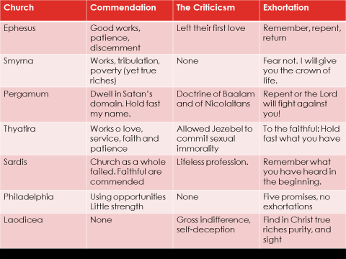

[[4]](#footnote-4)

Evaluate the following two leaders:

Solomon

Jeroboam I

We can that their lives did not align with their .

Summary:

**Day 1, Topic 2: *Divine Design, Direction and Development***

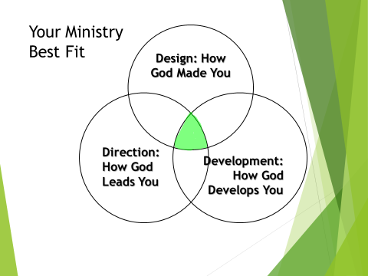

**Defining Terms**

* Divine Design: Understand how God has uniquely and intentionally wired you for ministry
* Direction: What does God want to do with your design?
* Development: How do you prepare for your ministry?

False Assumptions

* Anyone can be a pastor.
* Every pastor can become a turnaround pastor.

**Divine Design**

God’s “call” for vocational ministry

Are you gifted for pastoral or vocational ministry?

Prior Life Experiences

* Heritage
* Heroes
* High Points
* Hard Times

Current Life Experiences

* Age
* Marital Status
* Gender
* Ethnicity
* Education
* Health
* Finances
* Second Occupation
* Ministry Experience

Natural and Spiritual Gifts

He gives gifts to all.

. . . He makes His sun rise on the evil and on the good, and sends rain on the just and on the unjust.

Matthew 5:45

Passion

Temperament

**Direction**

Ephesians 2:10

You must have a clear sense of your won

* Core Beliefs
* Core Values
* Mission
* Vision
* Alignment

All your personal preferences ought to be aligned with your church or mission’s core statements!

**Development**

Where are leaders developed?

* Churches (Quote from *Re:Vision)*\*
* Seminaries
* Denominations
* Mission Agencies

Words of Encouragement

We can grow and develop throughout our lives.

We are a work in progress!

2 Timothy 3:14

Phil 4:9

**Day 1, Topic 3: *An Introduction to Church Transformation***

**Understand the Crucial Elements Needed for Church Revitalization**

***OVERVIEW:***

***LEADERSHIP AND TURNAROUND***

***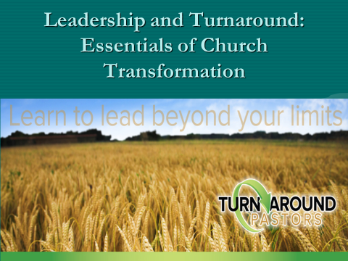***

How does one go about changing a dying church with a lot of history?

How does one go about leading a church that is off center?

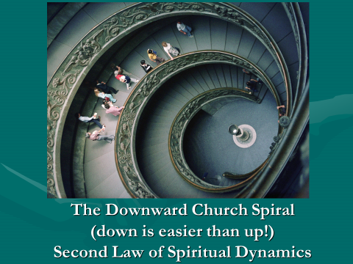

In America, one has at least an 85% chance of pastoring a .

The Three Ds: The Backdrop for Re-envisioning Leaders

Understand your **Divine Design**

**Direction**

**Development**

**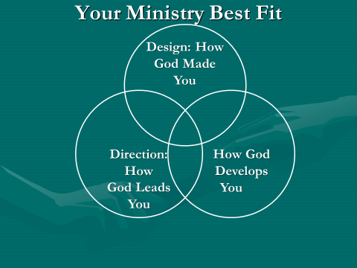**

**Matt Chandler discusses our lack of proper preparation for pastoral ministry.**

*When I graduated, I felt I had all the information I would need to accomplish all that God would demand of me as a pastor. I had a verse for everything. For the next few years, as an associate pastor over college students and as an itinerant preacher, I found very few gaps in my training and was extremely pleased with what I had paid so dearly for in money, hours and study.*

*But, my perceptions changed quickly when I became the lead pastor of the Village. It didn’t take me long (about a month and a half) as a twenty-eight-year-old pastor to figure out that I had more to learn than I had time to learn. The gaps in my training weren’t biblical, theological, or even philosophical. My gaps were in the areas of leadership and people. In the five years of theological training we never talked about how to hire the right people or remove people who need to be removed. There was never a class on how to build a board or work with an existing board. There wasn’t one seminar offered on how to set salaries, conduct performance reviews, or create clear job descriptions.*

*Although the Scripture taught me the spirit by which I was to interact with people and the grace I was to show even my enemies, I was at a loss regarding the practical aspects of leading a team—and a team of leaders at that.[[5]](#footnote-5)*

Our Development:

But you must continue in the things which you have learned and been assured of, knowing from whom you have learned them.

2 Timothy 3:14

The things which you learned and received and heard and saw in me, these do, and the God of peace will be with you.

Philippians 3:9

**A Painful Reality: In America, Pastors who take a new church stand an 85% chance of inheriting a church that is plateaued or declining in worship attendance.**

First, you must embrace . . .

Your Mission Matthew 28:18-20

Vision: Your ministry must communicate a clear, compelling vision with passion.

Know where you want your church to be in two, five, and ten years and move that direction.

Essential Keys

1. Seek the Face of God. Nehemiah 1

2. Pray and ask the Lord for His direction, for His vision. Nehemiah 1

3. Survey the church situation (Nehemiah)

4. Develop great .

5. Recognize your Employer!

Prov 29:24

1 Thess 2:4

*Lifeway Christian Research (LCR) asked over two hundred pastors to keep a record of the way they spent their time in a 168-hour week. Roughly half of them were in the top five percent of congregations for conversion growth; the other half were in congregations reporting no significant conversion growth.*

*Note some of the differences in the way pastors invested their time!*

6. Preach Well: TAPs spent an average of 22-hours in sermon preparation vs 4 hours for NTAP—LCR).

*When I began to preach, people looked up to preachers. In New York City, the sermons of New York ministers were published in The New York Times. People admired the church . . . That was 65 years ago. Today that has changed. Today the preacher has lost the respect of the people, lost its authority. We live in a day in which the wind is against us. All the games are away games.*

--Haddon Robinson Distinguished Professor, Gordon-Conwell Theological Seminary, 4/27/2012, at Biola University

7. Meet people outside the church (TAP—5 hours sharing the Gospel vs 0 hours for NTAPs). You may have to restructure your schedule to accommodate this change!

8. Delegate responsibility to others. (NTAP—33 hours in pastoral care, TAP—10 hours).

9. Develop a team.

10. Develop new leadership.

11. Learn good skills

12. Become a problem solver.

13. a mentor or a coach.

14. Know your spiritual gift mix and use your primary gifts.

15. Empower others to use their gifts.

16. Lead without being domineering. Be directive, not passive, but lead. (Tell not suggest).

17. Love the Lord and your people deeply.

18. Be more innovative than traditional.

19. Embrace necessary change

20. Be more of a leader than a manager.

21. Count the cost for you, your spouse, and your children.

Turnaround Is Possible! There is hope for your church!

**Day 1, Topic 4: *There’s Hope for Your Church—Part 1***

Introduction:

Why Is There Hope?

1. Christ said, .

2. God desires us to be .

3. God revitalizes .

Why Is Hope Important?

With hope, we ; without hope we .

Three Fogs Covering Hope

1. The Fog of \_\_\_\_\_\_\_\_\_\_\_\_\_\_\_

• When we are \_\_\_\_\_\_\_\_\_\_, we lose \_\_\_\_\_\_\_\_\_\_\_\_.

1. The Fog of \_\_\_\_\_\_\_\_\_\_\_\_\_

• When we are \_\_\_\_\_\_\_\_\_\_\_\_\_, we lose \_\_\_\_\_\_\_\_.

1. The Fog of \_\_\_\_\_\_\_\_\_\_

• When we are \_\_\_\_\_\_\_\_\_\_\_\_\_\_, we lose \_\_\_\_\_\_\_\_\_\_.

We Keep Hope Alive By …

1. Keeping a \_\_\_\_\_\_\_\_\_\_\_\_\_\_\_ focus

• We \_\_\_\_\_\_\_\_\_\_\_\_ to God.

1. Managing the \_\_\_\_\_\_\_\_\_\_\_\_\_\_\_

• We set up a \_\_\_\_\_\_\_\_\_\_.

Step #1: Keep A Spiritual Focus

1. Take time to \_\_\_\_\_\_\_\_\_\_ each day.

• We lose hope when we focus on \_\_\_\_\_\_\_\_\_\_\_\_\_\_\_\_\_.

1. Keep the big \_\_\_\_\_\_\_\_\_\_\_\_\_ in view.

• We lose hope when we focus too \_\_\_\_\_\_\_\_\_\_\_\_\_\_\_\_\_.

1. Focus on \_\_\_\_\_\_\_\_\_\_\_\_\_

• We lose hope when we focus on \_\_\_\_\_\_\_\_\_\_\_\_\_\_\_\_\_\_.

Step #2: Manage the Process

1. Revive .

• Remember: To turn your around, you must first turn

around.

1. Affirm your .

• Remember: What God has you to do he has you to do; What God has you to do, he has you to do.

1. Develop a posture.

• Remember: Leaders are .

1. Establish life .

Remember: Nothing happens until you it down.

1. Build .

• Remember: People buy into your when they buy into

.

1. Review your vision \_\_\_\_\_\_\_\_\_\_.

• Remember: Vision is an job.

1. Recruit a \_\_\_\_\_\_\_\_\_\_\_\_\_\_ team.

•Remember: If they want to , run with them;

If they want to , walk with them;

If they want to , find someone else.

1. How a \_\_\_\_\_\_\_\_\_\_\_\_\_\_\_\_ vision meeting.

• Remember: People need to be on a regular time schedule.

1. Preach your vision every other \_\_\_\_\_\_\_\_\_\_\_.

• Remember: People move in the direction of their thoughts.

1. Get some \_\_\_\_\_\_\_\_\_\_\_\_ and .

• Remember: Even Jesus took time from people.

1. Breaking Through: Develop a Turnaround Plan



Gary McIntosh, *There’s Hope for Your Church* (Grand Rapids, Baker, 2012), 164. (Used by permission)

Insight for my life and church:

**Day 2, Topic 1: *The Pastor’s Worth***



Please not that this *Pastor Unique* diagram is slightly different than the Divine Design, Development and Direction diagram. We are focusing in this section on “Who God Says You Are.”

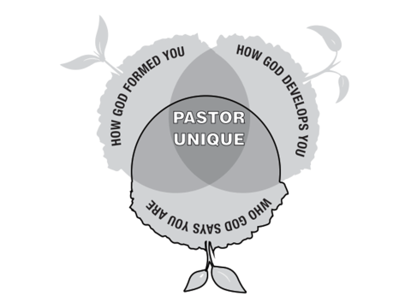

* **We are Specially Created by God Genesis 1:26-28**

26 Then God said, "Let Us make man in Our image, according to Our likeness; let them have dominion over the fish of the sea, over the birds of the air, and over the cattle, over all the earth and over every creeping thing that creeps on the earth."

27 So God created man in His own image; in the image of God He created him; male and female He created them.

28 Then God blessed them, and God said to them, "Be fruitful and multiply; fill the earth and subdue it; have dominion over the fish of the sea, over the birds of the air, and over every living thing that moves on the earth."

Genesis 3:26-28

We are God’s .

We bear God’s .

* **We are priceless beyond measure 1 Peter 1:18-19**

Knowing that you were not redeemed with corruptible things, *like* silver or gold, from your aimless conduct *received* by tradition from your fathers, but with the precious blood of Christ, as of a lamb without blemish and without spot.

1 Peter 1:18-19

We were redeemed not by the wealth of the world

We were redeemed by the Blood of Christ, the blood of the Lamb!

* **We are Precious Gift Ephesians 4:7-11**

But to each one of us grace was given according to the measure of Christ's gift. Therefore He says: "When He ascended on high, He led captivity captive, And gave gifts to men.” . . . And He Himself gave some to be apostles, some prophets, some evangelists, and some pastors and teachers.

Ephesians 4:7-8, 11

The Father gives the Son as Head of the Church Ephesians 1:22

The Son gives Christian leaders as a .

**Summary**

We are God’s craftsmanship.

We bear God’s image.

We are priceless beyond measure.

Christ dispensed you as a measure of His royal treasury.

**Day 2, Topic 2: *Mission, Vision and Core Values***

Filename: j0411673.jpg
Keywords: academics, concepts, discoveries ...
File Size: 483 KB

***Developing Biblically Based Vision***

***And Ministry Plan***

**Introductory Thoughts:**

Churches and pastors are often confused as they consider where they should go and how they should minister.

**The Role of Mission, Values and Vision in**

**Transformational Leadership**

* By way of reminder, here are some descriptions of Core Beliefs and Core Values/Behaviors.
* What are Core Beliefs?
* Core beliefs are those beliefs that significantly impact who you are
* Core beliefs “define” who you are.
  + - If someone read your core beliefs and knew nothing else about you, they would know who you are at your very center.
    - If one of your Core Beliefs were not true, was changed or removed you would cease to be who you are.
* Core beliefs are the biblical foundation for all you do.
* You do what you do because you believe these things are true.
* Core beliefs impact, in some way or another, virtually everything you do.
* What are Core Values/Behaviors?
* Ministry principles by which you live
* The things for which you will spend your lives
* The values/behaviors for which you are prepared to die
* One Core Value/Behavior per Core Belief
* Core Values are what we will **DO** in light of what we believe.

**Purpose** answers the question “why?”  
  
The over-arching reason. The *telos*. The end result we strive to accomplish.

**Mission** answers the question “what?”

What is to occur to lead to the fulfillment the of Purpose, to get to the ultimate goal?

**Vision** answers the question “how.”

With both the purpose (telos) and the mission (what) in mind, vision paints a picture of the path to get there.

**Exercise 1: Please write down the core values for your church:**

**Exercise 2: Please write down the vision for ministry for the church you serve. Be as clear and succinct as possible.**

**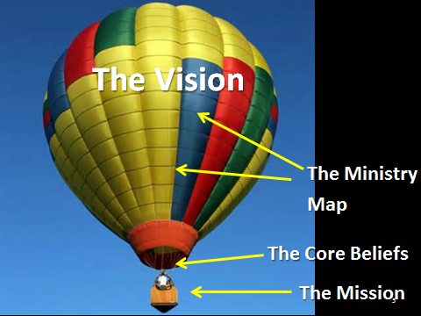**

**Foundations for Developing a Ministry Plan for Yourself and the Church You Pastor**

1. Understand (know) God--Be Deeply Immersed in the Word of God and Prayer

2. Understand (know) your Gifting

3. Understand (know) your Congregation

4. Understand (know) your Community

5. Understand the .

6. Understand your mission

7. Count .

Note: Your vision for ministry will affect how each of these seven foundations will functions in your church, your community and your own personal ministry.

**Ministry Mapping**

Note: Our Association, The Rocky Mountain Church Network, worked closely with Growing Healthy Churches (GHC) for over 10 years. GHC is the only association I know that effectively turned around a judicatory. This section relies heavily on GHC material in the processes we are using. Training was provided by Dr. Bill Hoyt of GHC.

What is Ministry Mapping? (Envisioning)

* This is a process that involves several steps:
* It begins with the of the church
* In the process, we identify the of the church.
* From the core beliefs come .
* An action plan is developed from the core values and the mission

Other Names for the Process

A Brief History of Strategic Planning Process

* + Great Mission and Vision Statements
    - No impact
  + Mission and Vision Statements don’t motivate
  + Values motivate
  + Clarify and articulate your values

Two Problems

Does not start far enough

Does not go far enough

Why Create a Ministry Map?

To achieve greater ministry effectiveness

To create unity around a commonly understood, widely supported mission and vision

“The problem with most churches is not a lack of vision, but too many visions”

--Leith Anderson

Judges 21: 25 In those days there was no king in Israel; everyone did what was right in his own eyes.

To achieve greater effectiveness and satisfaction by establishing specific ministry plans and clear ministry outcomes

The Mapping Process results in:

* Core beliefs
* Core values
* A sound biblical understanding of the church’s
* A clear, concise and compelling of what it will look like as your church fulfills its God-given Mission
* A that leads to ministry effectiveness by enabling you to you do by its contribution to your accomplishing your Mission and Vision.

This is a Spiritual Process

* We build upon
* We are guided by
* We agree on Biblical
* We bathe the process in prayer
* We seek the Spirit’s wisdom

Listening Process

* Listen to .
* Listen to .
* Listen to .
* Listen to .

*The Process*

Schedule (this process takes commitment on the part of the participants)

Tasks

Option 1—Using a Consultant (Denominational Leader)

* Takes 6-8 days
  + Friday (5:00 PM – 9:30 PM)
  + All day Saturday (8:30 AM – 5:00 PM)
* Schedule the dates
* Coach them on the Team make-up
* Obtain contact information for Team members
* Distribute Primary Teaching Passages and Instructions
* Collect their initial attempts at writing Core Beliefs
* Sharpen their ­
* Develop their
* Create the Ministry Map

Option 2—Working through your church membership.

Share the process with the church

Ask people to look at the passages and state the essential truths that each passage teaches in the particular area of study.

Encourage church members to write out their own statements of Core Beliefs

Bring the results to the study group that will develop the core belief statements.

* Teach the planning process
  + SMART Goals
    - S
    - M
    - A
    - R
    - T

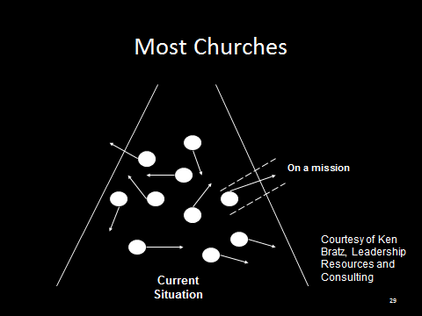

**Then . . .**

* **Create the Annual Plan**
  + **One or two primary SMART Goals** 
    - **From Key Measurement Areas**
      * **Conversions**
      * **Attendance**
      * **Assimilation**
      * **Lay Involvement**
      * **Small Group Involvement**
      * **Leader Development**
      * **Tithers**
      * **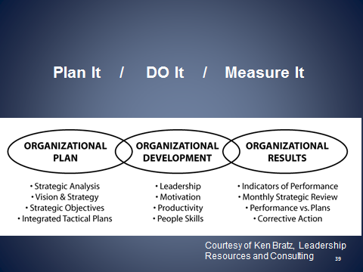**

**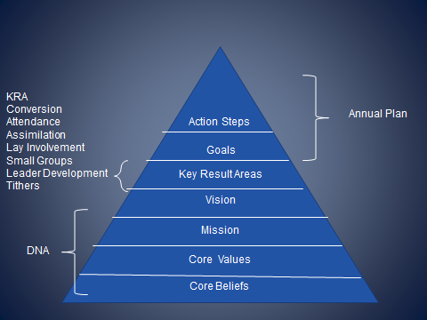**

**Core Beliefs**

**Core Values**

**+**

**The Mission**

**+**

**Community Needs**

**Vision**

**Ministry Map**

**Focusing on Mission**

* **Your God-given task**
* **Biblically based**
* **Unchanging**
* **Churches do not get to pick their mission**
* **The Church’s mission is the Great Commission**

**What is our mission?**

***Sample Mission Statements***

* **Many churches simply say, “We exist to make mature (obedient) Disciples.”**
* **We live to transform lives by following and proclaiming Jesus Christ as Savior and Lord.**
* **Our mission is to help people know Christ and grow to be like Him.**
* **We exist to be a community which enables people from all backgrounds to become mature followers of Jesus Christ through the power of the Holy Spirit.**
* **We exist to equip God's people to do His work in His world.**
* **We exist to carry out the Great Commission, live out the Great Commandment, and serve the Great Commander.**
* **We are a family of faith, lovingly adopting lost children.**
* **“The purpose of our church is to glorify God by finding, keeping and building people.”**

**Gary McIntosh, *One Size Doesn’t Fit All***

**FOCUSING ON CORE BELIEFS**

**Core Beliefs are not . . .**

* Core beliefs are not a comprehensive recitation of fundamental theological beliefs.
* Core beliefs are not a doctrinal statement rehearsing your entire belief system.
* Core beliefs are not your .
* Core beliefs are not values. Values flow from your core beliefs.

**Core Beliefs are . . .**

* Core beliefs are those beliefs that significantly impact .
* Core beliefs “define” .
  + If someone read your core beliefs and knew nothing else about you, they would know who you are at your very center.
  + If one of your Core Beliefs were not true, was changed or removed you would cease to be who you are.
* Core beliefs are the for all you do.
  + You do what you do because you believe these things are true.
* Core beliefs impact, in some way or another, virtually everything you do.

**State Core Beliefs . . .**

**Briefly!!!!!!**

As as possible.

Avoid obscure terms, Christian terminology and

“ ” language.

Think “ ” in the sense than an unchurched person just off the street could readily understand.

Use words that create . That is, they open doors to further conversation.

**They are . . .**

* + The “leading edge” of declaring a vital, deep and often complex Biblical truth.
  + Taught through annually.

How are Core Beliefs Used?

* + Printed and are used a part of the process of “introducing” the church to an inquirer or potential member. They would be reviewed as part of a new member orientation process.
  + Part of a cluster of “defining declarations” – your Core Beliefs, Core Values, Mission and Vision Statements.

**Focusing on Core Values**

**What are Core Values?**

* Not an academic statement listing your entire value system
* Identification and articulation of those values that significantly impact who you are and .
* The things that motivate you and shape , not what you say
* Ministry principles by which you live
* The things for which you will .
* The values you are prepared to .
* One Core Value per Core Belief
* More brief than Core Beliefs
* Core Values are what we will do in light of what we believe.
* The verbal construct…
  + Not “We believe...,” “Therefore we value…”
  + “We believe…,” Therefore …”
  + Express values in terms of

**The Process**

1. Each person writes a statement on their own

2. The team puts all the statements together

3. The team shows them all

4. The team formulates one statement—a core belief.

5. Then a team member or facilitator works to sharpen the wording

**Facilitator’s Position Description**

* **Assignment**
  + **Create a “Ministry Map” which will guide the Church in its ministry planning and implementation over the next three to five years.**
  + **The “Ministry Map” will be the foundation upon which the church’s staff (Paid and unpaid, full and part time) will build their Annual Ministry Plans.**
* **Tasks**
  + **The “Ministry Map” is comprised of the church’s Core Beliefs and Values, Mission and Vision Statements,**
  + **The Mapping Team will work together to:**
    - **Identify and articulate the church’s Core Beliefs**
    - **Identify and articulate the church’s Core Values**
    - **Clarify the church’s Mission**
    - **Articulate the church’s Vision**

**Assignment—Create a Ministry Map (Plan for Ministry)**

**Mapping Team Makeup**

* Not less than 5 and not more than 9
* Mixture and Balance of…
  + Long-timers and relatively new but involved
  + Pastoral staff (minimally Senior or Transitional Pastor)
  + Governing Board Members
  + Ministry Leaders
  + Systems thinkers
  + People who are good with words

**Personal Qualities of Mapping Team Members**

* + Cooperative and collaborative
  + Verbal people, good with words
  + Willing to speak up and lobby for their viewpoint
  + Cannot be:
    - Argumentative
    - Domineering
    - Judgmental
    - Rigid
  + Biblically literate (Knowledgeable)
  + Theologically astute (Insightful)
  + Person who tends to think “outside the box”
    - Sees things from “different” point of view
    - Readily sees alternatives
  + Flexible and creative
  + Deeply committed to the church
  + Happy to be part of the mapping process

**Preparatory Materials**

***Primary Teaching Passages (passages are listed at the end of this section)***

* + **God**
    - **God the Father**
    - **God the Son**
    - **God the Holy Spirit**
  + **Bible**
  + **Humankind, Sin, Salvation**
  + **Church**
  + **Worship**
  + **Prayer**

**Beginning the Process**

Initially your envisioning team, **individually and together**, will spend time reading, studying and meditating on these primary teaching passages of Scripture. After having spent time with these Scriptures have each team member write a brief Belief Statement for each of the following areas. “Brief” means Nine words or less, not counting the “I believe.”

* God the Father – email to me by . . .
* Jesus – email to me by . . .
* Holy Spirit – email to me by . . .
* Bible – email to me by . . .
* Mankind, Sin and Salvation (if not listed under “God”)
* Church – email to me by . . .
* Worship – email to me by . . .
* Prayer – email to me by . . .
* Edification—email me by . . .

**Coaching the Process**

***Your role is to:***

* + Frame the .
  + Guide the Discussion
  + Move the .

Remember .

* is mandatory. We will use enough words to say it well but not one word more
  + Core Beliefs are typically stated in .
  + Core Values are typically stated in .
* Avoid wasted words (like “that”) and superfluous adjectives
* Avoid “churchy language,” Christian jargon, unnecessary Biblical or theological words
* State Biblical and theological concepts in words that the unsaved, unchurched, untaught and uninitiated can readily understand
* Use Biblical and theological words when…
  + They are the clearest, most accurate and richest words we can think of
  + The concept is so fundamentally crucial that we intentionally want to create “a teaching moment”

* Whenever possible use present tense, active voice verbs
  + Avoid verbs like “is,” and “are” in favor of verbs like wants, loves, directs, frees, calls, sends, saves, instructs, etc.
* Avoid lists

**Breakout Session**

**Develop a statement of the core belief for God. Use the passages listed below on Worksheet 1. Follow the instructions given below.**

**UNDERSTANDING OUR BIBLICAL CORE BELIEFS**

**Discovering Our Core Beliefs**

**Worksheet #1**

**The Process**

**Develop a set of statements that give your Core beliefs. In this lesson focus on passages that deal with God. Take no more than two weeks to cover this section. You may use the first week to Discuss some of the questions you have. Then use the second week to write out a statement about God. Bring it to your group and try and write a concise core belief statement about God.**

1. **Take the passages listed below that deal with each of the Core belief areas. Read them, pray about them and wrestle with them.**
2. **Prepare a preliminary statement of a Core belief . . . in 15 words or less.**
3. **Avoid wasted words (like “that”) and superfluous adjectives**
4. **Avoid “churchy language,” Christian jargon, unnecessary Biblical or theological words**
5. **State Biblical and theological concepts in words that the unsaved, unchurched, untaught and uninitiated can readily understand**
6. **Use Biblical and theological words when…**
   1. **They are the clearest, most accurate and richest words we can think of**
   2. **The concept is so fundamentally crucial that we intentionally want to create “a teaching moment”**
7. **Whenever possible use present tense, active voice verbs**
   1. **Avoid verbs like “is,” and “are” in favor of verbs like wants, loves, directs, frees, calls, sends, saves, instructs, etc.**
8. **Avoid lists**

**Here are the passages that relate to our Core Beliefs about God.**

|  |  |
| --- | --- |
| **Core Value** | **Primary Teaching Passages** |
| **God** | **Genesis 1:1**  **Deuteronomy 6:4-5**  **Isaiah 43:10-11**  **Psalm 90:2**  **Psalm 102:25-27**  **John 3:16-17**  **1 Corinthians 8:4-6**  **2 Corinthians 13:14**  **1 Peter 1:1-3a**  **1 Peter 1:15-16**  **1 John 1:5** |

**What values about God’s person and character stand out in each of the passages?**

**Genesis 1:1**

**Deuteronomy 6:4-5**

**Isaiah 43:10-11**

**Psalm 90:2**

**Psalm 102:25-27**

**John 3:16-17**

**1 Corinthians 8:4-6**

**2 Corinthians 13:14**

**1 Peter 1:1-3a**

**1 Peter 1:15-16**

**1 John 1:5**

**Do you see any common themes or repeated themes? If so, please list them below.**

**Based on your observations, write out a core belief statement about God. Keep your statement to 15-words or less.**

**Worksheet #2**

**Here are the passages that relate to our Core Beliefs about Jesus.**

|  |  |
| --- | --- |
| **Core Value** | **Primary Teaching Passages** |
| **Jesus** | **Luke 4:16-19**  **John 1:1-3**  **John 14:3**  **John 14:6-7**  **Ephesians 1:3-10**  **Philippians 2:6-11**  **Col 1:15-20**  **Col 2:9-10**  **1 Tim 2:5-6**  **2 Peter 3:9** |

**Luke 4:16-19**

**John 1:1-3**

**John 14:3**

**John 14:6-7**

**Ephesians 1:3-10**

**Philippians 2:6-11**

**Col 1:15-20**

**Col 2:9-10**

**1 Tim 2:5-6**

**2 Peter 3:9**

**Do you see any common themes or repeated themes? If so, please list them below.**

**Based on your observations, write out a core belief statement about Jesus. Keep your statement to 15-words or less.**

**Worksheet #3**

**Here are the passages that relate to our Core Beliefs about the Holy Spirit.**

|  |  |
| --- | --- |
| **Holy Spirit** | **John 14:25-26**  **John 16:7-15**  **Acts 1:4-8**  **Acts 5:3-4**  **Romans 8:9-11**  **1 Corinthians 2:10-14**  **1 Corinthians 6:19**  **1 Corinthians 12:7-11**  **Gal 5:22-25**  **Ephesians 3:16-19**  **Ephesians 5:18-21** |

**John 14:25-26**

**John 16:7-15**

**Acts 1:4-8**

**Acts 5:3-4**

**Romans 8:9-11**

**1 Corinthians 2:10-14**

**1 Corinthians 6:19**

**1 Corinthians 12:7-11**

**Gal 5:22-25**

**Ephesians 3:16-19**

**Ephesians 5:18-21**

**Do you see any common themes or repeated themes? If so, please list them below.**

**Based on your observations, write out a core belief statement about the Holy Spirit. Keep your statement to 15-words or less.**

**Worksheet #4**

**Here are the passages that relate to our Core Beliefs about the Bible.**

|  |  |
| --- | --- |
| **The Bible** | **Deut 8:3**  **Nehemiah 8:2-6**  **Isaiah 55:10-11**  **Jeremiah 15:16**  **Psalm 119:105**  **Matthew 22:29**  **Luke 8:11-15**  **Luke 11:28**  **Luke 24:30-32**  **John 20:30-31**  **Acts 17:11-12**  **Romans 15:4**  **2 Tim 3:16-17**  **Hebrews 1:1-2**  **Hebrews 4:12**  **1 Peter 1:23-25**  **2 Peter 1:20-21**  **Rev 22:18-19** |

**Deut 8:3**

**Nehemiah 8:2-6**

**Isaiah 55:10-11**

**Jeremiah 15:16**

**Psalm 119:105**

**Matthew 22:29**

**Luke 8:11-15**

**Luke 11:28**

**Luke 24:30-32**

**John 20:30-31**

**Acts 17:11-12**

**Romans 15:4**

**2 Tim 3:16-17**

**Hebrews 1:1-2**

**Hebrews 4:12**

**1 Peter 1:23-25**

**2 Peter 1:20-21**

**Rev 22:18-19**

**Do you see any common themes or repeated themes? If so, please list them below.**

**Based on your observations, write out a core belief statement about the Bible. Keep your statement to 15-words or less.**

**Worksheet #5**

**Here are the passages that relate to our Core Beliefs about the Church.**

|  |  |
| --- | --- |
| **The Church** | **Matthew 16:17-18**  **Matthew 28:18-20**  **Acts 2:38-47**  **Acts 6:7**  **Romans 12:4-8**  **1 Corinthians 1:10**  **1 Corinthians 12:12-31**  **1 Corinthians 14:26**  **Ephesians 1:22-23**  **Ephesians 4:3-6**  **Ephesians 4:11-16**  **Col 1:18**  **Heb 10:24-25** |

**Matthew 16:17-18**

**Matthew 28:18-20**

**Acts 2:38-47**

**Acts 6:7**

**Romans 12:4-8**

**1 Corinthians 1:10**

**1 Corinthians 12:12-31**

**1 Corinthians 14:26**

**Ephesians 1:22-23**

**Ephesians 4:3-6**

**Ephesians 4:11-16**

**Col 1:18**

**Heb 10:24-25**

**Do you see any common themes or repeated themes? If so, please list them below.**

**Based on your observations, write out a core belief statement about the Church. Keep your statement to 15-words or less.**

**Worksheet #6**

**Here are the passages that relate to our Core Beliefs about the Worship.**

|  |  |
| --- | --- |
| **Worship** | **Ex 34:14**  **Judges 7:12-15**  **2 Samuel 15:32**  **1 Chronicles 16:29**  **2 Chronicles 29:27-31**  **Job 1:20-22**  **Psalm 95:6-7**  **Isaiah 6:1-9**  **Jeremiah 26:2-3**  **John 4:19-24**  **Rom 12:1**  **1 Corinthians 10:31**  **Ephesians 5:19-20**  **Phil 2:9-11**  **Heb 10:24-25**  **Rev 5:1-14**  **Rev 7:11-12** |

**Ex 34:14**

**Judges 7:12-15**

**2 Samuel 15:32**

**1 Chronicles 16:29**

**2 Chronicles 29:27-31**

**Job 1:20-22**

**Psalm 95:6-7**

**Isaiah 6:1-9**

**Jeremiah 26:2-3**

**John 4:19-24**

**Rom 12:1**

**1 Corinthians 10:31**

**Ephesians 5:19-20**

**Phil 2:9-11**

**Heb 10:24-25**

**Rev 5:1-14**

**Rev 7:11-12**

**Do you see any common themes or repeated themes? If so, please list them below.**

**Based on your observations, write out a core belief statement about the Worship. Keep your statement to 15-words or less.**

**Worksheet #7**

**Here are the passages that relate to our Core Beliefs about the Humanity.**

|  |  |
| --- | --- |
| **Humanity** | **Gen 1:26-28**  **Gen 3:1-6**  **Gen 3:7-19**  **Psalm 8:3-8**  **Psalm 139:13-14**  **Jeremiah 1:5**  **2 Corinthians 5:17-18** |

**Gen 1:26-28**

**Gen 3:1-6**

**Gen 3:7-19**

**Psalm 8:3-8**

**Psalm 139:13-14**

**Jeremiah 1:5**

**2 Corinthians 5:17-18**

**Do you see any common themes or repeated themes? If so, please list them below.**

**Based on your observations, write out a core belief statement about the Humanity. Keep your statement to 15-words or less.**

**Worksheet #8**

**Here are the passages that relate to our Core Beliefs about the Sin and Salvation.**

|  |  |
| --- | --- |
| **Sin and Salvation** | **Psalm 51:1-5**  **Isaiah 59:1-3**  **Isaiah 64:6**  **John 3:16-18**  **John 11:25-27**  **Acts 4:10-12**  **Romans 1:16-17**  **Romans 3:19-24**  **Romans 4:4-8**  **Romans 6:23**  **2 Corinthians 5:21**  **Ephesians 1:7-8**  **Ephesians 2:1-10**  **1 Pet 2:24-25**  **1 John 1:5-8**  **1 John 2:2**  **1 John 3:4-6** |

**Psalm 51:1-5**

**Isaiah 59:1-3**

**Isaiah 64:6**

**John 3:16-18**

**John 11:25-27**

**Acts 4:10-12**

**Romans 1:16-17**

**Romans 3:19-24**

**Romans 4:4-8**

**Romans 6:23**

**2 Corinthians 5:21**

**Ephesians 1:7-8**

**Ephesians 2:1-10**

**1 Pet 2:24-25**

**1 John 1:5-8**

**1 John 2:2**

**1 John 3:4-6**

**Do you see any common themes or repeated themes? If so, please list them below.**

**Based on your observations, write out a core belief statement about the Sin and Salvation. Keep your statement to 15-words or less.**

**Worksheet #9**

**Here are the passages that relate to our Core Beliefs about the Edification.**

|  |  |
| --- | --- |
| **Edification** | **Acts 4:32-35**  **Romans 14:19**  **Romans 15:2-3**  **1 Corinthians 8:1**  **1 Corinthians 10:23**  **Ephesians 4:11-16**  **Ephesians 4:29**  **Colossians 1:28** |

**Acts 4:32-35**

**Romans 14:19**

**Romans 15:2-3**

**1 Corinthians 8:1**

**1 Corinthians 10:23**

**Ephesians 4:11-16**

**Ephesians 4:29**

**Colossians 1:28**

**Do you see any common themes or repeated themes? If so, please list them below.**

**Based on your observations, write out a core belief statement about the Edification. Keep your statement to 15-words or less.**

**Worksheet #10**

**Here are the passages that relate to our Core Beliefs about the Prayer.**

|  |  |
| --- | --- |
| **Prayer** | **Matthew 6:9-13**  **Matthew 7:7-11**  **Luke 18:1-8**  **John 15:7-8**  **John 16:23-24**  **Acts 12:5-19**  **Acts 13:1-3**  **James 5:17-18** |

**Matthew 6:9-13**

**Matthew 7:7-11**

**Luke 18:1-8**

**John 15:7-8**

**John 16:23-24**

**Acts 12:5-19**

**Acts 13:1-3**

**James 5:17-18**

**Do you see any common themes or repeated themes? If so, please list them below.**

**Based on your observations, write out a core belief statement about the Prayer. Keep your statement to 15-words or less.**

**Core Beliefs**

**Examples of Statements:**

**One, Comprehensive Statement**

**Three Statement Model**

**Four Statement Model (one example)**

**Four Statement Model (second example)**

***Calvary Church—Core Beliefs and Core Values***

**Our Mission:**

Inspire and equip God’s people to lead others to follow Christ, one person at a time.

|  |  |
| --- | --- |
| **We believe…** | **Therefore, we will…** |
| The one holy, unchanging God created and sustains all things and loves everyone unconditionally. | Live for God and love everyone. |
| Everyone is separated from God because of sin and powerless to restore a relationship with Him. | Help people enter into a right relationship with God. |
| Jesus, fully God and fully man, died willingly and was raised to life again providing the only way to a restored relationship with God. | Seize every opportunity to share the good news of God’s forgiveness through Jesus’ sacrifice. |
| God’s Holy Spirit reveals sin and draws those who repent into right relationship with God. | Live in humble dependence on the Holy Spirit’s power. |
| The Bible is God’s true and complete word, a life-changing guide for knowing God and living with purpose. | Know, live, teach and proclaim God’s word every day. |
| The Church exists to help all people become obedient followers of Jesus. | Invest in people’s lives, providing a safe place to grow in relationship with God. |
| Worship is choosing a God-centered life offered in response to His holiness and love. | Celebrate God and His work in our lives, honoring Him with our thoughts, words and actions. |
| Prayer releases God’s power to transform lives for His purpose and to grow in relationship with Him. | Pray continually, confident that God will act according to His purpose. |

**Our Vision:** To see all of Calvary’s people leading others to faith in Jesus Christ, growing in

their relationship with God, and actively serving in the community.

***Bible Church***

**Our Mission:**

To equip and inspire God’s people to reach the world for Him one person at a time.

**Our Vision:**

To be a growing community that boldly pursues God’s purpose by sharing His love with all people.

**Our Core Beliefs & Values**

|  |  |
| --- | --- |
| **We believe…** | **Therefore, we will…** |
| There is one true God, creator of all things, who loves all people unconditionally. | Welcome and inspire all people to embrace God’s unconditional love. |
| All people are sinful, but God’s only Son Jesus died and rose again to offer the only way to God. | Seize every opportunity to share our faith in Jesus. |
| God gives His Holy Spirit to those who trust Jesus, empowering them to live for God. | Live Holy Spirit-empowered lives that glorify God by serving others. |
| The Bible is the error-free unchanging Word of God, the foundation of our faith, teaching those who trust Jesus how to live. | Engage people in serious Bible study and daily obedience to God. |
| The church exists to help all people become strong, healthy followers of Jesus. | Cultivate a community that supports people in growing relationships with God and others. |
| Worship is an enthusiastic expression of gratitude to God demonstrated by all we think, say, and do. | Praise and honor God while alone, with others, and in everyday life. |
| Prayer is humbly accessing God’s power to accomplish His purpose. | Appeal to God for restoration and strength to accomplish His purpose in our lives. |

GEP--Holyoke

**Developing Vision**

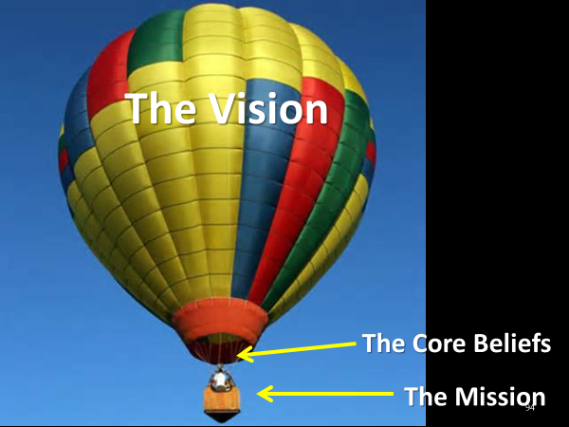

|  |  |  |
| --- | --- | --- |
|  | Mission | Vision |
| Definition |  |  |
| Application |  |  |
| Length |  |  |
| Purpose |  |  |
| Source |  |  |
| Development |  |  |

What is Vision?

A vision is a “clear and challenging picture of the future of a ministry as you believe that it can and must be.”—Aubrey Malphurs

“Moving a church in a direction by passion—that’s vision.”—Bob Humphrey

* Vision is a word picture of what it will look like when you accomplish your mission

The legendary Walt Disney died before Disney World in Florida was completed. On opening day in 1971, almost five years after Disney’s death, someone commented to Mike Vance, creative director of Walt Disney Studios, “Isn’t it too bad Walt Disney didn’t live to see this?”

He did see it,” Vance replied simply. “That’s why it’s here.”[[6]](#footnote-6)

Vision Statement Principles

* Flows from and is consistent with your foundational beliefs, core values and mission
* More specific, more distinctive and more “unique” than a mission statement
* Brief (Normally)
* Understandable without interpretation
* Flows from and is consistent with your foundational beliefs, core values and mission
* More specific, more distinctive and more “unique” than a mission statement
* Brief
* Understandable without interpretation

Sample Vision Statements

* Ten percent of Prior Lake’s population will be in weekly contact with our church where they will become partners in God’s plan to shape our community, country and world.
* We envision a growing movement of transformed people reshaping the culture to reflect God’s heart.—Waterstone Church
* Our Vision is to be a community of people who love Christ, live like Christ, serve Christ and share Christ.
* We see FBCP in the heart of the community with the
  + Sanctuary filled with worshippers
  + Building filled for God’s purposes
  + Community filled with transformed lives and
  + World filled with Disciples who share Christ’s love.

The Value of Vision

* Vision has value only when it…
  + Shapes our thinking
  + Aligns what we do
  + Focuses our efforts
  + Helps Keep the Main Thing the Main Thing
  + Results in the making of mature Disciples
* The Missing Catalyst – Transformational Vision
* Dramatically changes church’s behavior
* Shortens the distance between the idea and the implementation
* Transforms the church…

**Transformational Vision**

* Three Areas
  + Outreach
  + Evangelism
  + Disciple-making
* Outreach and Evangelism
  + Many see them as separate and unique
  + Others see them as interchangeable
* They are NOT interchangeable
  + Outreach is just as its name implies – reaching out
    - A systematic attempt to provide services beyond conventional limits, as to particular segments of a community: *an educational outreach to illiterate adults.*
  + Evangelism is the communication of the Good News resulting in conversions
* Outreach without evangelistic results is incomplete
* And evangelism without outreach is ineffective
* The Biblical case for both…

Matthew 5:16

Acts 2:44-47

1 Peter 2:12

Example of the wedding of Outreach and Evangelism in practice

* + Bayside of Granite Bay (Sacramento), CA
    - Good works…
    - Produces good will…
    - Giving opportunity for the Good News!

Case Study: Work in a Deeply Divided Church in South Denver

We want to glorify God by providing a safe place where . . .  
  
We love like Jesus loves  
Forgive like Jesus forgives   
Serve like Jesus serves and   
Extend grace the way Jesus extends grace

by

Touching 1500 people per year with the love of Christ  
  
Sharing the gospel with 150 people this year  
  
Asking God for 15 new believers this year.   
  
Faith Church

**The Great Lego Challenge**

**Day 2, Topic 3: *You Have Real Personality***

**Your Personality and Your Ministry**

This workshop is intended to address individual behaviors and provide each person information that will allow them to make course corrections in their day-to-day interactions with others to enhance the process of communication in your place of ministry.

* Understand your work behavioral tendencies and develop an understanding of how these styles may affect others.
* Understand, respect, appreciate, and value individual differences.
* Enhance your effectiveness in accomplishing better communication through style flexibility.

**Behavior Versus Personality**

***Personality*** is defined as “the pattern of collective character, behavior, temperamental, emotional, and mental traits of an individual.” Personality is very complex and consists of multiple factors.

***Behavior*** is defined as “one’s actions or reactions under specified circumstances.” Behavior is observable.

The distinction, then, we could make is that *personality* is our overall way of looking at a person – the totality of qualities, cultural values, beliefs, emotional make-up, skills, abilities, and traits particular to an individual. *Behavior*, on the other hand, is the way we respond to a specific situation. It is the *outward expression* of who we are.

**General Introduction:**

* Hippocrates – 400 BC – Observed four different areas of behavior
  + Blood
  + Black Bile
  + Yellow Bile
  + Phlegm
* Jung - 1921 – refined the four types
* Marsten – 1928 – Published “Emotions of Normal People” and identified the behavioral theory we use today

Personality Types: Lion, Otter, Golden Retriever, and Beaver

When it comes to personality profiles, most have heard of Myers-Briggs, Ned Herrmann’s Whole Brain, Galen’s four temperaments, DISC assessment, and the Keirsey Temperament Sorter. One of the lesser known profiles, but just as insightful, was developed by Dr. Gary Smalley and Dr. John Trent. They base their personalities around animal characteristics. Not only are these entertaining but they are very easy for children to grasp as well. People often say, “that person sure is a ‘beaver,’” or “you’re such a ‘lion-otter.’”

Personality Types: Lion, Otter, Golden Retriever, and Beaver

While these personality types are certainly broad categories, I find them very easy to remember and communicate. This is extremely beneficial when dealing with family members, employees, and/or people in general. Knowing their temperaments can make the home, work environment, meetings, and projects run much smoother.

Write down what you see from the slides on the screen:

Slide 1

Slide 2

Slide 3

How the DISC works:

Listed below are the characteristics of each temperament and how they line up with Galen’s and the DISC for comparison:

Lion (Choleric/Dominance)

Strengths– Visionary, practical, productive, strong-willed, independent, decisive, leader

Weaknesses– Cold, domineering, unemotional self-sufficient, unforgiving, sarcastic, cruel

Otter (Sanguine/Influence)

Strengths– Outgoing, responsive, warm, friendly, talkative, enthusiastic, compassionate

Weaknesses– Undisciplined, unproductive, exaggerates, egocentric, unstable

Golden Retriever (Phlegmatic/Steadiness)

Strengths– Calm, easy-going, dependable, quiet, objective, diplomatic, humorous

Weaknesses– Selfish, stingy, procrastinator, unmotivated, indecisive, fearful, worrier

Beaver (Melancholy/Compliance)

Strengths– Analytical, self-disciplined, industrious, organized, aesthetic, sacrificing

Weaknesses– Moody, self-centered, touchy, negative, unsociable, critical, revengeful

Often you’ll find that people have a primary character type and a secondary type. Take a look at yourself. Which one is your primary and which one is your secondary? Some naturally go together and make for a wonderful set of strengths. Also, be sensitive to the weaknesses in yourself and in others.

1. How the DISC Works

Task Oriented

**C D**

Responds Takes Action

**S I**

People Oriented

2. People who represent the various profiles and percentages of each group

Task Oriented

**C D**

Responds Takes Action

**S I**

People Oriented

Descriptors:

D

I

S

C

Desires of Each Personality Type

Task Oriented

**C D**

Responds Takes Action

**S I**

People Oriented

Representatives

Task Oriented

**C D**

Responds Takes Action

**S I**

People Oriented

Task Oriented

**C D**

Responds Takes Action

**S I**

People Oriented

3. What the DISC Personality Profile Demonstrates

Chart I (Most) **Adapted Style**

Graph I is generated from your “Most” responses

Your “Most” responses illustrate the behavior you exhibit in your “focus” environment.

Graph I is your “mask” graph

We tend to adapt our behavior to meet the demands of our environment. Graph I represents the behavior you project to others. It may not be the same as your natural behavior.

Graph I is the most changeable

Graph I can change depending on the demands from your environment. Many times, success can be directly related to your ability to read an environment and adapt the correct behavior to win.

Graph I is your “focus” graph

Graph I illustrates the behavior in your “focus” environment. It may change between work and home or can be situational. For example, meetings tend to demand certain types of behavior depending on your role, which may not be the same as your Basic (Natural) Style.

Chart II (Least) **Natural Style**

 Graph II is generated from your “Least” responses

When you select adjectives that are “Least” like you the system moves you away from that type of behavior. For example, if you select words that describe you least, such as bold, daring or determined, your plot point on that factor will move down. Identifying what you are “least” like allows the process to determine your natural behavior.

Graph II is your natural behavior

When you are under pressure, your behavior will reflect your natural style because you do not have the energy to adapt or mask your behavior. Also, when you are totally at ease and have no need to adapt, others will see your natural behavior.

Graph II is the least changeable

Graph II will seldom change significantly because this represents the “real” you.  
  
Graph II can change if you experience a significant emotional event

A significant emotional event can cause change in Graph II. For example, divorce, death of a loved one or loss of employment can significantly impact a person’s emotions and change Graph II.

# PERCEPTION

“Perception is all there is.

There is no reality.

There is only perceived reality.”

Tom Peters

What do you see?

****

**Behavioral Styles**

**INFLUENCE**

+ Emotional

+ Enthusiastic

+ Optimistic

+ Persuasive

+ Animated

+ Talkative

+ People oriented

**+ Stimulating**

Disorganized

Undisciplined

Manipulative

Excitable

Reactive

# Vain

# DOMINANCE

+ High ego strength

+ Strong-willed

+ Decisive

+ Efficient

+ Desires change

+ Competitive

+ Independent

+ Practical

# Pushy

Impatient

Domineering

Attacks first

Tough

Harsh

**High**

**Fast Pace**

#### ASSERTIVENESS

**STYLE**

**FLEXIBILITY**

**STEADINESS**

+ Dependable

+ Agreeable

+ Supportive

+ Accepts change slowly

+ Contented

+ Calm

+ Amiable

+ Reserved

Unsure

Insecure

Awkward

Possessive

Conforming

Wishy-Washy

**COMPLIANT**

+ Perfectionist

+ Sensitive

+ Accurate

+ Persistent

+ Serious

+ Needs much information

+ Orderly

+ Cautious

Picky

Stuffy

Critical

Judgmental

Fears criticism

Slow to make decisions

**Low**

**Slower Pace**

## RESPONSIVENESS

**Low**

**Task Oriented**

**High**

**Relationship Oriented**

 ©Leadership Resources and Consulting / [www.lrandc.com](http://www.tamcoinc.com/" \t "_blank) .  Used by permission.

**Recognizing DISC Styles**

**DOMINANCE**

The “D” is looking for: Results

**Emotion:** Anger

**Quick observations:** Extroverted, task oriented

**Communication:** Direct

**Overextension:** Impatient

**Body Language:**

**Stance –** Forward leaning, hand in pocket

**Walks –** Fast, always going somewhere

**Gestures –** A lot of hand movement when talking, big gestures

**Communication Clue:** Doesn’t want others’ opinions, only facts

**D**

**INFLUENCE**

The “I” is looking for: The “Experience”

**Emotion:** Trust/Optimism

**Quick observations:** Extroverted, People-oriented

**Communication:** Indirect

**Overextension:** Disorganized

**Body Language:**

**Stance –** Feet spread, two hands in pockets

**Walks –** Weaves, people focused, may run into things

**Gestures –** A lot of big gestures and facial expressions when talking

**Communication Clue:** Talks with hands

**COMPLIANCE**

The “C” is looking for: Information

**Emotion:** Fear

**Quick observations:** Introverted, task-oriented

**Communication:** Direct

**Overextension:** Critical

**Body Language:**

**Stance –** Arms folded, one hand on chin

**Walks –** Straight line

**Gestures –** Very reserved, little or no gestures

**Communication Clue:** Asks detailed questions

**STEADINESS**

The “S” is looking for: Security

**Emotion:** Non-emotional

**Quick observations:** Introverted, people-oriented

**Communication:** Indirect

**Overextension:** Possessiveness

**Body Language:**

**Stance –** Leaning back, hand in pocket

**Walks –** Steady, easy pace

**Gestures –** Will gesture with hands

**Communication Clue:** Has a “poker” face

**I**

**C**

**S**

**Blending Your Ministry Strengths**

©2007 Target Training International, Ltd - Used by permission

|  |  |  |  |  |
| --- | --- | --- | --- | --- |
|  | D | I | S | C |
| Value to the Team | Takes Initiative | Contacts people | Performs specialized follow-through | Concentrates on details |
| Major Strength | Strength of purpose; goal oriented, gets things done | Enthusiasm; gets people motivated, involved | Good people skills; good team player or leader | Thoroughness, accuracy in analyzing all the data |
| Major Weakness | Can be insensitive to feelings of others; impatient | Impulsiveness; may not focus attention on detail/ facts | May sacrifice results for harmony; reluctant to initiate | Overly cautious; can be too thorough and lose sight of time |
| Motivated by: | Results; challenge, action | Recognition; approval, visibility | Relationships; appreciation | Being right; quality |
| Time Management | Focus: Now; efficient use of time . . . likes to get to the point. | Focus: Future; tends to rush to the next exciting thing | Focus: Present; spends time in personal interaction sometimes to the detriment of the task | Value to the team |
| Communication | One-way . . . not as good a listener, better at initiating communication | Enthusiastic, stimulating, often one-way, can inspire others. | Two-way flow, a good listener | Good listener, especially in relation to tasks |
| Decision Making | Impulsive; always makes decisions with goal in mind | Intuitive, quick. Lots of wins and losses | Relational; makes decisions more slowly, due to input from others | Reluctant, thorough; needs lots of evidence |
| Behavior Under Tension | Autocratic | Attacks | Acquiesces | Avoids |
| Would Improve Effectiveness by | Listening | Pausing | Initiating | Declaring |

**Leading Your Ministry Team**

|  |  |  |  |  |
| --- | --- | --- | --- | --- |
|  | D | I | S | C |
| How to relate to a | **Be Direct:**   * Start with results/ benefits first * Provide details only as needed | **Be Enthusiastic**   * Be Positive, friendly * Provide praise * Validate their self –worth * Give them the feeling, “I need you.” | **Be Relational**   * Use friendship * Be easy-going * Be low-key on objectives * Don’t push | Be Analytical   * Give clear facts * Present ideas objectively |
| How to convince a | Key Question:  **What?**   * Focus on results/ bottom line * Answer their question, “What are the benefits?” | Key Question:  **Who?**   * Provide emotion/ be enthusiastic * Share testimonies or significant people * Answer their question, "Who else has done this?” | Key Question:  **Why?**   * Be friendly with them * Take time with them * Answer their question, “Why do you want things to change? | Key Question:  **How?**   * To them it is important to do it right, so show them step by step how to do it * Answer their question, “How do you want me to do this?” |
| How to manage a | Goals/Results   * Give them the what—let them determine the how * Let them have **control**, be in charge of something | Group/Recognition   * Consult/counsel with them about ideas, projects, people * Recognize their efforts in front of others * Let them have **fun** | Group/Together   * Doing things together is important * Always maintain the relationship * Let them have **peace**—minimize conflict | Goals/Quality   * How to do it the best way is important * Be available to work closely with them * Let them have time to do things **right** |
| How to disagree with a | **Agree with Their Goal + Test**  Ask: Why do you think this is the best way? Have you considered other alternatives to reach your goal? | **Agree on Their Vision + Time**  Allow time to pass. They get excited about so many things; they’ll move on to something else. | **Together**  Take time to convince them that the disagreement will not disturb the relationship | **Facts**  Gather our facts. They will not be swayed by emotional appeals or verbal persuasiveness |

|  |  |  |  |  |
| --- | --- | --- | --- | --- |
|  | D | I | S | C |
| **1. Results orientation** | **1** | **4** | **2** | **3** |
| **2. Listening ability** | **4** | **3** | **1** | **2** |
| **3. Approachable** | **4** | **1** | **2** | **3** |
| **4. Future orientation** | **1** | **2** | **3** | **4** |
| **5. Sensitivity to criticism** | **4** | **3** | **2** | **1** |
| **6. Tendency to use logic** | **3** | **4** | **1** | **2** |
| **7. Express aggression** | **1** | **2** | **3** | **4** |
| **8. Trusts others** | **3** | **1** | **2** | **4** |
| **9. Verbal skills** | **3** | **1** | **2** | **4** |
| **10. Self-Discipline** | **3** | **4** | **1** | **2** |
| **11. Ego strength** | **1** | **2** | **3** | **4** |
| **12. Consistency in performance** | **3** | **4** | **1** | **2** |
| **13. Expectations of self** | **3** | **4** | **2** | **1** |
| **14. Expectations of others** | **1** | **4** | **3** | **2** |

**Day 3, Topic 1: *God Expects You to Lead***

Three Observable Realities

1. Churches don’t want their pastors to ; they want them to .
2. Leadership isn’t a recipe, a checklist or a series of steps; it is a .
3. Churches don’s want ; they want the to keep working.

Shepherds lead their flocks

God Intends for Pastors to Lead!

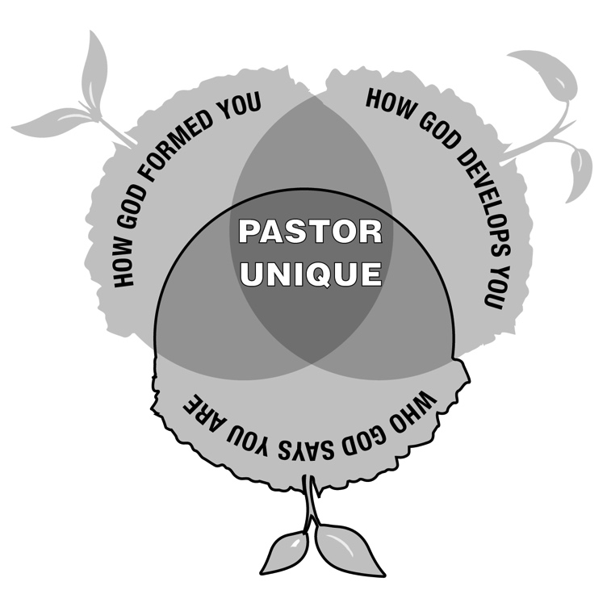

**The History of Pastoral Ministry**

1. Sacerdotalism—pastors became intermediaries (2nd Century)
2. Pastors became priests dispensing grace (4th Century)
3. Pastors became dispensers of “pastoral care (early Middle Ages)
4. The Reformation added preaching a teaching to the pastoral role.

Richard Baxter: “The leader ‘served as every person’s evangelist, catechist, teacher, overseer, counselor, disciplinarian, liturgist, and preacher (Sunday morning and evening); he took it on himself to minister to all sick people and to visit from house to house.”[[7]](#footnote-7)

1. Finney and revivalism added evangelism to pastoral expectations.
2. Professionalism
3. Counseling
4. And so forth!

**The Pastoral Challenge**

The greatest difficulty facing pastoral leadership is defining the role. Is the pastor to be a prophet, teacher, resource person, enabler, religious expert, preacher, counselor, therapist, CEO, facilitator, leader, equipper, administrator, shepherd, social activist, or all the above?[[8]](#footnote-8)

**New Testament Words Used to Describe the Pastor**

1. Elder (1 Peter 5:1-4)
2. Overseer (1 Timothy 3:2)
3. Shepherd (pastor) (Acts 20:28-30)
4. Teacher (Ephesians 4:11)

**The ancient kings of Mesopotamia used shepherd terminology as a metaphor for their sovereign authority!**

1. Lugizaggissi “born for shepherding”
2. Shushim “Enlil . . . Elected to be shepherd of the country and the four corners of the world”
3. Hammurabi called himself a shepherd.

**David was God’s Shepherd-King**

David was taken from following the sheep (1 Samuel 16:11). He was “a man skillful in playing, a mighty man of valor, a man of war, prudent in speech, and a handsome person and the Lord is with him” (1 Samuel 16:18).

**Jesus is the Good Shepherd**

“But you, Bethlehem Ephrathah, though you are little among the thousands of Judah, yet out of you shall come forth to Me The One to be Ruler in Israel . . . And He shall stand and feed His flock In the strength of the LORD, In the majesty of the name of the LORD His God” (Micah 5:2, 4).

“I am (*Ego eimi*) the good shepherd. The good shepherd gives His life for the sheep” (John 10:11)

In this passage, we see His care for His sheep.

**The Great Shepherd Leads Psalm 23**

The Pastor is to be shepherd and shepherds lead!

Psalm 23:1 The LORD is my shepherd; I shall not want.

2 He makes me to lie down in green pastures; He leads me beside the still waters.

3 He restores my soul; He leads me in the paths of righteousness For His name's sake.

4 Yea, though I walk through the valley of the shadow of death, I will fear no evil; For You are with me; Your rod and Your staff, they comfort me.

5 You prepare a table before me in the presence of my enemies; You anoint my head with oil; My cup runs over . . .

**Everything Rises and Falls with Leadership**

The Lord holds leaders accountable for their ministry.

Old Testament Kings 2 Kings 21:10-13

Scribes and Pharisees Matthew 23:13-36

“that on you may come all the righteous blood shed on the earth, from the blood of righteous Abel to the blood of Zechariah, son of Berechiah, whom you murdered between the temple and the altar.” Matthew 23:35

**The Pastor’s and the Church’s Accountability**

Remember those who rule (hegeomai-lead or rule) over you, who have spoken the word of God to you, whose faith follow, considering the outcome of their conduct.

Hebrews 13:7

Obey those who rule (hegeomai-lead or rule) over you, and be submissive, for they watch out for your souls, as those who must give account. Let them do so with joy and not with grief, for that would be unprofitable for you.

Hebrews 13:17

Addressed first to the messenger of each of the seven churches.

Then to “he who has an ear, let him hear what the Spirit says to the churches.”

Revelation 2-3

**Day 3, Topic 2: *Mission, Vision and Core Values***

**Grasping vision for your Ministry Context**

Developing Vision

*How to create a shared, unifying vision in small and medium sized congregations.*

Defining Terms (review)

* What do we mean by “mission”?
* What do we mean by “vision”?

Purpose answers the question “why?”

The over-arching reason. The *telos*. The end result we strive to accomplish.

Mission answers the question “what?”

What is to occur to lead to the fulfillment of the Purpose, to get to the ultimate goal?

Vision answers the question, “how?”

With both the purpose (telos) and the mission (what) in mind, vision paints a picture of the path to get there.

A longer statement that explains…

* + What is this church going to do
  + In this community
  + With these resources
  + To reach those people

Unique to each church and limited in time

The Problem

* Vision is essential because it determines how focus and resources will be allocated.
* Vision is difficult because it requires the ability to balance “big picture” and “fine detail.”
* Vision is difficult because it is a group process, especially in small churches
* Vision is challenging because it is never finished.
* Bible college and seminary don’t teach pastors how to develop and organize ministry around vision.
* Your congregants will fill the “vision vacuum.”

1. “The church is here to protect me from the world”
2. “The church is here to help me raise my children”
3. “The church is here to change political culture”

“In those days Israel had no king; everyone did what was right in his own eyes” (Jdg. 21:25)

**3 Elements of Vision**

**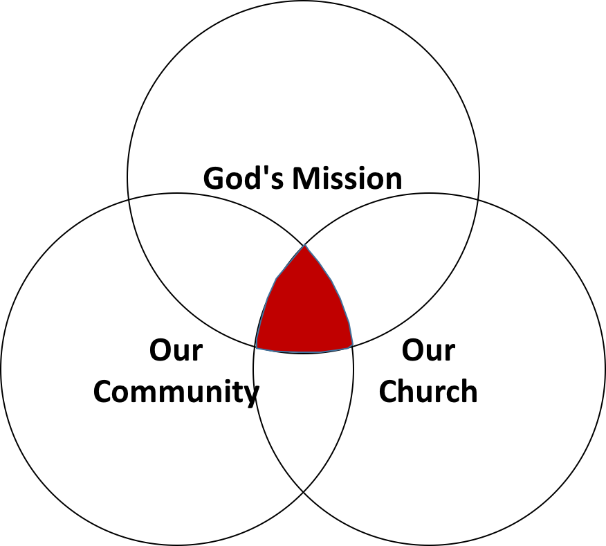**

**1. God’s Mission**

The first step in guiding your church toward a vision that everyone owns is to ensure that everyone understands the mission. You must explain two truths to the church:

1. What is God doing?
2. How do we fit in?

Why?

Because the most important and most difficult change you must lead is not in what people do, but in *how they think*.

This is near the fountainhead of behavior.

How do we change the way they think?

WE don't – but God will through his Word and his Spirit.

So, we cooperate with God to bring both to bear on the hearts and minds of those we lead.

Tell the “big story”

* *Naturalism: everything that exists is the result of naturally occurring processes in a closed universe*
* *Hinduism: everything is an illusion created by impersonal forces into which all individuality will one day be reabsorbed*
* *What is Buddhism’s story?*
* *What is the Bible account? All things are created by, through, and for Christ*

1.1.1 The Bible’s “big story,” like any other story, unfolds along a plot line.

* The “little stories” advance the “big story.”
* The “big story” lends sense to the “little stories.”

Your task as a turnaround pastor is to guide people through a transition in their thinking by showing them how *their “little story”* connects to the metanarrative.

* Move them from a self-referential to a theocentric worldview.
* A self-centric understanding of God, the world, salvation, and the church views all things as orchestrated to insure a blessed and happy life.
* A God-centric view sees each person as a servant assigned to participate in moving the “big story” forward.

1.1.2 Master the art of connecting your preaching text to the “big story”

“Do not be conformed to this world, but be transformed by the renewal of your mind…”

1.2 “Big Story” Approaches

* The Incarnation: God's self-revelation to us reaches its highest culmination in the Incarnation. The "Word became flesh" in the Messiah. Everything leads up to this in the Bible, or from it.
* The Two Covenants: The early church divided the Bible into two parts: the “Old Covenant” and the “New Covenant” to reflect the coming of the Messiah.
* The Old looks forward to his coming, the New looks back on it.
* This is prominent in Reformed and Reformed Baptist theology
* Christo-centric: In Luke 24:27 it says of Jesus: "And beginning with Moses and all the Prophets, he explained to them what was said in all the Scriptures concerning himself." The Christo-centric approach to the biblical metanarrative relates the entire Bible to Jesus.
* Salvation history: The Bible is the story of God's self-revelation to the world through a chosen people. The history of this relationship between God and the "chosen people" becomes a way to understand the biblical metanarrative. The major events in the story-line of this history are: Creation, the Fall, Abraham, the Exodus, Israel, Israel's exile, Israel's Restoration in the Messiah, and the Final Consummation. Or, stated more simply: Creation, Sin, Exile, Restoration.
* Worldview: A worldview provides an interpretive framework for understanding the world.
* Bible as Drama: We can also understand God's Big Story as a drama. Every drama revolves around a problem that needs to be resolved. In the Bible, we see the elements of this drama as: Paradise, Sin, a Resolution Promised, a Resolution Obtained.
* Covenant progress: The Bible records a series of covenant promises made to Eve, Abraham and David. It then describes how God honored these promises and worked through them to bring salvation to the world. This is typical of Dispensationalism, which traces the development of the Abrahamic covenant, particularly the promise in Genesis 12:3.
* Presence of God: The Presence of God had been given in Paradise, was lost in the Fall and is being restored in Christ. See Gordon D. Fee, *Paul, the Spirit and the People of God* (1996).
* Mission of God: The Bible describes the mission of God to redeem the world. Christopher J. H. Wright traces this theme in: *The Mission of God: Unlocking the Bible's Grand Narrative* (2006).
* Kingdom of God: God's mission to the world results in the reign of God. See John Bright's *Kingdom of God* (1953).

1.3 Sample metanarrative

|  |  |
| --- | --- |
| Genesis | Revelation |
| * God creates a perfect world | * God recreates a perfect world |
| * God creates man in his image | * The image of God is restored in man |
| * Man appointed to rule the creation | * The God-Man rules all creation |
| * God and man enjoy direct fellowship | * God and man enjoy direct fellowship |

Exercise

1. Write out the metanarrative scheme you will use to reorient the way your congregation thinks:

* A single declarative sentence if possible
* At most a short paragraph of two to three sentences

2. Identify key texts that will anchor your preaching and teaching

**2. Our Church**

The second step in developing vision is to articulate your church's role in the “big story.” For example, if you favor some variety of kingdom metanarrative, you might use a rubric like this:

* Evangelism: we recruit citizens into God’s kingdom by presenting the gospel in persuasive
* Discipleship: we train believers how to live as a witness to the and prepare them to serve as kingdom administrators

2.1 Assumptions

* Jesus wants to build his Church at your church
* He’s already provided what you need for the next step
* *Tabernacle in the Wilderness*
* *Offering for the saints in Jerusalem*
  1. Process

Figuring out what God wants your church to do to do starts with identifying what he’s given to work with

2.2.1 Identify all the resources Jesus has entrusted to the church

* Begin this process on your own. God-given resources to consider:
* Invite staff (paid and unpaid) to join the assessment
* Invite church leaders to join the assessment
* If you do a “Journey Wall” consider adding this

2.2.2 Write an assessment report for later reference

* Pastor's strengths, passions, experiences, interests and expertise?
* People's spiritual gifts, passions, experiences, interests, expertise, redemptive relationships?
* Prayer warriors, bridge builders, apologists, evangelists
* Material and financial resources?
* Reputation in the community?
* Acquired congregational wisdom?
* Identify the resources
* Differentiate your resources from other churches
* Rank the top 3 to 5 that could be most easily redeployed to bridge building or outreach activities

Exercise: What Resources has Jesus given your church?

* People
* Passions
* Abilities
* Opportunities
* Property
* Public reputation
* Special relationships
* Finances
* Spiritual maturity
* Prayer life
* Facilities
* Worship services
* Evangelistically minded
* Service oriented
* Bridge building events
* Location
* Calendar
* Other

**3. Our Community**

The third step in developing a widely held, unifying vision is to *identify the receptive groups in your community.*

*"…one of the major mistakes is to fail to do adequate research to understand the people [the churches] are seeking to reach with the gospel. It is important for a church to study the community and culture as well as the Scriptures."*

* Gary McIntosh, *Biblical Church Growth*

Jesus’ instructed his Disciples to concentrate their efforts on receptive groups.

“As you enter the house, give it your greeting. If the house is worthy, give it your blessing of peace. But if it is not worthy, take back your blessing of peace. Whoever does not receive you, nor heed your words, as you go out of that house or that city, shake the dust off your feet (Matthew 10:12-24).”

Example: Mark 5

3.1 Process

* 1. Identify the receptive groups in your community

1. Linked (kinship / friendship) to credible Christians
2. People like those already in your church
3. People with needs you can meet
4. Groups in which *any* religion is growing
5. People undergoing cultural change
6. Those who are dissatisfied with their lives
7. People experiencing major life transitions
8. Visitors to your worship service
   1. Assign a task force to identify the receptive groups in your community.

E4 E1

E1. No cultural, racial or linguistic barriers – only the need to believe

*E2. More* like us: share a common language, culture, worldview

*E3. Similar* to us: common language (not mother tongue), ethnicity and culture differ but of the same "cultural family"

*E4. Different* than us: different language, culture and worldview

* 1. Determine which groups will be easiest for your church to reach
  2. Focus your ministries, bridge building and outreach activities on clearly defined groups of responsive people.
     1. Identify potentially receptive groups:

*“Churches grow as they identify people with needs that the church can minister to, either by extending ministries already in place or building new ministries.”*

George Hunter

* + How many different groups can you identify within the “average drive” of the church?
  + What types of people or groups does your church tend to attract?
  + Who are the underserved, unwanted, or unreached groups in your community?
  + Organize your church around regular and passionate prayer for ‘missionary eyes’ to see the harvest fields.

3.1.2 Organize a Task Force to dig deeper

3.1.2.1 Train them to gather information from the public

* + Consult with community leaders
  + Consult with first responders
  + Consult with service agencies
  + A “missionary tour” of your community
  + Poll the congregation to identify community needs

Recruit a group of 7 to 10 people (thought leaders, influencers, officers) and train them to go out and poll community representatives who can help them identify groups in the community that experience *chronic anxiety* or are *in need*.

They will interview community leaders (mayor, city manager, city council), first responders (fire, police), service agencies (child welfare, women’s shelters, recovery programs, hospital social workers), schools (principals, superintendent, counselors), local news and other influential or knowledgeable people in the community.

They will interview these people to seek their help in identifying:

* People in constant need of services and intervention
* People who experience chronic anxiety
* People who are experiencing major unfavorable life change
* People who are overlooked by other churches and agencies
* People who are “on the bubble” (they are in need by do not qualify for public help)
* Ethnic enclaves

3.1.2.2 Take the Task Force on a “missionary tour” of the community

3.1.3 Poll the congregation to identify community needs

3.2. Facilitate group Discussion to determine which receptive groups will be easiest for your church to reach

* Assemble 15 to 30 influencers, thought leaders, officers
* You report your findings
* The Task force reports its findings
* You facilitate group process to evaluate ministry options

3.2.1 Clusters evaluate outreach potential to receptive groups:

Clusters of 3 to 5 people (no couples!) answer the following questions and prepare to report back to the whole group:

* “Which of these groups are most like us?”
* “Which of these groups are we passionate about?”
* “What resources tell us this is God’s 'next step' for us?”
* “What do we have to start doing or do differently to reach this group?”
* “Can we do this?”
* “Will we do this?”

3.2.2 Facilitate group Discussion until everyone is settled on and committed to ministering to a maximum of two target groups (but it is okay to settle on just one!)

Write Your Vision Statement

* Future oriented
* Measurable
* A “big picture” statement of *how*

“Over the next five years *Pathways Church* will touch 15,000 people with God’s love, lead 1,500 to saving faith in Jesus, and baptize 500. We will provide ministries and resources to meet the spiritual, emotional, and physical needs of African immigrant families and to the working poor living in Winterhaven section of town.”

****

**Vision resides where God's mission, receptive people, and church resources overlap.**

**Day 3, Topic 3**

**Goals and Ministry Alignment for Maximum Ministry Impact**

**Goal Setting and Ministry Alignment**

**I. Goal Setting**

1. **The General Electric S.M.A.R.T. System**

***1. Introduction***

The research shows that “focused” (goal oriented) people:

* harder
* Get tasks done more .
* Stay married longer
* Have deeper networks of friends
* Earn more
* Don’t themselves
* Are seen as more .
* Are seen as .

The emotional satisfaction that comes from (1) deciding and (2) clearing tasks from a list creates several problems.

**Problems:**

* + Focus on easy tasks at the expense of important tasks
  + Hasty decisions
  + Less likely to reconsider unwise decision
  + Authoritarian impulse
  + Close-mindedness
  + Preference for conflict over cooperation

*2. Cautions*

* When you set goals (or make decisions) be mindful of whether the goal (or decision) you’re settling on makes you feel good.

AVOID MOOD MAINTENANCE!

* If you are prone to be more concerned about being productive in the moment than you are about doing the right things over the long haul, you need a system to counterbalance that tendency.

*Metrics*

* 1. LEAD rather than LAG measures
  2. S.M.A.R.T. Goals + Stretch Goals
  3. Accountability Culture

Breakout Exercise

Take a few minutes and write down some areas of your personal life that you need to address.

Also, write down some ministry challenges in your personal ministry context that prove to be challenging.

**Lag and Lead Goals**

LAG and LEAD measures

* + LAG measures indicate you’ve already achieved a goal
  + LEAD measures indicate if you’re *likely* to achieve a goal

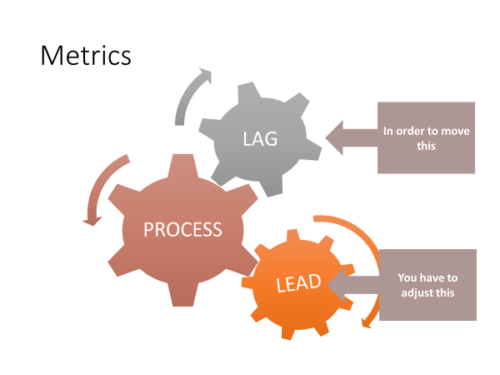

**Lag Lead**

|  |  |
| --- | --- |
| * Increase average monthly attendance 3% by 12/31 next year | * Increase visitor retention from 4% to 10%.   (*Increases average monthly attendance by 2%*) |
| * Reduce “back door” losses from 15 per year to 5 per year by 12/31 next year | * We will visit every family that falls into the “preparing to leave” category |

*3. Implementing the S.M.A.R.T. system*

In the 1940s General Electric began a decades long process of developing a corporate goal-setting system that eventually became a model that is followed by organizations around the world. In this model, goals must be provably within reach and described in a way that suggests a concrete plan.

Making a goal specific and proving it achievable involves figuring out the required steps. The timeline creates discipline that *aspiration* cannot.

*3.1 Implementation – use the process yourself*

This is an adaptation to the GE Smart Goal process. The labels are tweaked to bring about a more “aligned process.

A Sample S.M.A.R.T. Goal

“Making yourself break a goal into its SMART components is the difference between hoping something comes true and figuring out how to do it.”

* *Charles Duhigg,****Smarter Faster Better***

The following table illustrates what a S.M.A.R.T. Goal looks like when it’s fleshed out. A goal that is specific, measurable, achievable, and realistic is far more likely to be achieved when it includes a time commitment. When the timeline includes the appropriate intermediate steps, you have a plan that will move you toward achieving the goal!

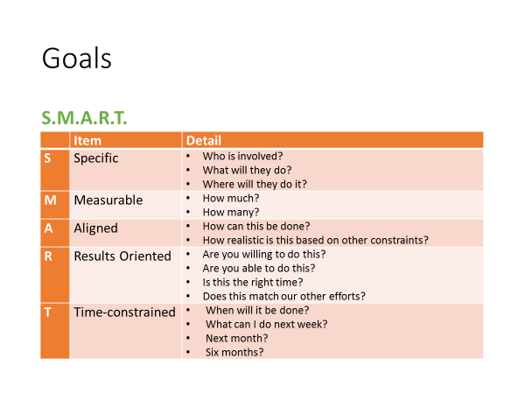

|  |  |  |
| --- | --- | --- |
|  | Item | Detail |
| S | Specific | * Add two new small groups for new people attending our congregation. * Train for new small group leaders * Use our existing groups to raise up new leaders who are willing to invests in new lives. |
| M | Measurable | * All two new groups bring our total small groups to eight. * We will add 16 new believers to our small group ministry. |
| A | Aligned |  |
| R | Results Oriented |  |
| T | Time-constrained |  |

*3.2 Implementation – train staff and hold them accountable*

You will have to train your leaders and volunteers to produce SMART goals for their ministries and events. Those who tend to be “big picture” types with little patience for details may resist, but if you frame this as a request for their help – so that you can manage more effectively – they should in time work with you. (If they won’t there’s an alignment problem that needs to be addressed, see below). Continually ask your team

* “Is this concrete?”
* “What are the specifics?”
* “Is this results oriented?”
* “Show me your timeline?”

1. Stretch Goals

*1. A caveat about SMART goals*

SMART goals will not insure that your ministry accomplishes anything significant. If you or the majority of your team members spend most of the time working on insignificant goals, you will remain stalled on the plateau.

* People who crave the sense of accomplishment
* Those who are afraid to risk striving for big goals
  + Shallow ego needs
  + Your organization penalizes failure
* Those who don’t connect their goals with the organization’s mission

*2. Stretch goals as a solution*

“A stretch is a concept that would have produced smirks, if not laughter, in the G E of three or four years ago, because it essentially means using dreams to set business targets-with no real idea of how to get there. If you do know how to get there-it’s not a stretch target.”

* Jack Welch, Letter to G.E. Shareholders, 1993

*a. Purpose of stretch goals*

The purpose of insisting that your church or ministry teams commit to stretch goals is to *shake them out of complacency* and promote new ways of thinking.

* + “Provide a Christian school to minister to orphans in our city.”
  + “Provide Vacation Bible School for every village in our province.”
  + “Begin a church in a neighboring city where there is no gospel witness. Transplant half of our congregation to the new church.”
  + “Cancel worship services every 5th Sunday to send every member to serve in the community.”

*b. Two challenges with stretch goals*

1) Studies have shown that if a stretch goal is audacious, it can spark innovation.

2) It can also cause panic and convince people that success is impossible

*There is a fine line between an ambition that spurs innovation, creativity and energy and one that destroys morale.*

1. Integrate STRETCH and SMART goals

STRETCH goals push us out of the “tried and true.” SMART goals break big dreams into a series of realistic, short-term objectives. Together they put the impossible within reach. Research in the world of sports, business, and self-management show that when methodical planning is applied to daunting challenges, people are motivated to achieve things they did not think possible!

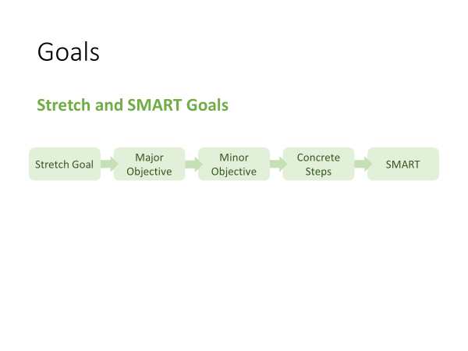

1. Develop a list of your biggest dreams.  
   (Become a catalytic church planter supervising multiple church planting teams)
2. Describe major objectives that at first glance seem impossible   
   (Become part of a church planting team)
3. Segment major objectives into smaller objectives  
   (Understand the essential steps of church planting)  
   (Learn to lead in each stop of the planting process)

(Shadow a director of church planting for one year)  
(Develop a group of people who will be prayer and financial supporters for planting multiple churches in ).

1. Break the smaller objectives into concrete steps
2. Create a to-do lists that pairs stretch and SMART goals

Those of you who are detail oriented won’t lose sight of the big picture, thereby avoiding the trap of using task lists to perform “mood maintenance.” Those of you who are big picture oriented won’t lose sight of all the little parts, thereby avoiding the trap of letting important details slip through the cracks.

EXERCISE

Use the following table to create a SMART STRETCH goal that at first blush seems impossible, but one which will propel your ministry forward in great ways.

|  |  |  |
| --- | --- | --- |
|  | Item | Detail |
| S | Specific |  |
| M | Measurable |  |
| A | Actionable |  |
| R | Realistic |  |
| T | Timeline |  |

**Day 3, Topic 3: *Alignment***

****

**Laser Light**

* A device that produces a narrow and powerful beam of light (Merriam-Webster)
* Organized
* Monochromatic

II. Ministry Alignment

1. Introduction
2. *Definition*

A church is fully-aligned for effective, efficient ministry when all …

* events
* strategies
* programs
* staff
* ministries
* systems
* expenditures
* literature
* policies
* procedures

… work together to fulfill the vision in order to accomplish the mission.

1. *The Need*

Leading a church is a lot like leading cats. In the absence of a comprehensive ministry plan that (1) is developed to fulfill a vision that (2) flows from a biblical vision and shared values, people will fill the void with their own plans. This typically results in their neglect or disregard of what others are doing.

Chaos ensues as cats you pursue!

1. *Signs of misalignment*

* People only Discuss their own “stuff” in meetings.
* Plans and budgets aren’t related to the church’s (agreed upon) direction.
* Your church’s vision statement is absent from promotional material for your various ministries.
* Ministry leaders and their team can’t explain how their work contributes to the mission and vision of the church.
* Lots of squabbles for resources between ministries.
* Doctrinal inconsistencies among various ministries.
* Ministries collect their own offerings and support their own projects.

*0*

1. *Signs of alignment: You will see your staff (paid and volunteer)*

* Champion the church’s vision
* Imbue the vision to their ministry team
* Scheduled events advance the vision
* Activities designed to dovetail with the vision
* Resources allocated to support the vision
* Regular re-evaluation of themselves, their team and their programming

1. The process

When the church’s ministries are aligned, people will be walking together in the same direction! They will still be cats – independent, uniquely gifted and occasionally unpredictable – but they’ll be moving toward a common destination.

1. *Overview*

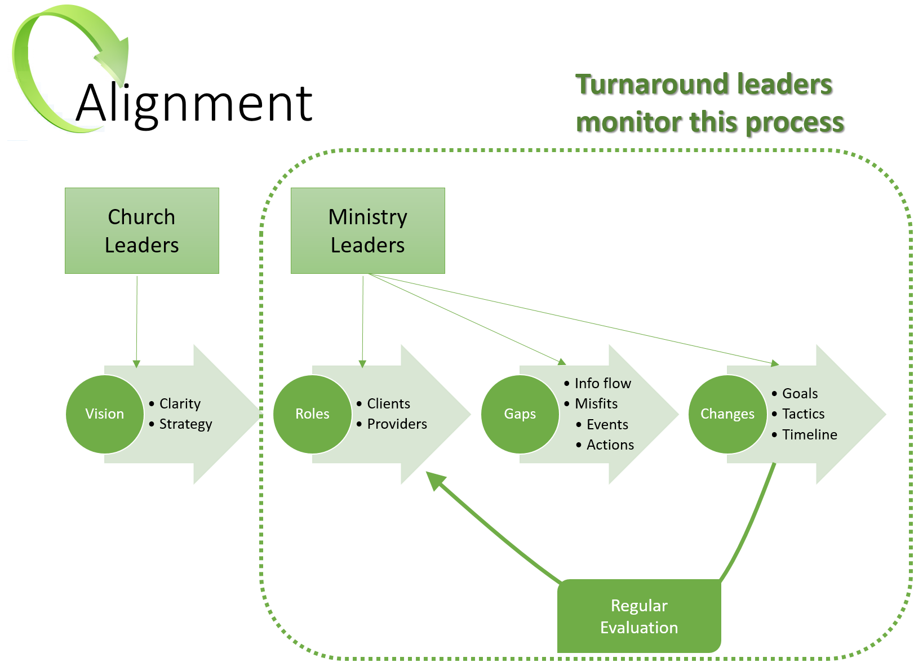

*ROLES*

* Clients
* Providers

*GAPS*

* Information Flow
* Misfits

*CHANGES*

* Goals (include your metrics)
* Tactics
* Timelines

1. *The process:* Create a culture of asking Four Alignment Questions

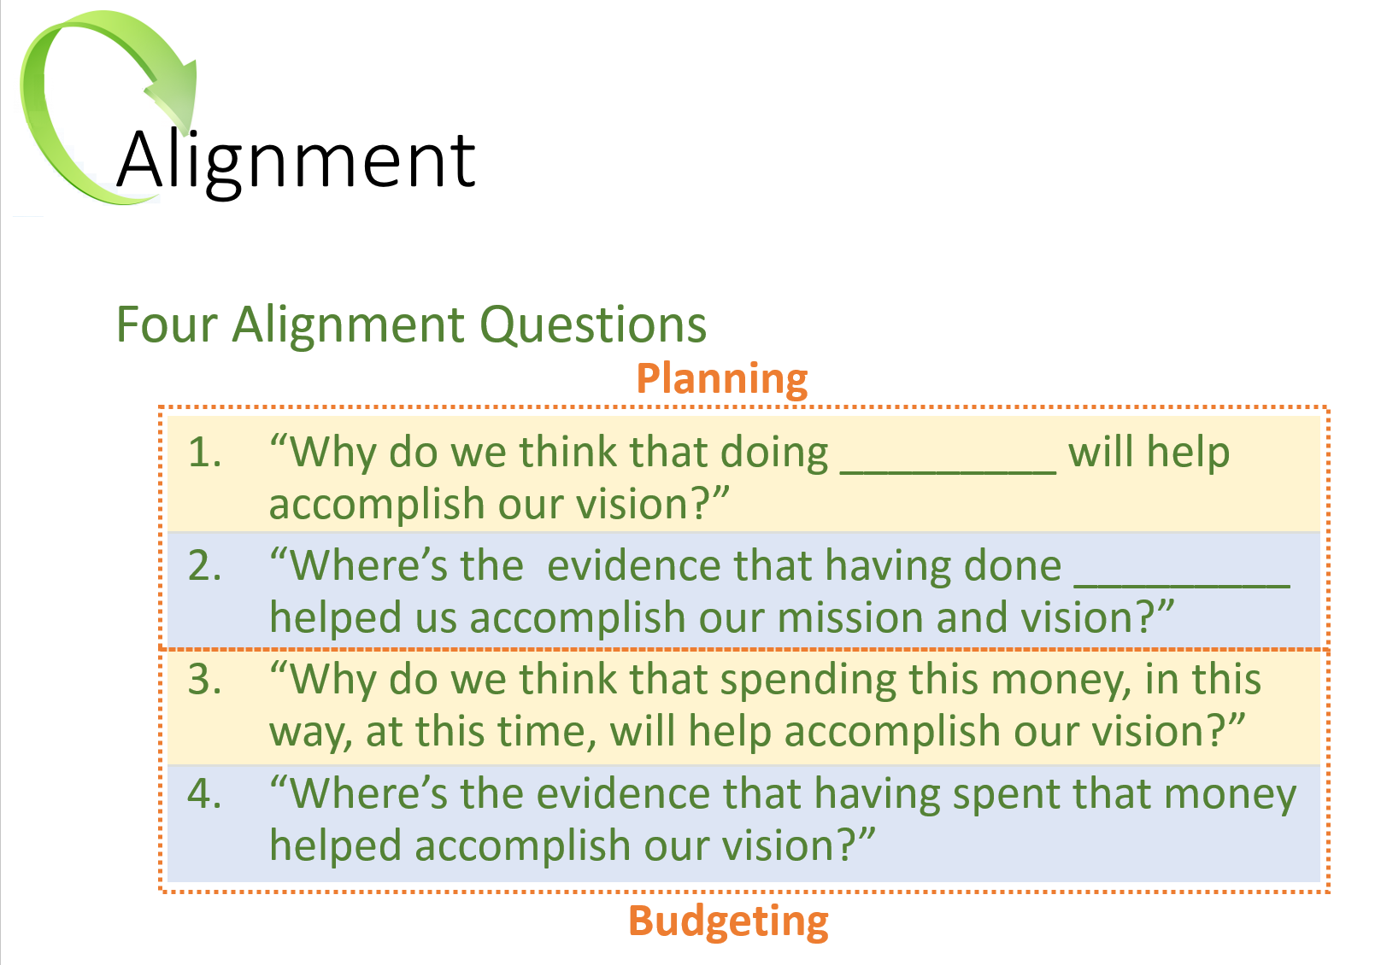

Asking and answering these questions during the planning, debriefing and budgeting phases will help you develop your own set of “best practices.” In time, you will accumulate a body of knowledge about what works and what doesn’t.

* “We know that if we do these things, they will lead to accomplishing our vision.”
* “We know that we need to avoid doing those things because either they don’t help us accomplish our vision, or they actually hinder us.

1. *Process: Create a culture of evaluating everything the church does:*

Develop metrics that will identify if a ministry, an event, a program, or a procedure contributes to the fulfillment its mission and vision.

Sample Measurements

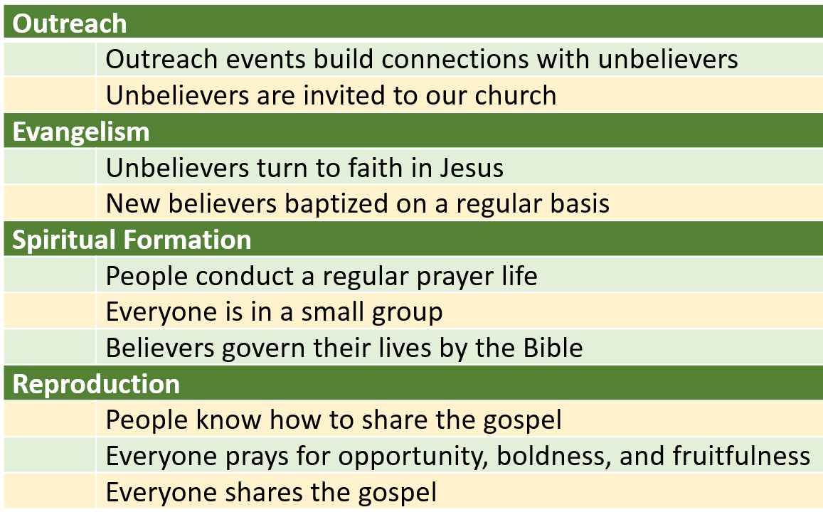

Develop your own concept or matrix for the various broad categories of your church’s ministries, and sketch out a brief description of how each contributes to the mission and the vision. Then, these descriptors will serve as reference points that you (and your team) will use to evaluate the church for alignment.

1. *Process: Conduct an audit to identify which components are aligned and which are not.*

A ministry audit looks at the church from several angles. Among them are:

1. Events and Activities
2. Ministries
3. Staff

An audit can be overwhelming. Create a simple system to keep track of everything at a glance. Your system should help you track the details and help you avoid becoming lost in them!

One useful system identifies the major ministries that must function at a high level in order to help you achieve your mission and vision. In the following sample, we use four main ministry initiatives. We list them across the top of a page. Then we list every activity and event down the page; some may be church-wide or they may be confined to a specific ministry (e.g., Men’s or Youth Ministry). Determine which major initiative each activity or event supports.

Sample Audit of Events

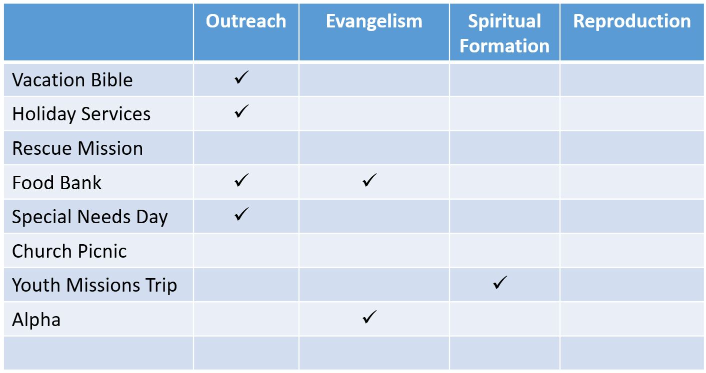

After you’ve audited every event in your church, you may see *significant gaps*. Note in this sample audit that no ministries help advance the cause of “Reproduction.” You may see that other initiatives are overly weighted, like “Outreach” in our example. And you’ll find events that really don’t contribute to anything (like the Annual Church Picnic!); you’ll need to be careful with some of those! (Example: *PVCC float in the annual community parade*)

Repeat this process by auditing all the church’s

* Programs
* Ministries
* Systems
* Expenditures
* Policies and procedures
* External communications (“marketing literature”)

Audit of Ministries

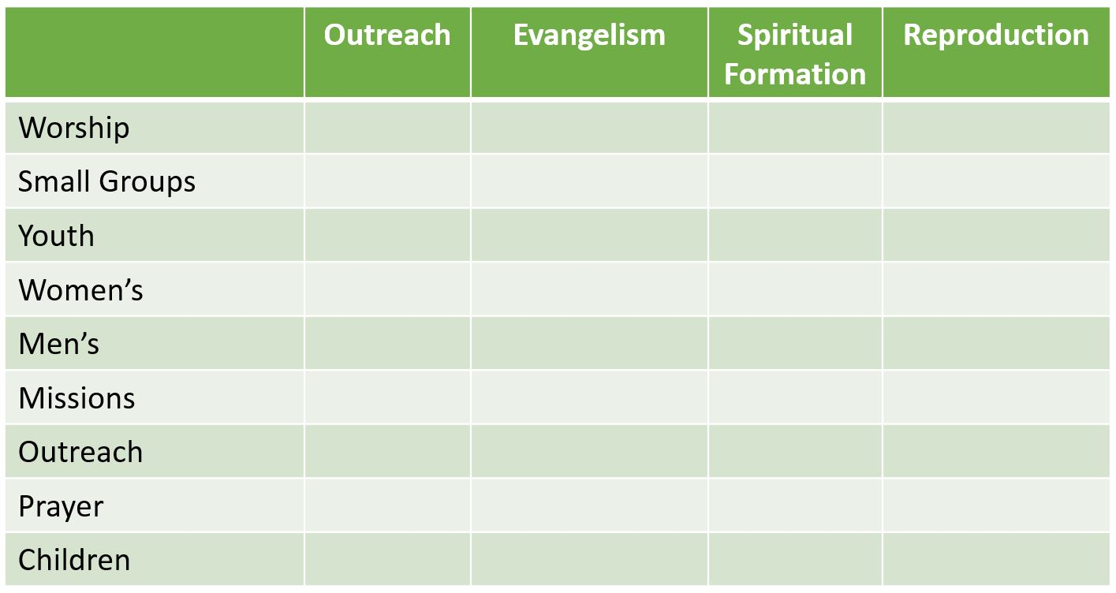

Audit Staff Responsibilities

Finally, use the same process to audit all staff (paid and unpaid), church officers, and ministry leaders. List them by name and identify their areas of responsibility. If you find out that no one on staff has primary responsibility for the church’s Evangelism initiative, you have identified why there’s so little evangelistic activity in your church. You have also identified the need for a significant staff realignment!

**Day 3, Topic 4: *Developing a Ministry Map***

Establish Smart Goals.

List the action steps required to achieve each goal.

* Establish church-wide SMART Goals in each Key Measurement Area
  + Conversions
  + Attendance
  + Assimilation
  + Lay Involvement
  + Small Group Involvement
  + Leader Development
  + Tithers
* Typically, at least one SMART Goal for each Measurement Area
* Every staff person (paid, unpaid, full or part-time) and ministry will establish SMART Goals that contribute to the church-wide goals
* Lead them in establishing one SMART Goal
  + Typically, conversions
* Review, critique and refine their work on the remaining goals
* Action Plan consists of the Action Steps required to achieve their SMART Goal
  + If the Action Plan is too detailed it will be counter-productive
  + But must be detailed enough to cover all the main activities required
* The creation of a System is often a basic Action Step in an initial Action Plan
  + Focus them on no more than three systems in one Ministry Year
  + Foundational Cluster of Systems to Address
    - Evangelism
    - Assimilation
    - Lay Involvement

Breakout Session

Establish a goal and create your Action Steps to achieve the goal.

Your goal:

Smart goals and stretch goals:

Action Plan:

Evangelism

Assimilation

Lay Involvement

Case Study: FC South of Denver

Deeply conflicted

Described as a hurricane that periodically drops a tornado.

**Day 3, Topic 5: *Leading Change***

(

**Introduction – the most difficult task pastors face**

**1. Turnaround leadership demands proficiency in every area**

* Envision the future
* Influence others to join the future
* Strategize a path to the future
* Execute strategy so the change is accomplished
* Manage conflict successfully
* Sustain passion
* Maintain momentum

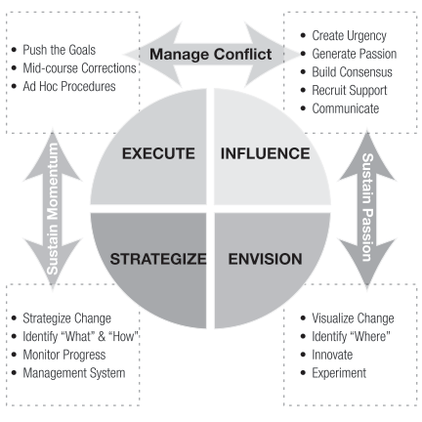

**2. Turnaround leadership is personally challenging**

**2.1 The Change Component**

As we've identified in our research, the Change Usual score is a hallmark distinction between TAP and NTAP pastors. NTAPs have lower scores, which indicate their need to focus on the task at hand without distraction.

The inevitable chaos that accompanies change challenges them. Under stress, they may resist rapid shifts in direction and timely midcourse corrections. If the stress is severe enough, they may refuse to adjust to new demands or to change their methods.

fresh and to move forward, they may give disjointed instructions and deal poorly with members they see as sources of resistance. Both TAPs and NTAPs will eventually need help in implementing systems to support ministry once growth occurs. To move forward, they may give disjointed instructions and deal poorly with members they see as sources of resistance. Both TAPs and NTAPs will eventually need help in implementing systems to support ministry once growth occurs.

**2.2 The Challenge Component**

This Component measures, among other things, image maintenance in social settings. It also evaluates how we impose demands on ourselves and others. ￼ People with low Challenge scores want to look good in front of a crowd. Image maintenance behaviors are often accompanied by risk aversion, which may result in pastors who avoid the "heavy lifting" of change leadership.[[9]](#endnote-1) People with low Challenge scores want to look good in front of a crowd. Image maintenance behaviors are often accompanied by risk aversion, which may result in pastors who avoid the "heavy lifting" of change leadership.[[10]](#endnote-2) People with low Challenge scores want to look good in front of a crowd. Image maintenance behaviors are often accompanied by risk aversion, which may result in pastors who avoid the "heavy lifting" of change leadership.

Accepting risk, managing acceptable loss ratios and mitigating conflict are more difficult for pastors with low Component scores if they fear that these will make them look bad. They may settle for more modest goals rather than settling on (the much needed) BHAGs (big hairy audacious goals) because failure will be deemed personal.

Those with high Challenge scores embrace lofty goals. But rather than building morale, their tendency to criticize themselves and others demoralizes, sucking energy out of the change initiative. The tendency to second guess themselves, their plans, and the competence or goodwill of others may attenuate their ability to persevere for long periods when progress is not self-evident.

**2.3 The Freedom Component**

The Freedom Usual Component is another hallmark distinction between TAPs and NTAPs. It assesses the degree to which our ways of thinking and responding are conventional or independent.

High Freedom scores reflect independent thinking and action; it reflects a bias for initiative and the need to avoid being micromanaged. Change leaders must have these qualities because, by definition, change requires independent thought – breaking out of the paradigm that, while once useful, has led the organization into the cul-de-sac it seeks to escape. They must also be able to act independently and take the initiative if they are to overcome the institutional inertia that resists movement.

However, when change leaders with a High Freedom score experience distress, they may react counter-productively and become unpredictable. This will produce uncertainty and self-protective behavior in others. They may reject ideas simply for the sake of being "the maverick." In the transition phase, these behaviors harm the church. This is a reminder that meeting our Needs to avoid destructive Stress Responses is not selfish, but helpful to both the pastor and the church.

Pastors with Low Freedom scores prefer convention and tradition. This puts them in a difficult place from which to lead change. They gravitate toward precedence and consensus. These propensities attenuate their ability to engage in independent thought and develop creative solutions. The ability to manage resistance and deal with conflict may be compromised in leaders who feel constrained by group expectations. This is a reminder that one "best ministry practice" is putting people around you who think differently than you – in this instance, "free thinkers."

**3. Turnaround leadership is possible**

* Pastors who develop strategies to manage their unproductive behaviors and employ best ministry practices are very likely to succeed as change leaders.
* Pastors who sequence the stages of the change process correctly will enjoy a higher degree of success as change leaders.
* Pastors who engage a coach and continue to develop their leadership skills are more likely to succeed as change leaders.
* Pastors who cultivate their spiritual lives and take the time to prepare the church spiritually and theologically are more likely to succeed as change leaders.

**Preparing to lead turnaround**

**1. Prepare yourself**

* Understand how your personality **helps or hinders** change leadership
* Retain **a coach** who will walk with you through the challenge
* Read widely on **change leadership** to develop a model that fits you

**2. Prepare your congregation (Video Gary McIntosh)**

* Redefine \_\_\_\_\_\_\_\_\_\_\_\_\_\_\_\_\_\_\_\_\_.
* Create \_\_\_\_\_\_\_\_\_\_\_\_\_\_\_\_\_\_\_\_\_ - dissonance so they see better ways to ministry.
* Make hard \_\_\_\_\_\_\_\_\_\_\_\_\_\_\_\_\_\_\_\_\_ - "the future of a church is directly tied to a pastor's ability to suffer pain (3:00 in the vid)
* Refocus on the \_\_\_\_\_\_\_\_\_\_\_\_\_\_\_\_\_\_\_\_\_.
* You have to start \_\_\_\_\_\_\_\_\_\_\_\_\_\_\_\_\_\_\_\_\_.

**A Transition Model**

This Transition Model, adapted from William Bridges, focuses on the internal transitions people must make to embrace change.[[11]](#endnote-3) Your goal is to help the members embrace new ways of thinking about their Christian identity and the church's mission.

|  |  |  |
| --- | --- | --- |
| **The Bridges Transition Model** | | |
| Phase 1: An Ending | Phase 2: Neutral Zone | Phase 3: New Beginning |
| **The Pastor’s Leadership Tasks** | | |
| * Help people deal with loss * Prepare them (mentally) to move on | * Help them learn new ways to think & act * Use the confusion to encourage innovation | * Help them develop a new identity * Guide them in Discovering new purpose that makes the change work |
| **People Will Experience** | | |
| * Fear * Denial * Anger * Sadness * Frustration * Loss | * Resentment for the change * Doubt about the change * Low morale & productivity * Disorientation * Uncertainty * Anxiety about the future | * High energy * Openness to learning * Renewed commitment * Passion about their role * Willingness to sacrifice |
| **Leadership Interventions** | | |
| * Check your ego at the door * Listen with empathy * Reflect understanding * Don’t try to “fix” them * Show them how they fit in * Stand apart from emotions * Remind them of God’s faithfulness and provision | * Give frequent feedback * Talk up the big picture * Given them short-term wins * Let them vent their feelings * Revise staff workloads * Build team morale * Rely on champions to move people to Phase 3 * Discipline as needed | * Link their personal goals with the church’s goals * Highlight success stories in public worship services * Take time to celebrate the big transition * Don’t forget the stragglers * Get ready for the next vision and transition |

**Notes About the Transition Model**

**Day 4, Topic 1: *Conflict Resolution and Biblical Peacemaking***

**Four major sections of this training:**

**Part 1: The Theology of Peacemaking**

**Part 2: The Practice of Peacemaking**

**Part 3: Your Personality and Peacemaking**

**Part 4: Intervention in Deeply Troubled Churches**

**Part 1: The Theology of Peacemaking**

**I. The God of Peace**

A. God is the “God of peace”

The God of Peace is present with us Romans 15:33

The God of Peace will destroy the enemy of peace Romans 16:20

The God of Peace wants us to imitate Him Philippians 4:9

The God of Peace transforms us 1 Thess 5:23

The God of Peace completes us in Christ Jesus Heb 13:20-21

The God of Peace imparts peace to us Judges 6:24

B. God’s Design for Peace

1. God offers peace to us through Christ (Justification) John 14:27

John 16:33

John 20:19-21

Acts 10:36

2. God desires us to live at peace with one another.

(Interpersonal0 Psalm 133:1

Romans 14:16-19

Eph 2:14-17

Eph 4:3

Col 3:15

3. God desires for us to live at peace with ourselves

Sanctification

It begins with righteousness Isa 32:17

It continues with faith and obedience Isa 26:3

Isa 48:18

4. God desires us to live at peace with our Enemies Matthew 5:9

Matthew 6:43-45

Proverbs 16:7

Romans 12:17-21

Hebrews 12:14

C. The Roots of Conflict

Observations:

1. Conflict is pervasive!

Conflict characterized the paragons of the faith

Abraham and Lot over grazing rights Gen 13:5-11

Some of the apostles doubted Jesus’ resurrection Matt 28:20-28

Conflict over language and culture Acts 6:1-8

Paul and Barnabas (over mission and vision) Acts 15:36-41

Peter and Paul and kosher practices Gal 2:11-21

Deep divisions in the church at Corinth 1 Cor 1:12-13

Our attitude? John 13:34-35

Christ desires unity in the church: “They may be

one, just as you, Father, are in me and I in you.” John 17:21

2. The Peace Chapters Gen 1-2, Rev 21—22

3. The Theology of Conflict (survey of conflict in Bible)

Conflict Defined: Conflict is a difference in opinion or purpose that frustrates someone’s goals or desires. (Ken Sande, The Peace Maker, 29)

Church Conflict Defined: Church conflict is a difference of opinion over mission, vision, and values that frustrate a person’s goals or desires.” (Brown, Penfold, Westra, *Pastor Unique,* 154).

4. The Entry of Sin into the Universe

Satan’s name: Adversary, one who withstands

Murderer John 8:44

Liar John 8:44

Confirmed and practicing sinner 1 John 3:8

Promotes false lifestyle Eph 2:1-3

Promotes false religion 1 Tim 4:1-3

Satan’s Description Ezek 28:11-17

Seal of perfection

Full of wisdom

Perfect in beauty

In Eden (certainly not true for the King of Tyre!)

Gloriously clothed

Prepared for music (timbrels and pipes)

Created

Satan’s Position (makes sin all the more untenable.)

Anointed Cherub who covers (close to God)

Walked in the midst of fiery stones (close to God)

Perfect in all your ways

Satan’s Sin (Lucifer—Day Star- bright enough to be seen above sun) Isaiah 14:12-17

Pride

I will ascend into heaven

I will exalt my throne above the stars of God (Cp. Job 38)

I will sit on the mount of the congregation on the farthest sides of the north

I will ascend above the heights of the clouds

I will be like the most high

Puffed up with pride 1 Tim 3:6

Extended to other angels Rev 12:14

5. Entrance of sin into humanity Gen 3:1-6

Temptation

Has God said?

Illust: “*When Satan talks to us about God, he lies. When he talks to God about us he tells the truth*”—Warren Wiersbe

Shall not eat nor touch

You will not surely die.

*You will be like God!* (N.B. Satan’s own desires are manifest in temptation)

Vs 6—Lust of the eyes, lust of the flesh,

pride of life 1 John 2:15-16

Consequences Gen 3:7-19

Adam and Eve’s eyes were opened. (7)

Sewed leaves

Hid from God (8)

God sought them! (9)

Fear of God (10)

Adam: Blamed the woman

Adam blamed God, “The woman you gave me.”

Eve blamed the serpent . . . and the serpent didn’t have a leg to stand on!

Conflict between the seed of the serpent and the seed of the woman

Victory promised—the Seed of the woman over seed of

serpent (15)

Childbirth issues

Marriage issues (wife derives her self-worth from husband, husband from work)

Cursing of ground

Toil

Thorns and thistles

Conflict between man and God Matt 16:21-23

D. Conflict in the Christian Life

Introductory Thoughts:

Note: Interpersonal Conflict: The History of the World is the history of conflict.

Spiritual Conflict: Human History is the history of conflict between Satan, God and man.

Principle: All conflict can be traced back to spiritual conflict.

Maps of War: <http://www.mapsofwar.com/ind/imperial-history.html>

The Five Types of Conflict: Conflict rises in the following five areas.

1. Conflict between people and God (Genesis 6:3)

If we don’t have peace with God we will not have peace with others.

2. Personal (self-condemning)—individuals struggle with accepting God’s forgiveness.

Isa 26:3

John 14:1, 27

Pilate’s wife Matt 27:19

3. The conflict of Spiritual Warfare—Conflict with Satan and his ungodly host

Eph 6:10-20

Rev 12:10

4. Interpersonal (Matthew 5:21-26; Matthew 18:15-18—more on this later)

5. Conflict with our Enemies Matthew 5:43-48

Romans 12:16-21

6. The Pervasiveness of Conflict (Conflict is Inevitable)

As previously discussed, conflict is inevitable. We have the four “peace chapters.” Conflict is Discoverable in every other chapter of the Bible. The balance of Scripture deals with problems. For example, the epistles of the New Testament deal with church issues. They were not simply nice letters written in a vacuum! They are written to real people with real interpersonal issues! Please examine the following passages. Which type of conflict do you discover in each passage.

Please note: The causes of conflict are complex and often deep. We normally see the surface issues and miss the deeper issue or issues. This fact becomes clear as you look over these passages. In order to properly handle conflict, we must carefully assess each situation before trying to serve as peacemakers.

|  |  |  |  |  |  |
| --- | --- | --- | --- | --- | --- |
| Passage | Type of Conflict? |  |  |  |  |
|  | With God | Personal | Spiritual Warfare | Interpersonal | With Enemies |
| Genesis 4:6-8 |  |  |  |  |  |
| Genesis 4:19-24 |  |  |  |  |  |
| Genesis 6:6 |  |  |  |  |  |
| 2 Sam 24:1  1 Chronicles 21:1 |  |  |  |  |  |
| Psalm 23:3-4 |  |  |  |  |  |
| Psalm 32:3-4 |  |  |  |  |  |
| Malachi 4:5-6 |  |  |  |  |  |
| Matthew 20:20-28 |  |  |  |  |  |
| Acts 6:1-6 |  |  |  |  |  |
| Acts 15:36-41 |  |  |  |  |  |
| 1 Cor 1:10-13 |  |  |  |  |  |
| Galatians 2:11-21 |  |  |  |  |  |
| Phil 4:2 |  |  |  |  |  |
| Rev 2:4 |  |  |  |  |  |

E. Flash Points: Problems that Ignite Conflict

1. Loss of Mission and Vision (many churches filled with conflict do so because they do not have a clear sense of mission and vision. This is a predominant issue in plateaued and declining churches.

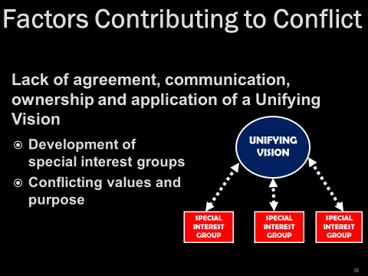

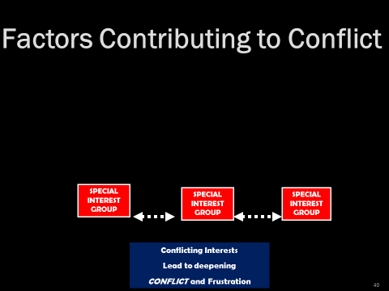

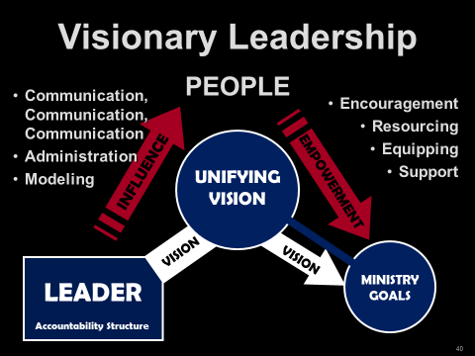

1. Sinful attitudes that lead to sinful actions James 4:1-12

Matt 15:19

3. Sins of commission

* Failure to submit to the Spirit (basic problem)

Gal 5:16-23

“Fruit of the Flesh” (contrast with the Fruit of the Spirit)

* + Jealousy
  + Envy
  + Greed/ Covetousness Luke 12:12-13
  + Maliciousness
  + Deceit
  + Pride
  + Lack of love
  + Lack of mercy
  + Adultery
  + Lewdness
  + Hatred/ Prejudice
  + Selfish Ambition
  + Drunkenness

4. Interpersonal Relationships Galatians 2:1-14

5. Language barriers Acts 6:1-6

6. Cultural Differences Galatians 2

7. Misunderstandings from poor communication Joshua 22:10-34

8. Incorrectly judging motives Joshua 22:10-34

9. The tongue James 3:1-12

Reckless words Prov 12:18

Grumbling & complaining 1 Cor 10:10

James 5:9

Lying Eph 4:25

Gossip Prov 16:28

Slander Titus 2:3

(diabolos—Devil, Matt 4:1) 2 Tim 3:2-5

Worthless talk Eph 4:29

10. Differences in values, goals, gifts, calling Acts 15:39

1 Cor 4:12

11. Competition for limited resources Genesis 13:1-12

12. “Ownership

13. Decline in membership and church vitality

14. Traditionalism

15. Ineffective pastor

16. Controlling or micromanaging governing board

17. Stubborn, rebellious church members

18. Poor fit between pastor and congregation

19. Conflict between the Pioneers (Old Guard) and homesteaders (new people)

20. Other

**Part 2: The Practice of Peacemaking in the Local Church**

1. Foundational Assumptions

A. Christ desires harmony to exist in the Body of Christ, the local church.

B. The primary objective of Conflict Resolution is the restoration of broken relationships.

C. In the event of a failure to achieve repentance, confession and forgiveness, the offending parties must be dismissed from the fellowship until such time as these biblical responses take place.

2. 4 Levels of Conflict Resolution for the Believer (Four Dimensions of Peace)

A. Peace with God Romans 5:1-5

Mark 5:5

B. Peace with ourselves

How do we gain Peace from self-condemnation?

Recognize our position in Christ Jesus Col 1:19-20

Trust in God Isa 26:3

Prayer with Thanksgiving Phil 4:6-7

Consequences of not submitting and repenting Psalm 32:3-5

C. Peace with others—Making Peace in the Church (Individuals)

1) Recognizing God’s Methods of Handling Conflict (more on this later)

Scripture rarely uses words we would translate as “confront”

Encourage 1 Tim 3:2

Correction 2 Tim 3:16

Warn 1 Thess 5:14

Admonish (teach, instruct, warn) Titus 2:3-4

Rebuke Luke 17:3

2 Tim 4:2

Reasoned Acts 17:17

Exhort 1 Thess 5:14

Not quarrel, but be gentle 2 Tim 2:24

D. Peace with Difficult People Romans 12:17-21

E. Our First Response to Conflict 1 Peter 4:8

F. Essential Keys for Biblical Conflict Resolution

* Keep the Circle Small.
* Own your own.
* Apply the proper passages: Maintain a clear understanding of the conflict issues and the appropriate responses to each. Each passage is conflict specific with specific prescriptions and remedies. Matthew 18:15-18 is not the cure-all for every conflict!
* You know, you go!

**3. Major Conflict Passages: Specific Passages with Specific Prescriptions for Peacemaking**

**Passage: Matthew 5:21-26**

Problem:

A believer realizes that he/she has offended another

Persons Involved:

Offender and one assumed to be offended

Party (Parties) Responsible for Resolution:

The one who caused the offense

Process:

1. Leave your offering (resolution is more important that giving!)

2. One who has offended seeks forgiveness

Purpose:

Reconciliation

Result:

Reconciliation and harmony

**Passage: Matthew 18:15-18**

Problem:

One believer has sinned against another believer

Persons Involved:

1. The offender and the person offended

2. One or two additional witnesses

3. The entire church.

Party (Parties) Responsible for Resolution:

Process:

1. Offended party meets alone with offender. Resolution: Praise the Lord!

2. No resolution, 1-2 witnesses

3. Offender is taken before the church. Reconciliation or dismissal from church

Purpose:

Result:

**Passage: Galatians 6:1, 10**

Problem:

A believer is overtaken (detect, overtake, surprise) in a fault (false step, transgression, sin).

Persons Involved:

1. The observer

2. Those from the church who are spiritual

3. The individual caught in sin

Party (Parties) Responsible for Resolution:

1. The observer

2. Those who are spiritual

3. The individual caught in sin

Process:

1. The observation

2. Spiritual preparation

3. Gently approaching the guilty party

Purpose:

Restoration to useful Christian living

Result:

1. Restoration

2. Dismissal if there is no repentance

**Passage: Titus 3:1-11 (primarily 3:10-11)**

**Romans 16:17-18**

Problem:

A divisive individual who disrupts the church

Persons Involved:

The individual and the church

Party (Parties) Responsible for Resolution:

The individual and the church

Process:

1. Give an initial warning

2. If there is no repentance and there is a second incidence of disruption, give a second warning.

3. If there is a third incident disruption, the member is removed from the church by the church.

Purpose:

1. Repentance and Restoration

2. If there is no repentance, then there will be removal from the church so that harmony will be restored.

Results:

Harmony in the church body

**Passage: 2 Thessalonians 3:6-15**

Problem:

A believer is behaving in a disorderly manner: not providing for one’s needs, a busybody

Persons Involved:

The church and the disorderly brother or sister.

Party (Parties) Responsible for Resolution:

The church and the disorderly brother or sister.

Process:

1. Recognize the condition

2. Do not keep company with them

3. Admonish the disorderly to become orderly

Purpose:

Repentance and restoration to full fellowship

Result:

That the disorderly brother would be shamed into repentance

**Passage: 1 Corinthians 6:1-11**

Problem:

One believer in a church has sued another believer in the church in a civil matter.

Persons Involved:

The two combatants and the church

Party (Parties) Responsible for Resolution:

The two combatants and the church

Process:

1. Recognize the church’s position.

* The church will judge the world
* The church will judge

2. Hold a “trial”

3. Appoint the “least” in the body as “judge” or appoint the most esteemed believer as the “judge.” (Your view of this issue will depend on whether you take verse 4 as a question or as a simple statement. The Greek text has no punctuation so either translation is possible).

4. Allow oneself to be defrauded rather than to defraud Christ.

5. Allow oneself to be cheated rather than defraud Christ.

Purpose:

1. To treat the with respect.

2. To settle the dispute dividing the church.

Result:

1. The issue is settled

2. The name of Christ is honored

3. Those outside the church will

**Passage: 1 Timothy 1:19-20**

**2 Timothy 2:16-17**

Problem:

False doctrine and those who teach blasphemy (slanderous, abusive speech)

Persons Involved:

Believers who slander and teach false doctrine and the church

Party (Parties) Responsible for Resolution:

Believers who slander and teach false doctrine and the church

Process:

1. Recognize the deadly poison

2. Deliver blasphemers to Satan so that they learn not to blaspheme.

Purpose:

To protect the church from blasphemy and false teaching

Result:

The church is protected from blasphemy and false teaching

**Passage: 1 Corinthians 5:1-8**

Problem:

Immorality in the church

Persons Involved:

Church and the immoral person

Party (Parties) Responsible for Resolution:

Process:

1. Recognize the sin of immorality

2. Confront. If repentance, PTL. If not, dismissal from the church. Turn one over to Satan for the destruction of the flesh.

Purpose:

Cleanse the church from moral uncleanness.

Result:

The church will be cleansed from .

**Gossip: Proverbs 26:20-22**

**2 Corinthians 12:20**

Gossip compounds all the issues mentioned in the preceding sections. Both Testaments, Od and New, warn of the tongue’s destructive power.

Dennis Maynard wrote a trilogy dealing with attacks on clergy based on twenty-five case studies of churches attacking their shepherds. The following chart rises from his book. The chart shows how opposition grows from the “facts” to a pastor’s removal. I have seen this type of character assassination and I’ll bet you have, too. It’s ugly and distasteful. Gossip plays a major role in this diabolic movement. The concepts are found in his book; the chart is my creation [Brown, Penfold, Westra, *Pastor Unique: Becoming a Turnaround Leader* (Bloomington, IN, Westbow Press), 171.]

Here’s an overview of the process divisive individuals use to control and manipulate the church. The following chart shows how bullies, clergy killers and church killers use gossip to destroy individuals, churches and ministries.

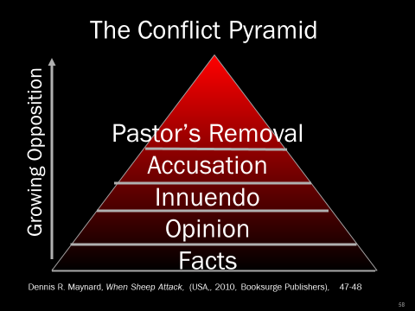

(*Pastor Unique*, 171)

Church bullies use this practice with particular deftness to control and ruin churches!

**Part 3: Your Personality and Peacemaking**

**1. Handling Conflict Satan’s Way**

**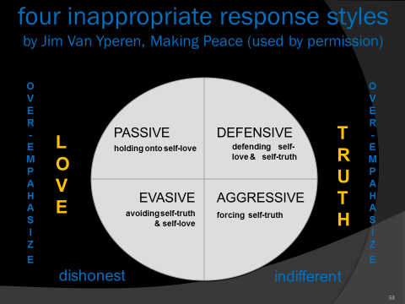**

## 

2. Additional notes:

Phil 2:14-15

Matt 22:39

1 Cor 13:5

Matt 7:12

Summary:

What if people don’t respond to overtures of peace?

For Believers: Biblical responses of Discipline

For our Enemies: Rom 12:20-21

Our response to those who do not respond well to us.

**Part 4: Intervention in Deeply Conflicted Churches**

**Step 1: Assess the Need for Reconciliation**

What particular passages apply to the conflicts found in Church?

What steps have been neglected?

What steps are necessary to resolve the conflicts at Church?

On the part of each individual

On the part of the Church?

What are the consequences of inaction?

What will be possible consequences of action?

**Step 2: Major Steps Towards Reconciliation**

1. Recognize the Need of Reconciliation

2. Seek to handle the needs biblically within the body.

3. If the problem is very deep and entrenched, call in an outside mediator to help facilitate the reconciliation process.

A. Find a seasoned mediator

B. The Church must vote to place themselves under the mediator during the reconciliation process.

4. Have the Church begin to prepare for handling the conflict

A. Biblical Peacemaking

1) The mediator helps the church through the immediate problem

2) The mediator helps the church develop healthy ways of handling future conflict

B. Spiritual Preparation

1) Apply 1 Corinthians 13 to each member of the church

2) Provide Bible studies during the preparation period (see Preparing for Reconciliation).

C. Develop an understanding of the Church.

1) Understand the pastor

2) Understand the people

3) Understand the dynamics of the conflict.

4) Understand the community

5) Understand the history of the church

6) Conduct an extensive church assessment

5. Understand the biblical methods of church conflict resolution

6. Present the Findings and Recommendations of the inquiry to the church body.

7. After a thorough examination of the church membership, leadership, community, history and the current problems, the mediator brings the church to a time of Sacred Assembly (see (Nehemiah 8:18, 9:1-4 for an example of a Sacred Assembly where Israel dealt with sin issues). A Sacred Assembly Schedule can be as follows (this is taken from an actual Sacred Assembly conducted in Dec 2015):

**Step 3: The Sacred Assembly**

*A Sacred Assembly*

Reminders of our “Place”

John 19:1-3, 16-30

Eph 5:22-33

Philippians 2:5-11

Own Your “Own”

Nehemiah 1 Nehemiah owned the sins of Israel

Daniel 9:1-19 Daniel owned the sins of Israel

Psalm 51 David owned his own sin

2 Corinthians 10:1-6

A Season of Prayer

A Time of Sharing Victories

A Time of Confession Wrong Done to Others (Matthew 5:21-26)

A Tim of Confronting Sins Against One Another (Matthew 18:15-18)

A Time of Inviting the Lord Jesus Christ to once again reign in this congregation Revelation 3:20

A Time of Reflection

The Lord’s Supper (only if there has been genuine reconciliation)

**Step 4: Observe a Celebration (Reflection) Sunday**

During these Sundays I have often said, “Satan has had you in his grasp. Satan has used you to bring reproach on the Name of the Lord Jesus Christ. However, you are no longer at his beck and call. You have been set free from his clutches. Never, never forget where you have been; and never let yourselves be brought into this position again.” Romans 8:1

**Ground Rules for the Resolution Process in the Sacred Assembly**

**1.** Pray fervently that the Lord would have freedom to deal with each heart.

2. Come prepared to do business before God and with one another.

3. No interruptions when someone is speaking.

4. The speaker must use the first person singular when addressing an issue, i.e., "I, me, my." They must speak only for themselves and not for the group.

5. You may address another individual only if you are addressing a specific sin committed against yourself by another individual.

6. No hitting below the belt by using caustic terms.

7. The speaker must speak to the opposing person specifically. They must face each other when speaking.

8. A person cannot speak twice until everyone has had the opportunity to speak once.

9. Before a speaker can talk on their topic they must repeat the last statement of the previous speaker to insure they are listening.

10. A person can only address one issue at a time.

11. A speaker must complete his or her comments within a three to five-minute time limit.

12. It is mandatory that each speaker speak the truth in love (Ephesians 4:15). Each one must come with a sincere heart seeking genuine reconciliation.

13. Each one must come prepared to repent, confess, seek forgiveness and be prepared to forgive and restore relationships.

**The Process of Intervention**

**THE ROLE OF THE PEACEMAKER**

The Church Contacts a Consultant/Peacemaker

The Consultant/Peacemaker Contacts the Denominational Office

The Consultant Secures and Invitation to the Church

The Church Votes to the Consultant/Peacemaker

The Consultant/Peacemaker Sends an Assessment Packet to the Church

The Consultant Assembles the Assessment Team

Church Returns Assessment Materials

Consultant/Peacemaker Provides Data and Manuals to Assessment Team

Assessment Team Reviews Data and Schedules Onsite Evaluation

Onsite Evaluation and Resulting Prescriptions

Preparation for Reconciliation

Sacred Assembly

Follow Up

**Day 4, Topic 2:  *Leading Change in the Midst of Conflict***

**Conflict: Pastors Must Stand Apart**

*In order to lead a stagnant or deteriorating church forward, the pastor must learn to distance himself from the church’s emotional system but stay connected in order to exert positive leadership.*

**A Church Is a System**

A church is more than **the sum of its parts**. It isn't just a **collection** of people bound by common goals, shared rules and regulations, and agreed upon meetings. It is a **living organism** with its own personality, mores, and values which operate in concert to create a unique identity that distinguishes it from every other church. It is a **system.** The Bible uses the human body as a metaphor for the system paradigm.

Rather, speaking the truth in love, we are to grow up in every way into him who is the head, into Christ, from whom the whole body, joined and held together by every joint with which it is equipped, when each part is working properly, makes the body grow so that it builds itself up in love (Ephesians 4:15-16).

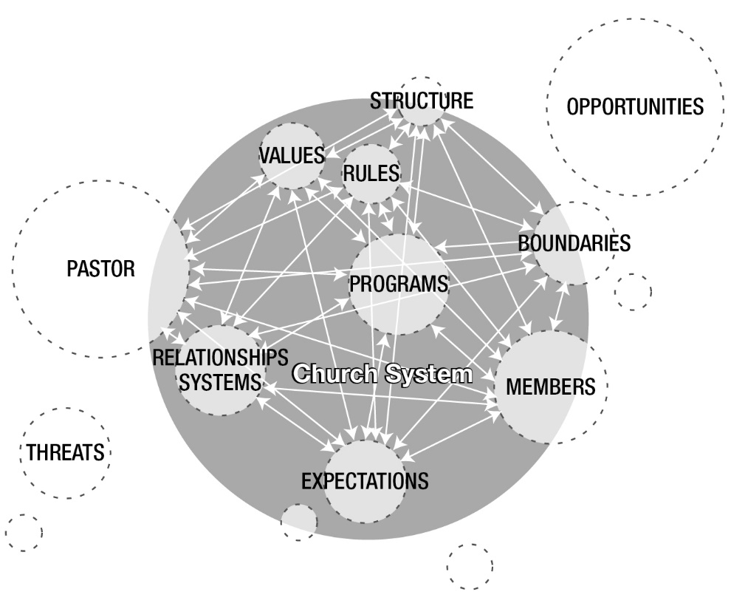You can think of a church system as a collection of parts that work together for specific purposes (whether intentional or unintentional).

* Structure
* Rules of operation
* Policies & procedures
* Relationship policies (between people)
* Boundaries
* Environment

**Primary Tasks**

The two primary tasks of any system are:

1. Maintain the status quo.
2. Reduce anxiety.

When something creates tension, systems automatically react to reduce anxiety and restore the status quo. Regardless of where it comes from, everyone is affected.

For the body does not consist of one member but of many. . .. But God has so composed the body, giving greater honor to the part that lacked it, that there may be no division in the body, but that the members may have the same care for one another. If one member suffers, all suffer together; if one member is honored, all rejoice together. (1 Corinthians 12:14-26)

*The anxious church*

Many issues cause anxiety in church:

* Conflict over leadership preferences (1 Corinthians 2-3)
* Gross sins Disclosed (1 Corinthians 5)
* Presence of false teachers (Galatians)
* Racial and cultural tensions (Acts 15:1-29￼)
* Problems between members (Philippians 4).
* Suffering and hardship (Hebrews & 1 Peter).

Here’s the problem:

***When anxious moments arise, the elements that create the system insure that it will react counterproductively.***

Rather than capitalizing on the anxiety as an opportunity for personal and corporate, churches will seek "quick fixes" to reduce the anxiety and attempt to restore the status quo instead of creating a new, healthier "normal." Typical, unhelpful processes of an anxious church include:

1. Reacting

Members focus on the crisis.

2. Closing ranks

The desire for good feelings promotes group-think over individuality; the church expresses a "self" of its own to which all are required to submit. Dissent is Discouraged, peace is valued more than progress, and individual thought is stifled.

This produces an appeasement strategy toward troublemakers.

The principled few who insist on growth rather than appeasement are branded as heartless or unfeeling. Eventually, the group organizes around the "problem" member.

Closing ranks masks the fact that the problem member isn't the "real" problem. The underlying problem is the way in which the church responds to anxiety.

3. Blaming

Anxious people and systems blame others instead of assuming personal and corporate responsibility.

Rather than permit people who insist on responsibility, integrity, honesty, and personal boundaries – which forces the church to remain anxious while it finds healthy solutions, the system pushes for an unhealthy “quick fix " so equilibrium can be restored.

4. THE Quick fix

Chronically anxious churches are impatient. The thinking that produces blaming assumes that first-order (simple) changes can easily solve problems. The focus is on symptom relief rather than fundamental change.

When the pastor or an influential leader refuses to be drawn into the emotional system’s demand for a quick fix, insisting instead on fundamental second-order change, the church will sabotage that person.

5. LackING well differentiated leadership

The system insists on symptom relief, quick fixes, and a return to the status quo. Under these pressures pastors who lack ego strength and the ability to stand outside of the system may succumb. In that case, they are no longer leading; they tinker with technique, turn a few knobs, and cobble together ad hoc solutions to tough problems.

For example, many churches experience anxiety over declining income.

The "quick fix" usually combination of tried and true failures:

* Notices in the bulletin
* Platform announcements
* Perhaps a letter to members
* A couple of sermons on tithing

A well differentiated pastor will stand outside the system, reject the quick fix, and insist on dealing with the underlying problem:

* Confronting church officers who are not tithing.
* Reducing expenditures for unproductive ministries, programs, events.
* Greater emphasis on spiritual formation
* Focus a series of sermons on the mission and vision
* Eliminate unnecessary tasks so the pastor can take a part-time job.

These more productive solutions will temporarily increase anxiety in the system. As a result, they will be met with initial resistance, but if the pastor withstands the resistance, he will move the church from cyclical or chronic anxiety to genuine resolution of the underlying problem.

***A turnaround pastor will not give in***

Catering to the demand for a quick fix deprives the church of the chance to encourage, promote, or even force members to deal with their own emotional and spiritual maturity.

Pastors with high ego needs (inappropriate sources of self-worth) need to be aware of how their image maintenance behaviors will work against the need to stand apart as a differentiated self. You need to be aware of how you respond when others label you as heartless or indifferent – and they will if you decide to stand apart. You should also be aware of how you tend to react when you become aware that others are sabotaging you when you attempt to produce necessary change. If challenges to your authority provoke a harmful response, you'll need to learn to manage that.

*Gridlocked by Anxiety*

Gridlocked systems manifest several predictable characteristics:

* An unending treadmill of trying harder at useless behaviors
* Looking for simple answers rather than thoughtfully reframing questions
* Either/or thinking that creates false dichotomies.

These keep people locked into futile thought patterns and responses. In order to find new "shores" those patterns need to be broken. But this requires imagination and risk-taking.

**The Pastor Who Stands Apart**

Most leadership training puts the emphasis on people, policies, and systems as objects to be motivated or moved. Little, if any, thought is given to how the pastor’s presence and responses bring about meaningful change. Might this be a partial explanation why 70 percent of change initiatives fail in business and industry?

When pastors are self-aware, and when they identify and provide for their needs, they become more effective turnaround leaders. Anxious churches need pastors who stand apart, refusing to get sucked into the reactive, huddling, blaming, quick-fix mentality. They need pastors who stand outside the system but stay connected to the people, so they can lead growth rather than manage anxiety. They need pastors who:

* Take time to calmly think and make well-reasoned decisions that are congruent with their vision.
* Lead change rather than being led from crisis to crisis.
* Take well-defined stands even at great personal cost.
* Recognize and deal with sabotage and bullies.

This is the profile of a pastor who isn’t motivated by a need of approval. The pastor ignores the slight when called "cold" or "unfeeling" or "insensitive." This is a pastor who resists the challenge, resolved to stand firm on principle.

The irony is that although the group needs a strong leader, the system processes insure that such a leader will not be forthcoming.

*The Myth of the Caring Pastor*

A widespread myth that shapes the pastor’s view of ministry within a therapeutic culture is the fallacy that feeling deeply for others helps them mature. This leads to the idea that trying to understand (when they are behaving inappropriately) is more important than being mindful of who you are and the principles on which you stand. This idea is problematic on two levels:

1. This view of empathy focuses on weakness and immaturity. It allows the other to avoid personal accountability. It also allows the pastor to avoid the of an unpleasant confrontation.
2. It overlooks the fact that the pastor’s *primary responsibility is to* precipitate maturity*, not* comfort the congregation.

Empathy is an important skill pastors should master. But the fact remains that sensitivity does not lead others to become more self-aware. Appreciating their plight does not motivate them to assume responsibility for themselves.

**Summary**

A pastor who stands apart is not an autocrat and does not order others around, even though a refusal to be co-opted by the anxious church's anxiety may be perceived that way. This pastor is clear about who he or she is, and knows what Jesus has commissioned us to do. This is the pastor who avoids the swirly anxiety by standing firm on biblical principles.

Self-differentiation is a new leadership paradigm for most pastors. Viewing the local church as a system requires a bit of training at the conceptual and behavioral levels. Most likely, you’ll need to work with a coach to develop these abilities:

* Separate yourself from the church’s emotional system.
* Maintain calm, clear commitment to your mission, vision, and values when you’re thrown into the furnace.
* Be exposed and vulnerable to harsh criticism without striking back or defending yourself.
* Maintain the physical and emotional stamina needed to overcome systemic inertia.
* Regulate your emotions in the face of reactive sabotage.
* Risk displeasing others for the sake of the system’s growth

**Day 4, Topic 3: *The Lifecycle of the Church***

LIFE CYCLE CHARACTERISTICS OF A CHURCH

Churches are born, they mature but without careful Biblical nutrition, missional vision and spiritual leadership, they can and will die. Below you will see the characteristics of a church at various states in its lifestyle. Most struggle to understand where their church is and how it can change. *Fresh Start* exists to help churches get a new lease on life and extend the life of the congregation. Dr. Penfold specializes in this area of ministry.

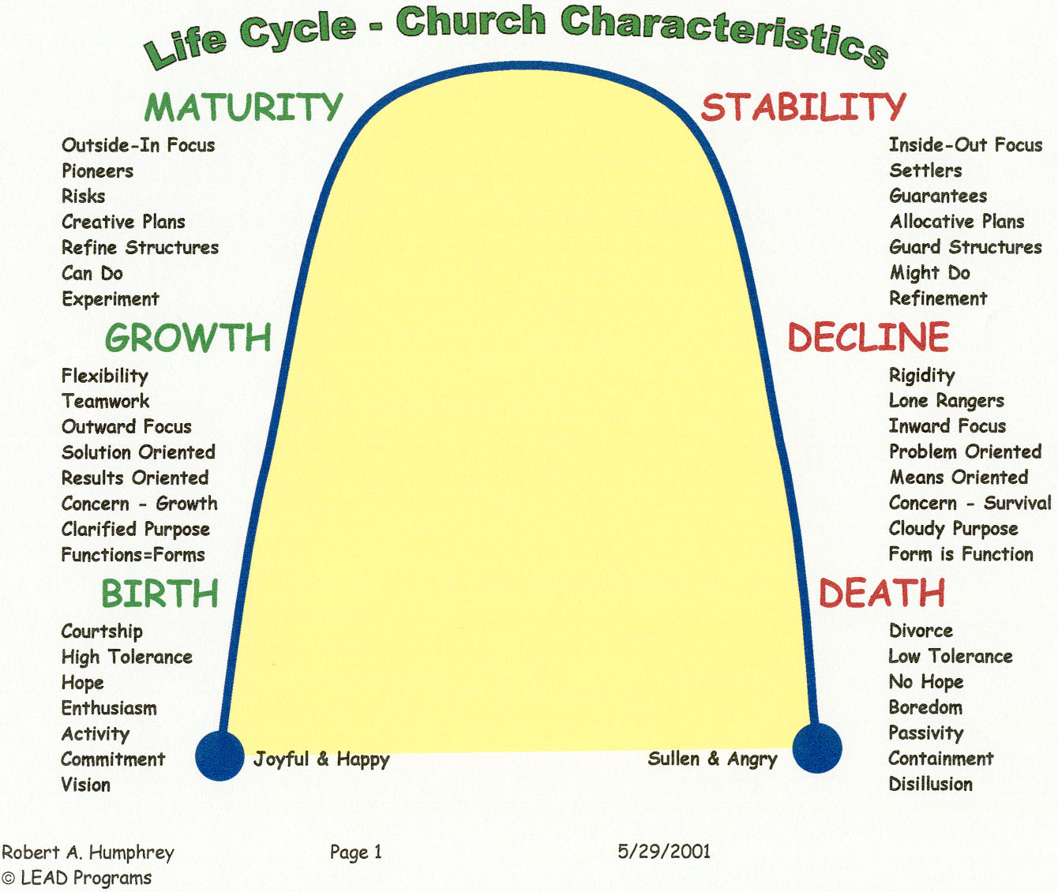

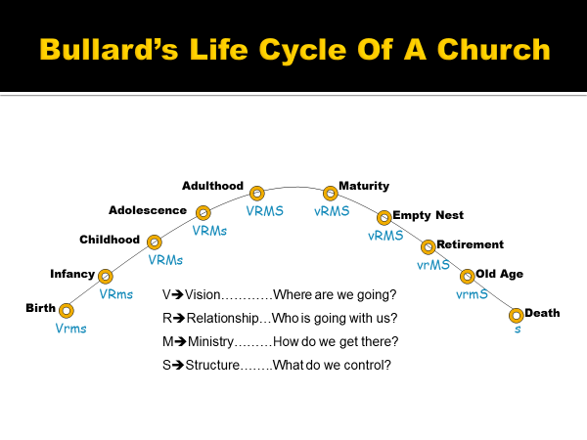

**Day 4, Topic 4: *The Lifecycle of Pastoring***

**Introduction:**

Phase One: The \_\_\_\_\_\_\_\_\_\_\_\_\_\_\_\_\_\_ Phase

Phase Two: The \_\_\_\_\_\_\_\_\_\_\_\_\_\_\_\_\_\_ Phase

Phase Three: The \_\_\_\_\_\_\_\_\_\_\_\_\_\_\_\_\_\_ Phase

Phase Four: The \_\_\_\_\_\_\_\_\_\_\_\_\_\_\_\_\_\_ Phase

Phase Five: The \_\_\_\_\_\_\_\_\_\_\_\_\_\_\_\_\_\_ Phase

Phase Six: The \_\_\_\_\_\_\_\_\_\_\_\_\_\_\_\_\_\_ Phase

**Reversing the trend:**

**The Life Cycle of a Career**

Survival

Success

Significance

|  |  |  |  |  |  |
| --- | --- | --- | --- | --- | --- |
| Sovereign Foundation | Inner Life  Growth  Conversion | Ministry Maturity (about 30) | Life Maturity  (50-60) | Convergence (60-70) | Afterglow  (70-90) |
|  |  |  |  |  |  |

**Day 4, Turnaround Church Leaders’ Interviews**

**Day 4, Review and Summary**

**Day 5, Topic 1: *No Pain, No Gain: Understanding the Cost of Revitalization***

Peter Wagner talks about the “price” pastors must pay if they want to grow. “First, a pastor must want the church to grow and be willing to pay the price.” *Leading Your Church to Grow,* 45.

Discussion from the article written by Hodge, Scott, “Sharp Curve Ahead." Leadership (2005).

http:// [www.christianitytoday.com/le/2005/fall/26.62.html](http://www.christianitytoday.com/le/2005/fall/26.62.html) or you may find the article at <http://www.theorchardcommunity.com/story>

**Principles from the Transformation**

**1**.

2.

3.

4. The journey required a change in staff.

Church researchers Ed Stetzer and Mike Dodson state emphatically, “Comeback churches changed staff. Let that sink in—six of seven comeback churches experienced staff change prior to their comeback. It is an inescapable fact that most comeback churches changed staff.”[[12]](#footnote-9)

5.

6.

7.

8.

9.

10.

11.

12.

13.

***Therefore, we also, since we are surrounded by so great a cloud of witnesses, let us lay aside every weight, and the sin which so easily ensnares us, and let us run with endurance the race that is set before us,***

***looking unto Jesus, the author and finisher of our faith, who for the joy that was set before Him endured the cross, despising the shame, and has sat down at the right hand of the throne of God.***

***Hebrews 12:1-2***

**Day 5, Topic 2: *Scheduling Your Ministry: Setting Your Priorities, Using Your Gifts, Delegating Responsibilities***

**Monday Morning Meltdown**



The concept of “pastoral care” had its roots in the Dark Ages. It was thought that only the pastor (or priest) could handle the Scriptures, pray, visit the sick, perform weddings, funerals, comfort the afflicted, and so on. There was an unnecessary and unbiblical division between the “clergy and the laity.” This type of thinking carried over into the Reformation. Richard Baxter in *The Reformed Pastor* (first published in 1656) portrays the view seen by many to be the normative view of the ministry in the sixteenth century. Baxter was a Puritan leader in Kidderrminster, England. His job description for a pastor is described by George Hunter III in *Radical Outreach* (105-6). ***The leader “served as every person’s evangelist, catechist, teacher, overseer, counselor, Disciplinarian, liturgist, and preacher (Sunday morning and evening); he took it on himself to minister to all sick people and to visit from house to house.”***

Baxter’s view, and the view of Christendom, permeated the church for nearly 1800 years! That same attitude persists in churches today. In the past I, too, fell prey to this kind of thinking. In one church, I did more than I should have done. In so doing, I actually crippled the congregation!

**Congregational Care—Not Pastoral Care**

NKJV Eph 4:11 And He Himself gave some to be apostles, some prophets, some evangelists, and some pastors and teachers,

12 for the equipping of the saints for the work of ministry, for the edifying of the body of Christ,

KJV Eph 4:11 And he gave some, apostles; and some, prophets; and some, evangelists; and some, pastors and teachers;

12 For the perfecting of the saints, for the work of the ministry, for the edifying of the body of Christ:

A question for the church: Do you desire a “maintenance” pastor or a “growth” pastor.

My comment to the search team: **“If you are looking for a maintenance pastor, find someone else!”**

Romans 12:3-8

**“If you do something that someone else in the church can do, you are robbing them of a blessing.”**

**Duane Ayers—Veteran pastor of more than 45-years’ fulltime ministry**

Having worked on research for my dissertation and having worked with multiple churches a few things always bob to the surface. One issue that repeatedly arises is this bottleneck for effective ministry called “pastoral care.” God’s antidote for this potent ministry killer is called **congregational care!** Congregational care is the biblical notion that the congregation is responsible for the care of its members and for the outreach ministries of the church, not the pastor! Ephesians 4:11-12 is perhaps the most explicit passage that deals with congregational care. Here the church leadership is charged with the responsibility of “equipping the saints” so the saints can do the “work of ministry.” That is **congregational care.**

Churches that do well are churches that have these two elements in place. The pastor uses his primary gifts, and the congregation provides the **congregational care for the body.** The leadership unleashes the potential of the church members for ministry. They empower and encourage the body of Christ to be the **body of Christ!**

As a pastor or ministry leader, do you feel the need to be involved in every part of ministry? Do you need to have your finger in every piece of the pie? Then you need to change

God has not called pastors or Christian leaders to do it all. Pastors are not able! Christ has called the body of Christ to be the body of Christ. He has called us together to engage the world with the Gospel, to serve one another with joy gladness. This style of ministry is effective and brings glory to God and usefulness to each church member. By the grace and power of God churches will accomplish ministry **together.** That is **congregational care.** That is New Testament ministry!

**The Necessity of Delegation**

A load shared is half a load . . . the necessity of delegation

Exodus 18:13-27

Two Problems

The Leader

The people

The Solution

Ex 18:19-20

Ex 18:21-23

Worthy (heil)

Reverent

Truthful

Honest

Acts 6:1-7—The Magnificent Seven

The Problem Acts 6:1

The Secondary Problem Acts 6:2

The Proposed Solution Acts 6:3-4

Picking the Seven Acts 6:5-6

The Prosperity of the Ministry Acts 6:7

How Many Leaders do I Need? Gary’s Book—leaders of 1000’s, 100’s, 50’s and 10’s

**Leadership Tools—MANAGING TIME & SETTING PRIORITIES**

God loves you . . . and everyone else has a wonderful plan for your life.

Rick Warren—Purpose Driven Life

Why have priorities?

The Lord Jesus had priorities Matthew 20:28

Luke 19:9-10

What are biblical priorities?

Scheduling Your Priorities

1. You will find that there are more tasks and more work to be done in the ministry than you can possibly accomplish. You will have numerous questions:

* Where do I begin?
* How can I most wisely spend my time?
* How can my gifts and abilities best be used for the glory of God?
* How am I able to balance my responsibilities at home, work and the church?

2. God will give you enough time. Ephesians 2:10

Now remember that a schedule

* is an attempt to control the details of your life.
* will be interrupted!
* can be modified.

PRINCIPLE: Schedule your work but don’t let your schedule stand in the way of opportunities to minister in the Name of the Lord.

Schedule your work but don’t let your schedule stand in the way of opportunities to minister in the Name of the Lord.

MAXIM: You make your schedule or your congregation will

Your Assignment:   
  
Prepare a schedule that fits your core values, mission and vision.   
  
Please list ministries you should delegate to others in order to free up directed ministry time.

**Day 5, Topic 3: *Recruiting a Mentor or a Coach***

**The Need for Mentoring and Coaching**

In the classic work, *As Iron Sharpens Iron,* Howard Hendricks, noted teacher and mentoring expert and Bill Hendricks, president of the Hendricks Group, raised the banner of mentoring before the Christian community. Their remarks trace the root of the term, “mentor” and the current need for mentoring in our culture.

Wherever you turn today, you will find men looking for a guide, a coach, a model, an advisor. They are looking for someone who knows about life.

In essence, they are looking for a mentor. When the Greek warrior Odysseus went off to fight in the Trojan War, he left his young son, Telemachus, in the care of a trusted guardian named Mentor. The siege of Troy lasted ten years, and it took Odysseus another ten years to make his way home. When he arrived, he found that the boy Telemachus had grown into a man—thanks to mentor’s wise tutelage.

Based on this story, we now speak of a mentor as someone who functions to some extent as a father figure (in the best sense of the term), a man who fundamentally affects and influences the development of another, usually younger man. (Howard G. Hendricks and William Hendricks, *As Iron Sharpens Iron: Building Character in a Mentoring Relationship* (Chicago: Moody Press, 1995), 17-18.

They continue,

Mentoring is defined by the relationship. That being the case, we have to define a mentor not in terms of any formal roles that he carries out, but in terms of *the character of his relationship* with the other person, and the *functions* that that relationship serves.(Hendricks and Hendricks, 158)

According to the Hendricks, a mentor is an older, more experienced person who is a guide, model or an advisor. This is the classic view of a mentor.

**The Distinction Between Coaching and Mentoring**

Since this book was penned, mentoring, like so many other areas of our society, has undergone a great deal of refinement. Mentoring is not the only term currently in use. Coaching is used as a further refinement in the realm of personal and professional development. The concepts of mentors and coaches have taken on their own special meaning in ministry and business circles. So our objective is to provide workable definitions of “coach” and “mentor” as they apply to ministry. We will begin with a discussion as to how these terms are used in business and ministry circles today.

Don Hahn, President of Hahn Training, LLC, defines coaching and mentoring in the following way:

Coaching and mentoring are the 2 highest levels of professional development available in today’s workplace . . . It is easy to become confused about the differences between coaching and mentoring. Often times the two terms are used interchangeably when in fact there are some very specific distinctions. In mentoring, the course of action is usually provided by the mentor, whereas in a true coaching engagement, it is the coachee who creates the action plan. (<http://www.champtrainer.com/documents/Similarities%20and%20Differences%20in%20Coaching%20and%20Mentoring.pdf> , Don Hahn, “Similarities and Difference in Coaching & Mentoring”, accessed August 12, 2013.)

In Hahn’s definition, a mentor provides a course of action for a protégé (this term is defined below), whereas a coach has the protégé develop his own course of action.

Many other voices join the chorus to agree with this distinction. These include Management Mentors (<http://www.management-mentors.com/resources/coaching-mentoring-differences/>) , accessed August 12, 2013)and the English coaching and mentoring Brefi Group. The Brefi Group provides a sharp distinction as they describe mentoring and coaching.

Coaching: helping another person to improve awareness, to set and achieve goals in order to improve a particular behavioural performance.

Mentoring: helping to shape an individual’s beliefs and values in a positive way; often a longer term career relationship from someone who has ‘done it before.’ (<http://www.brefigroup.co.uk/coaching/coaching_and_mentoring.html> , accessed August 12, 2013.

This group echoes the fundamental distinctions between coaching and mentoring prevalent today. Mentoring is imparting information whereas coaching helps an individual to discern their own personal goals and objectives.

Christian coaches Bob Logan and Sherilyn Carlton describe coaching in the same manner.

Sometimes we just need an outside set of eyes and ears to give us a sense of perspective.

And coaching isn’t about being an expert. Is there knowledge involved? Absolutely. But the most crucial knowledge focuses on areas like listening skills and asking good questions. Coaches don’t need to have all the right answers so they can tell people what to do. It’s not about listening to the coach—it’s about helping others learn to listen to God for themselves.( Bob Logan and Sherilyn Carlton, *Coaching 101, Discover the Power of Coaching,* (St. Charles, IL. ChurchSmart Resources, 2003), 19).

Their definition agrees with the basic tenets we’ve already observed. Coaching is about listening and asking good questions to help the protégé determine the direction God is leading them.

Perhaps the best way to understand coaching and mentoring is by comparing them in the following chart.

Chart **16.** Contrasting Mentoring and Coaching for Pastors and Christian Leaders

|  |  |  |
| --- | --- | --- |
| **Areas of Difference** | **Coaching** | **Mentoring** |
| Duration | Short term | Long term |
| Relationship | Impersonal | Personal |
| Method | Asking directed questions to help protégé determine his or her own course of action | Giving direction from the mentor’s past experiences |
| Age Difference | Does not matter | Normally the mentor is older with more experience |
| Focus | Self-discovery of solutions | Directed towards solutions that have been successful in the past in the life of the mentor |

**Definitions of Coaches and Mentors**

So, for the purposes of this volume, we will define “mentor” and “coach” in the following ways:

* A mentor is one who promotes the development of life and ministry skills for a protégé primarily by imparting wisdom and skill from lessons learned from the mentor’s own life and ministry experience.
* A coach is one who promotes the development of life and ministry skills for a protégé primarily through asking probing questions about a protégé’s life, divine design, direction and development so that the protégé grows primarily through self-discovery. (This entire first section is taken from Aubrey Malphurs and Gordon E. Penfold, *Re:Vision— The Key to Transforming Your Church,* 189-191.)

**Examples of Mentors and Protégés in Scripture**

**Requirements for today:**

Combination:

Why?

**Characteristics to seek in a Mentor/Coach**

**Characteristics to seek in a Protégé**

**Day 5, Topic 4: *Coaching Cluster: The Value of Peer to Peer Learning***

Pastor Clusters

**What is a Pastor Cluster?**

**I am indebted to Dr. William Hoyt and Dr. Paul Borden of Growing Healthy Churches for the training they have offered on Pastor Clusters. Their ministry has greatly influenced me in this arena.**

**Typical Names**

**Typical Names for Pastor Clusters**

**Clusters**

**Peer-to-peer Learning Communities**

**LLC: Leadership Learning Communities**

**LEAD Teams**

**A Pastor Cluster is a . . .**

* **Group of ministry peers**
* **Led by ministry practitioner mentor**
* **Meeting regularly for:**
  + **Learning**
  + **Encouragement**
  + **Accountability**
  + **Dreaming**

**Why a Pastor Cluster?**

* **Takes advantage of what experienced mentors have to offer younger and less experienced pastors**
* **Economy of time for mentors**
* **Multiplies impact for the same investment of time and money**
* **It is financially wise**
  + **To help pastors continue to learn after seminary of Bible College.**
  + **To fill in the leadership blanks left by formal education**
  + **To develop pastor’s effectiveness as leaders**
  + **For accountability**
  + **For mutual support, encouragement, friendship and fellowship**

**Organizing Principles**

**1.**

**2.**

**3.**

**Style of Cluster Meetings**

**Each cluster chooses their preferred meeting day(s), times and model.**

* + **Day and half model – “Town and Country Model”**
  + **One day model – “Metropolitan Model”**
  + **Half –day model – “Metropolitan Model” for “busy Type A” pastors**
  + **Virtual meeting model—meet online**

**Frequency and Location of Cluster Meetings**

**Frequency**

* + **Typically, monthly**
    - **10-12 months annually**

**Location**

* + **A single, regular meeting place**
  + **Rotate through the locations of each cluster member**
  + **Select two or three strategically situated locations and rotate through them**

**Cluster Mentors**

* **Typically selected by the denominational executive**
* **Pastors who have a track record of leading a growing church or a turnaround pastor**
* **Sign a formal covenant clarifying the expectations of both Region and the mentor.**
* **Often but not always paid a small stipend for their time**
* **Denominational executive seeks formal action by the Mentor’s Board, approving the mentor’s service to the Region as a mentor.**
* **Formal board “blessing” protects mentor when members are critical of time spent on mentoring.**
* **Creates value in the eyes of the church leadership**

**Learning Materials for the Cluster**

**Cluster Expectations**

**Cluster Meeting Agenda**

* **L.E.A.D.**
  + **Learning**
  + **Encouragement**
  + **Accountability**
  + **Dreaming**

**Learning**

* + **Commitment to being a life-long learner**
  + **Personal and spiritual health and maturity**
  + **Ministry skills**
  + **Exegeting the culture**
  + **Visioneering**
  + **Strategic Ministry Planning Skills**
  + **Discussion of book**
  + **Emphasis on adaptation and application to their ministry**
  + **Not a book review but a “what am I going to do about what I have learned from this book.”**
  + **Often leads to the accountability and/or dreaming component of agenda**
  + **Book discussion questions**
  + **What leadership principles did you note while reading this book? How do you see them applying to you and your leadership in your church?**
  + **As you were reading, did you find yourself saying “Oh, I need to do that” or “I could do that. That would be a good thing to do in my setting?”**
  + **Was there any part of the book where you found yourself thinking, “That will never work in my church?”**
  + **Were there places where you found yourself thinking, “I know that, I am already doing that?”**
  + **What are you going to apply to your ministry? What questions do you have about how to apply it in your context?**
  + **Understanding church systems**
  + **Church Systems**
    - **Evangelism**
    - **Inspiring Worship**
    - **Visitor Assimilation**
    - **Lay Mobilization**
    - **Spiritual Formation**
    - **Leader Development**
    - **Congregational Care**
    - **Effective Communication**
    - **Functional leadership**
    - **Corporate Prayer**

**Cluster Meeting Agenda Example**

**Book—McIntosh, *Beyond the First Visit***

* **Assimilation System**
  + **Defining and identifying visitors**
  + **Tracking visitors**
  + **Strategy for moving people from “visitor” to fully assimilated constituent**
  + **Definition of a “fully assimilated person”**
  + **Training**
  + **Goals and milestones**
* **Learning**
  + **Inevitably, real life questions emerge from the meetings.**
  + **Listen, discuss, learn, and seek biblically centered solutions**
    - **Some of the greatest times of learning occur during these times of impromptu discussion**

**Encouragement**

* + **NOT commiseration - “poor you-poor me”**
  + **Not whine and dine**
  + **Give affirmation**
  + **Sometimes you must give reproof**
  + **Inspire growth and improvement**
  + **Care and prayer**

**Accountability**

* + **Expectation that they will establish specific, measurable goals**
    - **Ministry**
    - **Personal**
  + **Coach them in establishing those goals**
    - **Specific**
    - **Measurable**
    - **Aligned**
    - **Results-oriented**
    - **Time constrained**
  + **Ask them about the relationships they are building with those who are lost. Are they making progress?**
  + **Ask them about their schedules. Are they in control of their time, or have they relinquished control to others?**

**Dreaming**

* + **Need to dream again**
    - **John 4:35**
      * **"Do you not say, 'There are still four months and *then* comes the harvest'? Behold, I say to you, lift up your eyes and look at the fields, for they are already white for harvest!”**
    - **Psalm 51:10 Create in me a clean heart, O God, and renew a steadfast spirit within me.**
    - **Matthew 9:37-38 “37 Then He said to His disciples, ‘The harvest truly *is* plentiful, but the laborers *are* few. Therefore, pray the Lord of the harvest to send out laborers into His harvest.’” We must once again see the harvest!**
* **Dreaming**
  + **Personal dreams**
  + **Ministry dreams**
  + **Specific goals and action steps**

**(SMART goals)**

**Reading List**

* **Intentionally, extremely top-heavy on leadership**
  + **Include both secular and Christian books on leadership**
* **Essential Secular Classics**

**Book Example—*Good to Great***

*Good to Great* is a business book that has shaped the thinking of many in terms of turnaround. In research for the book, Jim Collins and his team studied companies that had made the leap from being mediocre companies to being great companies, that is, companies that turned around. In so doing, Collins and his team of researchers tried to identify the shared traits of companies that emerged out of the shadows to become companies that far outstripped the competition. The results of his research are catalogued in this bestselling volume. The findings of the study were stunning. “Our five-year quest yielded many insights, a number of them surprising and quite contrary to conventional wisdom, but one giant conclusion stands above the others: We believe that almost *any* organization can substantially improve its stature and performance, perhaps even become great, if it conscientiously applies the framework of ideas we’ve uncovered.”[[13]](#footnote-10) Collins and his team identified six characteristics found in companies that made the leap from “good” to “great.” They are:

* Level 5 Leadership . . . Self-effacing, quiet, reserved, even shy—these leaders are a paradoxical blend of personal humility and professional will. They are more like Lincoln and Socrates than Patton or Caesar.
* First Who . . . Then What . . . We found instead that they *first* got the right people on the bus, the wrong people off the bus, and the right people in the right seats—and *then* they figured out where to drive it. The old adage “People are your most important assets” turns out to be wrong. People are *not* your most important asset. The *right* people are.
* Confront the Brutal Facts . . . You must maintain unwavering faith that you can and will prevail in the end, regardless of the difficulties, *AND at the same time* have the discipline to confront the most brutal facts of your current reality, whatever they might be.
* The Hedgehog Concept. To go from good to great requires transcending the curse of competence . . . If you cannot be the best in the world at your core business, then your core business absolutely cannot form the basis of a great company. It must be replaced with a simple concept that reflects deep understanding of three intersecting circles (see below for a description of the three intersecting circles).
* Culture of Discipline . . . When you are disciplined people, you don’t need hierarchy. When you have disciplined thought, you don’t need bureaucracy. When you have disciplined action, you don’t need excessive controls. When you combine a culture of discipline with an ethic of entrepreneurship, you get the magical alchemy of great performance.
* Technology Accelerators. Good-to-great companies *think* differently about the role of technology. They never use technology as the primary means of igniting a transformation. Yet, paradoxically, they are pioneers in the application of *carefully selected* technologies.[[14]](#footnote-11)

Collins describes the three intersecting circles (see the Hedgehog Concept) in the following manner:

More precisely, a Hedgehog Concept is a *simple, crystalline concept that flows from deep understanding about the intersection of the following three circles:*

1. What you can be best in the world at? . . . 2. What drives your economic engine? . . . 3. What are you deeply passionate about? The Good to Great Companies focused on those activities that ignited their passion.”[[15]](#footnote-12)

In ministry, these circles can be easily identified in the Great Commission and the Great Commandment. The church is God’s instrument of redemption in a fallen world. That is what the church is to be best at doing. The Spirit of God with the Word of God powered by the love of God must drive our engine. Finally, the church is to be deeply passionate about reaching the world with the Gospel.

Collins continues by describing Level 5 leadership.

* Humility + Will = Level 5.

Level 5 leaders are “modest and willful, humble and fearless. To quickly grasp this concept, think of United States President Abraham Lincoln (one of the few Level 5 presidents in United States history), who never let his ego get in the way of his primary ambition for the larger cause of an enduring great nation.

* Ambition for the Company: Setting Up Successors for Success
* A Compelling Modesty
* Unwavering Resolve . . . to Do What Must Be Done
* The Window and the Mirror: Level 5 leaders look out the window to apportion credit to factors outside themselves when things go well (and if they cannot find a specific person or event to give credit to, they credit good luck). At the same time, they look in the mirror to apportion responsibility, never blaming bad luck when things go poorly.[[16]](#footnote-13)

Thus, Collins identifies turnaround leaders as leaders who are humble but driven, who are good managers of people, who understand reality, who are sharply focused on their company’s mission, who are modest and yet ambitious, and who are not afraid to take responsibility for their company or their own actions.[[17]](#footnote-14)

**Reading List: Rocky Mountain Church Network (an example)**

***2011 – 2012***

1. ***Good to Great: Why Some Companies Make the Leap... and Others Don't***  
   Jim Collins
2. ***Winning On Purpose: How To Organize Congregations to Succeed in Their Mission***Bill Easum, Thomas G. Bandy, Dr. John Kaiser
3. ***Direct Hit: Aiming Real Leaders at the Mission Field***   
   [Paul D. Borden](http://www.amazon.com/Paul-D.-Borden/e/B001IGQQBW/ref=ntt_athr_dp_pel_1)
4. ***Taking Your Church to the Next Level: What Got You Here Won't Get You There***   
   Gary L. McIntosh
5. ***Spiritual Leadership: A Commitment to Excellence for Every Believer***   
   J. Oswald Sanders
6. ***Fusion: Turning First-Time Guests into Fully-Engaged Members of Your Church***Nelson Searcy, Jennifer Henson
7. ***Leading Change***  
   John P. Kotter
8. ***Sticky Teams: Keeping Your Leadership Team and Staff on the Same Page***Larry Osborne
9. ***\*Overcoming the Dark Side of Leadership***Gary L. McIntosh & Samuel D. Rima

**2012-2013**

***2012-2013 Suggestions:***

1. ***Make or Break Your Church in 365 Days: A Daily Guide to Leading Effective Change***Paul D. Borden
2. ***StandOut: The Groundbreaking New Strengths Assessment from the Leader of the Strengths Revolution***Marcus Buckingham
3. ***The Apostolic Congregation: Church Growth Reconceived for a New Generation***George G Hunter III
4. ***The Advantage: Why Organizational Health Trumps Everything Else In Business***Patrick Lencioni
5. ***You Lost Me: Why Young Christians Are Leaving Church...and Rethinking Faith***David Kinnaman
6. ***ReChurch: Healing Your Way Back to the People of God***  
   Stephen Mansfield
7. ***The Triumph of Christianity: How the Jesus Movement Became the World's Largest Religion***Rodney Stark
8. ***The Truth about Leadership: The No-fads, Heart-of-the-Matter Facts You Need to Know***James M. Kouzes & Barry Z. Posner
9. ***Maximize: How to Develop Extravagant Givers in Your Church***Nelson Searcy**&**Jennifer Dykes Henson
10. ***Humilitas: A Lost Key to Life, Love, and Leadership***John Dickson
11. ***The Art of the Start: The Time-Tested, Battle-Hardened Guide for Anyone Starting Anything***Guy Kawasaki
12. ***The Next Christians: Seven Ways You Can Live the Gospel and Restore the Wor*ld**  
    Gabe Lyon

**Day 5, Topic 5: *Review the Personal and Ministry Development Plans***

See pages 15-16 of this manual

**Day 5, Topic 6: *Course Debrief***

**Day 5, Topic 7: *The Triumph of Christ***

1. Gary Keller with Jay Papasan, *The One Thing: The Surprisingly Simple Truth Behind Extraordinary Results* (Austin, TX: Bard Press, 2012), 146-47. [↑](#footnote-ref-1)
2. Aubrey Malphurs and Gordon E. Penfold, *Re:Vision: The Key to Transforming Your Church* (Grand Rapids, Baker), 46-47. [↑](#footnote-ref-2)
3. Malphurs, Penfold, 45. [↑](#footnote-ref-3)
4. Adapted from Malphurs and Penfold, 49. [↑](#footnote-ref-4)
5. Larry Osborn, *Sticky Teams: Keeping your leadership and staff on the same page*, (Grand Rapids, MI: Zondervan, 2010), 13-14, In the foreword written by Matt Chandler. [↑](#footnote-ref-5)
6. Craig Groeschel, *IT, How churches and leaders can get it and keep it,* p 48. [↑](#footnote-ref-6)
7. George Hunter, III, *Radical Outreach* (Nashville: Abingdon Press, 2003), 105-6. [↑](#footnote-ref-7)
8. Linus J. Morris, *The High Impact Church* (Houston: Touch Publications, 1993) 264. [↑](#footnote-ref-8)
9. TAPs scored 23.8 and NTAPs 28.4 compared with 50.0 for the general population. This presents an interesting question that begs further research: are pastors more risk averse than the average church member? Although church members resist change, they may be more willing to bet the house when they’re finally convinced it’s time to move. [↑](#endnote-ref-1)
10. Although we don’t have hard research data to prove it, we suspect that the need to validate one’s ego by one’s works is also at work here. For more on this, see Chapter 2, “The Pastor’s Worth.” [↑](#endnote-ref-2)
11. Bridges, 130-132, “But the good news is that while the changes we are facing differ from any we’ve experienced before, the transition process by which people get through change is well-mapped. There are many things about this new world that we cannot yet understand, but we do know what change does to people and how to help them get through it.” According to Bridges, it is easier for companies to make situational changes than it is for people to make because of the psychological transitions needed to adjust to the organizational changes. Bridges, 160-163, distinguishes *change* and *transition*. “Change is situational: the move to a new site, the retirement of the founder, the reorganization of the roles on the team, the revisions to the pension plan. Transition, on the other hand, is psychological; it is a three-phase process that people go through as they internalize and come to terms with the details of the new situation that the change brings about.” [↑](#endnote-ref-3)
12. Ed Stetzer and Mike Dodson, *Comeback Churches: How 300 Churches Turned Around and Yours Can Too* (Nashville, TN: B & H Pub. Group, 2007), 177. [↑](#footnote-ref-9)
13. Collins, 5. [↑](#footnote-ref-10)
14. Ibid., 12-13. [↑](#footnote-ref-11)
15. Ibid., 95-96. [↑](#footnote-ref-12)
16. Ibid., 22-35. [↑](#footnote-ref-13)
17. Gordon E. Penfold, “Defining Characteristics of Turnaround Pastors among Evangelical Churches in the Rocky Mountain States” (D.Min diss., Biola University, 2011). [↑](#footnote-ref-14)