Chronology of the Patriarchs (Genesis 5 & 11)

Contrary to popular opinion, the dates on the next six pages are based on a strict chronology of the genealogies of Genesis 5 and 11. There are several reasons for adhering to a genealogy without gaps:

1. These records state lengths of time unlike other genealogies with gaps (e.g., Matt. 1:1-17) that only show bloodlines. Genesis 5 and 11 give each father’s age when a son is born—useless data apart from a strict chronology. Also, Methuselah’s death in the Flood year fits perfectly.

2. The Genesis genealogies have shorter lengths of time (creation to Noah, or Noah to Abraham) while Abraham to Jesus is 2000 years (Matt. 1) or Adam to Jesus is 4000 years (Luke 3).

3. A no-gaps sequence is the most natural, straightforward, objective method of interpretation.

4. The Genesis genealogies indicate a direct father-son relationship. This is the natural usage of the term “begot” or “was the father of” (dly), especially when the Hebrew Hiphil (causative) tense is used as it is here. When a father-son relationship is not meant, either the Hebrew Qal tense (Gen. 36:10-12; 46:18, 25; Exod. 6:20) or the Hebrew Niphal tense is used (Deut. 23:8). Also, no one questions that Adam had a son named Seth who had Enosh (Gen. 4:25-26), or that Noah had Shem, or that Terah had Abraham.

5. Jude 14 says that Enoch was the 7th generation from Adam so there can be no gaps between these two men. Since the subsequent names have the same structure it is likely that they too lack gaps.

6. Ancient extra-biblical records support a strict chronology. The earliest European and Middle Eastern records verify the accuracy of the Table of Nations (Gen. 10-11) and the early date of creation (5200-4000 BC).

Given this “no gap” strict chronology, exact dates can be established for many primeval events. Dates are first determined by starting at the zero year AH (Latin anno Homo sapiens) for “in the year of man’s beginning.” AH dates are then reckoned up to the substantiated date of 1845 BC and then BC dates counted backwards to creation.

Event | Reference | AH | BC
World created | "By the seventh day God had finished the work He had been doing…" (2:2a) | -6 days | 4143
Adam created | "When God created man [Adam], he made him in the likeness of God" (5:1b) | 0 | 4143
Seth born to Adam | "When Adam had lived 130 years, he had a son in his own likeness…and he named him Seth" (5:3) | 130 | 4013
Enosh born to Seth | "When Seth had lived 105 years, he became the father of Enosh" (5:6) | 235 | 3908
Kenan born to Enosh | "When Enosh had lived 90 years, he became the father of Kenan" (5:9) | 325 | 3818
Mahalalel born to Kenan | "When Kenan had lived 70 years, he became the father of Mahalalel" (5:12) | 395 | 3748
Jared born to Mahalalel | "When Mahalalel had lived 65 years, he became the father of Jared" (5:15) | 460 | 3683

Event | Reference | AH | BC
Methuselah born to Enoch | "When Enoch had lived 65 years, he became the father of Methuselah" (5:21) | 687 | 3456
Lamech born to Methuselah | "When Methuselah had lived 187 years, he became the father of Lamech" (5:25) | 874 | 3269
Adam died | "Altogether, Adam lived 930 years…" (5:5a) | 930 | 3213
God took Enoch away | "Altogether, Enoch lived 365 years…" (5:23-24) | 987 | 3156
Seth died | "Altogether, Seth lived 912 years…" (5:8a) | 1042 | 3101
Noah born to Lamech | "When Lamech had lived 182 years, he became the  father of Noah" (5:28-29) | 1056 | 3087
Enosh died | "Altogether, Enosh lived 905 years…" (5:11a) | 1140 | 3003
Kenan died | "Altogether, Kenan lived 910 years…" (5:14a) | 1235 | 2908
Mahalalel died | "Altogether, Mahalalel lived 895 years…" (5:17a) | 1355 | 2788
Jared died | "Altogether, Jared lived 962 years…" (5:20a) | 1422 | 2721
Shem, Ham, and Japheth  all born to Noah | "After Noah was 500 years old, he became the  father of Shem, Ham and Japheth" (5:32) | 1558+ | 2585
Lamech died | "Altogether, Lamech lived 777 years…" (5:31a) | 1651 | 2492
Methuselah died | "Altogether, Methuselah lived 969 years…" (5:27a) | 1656 | 2487
The Flood | "Two years after the flood… Shem was 100 yrs. old" (11:10b) | 1656 | 2487
Arphaxad born to Shem | "Two years after the flood, when Shem was 100 yrs. old, he became the father of Arphaxad" (11:10) | 1658 | 2485
Shelah born to Arphaxad | "When Arphaxad had lived 35 years, he became the father of Shelah" (11:12) | 1693 | 2450
Eber born to Shelah | "When Shelah had lived 30 years, he became the father of Eber" (11:14) | 1723 | 2420
Peleg born to Eber | "When Eber had lived 34 years, he became the father of Peleg" (11:16) | 1757 | 2386

Event |  | Reference |  | AH |  | BC
Reu born to Peleg | "When Peleg had lived 30 years, he became the father of Reu" (11:18) |  | 1787 |  | 2356
Serug born to Reu | "When Reu had lived 32 years, he became the father of Serug" (11:20) |  | 1819 |  | 2324
Nahor [II] born to Serug | "When Serug had lived 30 years, he became the father of Nahor [II]" (11:22) |  | 1849 |  | 2294
Terah born to Nahor [II] | "When Nahor had lived 29 years, he became the father of Terah" (11:24) |  | 1878 |  | 2265
Haran born to Terah | "After Terah had lived 70 years, he became the father of Abram, Nahor [II], and Haran" (11:26) |  | 1948 |  | 2195
Nahor II born to Terah | "After Terah had lived 70 years, he became the father of Abram, Nahor [II], and Haran" (11:26) |  | 1949-2007 |  | 2194-2136
Peleg died | "After he became the father of Reu, Peleg lived 209 years…" (11:17a) |  | 1996 |  | 2147
Nahor I died | "After he became the father of Terah [1878 AH], Nahor [I] lived 119 years…" (11:25a) |  | 1997 |  | 2146
Noah died | "Altogether, Noah lived 950 years…" (9:29) |  | 2006 |  | 2137
Abram born to Terah | "After Terah had lived 70 years, he became the father of Abram, Nahor [II], and Haran" (11:26) |  | 2008 |  | 2135
Sarai born | Sarai was 10 years younger than Abram since he was 100 when she was 90 (17:1, 17) |  | 2018 |  | 2125
Reu died | "And after he became the father of Serug, Reu lived 207 years…" (11:21a) |  | 2026 |  | 2117
Serug died | "And after he became the father of Nahor [I], Serug lived 200 years…" (11:23a) |  | 2049 |  | 2094
Shem died | "And after he became the father of Arphaxad, Shem lived 500 years…" (11:11a) |  | 2058 |  | 2085
Terah died | "Terah lived 205 years, and he died in Haran" (11:32) |  | 2083 |  | 2060

Event | Reference | AH | BC
Abram went to Egypt | "Now there was a famine in the land, and Abram went down to Egypt…" (12:10) | 2085? | 2058?
Abrahamic Covenant ratified | "Lift up your eyes… All the land you see I will give to you and your offspring forever" (13:14-15) | 2089? | 2054?
Ishmael born | "Abram was 86 years old when Hagar bore him Ishmael" (16:16) | 2094 | 2049
Arphaxad died | "And after he became the father of Shelah, Arphaxad lived 403 years…" (11:13a) | 2096 | 2047
Abrahamic Covenant reconfirmed | Abraham was circumcised at age 99 and Ishmael at age 13; "Sarah will bear [Isaac] to you by this time next year" (17:21, 24-25) | 2107 | 2036
Destruction of Sodom | Cities of the Plain destroyed between Abraham's circumcision and Isaac's birth | 2107 | 2036
Isaac born | "Abraham was 100 years old when his son Isaac was born to him" (21:5; cf. 17:17) | 2108 | 2035
Isaac taken to Mt. Moriah | "Some time later… Do not lay a hand on the boy" (22:1, 12)–estimates Isaac to be 17 years old | 2125? | 2018?
Shelah died | "And after he became the father of Eber, Shelah lived 403 years…" (11:17a) | 2126 | 2017
Sarah died | "Sarah was 127 years old" (23:1) | 2144 | 1991
Isaac marries | "Isaac was 40 years old when he married Rebekah" (25:20) | 2148 | 1995
Shem died | "After he became the father of Arphaxad, Shen lived 500 years…" (11:11) and died at 600 years (11:10) | 2158 | 1985
Jacob and Esau born | "Isaac was 60 years old when Rebekah gave birth to them" (25:26) | 2168 | 1975
Abraham died | "Altogether, Abraham lived 175 years" (25:7) | 2183 | 1960
Eber died | "And after he became the father of Peleg, Eber lived 430 years…" (11:17a) for a total of 464 years | 2187 | 1956
Esau marries | "When Esau was 40 years old, he married Judith… and also Basemath…" (26:34) | 2208 | 1935
Ishmael died | "Altogether, Esau lived 137 years" (25:17) | 2231 | 1912
Jacob fled to Laban | Jacob was 77 years old | 2245 | 1898
Event | Reference | AH | BC
Jacob married both  Leah and Rachel | “Jacob raged at Laban. “I worked seven years for Rachel! … [so Jacob married at age 84 and] . . . served Laban for another seven years” (29:30) | 2252 | 1891
Joseph born | Jacob was 91 at Joseph’s birth (see footnote below) | 2259 | 1884
Jacob returned to Canaan | At age 97, Jacob returned to Canaan after 20 years and was restored with his brother Esau (31:38, 41) | 2265 | 1878
Abrahamic Covenant confirmed to Jacob at Bethel | At age 100, God confirmed his covenant to Jacob one final time and changed his name to Israel (35:9-15); This is the beginning of the 430 years in Canaan and Egypt (Exod. 12:40). | 2268 | 1875
Joseph sold | "Joseph, a young man of 17…” (37:2, 28) | 2276 | 1867
Joseph interpreted dreams of baker and cupbearer | "When 2 full years had passed, Pharaoh had a dream" (41:1); Since Joseph was 30 upon entering Pharaoh's service (41:46), his dream interpretations for the baker and cupbearer were at age 28. | 2287 | 1856
Isaac died | "Isaac lived 180 years" (35:28); Jacob was 120 at Isaac's death since Isaac was 60 at Jacob's birth (25:26) | 2288 | 1855

Joseph interpreted Pharaoh's dream | "Joseph was 30 years old when he entered the service of Pharaoh" (41:46) | 2289 | 1854
Seven years of abundance | Joseph was immediately appointed by Pharaoh to administer the food of Egypt (41:41, 46) | 2289-2296 | 1854-1847
Seven years of famine | These immediately followed the 7 years of abundance | 2296-3003 | 1847-1840

Event | Reference | AH | BC
Jacob and family go to Egypt | Jacob was 130 (47:9) while entering Egypt during the second year of the famine (45:6); this occurred 400 years before the Exodus in 1445 BC. Joseph was 39. | 2298 | 1845
Jacob died | Jacob died at 147 after living in Egypt 17 years (47:28), so Joseph was 56 years old. | 2315 | 1828
Joseph died | Joseph died at 110 (50:26), so he lived another 71 years in Egypt after his family arrived there. | 2369 | 1774

Timeline of the Patriarchs
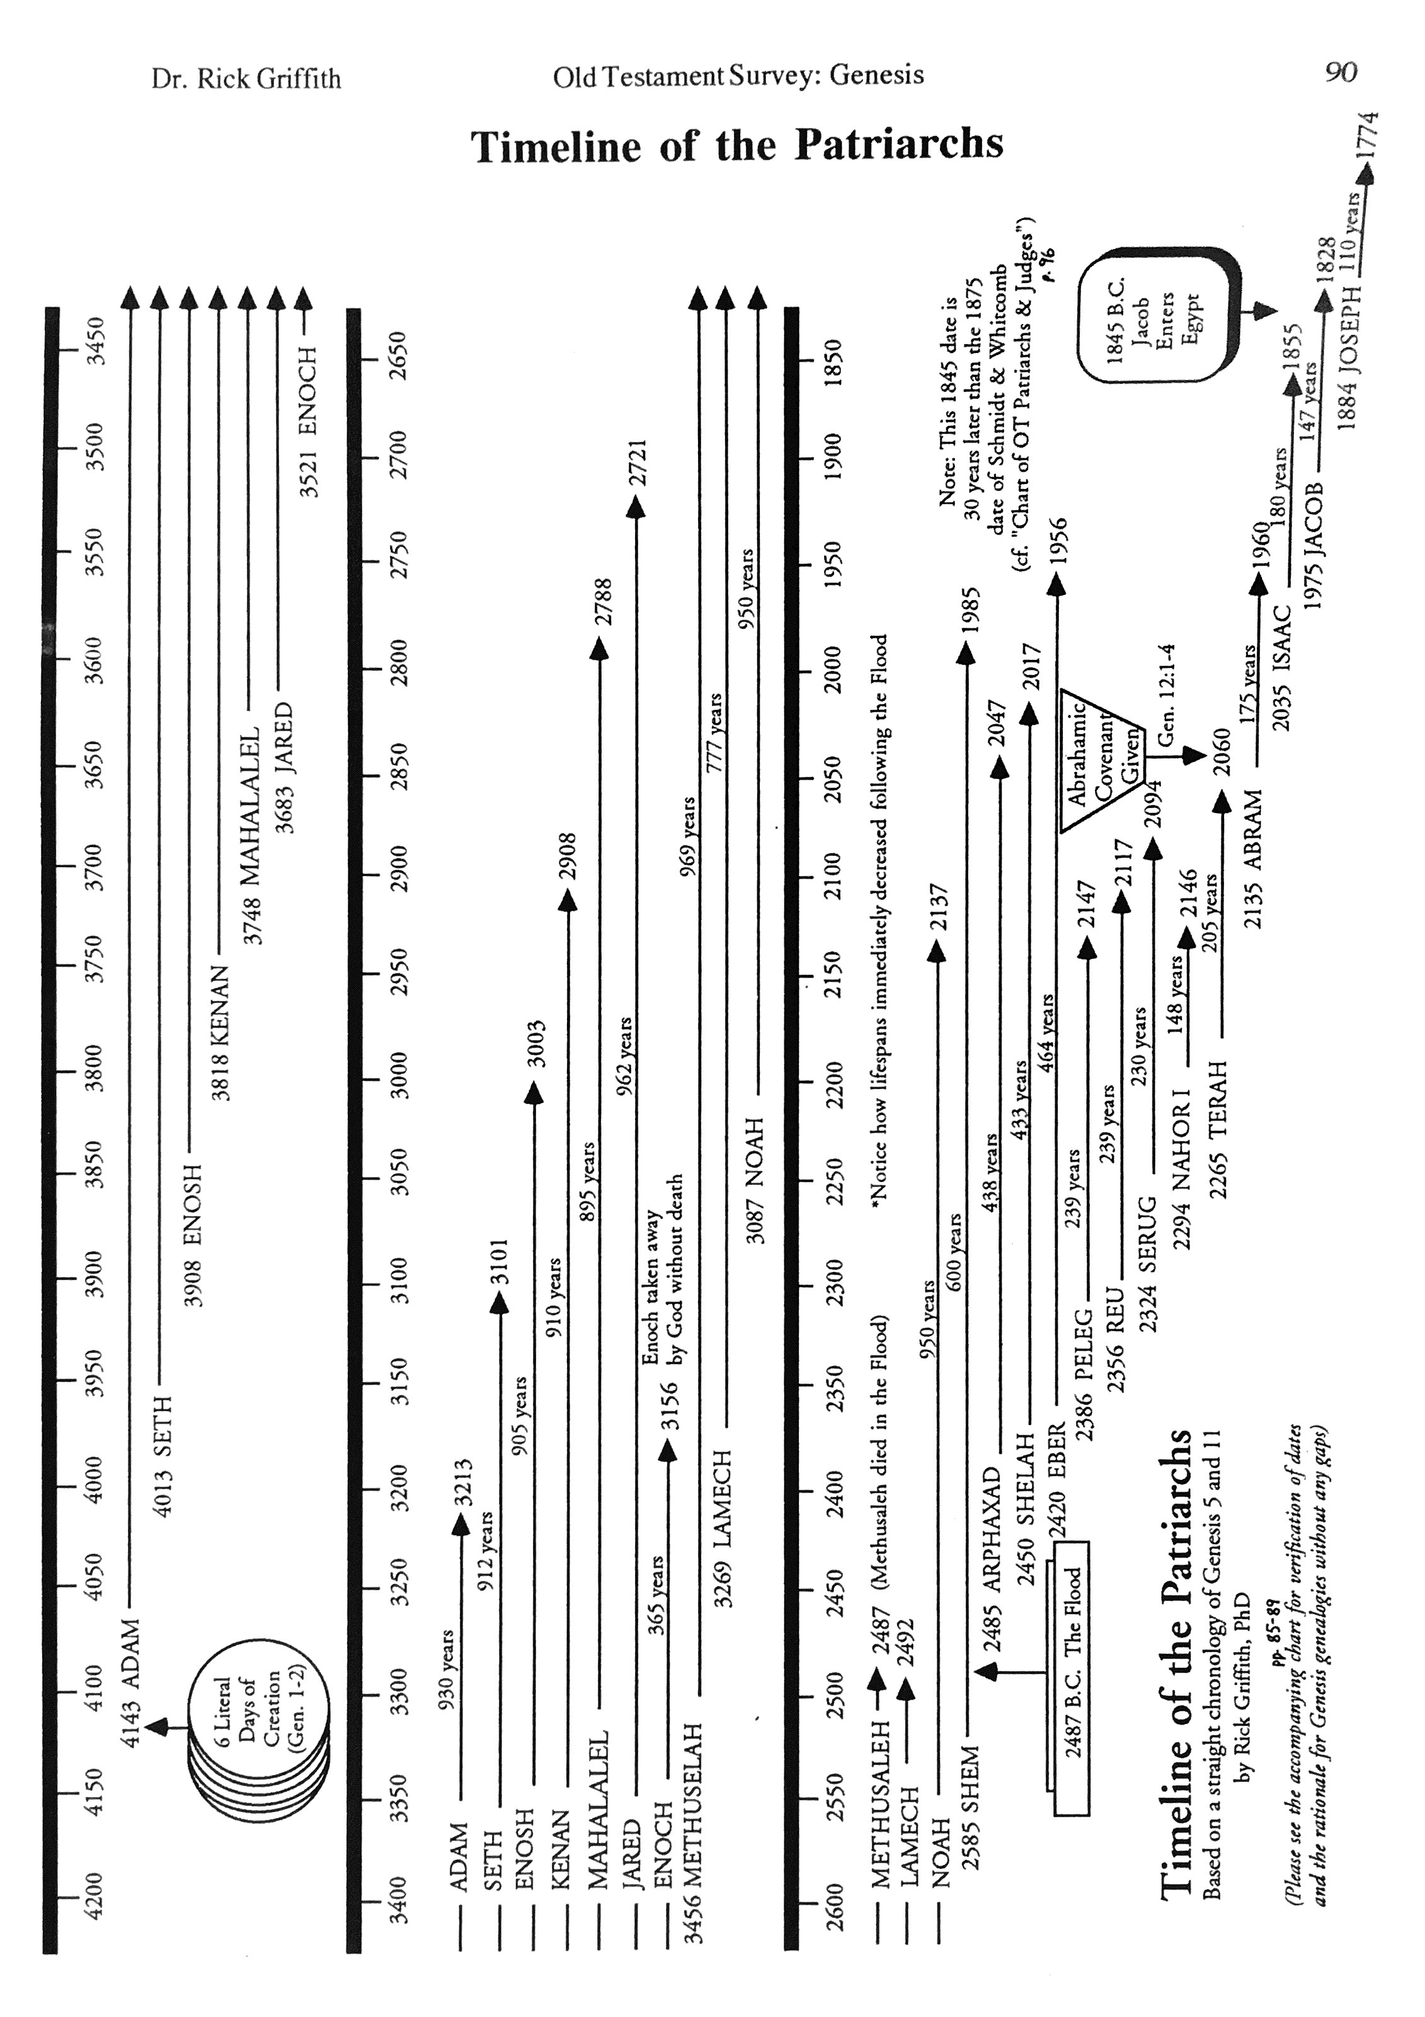

Bill Cooper, After the Flood (Chichester, England: New Wine Press, 1995), 36-39, 121-29.
This 4143 BC date is very close to the 4199 BC ± 25 years date of J. Paul Tanner, “Old Testament Chronology and Its Implications for the Creation and Flood Accounts,” Bibliotheca Sacra 172, no. 1 (2015): 24-44.
The plus (+) means Genesis 5:32 says Noah's three sons were born after he was 500 years old but does not specify the time of Ham and Japheth's births. Since Methuselah was born in 687 AH (see 5:21 above) and lived 969 years (5:27), the 687 + 969 = 1656 AH. Methuselah did not survive the Flood and the above chronology verifies it as it shows him dying the same year. Since Shem was 98 years old at the end of the Flood (Gen 11:10), the 1656 AH Flood date minus 98 years gives 1558 AH as the probable date of Shem's birth as the oldest son. But this timing assumes Shem as the oldest brother, whereas Genesis 10:21 may indicate either Shem (NET, NLT, NAU) or Japheth (KJV, NIV84) as the eldest. Japheth as eldest fits with Noah being 600 at the Flood start (Gen 7:6) but becoming a father at age 500 (Gen 5:32), so this 100 years shows him becoming a father of Japheth first and Shem two years later.
Obviously, this Nahor is a different Nahor than his grandfather by the same name, so I have called him Nahor II.
The text does not tell the time of the births of Abram, Nahor and Haran. However, Haran had a son (Lot) even before Abram and Nahor were married (11:27-28), so he was the oldest son and was born when Terah was 70 years old.
Since Nahor was the middle son he must have been born between Haran (1948 AH) and Abram (2008 AH).
Abram was 75 years old when he set out from Haran (2083 AH or 2060 BC; 12:4), which was immediately after Terah's death (Gen. 11:32; Acts 7:4), probably in the same year. Therefore, his birth 75 years earlier would have been 2008 AH or 2135 BC (2083 - 75 = 2008, or 2060 + 75 = 2135). This is true whether Abram was the oldest son or not.
The logic for Jacob's age of 77 when he fled to Laban at Paddan Aram is such: "Joseph stood before Pharaoh, aged 30 (41:46). At the end of 7 years' of plenty Joseph was 37 (41:29-30). At the end of 2 years' famine, when Jacob came down into Egypt, Joseph was 39 (45:6). At the end of 2 years' famine, when Jacob came down into Egypt, Jacob was 130 (47:9). Therefore Jacob was 130 when Joseph was 39. Therefore Jacob was 91 when Joseph was born. Jacob had served Laban 14 years when Joseph was born (29:30; 30:25-26). Therefore Jacob was 91 - 14 = 77 when he left home for Paddan Aram" (Martin Anstey, The Romance of Bible Chronology: An Exposition of the Meaning, and a Demonstration of the Truth, of Every Chronological Statement Contained in the Hebrew Text of the Old Testament, 2 vols. [London, Edinburgh, and New York: Marshall Bros., 1913], 1:115); cited by Hoehner, 2).
Harold W. Hoehner, "The Duration of the Egyptian Bondage," Bibliotheca Sacra 126 (October-December 1969): 306-16). Note that many evangelical OT scholars believe that Jacob's family entered Egypt in 1875 BC (see these notes, 96, 108) since this is 430 years before the Exodus in 1445. In contrast, Hoehner's chronology followed here follows the LXX and Samaritan Pentateuch reading of Exodus 12:40 which cites the 430 years as applying to the time the Israelites lived in "Egypt and Canaan." This is preferred since they were not called Israelites until Jacob's name was changed to Israel in 1875. "The commencement of their sojourning would have been the last confirmation of the Abrahamic covenant as given in Genesis 35:9-15, if one notices that from Genesis 35 onwards the children of Israel never remained in one place in Canaan but were always travelling (cf. Gen 35:16,21,27; in 37:1 they dwelt in the land of Canaan with no specific location mentioned)… Therefore, it seems that if one will take the 430 years as the period from the last recorded confirmation of the Abrahamic covenant to Israel (Jacob) before going into Egypt (Gen 35:9-15) until the time of the Exodus, the 400 years would be that period of time when the nation Israel was in Egypt, that is, from the time when Jacob and his family entered Egypt (Gen 46) until the Exodus. The phrase 'about 450 years' (Acts 13:19-20) would consist of the 400 years of bondage plus the 40 years of wilderness wanderings plus the 7 years for conquering the land of Palestine which makes a total of 447 years or ‘about 450 years’" (ibid., 315, 316).
Ibid., 316.
This 1845 BC date is actually the starting point of the BC dates on page 85. The year 1845 BC has been determined as the year Jacob entered Egypt (400 years before the early date for the Exodus in 1445 BC). The dates between Abram’s birth and 1845 BC are adapted from Harold W. Hoehner, "From the Birth of Abram to the Death of Joseph" (class handout in Th.D. course "Bible Chronology," Dallas Theological Seminary, June 1988, 3 pp.). We know from 1 Kings 6:1 that the Exodus occurred in 1445 (or many say 1446) BC because it happened 480 years after Solomon began building the temple in 966 BC. Thus, 966 + 480 = 1446/1445 inclusive.

