Crossroads International Church Singapore Dr. Rick Griffith
Title
16 Feb 2020 Message 66 of 66
NLT 60 Minutes
Be Triumphant
Book of Revelation

Topic: Victory
Subject: Jesus rules the world
Complement: so he can handle your puny problem.
Purpose: The listeners will trust Jesus as the Victor to triumph over suffering or compromise.
Attribute: We worship the God of Victory
Reading: Rev 1:1-3
Songs: Is He Worthy (Peterson), There is a Higher Throne (Getty), Crown Him (Tomlin), Sovereign (Tomlin), The Revelation Song (Jennie Lee Riddle)
Benediction: Rev 22:20-21

Introduction

Interest: Many Christians have defeated lives—they experience more setbacks than victories.
Look Down

Need: What about you? Are you “on top of it”? Are you looking up?
• Areas
Look Up

Family

What causes you to look down—Transition? Finances? Physical ailments? Relational issues? Coronavirus? These are such perilous times with the coronavirus that we don’t even know if it will be legal to meet next Sunday.
Corona

My step-father (my Mom’s husband for 47 years) is close to death, so I am heading back to the USA for ten days this week so I can share the gospel with him one last time. He is supposed to turn 90 next month but Mom fears he will not make it.

How can you look up to the LORD during your struggle?.

Subject: In light of all that we face… How can we be triumphant in Christ? What do we need to grasp about Jesus for victory?
Subject

Background: [The book of Revelation reveals Jesus as the real King.]

We will find our answer in the last book of the Bible. The name is “Revelation.” But what does it reveal?
Revelation

We typically think the prophecy primarily reveals the future—as if it is only supposed to satisfy our curiosity of what is to come.
Movie
1:1
Look Up
To Sovereign

Yet the first verse say it is “the revelation of Jesus Christ.”

How? Revelation tells us to look up to… the sovereignty of Jesus Christ.

The book of Revelation reveals Jesus as the real King.

Muslims have even begun to depict Jesus in movies—but this is a Jesus that I cannot recognize.
Muslim

My first “Jesus” as a young believer in 1970s was cool—some called him “surfer Jesus.”
Surfer

But then Jesus became wimpy—holding lambs, kissing babies, becoming more effeminate and basically a flower sniffing Jesus.
Real King
Caveman

Flower
Domitian
(2 slides)
Internal
• External
Theme
(2 slides)
Chart
MP
Patmos
(5 slides)
Triune
(3 slides)
Glorified
(9 slides)
Ephesus
(3 slides)
Smyrna
(3 slides)
Pergamum
(2 slides)
Thyatira
(4 slides)
Sardis
(3 slides)
Philly
(3 slides)
Wimp
Laodicea
(4 slides)

More recently archaeologists tried to show what he looked like from skeletal remains of other first-century men—so he became like a caveman.

So who is the real King? Jesus is.

Revelation addressed seven Asian churches during Domitian’s rule who had two basic struggles.

Internal struggles plagued the churches.

External persecution from Rome attacked them also.

Preview: The theme of the book is the sovereignty of Christ in Future Victory, so today we will see three truths we need to grasp about Jesus for victory in our lives. You will see my depiction of these three realities on the back of your sermon notes.

Text: I will survey the whole book of Revelation.
Rev 1
(What is the first truth we need to grasp about Jesus for victory over persecution and compromise? To be triumphant, we need to take hold of the reality that…)

I. Jesus rules over death (Rev 1).
[Christ is sovereign over our ultimate enemy that no one else has defeated.]

Jesus reveals the future and promises to bless all who read and obey the prophecy (1:1-3).

We should worship the Triune God because the Risen Ruler will soon return (1:4-8).

Seeing Christ glorified shows He can solve your problems (1:9-20).
Death

(So Jesus rules over our greatest enemy, death [Rev 1]. But what is the second truth we need to grasp about Jesus for victory over persecution and compromise? To be triumphant, we also must take hold of the reality that…)
• MP

II. Jesus rules over churches (Rev 2–3).
Rev 2
(5 slides)
[Christ is the boss over the seven Asian churches and every local church.]

Ephesus was Busy Yet Backsliding so they needed to rekindle their love for Christ (2:1-7).

Smyrna was Suffering Yet Steadfast so Christ encouraged them in their suffering (2:8-11).

Pergamum was Continuing Yet Compromising so they needed to reject heresy (2:12-17).

Thyatira was Involved Yet Immoral so must repent of immorality (2:18-29).

Sardis was Distinguished Yet Dead so they needed to renew their obedience (3:1-6).

Philadelphia was Mistreated Yet Missions-Minded so Jesus urged perseverance (3:7-13).

Laodicea was Luxurious Yet Lukewarm, so Lordship must replace materialism (3:14-22).

(So Jesus rules over both death (Rev 1) and all churches (Rev 2–3). But what is the third and final truth we need to grasp about Jesus for victory over persecution and compromise? To be triumphant, we also must take hold of the reality that…)
Outline
• MP
Rev 4
(2 slides)
Rev 5
(5 slides)
Rev 6-7
(6 slides)
Rev 8-18
(27 slides)
Rev 19
(3 slides)
Rev 20
(4 slides)
Submit
(3 slides)
Throne
(3 slides)
Rev 21
(5 slides)
Rev 22
(3 slides)
Main Idea
MPS
• Death
• Churches
• Future
APP
• Pre
• Christian
Prayer

III. Jesus rules over our future (Rev 4–22).
[Christ is both Judge and Saviour of the End Times and our Eternal State.]

The 7-year Tribulation will show Christ as worthy to judge the world (4:1–19:10).

The Tribulation’s first half shows Christ over Antichrist in a peaceful era (4:1–8:5).
    - The Tribulation’s second half (Great Tribulation) shows Christ over all (8:6–19:10).

Christ’s Second Coming reassures suffering believers that he is Ultimate Victor (19:11-21).

The Millennium will show Christ's rule over the earth, Satan, and death itself (Rev 20).

Satan will be bound and believers ruling with Christ on earth for 1000 years (20:1-6).

Satan will be tormented in the lake of burning sulfur after his defeat by Christ (20:7-10).

The Great White Throne Judgment will reveal Christ as victor over death (20:11-15).

The Eternal State will show the wonderful future of victors with Christ (21:1–22:6).

Jesus will live with us in the New Jerusalem so live for him and long for his return (22:7-21).
Subject
(Let’s return to our first question: How can we be triumphant in Christ? What do we need to grasp about Jesus for victory?)

Conclusion

Jesus rules the world! So he can handle your puny problem (Main Idea).

Main Points: What do we need to grasp about Jesus for victory?

Jesus rules over death (Rev 1).

Jesus rules over churches (Rev 2–3).

Jesus rules over our future (Rev 4–22).

Application: Jesus rules the world, so…

For Pre-Christians: Have you submitted to Christ’s rule over you?

For Christians: What issue do you need to entrust to Jesus today?

Prayer

Preliminary Questions

Verses Questions

Context: What did the author record just prior to this passage?

Here we find the culmination of all Scripture, so it actually looks back at every other biblical book.

Chronologically speaking, it is most likely that John’s three epistles preceded Revelation.

Purpose: Why is this passage in the Bible?

Many times it looks as if Christians are on the losing team—especially when persecuted externally and compromising internally within our churches.

God knows that we need the encouragement that comes from seeing our present situations in light of our victorious end so that we can be triumphant now in light of Christ as the world’s victor.

Background: What historical context helps us understand this passage?

Domitian was the emperor on the throne in Rome and he declared himself to be God. But Christians could not participate in emperor worship. The result was severe persecution from Rome where Christian villages were simply wiped out, believers thrown to the lions in the Coliseum, and other atrocities committed.

To make matters worse, many of the churches of Asia compromised within with immorality, greed, and false teaching.

Questions

Which interpretive view on Revelation is correct?

How can we apply today this book that speaks mostly of the future?

Tentative Main Ideas

Jesus wins!

Illustrations That Apply

The coronavirus is but a small picture of the plagues to come.

New Testament Survey Notes

Revelation

Introduction

Title

The Greek title for “Revelation” ( vApoka,luyij vIwa,nnou Apocalypse of John) means “disclosure” (BDAG 92), being the noun form of the verb avpokalu,ptw, to “uncover, reveal” (BDAG 92).

What does Revelation reveal? Christians normally think this book primarily reveals the future as if the goal is to satisfy our curiosity about what lies ahead.

However, the title notes that the book unveils the person, power, and program of Jesus Christ (1:1). How should we translate the genitive avpoka,luyij VIhsou/ Cristou/?

Most translations render 1:1 as “the revelation of Jesus Christ” in the sense of revealing who he is (KJV, NIV, NAU, NET). This is the normal meaning of this phrase and is preferred.

However, other translations read “the revelation from Jesus Christ” (NLT) to show that Jesus gave the vision. While this is true, it is not the usual meaning of the Greek text.

Authorship

External Evidence

Earliest Witnesses: Nearly all true believers since the first century have held that the Apostle John wrote Revelation. These include earliest witnesses such as Justin Martyr in Ephesus (Dialogue 81; ca. AD 130) and Irenaeus in Gaul (Against Heresies; ca. AD 185). Also citing Johannine authorship were Tertullian, Hippolytus, Clement of Alexandria, and Origen (Walvoord, The Revelation of Jesus Christ, 11-14; Guthrie, 934-35).

Opposition: However, some have taught that the author was not the Apostle John. Dionysius of Alexandria (ca. AD 264) questioned his authorship based upon linguistic, stylistic, and theological differences between Revelation and John’s Gospel (Guthrie, 935-36). Eusebius (Hist. Eccl. 3.39.4) affirmed in the fourth century that the author was a certain John the Elder. During the Reformation in the 1500s, Erasmus, Luther, and Zwingli denied Johannine authorship because Revelation teaches a literal 1000-year reign of Christ (Walvoord, BKC, 2:925). R. H. Charles also proposed a John the Prophet. One modern scholar even suggests that John the Baptist authored the book (J. Massyngberde Ford, Revelation, The Anchor Bible, 28-37).

Response: Nearly all of the early Church Fathers held to John's authorship. They saw differences between the Apocalypse and John’s Gospel as negligible and also believed in a literal millennium. Since they were closest to the time of the apostles and their statements make good sense, it seems arbitrary to abandon their witness that the writer was John, apostle of Jesus Christ and author of the Gospel of John and 1-3 John.

Internal Evidence

The author simply says he is John (1:1, 4, 9; 22:8), servant of Jesus Christ (1:1). The lack of further qualification shows that he maintains great authority typical of the apostle.

Many characteristics of the book suggest this is the Apostle John, the brother of James and son of Zebedee (Guthrie, 936-40):

He knows details of the history of the churches of Asia Minor (Rev 2–3).

Most apocalyptic works named honored ancient man (e.g., Enoch, Ezra), but John prophesies in his own name conscious of divine inspiration (1:1, 11, 19; 10:10; 12:6-9).

Like the Synoptics (Mark 3:17), Revelation depicts John as of a stormy disposition as a “son of thunder” who would call Jews worshippers of Satan (2:9; 3:9).

Common ideas (e.g., use of contrast), theology, and terminology (e.g., logos in John 1:1; Rev 19:13) exist between the Gospel of John and Revelation.

Circumstances

Date

The traditional view dates the book about AD 95 during the reign of the Roman Emperor Domitian (AD 81-96). John was banished to the small island of Patmos about seventy miles (112 km.) southwest of Ephesus in the Aegean Sea (1:9) and the earliest and weightiest evidence attests to this date in Irenaeus (Against Heresies 5.30.3; cf. Victorinus of Pettau, Apocalypse 10.11 (AD 304); Clement of Alexandria, Quis Dives Salvetur 42; Eusebius, Historia Ecclesiastica 3.17–18 [AD 260–340]). Other arguments in favor of this view are the imperial persecutions for refusing Emperor worship (the Beast in 13:4, 15f.; 14:9-11; 15:2; 16:2; 19:20; 20:4) and the spiritual decline in the churches that would have been more likely in the AD 90s than earlier.

However, dates late in Nero’s reign (AD 66-68) or during the reign of Vespasian (AD 69-79) have also been proposed, but with little evidence (Guthrie, 958-61). Also, the early church father Papias stated that John was martyred with his brother James in AD 44 (Acts 12:1; Walvoord, BKC, 2:925; Guthrie, 945). However, the stronger tradition argues that he lived to a ripe old age at Ephesus, which also better fits the data in the book of Revelation.

Preterists have theorized that the prophecy must have been written before AD 70 since 11:1-2 commands the measuring of the temple. However, this text refers to a literal future temple during the Tribulation. Also, the seventh bowl (16:17–21) does not picture “the great city” as entirely destroyed until after John’s time, so it looked to a future destruction. See the evaluation of the Preterist view in Appendix B (pp. 474-484).

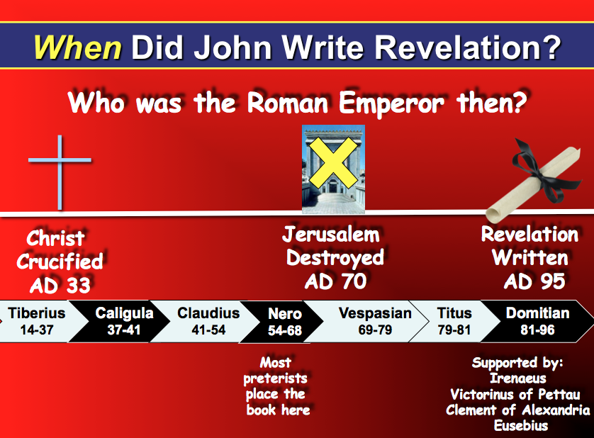

Recipients

The immediate destination of the prophecy is the seven churches of the Roman province of Asia (1:4, 11; Rev 2–3): Ephesus, Smyrna, Pergamum, Thyatira, Sardis, Philadelphia, and Laodicea. John was deemed to be the leader of this region with its capital at Ephesus.

However, the reoccurring phrase “hear what the Spirit says to the churches” (plural) indicates that these churches only represented a much wider Christian audience. This is supported by the fact that the seven churches were neither the only ones in the province nor the largest, as the small towns of Thyatira and Philadelphia could not compare in civic importance with Troas (Acts 20:7f.), Hierapolis and Colossae (Col. 2:1; 4:13, 16). W. M. Ramsay in The Letters to the Seven Churches (written in 1904, 468 pp.) discovered that a circular road connected the seven historical churches in the exact order they appear in chapters 2–3. This remains the best explanation why they were chosen as the means to distribute the prophecy to all the churches.

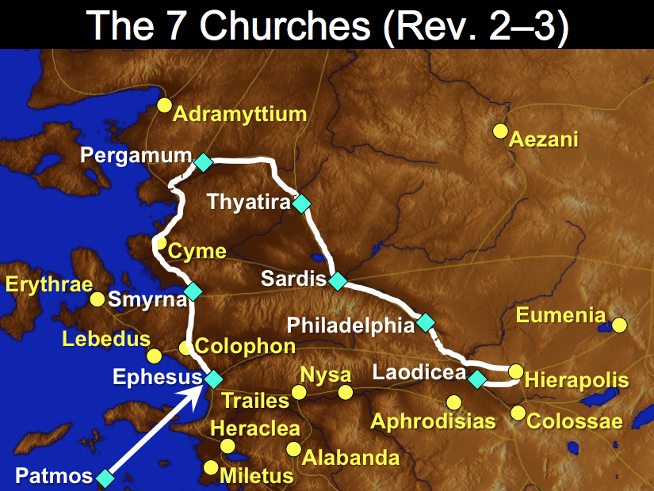

Occasion

Later first century churches had both internal and external problems:

Internal Struggles: Many churches compromised at the end of the first century. Ephesus didn’t love Christ (2:4), Pergamum tolerated heresy (2:14-15), Thyatira was immoral (2:21-24), Sardis was dead (3:1), and Laodicea was lukewarm (3:15-17).

External Persecution: These churches also endured severe testing from the Roman government (1:9; 2:9-10; 3:10). Tradition notes that John himself was boiled in oil but lived through it.

Therefore, John wrote a message of hope describing the ultimate victory of Christ to counteract compromise from within and to encourage perseverance in the midst of hostility from without. As readers see the final future triumph of Christ over evil they can gain confidence for the present.

Characteristics

Revelation is the climax of biblical revelation, completing the many prophecies of both testaments and providing numerous prophecies of its own. It closes all prophecy by warning like no other NT book not to add or subtract from it (22:18-19; cf. Deut. 4:2; Prov. 30:6; Gal. 3:15).

Revelation is the only NT book that deals primarily with the future. Without it, eschatology would lack its clearest descriptions of these events: the Tribulation (Rev 6–18), the second coming of Christ (19:11-21), Satan’s binding and the length of the kingdom as 1000 years (20:1-6), and the great white throne judgment (20:11-15). John continually saw glimpses of the future. In fact, the exact verbal form “I saw” appears 45 times (1:12, 17; 4:1, etc.)!

The book contains more symbolic language than any inspired writing. But why is this? Warren Wiersbe provides three advantages to symbolic language (Bible Exposition Commentary):

- Symbols are a “spiritual code” to hide the truth from the unbelieving (cf. parables)
- Symbolism is not weakened by time
- Symbols not only convey information, but also impart values and arouse emotions

Revelation is the only apocalyptic writing in the New Testament. Apocalyptic literature is characterized by secrecy, pessimism, end times emphases, warnings (not repentance), the triumph of God, determinism (God’s control comforting people), etc.

This book contains more allusions to the OT (250-550 allusions) than any NT writing. Ironically, Revelation also has very few quotes (1:7 quotes Zech. 12:10; 2:27 quotes Ps. 2:9).

Chapters 2–3 record the only letters written by Christ that have been saved for us. This book also is the only NT writing with separate letters for various churches.

This prophecy completes our scriptural understanding about Jesus Christ by including more about his glory than even the Gospels!

Here is the only NT book written in response to a direct command from God (1:10-11, 19). In all other NT writings, the Spirit prompted individuals to write rather than directly telling them.

Only Revelation was revealed in nearly its entirety as a vision by an angel (1:1). It was also shown to John on a single day—likely a Sunday if “the Lord’s day” denotes Sunday (1:10).

Revelation has more songs than any NT book. Angels break into worship 14 times, making the book a model for worship. It especially parallels Ezekiel in its worship (see next page).

Synthesis

Sovereignty of Christ in future victory

1 Sovereign over death
1:1-3 Subject
1:4-8 Worship of Trinity
1:9-20 Glorified Christ

2–3 Sovereign over churches
2:1-7 Ephesus (Busy yet Backslidden)
2:8-11 Smyrna (Suffering yet Steadfast)
2:12-17 Pergamum (Continuing yet Compromising)
2:18-29 Thyatira (Involved yet Immoral)
3:1-6 Sardis (Distinguished yet Dead)
3:7-13 Philadelphia (Mistreated yet Missions-Minded)
3:14-22 Laodicea (Luxurious yet Lukewarm)

4–22 Sovereign over end-time events
4:1–19:10 Tribulation
4:1–8:5 First half
4–5 Christ's heavenly position
4 Throne
5 Scroll
6:1–8:5 Seals
6 #1-6
7 (Saved Jews/Gentiles) () = Parenthetical information where
8:1-5 #7 the chronology is not carried forward
8:6–19:10 Second half
8:6–11:19 Trumpets
8:6–9:21 #1-6
10:1–11:14 (Saved protected/unsaved judged, 2 witnesses)
11:15-19 #7
12–14 (Satan's activity, etc.)
12–13 Satan/agents
14 144,000 triumph
15–16 Bowls #1-7
17:1–19:10 (Babylon’s destruction)
19:11-21 Second Coming
20 Millennium, Satan's Doom, Great White Throne
21:1–22:5 Eternal State
22:6-21 Conclusion: coming imminent

Be Triumphant
Revelation

Exegetical Outline (Steps 2-3)

Exegetical Idea: The way to triumph over internal compromise and external opposition is to trust the sovereignty of Jesus Christ in his ultimate future triumph.

I. The way to triumph over internal compromise and external opposition is to trust the sovereignty of Jesus Christ over death (Rev 1).

John's prologue shows that the divinely given prophecy unveils Jesus Christ’s sovereignty and promises a blessing on those who obey it (1:1-3).

John addresses seven churches in Asia and worships the triune God, especially Christ as the soon-to-come sovereign Ruler, to exhort his readers to watch for his return (1:4-8).

The glorified Jesus Christ shows his ability to handle the Church's internal and external problems and reveals the threefold outline of the book (1:9-20).

II. The way seven Asian churches can triumph over internal compromise and external opposition is to trust the sovereignty of Jesus Christ (Rev 2–3).

Busy Yet Backsliding—Apostolic Age: Christ praises Ephesian believers for their service and diligence in God's truth and exhorts them to rekindle their love for Christ (2:1-7).

Suffering Yet Steadfast: AD 100-313 when Constantine made Christianity the official religion of the Roman Empire: Christ praises Smyrna for their suffering and exhorts courage (2:8-11).

Continuing Yet Compromising—AD 313-Pre-Middle Ages: Christ praises Pergamum believers for their faithfulness despite satanic attack and exhorts them to reject heresy (2:12-17).

Involved Yet Immoral—Middle Ages: Christ commends some Thyatira believers as properly motivated and persevering to exhort the others to repent of immorality (2:18-29).

Distinguished Yet Dead—Catholics in the Reformation-late 1700's: Christ commends Sardis believers for their good deeds to renew them to obey what they had been taught (3:1-6).

Mistreated Yet Missions-Minded—Modern Missionary Era (1795-1900s]: Christ praises Philadelphia’s evangelism despite opposition and urges perseverance (3:7-13).

Luxurious Yet Lukewarm—Modern Materialistic Church: Christ criticizes Laodicean believers so they will repent of their materialistic selfishness and embrace Christ's Lordship (3:14-22).

III. The way to triumph over internal compromise and external opposition is to trust the sovereignty of Jesus Christ in his future end-time victory (Rev 4–22).

Prophecies of the seven-year Tribulation emphasize the second half (the Great Tribulation) and show Christ’s sovereignty as worthy to judge the world (4:1–19:10).

The first half of the Tribulation depicts Christ's sovereignty over Antichrist during this relatively peaceful period (4:1–8:5).
    - The second half of the Tribulation (Great Tribulation) in trumpet and bowl judgments shows Christ's sovereignty over the entire earth, its religions, and its political powers (8:6–19:10).

Christ’s Second Coming encourages believers under persecution that Christ will be Ultimate Victor (19:11-21).

The Millennium will show Christ's sovereignty as Ultimate Victor over the earth, Satan, and death itself (Rev 20).

The Millennium will fulfill many OT prophecies with Satan bound and believers ruling with Christ on earth for 1000 years (20:1-6).

Satan's torment in the lake of burning sulfur after his defeat by Christ at the Battle with Gog and Magog will show Christ's victory over his long-time enemy (20:7-10).

The Great White Throne Judgment shows God's just vengeance on all who opposed him and his victory over the last enemy, death (20:11-15).

Prophecies of the Eternal State show the wonderful future of victors with Christ because he defeats the forces of evil (21:1–22:6).

The reason God shows himself living with us in our eternal home in the New Jerusalem is to live for him in light of the imminent return of Christ (22:7-21).

Purpose or Desired Listener Response (Step 4)
The listeners will trust Jesus as the Victor to triumph over their suffering or compromises.

Homiletical Outline (Cyclical inductive form)

Introduction

Interest: Many Christians have defeated lives—they experience more setbacks than victories.

Need: What about you? Are you “on top of it”? Are you looking up?

Subject: In light of all that we face… How can we be triumphant in Christ? What do we need to grasp about Jesus for victory?

Background: The book of Revelation reveals Jesus as the real King.

Preview: The theme of the book is the sovereignty of Christ in Future Victory, so today we will see three truths we need to grasp about Jesus for victory in our lives.

Text: I will survey the whole book of Revelation.

(What is the first truth we need to grasp about Jesus for victory over persecution and compromise? To be triumphant, we need to take hold of the reality that…)

I. Jesus rules over death (Rev 1).

Jesus reveals the future and promises to bless all who read and obey the prophecy (1:1-3).

We should worship the Triune God because the Risen Ruler will soon return (1:4-8).

Seeing Christ glorified shows He can solve your problems (1:9-20).

(So Jesus rules over our greatest enemy, death [Rev 1]. But what is the second truth we need to grasp about Jesus for victory over persecution and compromise? To be triumphant, we also must take hold of the reality that…)

II. Jesus rules over churches (Rev 2–3).

Ephesus was Busy Yet Backsliding so they needed to rekindle their love for Christ (2:1-7).

Smyrna was Suffering Yet Steadfast so Christ encouraged them in their suffering (2:8-11).

Pergamum was Continuing Yet Compromising so they needed to reject heresy (2:12-17).

Thyatira was Involved Yet Immoral so must repent of immorality (2:18-29).

Sardis was Distinguished Yet Dead so they needed to renew their obedience (3:1-6).

Philadelphia was Mistreated Yet Missions-Minded so Jesus urged perseverance (3:7-13).

Laodicea was Luxurious Yet Lukewarm, so Lordship must replace materialism (3:14-22).

(So Jesus rules over both death (Rev 1) and all churches (Rev 2–3). But what is the third and final truth we need to grasp about Jesus for victory over persecution and compromise? To be triumphant, we also must take hold of the reality that…)

III. Jesus rules over our future (Rev 4–22).

The 7-year Tribulation will show Christ as worthy to judge the world (4:1–19:10).

The Tribulation’s first half shows Christ over Antichrist in a peaceful era (4:1–8:5).
    - The Tribulation’s second half (Great Tribulation) shows Christ over all (8:6–19:10).

Christ’s Second Coming reassures suffering believers that he is Ultimate Victor (19:11-21).

The Millennium will show Christ's rule over the earth, Satan, and death itself (Rev 20).

Satan will be bound and believers ruling with Christ on earth for 1000 years (20:1-6).

Satan will be tormented in the lake of burning sulfur after his defeat by Christ (20:7-10).

The Great White Throne Judgment will reveal Christ as victor over death (20:11-15).

The Eternal State will show the wonderful future of victors with Christ (21:1–22:6).

Jesus will live with us in the New Jerusalem so live for him and long for his return (22:7-21).

(Let’s return to our first question: How can we be triumphant in Christ? What do we need to grasp about Jesus for victory?)

Conclusion

Jesus rules the world! So he can handle your puny problem (Main Idea).

Main Points: What do we need to grasp about Jesus for victory?

Application: Jesus rules the world, so…

For Pre-Christians: Have you submitted to Christ’s rule over you?

For Christians: What issue do you need to entrust to Jesus today?

Prayer

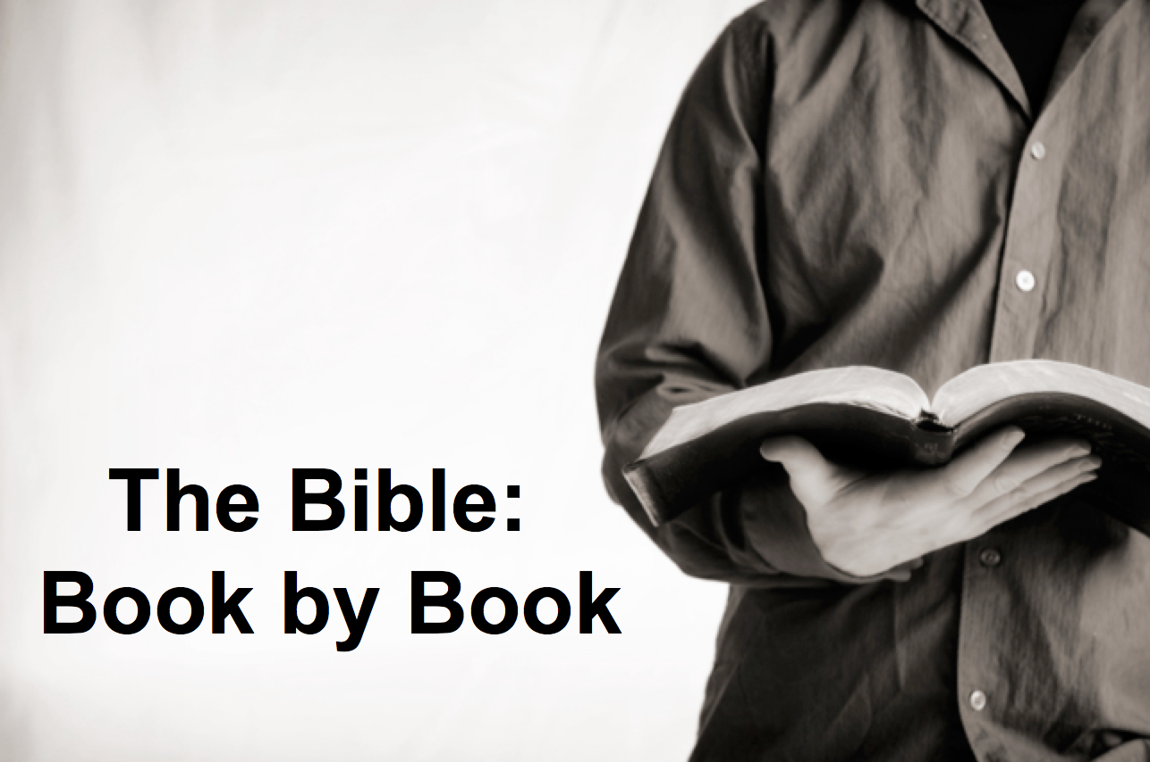

Rick Griffith
16 Feb 2020
Message 66 of 66

Be Triumphant
Revelation

Introduction

Are you “on top of it”? Are you looking up?

How can we be _________________ in Christ? What do we need to grasp about Jesus for victory?

I. Jesus rules over ______________ (Rev 1).

II. Jesus rules over ___________________ (Rev 2–3).

Ephesus was Busy Yet Backsliding so they needed to rekindle their love for Christ (2:1-7).

Smyrna was Suffering Yet Steadfast so Christ encouraged them in their suffering (2:8-11).

Pergamum was Continuing Yet Compromising so they needed to reject heresy (2:12-17).

Thyatira was Involved Yet Immoral so must repent of immorality (2:18-29).

Sardis was Distinguished Yet Dead so they needed to renew their obedience (3:1-6).

Philadelphia was Mistreated Yet Missions-Minded so Jesus urged perseverance (3:7-13).

Laodicea was Luxurious Yet Lukewarm, so Lordship must replace materialism (3:14-22).

III. Jesus rules over __________________________ (Rev 4–22).

The 7-year Tribulation will show Christ as worthy to judge the world (4:1–19:10).

Christ’s Second Coming reassures suffering believers that he is Ultimate Victor (19:11-21).

The Millennium will show Christ's rule over the earth, Satan, and death itself (Rev 20).

The Eternal State will show the wonderful future of victors with Christ (21:1–22:6).

Jesus will live with us in the New Jerusalem so live for him and long for his return (22:7-21).

Conclusion

Jesus ________________ the world! So he can handle your puny problem (Main Idea).

For Pre-Christians: Have you submitted to Christ’s rule over you?

For Christians: What issue do you need to entrust to Jesus today?

Download this sermon PPT and notes for free at BibleStudyDownloads.org/resource/new-testament-preaching/
Listen to this message online at cicfamily.com/sermon-listing/
Revelation

Sovereignty of Christ in Future Victory

Sovereignty  in His Person |  |  | Sovereignty  over Churches | Sovereignty  in End-Time Events
Chapter 1 |  |  | Chapters 2–3 | Chapters 4–22
“What you have seen” (1:19a) |  |  | “What is now”  (1:19b) | “What will take place later”  (1:19c)
Past |  |  | Present | Future
Christ Unveiled |  |  | Churches Unveiled | Consummation Unveiled
God  on Earth |  |  | God’s Ambassadors  on Earth | Hell on Earth to  Heaven on Earth
The Judge |  |  | The Assignments | The Judgments & Rewards
Subject  1:1-3 | Worship of Trinity  1:4-8 | Glorified Christ  1:9-20 | Seven Churches of Asia:  Ephesus  Smyrna  Pergamum  Thyatira  Sardis  Philadelphia  Laodicea | Tribulation  4:1–19:10 | Second Coming  19:11-21 | Millennium  20 | Eternal State  21:1–22:5 | Closing: Imminency  22:6-21
Island of Patmos (c. AD 95)

Key Word: Triumph

Key Verse: “Write, therefore, what you have seen, what is now, and what will take place later” (Revelation 1:19).

Summary Statement: The way to triumph over internal compromise and external opposition is to trust the sovereignty of Jesus Christ in his ultimate future victory.

Application: Does your life show that you’re on the winning team? Do your goals, values, and disposition show that you represent the Victor of the World?

