Grace Fellowship Church (21 Sept 1986)/ UBTC, Mongolia (10 June 2016) Rick Griffith
Crossroads Intl Church Singapore (26 June 2016 & Monologue 7 Apr 2019) 40 Minutes
Title
Be Forgiving
Paul's Letter to Philemon

Topic: Forgiveness
Subject: How to forgive those who offend us
Complement: We can forgive others when we see how God has forgiven us
Purpose: The listeners will forgive others
Attribute: We worship the God of forgiveness
Reading: Philemon 1-25
Closing: Forgiveness Video: https://www.youtube.com/watch?v=FG6cv64fzCc
Benediction: Philemon 25

Introduction
Corrie ten Boom
1. Corrie ten Boom was a Dutch believer famous for her courageous efforts to help Jews escape the Nazi persecutions during World War II. She hid them in “The Hiding Place” in her home until they could be secretly sent out of the country. For this she was sent to a concentration camp with her sister Betsy. After the war she traveled extensively sharing her experiences and recorded a very interesting account of one of these speaking engagements. At a city called Ravensbruck she spoke one night about forgiveness and afterwards a man came forward to talk to her. Corrie immediately recognized him as one of the guards in her concentration camp—one of the cruelest of all the guards! He was one responsible for the death of Corrie’s sister Betsy. “Nice sermon, Frauline,” he said. “I want to experience that forgiveness God gives us, but it starts with asking you to forgive me. Will you forgive me?” He stuck out his hand for her to shake, but she froze (Tramp for the Lord, 55-56).
Handshake
Guards
Guards & Jews
Concen-tration
Hiding Place
Subject
2. Today we will see a very active step, that of how to forgive those who offend us. We'll look at a scriptural example of one who was strongly urged to forgive an offender.
Chapters
(2 slides)
3. We know that most of the NT books are longer books or letters. But in the next four weeks, we will study the four shortest ones as they are too often neglected. These short letters are only 13 to 25 verses long, so we can cover one each week. I call these “New Testament Emails” as they are about the length one puts in an email.
Postcard
(2 slides)
4. Please turn in your Bible to the book of Philemon. It's just before Hebrews near the back of your New Testament. The book of Philemon is between Titus and Hebrews. It’s about the length of a postcard. In fact, you can put the entire letter on a postcard! It is the shortest of Paul’s epistles in the NT.
Verses
(14 slides)
5. Let’s read the entire letter to Philemon.

6. So how to forgive those who offend us?
Subject

I. Begin by seeing people in the best possible light (1-7).
MP
Paul began his appeal to Philemon on a very positive note (1-7).
1-2
A. Paul presents himself in a good light as imprisoned for Christ (1a).
Paul
1. He is mentioned three times as the sender of the letter (1a, 9, 19).
Prison
2. He wrote this personal letter from prison in Rome in AD 61.

3. The names in verse 24 match those in Colossians 4 exactly, indicating that this letter was sent along with Tychicus from Rome to the city of Colossae along with the letter to the Colossian church.
Philemon
B. Paul presents Philemon in a good light with many good virtues (1b-7).

1. He was a Christian who had been involved in ministry with Paul (1b).

a. He was a wealthy convert of the Apostle Paul (19b), probably during Paul's third missionary journey almost ten years earlier.

b. The two men didn't necessarily work together in the same city since Paul was in Ephesus while Philemon served in nearby Colossae. Interestingly, Paul had never even been to Colossae.

2. Apphia (his wife?) is “our sister” and Archippus (his son?) is “our fellow soldier” (2a)—probably a leader in the church, possibly the pastor (Col 4:17).
Recipients

3. He was a wealthy man since owned slaves (16) and lived in a home large enough for the church to meet (2b).
3
4. Paul wished Philemon God’s grace and peace (3).
4-5
5. Paul called Philemon a man of love and faith (5).
7
5. Philemon greatly encouraged people's faith in Christ (7).

(Verses 1-7 have introduced us to two very important people—Paul and Philemon. Now in verses 8-21 we'll see the third important character in the story, the runaway slave, Onesimus. At this point the story really gets interesting because…)
Onesimus
MP

II. Paul appealed for Philemon's forgiveness of his returning runaway slave, Onesimus (8-21).
[Paul handles this situation very delicately, not ever even using the word “forgive,” or commanding it, but he does address the need for reconciliation fairly directly.]
8-9
A. Onesimus was Philemon's slave that ran away from his master in Colossae to Rome.
Shackles

1. He had wronged his master Philemon, possibly robbed him (18).
Money from Hand
Slavery
(2 slides)
2. He then ran away to avoid punishment (15).

a. Slaves were property in the Roman world with no rights at the bottom of the food chain.

b. As a result, runaway slaves could legally be beaten, branded and even killed by their masters.
Quote

c. In an empire of 25 million slaves he felt that he could be the least inconspicuous in Rome, the huge capital of the Empire, so he fled there.
Chart
Rome
B. At Rome Paul met Onesimus by God's design and led him to faith in Christ.

1. This is why Paul referred to him as his "my child whom I have begotten in my imprisonment" (10).
Philemon Letter
2. Notice that Onesimus' name is mentioned here in verse 10 for the first time when Paul is almost halfway through the letter! He's using a little tact here by having prepared Philemon in the preceding comments before he mentions the name of his unfaithful servant. In the Greek "Onesimus" is the last word in the sentence.
10-11
C. Onesimus served Paul effectively and they became good friends.

1. The name "Onesimus" means "useful," and perhaps caused Philemon to say, "Sure, some useful worker he is! The guy takes my money and splits!"

2. Paul uses a clever play on words here by saying that although he was formerly useless, he now is living up to his name (11).

3. I have a feeling that Philemon had only seen Tychicus up to this point in the letter. Then, just when Tychicus reads the word “Onesimus,” Onesimus made his appearance from around the corner!
• 12
D. Paul desired to keep Onesimus but knew that restitution was the right thing to do (12).

1. Retaining a slave could legally be done only with the owner's consent.
13-14
2. Paul probably could have convinced Philemon into keeping Onesimus in Rome but didn't want to take advantage of their friendship.

E. When Tychicus was dispatched to Colossae with the epistle to the church Paul felt that this was time for Onesimus to return to his master to make things right.
15-16
Reunion
F. Paul wrote the epistle to Philemon explaining the situation and urging Philemon to take Onesimus back as a brother in Christ.

1. Paul urged the wealthy man to begin a new kind of relationship with Onesimus (15-16). (This doesn't necessarily mean to grant him his freedom, but only to treat him with Christian love as an equal brother in Christ so that all three men were on the same level.)
Repenting
2. Paul asked that Philemon accept Onesimus back without any debts (17-19a).

a. Here we see a picture of God's love for the world by offering to pay the debt Himself! Paul says, "Charge it to my account" just like Christ in essence, said on the cross, "Father, forgive their sins by accepting me as their sacrifice."
19
18

b. Paul reminds Philemon that he was responsible for his salvation (19b).

(Now that we're introduced to the key people and the basic idea of the book of Philemon, let's take a closer look at some principles about forgiveness found in the book. I've discovered four key truths from the book that will help us know the real character of true forgiveness…)
MP
III. Philemon teaches four principles on forgiveness.
We can gain four insights about true forgiveness here—what are its traits?
SP
Sunset
A. True forgiveness is granted freely, not under compulsion (14).
14
1. If Philemon responded out of obligation it would be good, but
if Philemon responded out of free will it would be best.

2. How freely has God forgiven us? Totally! And He wants us to imitate His example! Her is the clearest example of the need to show forgiveness in the NT.
Soldier & Repenting

3. Consider how freely God has forgiven us: If you sin only 3 times a day (which is a standard few would ever claim!) that's over 1,000 sins each year! Multiply that times the number of years you've been sinning. For me that's over 40,000 sins that God has freely forgiven me! How could I do any less than freely forgive anyone else?
If 3 sins per day…

B. True forgiveness is the natural demonstration of our partnership in the gospel (17).
SP B

1. Refusal to forgive in the church affects more than just the immediate people involved. It spreads to others as well. Forgiveness isn't an individual issue. It's a church issue since we're all partners in Christ.
1-2
2. Did you notice whom the letter addressed in verses 1-2? Not just Philemon!

a. Paul probably addressed the letter to Apphia, Archippus and the entire church which met at Philemon's home in order to rally the whole church body to persuade Philemon of his Christian responsibility.
25
22
b. Verses 22 and 25 also have the word "your" in the plural, further emphasizing how forgiveness was a church-wide issue.

C. True forgiveness is unconditional without putting requirements on the other person (18-19).
SP C

1. Paul says to charge the debts of Onesimus to him! Just forgive—with no strings attached—like God does for us. Conditional “forgiveness” is not true forgiveness.
Conditional
• “If…”
• “But…”
2. How do you know when forgiveness is not unconditional? When you say:

a. "Sure, I'll forgive you if…"

b. "I'll forgive—but I'll never forget…" (FORGIVENESS don't hold grudges).
• “Attitude”

c. "I forgive you but don't expect me to change my attitude."
Hunt quote
* "Forgiveness is surrendering my right to hurt you for hurting me"
- psychologist Archibald Hunt
SP D
D. True forgiveness "goes the second mile" (21).

1. Paul may have had in mind here that Onesimus should be returned to Paul or be granted his freedom, perhaps indicated in verse 16 where Paul encourages Philemon to take him back "no longer as a slave."
20-21

2. The father of the prodigal son was deeply hurt over his son squandering his wealth. Yet, when the son got to his lowest point and then returned home to ask forgiveness, the father not only forgave him for his foolishness, but the father welcomed him home, threw a feast, put the ring on his hand and celebrated.
Prodigal

3. Maybe you need to go the second mile by inviting that person you've forgiven over for dinner, praising that person before others or manifesting that "second mile spirit" in another creative way.
Subject
(We began by asking the question, “How can we forgive those who offend us?” The key is really in verse 17 in the example of Christ taking our sins on himself. This means…)

Conclusion
MI
1. We can forgive others when we see how God has forgiven us (Main Idea). It was clearly God's will that Philemon forgive his repentant, runaway slave who had become a brother in Christ. Why? God forgave Philemon of even a greater debt.
What Happened?
2. Well, what ever happened to Onesimus?

Scripture is silent here, but since Philemon preserved this epistle and it was included within the New Testament it's reasonable to assume that the letter accomplished its purpose. Philemon did forgive Onesimus and accept him back.
Did He Forgive?
• 2 Even More (21)
Paul expressed confidence that Philemon would do even more than he asked (v. 21)—perhaps even free Onesimus?

Tradition holds that Philemon welcomed Onesimus home, but then sent him back to serve Paul. And get this—over 50 years later the church father Ignatius records that a man named Onesimus was the first Bishop of the church at nearby Ephesus, the city which probably was the first place to collect the books of our New Testament! Who knows what God may do in our situations if we, too, are willing to forgive?
AD 115 Bishop
• 3 Bishop
Corrie ten Boom
3. Well, we left Corrie ten Boom before her former persecutor who was saying, "I know God has forgiven me for the cruel things I did at Ravensbruck…" The question was whether she would forgive him—whether she would shake that outstretched hand. Humanly speaking, she couldn’t do it, but, by faith, she sought to see this guard as God would. Although hand arm started stiff and cold, she felt a warmth starting at her heart, running to her shoulder, and down her arm into her hand—both hands, in fact. She grasped his hand with both hands, smiled, and said, “Yes, I forgive you! I forgive you!” (Tramp for the Lord, 56-57).
• Forgive defined
4. She later defined forgiveness: “Forgiveness is setting the prisoner free, only to find out that the prisoner was me.”
Application

5. With which person in this letter do you best relate to now? Let's humble ourselves before our great God… If Paul were writing a similar letter to you as if you were Philemon, whom would he ask you to forgive?
• Philemon

a) Would he request you to forgive a former friend who hurt you deeply?

b) Would Paul say, "Hey, credit to my account all the money lost in the bad business deal because ___ (you fill in the name) still owes big bucks?"

c) Would he ask you, plead with you, implore you to forgive your spouse who has really blown it? Or some believers who really did you wrong?

d) Will you, as an act of the will (not the emotions), grant forgiveness unconditionally even if your offender never requests it?
• Onesimus
5. Maybe you're not in the position of Philemon, needing to grant forgiveness, but perhaps you're where Onesimus was, needing to ask forgiveness. Onesimus risked his very life to make things right. Certainly your risk is not greater than his. How will you respond to God's desire for you? Will you take the risk of rejection to restore your walk with God by forgiving your offender?
• Paul
6. Maybe you relate best to Paul, who God wants to use to help two others reconcile.

7. Maybe you are part of the church that needs to affirm others in their reconciliation.
• Church

8. OPTIONAL: Perhaps you wonder what this whole deal about forgiveness is all about. It might be that you have never experienced God's forgiveness of your own sins so this makes it tough to know how to ask or receive forgiveness on a human level. God sent His only Son, Jesus Christ, to pay the penalty you deserved for your sins. He freely offers complete forgiveness to you today, right where you are. His hand is reaching out to you like Corrie ten Boom's guard, only He's not requesting forgiveness. He's offering it, along with a brand-new kind of life. I invite you to receive this new life by just silently repeating after me, "Lord, I know I've failed you and need your forgiveness. Thank you for dying for me. I receive your free offer of forgiveness right now."

9. "Lord God, oh how we well up with gratitude for your love for us and acceptance of us through Christ. Thank you for pardoning us completely and setting the example of how we should also forgive one another. We want to follow those good impulses you've placed in us to do what's right. Help us to trust in your strength to do what we know we should do. In the cleansing name of Christ, Amen."
Prayer

Preliminary Questions

Verses Questions

Context: What did the author record just prior to this passage?

See NT notes below for all questions on this page.

Purpose: Why is this passage in the Bible?

Background: What historical context helps us understand this passage?

Questions

Tentative Subject/Complement Statements

The way to forgive
The reason to forgive

Possible Illustrations

“Impossible People” talk by Joyce Landorf

Possible Applications

“How We Become Like Those We Resent” (Bill Gothard in NT Survey notes, 251)

NT Survey Notes

Philemon

Introduction

I. Title: The title (Pro.j Filh,mona To Philemon) follows the standard practice of naming New Testament epistles after their recipients.

II. Authorship

A. External Evidence: All believed that Paul wrote Philemon until some raised objections in the fourth century about its lack of doctrinal content. However, Jerome and Chrysostom vindicated the epistle and Paul’s authorship has been universally held until the 19th century radical critics.

B. Internal Evidence: Paul refers to himself three times as author (vv. 1, 9, 19). It also mentions Onesimus traveling with Tychicus to deliver the Colossian letter to the same city (Col 4:9), thus arguing for authorship of both letters by Paul.

III. Circumstances

A. Date: Paul wrote the letter in his first imprisonment in Rome (AD Feb. 60-March 62), evident in the parallels between this epistle and the one to the entire Colossian church (cf. v. 23 with Col 4:7-10). Hoehner’s date for this epistle is the same as that for Colossians: fall AD 61.

B. Origin/Recipients: Philemon (v. 1b), a wealthy Christian slave owner in Colosse, is the primary addressee, but it includes others in his church by using the plural “your” (vv. 2, 25).

C. Occasion: During Paul's first imprisonment in Rome (AD Feb. 60-March 62) he led to Christ the fugitive slave of Philemon named Onesimus (v. 10b). The letter reveals that Onesimus had done some injustices to and stolen from Philemon (v. 18) before he ran away. Paul sent this letter to Philemon, whom Paul had also led to Christ (v. 19b), with Onesimus to Colosse to convince Philemon to forgive Onesimus as a brother (Col 4:9).

IV. Characteristics

A. This “New Testament email” is the shortest letter of Paul in the NT (only 25 verses).

B. The letter to Philemon gives the clearest example of forgiveness in the New Testament. The Roman government gave absolute rights to slave owners and no rights to slaves, who were deemed their masters’ property. “The slave was absolutely at his master’s disposal; for the smallest offence he might be scourged, mutilated, crucified, [or] thrown to the wild beasts” (J. B. Lightfoot, Saint Paul’s Epistles to the Colossians and to Philemon, 321). Onesimus’ commitment to return to his former master risked his life to ask forgiveness, yet he still did it.

C. This writing shows the nature of imputation perhaps better than any other. Paul requests that all of the sin of Onesimus be placed not on Onesimus but on Paul (v. 18). In like manner, Christ took the sin of humanity on himself (Rom 5:12-21).

D. In this correspondence Paul provides many reasons forgiveness is important:

1. Forgiveness solidifies friendships (vv. 8-11, 17, 20).

2. Restored relationships make people more helpful to us (v. 11).

3. Forgiveness involves one’s heart (v. 12).

4. The sacrifice that forgiveness requires is painful but good for us (vv. 13, 18-19a).

5. Forgiveness shows humility since it must be voluntary not forced (vv. 14, 21).

6. Forgiveness reminds one that God is in control of painful events (vv. 15, 16).

7. Forgiving others reminds us of how God forgave us (v. 19b).

E. The letter finishes without the end of the story ever completed. The question looms, “Did Philemon forgive Onesimus?” Three factors support that he did:

1. Philemon preserved this epistle and allowed the churches to circulate and copy it so that later it was included within the canon. If he had not forgiven Onesimus, it is unlikely that he would have allowed this lack of forgiveness to be publicized!

2. Paul expressed great confidence that Philemon would do more than even forgive Onesimus (v. 21). Perhaps this means that the apostle had no doubt that Philemon would grant Onesimus his freedom so that he would no longer be a slave.

3. Ignatius wrote a letter to the nearby church in Ephesus about AD 115 and addressed it to “Bishop Onesimus”! Are the former slave and the Ephesian bishop the same man? This took place approximately 55-57 years later when Onesimus was in his 70s.

Argument

Paul's short letter to Philemon shows both the importance of forgiving offenders and also being forgiven (making right the offenses one causes) as necessary decisions for walking with God. This views the letter from the perspective of both Onesimus and Philemon. Paul greets Philemon (vv. 1-3) and praises him (vv. 4-7) as introduction to his main request, the pardon of Onesimus (vv. 8-21), followed by closing personal remarks (vv. 22-25). The letter served not only as a personal piece of correspondence to Philemon since it addresses others in the church (v. 2) and uses the plural of “your” in verse 25.

Synthesis

Forgive others and seek forgiveness

1-3 Greeting

4-7 Prayer/commendation

8-21 Appeal for Onesimus
8-11 General appeal
8-9 Paul's credentials
10-11 Onesimus' new status
12-16 Reasons for return
12-13 Proper
14 Philemon's authority
15-16 Sovereignty
17-21 Specific appeal
17 Forgiveness
18-19a Imputation
19b Debt to Paul
20 Complete acceptance
21 Grant freedom

22-25 Conclusion
22 Preparations
23-24 Greetings from co-workers
25 Blessing

Outline

Summary Statement for the Book
The way a Christian slave owner should forgive and reinstate his runaway but repentant slave is how Christ forgives us.

Paul greets Philemon, his wife, his son and his church with wishes for God's grace and peace to prepare for his appeal for Onesimus (1-3).

Paul introduces himself in humble and friendly terms to stir Philemon's sympathy and conscience, and adds Timothy's name to add weight for his appeal (1a-b).

Paul humbly and warmly (no apostolic appeal) greets Philemon to touch his conscience from one bondsman for another (1a).

Paul adds Timothy to give weight to his appeal by affirming that Timothy agreed with Paul about the letter (1b).

Philemon and others receive the letter to show Philemon the widespread influence of his private decision about Onesimus (1c-2).

Philemon, a wealthy Christian slave owner, is the primary recipient of the letter (1c).

Apphia, Archippus, and the house church also receive the letter as additional incentive for Philemon to accept Onesimus (2).

Apphia, placed between two men instead of after, is apparently Philemon’s wife and would influence his decision about Onesimus (2a).

Archippus is probably Philemon's son and pastor of the church so would need to know about Philemon's response to Onesimus (2b).

The church in Philemon's home being addressed shows the public effects of his decision about Onesimus (2c).

Paul wishes his readers God's unmerited favor and peace to remind Philemon that grace and peace for Onesimus come from God (3).

Paul prays for and commends Philemon’s love and faith to encourage these qualities towards his runaway but repentant slave Onesimus (4-7).

The nature of Paul's thanksgiving is continual, Godward, and personal to let Philemon know he esteems him highly (4).

The reason Paul thanks God for Philemon's faith in Christ shown by loving believers is to imply that Onesimus is among them (5).

Paul prays for Philemon's faith to be active in his relationships so this same faith might be shown towards Onesimus (6).

Paul thanks God for Philemon's love shown in good deeds that refreshed believers (7).

The way Philemon should forgive and reinstate Onesimus is how Christ forgives us (8-21).

Paul makes a general appeal for mercy on Onesimus to prepare Philemon to grant his specific request later (8-11).

Paul appeals based on his credentials as Philemon’s old friend suffering for Christ to arouse Philemon's sympathy (8-9).

Paul appeals not from his apostolic authority but from brotherly love so that Philemon's decision would be voluntary (8-9a).

Paul appeals as a man having grown old through a strenuous life to add weight to his entreaty (9b).

Paul appeals as prisoner for Christ's sake to arouse Philemon's sympathies and make him favorable to grant Paul's request (9c).

Paul appeals to Onesimus' new position and usefulness as a believer so Philemon would treat him like other Christians (10-11).

Paul appeals to Philemon based Onesimus' new position in Christ so he would act properly in the family of God (10).

Paul appeals based Onesimus' new usefulness to both Philemon and Paul as a believer so he would see his true value (11).

Paul gives many reasons for sending Onesimus back to Philemon to show his real motives and so Philemon would forgive Onesimus (12-16).

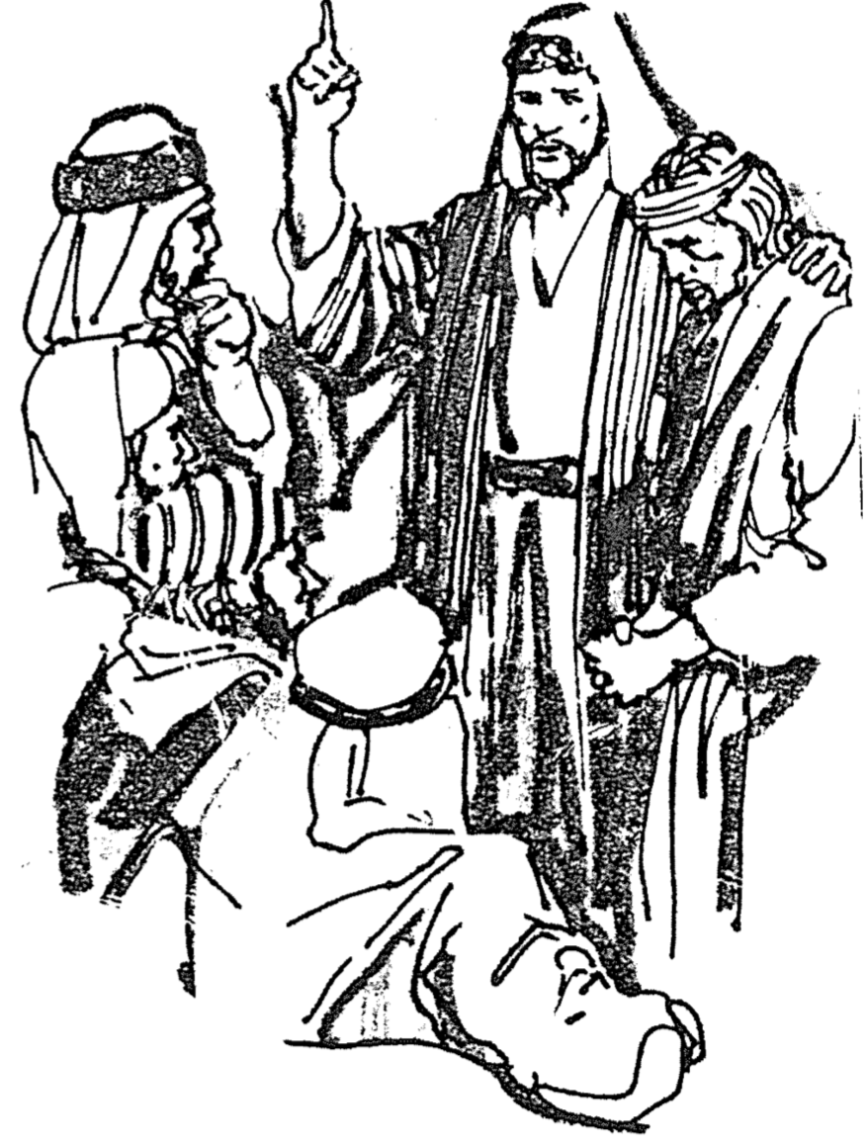
His desire for a continuing relationship with Onesimus could not overrule doing what was right (12-13).

He recognizes Philemon's authority over Onesimus as his slave so Philemon could decide if Onesimus could stay with him (14).

Perhaps God was working for the greater good by Philemon and Onesimus becoming brothers in Christ (15-16).

The way Philemon should forgive and free Onesimus is how Christ forgives us (17-21).

Philemon should accept Onesimus back as a brother to show Onesimus' equal standing with him in Christ (17).

Paul offers to pay Onesimus' debts to Philemon like Jesus forgave him unconditionally (18-19a).

Philemon owes his salvation to Paul so he should forgive Onesimus rather than require paying of his debts for stealing (19b).

Philemon accepting Onesimus would encourage Paul (20).

Paul expresses confidence that Philemon will both forgive and free Onesimus (21).

Paul closes his letter to reinforce the public nature of Philemon's decision and to remind of God's power for fulfilling his appeal (22-25).

The church should prepare for Paul’s soon visit in answer to their prayers and quickly respond to Paul's plea for Onesimus (22).

Five voluntary fellow prisoners with Paul also greet Philemon to reinforce the public nature of his decision about Onesimus (23-24).

Epaphras, who started the Colossian church (Col 1:7) and voluntarily shared Paul's confinement, greets Philemon (23).

Four other fellow workers with Paul also greet Philemon to emphasize the public influence that Philemon's decision will carry (24).

Paul blesses the Colossian church with Christ's grace to underscore the Source of power to fulfill his appeal in the letter (25).

Be Forgiving
Philemon

Exegetical Outline (Steps 2-3)

Exegetical Idea: The way a Christian slave owner should forgive and reinstate his runaway but repentant slave is how Christ forgives us.

I.

II.

III.

Purpose or Desired Listener Response (Step 4)
The listeners will

Homiletical Outline (Cyclical inductive form)

Introduction

Interest: Corrie ten Boom needed to forgive. So do we.

Need:

Subject: How to forgive those who offend us

Background:

Preview:

Text:

(How can we forgive those who offend us?)

I. Begin by seeing people in the best possible light (1-7).
[Restate MP here.]

II. Paul appealed for Philemon's forgiveness of his returning runaway slave, Onesimus (8-21).

III. Philemon teaches four principles on forgiveness.

A. True forgiveness is granted freely, not under compulsion (14).

B. True forgiveness is the natural demonstration of our partnership in the gospel (17).

C. True forgiveness is unconditional without putting requirements on the other person (18-19).

1. When forgiveness is conditional, it's not true forgiveness.

2. How do you know when forgiveness is not unconditional? When you say:

a. "Sure, I'll forgive you if…"

b. "I'll forgive—but I'll never forget…" (FORGIVENESS don't hold grudges).

c. "I forgive you but don't expect me to change my attitude."
* "Forgiveness is surrendering my right to hurt you for hurting me"
- psychologist Archibald Hunt

D. True forgiveness "goes the second mile" (21).

(How can we forgive those who offend us?)

Conclusion

1. We can forgive others when we see how God has forgiven us (Main Idea).

2. Well, what ever happened to Onesimus?

3. With whom do you best identify now? Circle one of these four below:

• Philemon?

• Onesimus?

• Paul?

• The Colossian church?

4. What is God telling you to do?

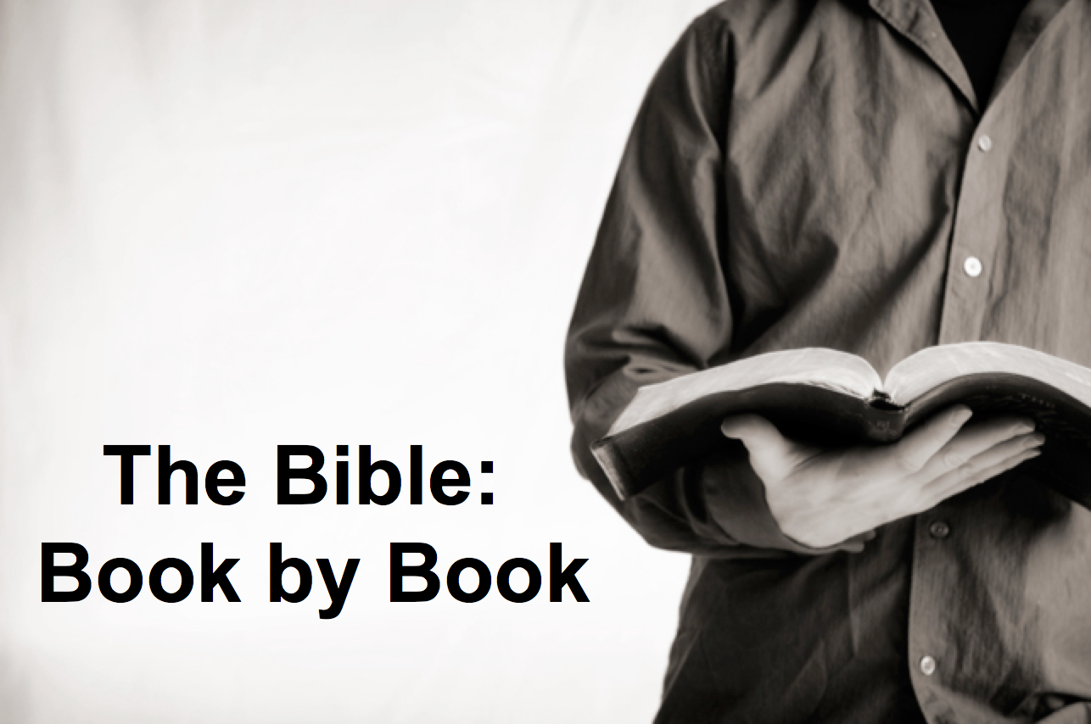

Rick Griffith
26 June 2016
Message 51 of 66

Be Forgiving
Paul’s Letter to Philemon

Introduction

1. Corrie ten Boom needed to forgive. So do we.

2. Our Question Today: How can we ___________________ those who offend us?

I. Begin by seeing people in the best possible _____________ (1-7).

II. Paul appealed for Philemon's __________________ of his returning runaway slave, Onesimus (8-21).

III. Philemon teaches four principles on forgiveness.

A. True forgiveness is granted freely, not under compulsion (14).

B. True forgiveness is the natural demonstration of our partnership in the gospel (17).

C. True forgiveness is unconditional without requirements on the other person (18-19).

D. True forgiveness "goes the second mile" (21).

Conclusion

1. We can forgive __________ when we see how God has forgiven _____ (Main Idea).

2. With whom do you best identify now? Circle one of these four below:
• Philemon?
• Onesimus?
• Paul?
• The Colossian church?

3. What is God telling you to do?

Thought Questions

- Read the passage aloud. What principles or universal truths about forgiveness can you discern from this short letter?

- Why is it so hard for us to forgive others?

Download this sermon PPT and notes for free at BibleStudyDownloads.org/resource/new-testament-preaching/
Listen to this message online at cicfamily.com/sermon-listing/
Philemon

Forgive Others and Seek Forgiveness

Greeting  1-3 |  | Prayer & Commendation  4-7 |  | Appeal for Onesimus  8-21 |  |  | Conclusion  22-25
Preface |  | Praise |  | Petition |  |  | Postscript
People  Concerned |  | Philemon’s  Character |  | Onesimus’  Conversion |  |  | Paul’s  Co-Workers
Authors  1a-b | Recipients  1c-3 | Thanks  4-5 | Relationships  6-7 | General Appeal  8-11 | Reasons for Return  12-16 | Specific  Appeal  17-21 | Preparations  Greetings  Blessing  22-25
Rome to Colosse

Fall AD 61

Key Word: Forgiveness

Key Verse: “So if you consider me a partner, welcome him [Onesimus] as you would welcome me. If he has done you any wrong or owes you anything, charge it to me” (Philemon 17-18).

Summary Statement: The way a Christian slave owner should forgive and reinstate his runaway but repentant slave is how Christ forgives us.

Application: With whom do best relate to now?
1. Philemon: Whom do you need to forgive a wrong done to you?
2. Onesimus: Whose forgiveness do you need to request?
3. Paul: How can you help two others reconcile?
4. The Church: How can you affirm the reconciliation of others?

