2 Thessalonians

Tribulation Corrections

Persevere in Persecution |  | Day Still Future |  |  | Discipline the Idle
Chapter 1 |  | Chapter 2 |  |  | Chapter 3
Emotional |  | Theological |  |  | Practical
Encouragement  in Persecution |  | Explanation  of the Day |  |  | Exhortation  in Body Life
Discouraged  Believers |  | Disturbed  Believers |  |  | Disobedient  Believers
Correct  Perspective |  | Correct  Doctrine |  |  | Correct  Behaviour
Salutation  1:1-2 | Reward vs. Judgment  1:3-12 | Pretrib  Teaching  2:1-2 | Antichrist  Prerequisite  2:3-12 | Stand  Firm  2:13-17 | Prayer  Requests  3:1-5 | Discipline  Idle  3:6-15 | Blessing  Given  3:16-18
Corinth

Late Summer AD 51

Key Word: Tribulation

Key Verse: Do not “become easily unsettled or alarmed by some prophecy, report or letter supposed to have come from us, saying that the day of the Lord has already come. Don’t let anyone deceive you in any way, for that day will not come until the rebellion occurs and the man of lawlessness is revealed, the man doomed to destruction” (2 Thessalonians 2:2-3).

Summary Statement: The way Paul affirmed others during the heresy that the day of the Lord (Tribulation) had already begun was holistic: emotional, theological and practical.

Application: How does your view of the future spur your commitment to serve Christ?

2 Thessalonians

Introduction

I. Title The Greek title (Pro.j Qessalonikei/j b , Second to the Thessalonians) distinguishes this letter from Paul's first letter to the church just a few months before.

II. Authorship

A. External Evidence: Support for Pauline authorship has been upheld “very probably” since Polycarp (ca. AD 135; cf. Best, 37-38) and possibly earlier with Ignatius (ca. AD 110). One can add to this the Marcion Canon (ca. AD 140) and Muratorian Canon (ca. AD 170), plus the testimony of the early Church Fathers and ancient versions.

B. Internal Evidence: The letter itself strongly supports Pauline authorship:

1. The epistle claims that Paul wrote it (1:1; 3:17).

2. The premature ending (3:1-5) suits Paul more than a conscious imitator (Kümmel, 189).

3. The similarities to 1 Thessalonians, cited by some critics as evidence against Pauline authorship, actually support it (Best, 50-56).

4. Critics infer discrepancies between 2 Thessalonians 2:1-12 and 1 Thessalonians 4:13–5:11, but these differences refer to two different phases of Christ’s coming (Hiebert, 57).

C. Conclusion: The attacks upon Paul’s authorship have been soundly defeated so that nearly all scholars, despite their critical assumptions, believe that Paul penned this epistle.

III. Circumstances

A. Date: Hoehner suggests that Paul wrote 2 Thessalonians in the summer AD 51 (just a few months after his first letter). The following supports this claim:

1. Paul, Silas, and Timothy (1:1) are not known to have been together again after their stay in Corinth, which was the place Paul wrote the letter (Hiebert, 59).

2. The same general conditions exist in the church as discussed in 1 Thessalonians (e.g., idleness; cf. 1 Thess. 4:11-12; 2 Thess. 3:6-15).

3. These men apparently stayed in Corinth another year. This doesn’t necessarily argue for a date only a few months after 1 Thessalonians, but certainly the second letter precedes Paul's visit to them five years later (May 56). It is fairly certain that 2 Thessalonians did not follow the first letter by more than 12 months (Constable, BKC, 2:713).

B. Origin/Recipients: Paul wrote from Corinth to the Thessalonian believers north of him in the province of Macedonia (see “Date” above for support). Although this was his second letter to them, the congregation was still young—probably less than year old.

C. Occasion: The historical and chronological scenario for Paul’s ministry at Thessalonica during his second missionary journey probably looks like this:

1. Paul plants the Thessalonian church November 50-January 51
2. Paul’s ministry in Berea, Athens, and Corinth February-March 51
3. Silas and Timothy report to Paul in Corinth April/May 51
4. Paul writes 1 Thessalonians and sends it from Corinth Early Summer 51
5. The carrier of 1 Thessalonians reports back to Paul Mid-Summer 51
6. Paul writes 2 Thessalonians from Corinth Late Summer 51
7. Paul departs Corinth First of September 52

Within only a few months after writing 1 Thessalonians, Paul got news (probably from the letter carrier) of problems unresolved by his first letter. The persecution of the believers had increased (1:3-10), false teachers had taught that the day of the Lord had already come (2:1-12), and some of the Thessalonian Christians had become idle as they simply “waited for the rapture” (3:6-15). Therefore, Paul decided to write the church again to help the believers handle these difficulties.

IV. Characteristics

A. Although 2 Thessalonians is Paul's shortest letter to a New Testament church, it contains significant information regarding the second coming of Christ and the day of the Lord.

1. The return of Christ, occupying the major theme of chapters 1–2, is the most mentioned doctrine in the New Testament, referred to 318 times (TTTB, 423). This averages out to every 25 verses in the New Testament, or 1.2 times per chapter! (The NT has 7959 verses and 260 chapters.) In 2 Thessalonians, 18 of 47 verses (38%) stress eschatology.

2. The day of the Lord is also taught many places in Scripture (cf. Isa. 13:6, 9; Joel 1–2; Zeph. 1:14-16; 1 Thess. 5:1-11; Rev. 6–20) and refers to a time of judgment upon God's enemies and blessing upon His children that is unsurpassed. Chronologically, it begins after the rapture (perhaps half way through the seven-year tribulation) and continues to the end of the millennium (Constable, BKC, 2:717).

3. The rapture is the “catching up” of the saints by Christ at his return (1 Thess. 4:17). The word itself comes from around AD “1600, ‘act of carrying off,’ from Middle French rapture, from Medieval Latin raptura ‘seizure, rape, kidnapping,’ from Latin raptus ‘a carrying off, abduction, snatching away; rape’ (see rapt). Earliest attested use in English is of women and in 17c. it sometimes meant rape (v.), which word is a cognate of this” (https://www.etymonline.com/word/rapture). This negative connotation is not found in the theology of the rapture but the act of being suddenly carried off is the common element of both rape and the rapture.

4. A problem exists concerning the day of the Lord: if the rapture can happen at any time (i.e., without preceding signs), and the day of the Lord begins after that, how then can this latter “day” be preceded by three signs (2:3-12)?

a. These verses are clear that three signs (the apostasy, the revelation of the Antichrist, and the removal of the restrainer) all precede the day of the Lord. At first this may look like support for the posttribulational position (i.e., that the church will be removed from the earth after the tribulation).

b. However, the tribulation does not begin with the rapture. It begins when the Antichrist signs a covenant with Israel (Dan. 9:27). What 2 Thessalonians 2:3-7 notes is only that the three signs will take place prior to the beginning of the tribulation, which could happen days, weeks, or months after the rapture.

c. Therefore, while no signs precede the rapture, at least three signs precede the day of the Lord during the time period between the rapture and day of the Lord.

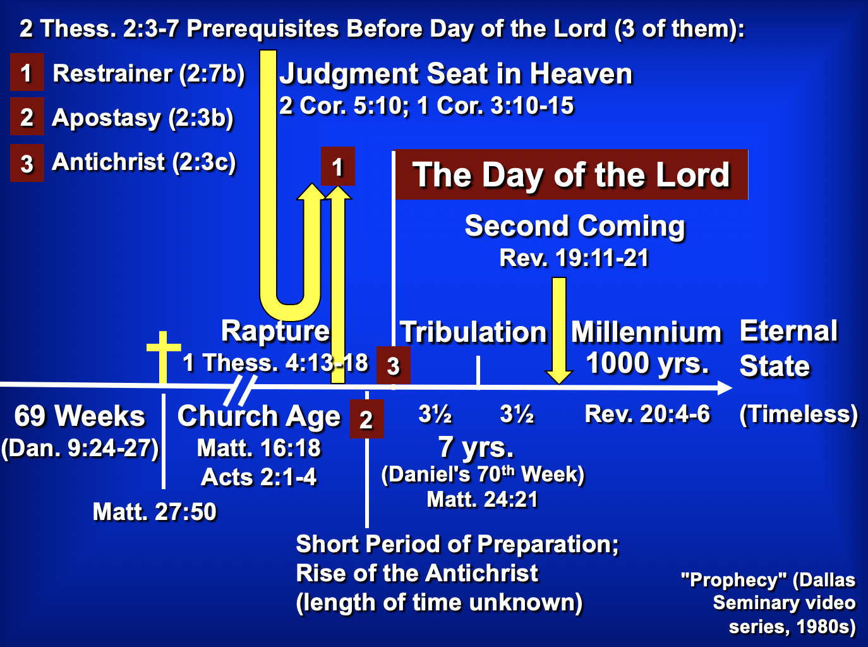

B. Whereas Paul wrote 1 Thessalonians to comfort, he wrote 2 Thessalonians to correct.

C. Paul deviates from his usual epistolary pattern through his two thanksgivings (1:3f.; 2:13f.) and two prayers (1:11-12; 2:16-17). Some believe that this indicates a merging of two separate letters, but there is no evidence that Paul ever felt constrained by a particular literary pattern and no manuscript evidence exists to doubt the unity of the epistle.

Argument

As mentioned above, Paul wrote 2 Thessalonians to help the believers handle three difficulties facing the church: increased persecution (1:3-10), false teaching that the day of the Lord had already come (2:1-12), and idleness among some of the Thessalonian Christians who were “waiting for the rapture” (3:6-15). Paul's design in writing was to encourage perseverance based upon their future reward at the day of the Lord (2 Thess 1) and to correct their false notion of the day of the Lord (2 Thess 2) which had resulted in idleness (2 Thess 3). The overriding theme is the day of the Lord and its implications on behavior.

Synthesis

Day of the Lord corrections

1 Emotional: Persevere in persecution
1:1-2 Salutation
1:3-12 Church's reward vs. persecutors' judgment at day of the Lord

2 Theological: Day still future
2:1-2 Teaching hasn't changed
2:3-7 Antichrist events preceding Day
2:3a Apostasy
2:3b-4 Worship as God
2:5-7 Restrainer removed
2:8-12 Antichrist activity and end
2:13-17 Stand firm

3 Practical: Discipline the idle
3:1-5 Pray for spread of the gospel
3:6-15 Discipline lazy unemployed members
3:16-18 Blessing/benediction

Outline

Summary Statement for the Book
The way Paul affirmed others during the heresy that the day of the Lord (Tribulation) had already begun was holistic: emotional, theological and practical.

Emotional: Persecuted believers should persevere since God will judge their persecutors but make them mature (2 Thess 1). Swindoll: Persevering through affliction develops maturity.

Paul mentions his fellow-workers Silas and Timothy but not his position as an apostle to begin his letter relationally (1:1-2).

God will reward the church’s perseverance during affliction but punish their persecutors by helping the church become mature (1:3-12).

Theological: Paul teaches that the day of the Lord required the Antichrist so the church could be stable (2 Thess 2). Swindoll: Trusting amidst confusion produces stability.

Paul had not changed his views on the time of the day of the Lord meaning that they had missed the rapture (2:1-2).

Specific events will precede the day of the Lord so that the Thessalonians could see that they had not missed this event (2:3-12).

The Church will depart from the earth (or from the God’s Word) before the day of the Lord comes, leaving only an apostate church (2:3a).

The Antichrist will reveal himself to the discerning before the day of the Lord begins (2:3b-4; by signing a covenant with Israel; cf. Dan. 9:27).

The restraining ministry of the Holy Spirit in the Church will be removed from earth, allowing the Antichrist to rule (2:5-7).

Then the Antichrist will prove himself in counterfeit miracles and a powerful delusion sent by God but will be destroyed at Christ’s return (2:8-12).

Paul prays that they will stand firm in good works since they will be spared from the day of the Lord by sharing in Christ's glory (2:13-17).

Practical: The church must discipline lazy believers living off others so they will work like Paul and his companions (2 Thess 3). Swindoll: Waiting with discipline cultivates responsibility.

Paul requests prayer for the progress of the gospel and prays the same for them to model sensible behavior in light of the day of the Lord (3:1-5).

They must discipline idle believers who live off others as they wait for the rapture to shame them into responsible work (3:6-15).

Paul signs the concluding blessing and benediction to show the genuineness of the epistle (cf. 2:2b) so that the church would act on its authority (3:16-18).

In our day when most talk of self-esteem, it is refreshing to find the Godhead noted more than once each verse on the average in these books…

Focus on God in the Thessalonian Epistles
Total Verses | “God” | “Lord” | “Jesus” | “Christ” | Total
1 Thess. (89) | 36 | 24 | 16 | 10 | 86
2 Thess. (47) | 18 | 22 | 13 | 10 | 63
Total (136) | 54 | 46 | 29 | 20 | 149
Numbers of Greek occurrences from Elwell & Yarbrough, Encountering the New Testament, 332

The Day of the LORD

I. Usage

A. The “day of the LORD” concept appears in every prophetical writing in the Old Testament, although not always by that same term.

B. The judgment aspect receives detailed treatment in Zephaniah, Joel, and Revelation 6–19. Some believe that the “Lord’s day” of Revelation 1:10 also refers to this period (cf. 2 Thess. 2:2-3).

II. Definition

A. The day of the LORD is “the time of Yahweh’s final intervention in history when He will judge the wicked, deliver the righteous, and establish His kingdom” (Hobart Freeman, An Introduction to the OT Prophets, 146).

1. Judgment

a. Primarily it refers to a destruction of Israel’s enemies (Zeph. 2–3; Amos 1:3–2:3; Joel 3; Zech. 12–14; Isa. 13:6, 9; 14:28-32; 17:1ff.; 20:1-6; 31:1-5; Jer. 46:10; Ezek. 30:3ff.).

b. However, it also includes punishment of the rebellious and disobedient in the nation of Israel (Amos 5:18-20).

c. The Great Tribulation of Revelation 6–19 finds so many parallels with descriptions by the OT prophets that the two judgments must certainly be the same period.

d. Ultimately the day of the LORD will end in a destruction of the world (2 Pet. 3:10).

2. Deliverance

a. Israel’s salvation from Gentile oppressors will occur through God who preserves and delivers a remnant of Israel (Joel 2:32; Zech. 14; Zeph. 3:8-20; Isa. 2, 11; 65-66; Amos 9:11-15; Ezek. 20:33-44, etc.).

b. This salvation is to enable Israel to enter into the kingdom in which God will fulfill all His promises to Abraham (cf. class notes, 336-37).

c. The deliverance has many blessings (Deut. 30:3-9) also for Gentiles (Zeph. 3:9).

d. Final salvation after judgment will be in the new heaven and earth (2 Pet. 3:11-13).

3. Diagram

Judgment + Salvation = Day of the LORD

Great Tribulation + Christ’s Return/ = Day of the LORD
Millennium

B. The day of the LORD also had a nearer aspect to the prophets, depicting an imminent, impending disaster–generally through the Assyrians or Babylonians. Sometimes even both the near and far aspects appear together in a dual sense. God did not clearly reveal whether a near or far perspective was to be understood so as to encourage repentance.

C. For further study see Greg A. King, “The Day of the LORD in Zephaniah,” Bibliotheca Sacra 152 (January-March 1995): 16-32.

The Antichrist

I. The Post-Rapture Crisis for Leadership

A. The need for a world leader after the rapture cannot be overstated.
1. Someone will need to explain the disappearance of millions of Christians.
2. Communications, transportation, economic, and all other systems will be disrupted.
3. The middle-east problem especially will need to be resolved.

B. Difficult times have always set the stage for a strong man to take control. The world scene after the rapture will be a perfect environment for the Antichrist to gain power.

II. Names for the Future Fuhrer

A. The names are many, describing his multifaceted character and the great emphasis placed upon this man in the Bible.

B. List of the names in scriptural order:

Bloody and Deceitful Man Ps. 5:6
Wicked One Ps. 10:2-4
Man of the Earth Ps. 10:18
Mighty Man Ps. 140:1
Assyrian Isa. 10:5-12
King of Babylon Isa. 14:2
Sun of the Morning Isa. 14:12
Spoiler Isa. 16:4-5; Jer. 6:26
Branch of the Terrible Ones Isa. 25:5
Profane Wicked Prince of Israel Ezek. 21:25-27
Little Horn Dan. 7:8
King of Fierce Countenance Dan. 8:23
Prince that shall Come Dan. 9:26
One who causes Desolation Dan. 9:27
Vile Person Dan. 11:21
Willful King Dan. 11:36
Idol Shepherd Zech. 11:16-17
Abomination of Desolation Matt. 24:15
One Coming in His Own Name John 5:43
Man of Sin 2 Thess. 2:3
Man Doomed to Destruction 2 Thess. 2:3
Lawless One 2 Thess. 2:8
Antichrist 1 John 2:18, 22
Angel of the Bottomless Pit Rev. 9:11
Beast from the Abyss/Sea Rev. 11:7; 13:1
[Scarlet] Beast Rev. 17:3, 8, 12

III. Summary of the Activity of the Future Fuhrer

A. Makes 7-year treaty with Jews Dan. 9:27a; 2 Thess. 2:3 (treaty reveals him?)
B. Peaceful beginning Rev. 6:1-2
C. Heads 10 nation confederacy Dan. 7:20
D. Dominated by world church Rev. 17:3-11
E. Dominates world church Rev. 17:12-16
F. Breaks covenant with Israel Dan. 9:27 (midpoint of the Tribulation)
G. Counterfeits death/resurrection Rev. 13:3a
H. Worshiped worldwide Rev. 13:3b-8, 11-15
I. Sets up image for worship 2 Thess. 2:3-4
J. False prophet promotes mark Rev. 13:16-18
K. Two witnesses slain Rev. 11:7
L. Persecutes Jews & Victorious in Israel Dan. 11:40-43
M. Defeated by Christ Rev. 19:11-19
N. Doom in Lake of Fire Rev. 19:20

