Luke

Universal Savior Ministers in Sovereign Kingdom Progress

To Seek the Lost |  |  |  |  |  | To Save the Lost
Introduction |  |  | Ministry |  |  | Passion |  | Conclusion
1:1–4:13 |  |  | 4:14–21:38 |  |  | 22–23 |  | 24
Sources  1:1-4 | Advent  1:5–2:52 | Prepared  3:1–4:13 | Galilee  4:14–9:50 | Travelogue  9:51–19:27 | Rejection  19:28–21:38 | Night  22:1–23:25 | Crucifixion  23:26-56 | Resurrection  24:1-44 | Commission  24:45-53
0  kingdom  references | 1 | 0 | 8 | 25 | 2 | 4 | 2 | 0 | 0
30 years |  | 3 years |  | 3-4 months | 8 days
Miracles Prominent |  |  |  | Teaching Prominent
Caesarea

Written AD 57-59
Covers 5 BC–AD 33

Key Word: Sovereignty I

Key Verse: “For the Son of Man came to seek and to save what was lost” (Luke 19:10).

Summary Statement: The way to confirm Theophilus in his faith is to show the sovereignly directed progress of the kingdom message from Jewish rejection of Jesus as Messiah to Gentile acceptance.

Application: Have you recognized God’s sovereign leading in your life to bring you to Christ?
Luke

Introduction

I. Title: The Greek title (Kata, Luka'n According to Luke) was added to this volume at a very early date. We know that Acts was a companion volume as both books address Theophilus (Luke 1:3; Acts 1:1).

II. Authorship

A. External Evidence: The Church Fathers from the latter half of the second century agreed that Luke, “the beloved physician” (Col. 4:14), wrote this Gospel which bears his name:

1. The earliest evidence for Luke’s authorship stems from the Muratorian Canon and the Anti-Marcionite Prologue (both dated AD 160-200).

2. Others cite Luke as the author: Irenaeus (Against Heresies; ca. AD 185), Tertullian (Against Marcion; ca. AD 150-222), Clement of Alexandria (ca. AD 155-216), Origen (Comm. on Matt.; ca. AD 230, quoted by Eusebius), Eusebius, and Jerome (Hiebert, 1:114-17).

Luke is mentioned only three times in the New Testament (Col. 4:14; 2 Tim. 4:11; Philem. 24). Since Paul lists his companions as Jews (Col. 4:10-11) then Gentiles (Col. 4:12-14), and Luke's name appears among the latter group, he evidently was a Gentile, which is confirmed by his brilliant use of Greek and his phrase “their own language” (Acts 1:19). Tradition says that he came from Syrian Antioch, never married, and died at the age of eighty-four (TTTB, 327).

B. Internal Evidence: Support for Lukan authorship can be found in the book itself, especially when it is compared with Acts.

1. Several factors show that Luke and Acts had the same author: (a) Both are dedicated to the same man, Theophilus, (b) Acts 1:1 refers to “the first account,” which is most naturally understood as Luke's Gospel, (c) The language and style of the two books are remarkably similar, and (d) Both books share many common interests (cp. “Characteristics” sections; cf. Guthrie, 100).

2. Acts has four first-person narratives often called the “we sections” (16:10-17; 20:5-15; 21:1-18; 27:1–28:16) that show the author to be a close traveling companion of Paul. Of his traveling companions, only Titus and Luke are not mentioned by name in these sections and Titus has never been seriously considered as a candidate for the authorship of Acts (Hiebert, 1:119ff.).

3. Luke uses technical medical terms as expected by a doctor (Luke 4:38 vs. Mark 1:30; Luke 5:12 vs. Mark 1:40; Luke 8:43 vs. Mark 5:26, 29; Luke 4:35; 10:34ff.; 13:11; cf. Kümmel, 104).

III. Circumstances

A. Date: Acts ends with Paul's two-year imprisonment, ending in AD 62, and Luke was written before Acts (cf. Acts 1:1). Luke probably wrote his gospel during Paul's two-year imprisonment at Caesarea (AD June 57-August 59) as this period would have given Luke time to interview Paul and travel in Israel to gather information from eyewitnesses of Jesus' ministry.

B. Origin/Recipients: Assuming the above scenario is correct, Luke wrote from Caesarea. However, others suggest Rome, Arabia, Asia Minor, and Alexandria. He clearly wrote to Theophilus (1:3), a man whose name means “lover of God,” but many verses show that a wider Gentile audience is also in view (Guthrie, 95; Hiebert, 1:130f.). Luke translates Aramaic terms, traces Christ's genealogy back to Adam, refers to Roman rulers for dating, avoids mentioning fulfillment of prophecies, quotes the Septuagint, and explains Jewish customs and Israel’s geography. The title of “most excellent” for Theophilus (Luke 1:3) probably indicates that he was an official of some kind and as a man of high social standing he may have assumed responsibility for publishing Luke and Acts.

C. Occasion: Theophilus considered Dr Luke a tremendous resource to give an orderly account of the life of Christ. He was well educated, an excellent historian, well acquainted with Paul, and as a single man able to travel and interview eyewitnesses. Luke probably wrote at Theophilus' request, but in any event, he purposed to strengthen the wealthy Christian's faith by showing that his faith rested on firm historical facts (1:3-4). Perhaps even more significantly, Luke sought to explain to his wider Gentile audience how Christ died for the entire world despite being a Jew. Unlike today, most westerners considered Christianity an eastern religion, so Luke wrote to say that “this easterner” (Jewish) Jesus was the universal Savior who could save westerners too.

IV. Characteristics

A. The purpose of Luke's Gospel has many different views:

1. Kingdom: to explain God’s orderly and sovereignly directed progress of the kingdom message from Jews to Gentiles to answer the natural question of any Gentile unbeliever, “How could a Jewish Savior be the Savior of the world?” This kingdom theme is evident in several ways:

a. The concept of the “kingdom” and the “kingdom of God” in Luke appears at least 42 times (e.g., 1:33; 4:43; 6:20; 7:28; 8:1, 10; 9:2, 11, 27, 60, 62; 10:9, 11; 11:2, 17, 18, 20; 12:31, 32; 13:18, 20, 28, 29; 14:15; 16:16; 17:20a, 20b, 21; 18:16, 17, 24, 25, 29; 19:11; 21:10, 31; 22:16, 18, 29, 30, 23:42, 51). In Acts it appears only eight times but the concept is throughout from the beginning (1:8) to the end (28:31) in three sections: the witness in Jerusalem (1:1–6:7), Judea and Samaria (6:8–8:40) and the uttermost parts (Acts 9–28).

b. Luke emphasizes sovereignty through God's control of all events despite obstacles (e.g., 1:13, 30-33; 2:1, 29; 13:31-35) and Acts emphasizes predestination (2:23; 4:28; 13:48).

c. Since Luke and Acts have the same author and the Gospel account has a strong kingdom emphasis, one would expect the same emphasis in Acts since it is a continuation of Luke's gospel. This emphasis does in fact exist.

d. Luke presents Christ as the “perfect man,” not the Jewish man. “Luke’s portrait of Jesus was ideally suited to the Greek mind. The Greek ideal was human excellence, the perfect individual. In his gospel Luke shows that Jesus fulfilled this ideal in the highest and most absolute sense” (Hiebert, 1:142). Jesus especially fulfills this role by using the title “Son of Man”—a title from Daniel 7:13-14 for the Messiah who will bring in the universal kingdom.

e. This kingdom view includes all of the following purposes except #7.

2. Instructional/Edification: to confirm Theophilus and other Gentile believers in their faith (1:4; TTTB, 328; Hiebert, 1:132-135).

3. Soteriological/Evangelistic: to present Christ to non-Christian Gentile readers as the perfect Son of Man who “came to seek and to save that which was lost” (19:10; TTTB, 328)

4. Apologetic: to show that Christianity was not a politically subversive sect but rather a universal movement (cf. Pilate's three announcements of Christ's innocence in 23:4, 14, 22; TTTB, 328)

5. Ecclesiastical: to “trace the development and distinction of the Church over and against Judaism” (Ellis, The Gospel of Luke, 60-62)

6. Narration of History: to preserve “the record of the origin and growth of the early church” (Fitzmyer cited by Liefeld, EBC, 8:800)

7. Conciliation: to solve an argument between Peter and Paul to show Paul's credentials equal with Peter's to defend Paul's apostleship (Baur and Tübingen School cited by Liefeld, EBC, 8:801)

B. Luke wrote with superb style and structure, his book being the most literary of the four Gospels. The Greek syntax is the best in the New Testament.

C. The universal message of the gospel is stressed more than in any other gospel. This is seen in the many references to Gentiles (2:32; 18:32; 21:24a, 24b; 22:25).

D. Forgiveness holds a prominent place (3:3; 5:18-26; 6:37; 7:36-50; 11:4; 12:10; 17:3-4; 23:34; 24:47; cf. Martin, BKC, 2:201).

E. A large emphasis is the Holy Spirit and his ministries (1:15, 35; 3:22; 4:1, 18; 10:21).

F. Only Luke relates his account with events and persons of secular history (2:1-2; 3:1).

G. This Gospel is by far the most comprehensive. It is the longest of the four, it starts with the earliest account (John's birth; 1:5-25, 39-45, 57-80) and ends later (with the ascension of Christ; cf. 24:50-53) which bridges his gospel account into the Book of Acts (1:1-11). Its comprehensiveness is also seen in the many parables and miracles not recorded in the other Gospels. Luke and Acts together comprise 2138 verses, or 28% of the New Testament. Since Paul wrote only 2033 verses, Luke wrote more than any other author in the New Testament (TTTB, 329).

H. Luke has a special emphasis upon prayer as it records nine prayers of Christ–seven being unique to Luke (3:21; 5:16; 6:12; 9:18, 29; 22:32, 40-41).

I. Money and material things are in Luke more than any other NT book (Martin, BKC, 2:201).

J. The temple is mentioned frequently (1:8, 21-22; 2:27, 37, 41-51; 24:53).

K. Luke emphasizes Christ's redemptive mission, often quoting and/or alluding to Isaiah 53 and 40–66 (22:37; 24:27, 44, 46).

L. The prominence of glory abounds in relation to wonder and praise for miracles (5:25-26; cf. Acts 3:8-10) and for other events (1:46-55, 68-79; 2:13-14, 20, 28-32; 7:16; 10:21; 18:43; 19:37-38; cf. Liefeld, EBC, 8:811).

M. “Luke noted the individual's place in coming to repentance. He stressed the action which must come from each individual who followed Jesus. Examples include Zechariah, Elizabeth, Mary, Simeon, Anna, Martha, Mary, Simon, Levi, the centurion, the widow of Nain, Zacchaeus, and Joseph of Arimathea” (Martin, BKC, 2:201). Especially notable is his emphasis upon women (thirteen nowhere else mentioned in the NT), children, and angels.

N. “Luke often spoke of the joy that accompanies faith and salvation (1:14; 8:13; 10:17; 13:17; 15:5, 9, 32; 19:6, 37)” (Martin, BKC, 2:201).

O. Luke stresses the humanity of Christ in that the genealogy begins with Adam, the first man (3:37).

P. Luke alludes to the Septuagint frequently (2:23-24; 3:4-6; 4:4, 8, 10-12, 18-19; 10:27; 18:20; 19:46; 20:17, 28, 37, 42-43; 22:37), although 7:27 is from neither the Septuagint nor the Masoretic text.

Q. Promises regarding the Abrahamic and Davidic Covenants are prominent (e.g., 1:54-55, 69, 72-73), and the New Covenant is mentioned once as well (22:20).

R. If a Jew wrote Hebrews, then Luke-Acts remains the only book in the Bible written by a Gentile.

S. Luke alone gives his sources used to write his account, of which there were three: (1) written records of oral traditions stemming from the apostles' teaching (1:1), (2) the apostles themselves (1:2), and (3) interviews with non-apostolic eyewitnesses—perhaps Mary, Elizabeth, John, and Mark (1:3).

Argument

Luke's Gospel is written from a Gentile mind to the Gentile mind to confirm Theophilus' faith (1:3), but also to answer how the Jewish Savior could be a Savior for Gentiles. Luke performs this task masterfully by tracing the divinely directed kingdom message from Jews to Gentiles. This is evident even in his introduction (1:1-4), which affirms that he has carefully investigated the facts–a concern any intellectual Gentile would want to know. Next, he documents the pre-public life of Christ through the infancy narratives and preparation for ministry, both of which show that from the beginning Christ came to save Gentiles (1:5–4:13). The bulk of the Gospel (4:14–21:38) records the history of Jesus' ministry of being rejected by Israel and turning to the Gentiles. This is true in his early Galilean ministry (4:14–9:50), even more so while en route to Jerusalem (9:51–19:27), but especially in Jerusalem itself (19:28–21:38), particularly at the temple (19:45–21:38). The height of Jewish rejection appears when Christ submits to the Father's will for him to die to provide salvation for Jew and Gentile alike (Luke 22–23), and this atoning death is authenticated in his resurrection, commission, and ascension as worthy of bringing to the nations (Luke 24). Therefore, since Israel has rejected its Messiah, all men can receive salvation by simple faith, a message that is continued in Luke's Book of Acts, which chronicles the kingdom message from its reception by Jerusalem Jews to Gentiles in the uttermost part of the Roman Empire.

Synthesis

Universal Savior ministers in sovereign kingdom progress
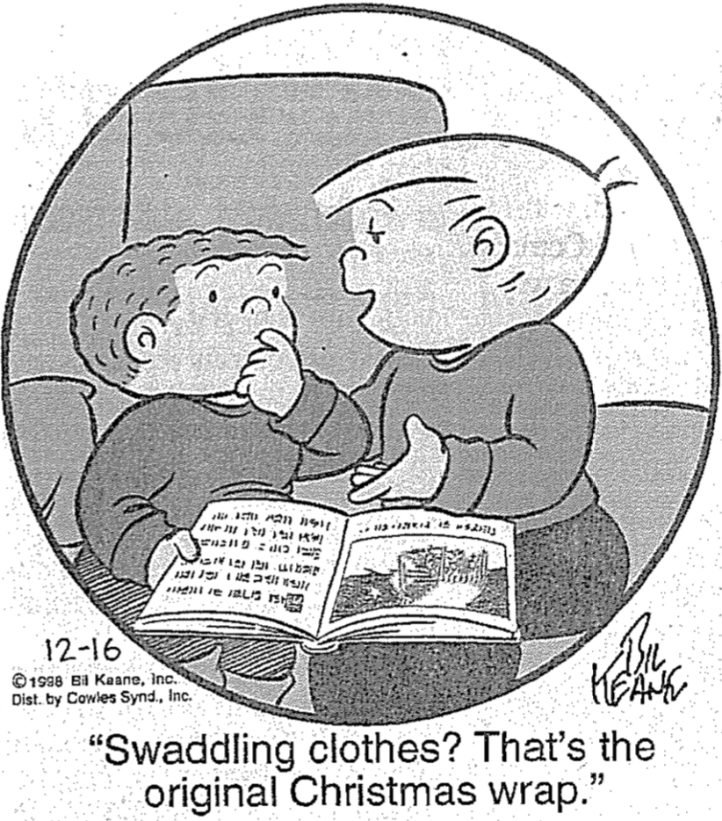
1:1-4 Sources

1:5–4:13 Pre-public life
1:5–2:52 Advent
1:5-56 Announcements
1:57–2:20 Births
2:21-52 Early life
3:1–4:13 Preparations
3:1-20 John
3:21-22 Baptism
3:23-38 Genealogy
4:1-13 Temptation

4:14–21:38 Ministry
4:14–9:50 Galilee
4:14-30 Galilean acceptance vs. Nazareth rejection
4:31–6:16 Authentication/discipleship
6:17-49 Sermon on the Level Place
7–8 Miracles/teachings
9:1-50 Teaches dependence
9:51–19:27 Lukan Travelogue
9:51–11:54 Rejection
12:1–19:27 Teaching
19:28–21:38 Official presentation/rejection
19:28-44 Triumphal Entry
19:45–21:38 Temple ministry
19:45-48 Second cleansing
20:1–21:4 Confrontations
21:5-38 Olivet Discourse

22–23 Passion
22:1-38 Passover
22:39-46 Gethsemane
22:47–23:25 Arrest/trials
23:26-56 Crucifixion

24 Final events
24:1-44 Resurrection/appearances
24:45-53 Commission/ascension

Outline

Summary Statement for the Book
The way to confirm Theophilus in his faith is to show the sovereignly directed progress of the kingdom message from Jewish rejection of Jesus as Messiah to Gentile acceptance.

Luke’s sources were credible for skeptical Gentiles and to achieve his purpose to confirm the faith of Theophilus (1:1-4).

Luke’s formal, classical prologue informs Theophilus that he has reliable sources for this account of Christ's life in a chronological manner (1:1-3).

Luke's purpose in writing is to confirm the faith of Theophilus (and other Gentile Christians who would read the account) with historical, factual data (1:4).

Christ’s pre-public life in his advent and ministry preparation shows God's orderly and sovereignly directed plan in a Semitic context but with universal overtones (1:5–4:13).

Christ’s advent in the infancy narratives of John and Jesus shows God sovereignly provided Jesus as Israel’s Messiah, the world’s Savior, and the Son of God (1:5–2:52).

The announcements of the births of John and Jesus reveal in their Old Testament allusions that Jesus is truly Israel’s Messiah (1:5-56).

Miraculous births of John and Jesus show that God controls all things—from barren women to the dictates of kings—to give Israel’s Messiah to the world (1:57–2:20).

In the early life of Jesus, both Simeon and Jesus himself recognize him as Messiah of Israel, Savior of the world, and Son of God (2:21-52).

Simeon's prophecy of Jesus as a light to the Gentiles shows Gentile readers that Jesus is Israel’s Messiah and the world’s Savior (2:21-40).

Christ's teaching in the temple as a boy shows that from his youth, he was fully conscious of his identity as Son of God (2:41-52).

The ministry preparation of Jesus shows God's sovereign hand to give his Son who completely identifies with humanity for the world’s salvation (3:1–4:13).

John's ministry prepares the hearts of Israel through repentance so that Jesus might provide salvation for the world (3:1-20).

The baptism of Jesus asserts God's sovereignty over his Son who pleases him (3:21-22).

Christ's genealogy is traced through Mary back to Adam and God to indicate his humanity, his deity, and his universal offer of salvation (3:23-38).

Christ's temptation by Satan records his refusal to gain people's acceptance without the cross as an example of waiting upon God's plan to save the world (4:1-13).

The Galilean ministry and route to Jerusalem show Israel rejecting Jesus as Messiah and his judgment by turning to Gentiles in the times of the Gentiles (4:14–21:38).

Christ's ministry in Galilee is the first stage of Jewish rejection despite his miracles to prove he is Messiah in contrast to reception by Gentiles and his disciples (4:14–9:50).

Gentiles accepting Jesus in Galilee contrasts with Jewish rejection in Nazareth to foretell Jewish unbelief and Gentile reception to fulfill OT prophecy (4:14-30).

Jesus’ validation as the Son of Man (Messiah) comes in three alternating cycles of miracles and calling of disciples (4:31–6:16).

Christ's Sermon on the Level Place omits Jewish parts of the Sermon on the Mount to show his discipleship teaching for Gentile readers (6:17-49).

Christ's ministry to needs in and near Capernaum chronicles the kingdom expansion through his miracles and teaching to further show his identity as Messiah (Luke 7–8).

Christ's teaching dependence upon himself to his disciples climaxes his Galilean ministry before he begins to approach Jerusalem (9:1-50).

The Lukan Travelogue (Jesus rejected en route to Jerusalem) with his consequent teaching highlights the need for discipleship despite opposition (9:51–19:27).

Opposing Jesus increases as he is rejected by Samaria and accused of demonic power by Pharisees (9:51–11:54).

Note: Luke's travelogue has a chiastic structure where themes reappear in reverse order later in the section (adapted from Charles Talbert, Reading Luke, 111-12).

a. Approaching Heaven: Set Out for Jerusalem (9:51)

b. Purpose for Coming: Samaritans and Salvation (9:52-56)

c. Discipleship and Following (9:57-62)

d. Rejection: 70 and Message of the Kingdom (10:1-24)

e. Service and Rewards: Lawyer and Eternal Life (10:25-42)

f. Prayer Principles Illustrated Through Children (11:1-13)

g. Pharisees to Be Judged for Blasphemy (11:14-28)

h. Resurrection: Sign of Jonah (11:29-36)

i. Woes on the Pharisees (11:37-54)

Christ teaches via parables on various subjects in response to his rejection (12:1–19:27).

j. Money and Faithfulness: Discipleship and Rich Fool (12:1-34)

k. Parables of Readiness: Faithfulness (12:35-59)

l. Discipleship: Division (12:49-53)

m. Poor Judgments: Hypocrites (12:54-59)

n. Parable of Grace: Repentance (13:1-9)

o. Healing a Crippled Woman on the Sabbath (13:10-17)

p. Growth of the Kingdom: Universal Inclusion (13:18-21)*

p.' Judgment on Israel: Jerusalem Rejection (13:22-35)*

o.' Healing a Dropsy Man on the Sabbath (14:1-6)

n.' Parables of Invitation: Humility (14:7-24)

m.' Poor Judgments: Rejection (14:16-15)

l.' Discipleship: Dedication (14:25-35)

k.' Parables of Lost Sheep, Coin, and Son: Reconciliation (Luke 15)

j.' Money and Faithfulness: Discipleship and Unjust Steward (16:1-13)

i.' Condemnation on the Pharisees (16:14-18)

h.' Resurrection: Rich Man and Lazarus (16:19-31)

g.' Israel to Be Judged at the Second Advent (17:1-37)

f.' Prayer Principles Illustrated Through Children (18:1-14)

e.' Service and Rewards: Rich Young Ruler and Eternal Life (18:18-30)

d.' Rejection: Announcement of Jerusalem (18:31-34)

c.' Bartimaeus and Following (18:35-43)

b.' Purpose for Coming: Zacchaeus and Salvation (19:1-10; 19:10 = Luke’s Key Verse)

a.' Approaching the Kingdom: Delay of Messianic Kingdom (19:11-27)

The above chiastic structure shows Luke 13:18-35 as the focus of the book (p & p'). Israel rejecting Christ was in God’s sovereign plan to extend his salvation plan to Gentiles so that Christ would not only be a Jewish Savior but also the Savior of the world.

Christ is rejected as Messiah in the Triumphal Entry in Jerusalem, so he predicts the temple destruction and Israel's judgment in the times of the Gentiles (19:28–21:38).

Jesus' official presentation as Israel's Messiah in the Triumphal Entry in Jerusalem fulfills Daniel 9:26 which prophesies his rejection (19:28-44).

The temple teachers reject Jesus rebuking their greed so his Olivet Discourse predicts temple destruction and Israel's judgment in the times of the Gentiles (19:45–21:38).

Christ's second cleansing of the temple incident confirms that the nation has replaced spiritual life with materialistic pursuits (19:45-48).

Jesus' confrontations with the national leaders in the temple confirm their rejection of him as Messiah and that of the nation as a whole (20:1–21:4).

Christ's Olivet Discourse predicts Israel's judgment in the times of the Gentiles when Gentiles rule Jerusalem before his return (21:5-38).

The passion narrative shows Christ submitted to the Father as the innocent Passover Lamb whose death offers forgiveness and eternal life to all who believe (Luke 22–23).

The Passover Supper shows Christ as the Passover Lamb through whose blood the new covenant is established (22:1-38).

The agony of Jesus in Gethsemane affirms his difficult yet unmovable submission to the Father’s will to model true discipleship amidst difficulty (22:39-46).

Jesus’ arrest and trials repeatedly show him innocent of all charges leveled at him to confirm his sacrifice for the sins of the world—not his own sins (22:47–23:25).

The crucifixion of Jesus confirms his death as the basis for forgiveness and eternal life for all who believe—Jew and Gentile alike (23:26-56).

Christ's resurrection, commission, and ascension authenticate his ministry and atoning death as worthy of bringing to the nations (Luke 24).

The resurrection of Jesus and appearances on the Emmaus Road and to the Eleven prove him to be the Messiah who fulfilled the Scriptures (24:1-44).

The commission and ascension of Jesus commands the disciples to proclaim his salvation to the nations after the Spirit comes, thus bridging to Acts 1:1-11 (24:45-53).

The Genealogy of Jesus
John Fryman, “The Bible… Basically” Seminar (Ft. Worth, 2004), Study Guide 16

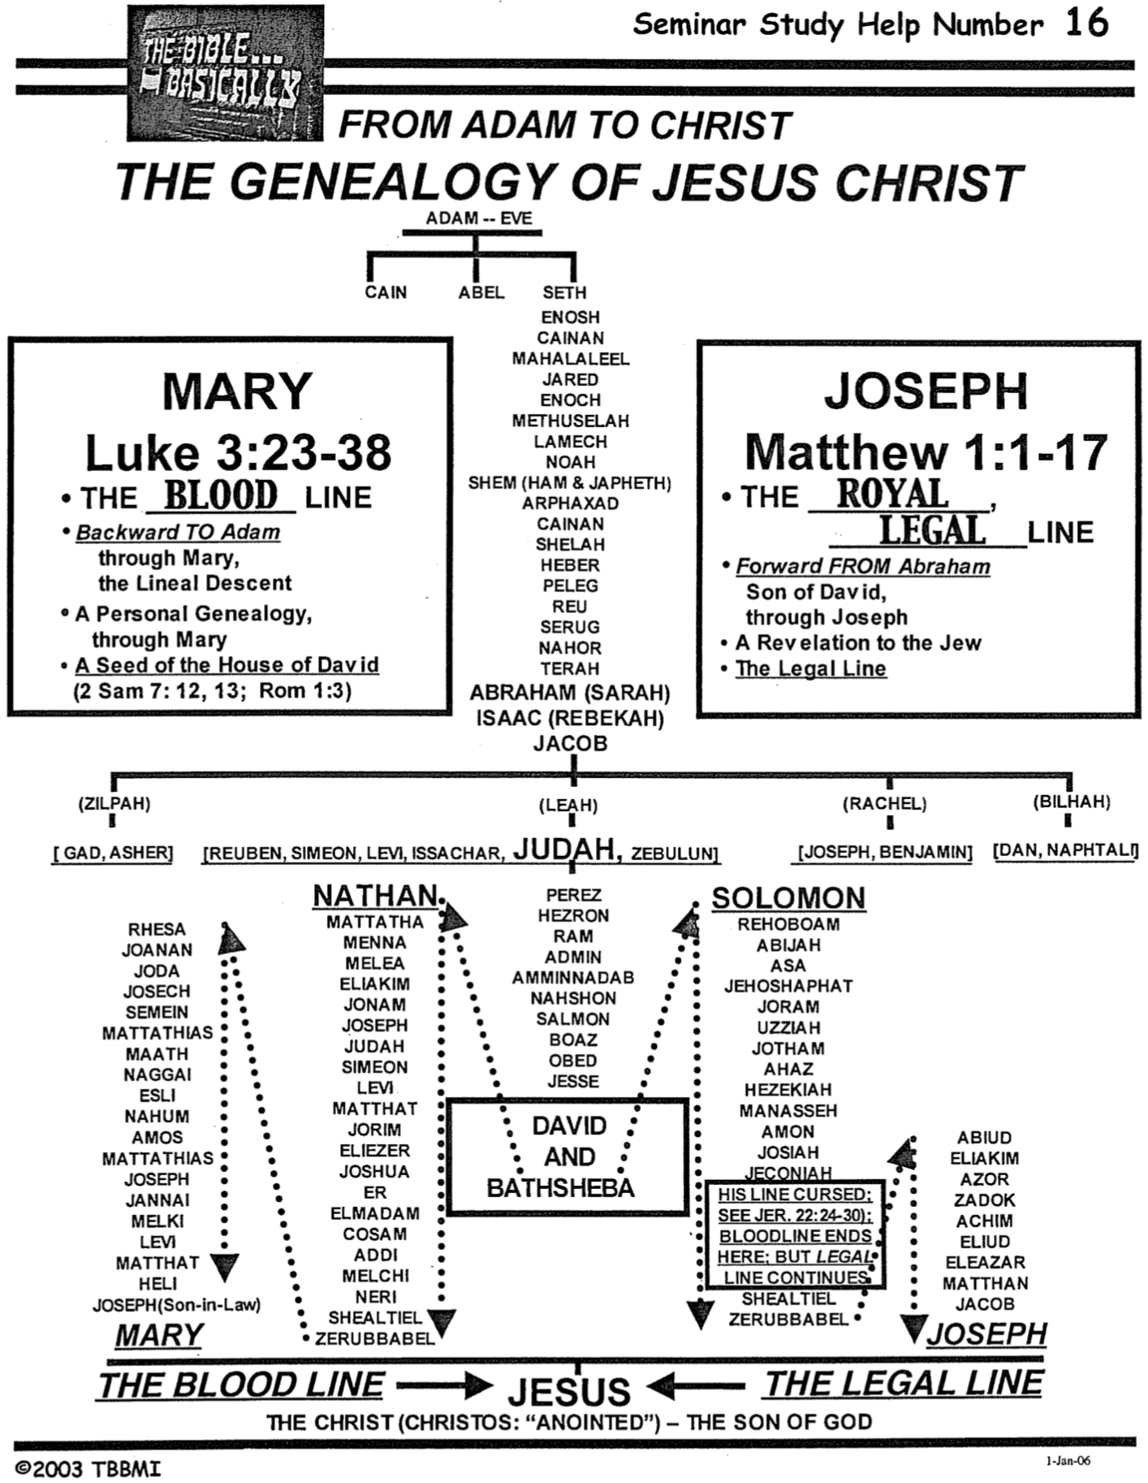
Contrasting Genealogies by Matthew and Luke
Darrell Bock, Luke, 2 vols., Baker Exegetical Commentary on the NT (Grand Rapids: Baker, 1994-95), 918-22

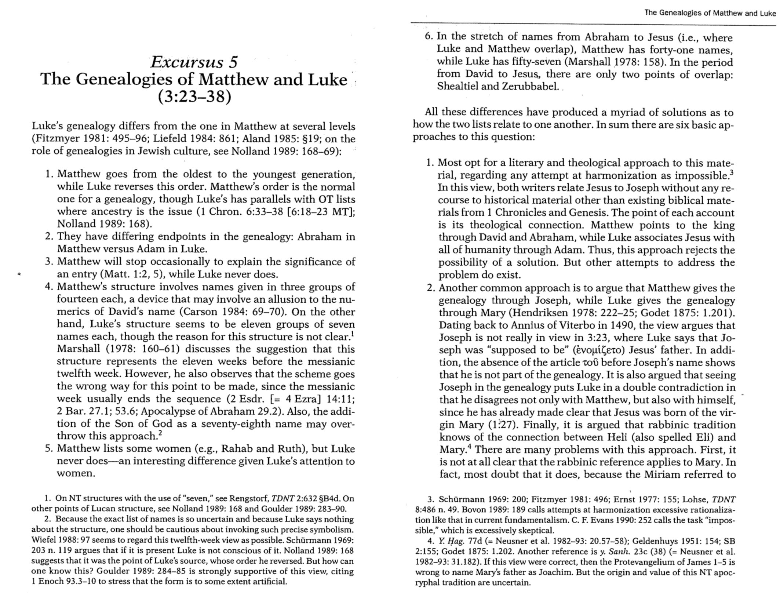
Contrasting Genealogies by Matthew and Luke
Darrell Bock, Luke, 2 vols., Baker Exegetical Commentary on the NT (Grand Rapids: Baker, 1994-95) 2 of 3
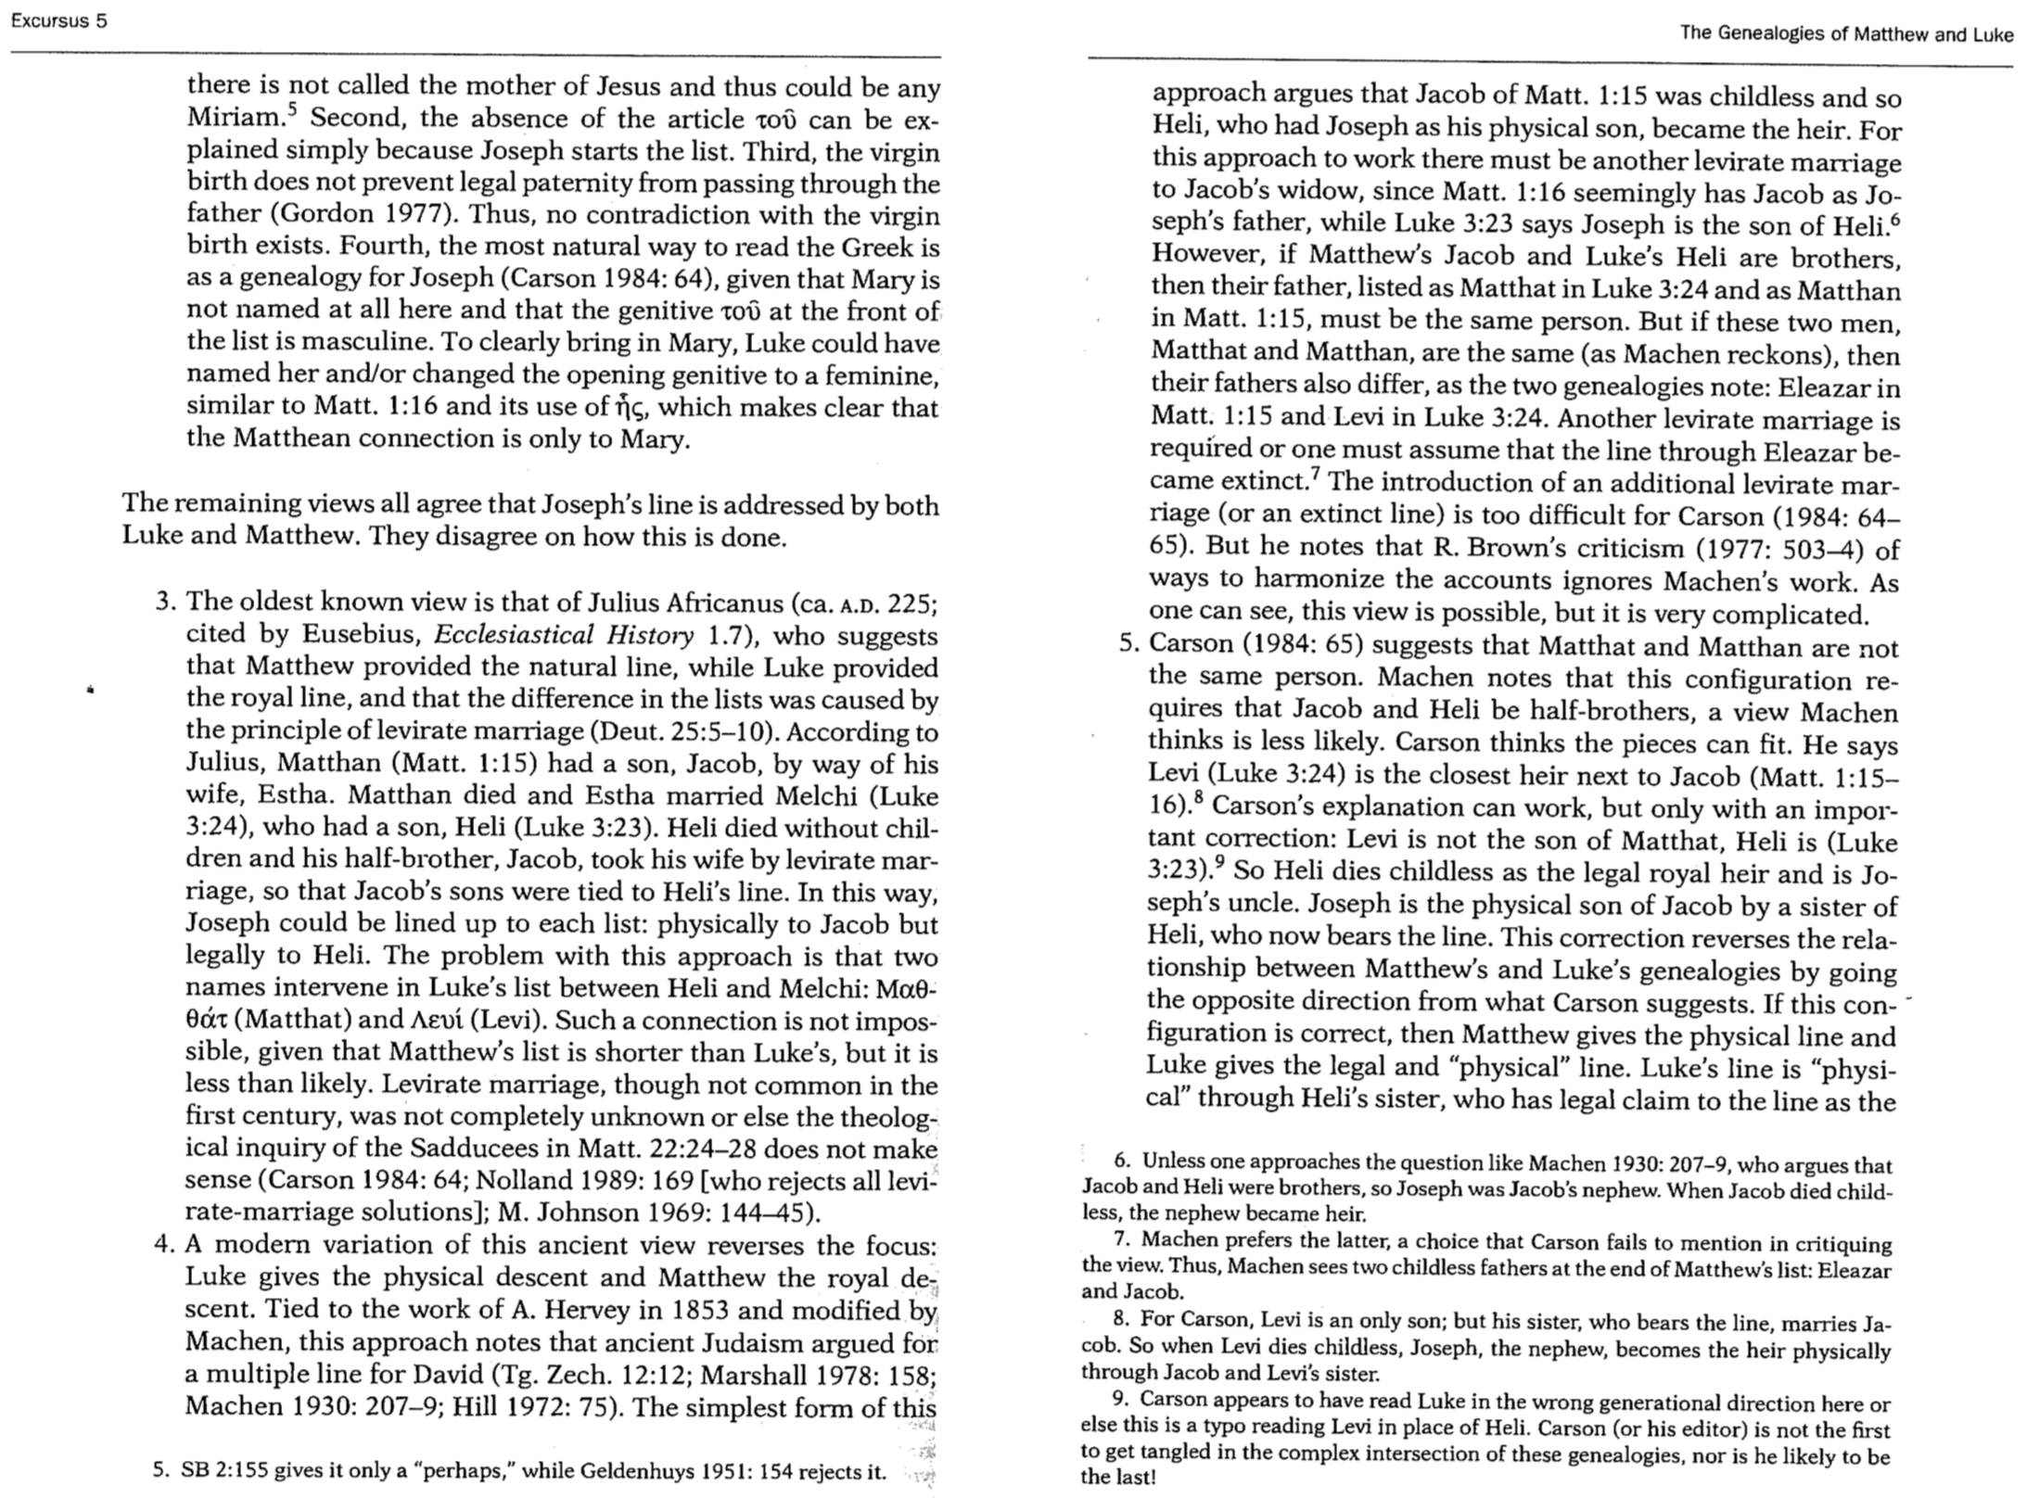
Contrasting Genealogies by Matthew and Luke
Darrell Bock, Luke, 2 vols., Baker Exegetical Commentary on the NT (Grand Rapids: Baker, 1994-95) 3 of 3

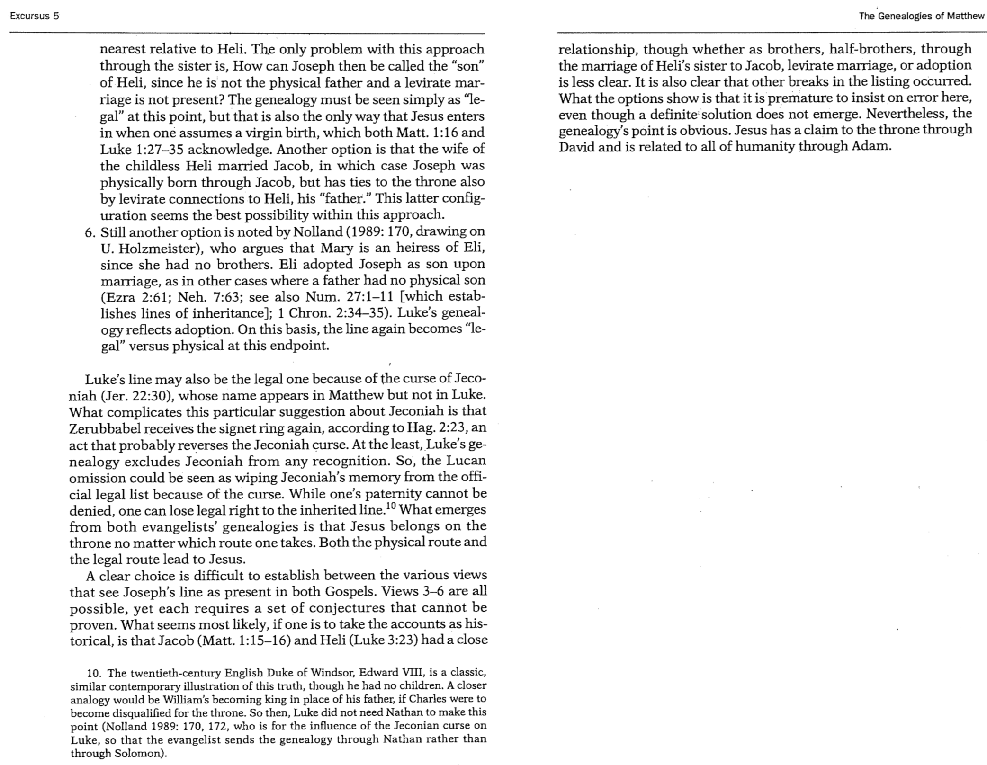

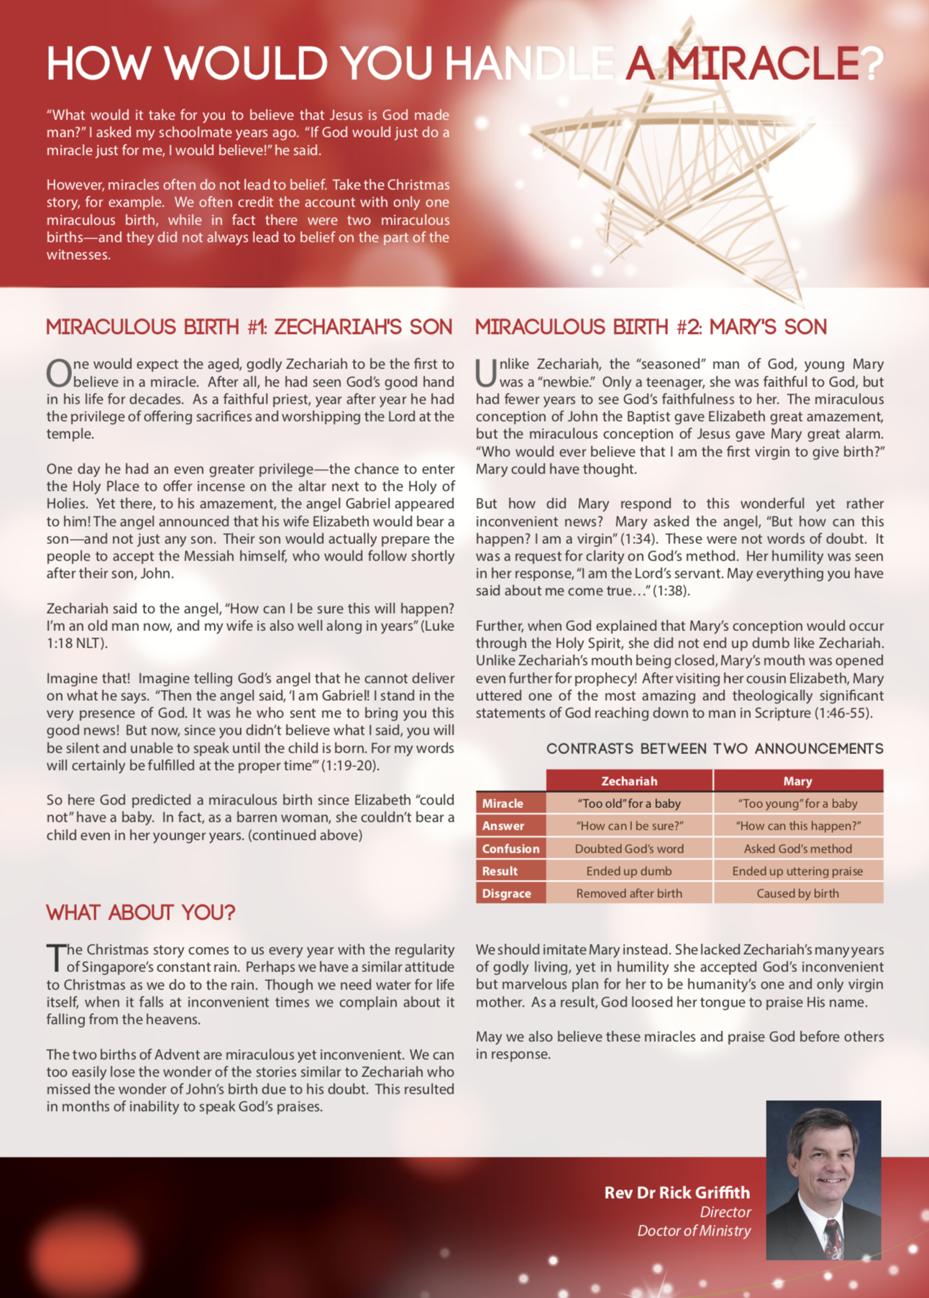
How Would You Handle a Miracle?
Rick Griffith, “Pray for Us” (Singapore: SBC)

“What would it take for you to believe that Jesus is God made man?” I asked my schoolmate years ago. “If God would just do a miracle just for me, I would believe!” he said.

However, miracles often do not lead to belief. Take the Christmas story, for example. We often credit the account with only one miraculous birth, while in fact there were two miraculous births—and they did not always lead to belief on the part of the witnesses.

Miraculous Birth #1: Zechariah’s Son

One would expect the aged, godly Zechariah to be the first to believe in a miracle. After all, he had seen God’s good hand in his life for decades. As a faithful priest, year after year he had the privilege of offering sacrifices and worshipping the Lord at the temple.

One day he had an even greater privilege—the chance to enter the Holy Place to offer incense on the altar next to the Holy of Holies. Yet there, to his amazement, the angel Gabriel appeared to him! The angel announced that his wife Elizabeth would bear a son—and not just any son. Their son would actually prepare the people to accept the Messiah himself, who would follow shortly after their son, John.

Zechariah said to the angel, “How can I be sure this will happen? I’m an old man now, and my wife is also well along in years” (Luke 1:18 NLT).

Imagine that! Imagine telling God’s angel that he cannot deliver on what he says. “Then the angel said, ‘I am Gabriel! I stand in the very presence of God. It was he who sent me to bring you this good news! But now, since you didn’t believe what I said, you will be silent and unable to speak until the child is born. For my words will certainly be fulfilled at the proper time’” (1:19-20).

So here God predicted a miraculous birth since Elizabeth “could not” have a baby. In fact, as a barren woman, she couldn’t bear a child even in her younger years.

Miraculous Birth #2: Mary’s Son

Unlike Zechariah, the “seasoned” man of God, young Mary was a “newbie.” Only a teenager, she was faithful to God, but had fewer years to see God’s faithfulness to her. The miraculous conception of John the Baptist gave Elizabeth great amazement, but the miraculous conception of Jesus gave Mary great alarm. “Who would ever believe that I am the first virgin to give birth?” Mary could have thought.

But how did Mary respond to this wonderful yet rather inconvenient news? Mary asked the angel, “But how can this happen? I am a virgin” (1:34). These were not words of doubt. It was a request for clarity on God’s method. Her humility was seen in her response, “I am the Lord’s servant. May everything you have said about me come true…” (1:38).

Further, when God explained that Mary’s conception would occur through the Holy Spirit, she did not end up dumb like Zechariah. Unlike Zechariah’s mouth being closed, Mary’s mouth was opened even further for prophecy! After visiting her cousin Elizabeth, Mary uttered one of the most amazing and theologically significant statements of God reaching down to man in Scripture (1:46-55).

Contrasts Between Two Announcements
 | Zechariah | Mary
Miracle | “Too old” for a baby | “Too young” for a baby
Answer | “How can I be sure?” | “How can this happen?”
Confusion | Doubted God’s word | Asked God’s method
Result | Ended up dumb | Ended up uttering praise
Disgrace | Removed after birth | Caused by birth

What About You?

The Christmas story comes to us every year with the regularity of Singapore’s constant rain. Perhaps we have a similar attitude to Christmas as we do to the rain. Though we need water for life itself, when it falls at inconvenient times, we complain about it falling from the heavens.

The two births of Advent are miraculous yet inconvenient. We can too easily lose the wonder of the stories similar to Zechariah who missed the wonder of John’s birth due to his doubt. This resulted in months of inability to speak God’s praises.

In contrast, Mary’s simple faith is admirable. This fits Luke’s purpose in his gospel to present Jesus not as the Jewish Saviour, but as the universal Saviour. Luke’s gospel often highlights Christ’s grace towards women and other outcasts of society. Mary lacked Zechariah’s many years of godly living, yet in humility she accepted God’s inconvenient but marvelous plan for her to be humanity’s one and only virgin mother. As a result, rather than being prevented from praise as was true of Zechariah, Mary used her tongue to praise His name.

May we also see God’s grace in these miracles and praise God before others in response.

Parables of Jesus
Bible Visual Resource Book, 199

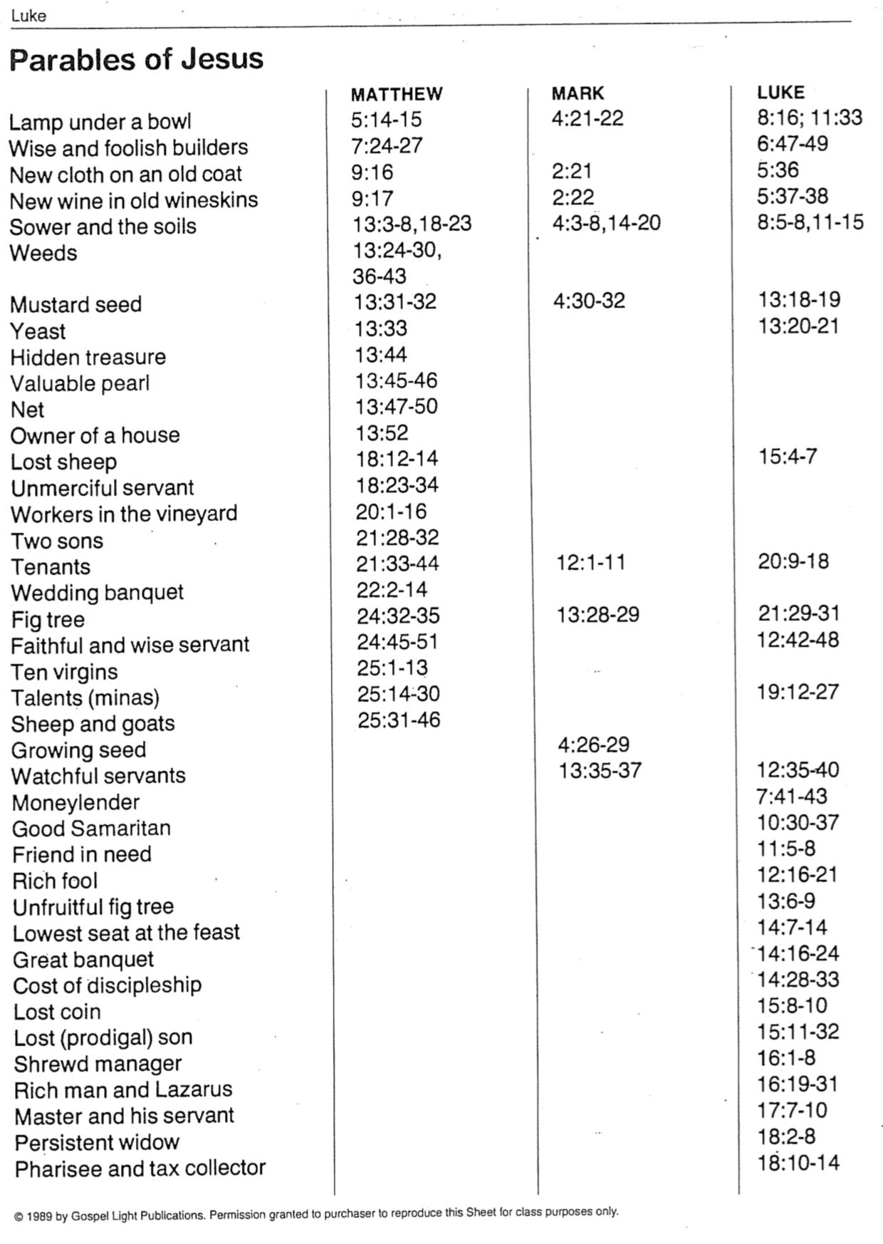
A Prodigal Returns
A First-Century Monologue of the Lost Son of Luke 15:11-31

(A man in tattered first-century garb walks wearily to the front of the audience.)

Problems at Home

At times we don’t like our brothers or sisters—but my problem was worse than that. I hated my older brother. Always hard working. Always submissive to Dad. Always… Mr. Right.

Not only that, there’s this custom called the birthright. This means the oldest son gets twice as much inheritance. That left two thirds for him, and only one third for me. As if I didn’t have enough problems already!

So, I told Dad, “Father, give me my share of the estate.” This was a lot to ask. Imagine giving away a third of your business and then try to survive against the competition!

But Father didn’t argue. With a grieved heart, he just gave me my share.

Problems Away

Pretty soon I gathered all that money and everything I had—and I headed far away for a good time. It wasn’t hard to leave because I hated my brother and had no friends at home.

Hmm, interesting. I discovered that in the distant land, all of a sudden, I had plenty of friends! Drinks were on me! The wild women noticed my wealth too. It didn’t take long for all my wealth to transfer over to them and I became the one in need.

Just when my “friends” disappeared, so did the food. A real tough famine came. I had never known hunger before, so my stomach pains were really intense.

But I got a job—if you can call it that—for a Gentile! A Gentile! He had me raise pigs—that’s as low as a good Jewish boy like me can get. My boss hadn’t paid me yet, so even the pods I threw to these unclean animals looked tasty after a while!

Then a thought hit me, “Even my Dad’s servants don’t go hungry like this! Yet here I am, starving to death! I’ll return to him and say, ‘Father, I’ve sinned against God and sinned against you. I don’t ever deserve to be called your son again. Take me as a hired hand.’”

My Return

On the long journey back home, I rehearsed my speech many times—not that I thought he’d reject me, but I wanted to say it just right.

As I approached my house, I wondered which servant I’d see first in the fields. Would it be Eliab? Jonadab? But no, it was my Father himself—still watching for me! He ran to me and I didn’t know what to expect. It looked like he would give me a punch in my hungry stomach—but then he gave me a great bear hug! He kissed me over and over so much I almost forgot my speech.

Then it came to me: “Father, I’ve sinned against God and sinned against you. I don’t ever deserve to be called your son again.”

Before I could get to the “take me as a hired hand” part my Dad was shouting to the servants, “Hey, Eliab! Jonadab! Quick! Bring the nice robe. Put the family ring on his finger and sandals on his feet! Roast that fat heifer! It’s feast time tonight! My younger son was dead but now has come back to life! He was lost and now is found!”

Conclusion

So, they did it. I never knew my Dad could party like that.

The grand feast happened so fast that they forgot to invite my brother. But he heard the music from the fields and, soon enough, he found out about it, stalking off in anger. Dad himself went out to the fields and begged him to come in.

Then he gave Father his own speech: “Look how many years I’ve slaved for you, never giving you a moment of grief. But have you ever thrown a party for my friends and me? No! Yet this idiot son of yours wastes your money on whores and you whoop it up with a feast?!”

Father had the last word though: “Son, you are with me now and the whole inheritance is yours. But we have to celebrate! Your brother was dead but is alive now! He was lost but now is found!”

How to Get a Camel Through the Eye of a Needle
(Luke 18:25)

The Problem

Jesus once encountered a rich young ruler who asked what he could do to inherit eternal life. Christ told him to sell everything and follow him, but the man went away sad as he was unwilling to part with his wealth.

Christ then responded with a proverb that “it is easier for a camel to go through the eye of a needle than for a rich man to enter the kingdom of God.” This saying is so important that each Synoptic writer records it (Matt. 19:24; Mark 10:25; Luke 18:25).

The problem we encounter is that Jesus appears to claim that no rich person can be saved—and yet each of us knows at least some wealthy believers! Are these people actually not Christians (!) or could we be misunderstanding what Jesus meant?

Proposed Mistranslations

Change the Camel: One solution to the severity of this proverb is to suppose that copyists confused the Greek words for “camel” and “cable” since they differ only by one letter (kamelon and kamilon, respectively). In this view, Jesus would be saying that threading a cable through a needle is certainly harder than using thread, but at least it is still possible—if the needle is large enough! However, though a few manuscripts do read “cable,” thousands of others render it “camel,” including the best and earliest manuscripts.

Change the Needle: The more popular response has been that the “needle” referred to here is not a literal sewing needle but rather a gate in Jerusalem. The gate was so small that camels had to crawl through on their knees. Many commentaries have followed this interpretation over the years. This second explanation appears to solve the problem, allowing rich people to get into heaven, while at the same time acknowledging that their riches do make it difficult for them to submit to the point of accepting Christ.

Problems with the Needle Gate View

No archaeological dig has ever found such a gate. We also have no sources that ever mention it as a possibility before AD 1100. While lack of evidence does not disprove the existence of a biblical event, when a literal understanding makes complete sense (i.e., an actual needle), one should reject other unsupported options that arise a millennium later.

The theology of a camel actually being able to enter a “needle” makes Jesus say exactly the opposite of his intent. The rich man held to the prevailing view of salvation by works (“what good thing must I do to obtain eternal life?” in Matt. 19:16). Jesus challenged his obedience to God’s commandments by telling him to give everything away to follow him. This meant that no one can trust in his wealth and also enter heaven. Another common belief was that riches showed God’s approval and a righteous life (= salvation). However, the “Needle Gate” hypothesis teaches that one can take his riches with him after his possessions are removed from the camel’s back long enough to get the camel through. (Obviously, no one would leave his treasures outside the gate, but would haul them into the city only to place them on the back of his camel again.) This false theology is refuted by the NT scholar Bruner:

The vice of the teaching that says “the needle’s eye is a low gate in the Middle East that camels must stoop to enter” is that it tells the well-to-do that by acts of humility they can get into the kingdom, that they can keep their comforts and even continue their drive for financial enrichment if they will only be a little humbler in the process. This teaching turns Jesus’ teaching on its head—it teaches how to be covetous and Christian at the same time. “The fact that such minimizing interpretations [as the cable or the gate] have been thought up is itself an eloquent comment on the passage” (Nineham, 275).

Not only was a “Needle Gate” never known in the time of Jesus or discovered later, this view is not known to be earlier than the time of Anselm, who served as Archbishop of Canterbury from AD 1093-1109. Bruner notes that this medieval gloss by Anselm “lives on still in countless sermons. Luz, 3:128n.59 comments appropriately: ‘More interesting than this misinterpretation is the question, Why has it remained so popular!’”

The NET Bible© notes, “The eye of a needle refers to a sewing needle. (The gate in Jerusalem known as ‘The Needle’s Eye’ was built during the middle ages and was not in existence in Jesus’ day.) Jesus was saying rhetorically that it is impossible for a rich person to enter God’s kingdom, unless God (v. 26) intervenes.” Evidently Christians named their newly built gate after Jesus’ saying, though their exegesis was wrong. Sadly, the gate built 1100 years after Christ has since been used to interpret Christ!

Conclusion

Interestingly, a small door within a city wall does exist today in Rothenburg, Germany. In fact, it is called the “Eye of the Needle.” One tourist notes,

The town of Rothenburg, Germany began with the construction of its first castle in 970. In 1142 the imperial castle was erected by King Conrad III.... At night, the town was locked up tight. If you stayed out too late, you had to identify yourself to the guards. If they believed you were who you said you were, they would let you enter the “Eye of the Needle” for a fee.

However, no door of the sort existed in Jerusalem during the time of Jesus. We must reject this legend and accept this difficult saying of Jesus as it appears—that it is not only difficult but impossible for the rich to get into heaven by their money or good works.

Principles of Discipleship from the Lukan Travelogue
(Luke 9:51–19:27)
Mark L. Bailey, Dallas Theological Seminary (1 of 2)

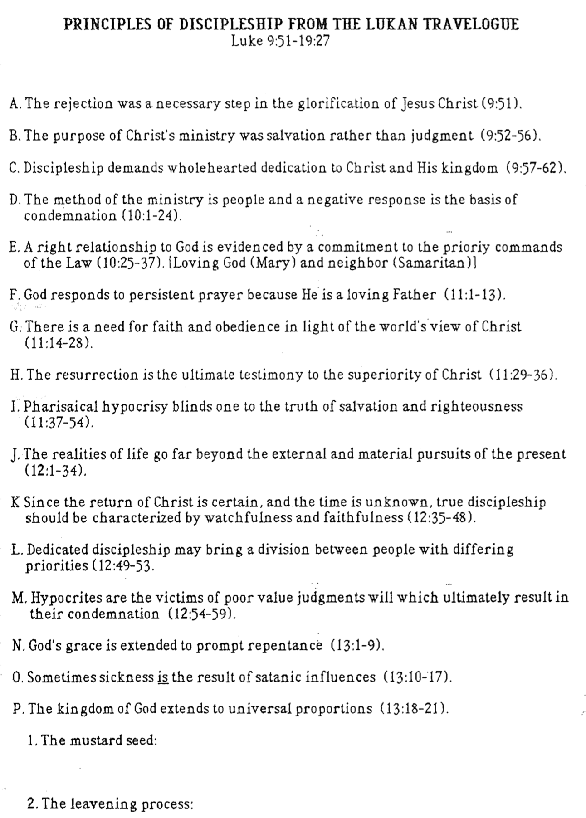
Principles of Discipleship from the Lukan Travelogue
(Luke 9:51–19:27)
Mark L. Bailey, Dallas Theological Seminary (2 of 2)

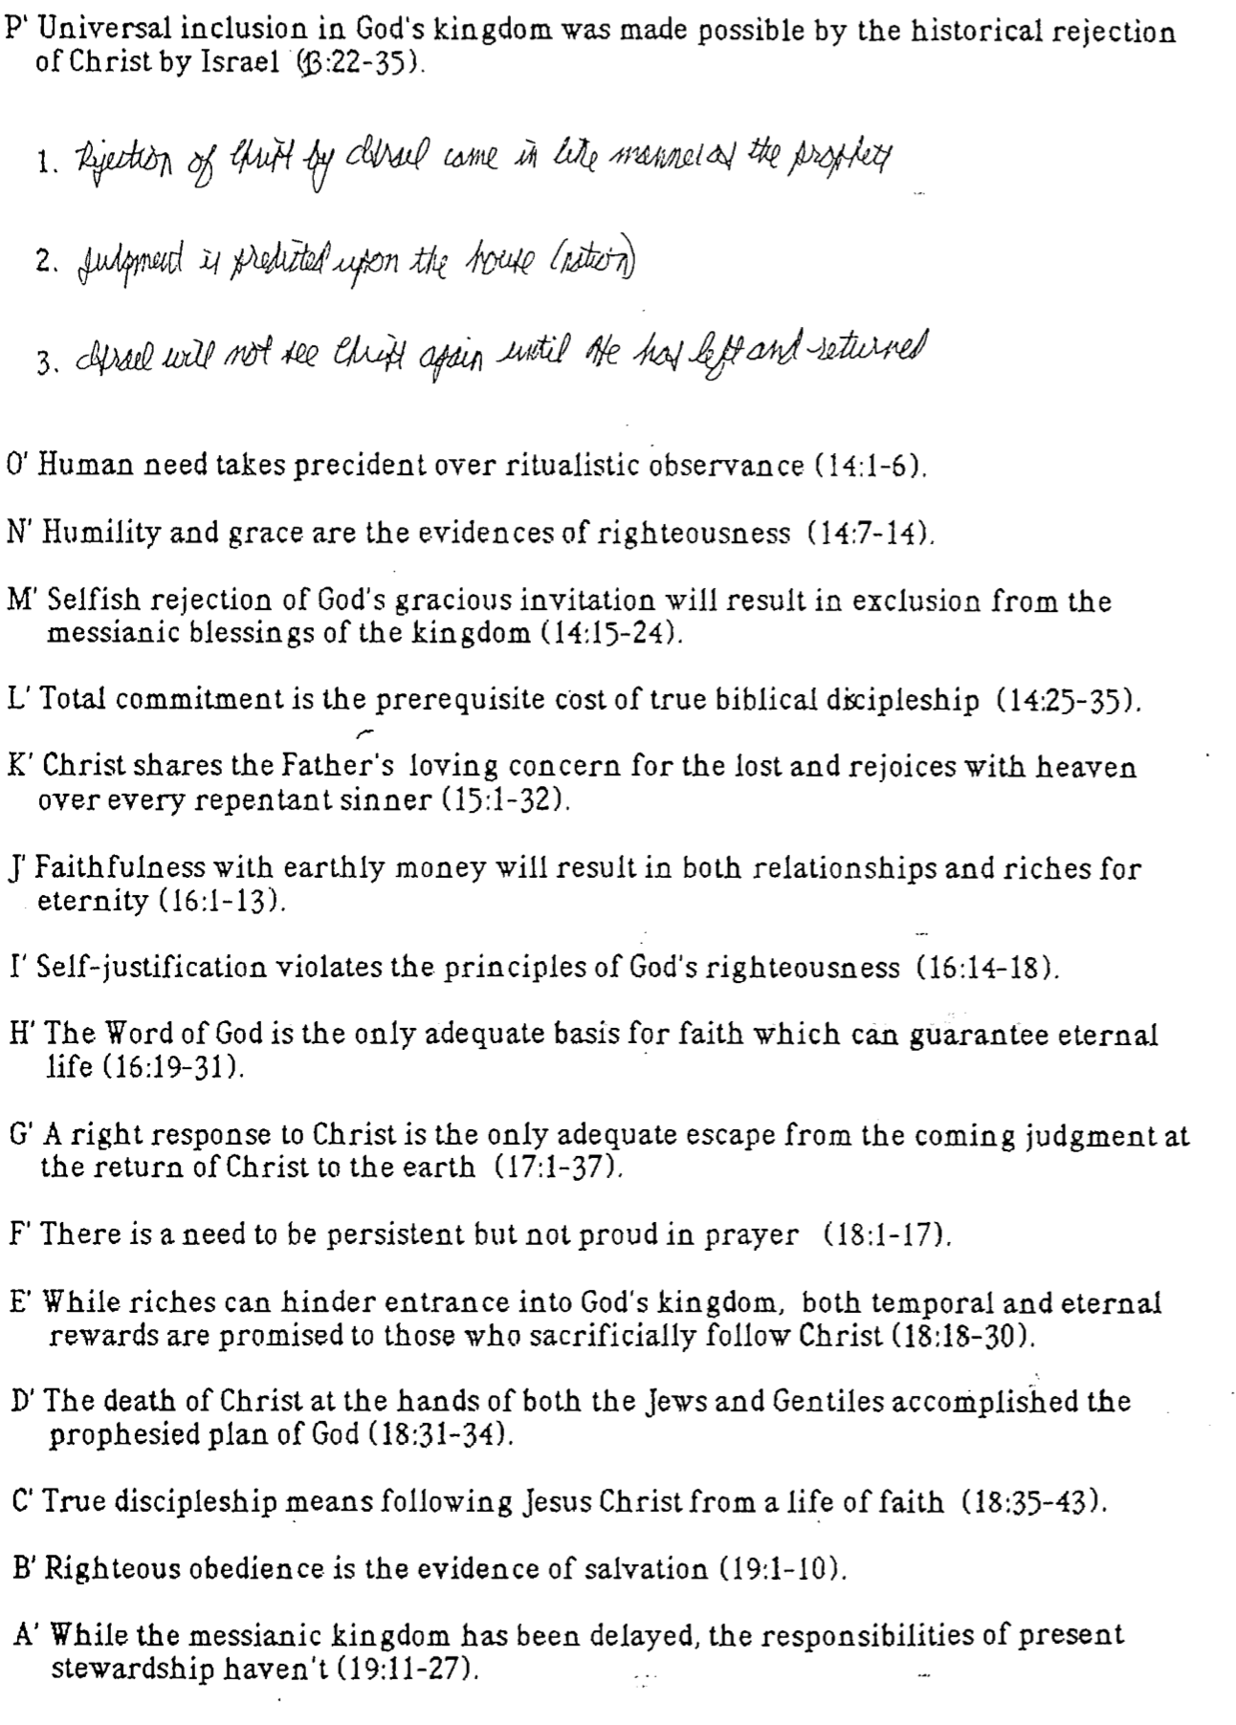

The Crucifixion of Jesus

(1 of 5)
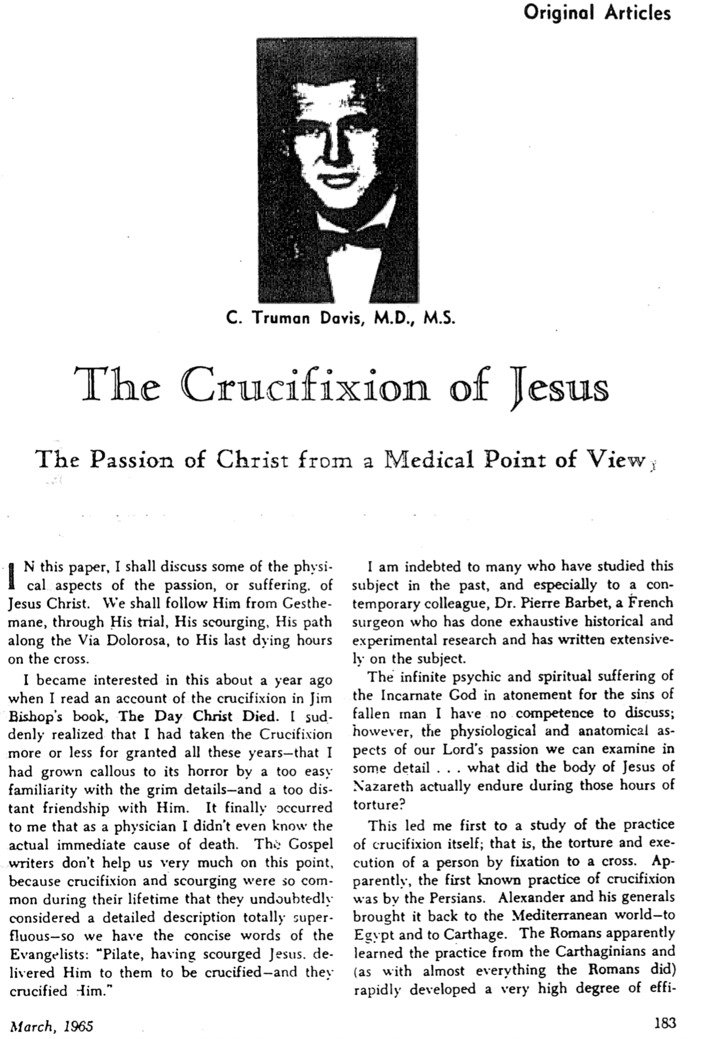

The Crucifixion of Jesus (2 of 5)

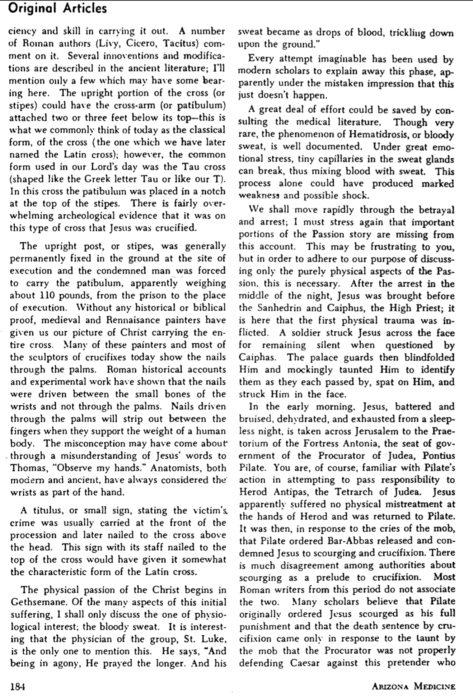

The Crucifixion of Jesus (3 of 5)

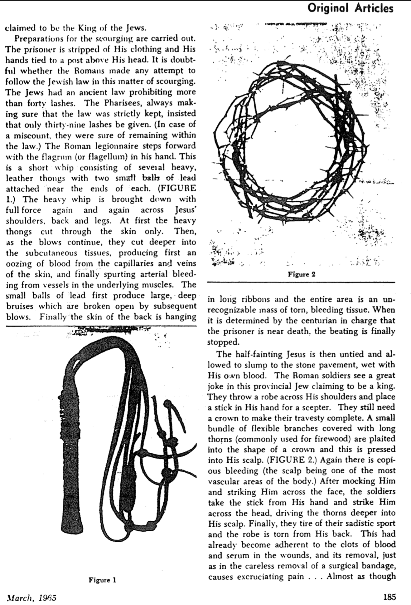

The Crucifixion of Jesus (4 of 5)

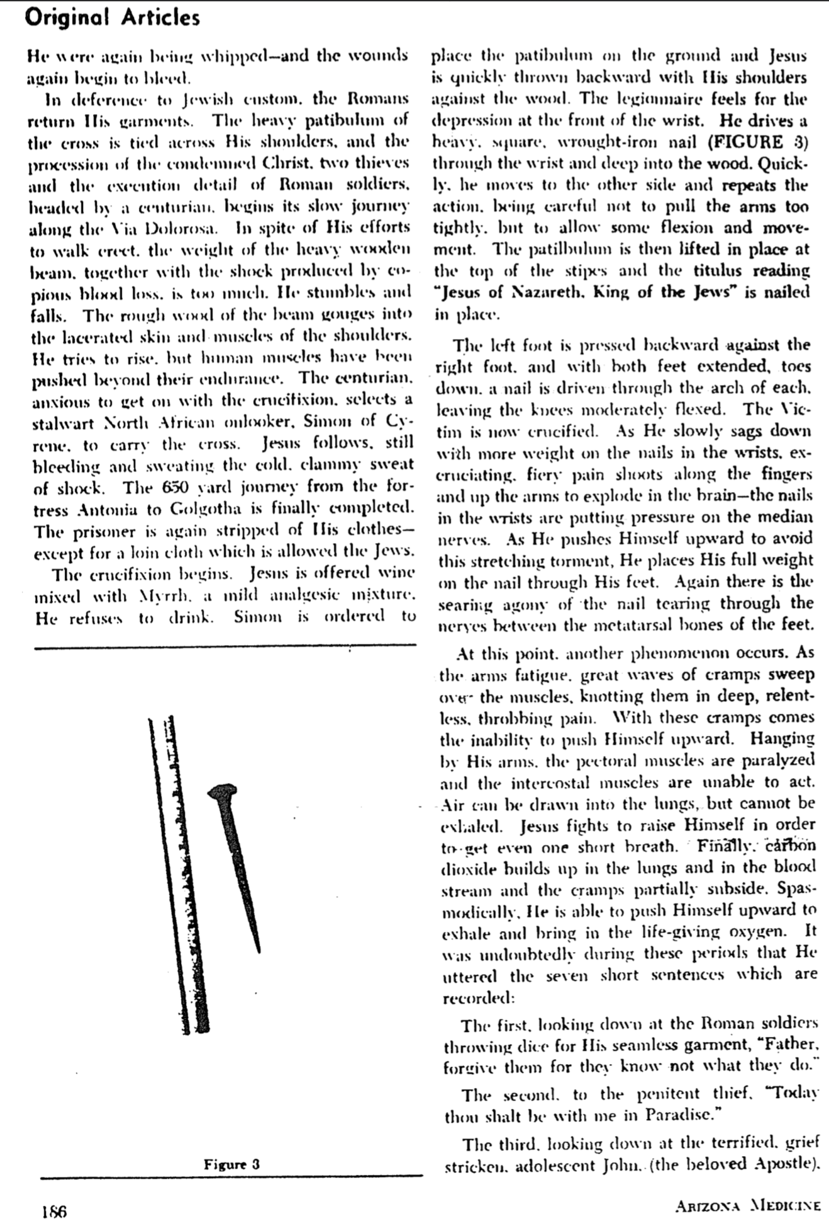

The Crucifixion of Jesus (5 of 5)

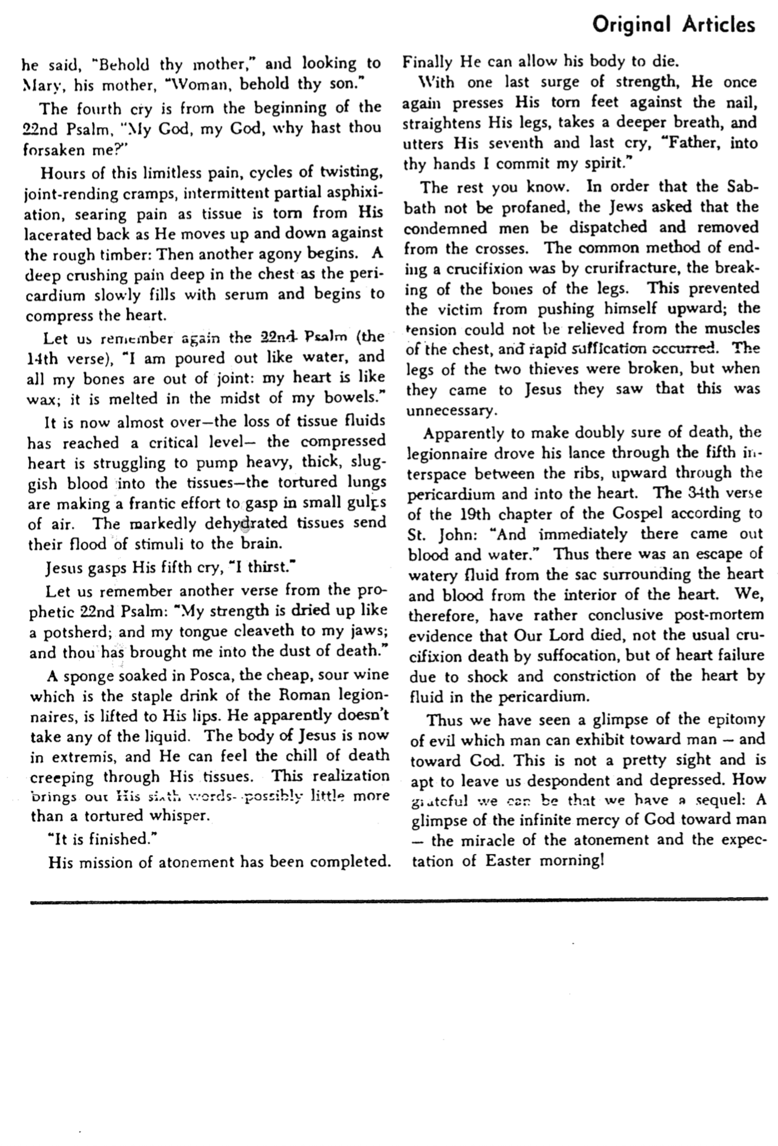

Proofs for Christ's Resurrection

Grace Baptist (Pinetree Town & Country Club) 20 April 1996 Dr. Rick Griffith
Crossroads International Church Singapore 16 April 2017 Single Message
NIV; PPT uploaded at the Topical Preaching link at BibleStudyDownloads.org 25 Minutes
Title

Who Moved the Stone?
Matt 24 Reading
Topical Message

Topic: Resurrection
Subject: Proofs for the resurrection of Christ
Complement: lead us to believe this is a historical fact.
Purpose: The listeners will believe intellectually that the resurrection took place.
Note: This message was originally preceded by Dr. Wee’s proofs that Christ indeed did die and followed by Dr. Poulson’s evangelistic closing (implications of the event).
Meditation: 1 Corinthians 15:58
Reading: Matthew 24
Song: Christ the Lord is Risen Today

Introduction
    - Attention: In February 2007 members of the media gathered at a news conference in New York to photograph two ossuaries (chests with human skeletal remains) said to have been found in a 2000-year-old tomb in Talpiot Jerusalem in 1980 that may have held the bones of Jesus and Mary Magdalene. Filmmaker James Cameron unveiled the artifacts in New York to promote a documentary film that claims scientists may have found the lost tomb of Jesus Christ and that—to support Dan Brown’s claim in The Da Vinci Code—Jesus and Mary Magdalene may have had a son named Judah. Time and again BBC and other news agencies report that archaeologists in Jerusalem have discovered the bones of Jesus of Nazareth. Is this true?
Da Vinci Code
Ossuary
What’s the Diff Black
    - Interest: This is no idle question, for since the first days of Christianity believers have claimed a resurrection for Jesus Christ. In fact, the resurrection of Jesus Christ and Christianity stand or fall together.
Difference it makes
      - Why? Christians claim to have a living relationship with the person of Christ. No one can have a relationship with a dead man.
World Religions
      - No other religion makes a claim of an empty tomb for its founder. If the claim of a resurrection is false then over one billion people have believed a lie (which is certainly possible, but would be sad indeed!).
What’s the Diff 1 Cor
      - Without a resurrection, Christianity would be the most vicious lie of history—for even today 245 people per day all give their lives for Christ.
833 martyrs daily
      - A dead Jesus invalidates all that he taught. He claimed to be “the resurrection and the life.”
Resurrect & Life
      - In other words, the resurrection is an issue of utmost importance!
    - Background: So, let’s evaluate what we know are the facts.
Facts
      - You are all thinking people, skilled in looking at facts in science, law, and business. I trust that you can look at evidence and weigh it for what it is like many have in the generations preceding you. I was trained this way in business school myself, being forced to make decisions based on balance sheets, cost analyses, and the like.
Thinking people
      - The facts show at least six precautions to assure that Christ would not rise again:
        - Fact 1: Christ was dead. If anyone knew how to kill, it was the Romans. One remnant of a crucified man shows the ankle wholly pierced with a massive nail.
1: Dead
(2 slides)
        - Fact 2: He was buried in a solid rock tomb according to the practice of the time
—a cave carved out of a rock wall with no entry except a 1.5-meter door.
2: Tomb
(2 slides)
        - Fact 3: The body was wrapped with a 45 kg (100-pound) encasement of grave clothes. These linen strips and gummy spices hardened into a cocoon case much like a mummy. The friends of Jesus would have had a hard time carrying such a heavy load.
3: Wrapped
(2 slides)
        - Fact 4: Engineers have calculated that a stone of nearly 2 tons would have been required to cover the 1.5-meter opening. The Bible says that after two days of burial this was rolled uphill away from the entire tomb area!
4: Stone
(2 slides)
        - Fact 5: A Roman guard was placed at the tomb to protect the body from being stolen. Some imagine a few men in miniskirts “guarding the tomb.” Hardly! A Roman guard was a 4 to 16-man force capable of withstanding an advancing army of enemy troops. These guys were tough dudes!
5: Guard
(4 slides)
        - Fact 6: The seal. After the guard inspected the body and rolled the stone into place, they stretched a cord across it, fastening it with sealing clay at either end. On the clay in the middle was stamped the seal of the governor. Breaking his signet would incur the wrath of Roman law.
6: Seal
(2 slides)
    - But something happened two days later that changed the course of history.
      - Today’s date testifies to it, for the date at the top—2017, “in the year of our Lord”—bears witness to the events of that day.
2017
      - In fact, you even have each Sunday off work due to belief in the resurrection, which eventually made Sunday a rest day!
Sunday
Cross
    - So, what happened with the body of Jesus?
      - Some have claimed that what happened was not a resurrection, but the so-called eyewitnesses went to the wrong tomb. Sounds plausible, especially for people mourning over the death of a loved one. I’m not sure how that will make angels appear at that wrong tomb, though!
Angels & Mary
Wrong Tomb
      - But the Jewish authorities didn’t have misty eyes! When it was proclaimed that Jesus arose, all these unbelieving authorities had to do was to bring people to the right tomb and display the body of Jesus!
Pharisee
    - No, somebody moved stone. You’re thinking, educated people. Let’s think through this together: Who moved the massive stone over Christ’s tomb (subject)?
Who Moved?

Robbers didn’t move the stone.
MP
[Random thieves certainly did not fake a resurrection.]
Why am I so convinced that grave robbers didn't take the body?
One author notes, "Aside from there being zero explicit historical evidence to support such a notion, there is strong evidence from history to show that this would not have possibly happened, and that comes from an artifact known as the Nazareth Inscription. It likely dates to either the reign of Julius Caesar, or perhaps Augustus — at about 30 BC – [14] AD. This is what it says:"
Caesar
(3 slides)
  - The well-known edict of Caesar proclaimed the death penalty for those who disturbed graves.
Possible?
  - Besides, there was no incentive or wealth buried with Jesus—plus they would have to risk their lives against the Roman contingent. And John says that the headpiece on Jesus was folded by itself. Why would robbers leave any of the grave clothes?
Romans?
Neat clothes?
- Disciples didn’t move the stone.
MP
[The followers of Jesus certainly did not fake a resurrection.]
  - Why not? They were least expecting a resurrection! Nearly every disciple fled when Jesus was crucified and then locked themselves up like scared chickens in a hen house.
Despond
  - But within a few days they changed from fearful men to fearless men boldly proclaiming the resurrection—and ten of the eleven disciples died a martyr’s death for their faith. Would you give your life for a lie? That’s not courage but insanity!
  - Jesus’ followers were mostly fishermen by trade. Can we really believe that such men could fight through a Roman guard and move a 2-ton stone? You’ve heard of the Jewish 6-day war? This would have been the Jewish 6-second war!
Hands
  - Even still, the rumor that the leaders spread was that the Roman soldiers saw the disciples steal the body while they were asleep. Tell me, friends, have you ever seen anybody steal anything when you were asleep?
Guards floored
  - Do you know the penalty for Roman soldiers who fell asleep on duty? Especially at night? Automatic execution by having his clothes set on fire! These soldiers would be banging each other on the head to keep awake! Not one of these guards would have been asleep—let alone the whole bunch of them!
Pilate

(So, Jesus’ disciples didn’t move the stone. What about the unbelieving authorities? No, the…)
- Jews didn’t move the stone.
Jews
[The religious authorities in Jerusalem certainly didn’t want to fake a resurrection.]
Close-Up
  - They were the ones to try to prevent the stone from being moved!
Jews Standing
  - The Jewish leaders were the ones who requested the Roman guard.
  - If the Jews took the body not anticipating that others would see this as a resurrection, all they had to do was to publicly show the body! They felt that a fake resurrection would lead to even more followers of Jesus. No one out of envy aids his opponent!
Grave Clothes

(So, neither the disciples nor Jewish authorities moved that stone. What about the Romans? No…)
- Romans didn’t move the stone.
MP
[Guards funded by the occupying power had no interest in suicide by not doing their job.]
  - The Roman soldiers were the ones commanded by Pilate to guard the tomb!
  - Do you know the penalty for a Roman soldier who let the seal get broken? Execution again! You can be sure they guarded it for fear of death itself.
  - As hard as they tried to protect it, though, the Bible says that an earthquake occurred, the seal was broken and then the guards became the scared chickens. In fact, they were the first witnesses to the resurrection! They told the religious leaders about it and even made some money off by taking a bribe. The Jewish authorities also protected their lives.
  - The 2016 movie “Risen” accurately depicts the plight of the Romans who needed to find the body to prevent the resurrection story from being spread.
Risen
(4 slides)

(No grave robber, disciple, Jewish leader, or Roman soldier would have stolen the body. And if an unbeliever ever found a body, the enemies of Christianity would have paraded it through Jerusalem to kill this new faith in the womb. And who would have become a believer in Jesus by seeing a dead body—or even die for a hoax? No, it stands to reason that…)
- Jesus Christ moved the stone!
MP
[Our Lord is the only reasonable option for the empty tomb—so he rose from the dead!]
  - And why not? Several times before his death he predicted that he would die and rise again.
Large Stone
  - But you say, “Maybe he did it, but he didn’t actually die.” Suppose Jesus wasn’t really dead.
    - No, he was up all night in six trials that included being beaten beyond recognition…
    - Was so weak he couldn’t even carry his own cross…
    - Was crucified with seven-inch nails driven through his hands and feet…
    - Received a spear thrust into his heart…
    - Was put into a 100-pound cocoon of grave cloths…
    - Laid in a dark, cold, wet tomb with a nearly 2-ton doorway…
  - But, instead of all of these things killing him, it healed him?
    - He split out of the clothes…
MI
    - He pushed the stone uphill away from the tomb…
    - He conquered the entire group of guards…
    - He appeared to his disciples and never even got any pity from them?
  - Sorry, I don’t have enough faith to believe that! That’s even more miraculous than a resurrection!

Conclusion
    - Since no person would have or could have moved the stone, a supernatural resurrection must have occurred (Main Idea)! We have exhausted all reasonable options. Jesus rose!
    - I appeal to you as intelligent friends. Christianity is based on the most incredible event of history—the resurrection of Jesus Christ.
Garden Tomb
    - In the 1920s, the skeptic Frank Morison set out on a quest to disprove the resurrection. His research ended in proving what he tried to destroy, so instead he wrote the classic book, Who Moved the Stone?
He is Not Here!
Morison Book
    - Why is this important? It relates to the message we preach called the gospel, or Good News. This news includes the death, burial and resurrection of Christ.
Gospel Circle
Garden Tomb
    - It is based in history as you can visit the tomb today to see it for yourself.
    - It’s not an issue as much as it is a Person—the Person of Jesus Christ of Nazareth.
Jesus
    - Jesus came alive and never died since. That means that he is as alive today as you or me. It also means that as God himself he can change your life as a living Saviour.
Resurrect Life!
    - As he reached out his hand to give his followers bread, so he is reaching out to give you himself as the True Bread from heaven right now. Will you accept him?
Jesus & Bread

Because He Lives
Implications of Christ’s Resurrection

Small Group Question: What difference does Christ’s resurrection make in your life? What implications of Christ being alive today can be gleaned from the passages below?

Christ’s resurrection affects you in many ways!

Christ’s resurrection gives you a new day of worship.

John 20:1, 19, 26

Acts 20:7

Rev. 1:10

Christ’s resurrection proves that Jesus taught truth.

Acts 2:32, 36

John 14:6

Christ’s resurrection gives you forgiveness.

Rom. 4:25

1 Cor. 15:17-19

1 Pet. 1:3

Christ’s resurrection gives you victory over sin in your life.

Rom. 6:10-11

Rom. 6:14

Christ’s resurrection gives you assurance of a new body in the future.

1 Cor. 15:51

1 John 3:2

Luke 24:31, 36

1 Cor. 15:20

How then should you live?

Believe that Christ is alive (1 Cor. 15:58a).

Serve Him fully (1 Cor. 15:58b).

Work for rewards (1 Cor. 15:58c).

Conclusion

Christ’s resurrection gives you lots of benefits, so serve Him and He will reward you! (Main Idea)

Which of the five results or implications of the resurrection means the most to you?

How will you respond? What specifically can you do to show that Christ being alive today is something you genuinely believe?

Capernaum Synagogue & Resurrection Appearances
Bible Visual Resource Book, 201

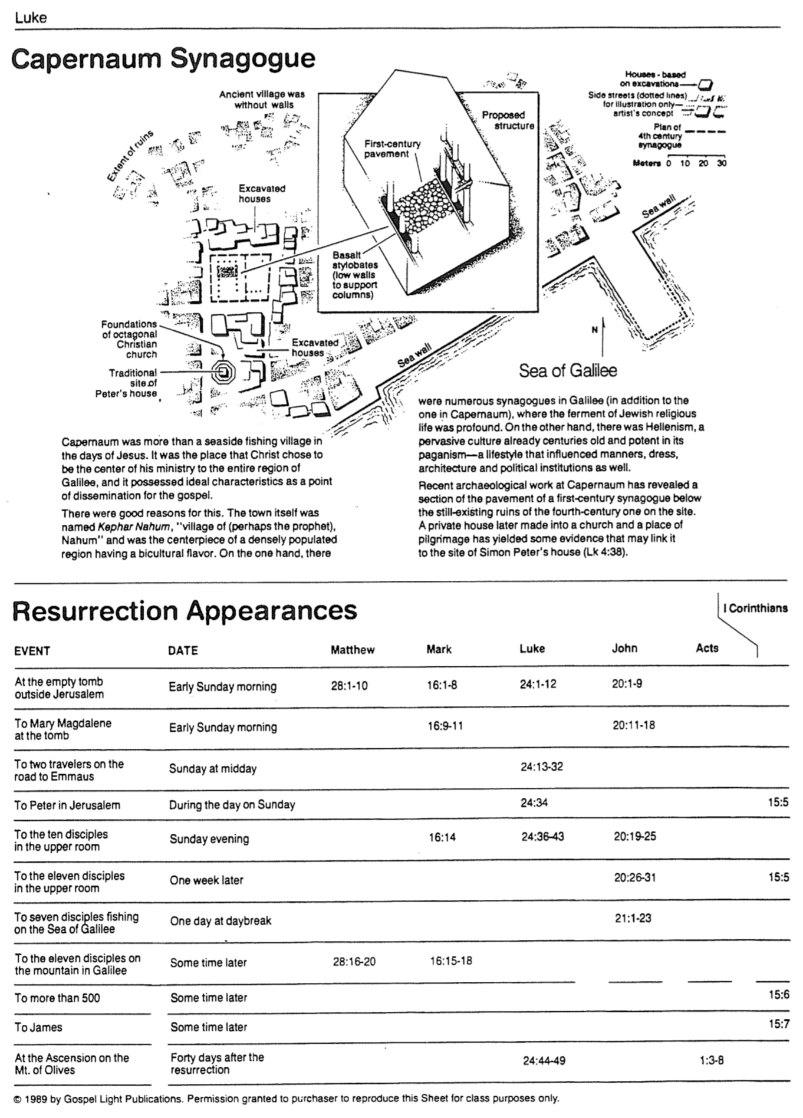
The Church and Kingdom (Luke 19:41-44)
Adapted from Raymond Ludwigson, A Survey of Bible Prophecy (Grand Rapids: Zondervan, 1975), 83

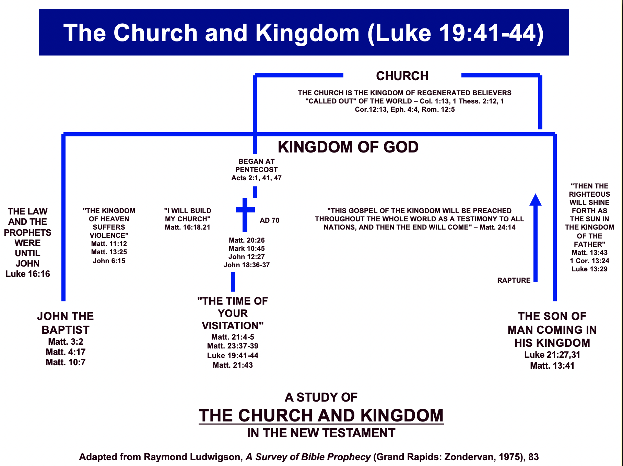

The Times of the Gentiles (Luke 21:24)
Adapted from Raymond Ludwigson, A Survey of Bible Prophecy (Grand Rapids: Zondervan, 1975), 181
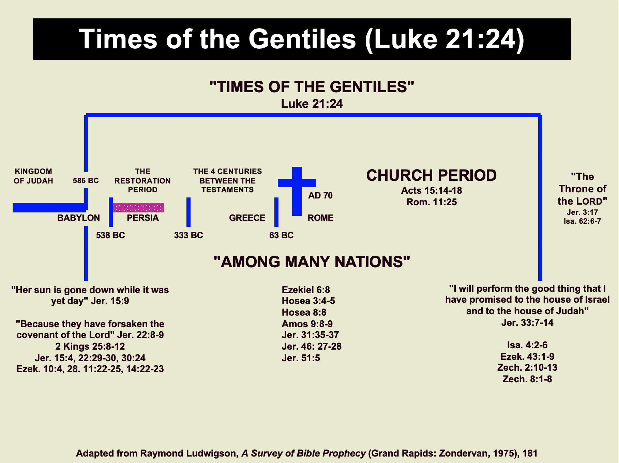

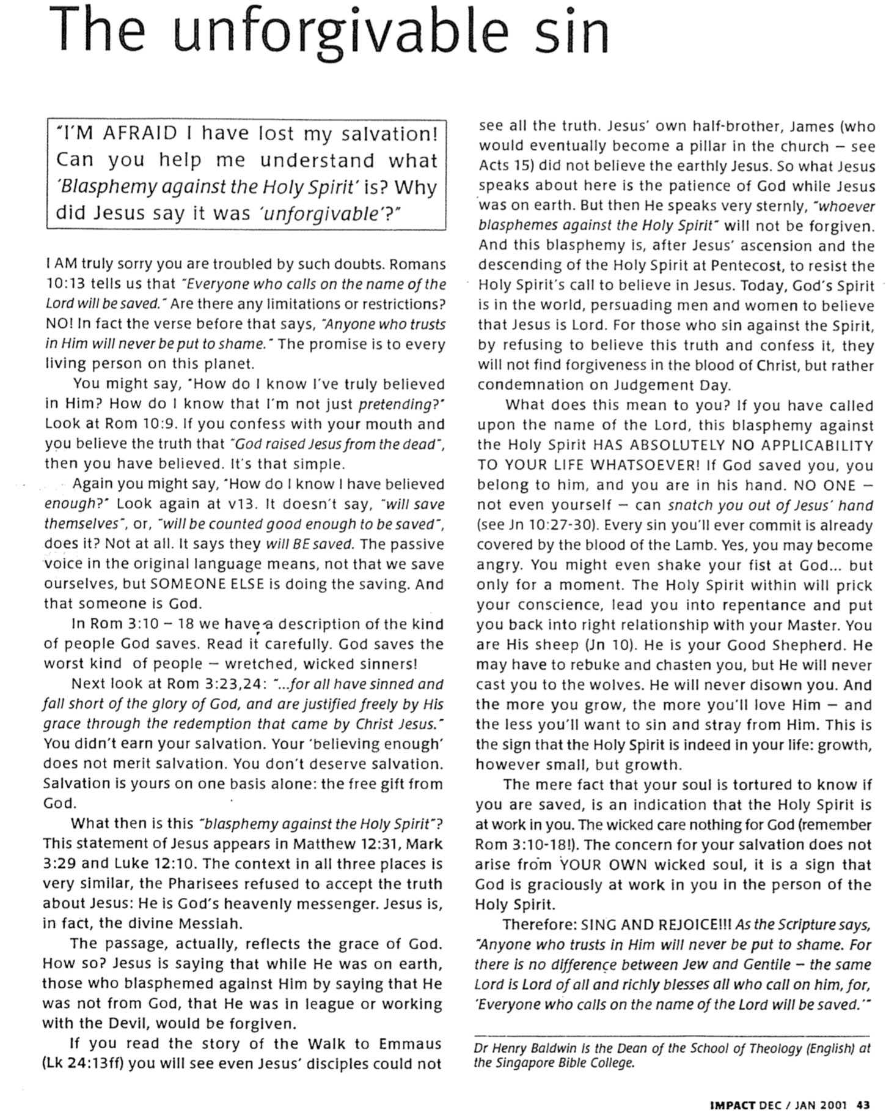
The Unforgivable Sin

Satan at the Cross
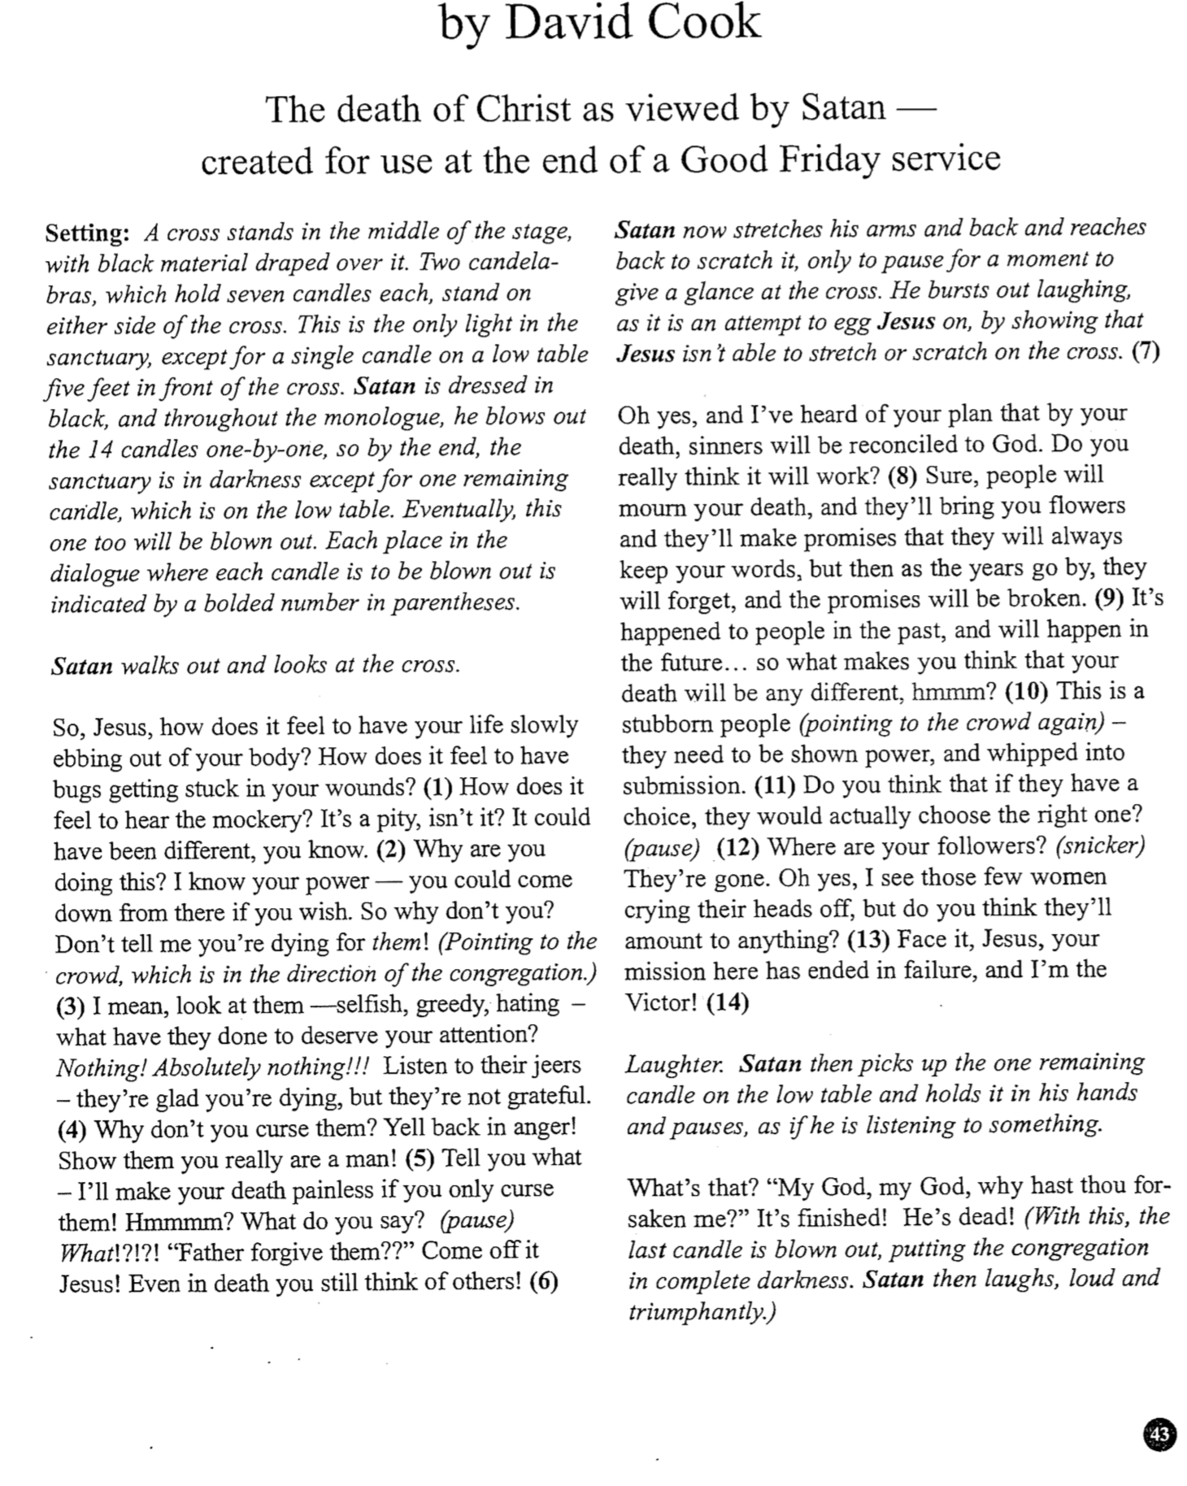

The UBS4 Greek textual apparatus cites only seventeen late sources for “cable” (e.g., f¹³ 180 579 1010 1424 ten lectionaries Cyril [AD 444] Arminian [Georgian version]) while “camel” has evidence from thousands of the earlier and better sources, including a (Sinaiticus, 4th cent.), A (Alexandrinus, 5th cent.), and B (Vaticanus, 4th cent.).
The Pharisees were wealthy, so people reasoned that Pharisees must also be godly, but Jesus taught that people’s righteousness must surpass Pharisaical standards (Matt. 5:20). Becoming right with God came only by hearing and acting upon Christ’s words as a foundation (Matt. 7:24), both of which came by faith.
Frederick Dale Bruner, Matthew, a Commentary: Matthew 13-28, 2d ed. (Grand Rapids: Eerdmans, 2004), 305. Also arguing against the needle gate are Craig Blomberg, Matthew (Nashville: Broadman, 1992), 299; Darrell L. Bock, Luke 9:51-24:53 (Grand Rapids: Baker, 1996), 2:1485; John A. Martin, “Luke,” Bible Knowledge Commentary: NT (Wheaton: Victor, 1983), 251; Walter W. Wessel, “Mark,” Expositor’s Bible Commentary (Grand Rapids: Zondervan, 1984), 8:716; Robert L. Thomas, “Needle’s Eye,” Zondervan Pictorial Bible Encyclopedia (Grand Rapids: Zondervan, 1976), 4:402; James A. Patch, “Needle,” International Standard Bible Dictionary; “Needle,” Easton’s Bible Dictionary; Gordon Fee and Douglas Stuart, How to Read the Bible for All Its Worth, 3d ed. (Grand Rapids: Zondervan, 2003), 25.
Bruner, 306; he also cites the Anselm gloss as in C.A. (Cosmological Argument?), 670. D. A. Carson, “Matthew,” Expositor’s Bible Commentary (Grand Rapids: Zondervan, 1984), 8:425 notes that this “misguided… conjecture may come from some of Jerome’s allegorizing (cf. Broadus).”
See the NET Bible© footnote 31 on Luke 18:25 (emphasis theirs).
See the account and picture by Mr. Sedivy (Highlands Ranch High School history teacher in Colorado) at http://members.tripod.com/~mr_sedivy/roth_tour.html. This is also noted in the official Rothenburg site at http://www.romanticroad.com/rothsigh.htm.

