Daniel

Universal Sovereignty in Times of the Gentiles

Sovereignty  over Daniel |  |  | Sovereignty  over Gentiles |  |  |  |  |  | Sovereignty  over Jews
Chapter 1 |  |  | Chapters 2–7 |  |  |  |  |  | Chapters 8–12
Narrative |  |  | Visions  in Narrative |  |  |  |  |  | Visions
Hebrew |  |  | Aramaic |  |  |  |  |  | Hebrew
Gentile  Names for God |  |  | Gentile  Names for God |  |  |  |  |  | Jewish  Names for God
Third Person  (“Daniel”) |  |  | Third Person  (“Daniel”) |  |  |  |  |  | First Person  (“I”)
Daniel’s  Example |  |  | Daniel Interprets  King’s Dreams |  |  |  |  |  | Angel Interprets  Daniel’s Dreams
 |  |  | Images |  | Kings
Exile  1:1-7 | Food  1:8-16 | Exaltation  1:17-21 | Varied  2  Promoted | Gold  3  Furnace | Neb.  4  Exile | Bel.  5  Party | Dar.  6  Lions | All  7  Beasts | Medo-Persia to Greece  8 | Return  to  Seventy “7s”  9 | Intertestamental Period to Tribulation  10–12
Babylon

605-536 BC

Key Word: Sovereignty

Key Verse: (Daniel to God) “…Praise be to the name of God for ever and ever; wisdom and power are his. He changes times and seasons; he sets up kings and deposes them…” (Daniel 2:20-21a).

Summary Statement:
The exiles could be confident by resting in God’s sovereignty over them as individuals, over all nations and over Israel until the times of the Gentles end with the nation under Messiah.

Application:

We need not fear political and personal trouble since God rules all nations.

Daniel

Introduction

I. Title Daniel (laenID; dani'el, Ezek. 14:14, 20; 28:3; laYEnID; daniye'l , Dan. 1:3, etc.) means literally "El [God] is my judge" (BDB 193b 4). While liberals have said that the difference in spelling above indicates two separate persons, this is unnecessary as Ezekiel wrote about 50 miles away and at the same time as Daniel, who was an important government figure. The meaning of the name is fitting since the main focus of Daniel's writing declares God's sovereign right to judge.

II. Authorship

A. External Evidence: Ezekiel lists Daniel along with Noah and Job as models of righteousness (Ezek. 14:14, 20) and wisdom (28:3). This shows that his reputation as a man of character spread quickly. Christ acknowledged Daniel 9:27 as spoken by "Daniel the prophet" (Matt. 24:15), but others note that Jesus did not say that it was written by Daniel (LaSor, 667). Evidence from the Jewish Talmud contradicts this claim as it attributes the work to Daniel (TTTB, 221). However, LaSor, 667, notes that B. Bat. 15a indicates that "a Jewish tradition placed some sort of editorial responsibility for Daniel on the men of the Great Synagogue, sometime between Ezra (ca. 450) and Simeon the Just (270)." However, the fact that Jews accepted the work into the canon of Scripture bears witness that Daniel indeed was the author as the internal evidence indicates below.

B. Internal Evidence: While many have sought to discredit Daniel as author, the letter itself supports it as Daniel is expressly called the writer (7:2; 8:1; 9:2; 12:4) and he uses the autobiographical first person throughout the prophetic section (7:2–12:13). Since the first section has historical (not prophetic) material written in the third person, some have inferred a multiplicity of authors, especially since Daniel uses two different languages. However, the different content explains the change in languages and this practice was not unusual. Also, ancient literature often used different literary forms (e.g., historical and prophetic) to heighten contrast, as in the book of Job, which consists mainly of poetry with the exception of the prologue (Job 1–2) and epilogue (42:7-17).

Daniel was a youth taken captive by Nebuchadnezzar in 605 BC because he was of nobility or from the royal family (1:3). He was trained in the Babylonian court because of his health, good looks, intelligence, and ability to learn quickly (1:4). He proved to possess an unusual commitment to the LORD as a youth who held to his standards without compromise (1:5, 8-20), could understand dreams (2:27), and possessed great administrative skill. As a result, he served under several administrations over the entire seventy-year exile until the third year of Cyrus (536 BC; 10:1). If he was 16 when captured then he would have been 85 in Cyrus' third year after which he retired! This chronology places his birth year at about 621 BC, at about the same time as Ezekiel, who was born about 622 BC (see Ezekiel notes). Therefore, these contemporaries were roughly the same age although Ezekiel was taken to Babylon eight years after Daniel (in 597 BC).

III. Circumstances

A. Date: The biographical data above shows that Daniel wrote from 605 (1:1) to sometime after 536 BC (10:1). Nevertheless, the date of Daniel has been debated more than in any other biblical book (LaSor, 665). Many liberal scholars date the work around 164 BC and others in the fourth or fifth century (e.g., LaSor, 666). A late date is held generally for three reasons (TTTB, 222):

1. The prophetic argument holds that Daniel could not have made so many accurate predictions that were fulfilled between the exile and the Maccabean era (ca. 164 BC). Chapter 8 very specifically foresees the rise of the Persian and Greek empires, and chapter 11 details over one hundred specific prophecies, including those about Alexander the Great and his four generals who succeeded him (11:3-4), the Ptolemies and Seleucids (11:5f.), and especially the desolation of the temple by Antiochus IV Epiphanes in 168 BC (11:31). Late date advocates believe that such knowledge could only be known "after the fact" and therefore consider Daniel as recounting history rather than giving predictive prophecy. They claim that the kingdoms mentioned in chapters 2 and 7 were recorded as history and ended at 168 BC, then Daniel’s prophecy was then written within four years (168-164). Since there is no historical evidence that 11:40-45 can be applied to Antiochus (he died in 164 BC), this must be an inaccurate prediction.

2. The linguistic argument claims that the book uses a late Aramaic in chapters 2–7 and Persian and Greek words that could only have been known in the second century. A median date of the fourth or fifth century has also been advocated based upon linguistic evidence (e.g., by LaSor, 666).

3. The historical argument asserts that Daniel inaccurately recorded the reigns of some kings, especially with the lack of evidence that Nebuchadnezzar was insane for seven years (4:25, 32).

How can we respond to these claims? The late date theory falls on several fronts:

1. The prophetic argument begins with the assumption that prophecy cannot happen, which is foreign to the entire tenor of Scripture. Daniel repeatedly states that his prophecies come from God, not man (2:27-28; 4:9), and God certainly knows the future. Also, it is impossible that Daniel’s prophecy could have been written after 168 and then copied and circulated so that it gained acceptance within four years before the “never fulfilled” prophecies of 11:36-45 could be exposed as inaccurate.

2. The linguistic argument also is invalid as the language of the book is earlier than the second century (LaSor, 666). The Hebrew resembles that of the Chronicles and the Aramaic (2:4b–7:28) is closer to that of Ezra and the fifth-century papyri than to that of Qumran (second century). Similarly, one should not be surprised to find Persian words since Daniel lived in the Persian period under Cyrus! Finally, the only Greek words are the musical instruments, which would be expected as Greek mercenaries served in the Assyrian and Babylonian armies. Even more Greek words would be expected if the book was composed in the second century Greek period.

3. The historical argument also has recently been proved wrong as recent inscriptions found at Haran show Belshazzar reigning in Babylon while his father Nabonidus was fighting the Persians. Further, while liberals thought Darius the Mede (5:31; 6:1) to be fictitious, now archaeological finds have identified him as Gubaru, a governor appointed by Cyrus (TTTB, 222). Finally, there exists no attested activity by Nebuchadnezzar from 581-573 BC except the ongoing, drawn out siege of Tyre that took 13 years (Hill and Walton, 350).

4. The late date view denies the authorship of the book by Daniel (see Internal Evidence above). Daniel lived before (605 BC; cf. 1:1-6), throughout (Dan 1–9), and after (536 BC; cf. 10:1) the 70-year captivity. This means that the writing must have occurred from 605-536 BC.

5. The 1947 Dead Sea Scrolls discovery includes a second century BC Daniel scroll in the Qumran Community (ca. 100 BC–AD 68). This find makes the late date of 164 BC impossible as it requires a period of less than six decades between the date of composition in Babylon and the final, copied form in this small community in Israel!

6. Daniel is found even earlier as it appeared in the Septuagint (Greek translation of the OT in ca. 250 BC). How, then could it have been written ca. 165 BC?

B. Recipients: Daniel writes primarily to the Jews in captivity in Babylon.

C. Occasion: During the dark days of captivity, Jews certainly wondered whether they would ever return to their homeland and regain independence. In all probability those who did believe expected the kingdom of God to be established upon their return from exile. Daniel answers by proclaiming that they would indeed return but the Gentile domination that began with the captivity would last many years, followed by the messianic kingdom that will last forever. Therefore, Daniel's message is one of hope for the captives that God is sovereign over all nations. It also includes elements that encourage continued purity before God while awaiting the restoration to the land of Israel.

IV. Characteristics

A. Daniel is the most symbolic of OT books. Since nine of its twelve chapters include symbolic and unusual depictions about dreams of trees, animals, beasts, and images, Daniel has sometimes been referred to as the "Apocalypse of the Old Testament."

B. The man Daniel is unique among the prophets in regard to his profession. While God called a few prophets from their "secular" vocations (e.g., Amos), Daniel remained in his position as politician throughout his ministry. Additionally, he is not called a prophet in the book itself as he did not deliver a message publicly to the nation Israel (Pentecost, BKC, 1:1323).

C. The date of Daniel has been debated more than any biblical book (cf. "Date" above).

D. Daniel and Ezra are the only biblical works penned in two languages: Hebrew (cf. Dan 1:1–2:4a; 8:1–12:13) and Aramaic (2:4b–7:28).

E. Daniel is one of two OT books that were recorded outside of Israel. The other is Ezekiel.

F. While both Job and Daniel teach on God’s sovereignty, Job emphasizes God’s sovereignty over individuals whereas Daniel sees God’s rule over the nations.

G. Daniel records more about the “times of the Gentiles” of any book in Scripture (see p. 548). Jesus called this time period the “times of the Gentiles” in His Olivet Discourse (Luke 21:24):

1. Beginning: The "times of the Gentiles" refers to that period in Israel's history when the nation is ruled and disciplined by Gentile powers rather than exercising its own self-rule. This began in 605 BC when Nebuchadnezzar invaded Judah the first of six times, deported some of its citizens (e.g., Daniel), and brought the nation under his control through puppet kings. Daniel admits that Nebuchadnezzar began this era in his prophecy in chapter 2 through the image of many materials and in chapter 4 in the vision of Nebuchadnezzar as a large tree cut down.

2. Continuation: Chapters 2 and 7 provide the broad scope of this time period in a prophetic history of four nations: Babylon, Medo-Persia, Greece, and Rome. While each of these nations defeated the former in the succession of intertestamental kingdoms, none of them will be finally defeated in their ultimate sense until the establishment of the kingdom of Messiah. This finds support in the fact that the various layers of material in the image (Dan 2) lay upon one another without replacing the former, and the entire image will be destroyed simultaneously by the "Rock" (Christ, 2:44). Similarly, the beasts of chapter 7 are not specifically declared defeated until they all die at once (7:17-18, 27). History bears this out in that each of these kingdoms is now operative in some sense: Babylon (mystery religions, included in many elements of Catholicism), Medo-Persia (systems of government), Greece (sports, art, literature, sciences), and Rome (also art, literature, etc.).

Daniel teaches about the Hellenistic era more than any biblical book. Chapter 11 includes over 100 pointed predictions that were fulfilled during Alexander the Great's conquest and the subsequent Seleucid and Ptolemaic attempts to control Israel during the times of the Gentiles.

The final acts of the times of the Gentiles that Daniel records relate to the Antichrist (11:36-45). After an initial time of peace in his covenant with Israel (9:27), he will seek worship for himself and cause the slaughter of many in a battle of rage.

3. Culmination: The end of the times of the Gentiles can only arrive when Israel as a nation chooses to accept its Messiah at the Second Coming of Christ. This will not occur until the end of the Great Tribulation that Daniel specifies as 3.5 years in length (the latter half of the Tribulation noted in 9:24-27; cf. Dan 12). At Israel's reception of Christ, the times of the Gentiles will end since Jesus Himself will rule the nation.

Argument

The book of Daniel aims to encourage Babylonian exiles that God is sovereign over any and all nations, including Babylon. Daniel records this through his personal history of God's sovereign work in his own life as an exemplary exile (Dan 1), but primarily in God's sovereign timetable in the prophetic history of the Gentiles (Dan 2–7) and of his own covenant people (Dan 8–12). Since God is sovereign, a practical application of this truth is that His people should be confident to keep themselves pure from the godless (e.g., polytheistic) influences of the Gentile world until the long-awaited kingdom is finally established.

Synthesis

Universal sovereignty in times of the Gentiles

1 Narrative: Example for captives
1:1-7 Exile
1:8-16 Food
1:17-21 Exaltation

2–7 Visions in Narrative: Gentile history Chiastic Structure
2 Multi-material image destroyed 2–Kingdom
3 Golden image—fiery furnace 3–Deliverance
4 Nebuchadnezzar humbled 4–King humbled
5 Belshazzar humbled 5–King humbled
6 Darius humbled (lion's den) 6–Deliverance
7 Vision of Gentile world history 7–Kingdom Animals

8–12 Visions: Jewish history
8 Medo-Persia to Greece (Antiochus) Animals
9 Restoration after Seventy "Sevens"
10–12 Intertestamental period to Tribulation period
10:1–11:1 Vision of Gabriel
11:2-35 Intertestamental Persian and Greek battles
11:36–12:3 Tribulation battles of Antichrist
12:4-14 Judgment/blessing in 3.5-year Tribulation

Outline

Summary Statement for the Book
The exiles could be confident by resting in God’s sovereignty over them as individuals, over all nations and over Israel until the times of the Gentles end with the nation under Messiah.

The exiles could confidently trust God’s sovereignty by rewarding Daniel’s godliness in Babylon despite deportation (Dan 1).

At the first deportation to Babylon (605 BC), Daniel and three friends were captured and groomed to minister in Babylon (1:1-7).

Daniel and his friends were faithful to God’s law even while in captivity as an encouragement to other exiles to remain true to God (1:8-16).

The four Hebrews impressed the king with their wisdom and entered his service as a reward by God for obeying the Law (1:17-21).

The exiles could confidently trust God’s sovereignty over the nations seen in Daniel's devotion and prophecy of "the times of the Gentiles" (Dan 2–7).

Nebuchadnezzar recognized God's sovereignty in his dream of the destruction of a statue revealed by Daniel (Dan 2).

In 604 BC Nebuchadnezzar had a dream that his wise men could not discern as they did not know God (2:1-13).

However, Daniel revealed and interpreted the dream of the destruction of a multi-material image to show God's sovereignty (2:14-45).

Note: The critical view on this section is: gold (Babylon), silver (Medes), bronze (Persia), iron (Greece), iron/clay (Maccabean), and rock (kingdom). But while these kingdoms follow one another in dominion, they are simultaneous in influence (2:44 all of the “kings” [plural] are destroyed at once—not just the last one). Also, the Medes and Persians shared power simultaneously rather than being successive.

Nebuchadnezzar confessed God's sovereignty and promoted Daniel to a high position in Babylon (2:46-49).

Nebuchadnezzar admitted God's sovereignty after he saved Daniel's friends from fire for not worshipping a gold statue (Dan 3).

Nebuchadnezzar erected a gold image in self-worship that was worshiped by all the peoples of Babylon (3:1-7).

Shadrach, Meshach and Abednego refuse to worship the image to show Israel and Babylon loyalty to the true God (3:8-23).

God rescued Daniel's friends from a furnace to show how God often protects those who fear him (3:24-27).

Nebuchadnezzar admitted God's sovereignty after witnessing his power to rescue Shadrach, Meshach and Abednego (3:28-30).

Nebuchadnezzar again recognized God's sovereignty over Babylon and all nations, but this time based on his own experience (Dan 4).

Nebuchadnezzar proclaimed that his own experience showed God's kingdom as supreme and eternal (4:1-3).

Nebuchadnezzar shared how God put down his pride to lead him to admit God's sovereignty (4:4-37).

Nebuchadnezzar showed confidence in Daniel over his wise men to interpret his vision of the near destruction of a large tree (4:4-18).

Daniel interpreted the dream so the king would repent and admit God's sovereignty to avert judgment (4:19-27).

Nebuchadnezzar exalted himself instead and received God's judgment by living like a wild animal for seven years (4:28-33).

After the judgment, Nebuchadnezzar acknowledged God's sovereignty over him and all nations (4:34-37).

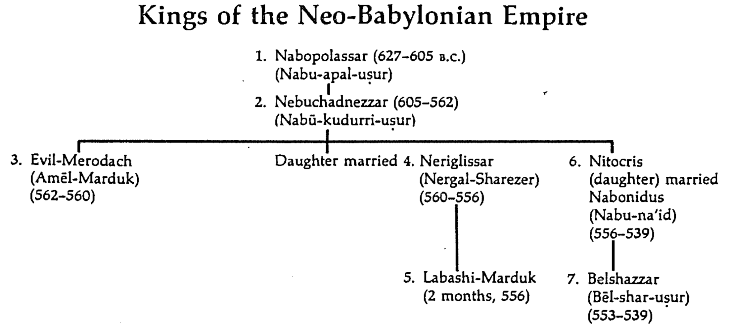

—Pentecost, BKC, 1:1326

Belshazzar’s denial of God's sovereignty led to death while Daniel was honored to show God is pleased with those who follow him (Dan 5).

In 539 BC Belshazzar denied God's sovereignty at a huge party by praising false gods while drinking from the temple goblets (5:1-4).

God hid his judgment due to Belshazzar’s pride in an unreadable wall inscription that the wise men could not decipher (5:5-9).

God helped Daniel interpret the inscription as his judgment on Belshazzar’s pride and wisdom for the humble (5:10-28).

Daniel was promoted to Babylon’s third position to show God's pleasure with those who accept his sovereignty (5:29).

Belshazzar lost his kingdom that night to Darius the Mede [in the reign of Cyrus the Persian, 6:28] for denying God's rule (5:30).

Darius admitted God's rule after seeing Daniel delivered from the lion's den for refusing to petition any god or man except Darius (Dan 6).

In 539 BC under Darius the Mede (Gubaru), Daniel’s promotion in the empire shows that purity is possible even among pagans (6:1-3).

Daniel’s fellow officers jealously tricked Darius into a death decree by lions for anyone who petitions anyone except Darius (6:4-9).

Daniel openly worshipped God despite the death threat to model loyalty to God for captives tempted to worship Babylon’s gods (6:10-15).

Daniel was cast into the lion's den but delivered by the power of God as a testimony to God's sovereignty and power (6:16-24).

Darius admitted God’s rule after witnessing Daniel's deliverance from the lion's den (6:25-27).

God rewarded Daniel’s honest work in the reigns of Darius the Mede (Gubaru, 539-525 BC) and Cyrus (6:28; cf. 550-530 BC).

Daniel’s vision of Christ's future kingdom rule replacing four animals shows God's sovereignty over all worldly kingdoms (Dan 7).

In Belshazzar’s reign, Daniel saw a vision of four beasts succeeded by Christ’s eternal kingdom with power over all peoples (7:1-14).

Note: The liberal view of this section is the lion (Babylon), bear (Medes), leopard (Persia), horrible beast (Greece), and 10 horns/little horn (Maccabean). See page 552 on 9:24-27.

Gabriel decoded these as kingdoms of Babylon, Medo-Persia, Greece, Rome, and Christ to show God's rule over them all (7:15-28).

The exiles could confidently trust God’s sovereignty over Israel in "the times of the Gentiles" by being faithful to his covenant (Dan 8–12).

The animal vision of Alexander the Great over the Medo-Persian Empire and Antiochus IV defiling the temple foretell the same by Antichrist (Dan 8).

Daniel sees a vision of a goat defeating a ram but being replaced by four horns with one gaining power and desecrating the temple (8:1-14).

The goat (Alexander the Great) over the ram (Medo-Persia) will lead to the Seleucid Antiochus IV desecrating the temple like Antichrist (8:15-26; cf. 9:27).

As a result of the vision Daniel got sick, and even after recovering did not grasp the meaning of the vision (8:27).

Daniel confessed Israel's sin before the 70 "sevens" vision where God revealed that the full restoration would need Messiah to come twice (Dan 9).

In 539 BC under the rule of Darius, Daniel read Jeremiah 25:11-12 that limited the exile to 70 years (605-536 BC), or only three years away (9:1-2).

The nearness of restoration compelled Daniel to confess God’s just judgment of Israel's sins and ask God to restore Jerusalem’s temple (9:3-19).

Seeing the nearness of the restoration to the land, Daniel confessed that Israel had sinned by disobeying the Law of Moses (9:3-11).

Daniel admitted that God had faithfully subjugated his people to Gentiles as he said he would (9:12-15; cf. Deut. 28:48-57, 64-68).

Daniel requested God to mercifully restore the Jerusalem temple for his name’s sake (9:16-19).

Gabriel brought to Daniel the 70 "sevens" vision where God revealed that the full restoration would need Messiah to come twice (9:20-27).

Gabriel appeared to Daniel while he confessed Israel’s sin and asked God for the restoration (9:20-23).

God's vision of 70 "sevens" (490 years) showed the end of the captivity, Christ’s first coming and events before Christ’s return (9:24-27).

Seventy "sevens" (490 years) after the captivity ends, Israel will believe in Christ and enter the kingdom at his return (9:24).

Israel will embrace Christ's atonement at his Second Coming to end the 490 years (70 "sevens") after the captivity ends (9:24a-c).

Israel's disobedience will end at Christ's Second Coming when it embraces him as Messiah and Savior (9:24a).

Israel's sin will be punished in Christ as its Substitute so that the nation's sin will be removed when it repents (9:24b).

Israel's wickedness will be satisfied by Christ's blood when the nation trusts him as Savior at his Second Coming (9:24c).

Israel will experience the millennial kingdom blessings after the 490-year period(70 "sevens") after the captivity (70 "sevens") after the captivity (9:24d-f).

Israel will come into a righteous age at the end of the 490 years, or 70 "sevens" (9:24d).

Israel's kingdom will totally fulfill all of God’s promises in visions and prophecies in his covenant with Israel (9:24e).

Israel's millennium will begin with Christ’s holy coronation or by dedicating the holy temple of Ezek 40–46 (9:24f).

The 70 "sevens" will have three distinct eras from Artaxerxes' decree to rebuild Jerusalem (444 BC) to the end of the Tribulation (9:25-27).

Sixty-nine "sevens" (483 yrs.) will occur from Artaxerxes' rebuilding Jerusalem (444 BC) to the Triumphal Entry (9:25; AD 33).

Seven "sevens" (49 yrs.) after Artaxerxes I decrees to rebuild Jerusalem (5 Mar 444 BC) the city will be rebuilt (9:25a; 395 BC).

Sixty-two "sevens" (434 yrs.) later, Jesus will appear to Israel as Messiah at the Triumphal Entry (9:25b; 30 Mar AD 33).

Jerusalem will surely be rebuilt with streets and trench, but only amid much opposition in Nehemiah’s time (9:25c).

After 62 "sevens" (after 30 Mar AD 33), Messiah will die, Titus will destroy the city, and Israel will suffer until Messiah’s return (9:26).

After 62 "sevens" (after 30 Mar AD 33) Christ will die with no kingdom for Israel due to the nation's rejection (9:26a).

Between weeks 69 and 70 (AD 33 to Christ's Second Coming), Romans will destroy Jerusalem and the temple (9:26b; AD 70).

Israel will suffer during the Church Age until Christ's Second Coming (9:26c).

At the middle of the "seven" (7-year Tribulation), Antichrist will replace his temple sacrifice covenant with self-worship (9:27).

At the center of the 7-years, Antichrist, Titus’ antitype (cf. 9:26b), will end his 7-year covenant of revived sacrifices (9:27a).

Antichrist will force people to worship his temple image until the end of the Tribulation (9:27b; cf. Rev. 13:14; 20:10).

Gabriel revealed Israel's intertestamental future and the Tribulation until Christ's Second Coming to show God's rule over the nations (Dan 10–12).

Gabriel appeared to Daniel after delay by a demon to strengthen him to fathom Israel's future to show God's rule over all nations (10:1–11:1).

In 536 BC, while Cyrus rebuilt the temple, God told Daniel that Israel would have a great war in the land, so he mourned for three weeks (10:1-3).

Gabriel appeared to Daniel in great splendor at the Tigris River while he was in a deep sleep (10:4-9).

He tried to come earlier but a demon of Persia delayed him as Daniel was highly esteemed and needed to know Israel's future (10:10-14).

One of Gabriel’s purposes for appearing to Daniel was because he was highly esteemed (10:10-11).

Gabriel started to come to Daniel when he began mourning but was delayed by the demon assigned to Persia (10:12-13).

Gabriel’s other purpose for appearing to Daniel was because Daniel needed to know about Israel's future (10:14).

Gabriel gave Daniel strength to understand the message he was to receive (10:15–11:1).

Israel's intertestamental future would include Persian and Greek rule to show in advance God's rule over the nations (11:2-35).

Israel's future under Persia will span four more kings, the last being the wealthy Xerxes who will fight against Greece (11:2).

Israel's turbulent future of Greek rulers (Alexander, Ptolemies, and Seleucids) will show God's rule in Antiochus IV’s temple sacrilege (11:3-35).

Alexander the Great will rule with great power and then have his kingdom divided into four empires (11:3-4).

Various Ptolemaic and Seleucid rulers will fight one another over Israel’s land (11:5-20).

The Seleucid Antiochus IV Epiphanes will first defeat the Ptolemies but later lose and desecrate the Jerusalem temple (11:21-35).

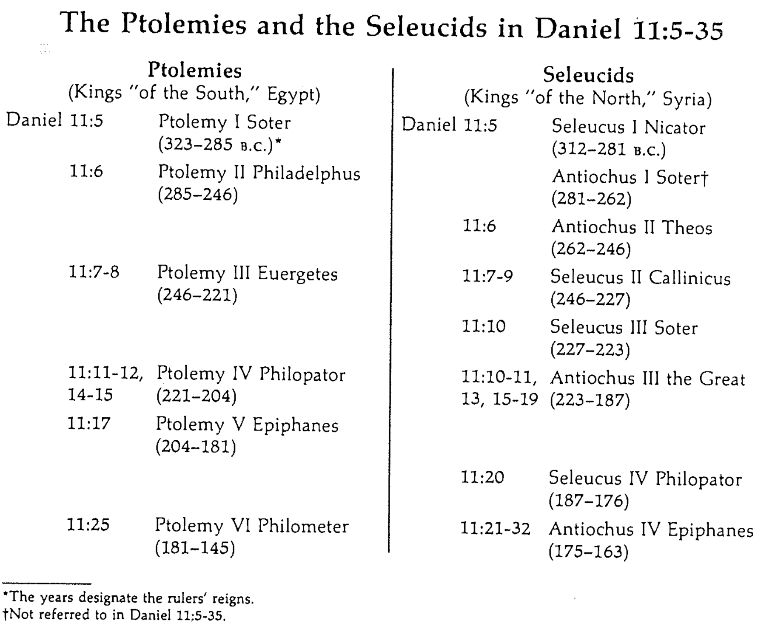

—Pentecost, BKC, 1:1367

Israel's future will see Antichrist’s self-deification and military power end at Christ’s Second Coming to show God's rule over all nations (11:36–12:3).

Antichrist will set himself up as God to rule by military might (11:36-39).

Antichrist will be attacked repeatedly and will die at the Second Coming of Christ that ends the Tribulation (11:40-45).

Antichrist will defeat Egypt and its southern allies along with a northern Arab alliance and many other countries (11:40-43).

A looming invasion of [200 million Chinese] eastern soldiers and northern Arab nations will incite Antichrist to kill many in a rage (11:44).

Antichrist will pose as Christ from Jerusalem over a world rule and religion but die at Christ’s Second Coming (11:45; cf. Rev. 19:19-20).

Michael will protect Israel before the millennium and resurrections will decide entrance into the kingdom or punishment (12:1-3).

The archangel Michael will protect the nation of Israel during these difficult times (12:1).

A resurrection will lead the righteous into the millennium and the wicked into punishment (12:2-3).

These prophecies will bless Israel in the Tribulation and reveal judgment for unbelievers to encourage Israel with God's rule (12:4-14).

Gabriel told Daniel to seal up these prophecies until the Tribulation when travel and knowledge will increase rapidly (12:4).

Gabriel declared that a 3.5-year Great Tribulation will lead unbelievers to punishment and Israel will enter the Kingdom (12:5-13).

The setting was Daniel's observations of two angels standing on opposite sides of the Tigris River (12:5; cf. 10:4).

The Great Tribulation will last 3.5 years or 1260 days (12:6-7).

One of two angels requested Gabriel, a third angel above the Tigris River, on the length of the Great Tribulation (12:6).

Gabriel responded that the Great Tribulation will last a time, times and half a time, or 3.5 years or 1260 days (12:7).

The Great Tribulation will judge unbelievers worshipping Antichrist but bless Israel with the kingdom (12:8-13).

Daniel asked Gabriel the second question on the outcome of the Great Tribulation (12:8).

Gabriel said that Great Tribulation unbelievers will worship Antichrist but Israel will enter the kingdom after 1335 days (12:9-13).

People will be polarized after the Great Tribulation so Daniel need not be concerned about it (12:9-10).

Antichrist worship will last through the Great Tribulation (1290 days) but Israel’s reward will come after 1335 days (12:11-12).

Antichrist worship will replace sacrifices 1290 days before the end of the Great Tribulation (12:11).

God will judge unbelievers after 1290 days but reward believing Israel after 1335 days (12:12).

Daniel will die but still receive his inheritance to enjoy in the kingdom after the Great Tribulation (12:13).

Names of Daniel and His Friends

Names are significant. We tend to live up to them or down to them, as the case may be. Yet Daniel and his friends who were brought into exile did not stoop to the low meaning of their new names. Nebuchadnezzar’s chief official changed their Hebrew names that each ended with the name “God” (-el) or “LORD” (-iah) into names that honored Babylonian deities. Daniel’s new name was never used again in the book except by the king himself (4:9, 18) whereas the others only used their new names. However, despite these name changes, all four of these men stayed true to their God.

Hebrew Names | Babylonian Names
Daniel  “God is judge” | Belteshazzar  “Bel, protect his life!”
Hananiah  “The LORD is gracious” | Shadrach  “Command of Aku (moon god)”
Mishael  “Who is what God is?” | Meshach  “Who is what Aku is?”
Azariah  “The LORD helps”  (or “Whom the LORD helps”) | Abednego  “Servant of Nego”  (or Nebo, i.e., the god Nabu)

Despite taking pagan names, these men exemplified many principles of obedience:

1. Choose your battles carefully–for example, don’t insist on your “godly” name (1:7)
2. Resolve to obey God even when others compromise (1:8a)
3. Appeal to proper authority when asked to do something wrong (1:8b)
4. Test the Lord’s faithfulness in a plan to set yourself apart (1:11-16)
5. Show “staying power” despite changes in authorities (1:21)
6. Appeal to proper authority when threatened (2:16)
7. Wait upon God’s answer rather than doing something rash (2:16)
8. Involve others in solving problems (2:17)
9. Pray to God for wisdom and mercy (2:18)
10. Give God the credit for abilities he has given you (2:19, 28-30)
11. Worship God alone despite the outcome (3:12; 6:7)
12. Accept the consequences of obedience (3:16-18; 6:16)
13. Humble yourself so God will not have to humble you (4:28-37; 5:22)
14. Handle all your affairs with utmost integrity (6:3-4)
15. Obey publicly–not just privately (6:10)
16. Respect your persecutors with authority even over your life (6:21-22)

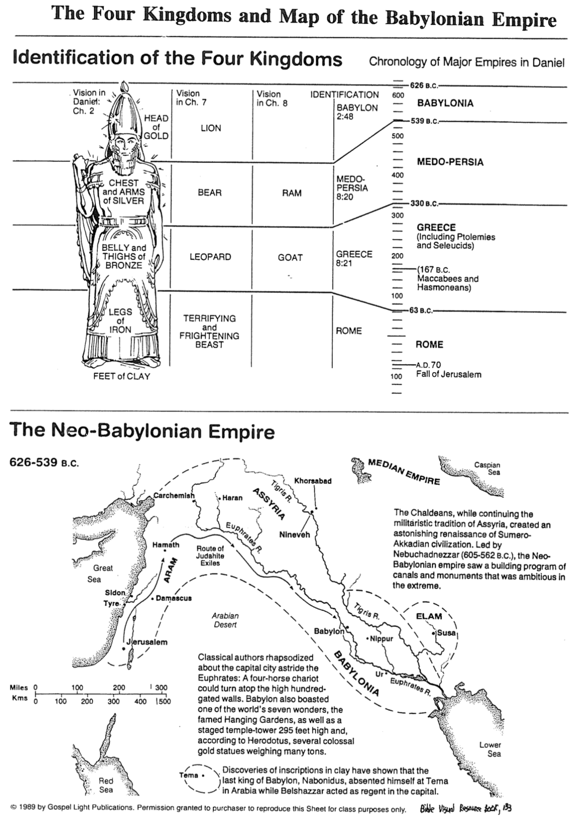
The Four Kingdoms and Map of the Babylonian Empire
Bible Visual Resource Book, 133

Comparison of Daniel 2, 7, 8, 9, 11, and Revelation 13

Dr. Homer Heater, Dallas Theological Seminary

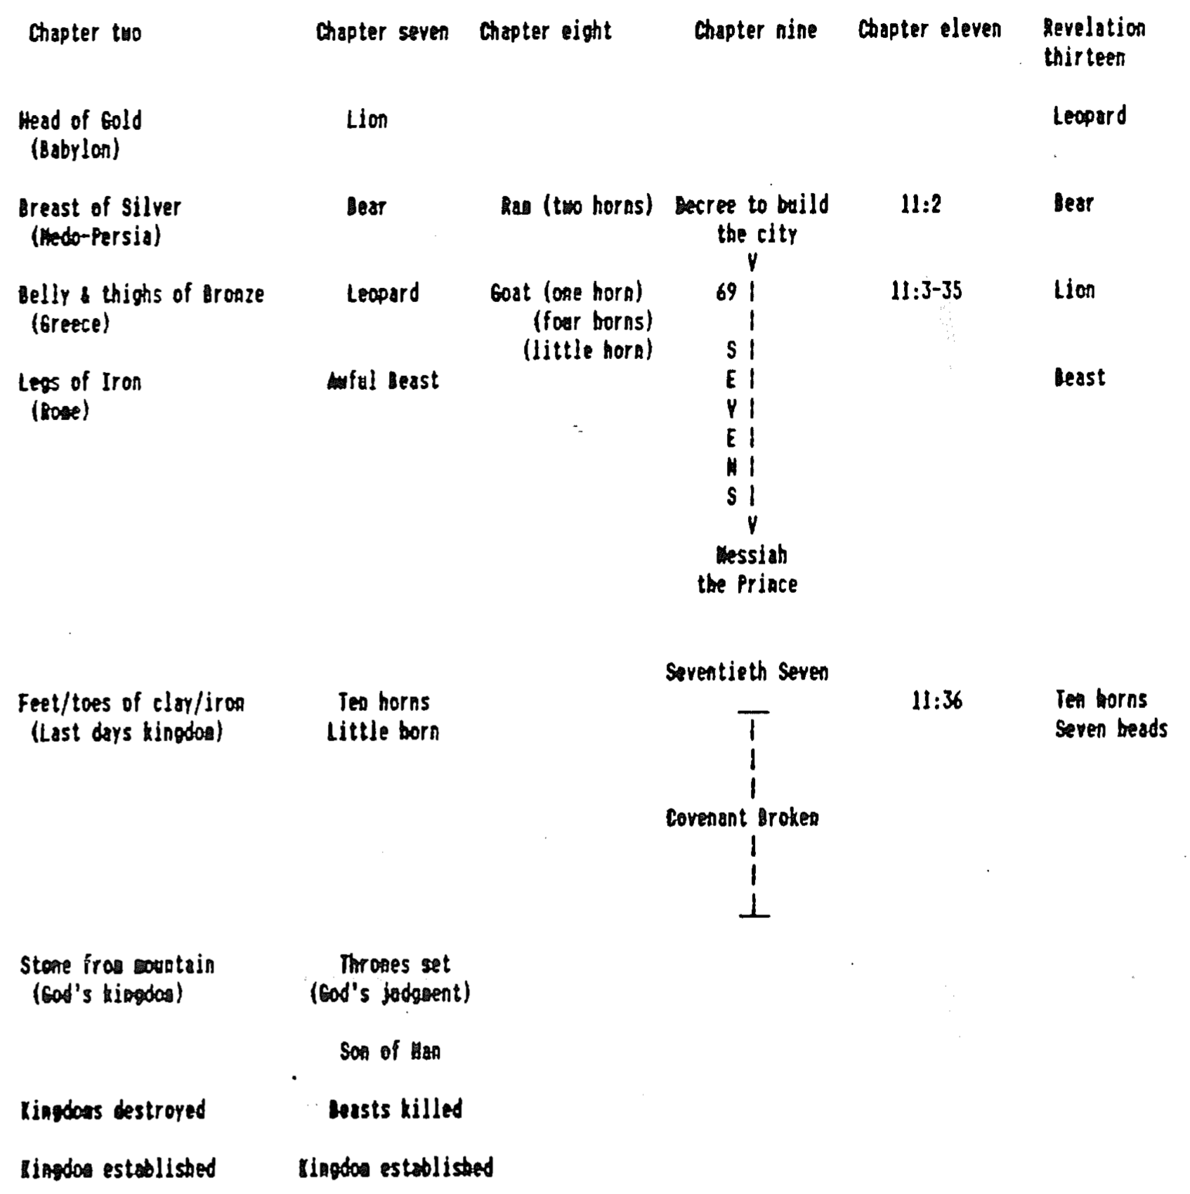
Maps of the Four Empires in Daniel

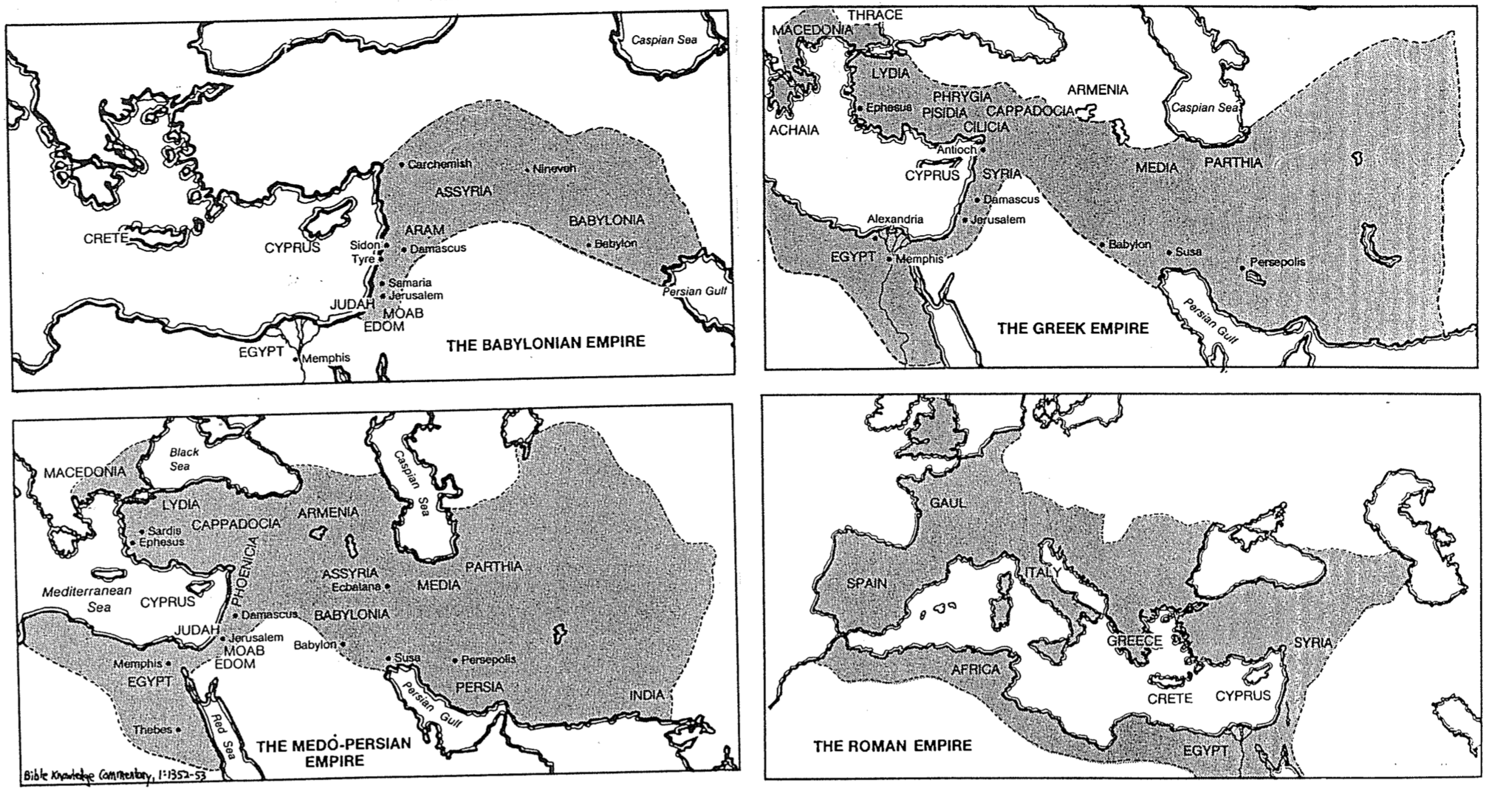
The Route of Alexander’s Conquests (Dan. 8:5-8)

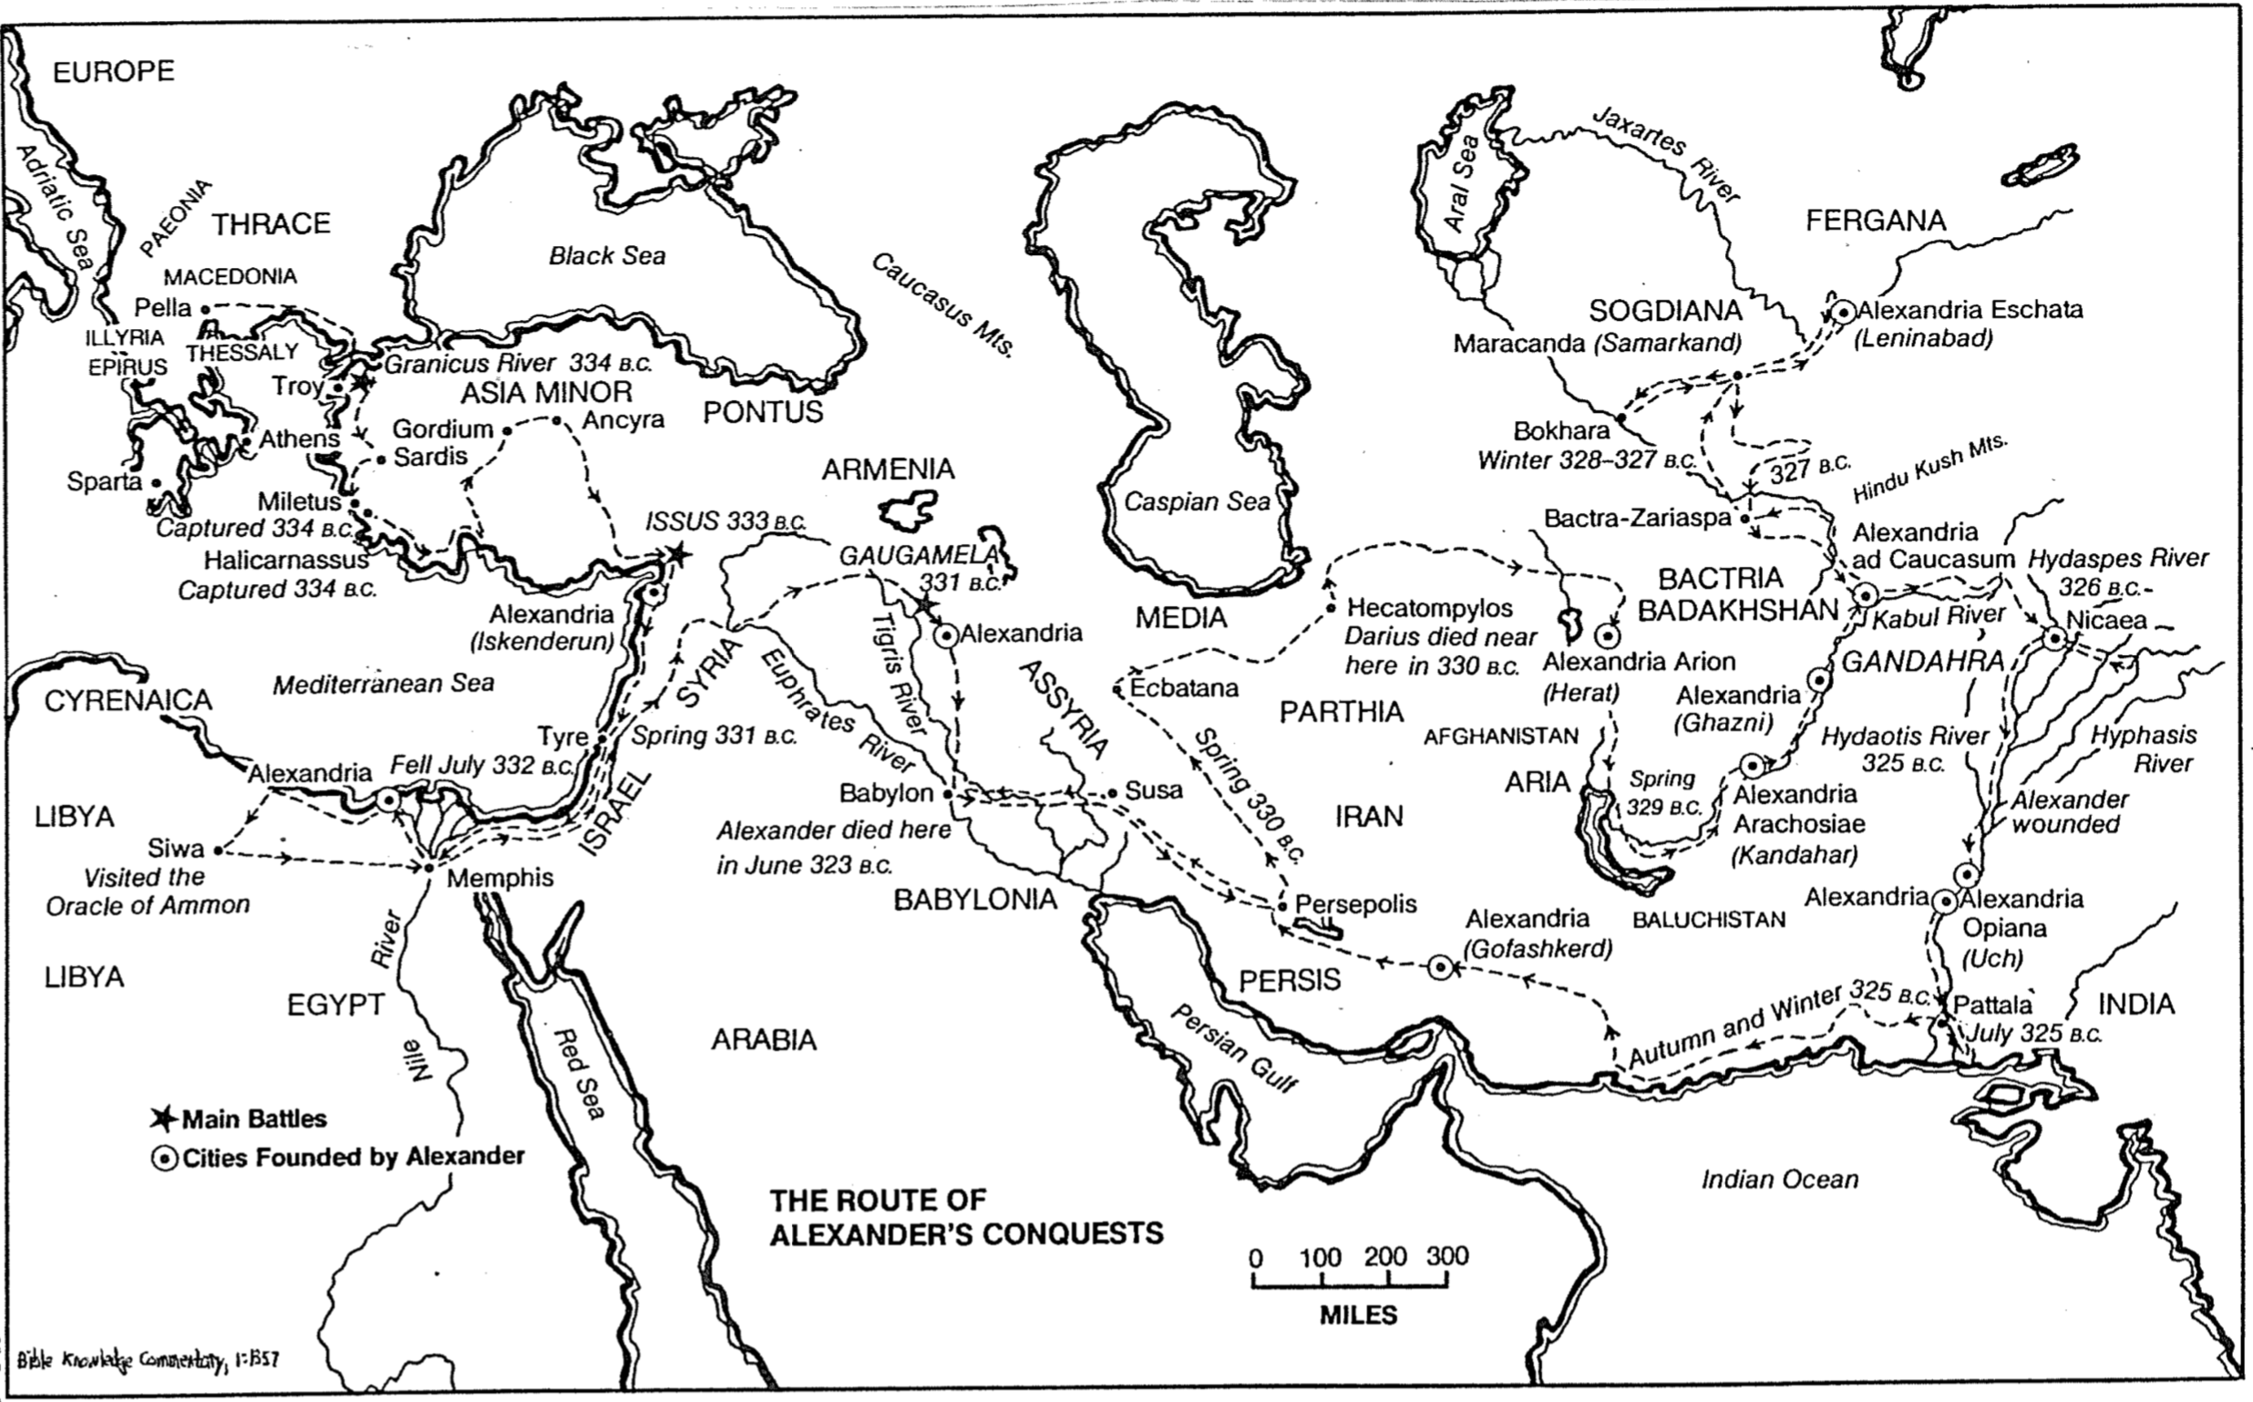
Outline of End-Time Events Predicted in the Bible

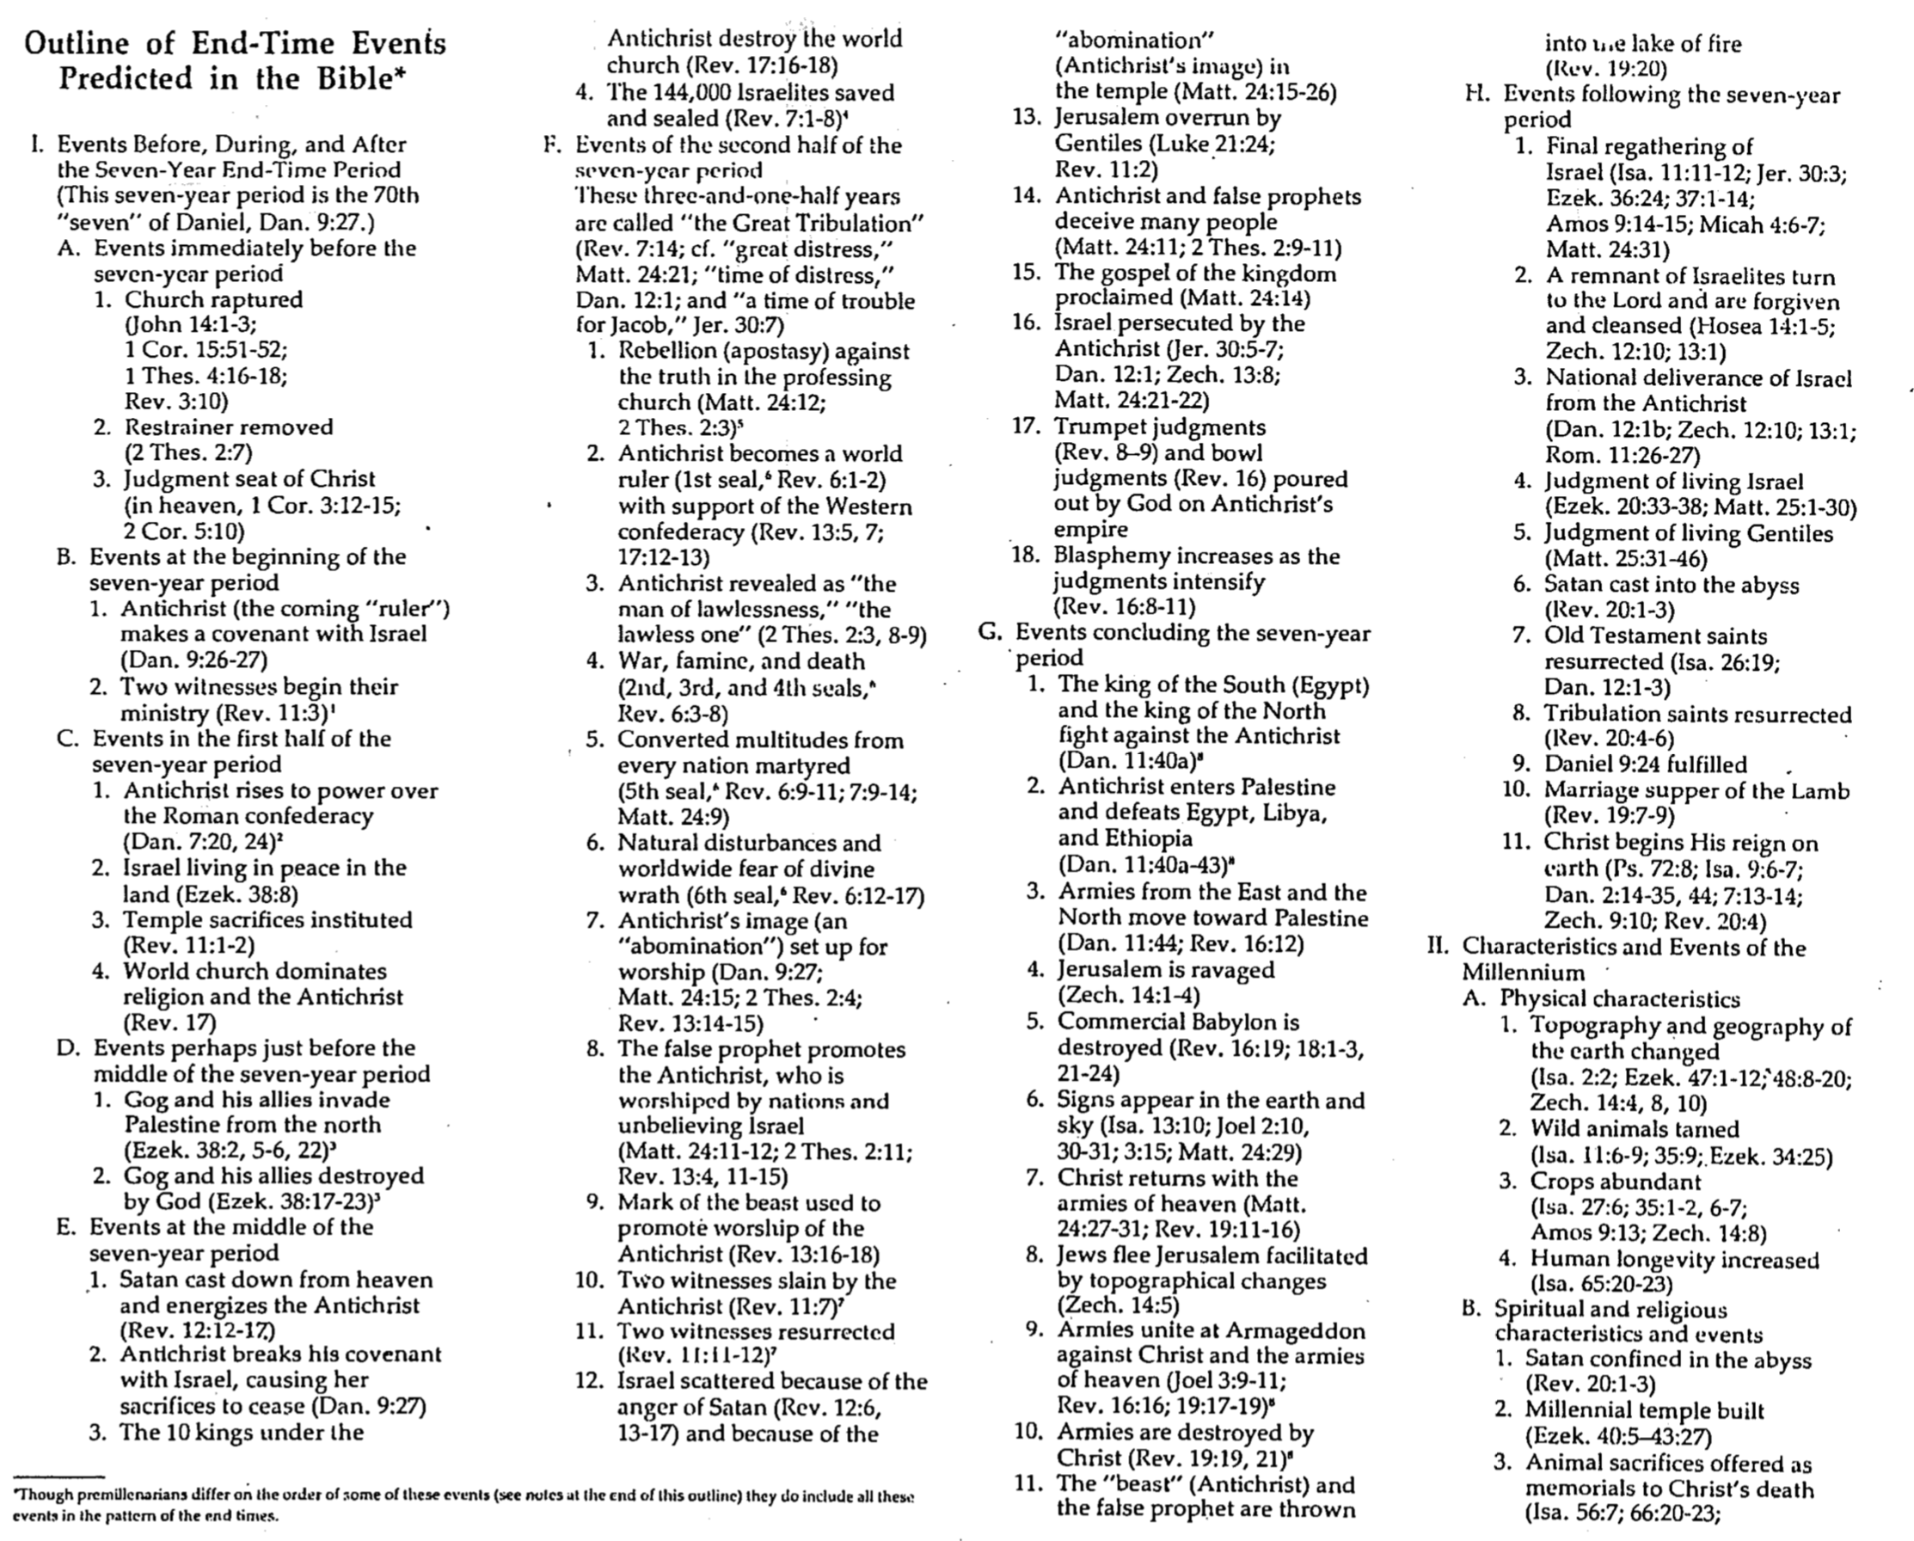

Outline of End-Time Events Predicted in the Bible

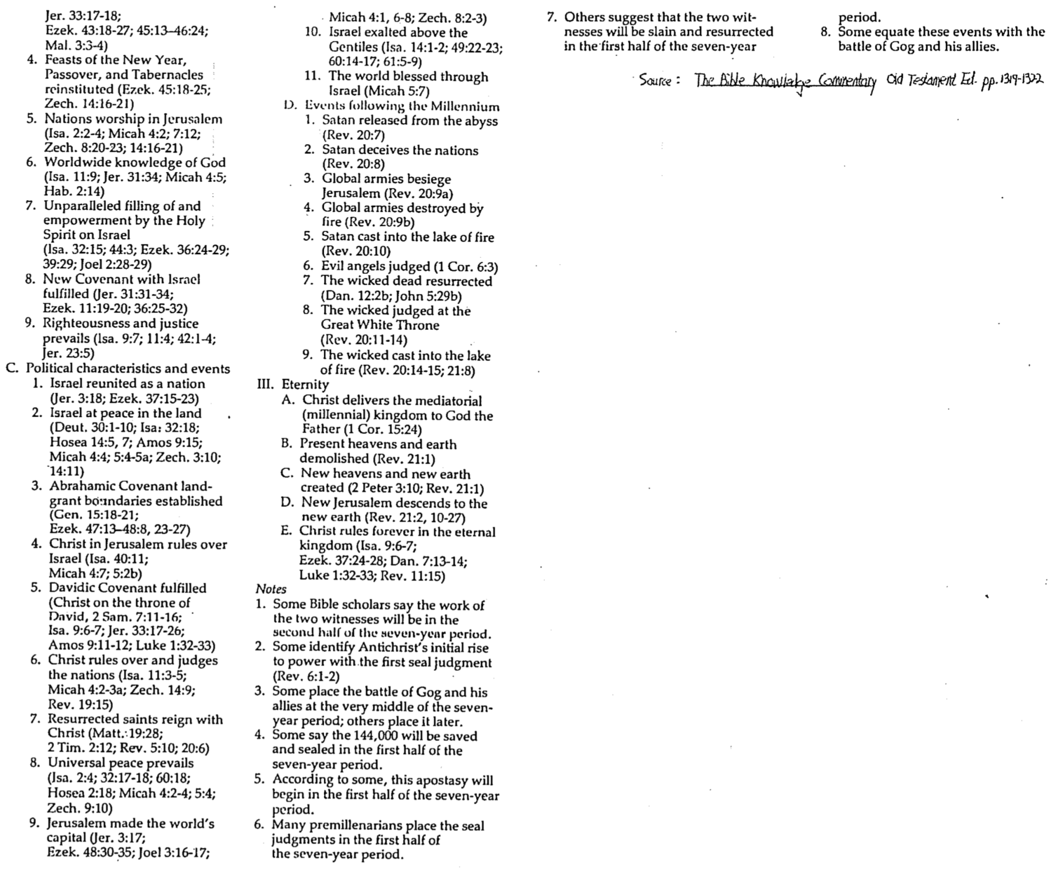

The Times of the Gentiles
R. Ludwigson, A Survey of Bible Prophecy, 181

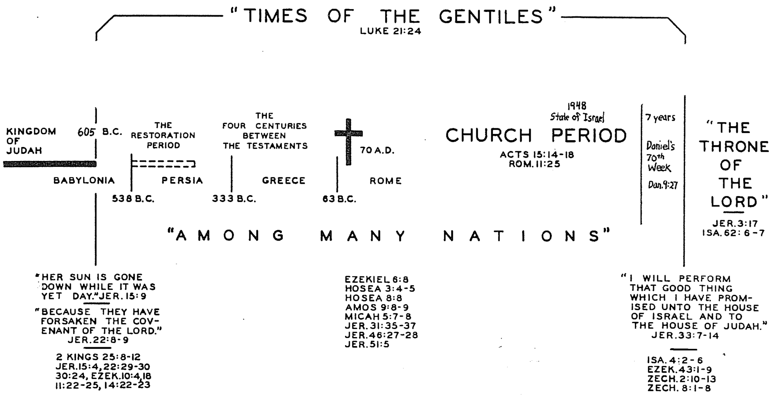

Chart of Daniel’s Seventy Weeks

R. Ludwigson, A Survey of Bible Prophecy, 49

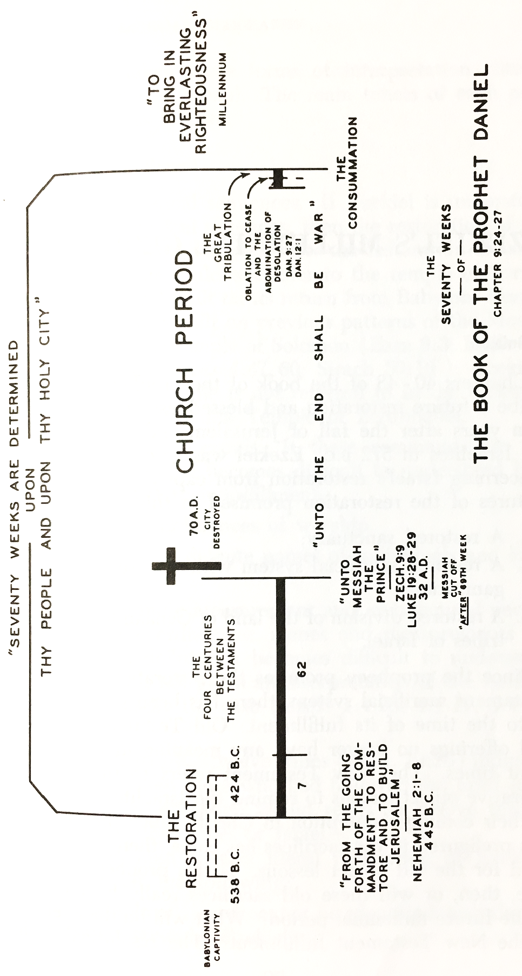
Determinations of the Seventy Weeks

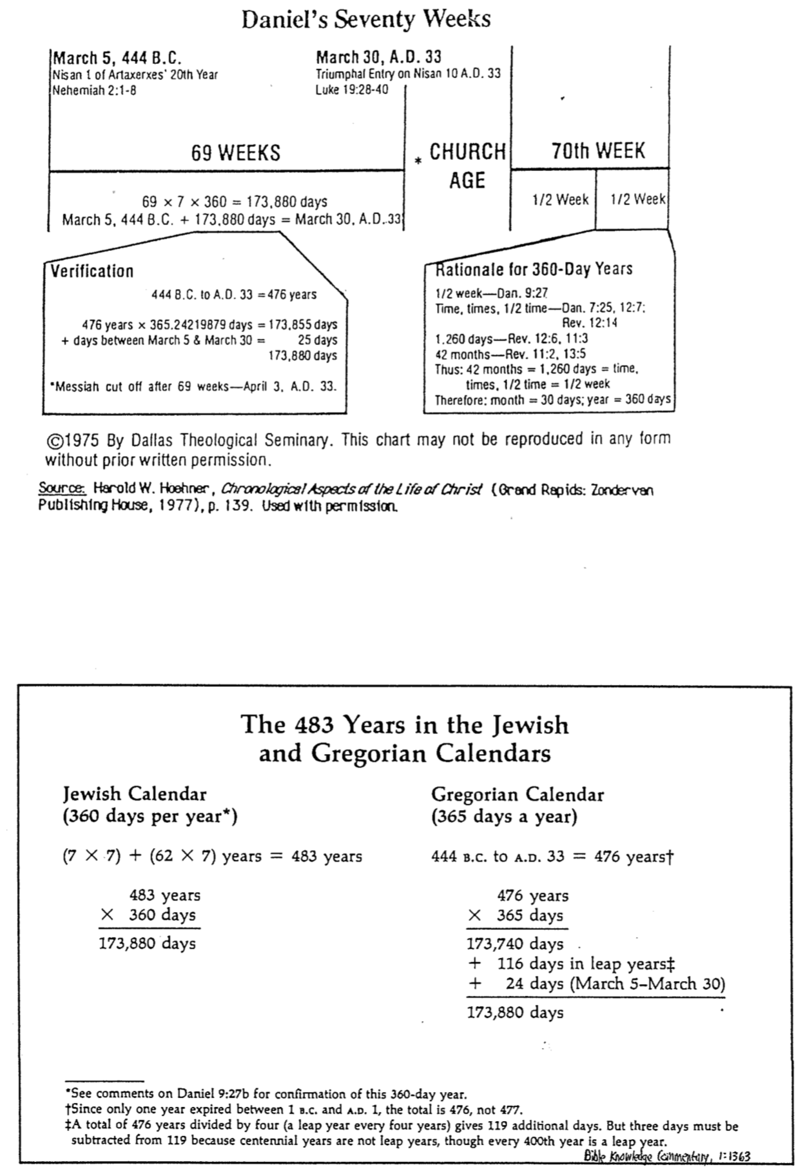

Summary of Views on Daniel 9:24-27

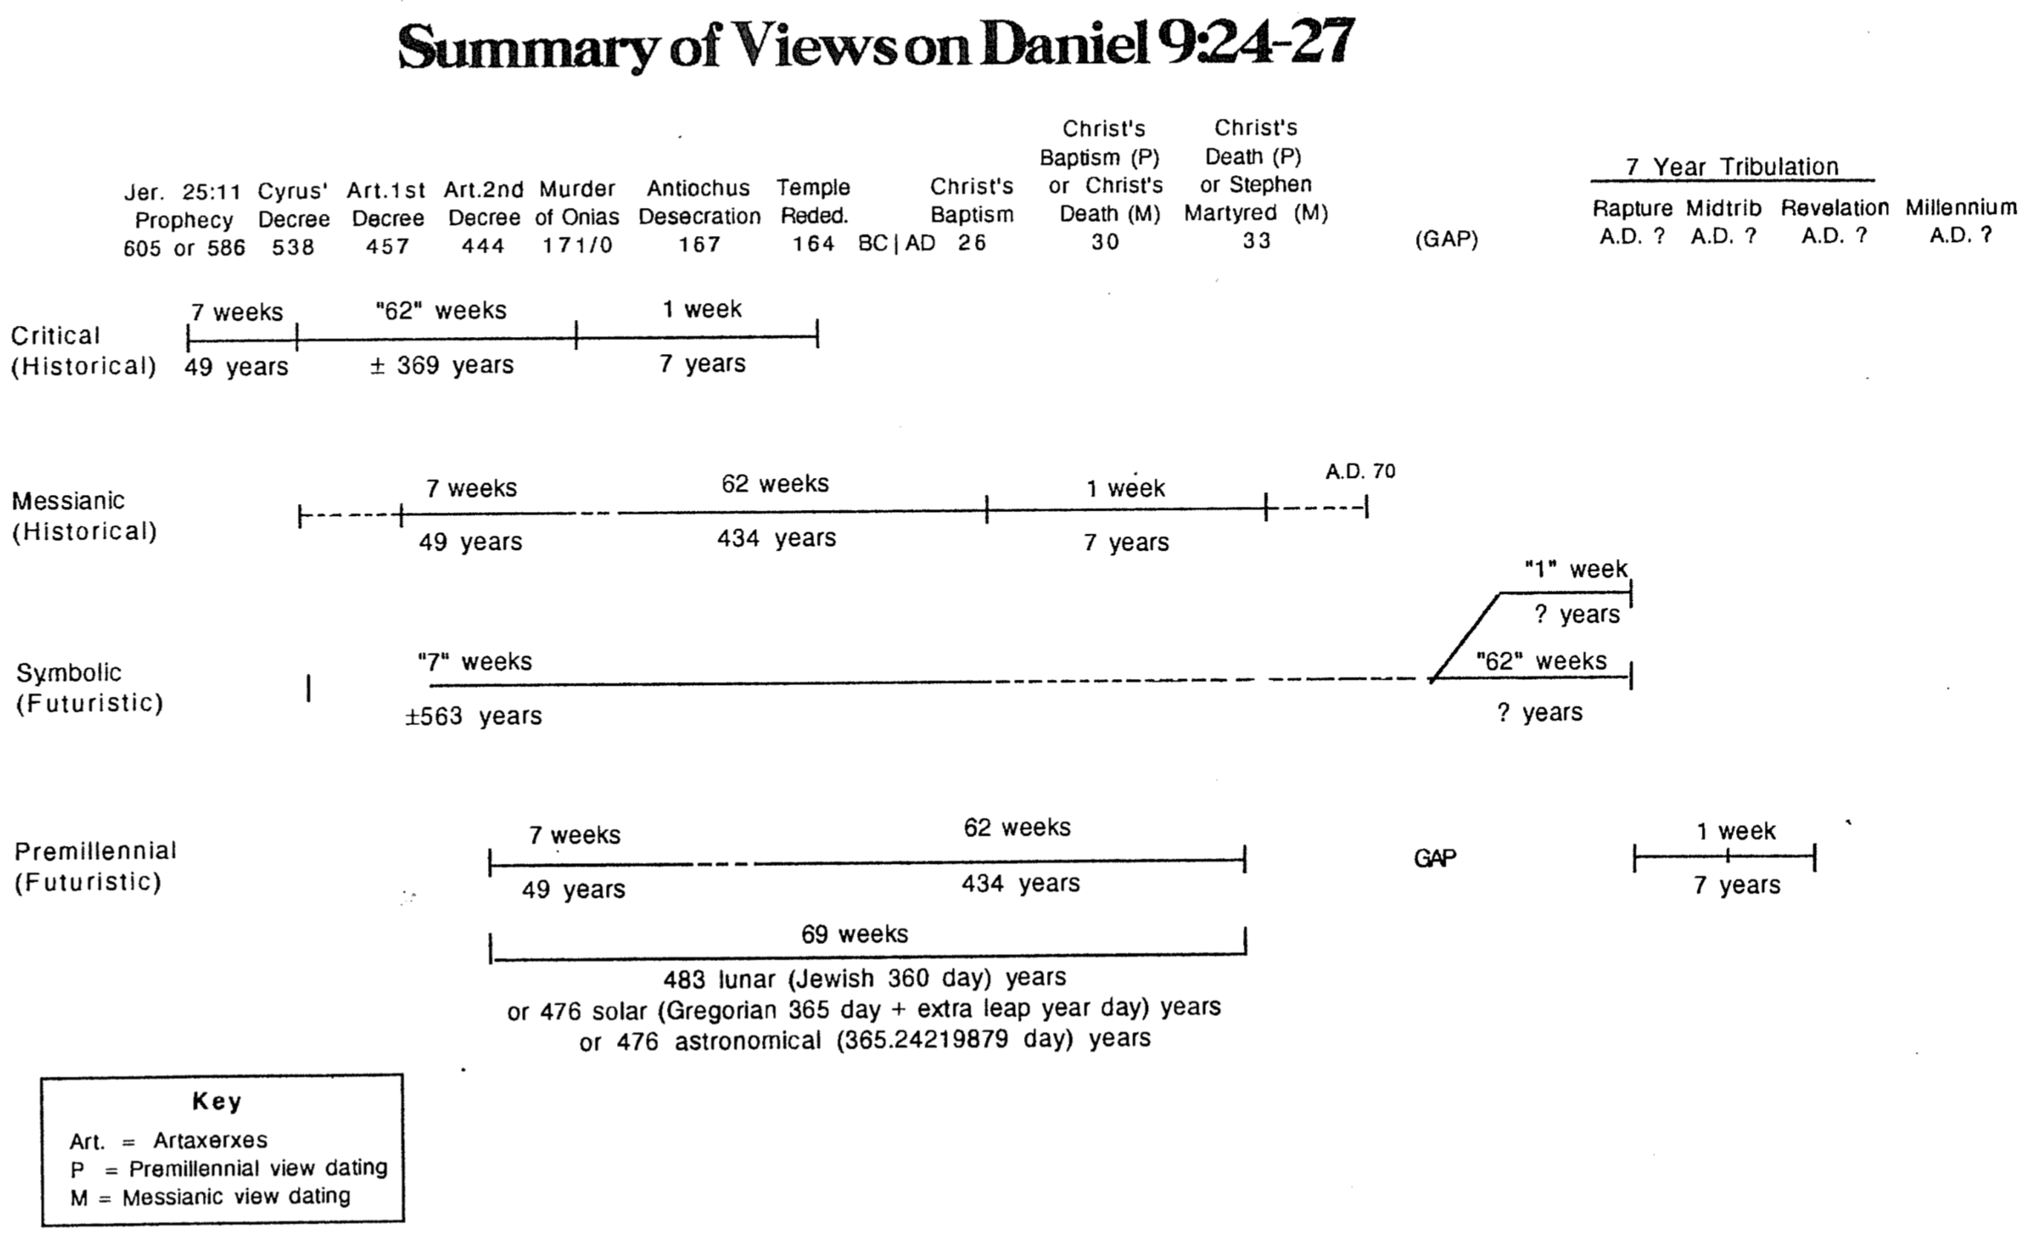
Evaluating Views on Daniel 9:24-27
(Correlate with previous page and a more detailed chart in Payne, The Theology of the Older Testament, 250-52)

 | Historical |  | Futuristic
 | Critical | Messianic | Symbolic | Premillennial
Who’s decree begins the 70 “sevens” (v. 25)? | Jeremiah (Jer. 25:11), referring to 605 BC or 586 BC (better) | Cyrus (538 BC) or Artaxerxes’ 1st decree (457 BC, Ezra) | Cyrus  (538 BC) | Artaxerxes’ 2nd decree  (444 BC, Nehemiah)
When do the 70 “sevens” end (v. 27)? | Temple Rededication (164 BC) | Stephen’s death and Paul’s call (AD 33) | Rapture of the Church (no 7 yr. Tribulation) | Christ’s return after the Tribulation
Who is the “Anointed One” and when does he “come” (vv. 25-27)? | Cyrus (538 BC) in v. 25 but Joshua the High Priest (457 BC) in v. 26 | Christ at His baptism  (AD 26) | Christ at His baptism  (AD 26) | Christ at His triumphal entry  (AD 33)
Who destroys the city and the Temple (v. 26)? | Antiochus Epiphanes desecrates the Temple | Titus destroys Jerusalem and the Temple (AD 70) | Antichrist destroys the visible Church | Titus destroys Jerusalem and the Temple (AD 70)
Is there a gap between the 69th and 70th “7”? | No | No | No | Yes
Who makes covenant/ ends sacrifice (v. 27)? | Antiochus Epiphanes (170-164 BC) | Christ  (AD 26-33) | Antichrist | Antichrist (as antitype of Titus)
What’s the covenant? | (Noncommittal view) | New Covenant | Covenant of terror | Peace with Jews
With whom is the covenant confirmed (who are the “many”)? | Jerusalem Jews tired of Hellenistic (Greek) rule | Disciples at the Last Supper (extended to the church) | The Gentile masses who follow the Antichrist | End-time Jews (who are “[Daniel’s] people,” v. 24)
What is “the end to sacrifice” (v. 27)? | Offering a pig on the Temple altar | Christ’s death | Antichrist overthrows Church’s worship | Antichrist stops future Tribulation sacrifices
Who causes the desolation’s (v. 27b)? How? | Antiochus sets up a pagan emblem on the temple porch | Titus destroys Jerusalem and the Temple (AD 70) | Antichrist’s idols–materialism, goals, paradise w/o God, etc. | Antichrist insists that the Jews worship his image (Rev. 13:14-15)
Problems | • Says prophecy is a forgery after the fact  • Inconsistent identity of the Anointed One (vv. 25, 26)  • Antiochus made no covenant with Jews  • Antiochus did not destroy the city or temple (desecrated it only) and Jesus saw this as future (Matt. 24:15; Mark 13:14)  • The city was ruined in 586, not rebuilt as required by v. 25  • 538 to 170 BC is only 369 yrs. (not the required 62 x 7 = 434) –65 years off target  • Accuses Daniel of mathematical errors | • Inconsistent use of the word “seven” (in 538 BC reckoning)  • Christ didn’t make a covenant in AD 26  • Christ’s death didn’t end sacrifices–they continued to AD 70  • See “abomination” as AD 70 but before “week” of AD 26-33  • A 7 yr. period re: Christ does not exist  • Not 7 yrs. between Christ’s death and AD 70, so v. 27 not fulfilled literally  • Rev. 13:5, 14-15 (written AD 95) are future fulfillment  • “He” (v. 27) looks back to Titus as antecedent (v. 26b), not to Christ (v. 26a) | • Why all the specific “sevens” if each is indefinite–not years?  • “City and sanctuary” are allegorized to be the Church  • Daniel’s people (Israel) is addressed, not the church/masses  • Stretches it to call “sacrifice & offering” the Church’s worship  • Overlapping of the 62 “sevens” and 70th “sevens” improbable  • Francisco’s teaching that Jerusalem has not yet been destroyed and that the present age is the last half-week denies history and allegorizes the text | Support:  • The decree of 444 BC is the best date since it included both the city and walls (cf. Neh. 2:3, 5, 8)  • Employs 360-day (lunar) years of the Jewish calendar but still works with the Gregorian and even astronomical calendar  • Deals fairly with a gap “after the 62 sevens” (v. 26)  • Allows a literal fulfillment of vv. 24, 27–neither of which is presently fulfilled  • Considers v. 27 as future in line with Dan. 7:25; Rev. 12, 13, 19
Advocates | Montgomery (ICC), Hartman & DiLella (AB), F. F. Bruce (but he notes future significance too) | E. J. Young, Pusey, J. Barton Payne | Leupold, Keil, McComisky, Francisco, Review & Expositor 57 (April 1960): 126-37 | Hoehner, Anderson, Walvoord, Whitcomb, Archer (but he says 457 BC–AD 27 for the 69 “sevens”)
Perspective | Liberal  critical | Conservative  amil or premil | Conservative amillennial | Conservative  premillennial

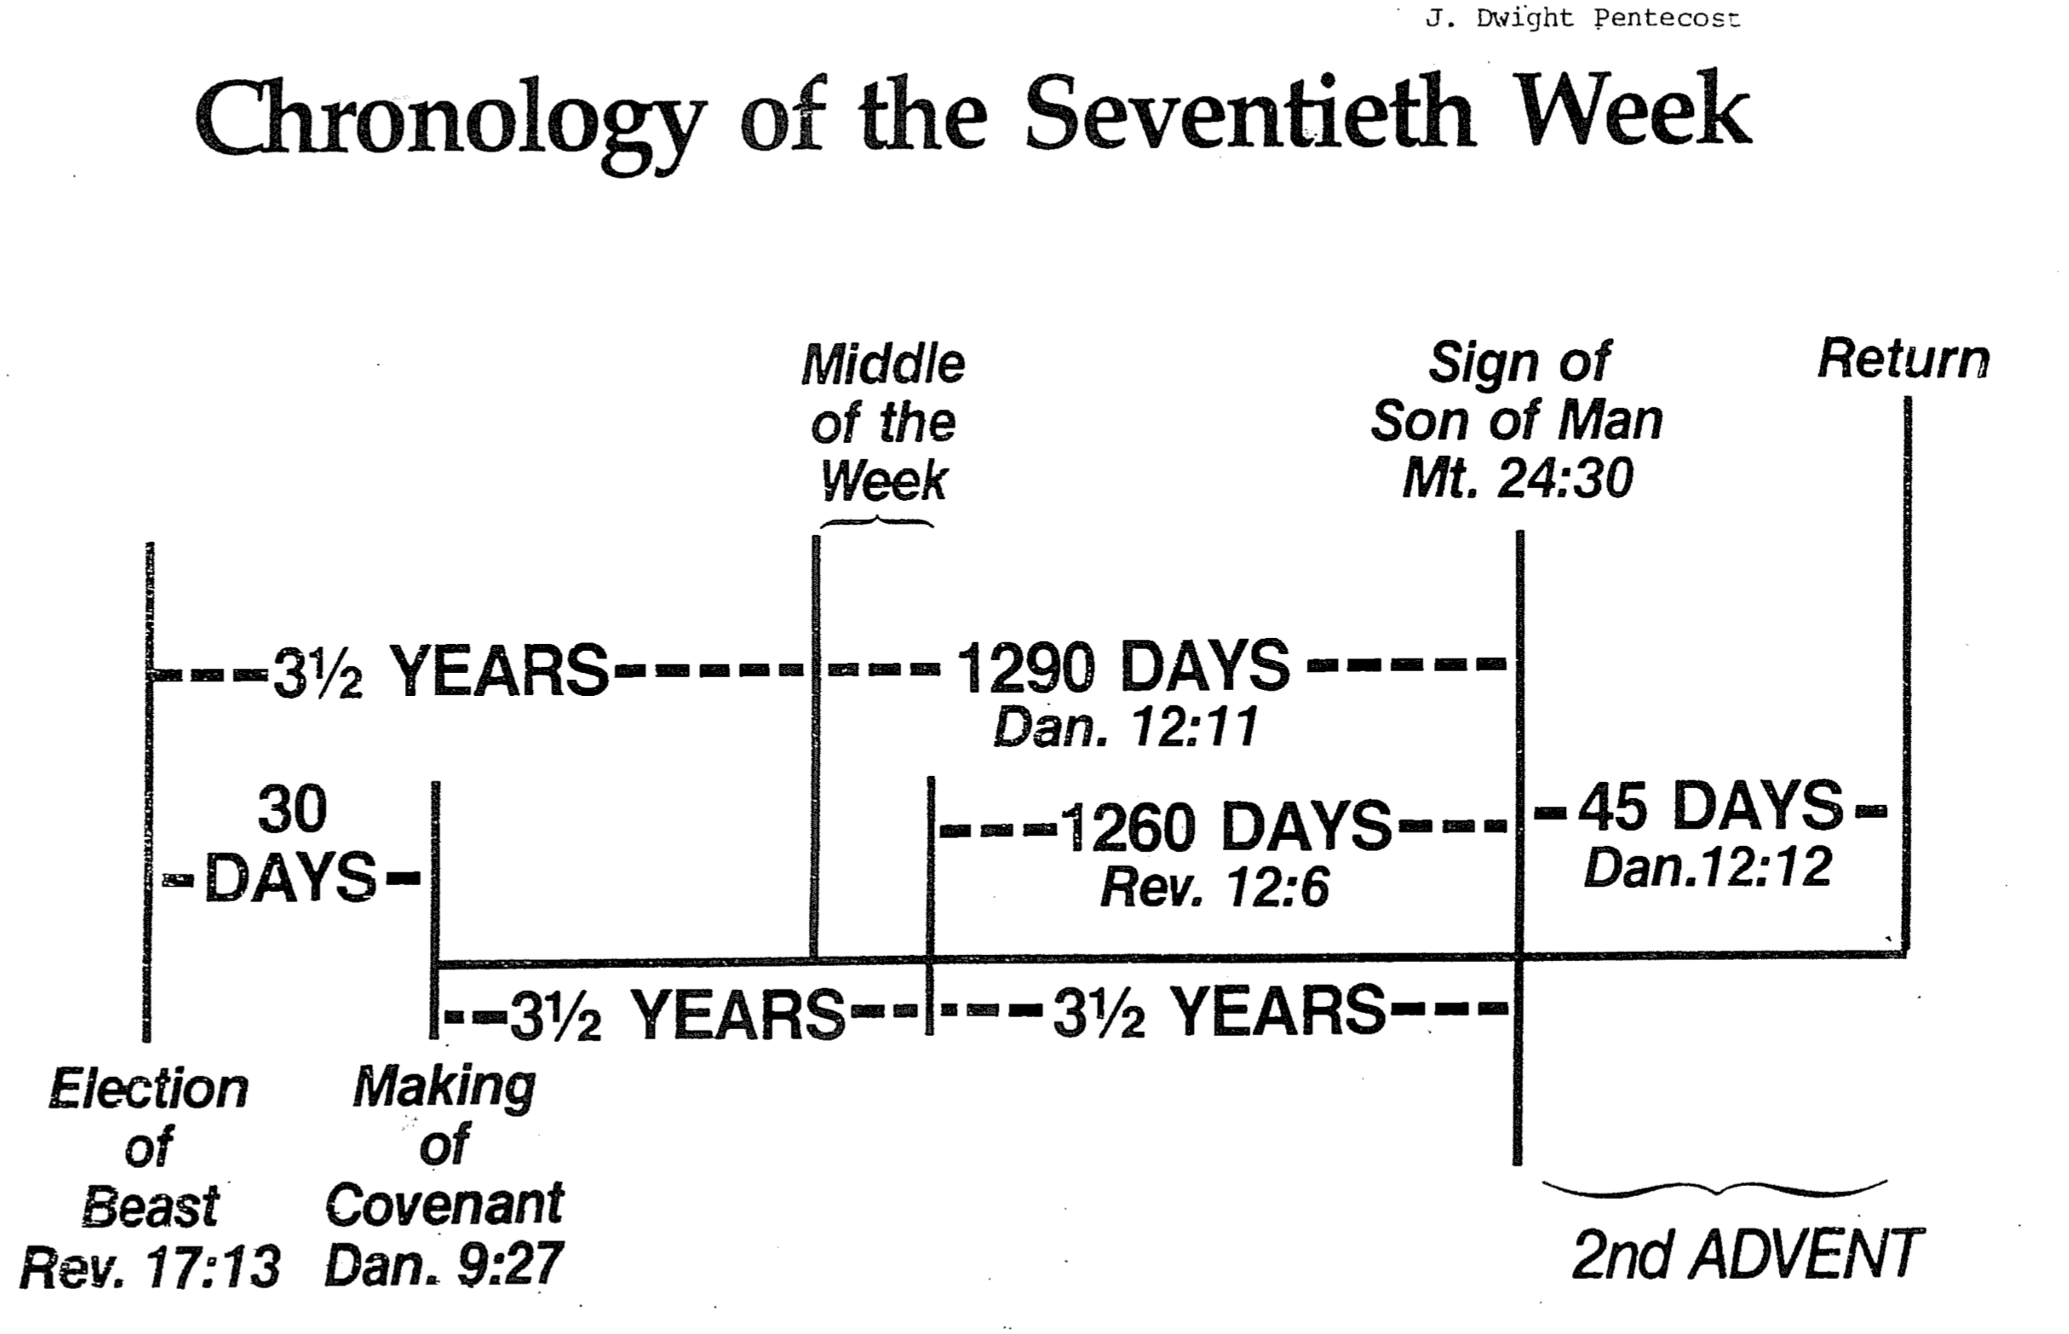
† Due to varying opinions even within each of the four views, the chart mostly reflects opinions of their first advocate.
Chronology of the Seventieth Week

Daniel’s Seventy Weeks Compared with Revelation

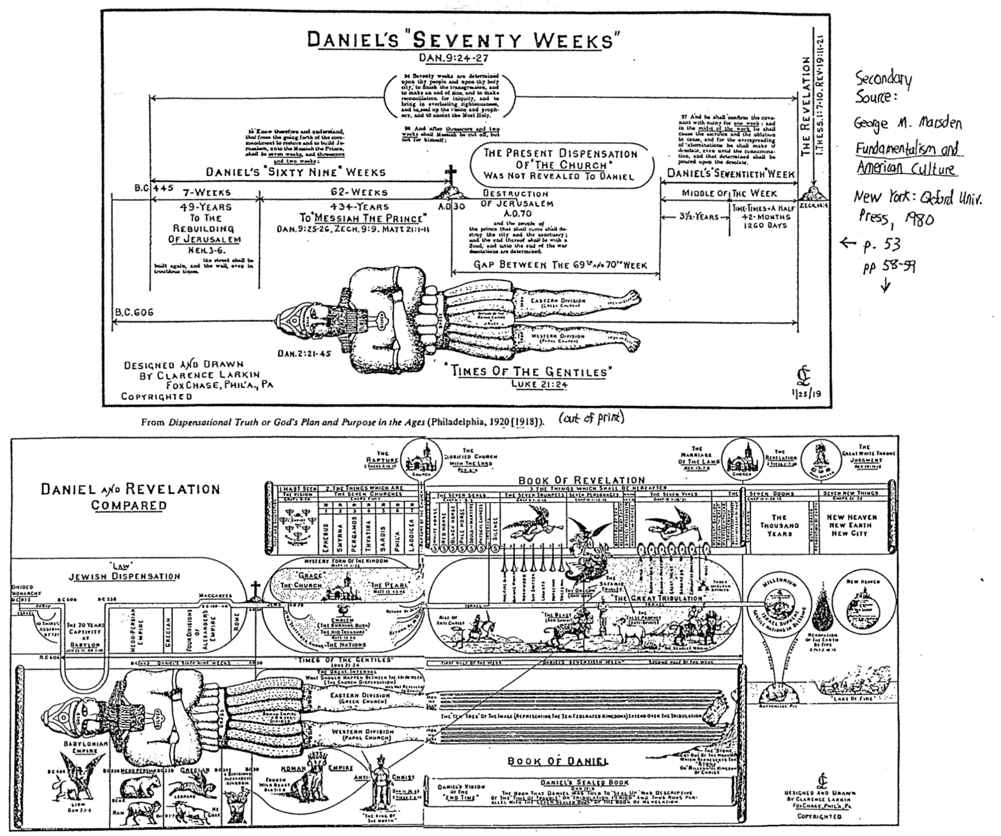

Ptolemies and Seleucids

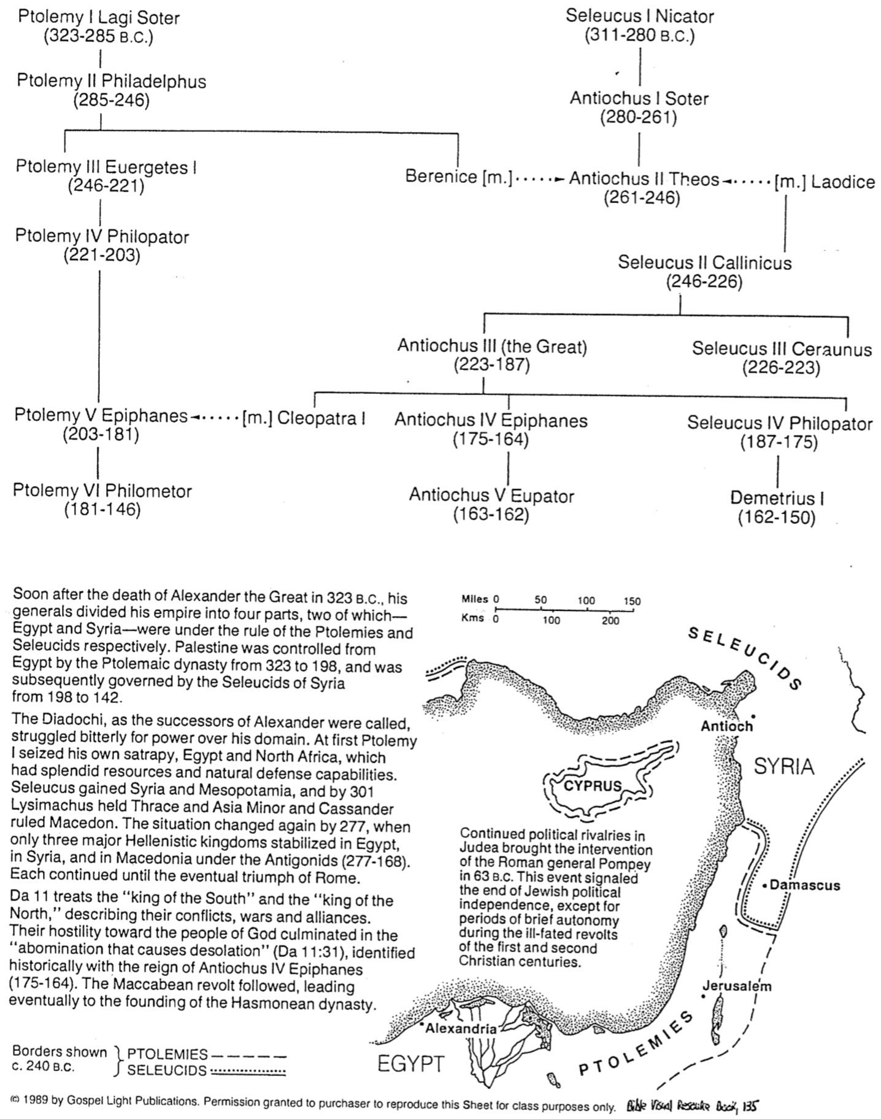
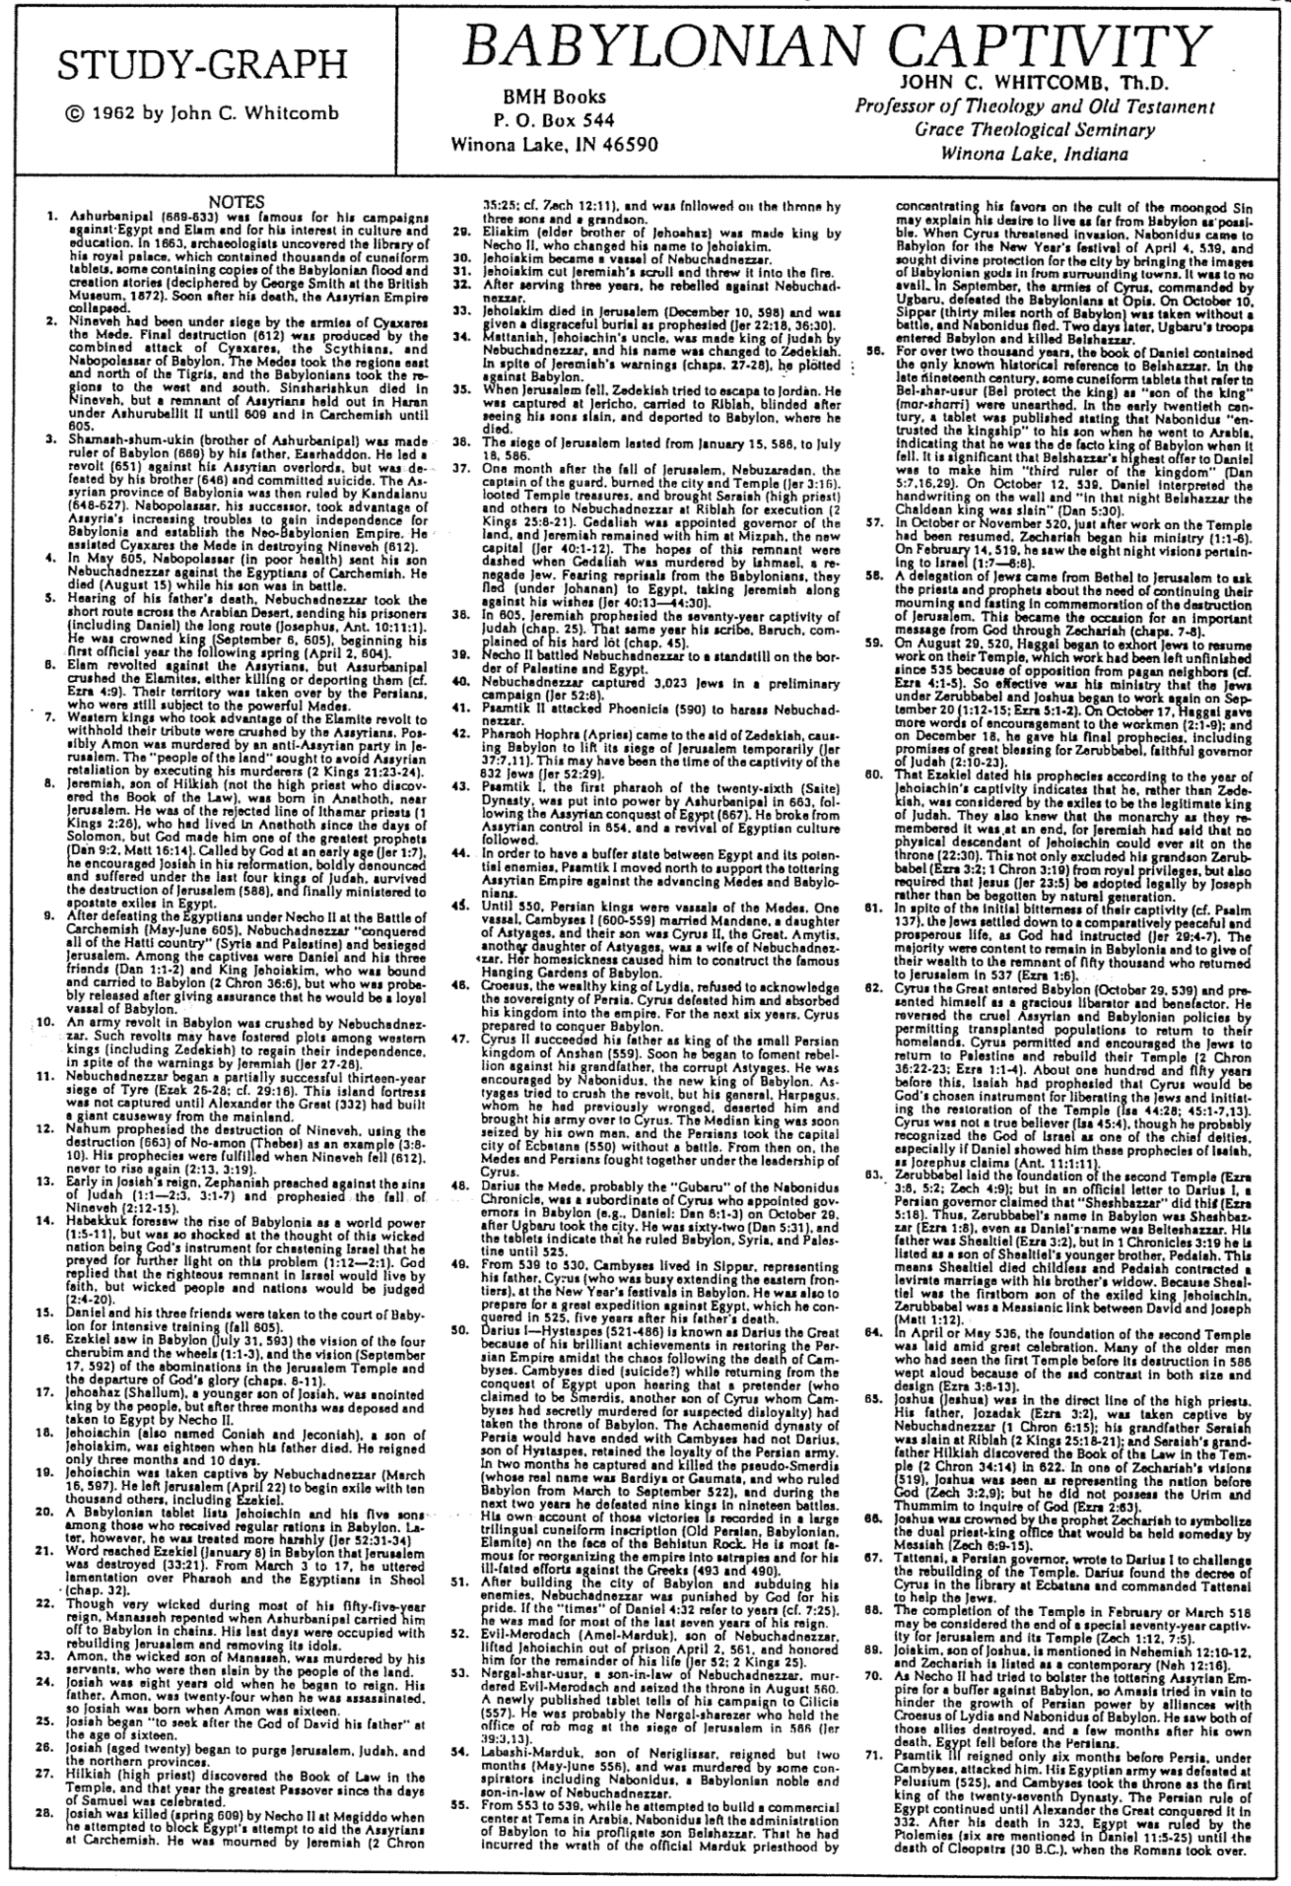
Babylonian Captivity

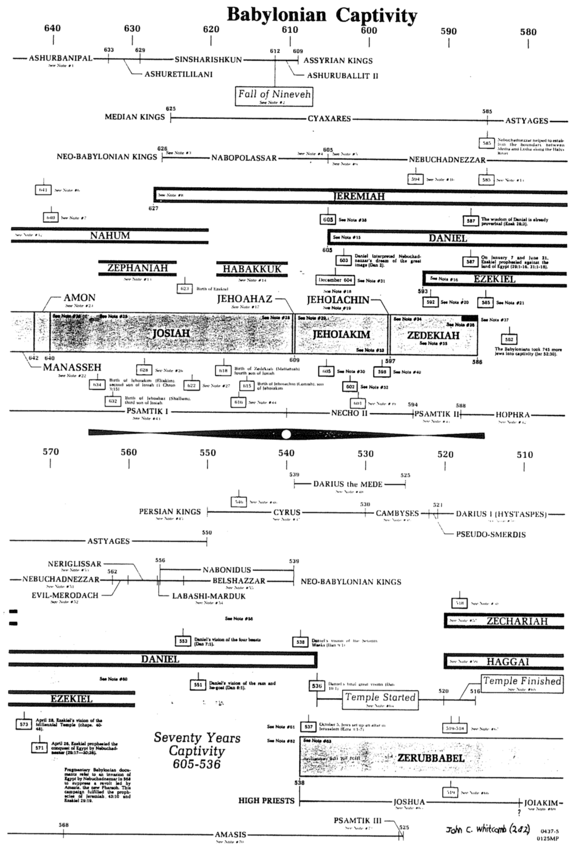
Babylonian Captivity
John C. Whitcomb (2 of 2: Chronology)

Contrasting the Exilic Prophets

 | Daniel | Ezekiel
Date | 605-536 | 597-570
Beginning of Ministry | First invasion of Nebuchadnezzar | Second invasion of Nebuchadnezzar
End of Ministry | After the exile | In the exile
Length of Ministry | longer  (70 years) | shorter  (27 years)
Restoration | Political | Religious
God’s | Sovereignty | Glory/Holiness
Occupation | Administrator/prophet | Prophet
Style | Abstract | Concrete
Length | 12 chapters | 48 chapters
Subjects | Nations & Israel | Israel & Nations
Proclamations | Private | Public

