Crossroads International Church Singapore Dr. Rick Griffith

Title

16 September 2018 Message 25 of 66

NLT 60 Minutes

**Be Repentant**

***Book of Lamentations***

**Topic:** Repentance

**Subject:** How should we repent?

**Complement:** Be repentant over your sin by viewing it as God does.

**Purpose:** The listeners will repentant over sin by changing their mind to view it as God does.

**Attribute:** We worship the God of Compassion

**Reading:** Lam 3:19-24

**Benediction:** Lam 3:25-30

**Song:** Great is Thy Faithfulness

# Introduction

### Interest: [Some people claim to their peril that evil does not exist.]

#### “This past year a young American couple who took a year-long bike trip around the world.

Bikers

#### “Jay Austin and Lauren Geoghegan [GAY-gen], 29, [quit their jobs](https://www.pluralist.com/posts/1824-millennial-couple-bikes-through-isis-territory-to-prove-humans-are-kind-and-gets-killed) last year [2017] in order to make their trip. [Jay] was a vegan who worked for the U.S. Department of Housing and Urban Development; [Lauren], a vegetarian who worked in the Georgetown University admissions office.

#### “[Jay] had a [personal blog](http://www.simplycycling.org/blog/2017/6/8/i-quit-my-job-today) on which he wrote in June 2017, ‘I’ve grown tired of spending the best hours of my day in front of a glowing rectangle, of coloring the best years of my life in swaths of grey and beige. I’ve missed too many sunsets while my back was turned. Too many thunderstorms went unwatched, too many gentle breezes unnoticed.’

#### “Their trip, which lasted 369 days, [took them](http://www.simplycycling.org/blog) from the southernmost tip of Africa in Capetown, South Africa, to Namibia, Botswana, Zambia, Malawi, Tanzania, Egypt, Morocco, Spain, France, Italy, Croatia, Montenegro, Kosovo, Turkey, Kazakhstan, Kyrgyzstan, and finally Tajikistan, where they were murdered along with two other cyclists, one from Switzerland and the other from the Netherlands.

#### “While in Morocco, Austin [wrote](http://www.simplycycling.org/blog/2018/3/25/22),

Blog

##### ‘You watch the news and you read the papers and you're led to believe that the world is a big, scary place. People, the narrative goes, are not to be trusted. People are bad. People are evil. People are axe murderers and monsters and worse.

##### ‘I don't buy it. Evil is a make-believe concept we've invented to deal with the complexities of fellow humans holding values and beliefs and perspectives different than our own—it's easier to dismiss an opinion as abhorrent than strive to understand it. Badness exists, sure, but even that's quite rare. By and large, humans are kind. Self-interested sometimes, myopic sometimes, but kind. Generous and wonderful and kind. No greater revelation has come from our journey than this.’”

#### Well, now I will show you the title of the article about them: “American Couple Believing 'Evil Is A Make-Believe Concept' Bike Through Territory Near Afghan Border. ISIS Stabs Them To Death.”

Article Heading

#### This couple raises a life-and-death question…

### Does evil exist? The simple answer is, ”Yes. Evil exists. In fact, it exists in you and me.” This is why we must repent.

Evil

### Need: Do you believe in evil? Have you repented from it? But what does it mean to repent?

#### Perhaps you have been told that repentance means “to turn”—to *turn* *from* sin, Satan, and death to *turn to* salvation, God, and life. But is that correct?

Repent?

#### Biblically, repentance means to change your mind about who Jesus is and what saves you. It means going from unbelief where we say Jesus is not God to belief that Jesus is God and died for us. So…

Chiasm

MP

Real Meaning

### Subject: How should you repent? How should we change our minds about evil, Jesus, and our sin? Here is where the book of Lamentations can help.

Subject

### Background: Last week we studied how Jerusalem had been devastated.

Two Glimpses

#### The Book of Jeremiah looked ahead with a warning about the fall of Jerusalem.

• Warning

#### Now we will study Jeremiah’s sequel in the book of Lamentations, looking back on this destruction. We are shifting from *warning to mourning.*

• Mourning

#### The city is destroyed. Now what should Judah do?

History

Lament

#### The historical background is sad…

#### This genre is quite different from Kings (and Jeremiah)…

Genre

#### The name and place where it is read are significant…

Name & Place

#### Even the structure is unique. Lamentations is the only Bible book whose basic structure forms an acrostic. All chapters (except chapter 3) have 22 verses, each beginning with successive letters of the Hebrew alphabet (except chapter 5). Chapter 3 has 66 verses with each letter repeated three times. The pattern may be for easy memorization or to emphasize the complete nature of suffering for sin (Dyer, BKC, 1:1211).

Acrostic

#### Not only does the book use multiple acrostics but it has a chiastic structure as well. In other words, certain elements reappear in a deliberate order later in the book. Chapters 1 and 5 both depict Jerusalem’s destruction from the viewpoint of the inhabitants, chapters 2 and 4 both describe God’s view, and the center of the book (chap. 3) shows Jeremiah’s response. The point of drawing attention to chapter 3 is to instruct each of us to imitate Jeremiah's individual response of repentance. Do you just let your calamity pass without really learning from it or do you fall upon God in a spirit of genuine remorse for your sin?

### Preview: Lamentations gives five ways to repent—for the Jews and for us.

5 Ways

### Text: Today we will survey the five chapters of Lamentations.

Lam 1

(What is the first way we can repent from evil?)

# I. Admit your need (Lam 1).

[Don’t cover up the price of your sin.]

## Jerusalem’ rebellion against God led to a horrible siege (Lam 1).

### The fall of Jerusalem from prominence to a lowliness reminds the nation of the heights the city enjoyed by grace before God's judgment (1:1-11).

Acrostic+

(6 slides)

### Jerusalem confesses her deserved desolation with the agony the people feel over the awful effects of rebellion against God (1:12-22).

## Do you confess that your sin has put you into a sad state?

Application Question

Title

### When was the last time you confessed a sin to God?

### Was that a while back because you sin less now—or because you are growing colder to God?

Lam 2

(What is the second way we can repent from evil?)

MP

# II. Admit your fault (Lam 2).

[Don’t make excuses by blaming someone else for your sin.]

## God said that he caused Jerusalem's destruction (Lam 2).

2:1-15

(6 slides)

### God caused the destruction of the city and its covenantal institutions to help his people see this as his judgment (2:1-10).

### Jeremiah laments the city's condition so that all would admit this as God’s judgment and seek his mercy (2:11-22).

#### The people listening to their false prophets caused their suffering by their enemies as God prophesied (2:11-17; cf. Deut. 28).

#### The people should cry out to God in prayer to prevent their deaths from starvation (2:18-19).

#### Jeremiah prays for God to deliver them from their cannibalism, murders, and terrors on every side (2:20-22).

Title

## Do you say the same thing that God says about your sin?

Application Question

### James Boice says, “If you keep close to God, you will keep from sin. But if you sin persistently, you will fall away from God. Then you will rename the sin.

### You will not talk about pride, the great sin; you will call it “self-esteem,” “self-worth,” or what is “due to me.” You will not talk about gluttony and materialism; you will talk about “the good life.” You will not talk about disobedience; you will talk about “shortcomings.” You will not talk about the Ten Commandments and your violation of them; you will talk about your “mistakes.” It is only when you draw close to God that these things will become increasingly sinful in your sight” (https://www.ligonier.org/blog/renaming-sin/).

Lam 3

(How else can we repent from evil?)

MP

# III. Hope in God (Lam 3).

Father Praying

[Express your trust in the LORD alone.]

## Jeremiah repents in his affliction that his confidence is in God (Lam 3).

Hebrew

(2 slides)

### Jeremiah describes his afflictions in general, poetic terms to identify with the suffering people (3:1-18).

3:1-18

(3 slides)

### Jeremiah puts his hope in God to model how to pray for mercy (3:19-39).

3:1-18

(8 slides)

### Jeremiah repents and acknowledges God's deliverance to model national repentance and confident faith in God (3:40-66).

#### The remnant must pray so that those still living after the holocaust will repent (3:40-42).

4:12-13, 20

(2 slides)

#### The sad state of the people should show the awful consequences of disobedience (3:43-54).

#### God will defend the repentant Israelites and pay back the Babylonians to stir national repentance and faith in God’s justice (3:55-66).

## Do you have misplaced hope—or is it in God alone?

Application Question

### Do you sing, “Great is YOUR Faithfulness”?

### Or do you sing, “Great is MY Faithfulness”?

### Are you placing your trust in Jesus alone as your hope in God?

Lam 4

(What is the fourth way to repent from evil?)

MP

# IV. Distrust your leaders (Lam 4).

[Hmmm, this sounds incriminating but I also can’t ultimately trust my leaders.]

4:1-3

(3 slides)

## Trust in their leaders instead of God was Jerusalem’s downfall (Lam 4).

### Jerusalem’s pre-siege glory contrasts with the contemptible siege conditions to recall God's wrath for breaking their covenant (4:1-11).

### The city fell because the people trusted their prophets, priests, elders, alliances, and king rather than God but they can trust him now (4:12-20).

### Jeremiah sarcastically calls on Edom to rejoice over Jerusalem's doom but warns of their coming judgment as God is fair to all (4:21-22).

4:21-22 Diagram

## Do you put more trust in your pastor than in God?

Application Question

### Do you check what I say by the Bible or do you just accept what I say as the truth?

### Do you read more of the Bible to yourself than I read to you?

Lam 5

(What is the last way we can repent from evil?)

# V. Keep looking forward (Lam 5).

MP

[Trust that God will indeed restore you.]

## Jerusalem’s lament and confession look towards restoration (Lam 5).

5:1-15

(4 slides)

### The city (“us/our”) laments to God so the remnant will feel their suffering (5:1-15).

5:16-18

### The city (“us/our”) confesses sin to exhort the remnant to repent (5:16-18).

5:19-22

### The city (“us/our”) prays for restoration to encourage the remnant to hope for renewal (5:19-22).

## Do you pray for restoration?

Application Question

### Joel Osteen wrote the book entitled *Your Best Life Now.*

Osteen Book

### John MacArthur’s comment on this was, “If you are living your best life now, then you are headed for hell.” It’s easy to look at God only as the one who is supposed to give us money. He offers so much more!

• Dollar

### Do you believe that your best days are ahead? You can if you trust in God’s full restoration of your life at death or the return of Christ.

Sky

### Trust in the most trustworthy of all people—the only one who died for your sins and then proved it by rising from the dead!

Subject

(How should you repent?)

# Conclusion

### Be repentant over your sin by changing your mind to view sin as God does (Main Idea). We need to realign our thinking about our doing wrong—our depravity. God doesn’t excuse it, so neither should we (Restatement).

MI

### Main Points: This lament has five keys to repentance that raise five thought questions:

• Fault

• Need

Five Ways

• Forward

• God

• Leaders

#### Admit your need (Lam 1): Do you confess that your sin has put you into a sad state?

#### Admit your fault (Lam 2): Do you say the same thing that God says about your sin?

#### Hope in God (Lam 3): Do you have misplaced hope—or is it in God alone?

#### Distrust your leaders (Lam 4): Do you put more trust in men than in God?

#### Keep looking forward (Lam 5): Do you pray for restoration?

### Remember the young American couple who took a year-long bike trip around the world, believing that evil was a make-believe concept? They took a fatal route in Tajikistan near the Afghan border, where alleged ISIS terrorists stabbed them to death. They let their guard down, not believing that evil was just around the corner.

Bikers

### How does that relate to us (Application)?

Application

#### Beware lest you think you stand and begin to take God's grace for granted. Are you playing with sin in any area of your life? It could also be deadly.

#### Is God disciplining you in an area? When God punishes us, our only hope lies in turning to our "Enemy" (Huang Sabin)

### Prayer (Just trust me—God)

Just Trust Me

# Preliminary Questions

**Verses Questions**

# Context: What did the author record just prior to this passage?

### The book follows on the heels of Jeremiah.

# Purpose: Why is this passage in the Bible?

### It gives God’s example through Jeremiah how to respond to his judgment.

### We all need practical models of God’s will.

# Background: What historical context helps us understand this passage?

### Jerusalem had just been destroyed.

### Now what were those who lived through it supposed to do?

# Questions

### Which people is Lamentations more properly applied to?

#### Believers under God’s discipline as only Yahweh worshippers lived through the destruction of Jerusalem?

#### Believers who saw God disciplining others but had not succumbed to idolatry?

#### Unbelievers who had been idol worshippers and yet were spared to have a second chance to trust in God?

# Tentative Main Ideas

Text

# Illustrations That Apply

### Text

# Old Testament Survey Notes

**Lamentations**

**Introduction**

**I. Title** The Hebrew title for the book (hk;yae *'ekah*) is the exclamation "How!" (BDB 32d 2) or "Oh!" taken from the first word of chapters 1, 2, and 4 (1:1; 2:1; 4:1, 2; cf. Isa. 1:21; Jer. 48:17). The Greek title *Threnoi* means "Dirges" or "Laments," and the Latin title *Threni* ("Tears" or "Lamentations") was derived from this word. The subtitle in Jerome's Vulgate became the basis for the English title "The Lamentations of Jeremiah" (*TTTB*, 207). Lamentations is the only prophetical book not named after its author. Rather, the title conveys the deep personal and national loss that the author feels after the fall of Jerusalem.

**II. Authorship**

A. External Evidence: The Masoretic (Hebrew) text does not claim a particular author, but Jewish tradition attributes the authorship to Jeremiah (Targum at Jer. 1:1; Talmud *B. Bat.* 15a; LXX and Vulgate headings: cf. LaSor, 617, n. 2). The LXX introduction reads, "And it came to pass after Israel was taken captive and Jerusalem laid waste that Jeremiah sat weeping and raised this lament over Jerusalem…" Jeremiah's authorship was universally accepted until 1712 when Herman von der Hardt challenged it (Dyer, *BKC*, 1:1207). All objections of von der Hardt and others have been thoroughly refuted (LaSor, 618; Gleason L. Archer, Jr., *A Survey of Old Testament Introduction*, 365-7; Walter C. Kaiser, *A Biblical Approach to Personal Suffering*, 24-30).

B. Internal Evidence: The book is anonymous yet its contents reveal an author who was an eyewitness, profound theologian, skillful poet, and true patriot (LaSor, 618). Nothing in it raises doubt to the tradition that the author is Jeremiah. Similarities between the Books of Jeremiah and Lamentations are striking: 1:2 (Jer. 30:14); 1:15 (Jer. 8:21); 1:16; 2:11 (Jer. 9:1, 18); 2:20; 4:10 (Jer. 19:9); 2:22 (Jer. 6:25); 4:21 (Jer. 49:12). Both books express the same compassion, sympathy, and grief over Judah's downfall (*TTTB*, 207). It is no wonder that Jeremiah has been called "the weeping prophet."

**III. Circumstances**

A. Date: Nearly all scholars agree that the book refers to the fall of Jerusalem to Nebuchadnezzar of Babylon in 586 BC. Nothing indicates that it was written during the exile. The vividness and deep emotions in the account indicate that an eyewitness composed it shortly after the events took place.

B. Recipients: Jeremiah was never exiled to Babylon (cf. Jer. 40–44), so Lamentations shows to the remnant left in the land the devastating effects of God's judgment on His people.

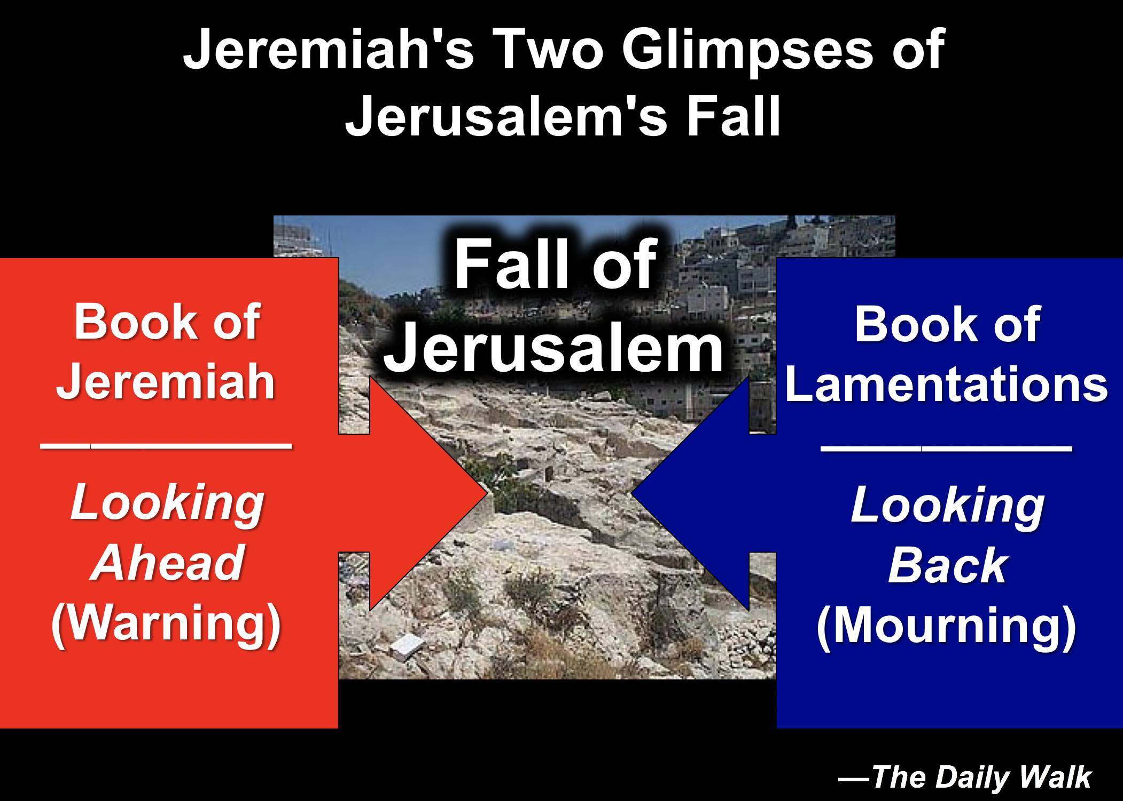C. Occasion: In 586 BC Nebuchadnezzar destroyed Jerusalem with its temple and the nation of Judah went into exile, following years of prophetic warning by Jeremiah, Zephaniah, Habakkuk, and others—warnings which stretched back even as far as the Law (cf. Deut. 28:41, 49-57, 64f.). On the heels of such a catastrophic defeat Jeremiah mourned the loss in the five poems that comprise Lamentations. These poems express the anguish of the remnant and the reasons for God's judgment as a stimulus to national repentance. The worst disaster ever to befall the Jewish nation was certainly this destruction of Jerusalem and the temple (including the departure of the Spirit of God from the Holy of Holies). The two scriptural books written by Jeremiah focus on this tragic event:

Jeremiah’s Two Glimpses of Jerusalem’s Fall



**IV. Characteristics**

A. As previously noted, Lamentations is the only prophetical book not named after its author. This makes sense since Jeremiah already has a prophecy bearing his name. The title conveys the deep personal and national loss which he felt after the fall of Jerusalem.

B. This is the saddest of all books in Scripture. In 2 Kings 25 and Jeremiah 52 we find the *facts* of the destruction of Jerusalem and the temple, but only Lamentations captures the *emotions* (LaSor, 617).

C. Lamentations is also the only Bible book whose basic structure forms an acrostic. All chapters (except chapter 3) have 22 verses, each beginning with successive letters of the Hebrew alphabet (except chapter 5). Chapter 3 has 66 verses with each letter repeated three times. The pattern may be for easy memorization or to emphasize the complete nature of suffering for sin (Dyer, *BKC*, 1:1211).

**Verse Chapter 1 Chapter 2 Chapter 3 Chapter 4 Chapter 5**

1 a (=A) a a a not

2 b (=B) b a b acrostically

3 g (=“C”) g a g arranged

4 d (=D) d b d

5 h (etc.) h b h

6 w (etc.) w b w

etc. etc. etc. etc. etc.

# of Verses 22 22 66 22 22

# of Lines 66 66 66 44 22

Lines/stanza 3 3 1 2 1

Chapter 5 is not an acrostic, but it does have a "mini-acrostic." Verses 19-20 are composed of four lines starting with the letters A, K, L, and “Z,” respectively (i.e., a, k, l, and t). The effect is to express the highest praise for Yahweh followed by the last two verses of the book that contain a tentative, hopeful cry for help (Homer Heater, Jr., “Structure and Meaning in Lamentations,” *Bibliotheca Sacra* 149 [July-September 1992]: 304-15).

D. Not only does the book use multiple acrostics but it has a chiastic structure as well. In other words, certain elements reappear in a deliberate order later in the book. Chapters 1 and 5 both depict Jerusalem’s destruction from the viewpoint of the inhabitants, chapters 2 and 4 both describe God’s view, and the center of the book (chap. 3) shows Jeremiah’s response:

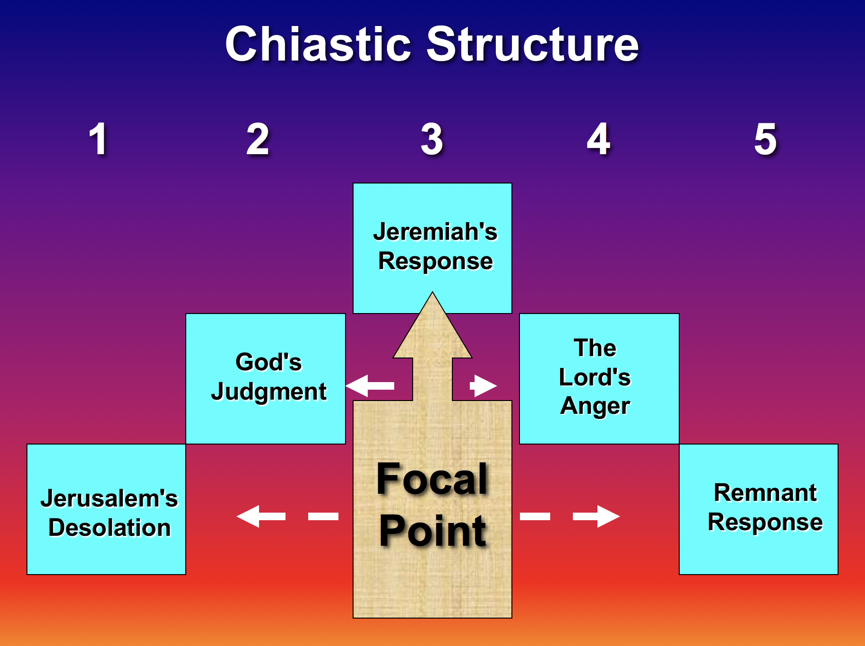

The Chiasm Structure of Lamentations



E. Deuteronomy 28 prophesied the terrible judgments resulting from sin nearly 800 years before Lamentations was written. The parallels between these writings are striking (Charles Dyer, *Bible Knowledge Commentary*, 1:1209):

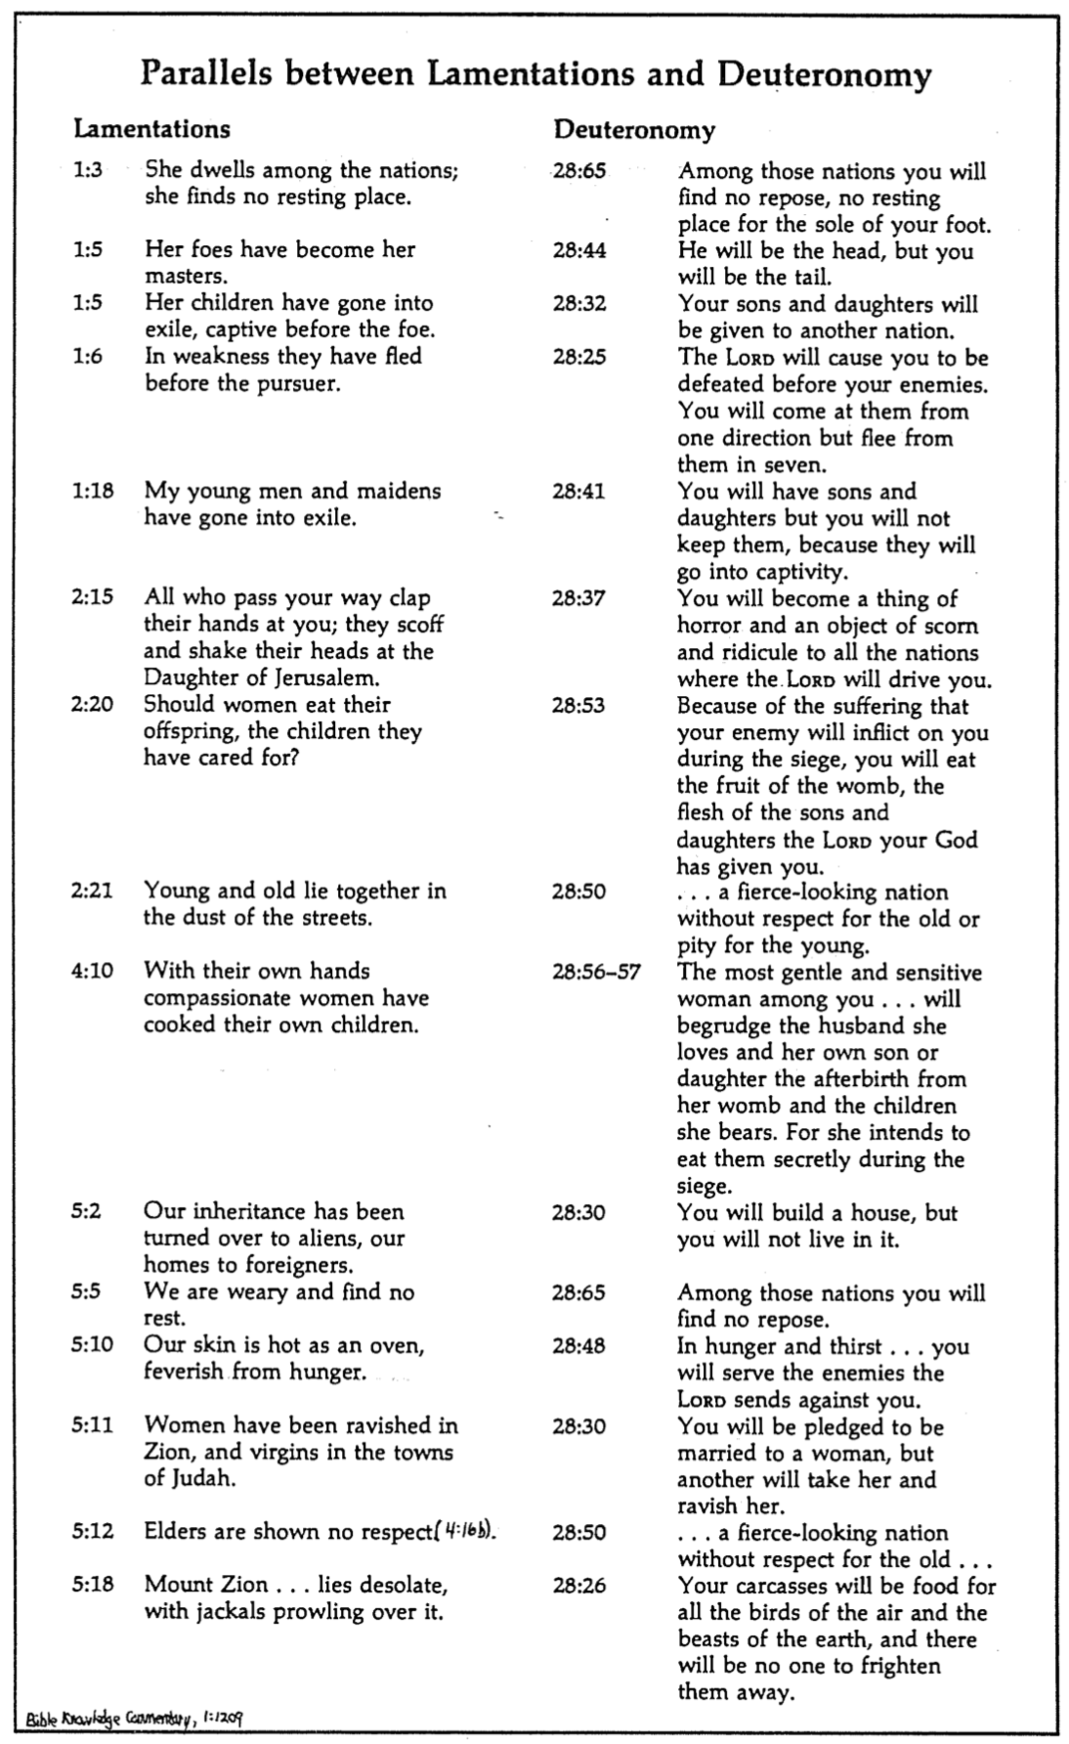

Parallels between Lamentations and Deuteronomy

(BKC)

**Argument**

Jeremiah's Lamentations consists of five poems that express in deeply emotional terms the siege conditions and reasons God caused the fall of Jerusalem. The purpose of documenting such an unpleasant situation is to serve as a model of national confession that the remnant would repent and trust God for His merciful restoration. It begins with two acrostic poems of equal length which describe the siege (ch. 1) as a result of God's withdrawal of His hand (ch. 2), then expresses in an extended poem his own feelings of affliction, hope, and repentant confidence in God as a model for the suffering people to follow (ch. 3). The fourth acrostic poem indicates that the city fell for trusting in its leaders rather than God (ch. 4), and the final poem (not an acrostic) laments, acknowledges national sin, and requests restoration (ch. 5). The chiastic structure makes chapter 3 the focal point in which Jeremiah models the repentant attitude needed in Judah (see previous paragraph “D” above).

**Synthesis**

**Emotions of and reasons for the fall**

**1 Fall described**

1:1-11 Heights to depths (3ps)

1:12-22 Deserved desolation (1ps)

**2 Judgment acknowledged**

2:1-10 God caused it

2:11-22 Lament/exhortation

**3 Jeremiah's feelings**

3:1-18 Affliction

3:19-39 Hope

3:40-66 Repentant confidence

**4 Reason: trusting leaders**

4:1-11 Glory vs. siege

4:12-20 Trusted leaders—not God

4:21-22 Edom to be punished

**5 Prayer**

5:1-15 Lamentation

5:16-18 Confession

5:19-22 Restoration

**Outline**

**Summary Statement for the Book**

**The way Jeremiah modeled repentance after Jerusalem’s destruction was by confessing that God alone could restore Judah from their sin.**

# Jerusalem's horrible fall recalls the awful effects of rebellion against God to stir Judah to repent and obey (Lam 1).

## The fall of Jerusalem from prominence to a lowliness reminds the nation of the heights the city enjoyed by grace before God's judgment (1:1-11).

## Jerusalem confesses her deserved desolation with the agony the people feel over the awful effects of rebellion against God (1:12-22).

# God caused Jerusalem's destruction so that all would admit this as his judgment and seek his mercy (Lam 2).

## God caused the destruction of the city and its covenantal institutions to help his people see this as his judgment (2:1-10).

## Jeremiah laments the city's condition so that all would admit this as God’s judgment and seek his mercy (2:11-22).

### The people listening to their false prophets caused their suffering by their enemies as God prophesied (2:11-17; cf. Deut. 28).

### The people should cry out to God in prayer to prevent their deaths from starvation (2:18-19).

### Jeremiah prays for God to deliver them from their cannibalism, murders, and terrors on every side (2:20-22).

# Jeremiah voices his affliction, hope, and repentant confidence in God so the suffering people will follow (Lam 3).

## Jeremiah describes his afflictions in general, poetic terms to identify with the suffering people (3:1-18).

## Jeremiah puts his hope in God to model how to pray for mercy (3:19-39).

## Jeremiah repents and acknowledges God's deliverance to model national repentance and confident faith in God (3:40-66).

### The remnant must pray so that those still living after the holocaust will repent (3:40-42).

### The sad state of the people should show the awful consequences of disobedience (3:43-54).

### God will defend the repentant Israelites and pay back the Babylonians to stir national repentance and faith in God’s justice (3:55-66).

# God judged Jerusalem in the siege for trusting in their leaders instead of him and will judge Edom to move them to trust him (Lam 4).

## Jerusalem’s pre-siege glory contrasts with the contemptible siege conditions to recall God's wrath for breaking their covenant (4:1-11).

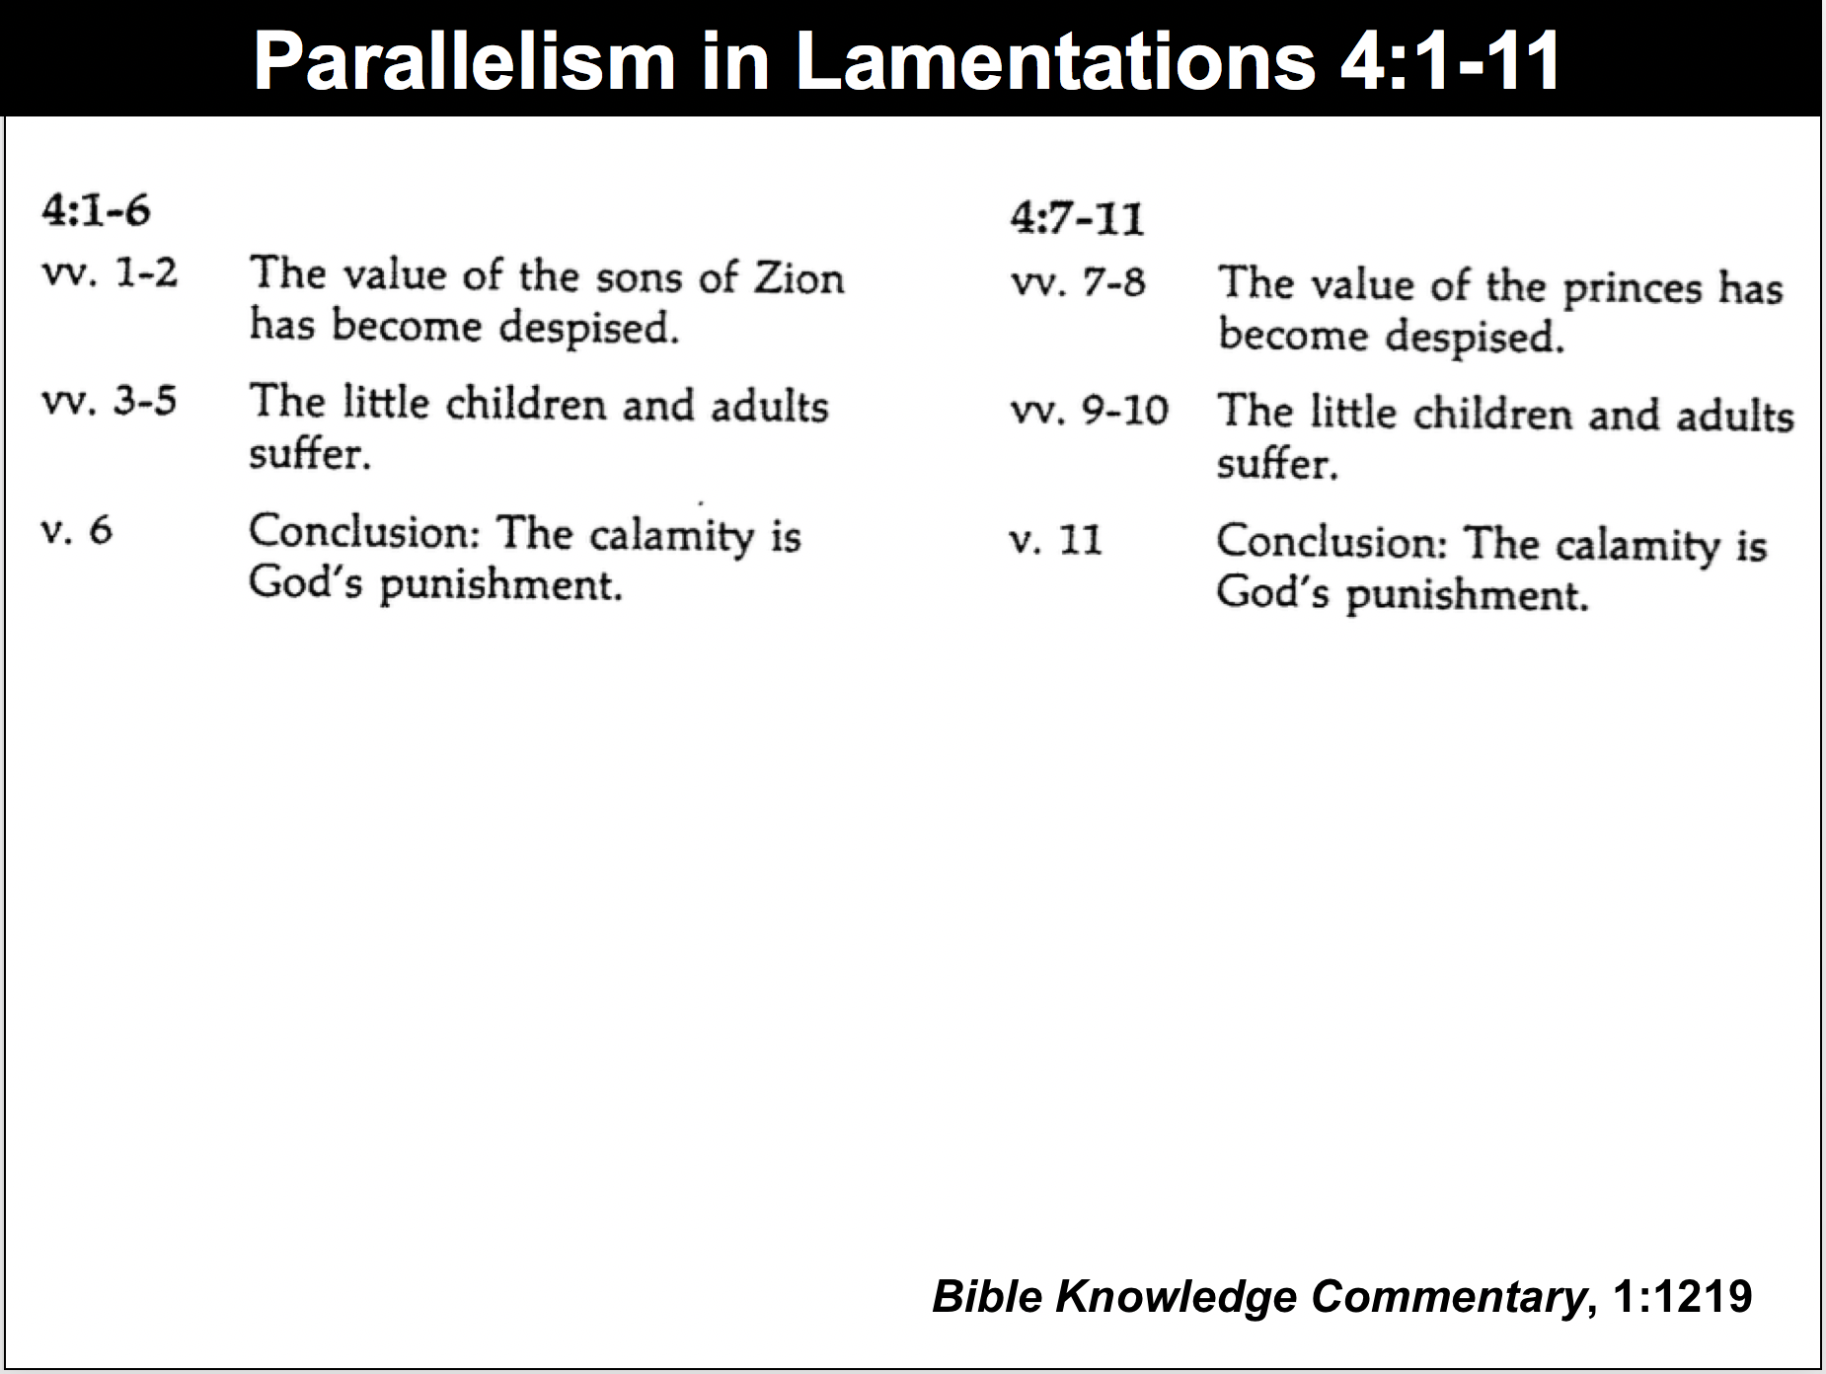

Parallelism in Lamentations 4:1-11

## The city fell because the people trusted their prophets, priests, elders, alliances, and king rather than God but they can trust him now (4:12-20).

## Jeremiah sarcastically calls on Edom to rejoice over Jerusalem's doom but warns of their coming judgment as God is fair to all (4:21-22).

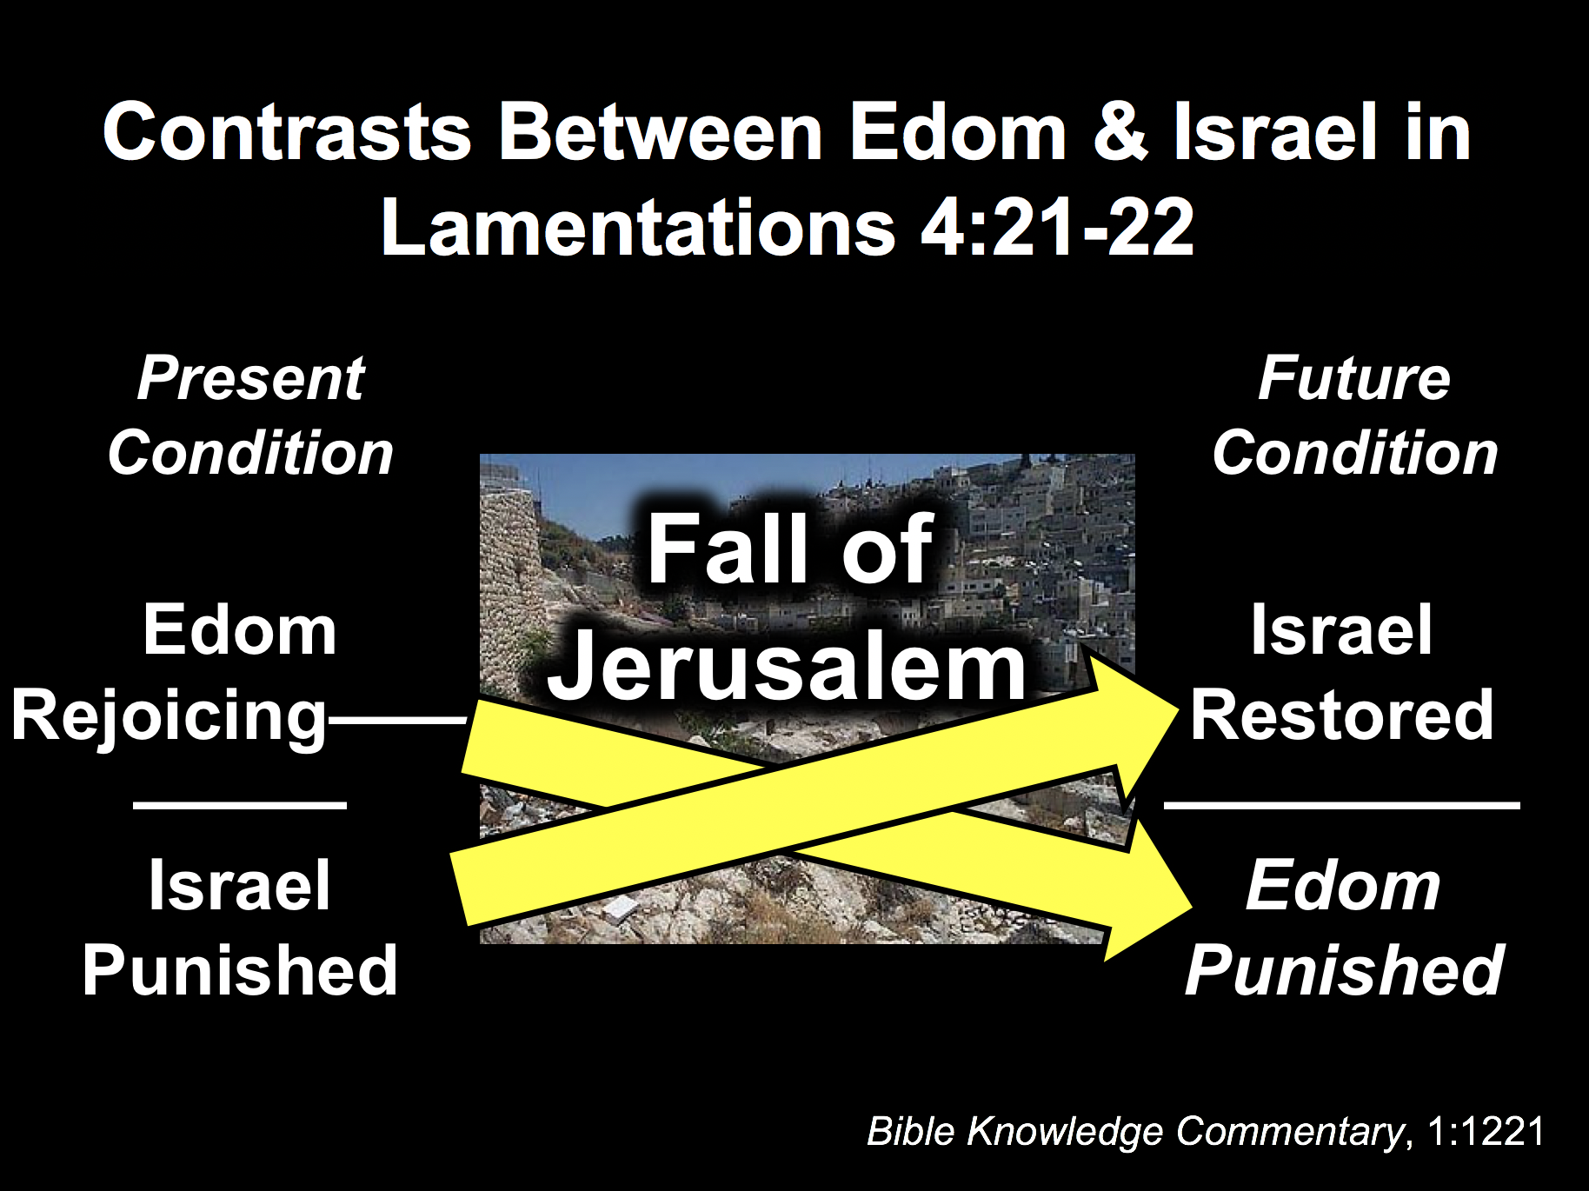

Contrasts between Edom & Israel



# Jerusalem’s lament, confession, and appeal for restoration should move the remnant to repent and hope for renewal (Lam 5).

## The city (“us/our”) laments to God so the remnant will feel their suffering (5:1-15).

## The city (“us/our”) confesses sin to exhort the remnant to repent (5:16-18).

## The city (“us/our”) prays for restoration to encourage the remnant to hope for renewal (5:19-22).

**Be Repentant**

***Lamentations***

**Exegetical Outline (Steps 2-3)**

# *Exegetical Idea*: The way Jeremiah modeled repentance after Jerusalem’s destruction was by confessing that God alone could restore Judah from their sin.

# Jerusalem's horrible fall recalls the awful effects of rebellion against God to stir Judah to repent and obey (Lam 1).

## The fall of Jerusalem from prominence to a lowliness reminds the nation of the heights the city enjoyed by grace before God's judgment (1:1-11).

## Jerusalem confesses her deserved desolation with the agony the people feel over the awful effects of rebellion against God (1:12-22).

# God caused Jerusalem's destruction so that all would admit this as his judgment and seek his mercy (Lam 2).

## God caused the destruction of the city and its covenantal institutions to help his people see this as his judgment (2:1-10).

## Jeremiah laments the city's condition so that all would admit this as God’s judgment and seek his mercy (2:11-22).

### The people listening to their false prophets caused their suffering by their enemies as God prophesied (2:11-17; cf. Deut. 28).

### The people should cry out to God in prayer to prevent their deaths from starvation (2:18-19).

### Jeremiah prays for God to deliver them from their cannibalism, murders, and terrors on every side (2:20-22).

# Jeremiah voices his affliction, hope, and repentant confidence in God so the suffering people will follow (Lam 3).

## Jeremiah describes his afflictions in general, poetic terms to identify with the suffering people (3:1-18).

## Jeremiah puts his hope in God to model how to pray for mercy (3:19-39).

## Jeremiah repents and acknowledges God's deliverance to model national repentance and confident faith in God (3:40-66).

### The remnant must pray so that those still living after the holocaust will repent (3:40-42).

### The sad state of the people should show the awful consequences of disobedience (3:43-54).

### God will defend the repentant Israelites and pay back the Babylonians to stir national repentance and faith in God’s justice (3:55-66).

# God judged Jerusalem in the siege for trusting in their leaders instead of him and will judge Edom to move them to trust him (Lam 4).

## Jerusalem’s pre-siege glory contrasts with the contemptible siege conditions to recall God's wrath for breaking their covenant (4:1-11).

## The city fell because the people trusted their prophets, priests, elders, alliances, and king rather than God but they can trust him now (4:12-20).

## Jeremiah sarcastically calls on Edom to rejoice over Jerusalem's doom but warns of their coming judgment as God is fair to all (4:21-22).

# Jerusalem’s lament, confession, and appeal for restoration should move the remnant to repent and hope for renewal (Lam 5).

## The city (“us/our”) laments to God so the remnant will feel their suffering (5:1-15).

## The city (“us/our”) confesses sin to exhort the remnant to repent (5:16-18).

## The city (“us/our”) prays for restoration to encourage the remnant to hope for renewal (5:19-22).

**Purpose or Desired Listener Response (Step 4)**

The listeners will repentant over sin by changing their mind to view it as God does.

**Homiletical Outline** (Cyclical inductive form)

# Introduction

### Interest: Some people claim to their peril that evil does not exist.

### Need: Do you believe in evil? Have you repented from it?

### Subject: How should you repent?

### Background: Jerusalem has been devastated. Now what should Judah do?

### Preview: Lamentations gives five ways to repent—for the Jews and for us.

### Text: Today we will survey the five chapters of Lamentations.

(What is the first way we can repent from evil?)

# I. Admit your need (Lam 1).

## Jerusalem’ rebellion against God led to a horrible siege (Lam 1).

## Do you confess that your sin has put you into a sad state?

(What is the second way we can repent from evil?)

# II. Admit your fault (Lam 2).

## God said that he caused Jerusalem's destruction (Lam 2).

## Do you say the same thing that God says about your sin?

(How else can we repent from evil?)

# III. Hope in God (Lam 3).

## Jeremiah repents in his affliction that his confidence is in God (Lam 3).

## Do you have misplaced hope—or is it in God alone?

(What is the fourth way to repent from evil?)

# IV. Distrust your leaders (Lam 4).

## Trust in their leaders instead of God was Jerusalem’s downfall (Lam 4).

## Do you put more trust in me than in God?

(What is the last way we can repent from evil?)

# V. Keep looking forward (Lam 5).

## Jerusalem’s lament and confession look towards restoration (Lam 5).

## Do you pray for restoration?

# Conclusion

### Be repentant over your sin by changing your mind to view sin as God does (Main Idea).

### Main Points: This lament has five keys to repentance:

#### Admit your need (Lam 1).

#### Admit your fault (Lam 2).

#### Hope in God (Lam 3).

#### Distrust your leaders (Lam 4).

#### Keep looking forward (Lam 5).

### Applications

#### Beware lest you think you stand and begin to take God's grace for granted.

#### When God punishes us, our only hope lies in turning to our "Enemy" (Huang Sabin)

### Prayer

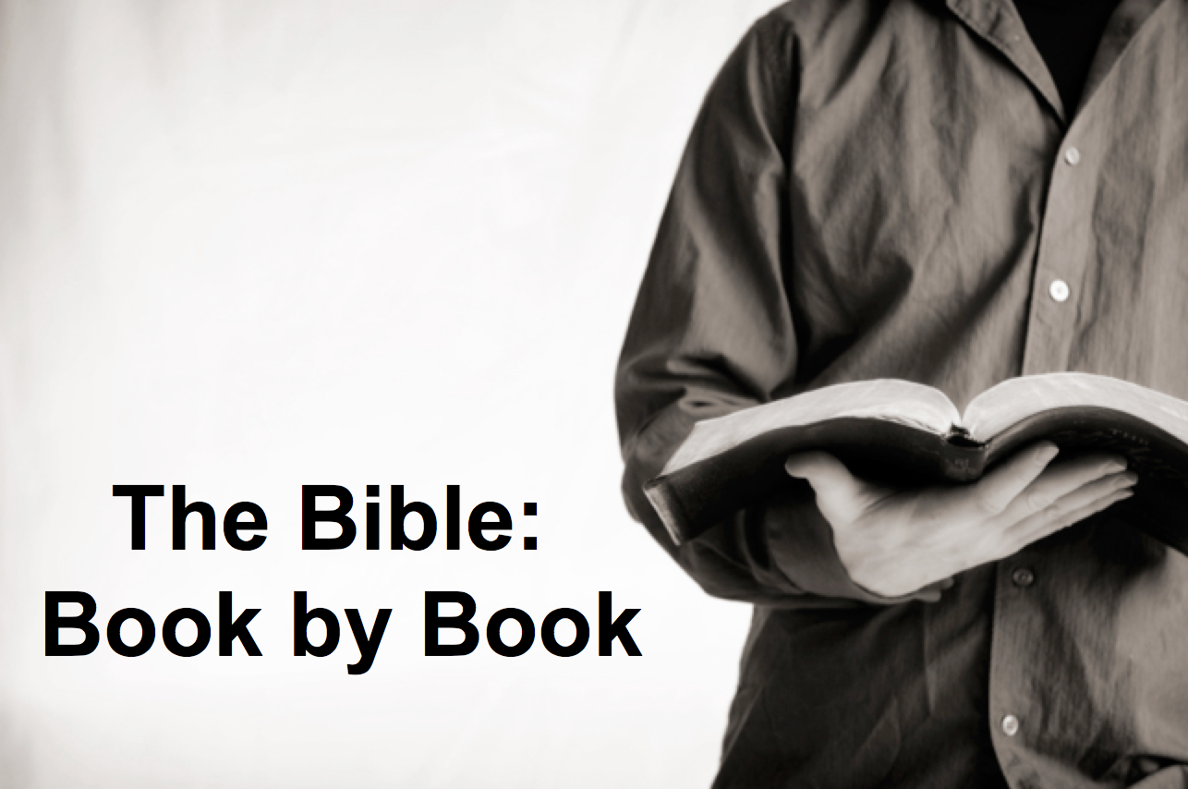

**Rick Griffith**

16 Sep 2018

Message 25 of 66

**Be Repentant**

***Lamentations***

# Introduction

### Some people claim to their peril that evil does not exist. Do you believe in evil? Have you repented from it?

### How should you __________________?

### Jerusalem has been destroyed. Now what should Judah do?

# 1. Admit your ______________ (Lam 1).

## Jerusalem’ rebellion against God led to a horrible siege (Lam 1).

## Do you confess that your sin has put you into a sad state?

# 2. Admit your ______________ (Lam 2).

## God said that he caused Jerusalem's destruction (Lam 2).

## Do you say the same thing that God says about your sin?

# 3. Hope in ______________ (Lam 3).

## Jeremiah repents in his affliction that his confidence is in God (Lam 3).

## Do you have misplaced hope—or is it in God alone?

# 4. Distrust your ______________ (Lam 4).

## Trust in their leaders instead of God was Jerusalem’s downfall (Lam 4).

## Do you put more trust in your pastor than in God?

# 5. Keep looking ______________ (Lam 5).

## Jerusalem’s lament and confession look towards restoration (Lam 5).

## Do you pray for restoration?

# Conclusion

### Be repentant over your sin by changing your mind to see it as God does (Main Idea).

### Beware lest you think you stand and begin to take God's grace for granted.

### When God punishes us, our only hope is turning to our "Enemy" (Huang Sabin)

Download this sermon PPT and notes for free at BibleStudyDownloads.org/resource/old-testament-preaching/

Listen to this message online at cicfamily.com/sermon-listing/

**Lamentations**

|  |  |  |  |  |  |  |
| --- | --- | --- | --- | --- | --- | --- |
| **Emotions of and Reasons for the Fall** | | | | | | |
| **Fall**  **Described** | | **Judgment**  **Acknowledged** | | **Jeremiah’s**  **Feelings** | **Trusting**  **Leaders** | **Prayer** |
| **Chapter 1** | | **Chapter 2** | | **Chapter 3** | **Chapter 4** | **Chapter 5** |
| **The**  **Suffering** | | **The**  **Cause** | | **The**  **Hope** | **The**  **Reason** | **The**  **Lament** |
| **3 Line**  **Acrostic** | | **3 Line**  **Acrostic** | | **1 Line**  **Acrostic** | **2 Line**  **Acrostic** | **1 Line**  **Not Acrostic** |
| **People** | | **God** | | **Prophet** | **God** | **People** |
| Third Person  Singular  (“she”)  1:1-11 | First Person  Singular  (“I”)  1:12-22 | Third Person  Singular  (“He”)  2:1-10 | First  Person  Singular  (“I”)  2:11–4:22 | | | First  Person  Plural  (“us/our”)  5:1-22 |
| **Jerusalem** | | | | | | |
| **586 BC** | | | | | | |

**Key Word: Confession**

**Key Verse: “Because of the LORD’s great love we are not consumed, for his compassions never fail. They are new every morning; great is your faithfulness” (Lamentations 3:22-23).**

**Summary Statement:**

**The way Jeremiah modeled repentance after Jerusalem’s destruction was by confessing that God alone could restore Judah from their sin.**

**Application:**

**When God punishes us, our only hope lies in turning to our ‘Enemy’**

**(Adapted from Huang Sabin)**