Crossroads International Church Singapore Dr. Rick Griffith
9 Sept 2018 Message 24 of 66
NLT 50 Minutes
Be Comforted
Title
Jeremiah

Topic: Comfort
Subject: How does God comfort even those he disciplines?
Complement: God works within his own limits so we will submit to his discipline.
Purpose: The listeners will be comforted even if God is disciplining them.
Attribute: We worship the God of Comfort
Reading: Jer 31:31-34
Benediction: Jer 31:35-37
Song: What a Friend We Have in Jesus

Introduction

Interest: [We must balance discipline with comfort.]

It is wonderful to be with you all again after taking a week off to be with my family in the USA. This is a first for us—three days of flying to have four days with my family—but when a $4000 trip costs only $100 now since our son is a pilot, we had little excuse not to go!
Visit
(5 slides)

As we study the Scripture book-by-book, today we come to the book of Jeremiah. Jeremiah was the only prophet to live through the 586 BC fall of Jerusalem. God called him to show God’s compassion even in Judah’s darkest hours. Jeremiah is known as "The Weeping Prophet." I suspect you would weep also if you saw your country ravaged and destroyed before your very eyes and you were powerless to stop it. It actually makes sense that God would call one like him who experienced such loss to be one who teaches us the need to be comforted.
Weeping Prophet
Book by Book

That’s because we all need to be comforted at various times of our lives. This is true for women, of course, but not only for women.
Woman

Men also need comfort many times.
Soldier

As one who often gives comfort, I found myself as one needing to be on the receiving end in January. It was challenging to be both the son and the officiating minister at my father’s memorial service, but God granted comfort from this same son, Stephen, who made the effort to fly to be there as a support.
• Son
Me

Of course, we all know that life is not only about comfort. One of the signs of growing up is to realize that we must balance discipline with comfort.
Spanking

Discipline shows us when we are off track and need to realign.

Comfort helps us feel appreciated and loved.
Father Comfort

Need: What images or memories come to your mind when you hear the word "discipline"? When you were growing up, were you disciplined in a balanced way?
Discipline

Did you receive mostly harsh discipline?

Or did your parents give you no discipline at all?

Or did you experience a good balance where standards (the principle of the thing) were matched with support? Did you receive comfort along with the discipline?
Subject

Subject: How does God comfort even those he disciplines? In what ways can we see God's compassion even when he has to punish sin?

A good father does not discipline in harshness and then reject and neglect his child.

Like the best earthly father, God wants us to realize that, despite his discipline, he also offers his comfort.

Background: Jeremiah was the only prophet to live through the 586 BC fall of Jerusalem. God called him to show God’s compassion even in Judah’s darkest hours.
Weeping Prophet

How? Josiah was the last good king, who died in 609. • After him the reigns of his descendants alternated between 3 months• to 11 years • to 3 months • to 11 years once again! • But God spoke to these godless kings through three major prophets. Jeremiah was the only one to preach in Jerusalem until the city fell in 586, • while Daniel was taken to Babylon in 605 • and Ezekiel in 597.
Josiah’s Sons

By the time we get to Jeremiah, God proclaims that the exile will definitely come. It is inevitable.
Key Word

Jeremiah’s theme is that captivity is deserved but also the restoration is undeserved and will also happen.
Theme

Judgment was because of Judah’s sin, as the key verse indicates in 8:14.
Key Verse

Preview: Our title is “Be Comforted.” Today we will see four ways that God comforts even those he disciplines.
Be Comforted

Text: We will see these four ways of God’s comfort by surveying the entire book of Jeremiah.
4 Ways

(So how does God comfort even those he disciplines?)

I. God calls messengers who are honest with us (1).
MP
[He appoints candid people to show us both his discipline and restoration.]

God comforted Judah through Jeremiah to both judge and restore (Jer 1).
Jer 1

Jeremiah reveals himself as author and reveals that his ministry lasted over four decades from Josiah's thirteenth year (627 BC) to the exile (1:1-3; 586 BC).

Jeremiah spoke the uncomfortable truth for God in a long ministry of 40 years, beginning in the reign of Josiah, the last godly king of Judah.
Length

He served through the siege of fall of Jerusalem and remained among the captives afterwards.

God calls Jeremiah as a prophet to proclaim judgment and restoration to the nation (1:4-10).
Call

God assured Jeremiah – He knew, set apart, appointed him. And said he would put His words into His mouth. The Lord reached out His hand and touched his mouth. He is to stand up against nations and kingdoms, uproot and tear them down. He is to build up and plant others.

Jeremiah’s success was not determined by the size of his “church”!

In fact, like Isaiah, Ezekiel, and, frankly, all the prophets, his success was in saying and doing what God commanded to a stubborn and rebellious people who were bent on their own way all their days until the Babylonians stormed the gates of their capital—and remained stubborn and rebellious even afterwards.
Assurance

God confirms Jeremiah's call to proclaim judgment through the signs of the blossoming almond branch and the boiling pot (1:11-16).

God assures Jeremiah of his presence to encourage him to speak God's entire message without fear (1:17-19).

Is God trying to comfort you through his truthful messengers?
Comforting You?

I will be honest with you—my main goal is to be honest with you!

That honest truth includes both the things we like to hear and those things that we do not like.

St. Augustine said, “The truth is like a lion. You don’t have to defend it. Let it loose. It will defend itself.”
• Augustine

My prayer is that those of us who need comfort will find it here today. God is, after, the “God of all comfort” (2 Cor). That is the “building up” aspect of pastoral ministry. I have come to build you up.
Title

But God has also called me to “tear down.” That means that God’s primary goal in your life is not to make you comfortable. It is to make you like his son Jesus. That will take some tearing down of patterns that hinder Christlikeness in us.
Subj
(So how does God comfort even those he disciplines? God calls messengers who are honest with us. Jeremiah was one such spokesman true to God’s word, including both God’s comfort and discipline. How else does God comfort even those he disciplines?)
MPI

II. God has limited discipline but unlimited blessing (2–45).
MP
[The LORD's punishment is always less than his rewards.]

God comforted Judah throughout Jerusalem's fall that the 70-year exile would result in a new covenant (Jer 2–45).
Jer 2

People opposed prophecies of judgment and submission before restoration under a new covenant (Jer 2–38).

God has just reasons to judge the nation so Judah cannot think its punishment is undeserved (Jer 2–20).
Judah with God

God indicts the nation for its sinful treatment of God seen in its ingratitude, idolatry, immorality, and irrationality (Jer 2; see esp. 2:10-11).

God calls the nation to repent from spiritual adultery to motivate the people to escape the impending judgment of the Babylonians (Jer 3–6).
Jer 6
(2 slides)

Jeremiah's temple address aims to convince the people to turn from their false reliance on the temple and idolatry to avoid impending judgment (Jer 7–10).
Jer 7
(2 slides)

Jeremiah delivers his covenant sermon detailing how Judah violated God's statutes and the consequences of violating the covenant (Jer 11–12).
Jer 11
(2 slides)

God uses various illustrations of Judah’s judgment to graphically portray the severity of Judah’s sin and his response (Jer 13–20).

An unavoidable 70-year captivity should encourage the people to submit to Babylon but receives stiff opposition (Jer 21–29).

Jeremiah prophesies judgments against Judah's kings and leaders but promises that the Messiah will come to lead the nation justly (21:1–23:8).

Jeremiah prophesies destruction on Judah's false prophets who claim that God sent them to prophesy safety on the unrepentant land (23:9-40).

Baskets of good and bad figs denote Jews exiled or who die in the land to exhort Judah to submit to Babylon despite Jeconiah’s deportation (Jer 24; 597 BC).
Jer 24
(2 slides)

Jeremiah predicts seventy years of captivity (605-536 BC) to let the people know that while God will punish Judah it will not be permanent (Jer 25).
Jer 25
(3 slides)

Jerusalem’s leaders reject Jeremiah and lead to captivity as unavoidable (Jer 26–29).
Jer 27-29
(8 slides)

Israel’s future restoration with a new covenant (The Book of Comfort) should encourage the remnant that God has not forgotten his promises (Jer 30–33).
Jer 30-31
(12 slides)

Israel and Judah will be reunited in the land with a new heart under a new covenant [after Messiah’s second coming] (Jer 30–31).
Title

Jeremiah buys a field to comfort the people that they will return to the land (Jer 32).

Jeremiah prophesies restoration of the people, land, and Davidic line under Messiah who will sit on the throne (Jer 33).

Final messages warn against disobedience while Jerusalem is under siege lead to Jeremiah being imprisoned instead (Jer 34–38).

The disobedience of Zedekiah and Jehoiakim is contrasted with Recabite obedience to convince the people to obey God in surrender to Babylon (Jer 34–36).

Jeremiah suffers in a dungeon and cistern for faithfully proclaiming God's message of judgment (Jer 37–38).

God destroyed Jerusalem but spared Ebed-Melech for protecting Jeremiah (cf. 38:7-13) to show the profits of obedience (Jer 39).

Jeremiah did not go to Babylon but served Jews in Judah and Egypt to show God blessing his faithfulness (Jer 40–44).

Jeremiah’s encouragement to Baruch 20 years before recalls how God kept his promise to save his life (Jer 45).

Do you focus on God’s unlimited comfort or his limited discipline?
Focus

You might ask, “Well which should I focus on? God has both, right?”

Yes, he does. Whatever your concern today, he offers you his unlimited comfort in this Book of Comfort. He cannot care for you more than he does right now!

But he also offers you his limited discipline. He will hold you accountable for how you live—not for salvation, since that is by faith in our Lord Jesus Christ—but accountable for your actions that lead to reward in the coming kingdom. Like the farmer who prunes his plant for greater yield later, he may be trimming you down in discipline for your glorious future.

(How else does God comfort even those he disciplines?)
MPs
(3 slides)

III. God applies the same standards to all people (46–51).
MP
[He will judge unbelievers as well as his own people.]

God comforted his people by judging their persecutors (Jer 46–51).
Jer 46
(2 slides)

The title introduces chapters 46–51 as oracles against nations that persecuted Judah (46:1).

God prophesies judgment against Egypt at Carchemish and within its own borders as a testimony to Judah that God will regather her from exile (46:2-28).

God prophesies judgment against Egypt at Carchemish [fulfilled in 605 BC] (46:2-12).

God prophesies judgment against Egypt to occur within its own borders in an invasion and exile (46:13-26).

God encourages Judah that he will regather the nation from exile even if all nations are destroyed (46:27-28).
Title

God prophesies judgment against Philistia to encourage Judah that its enemies will be punished also (Jer 47).

God prophesies Moab's judgment to encourage Judah that its enemies will be punished also (Jer 48).

God prophesies Ammon's judgment to encourage Judah that its enemies will be punished also (49:1-6).

God prophesies Edom's judgment to encourage Judah that its enemies will be punished also (49:7-22).

God prophesies Damascus' judgment to encourage Judah that its enemies will be punished also (49:23-27).

God prophesies Kedar and Hazor's judgment to encourage Judah that its enemies will be punished also (49:28-33).

God prophesies Elam's judgment to encourage Judah that its enemies will be punished also (49:34-39).

God prophesies Babylon's judgment to encourage Judah that its enemies will be punished also [key verse is 51:49] (Jer 50–51).

Do you recognize that God has been fair with you?
Is God Fair?

None of these nations received the same level of revelation that Israel got, but they still were responsible based on the moral law that God has put into the heart of every person. They should not have persecuted Israel.

Likewise, God has been and will be fair to you. Now “fair” doesn’t mean that every one of us has had the same experiences in life. It only means that the way God has dealt with you is just—as he dealt fairly with these nations who refused him.

(How else does God comfort even those he disciplines?)

IV. God balances justice with mercy (52).
MP
[He judges but also restores.]

God balanced Jerusalem’s fall with Jehoiachin’s elevation so the exiles would see that they also would be elevated in a return to the land (Jer 52).

There was an evil end to Judah (explain slide).
Evil End Diagram

The fall of Jerusalem is detailed as a declaration of God's faithfulness to fulfill his promise of judgment upon his unrepentant people (52:1-30).

Evil-Merodach's elevation of Jehoiachin encourages the exiles that they too would soon be elevated in a return to the land, to show God's mercy and faithfulness to his promise (52:31-34).
Gavel

Do you focus on God’s discipline instead of his mercy in your life?

Few, if any, of us has had our country totally destroyed, though this still happens today in places like Iraq, Syria, Lebanon, and even closer to home like Jakarta in 1998 when a fourth of the city was destroyed. Yet even in these situations, God has shown his mercy. Many have trusted Christ by being expulse from their country.

But on a more personal level, do you think more of God’s judgment or his grace in your own life? Do you realize have much he has blessed you? The old song tells us to “count your many blessings, count them one by one.” Do you?
Sub
(How does God comfort even those he disciplines?)

Conclusion

God works within his own limits so we will submit to his discipline (MI). Even inevitable judgment has unlimited comfort.
MI

Main Points: How does God comfort even those he disciplines?
MPI

God calls messengers who are honest with us (1).

God has limited discipline but unlimited blessing (2–45).
MPII

God applies the same standards to all people (46–51).
MPIII

God balances justice with mercy (52).
MPIV

Exhortation: Are you like Jeremiah, Judah, or the faithful remnant?
Apply
(13 slides)

Is God disciplining you right now? How?

How should you submit to God’s discipline in your life?

How can you receive God’s comfort even if he is disciplining you?

Prayer
Prayer

Preliminary Questions

Verses Questions

Context: What did the author record just prior to this passage?

God had sent a whole line of prophets prior to Jeremiah. Each warned about the coming judgment of Jerusalem if the people did not repent of their idolatry.

Now we have come to the last of the pre-exilic prophets—to Jeremiah himself, the only prophet to live through the destruction within the walls of Jerusalem.

Purpose: Why is this passage in the Bible?

A good father does not discipline in harshness and then reject and neglect his child.

Like the best earthly father, God wants us to realize that, despite his discipline, he also offers his comfort.

Background: What historical context helps us understand this passage?

Jeremiah spoke for God in a long ministry of 40 years, beginning in the reign of Josiah, the last godly king of Judah. He served through the siege of fall of Jerusalem and remained among the captives afterwards.

Jeremiah’s success was not determined by the size of his “church”! In fact, like Isaiah, Ezekiel, and, frankly, all the prophets, his success was in saying and doing what God commanded to a stubborn and rebellious people who were bent on their own way all their days until the Babylonians stormed the gates of their capital–and remained stubborn and rebellious even afterwards.

Questions

Should we think of the prophet Jeremiah as a strong leader or a weeping prophet—or both?

Why is Jerusalem’s destruction narrated twice in Jeremiah’s prophecy (Jer 39, 52)?

To what extent is the new covenant applicable to the church today (Jer 31:31-34)?

Has God rejected Israel and replaced the Jews with the Church (Jer 33)?

Tentative Main Ideas

Text

Illustrations That Apply

Optional Introduction 1

It is wonderful to be with you all again after taking a week off to be with my family in the USA. This is a first for us—three days of flying to have four and half days with my family—but when a $4000 trip costs only $100 now since our son is a pilot, we had little excuse not to go!

Each time we come together in a church service we are all doing the same thing—that is, sitting in this same service at this same time—but with a different motivation.

A key motivation that I hear for people coming to a specific church is, “I tried several churches until I found one that made me feel comfortable.”

Optional Introduction 2

Great to see you here at church this morning! But why are you here? A key motivation that I hear for people coming to a specific church is, “I tried several churches until I found one that made me feel comfortable.”

I can sympathize with that since I try to wear comfortable shoes and put my body in a comfortable position. I didn’t look for a job where I could be miserable long-term, did you? Like you, I tried to get into a place where I am appreciated and it’s a good fit—comfortable, if you will.
Sleeper

But, of course, we need more than comfort. We need for God to challenge our comfortable way of thinking because the comfortable way can lead us to apathy and even death.

I read this week, “When on the beautiful road, seek no other road.” Doesn’t that sound nice? But what if the beautiful road leads us to destruction? We need the discipline to stay on the right road, even if it is not so comfortable or beautiful.
Road

One preacher expressed his goal for speaking this way: “I seek to comfort the disturbed and to disturb the comforted.” I suspect we need both—but just at different time—don’t we?
Steeple

Old Testament Survey Notes

Jeremiah

Introduction

I. Title The name Jeremiah (WhymryI yirmeyahu; BDB 941c 1) is difficult to determine in meaning as it may come from either of two roots meaning "cast, shoot" or possibly "loosen." Some say it has the connotation "Yahweh throws," perhaps in the sense of laying a foundation, or even "Yahweh establishes, appoints or sends" (TTTB, 198), but no one really knows.

II. Authorship

A. External Evidence: Daniel 9:2 calls Jeremiah 25:11-14; 29:10 a prophetic writing from Jeremiah's hand, as does the NT explicitly in Matthew 2:17-18 (31:15) and implicitly in Matthew 21:13; Mark 11:17; Luke 19:46 (7:11), Romans 11:27 (31:33) and Hebrews 8:8-13 (31:31-34), this last quote being the longest OT quote in the NT. The Talmud, Josephus, and Ecclesiasticus also affirm Jeremiah as author (TTTB, 198).

B. Internal Evidence: Despite the above external support, critical scholars continue to doubt Jeremiah's authorship on several internal grounds. However, the author is clearly designated as Jeremiah (1:1, 11) who was appointed to be a prophet by God before his birth (1:5) and officially called to the prophetic office as a youth (1:6f.). He was the son of Hilkiah, one of the priests at Anathoth in the territory of Benjamin (1:1; 11:21, 23; 29:27; 32:7-9), a village just over two miles (three kilometers) north of Jerusalem.

However, chapter 52 is nearly identical to 2 Kings 24:18–25:30 and the postscript (52:31-34) says Jehoiachin was released 37 years into his exile (ca. 560 BC) and lived at the king's table until his death. Assuming 645 BC for Jeremiah's birth would make him at least eighty-five when Jehoiachin was elevated (but no one knows how long Jehoiachin lived after this). It is likely that chapter 52 was recorded by the same author as the 2 Kings postscript under the direction of the Holy Spirit, especially since “the words of Jeremiah end here” (51:64).

III. Circumstances

A. Date: Jeremiah prophesied in the darkest days of Judah's history, starting in the thirteenth year of Josiah (627 BC; cf. 1:2) and extending past the fall of Judah (586 BC) to about 580 BC. Thus, his ministry spanned over four decades during the reigns of Josiah's four successors, the last kings of Judah (Jehoahaz, Jehoiakim, Jehoiachin, and Zedekiah). Most of his material, however, concerns events after Josiah's tragic death in 609 BC (LaSor, 404).

B. Recipients: The majority of the prophecy addresses Judah before the fall of Jerusalem, but some directs itself to the exiles following the fall (Jer 38–44, 52). One chapter (Jer 29) was sent to the exiles in Babylon before the fall of Jerusalem.

C. Occasion: Rule over Judah during Jeremiah’s time shifted hands from several powers:

1. Assyria: Since before 722 BC (nearly 100 years before Jeremiah’s birth) Assyria had been the foreign power dominating Jerusalem.

2. Babylon: In 612 BC Nineveh, Assyria’s capital, fell to Babylon, the rising power to the south. This meant Judah would be subject to Babylon.

3. Egypt: But Assyria-Babylon conflicts in the east gave Egypt control of Israel in the west. Pharaoh Neco killed Josiah of Judah in 609 BC, then his son Jehoahaz ruled three months. Neco then deposed him and replaced him with Jehoahaz's brother Jehoiakim.

4. Babylon: When Nebuchadnezzar of Babylon defeated Pharaoh Neco of Egypt at the Battle of Carchemish (605 BC), Jehoiakim switched allegiance from Egypt to Babylon.

5. Egypt: Then again only four years later (601 BC) Neco defeated Nebuchadnezzar and Jehoiakim switched his allegiance back to Egypt.

6. Babylon: Jehoiakim’s trust again in Egypt as the main power force was a fatal mistake. Within 3 years (597 BC) Nebuchadnezzar regrouped, successfully attacked Jerusalem and killed Jehoiakim. Nebuchadnezzar replaced him with his son Jehoiachin and 3 months later deported him to Babylon with 10,000 others, replacing him with his uncle Zedekiah as Judah's vassal king. Zedekiah's control was instable and defiant towards Babylon, which soon sieged Jerusalem, leading to the city's final fall in 586 BC.

Although Jeremiah preached over forty years, most of his prophecy (all except Jer 1–6, 11–12, 52) was delivered in this 22-year period (points #3-6 above; cf. p. 12 chart) before Jerusalem’s fall (ca. 607-586 BC). At times he encouraged the people of Judah to repent, but after chapter 19 he indicated to Judah that God's warnings against the nation's sin would soon stop since the captivity was inevitable. Many of his sermons noted the people’s sins, showing that God was just in punishing the nation.

IV. Characteristics

A. Jeremiah communicated his messages through many symbolic acts, including a rotten waistband (Jer 13), his never marrying (Jer 16), a potter's clay (Jer 18), a broken jar (Jer 19), wearing a yoke (Jer 27), purchasing a field (Jer 32), hiding stones in the palace of Egypt (Jer 43), and throwing scrolls into a river (Jer 51).

B. Several literary types compose the prophecy: poetic discourse (e.g., Jer 30–31), prose discourse (e.g., Jer 32–33), and prose narrative (e.g., Jer 46–51).

C. The LXX (Greek) version of this book has a different arrangement and omits about one eighth (about 2700 words) of the original. The LXX omits 10:6-8; 27:19-22; 29:16-20; 33:14-26; 39:4-13; 52:2-3, 15, 28-30, etc. in comparison to the MT (Hebrew) that underlies the English translations. The LXX is therefore not recommended.

D. Jeremiah includes the key passage in the entire Bible on the New Covenant (31:31-34). The significance of this covenant can be seen in the following:

1. Definition: God’s unconditional amplification of the blessing promise in the Abrahamic Covenant in which Israel and Judah will experience national and spiritual redemption.
Four Unconditional Biblical Covenants

ABRAHAMIC
Genesis 12:1-3

LAND SEED BLESSING

LAND DAVIDIC NEW
Deuteronomy 30:1-10 2 Samuel 7:12-16 Jeremiah 31:31-34

Adapted from Robert P. Lightner, Last Days Handbook, 77

2. Provisions

a. Indwelling of the Holy Spirit (Jer. 31:33 with Ezek. 36:27)
b. New nature, heart, and mind (Jer. 31:33; Isa. 59:21) Fulfilled now
c. Forgiveness of sins (Jer. 31:34b)
d. Everyone will know the LORD (Jer. 31:34a) Not yet
e. Israel and Judah will be reunited (Jer. 31:31) Fulfilled

3. Unconditional Nature

a. Eternal (Jer. 31:36, 40; 32:40; 50:5; Isa. 61:2, 8-9; 24:5; Ezek. 37:26)

b. Amplification of the Abrahamic Covenant, which is unconditional

c. Unqualified “I will” statements of God (Jer. 31:31-34; Ezek. 16:60-62)

4. Time of Fulfillment

a. Partial fulfillment in the present church age: Three premillennial views have been given on how to correlate Jeremiah 31:31f. with various NT passages (Luke 22:20; 1 Cor. 11:25; 2 Cor. 3:6; Heb. 8:8; 9:15)

1) Only one New Covenant for Israel (Darby)

2) Two New Covenants: one for Israel and one for the church (Chafer)

3) One New Covenant with a two-fold application: to the church now and to Israel in the future (Scofield)

b. Complete fulfillment in the future after return of Christ (amillennialists believe all of the provisions of the New Covenant are being realized now in the Church which they consider the “new Israel”)

E. Jeremiah edited his own material, arranging it logically rather than chronologically (as did Ezekiel). Therefore, dates of the prophecies move from the reigns of earlier kings to later ones and back several times. Note this chart by Charles H. Dyer (BKC, 1:1126):

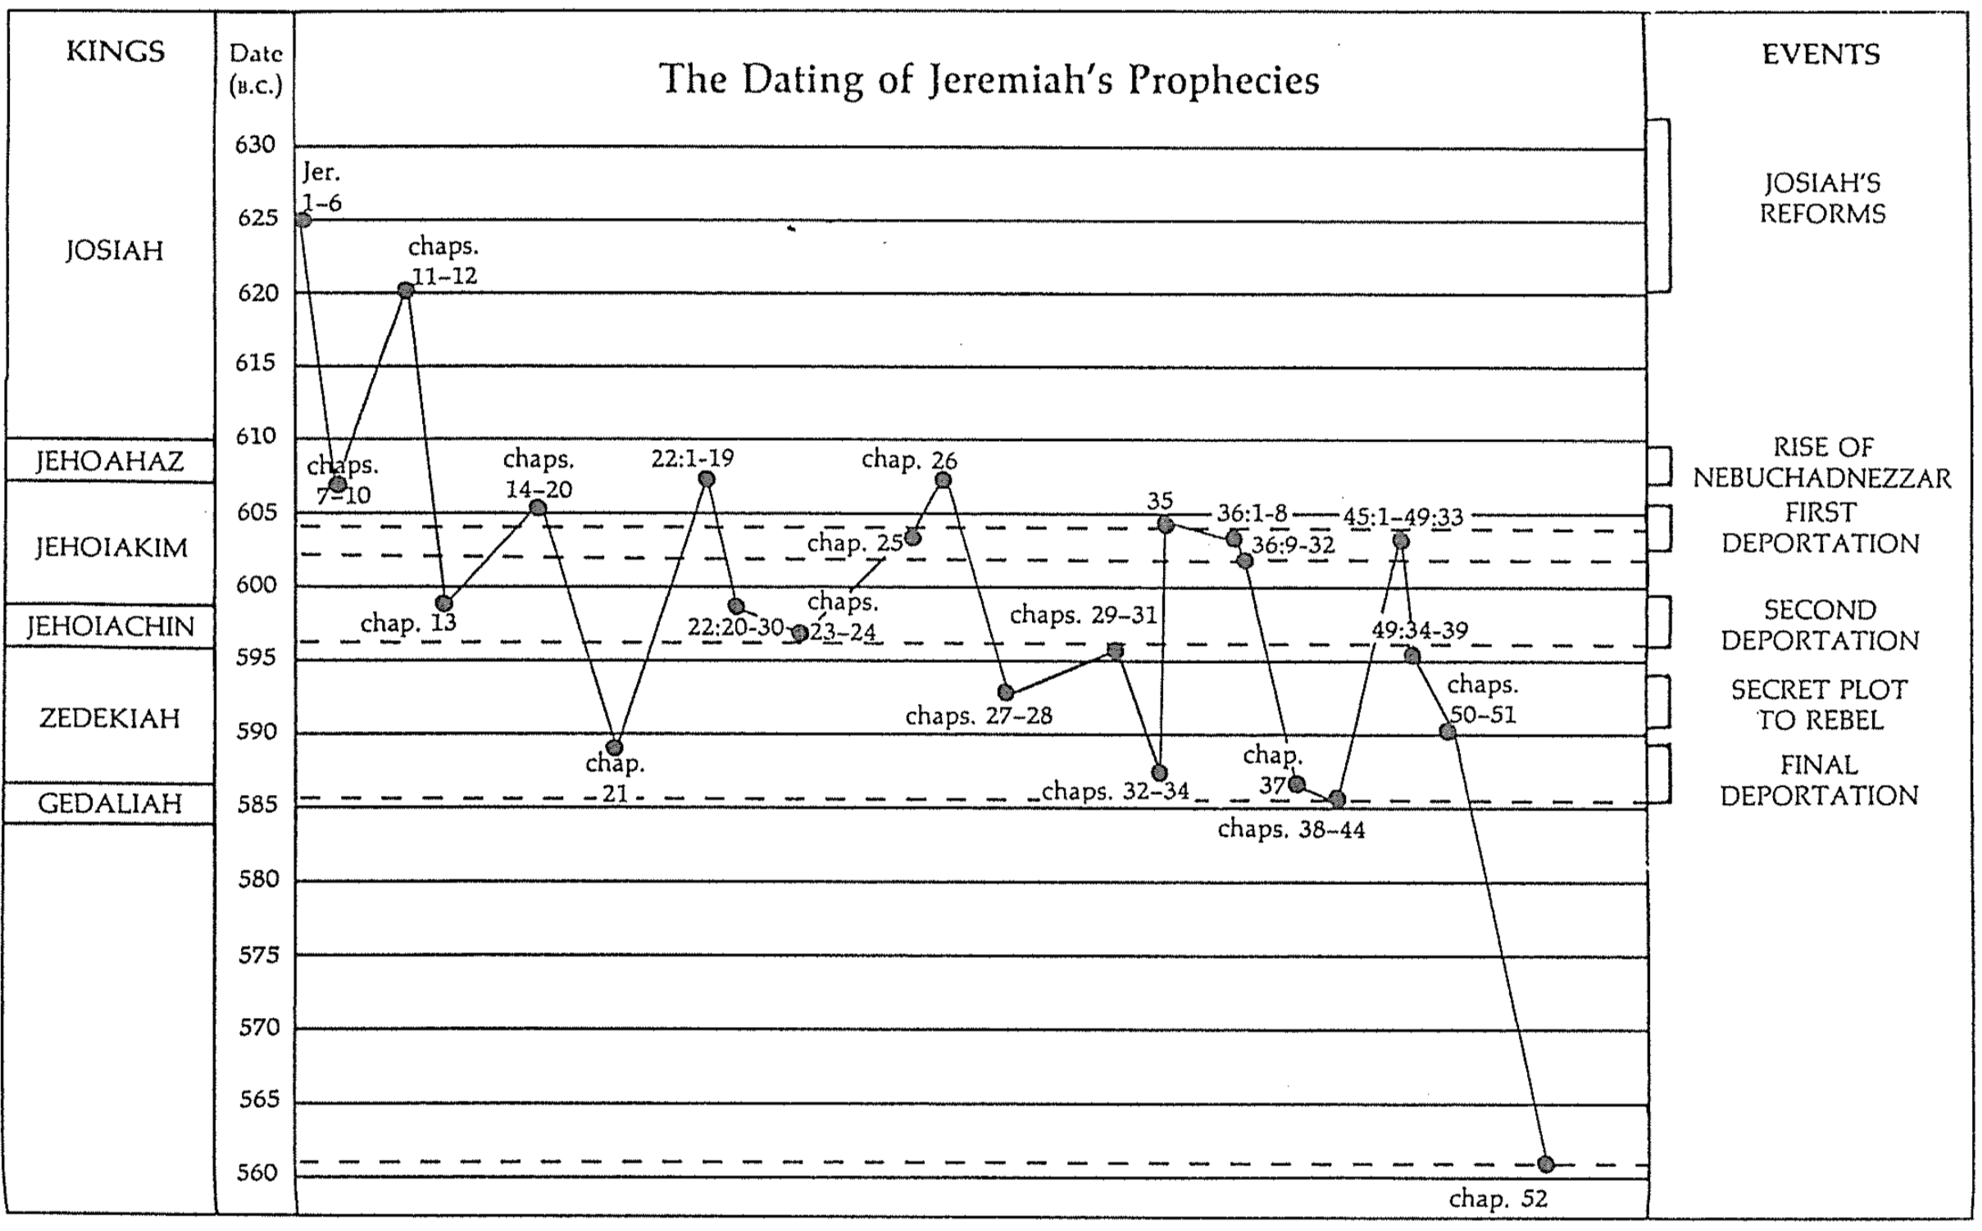

F. Jeremiah is the only prophet to specify the length of the exile as 70 years (25:11-12; 29:10).

G. Jeremiah alone chronicled the fall of Jerusalem twice in the same book (chapters 39, 52). He also wrote a poetic description in Lamentations on the same theme.

H. Jeremiah was the sole prophet in Judah who ministered through the fall of the southern kingdom. Thus he alone provides personal perspectives before, during, and after Jerusalem’s downfall.

- Jeremiah is the longest prophetic book in terms of the number of words.

Book | Chapters | Verses | Words
Psalms | 150 | 2461 | 43,743
Jeremiah | 52 | 1364 | 42,659
Ezekiel | 48 | 1273 | 39,407
Genesis | 50 | 1533 | 38,267
Isaiah | 66 | 1292 | 37,044

J. Jeremiah 31:31-34 is the longest OT quotation found in the NT (Heb. 8:8-13).

K. This prophet alone records how judgment for Judah was inevitable. In other words, the nation had gone so far in its sin that even if it repented, the judgment would still come. This is seen in the book in several ways:

1. The people are encouraged to repent only up until chapter 19 (e.g., 15:19; 17:24; 18:8; cf. 5:3; 8:6). Yet after this point no exhortations to repent are forthcoming.

2. Jeremiah was instructed by God not even to pray for the people of Judah (11:14; 14:11).

3. Jeremiah told the people that each could individually have life instead of death if he/she would surrender to the Babylonians, but the destruction still would come on the nation as a whole (21:8-9; 24:1-10; 27:5-12, 16-17; 32:5; 38:17-23; 42:9-22; 52:24-27).

4. God's determination of the length of the captivity at 70 years indicates that judgment was unavoidable (25:11-12; 29:10).

5. Jeremiah smashed a pot to illustrate that God’s decision to destroy the city was not retractable (19:1-2, 10-11).

6. Jeremiah instructed those already in exile to settle down (29:4-14) in contrast to the false prophet Hananiah, who said the exile would only last two years (28:1-3, 10-12). This shows that the “die was already cast” and even repentance of the people could not forestall God’s judging hand.

Argument

As already noted, Jeremiah's prophecies follow a thematic arrangement. This explains why the fall of Jerusalem appears twice in the book (Jer 39, 52). Following the introductory chapter that reveals Jeremiah's mission to proclaim God's judgment upon the nation (Jer 1), the material is arranged to prove the deserved judgment of Judah (Jer 2–45) and the nations (Jer 46–51). The final chapter (Jer 52) describes how God fulfilled His promise of judgment in the fall of Jerusalem but would soon return the people to their land. Throughout the prophecy Jeremiah lists the moral and spiritual causes for God's judgment balanced with His gracious promise of hope through restoration to the land under a new covenant.

Synthesis

Deserved captivity and undeserved restoration

1 Jeremiah’s call
1:1-3 Ministry at fall
1:4-10 Judgment and restoration
1:11-16 Branch and pot
1:17-19 God's presence

2–45 Judah’s deserved captivity
2–38 Pre-fall ministry
2–20 Reasons for judgment
2 Treatment of God
3–6 Spiritual adultery
7–10 Temple address (temple trust misguided)
11–12 Covenant sermon (Mosaic covenant replaced by idolatry)
13–20 Illustrations
13 Rotten waistband
14–15 Drought
16:1-9 Restrictions: singleness, no parties or funerals
16:10–17:18 *Restoration (excursus)
17:19-27 Sabbath disobedience
18–20 Pots
18 Potter
19 Broken pot
20 Pashhur #1 (evil)
21–29 Captivity unavoidable
21:1–23:8 Messiah replaces civil leaders—Pashhur #2 (righteous)
23:9-40 False prophets
24 Figs
25 70-year captivity
26–29 Opposition
26 Priests
27 Yoke
28 Hananiah (“Exile’s only 2 years!”)
29 Shemaiah (“Don’t believe Jeremiah”)
30–33 Book of Comfort (Undeserved restoration)
30–31 New Covenant (Israel/Judah reunited)
32 Field redemption
33 Restoration under Messiah
34–38 Siege messages
34–36 Contrasts
34 Zedekiah (evil)
35 Recabites (good)
36 Jehoiakim (evil)
37–38 Jeremiah's imprisonment
39 Fall ministry
40–44 Post-fall ministry
40–42 in Judah
43–44 in Egypt
45 Baruch's depression

46–51 Nations’ deserved judgment
46 Egypt
47 Philistia
48 Moab
49:1-6 Ammon
49:7-22 Edom
49:23-27 Damascus
49:28-33 Kedar/Hazor
49:34-39 Elam
50–51 Babylon

52 Fall of Jerusalem
52:1-30 Fall
52:31-34 Elevation (of Jehoiachin by Evil-Merodach)

Outline

Summary Statement for the Book
The ways God comforted his people were by limiting Jerusalem’s deserved and inevitable fall to 70 years and promising restoration under a new covenant.

The way God comforted his people was through Jeremiah’s prophetic call to proclaim judgment and restoration to the nation (Jer 1).

Jeremiah reveals himself as author and reveals that his ministry lasted over four decades from Josiah's thirteenth year (627 BC) to the exile (586 BC) (1:1-3).

God calls Jeremiah as a prophet to proclaim judgment and restoration to the nation (1:4-10).

God confirms Jeremiah's call to proclaim judgment through the signs of the blossoming almond branch and the boiling pot (1:11-16).

God assures Jeremiah of his presence to encourage him to speak God's entire message without fear (1:17-19).

The way God comforted his people was by speaking to them before, during, and after Jerusalem's fall that the exile would last only 70 years and result in a new covenant (Jer 2–45).

Prophecies before Jerusalem’s fall on God’s just judgment and the need to yield to Babylon’s 70-year exile before restoration under a new covenant are violently opposed (Jer 2–38).

Jeremiah prophesies messages that reveal the just reasons God has to judge the nation so Judah cannot think its punishment is undeserved (Jer 2–20).

God indicts the nation for its sinful treatment of God seen in its ingratitude, idolatry, immorality, and irrationality (Jer 2; see esp. 2:10-11).

God calls the nation to repent from spiritual adultery to motivate the people to escape the impending judgment of the Babylonians (Jer 3–6).

God calls Israel to repentance from its spiritual adultery shown in its turning to other gods (3:1–4:4).

God foretells of the impending destruction from Babylon as a motivation for the people to repent (4:5–6:30).

Jeremiah's temple address aims to convince the people to turn from their false reliance on the temple and idolatry to avoid impending judgment (Jer 7–10).

Jeremiah preaches his temple sermon to convince the people that the temple’s presence cannot prevent God's judgment on their false worship (7:1–8:3).

God details the coming judgment for the nation's idolatry to cause the people to repent from their false worship (8:4–10:25).

God describes the coming judgment as imminent and terrible so that the people would lament like Jeremiah does (8:4–9:26).

God’s description of the coming judgment as imminent and terrible enables the people to see his perspective (8:4-17).

Jeremiah’s lament models the kind of repentant response God desires of the entire nation (8:18–9:2).

God again describes the horrible nature of and justified reasons for the coming catastrophe (9:3-26).

God proclaims that the judgment will come upon the nation for its idolatry and Jeremiah requests judgment on the other nations also (Jer 10).

Jeremiah delivers his covenant sermon detailing how Judah violated God's statutes and the consequences of violating the covenant (Jer 11–12).

Jeremiah delivers his covenant sermon that proclaims that Judah violated God's statutes through its idolatry (11:1-17).

The men of Anathoth, Jeremiah's home town, plot against his life because they do not want to listen to the violations of the covenant (11:18-23).

Jeremiah complains about the prosperity of the wicked and God says that worse events are coming, but the destruction will bring Judah to repent (Jer 12).

God uses various illustrations of Judah’s judgment to graphically portray the severity of Judah’s sin and his response (Jer 13–20).

A rotten waistband and a proverb about drunkenness depict how useless the nation has become to God (Jer 13).

Jeremiah identifies with Judah during God's judgment of drought (Jer 14–15).

God restricts Jeremiah to singleness and prohibits attendance at funerals or parties to illustrate his judgment coming upon the land (16:1-9).

Excursus (16:10–17:18): God promises restoration after Judah experiences the consequences of its sin and Jeremiah expresses his trust in Yahweh.

Jeremiah rebukes the Sabbath disobedience shown in carrying loads on this day that signifies the covenant (17:19-27).

Jeremiah announces God's sovereign decision to destroy Judah using the imagery of pots and Pashhur persecutes him as a result (Jer 18–20).

God is sovereign like a potter with clay (Jer 18).

God will destroy Judah like a broken pot (Jer 19).

The priest Pashhur persecutes Jeremiah because he compares the judgment of Judah to the broken pot, then Jeremiah laments to God (Jer 20).

Jeremiah prophesies to Judah's leaders of an unavoidable 70-year captivity to encourage the people to submit to Babylon but receives stiff opposition (Jer 21–29).

Jeremiah prophesies judgments against Judah's kings and leaders but promises that the Messiah will come to lead the nation justly (21:1–23:8).

Jeremiah tells the priests to tell Zedekiah that he will be judged and God will reject his request to save them from the Babylonian siege (21:1–22:9).

Shallum (Jehoahaz) will be judged through his death in exile (22:10-12).

Jehoiakim will be judged through a terrible death without burial (22:13-23).

Coniah (Jehoiachin) will be judged by not having any of his immediate descendants sit upon the throne (22:24-30).

Godless leaders will be replaced with ones who genuinely care for the people, the Messiah (Righteous Branch) being the preeminent leader (23:1-8).

Jeremiah prophesies destruction on Judah's false prophets who claim that God sent them to prophesy safety on the unrepentant land (23:9-40).

Baskets of good and bad figs denote Jews exiled or who die in the land to exhort Judah to submit to Babylon despite Jeconiah’s deportation (Jer 24; 597 BC).

Jeremiah predicts seventy years of captivity (605-536 BC) to let the people know that while God will punish Judah it will not be permanent (Jer 25).

Jeremiah and his message receive stiff opposition from the leaders of Jerusalem, due to their unbelief captivity is unavoidable (Jer 26–29).

Priests and false prophets oppose Jeremiah in his second temple sermon but others save him, in contrast to Uriah prophesying and dying for his false prophecies (Jer 26).

The genealogy of Shaphan (26:24) below depicts how his sons righteously stood for the truth in various ways (except the youngest, who rebelled against his father’s values).

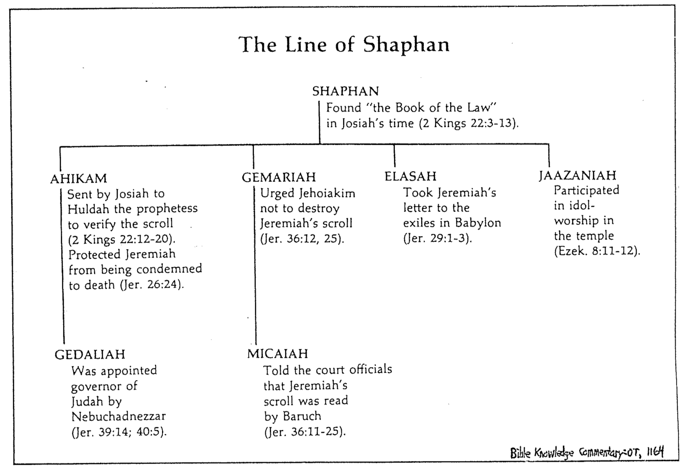

Jeremiah uses a yoke to convince the people of Judah and the nations to submit to Babylon (Jer 27).

The false prophet Hananiah opposes Jeremiah by claiming that the captivity will last only two years but he dies only two months later (Jer 28).

The false prophet Shemaiah opposes Jeremiah's open letter to the exiles that tells them to unpack their bags for a long stay but God promises to judge him (Jer 29).

Messages of hope for Israel in a future restoration with a new covenant (The Book of Comfort) encourage the remnant that God has not forgotten his promises (Jer 30–33).

Israel and Judah will be reunited in the land with a new heart under a new covenant [after Messiah’s second coming] (Jer 30–31).

Jeremiah buys a field to comfort the people that they will return to the land (Jer 32).

Jeremiah prophesies restoration of the people, land, and Davidic line under Messiah who will sit on the throne (Jer 33).

Jeremiah gives final messages of warning against disobedience as Jerusalem is besieged but is imprisoned instead (Jer 34–38).

The disobedience of Zedekiah and Jehoiakim is contrasted with Recabite obedience to convince the people to obey God in surrender to Babylon (Jer 34–36).

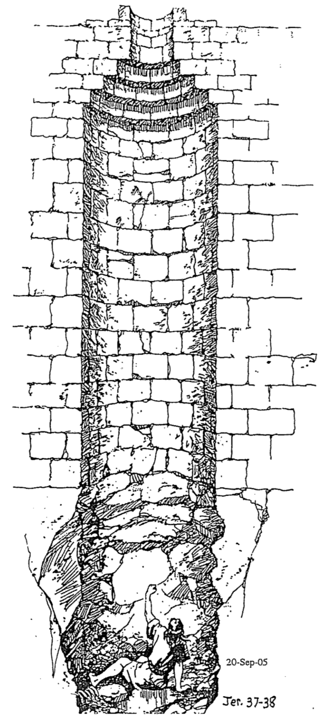
Zedekiah frees Jewish slaves in supposed repentance but takes them back (Jer 34).

The Recabite abstinence exemplifies for the people that obeying leads to blessing (Jer 35).

Jehoiakim burns Jeremiah's scroll in disdain for God's word, but Jeremiah rewrites an expanded prophecy to show how God's word cannot be thwarted (Jer 36).

Jeremiah suffers in a dungeon and cistern for faithfully proclaiming God's message of judgment (Jer 37–38).

God fulfills his threat to destroy Jerusalem, but Ebed-Melech, God's foreign servant, is spared for protecting Jeremiah (cf. 38:7-13), showing the profits of obedience (Jer 39).

Jeremiah need not go to Babylon so he ministers to the remnants in Judah and Egypt, showing God’s blessing on his faithfulness (Jer 40–44).

Jeremiah exhorts the remnant in Judah after the slaughter of Gedaliah to remain in the land under Babylon's rule, and not go to Egypt (Jer 40–42).

Jeremiah rebukes the remnant in Egypt who disobeyed God's command by fleeing Israel, warning against falsely claiming to want God’s will (Jer 43–44).

An incident 20 years before, when Jeremiah encouraged Baruch in his depression over Jehoiakim's burning of the scroll shows that God sovereignly kept his promise to save his life (Jer 45).

The way God comforted his people was by judging the nations that persecuted Judah (Jer 46–51).

The title introduces chapters 46–51 as oracles against nations that persecuted Judah (46:1).

God prophesies judgment against Egypt at Carchemish and within its own borders as a testimony to Judah that God will regather her from exile (46:2-28).

God prophesies judgment against Egypt at Carchemish [fulfilled in 605 BC] (46:2-12).

God prophesies judgment against Egypt to occur within its own borders in an invasion and exile (46:13-26).

God encourages Judah that he will regather the nation from exile even if all nations are destroyed (46:27-28).

God prophesies judgment against Philistia to encourage Judah that its enemies will be punished also (Jer 47).

God prophesies Moab's judgment to encourage Judah that its enemies will be punished also (Jer 48).

God prophesies Ammon's judgment to encourage Judah that its enemies will be punished also (49:1-6).

God prophesies Edom's judgment to encourage Judah that its enemies will be punished also (49:7-22).

God prophesies Damascus' judgment to encourage Judah that its enemies will be punished also (49:23-27).

God prophesies Kedar and Hazor's judgment to encourage Judah that its enemies will be punished also (49:28-33).

God prophesies Elam's judgment to encourage Judah that its enemies will be punished also (49:34-39).

God prophesies Babylon's judgment to encourage Judah that its enemies will be punished also [key verse is 51:49] (Jer 50–51).

The way God comforted his people was by balancing Jerusalem’s fall with Jehoiachin’s elevation to reassure the exiles that they too would soon be elevated in a return to the land (Jer 52).

The fall of Jerusalem is detailed as a declaration of God's faithfulness to fulfill his promise of judgment upon his unrepentant people (52:1-30).

Evil-Merodach's elevation of Jehoiachin encourages the exiles that they too would soon be elevated in a return to the land, to show God's mercy and faithfulness to his promise (52:31-34).

Be Comforted
Jeremiah

Exegetical Outline (Steps 2-3)

Exegetical Idea: The ways God comforted his people were by limiting Jerusalem’s deserved and inevitable fall to 70 years and promising restoration under a new covenant.

The way God comforted his people was through Jeremiah’s prophetic call to proclaim judgment and restoration to the nation (Jer 1).

The way God comforted his people was by speaking to them before, during, and after Jerusalem's fall that the exile would last only 70 years and result in a new covenant (Jer 2–45).

Prophecies before Jerusalem’s fall on God’s just judgment and the need to yield to Babylon’s 70-year exile before restoration under a new covenant are violently opposed (Jer 2–38).

God fulfills his threat to destroy Jerusalem, but Ebed-Melech, God's foreign servant, is spared for protecting Jeremiah (cf. 38:7-13), showing the profits of obedience (Jer 39).

Jeremiah need not go to Babylon so he ministers to the remnants in Judah and Egypt, showing God’s blessing on his faithfulness (Jer 40–44).

An incident 20 years before, when Jeremiah encouraged Baruch in his depression over Jehoiakim's burning of the scroll shows that God sovereignly kept his promise to save his life (Jer 45).

The way God comforted his people was by judging the nations that persecuted Judah (Jer 46–51).

The way God comforted his people was by balancing Jerusalem’s fall with Jehoiachin’s elevation to reassure the exiles that they too would soon be elevated in a return to the land (Jer 52).

Purpose or Desired Listener Response (Step 4)
The listeners will be comforted even if God is disciplining them

Homiletical Outline (Cyclical inductive form)

Introduction

Interest: We must balance discipline with comfort.

Need: When you were growing up, were you disciplined in a balanced way?

Did you receive mostly harsh discipline?

Or did your parents give you no discipline at all?

Or did you experience a good balance where standards (the principle of the thing) were matched with support? Did you receive comfort along with the discipline?

Subject: How does God comfort even those he disciplines?

Background: Jeremiah was the only prophet to live through the 586 BC fall of Jerusalem. God called him to show God’s compassion even in Judah’s darkest hours.

Preview: Today we will see four ways that God comforts even those he disciplines.

Text: We will see these four ways of God’s comfort by surveying the entire book of Jeremiah.

(So how does God comfort even those he disciplines?)

I. God calls messengers who are honest with us (1).
[He appoints candid people to show us both his discipline and restoration.]

God comforted Judah through Jeremiah to both judge and restore (Jer 1).

Is God trying to comfort you through his truthful messengers?
(How else does God comfort even those he disciplines?)

II. God has limited discipline but unlimited blessing (2–45).
[The LORD's punishment is always less than his rewards.]

God comforted Judah throughout Jerusalem's fall that the 70-year exile would result in a new covenant (Jer 2–45).

People opposed prophecies of judgment and submission before restoration under a new covenant (Jer 2–38).

God destroyed Jerusalem but spared Ebed-Melech for protecting Jeremiah (cf. 38:7-13) to show the profits of obedience (Jer 39).

Jeremiah did not go to Babylon but served Jews in Judah and Egypt to show God blessing his faithfulness (Jer 40–44).

Jeremiah’s encouragement to Baruch 20 years before recalls how God kept his promise to save his life (Jer 45).

Do you focus on God’s unlimited comfort or his limited discipline?
(How else does God comfort even those he disciplines?)

III. God applies the same standards to all people (46–51).
[He will judge unbelievers as well as his own people.]

God comforted his people by judging their persecutors (Jer 46–51).

Do you recognize that God has been fair with you?
(How else does God comfort even those he disciplines?)

IV. God balances justice with mercy (52).
[He judges but also restores.]

God balanced Jerusalem’s fall with Jehoiachin’s elevation so the exiles would see that they also would be elevated in a return to the land (Jer 52).

Do you focus on God’s discipline instead of his mercy in your life?
(How does God comfort even those he disciplines?)

Conclusion

God works within his own limits so we will submit to his discipline (MI). Even inevitable judgment has unlimited comfort.

Main Points: How does God comfort even those he disciplines?

God calls messengers who are honest with us (1).

God has limited discipline but unlimited blessing (2–45).

God applies the same standards to all people (46–51).

God balances justice with mercy (52).

Exhortation

Is God disciplining you right now? How?

How should you submit to God’s discipline in your life?

How can you receive God’s comfort even if he is disciplining you?

Prayer

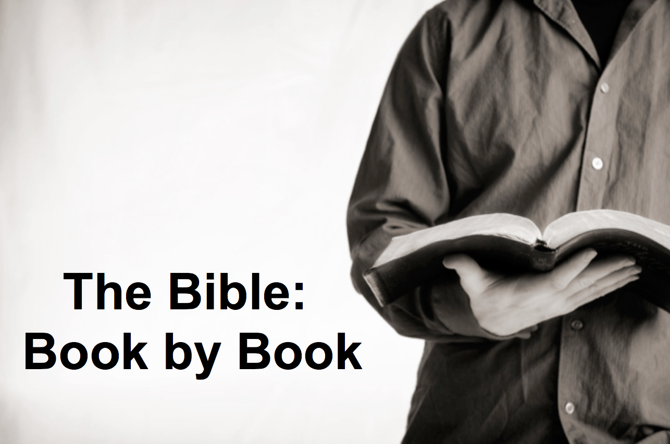

Rick Griffith
9 Sept 2018
Message 24 of 66

Be Comforted
Jeremiah

Introduction

We must balance discipline with comfort.

How does God ____________________ even those he disciplines?

Jeremiah was the only prophet to live through the 586 BC fall of Jerusalem. God called him to show God’s comfort even in Judah’s darkest hours.

I. God calls messengers who are ___________________ with us (1).

God comforted Judah through Jeremiah to both judge and restore (Jer 1).

Is God trying to comfort you through his truthful messengers?

II. God has limited discipline but unlimited ___________________ (2–45).

God comforted Judah throughout Jerusalem's fall that the 70-year exile would result in a new covenant (Jer 2–45).

Do you focus on God’s unlimited comfort or his limited discipline?

III. God applies the same standards to all ___________________ (46–51).

God comforted his people by judging their persecutors (Jer 46–51).

Do you recognize that God has been fair with you?

IV. God balances justice with ___________________ (52).

God balanced Jerusalem’s fall with Jehoiachin’s elevation so the exiles would see that they also would be elevated in a return to the land (Jer 52).

Do you focus on God’s discipline instead of his mercy in your life?

Conclusion

God works within his own _____________ so we will submit to his discipline (Main Idea). Even inevitable judgment has unlimited comfort.

Is God disciplining you right now? How?

How should you submit to God’s discipline in your life?

How can you receive God’s comfort even if he is disciplining you?

Download this sermon PPT and notes for free at BibleStudyDownloads.org/resource/old-testament-preaching/
Listen to this message online at cicfamily.com/sermon-listing/

Jeremiah

Deserved Captivity & Undeserved Restoration

Jeremiah’s  Call | Judah’s  Judgment Deserved |  |  |  | Nations’  Judgment Deserved |  |  |  | Jerusalem’s  Fall
Chapter 1 | Chapters 2–45 |  |  |  | Chapters 46–51 |  |  |  | Chapter 52
Commission | Condemnation & Comfort |  |  |  | Condemnation |  |  |  | Captivity
Judgment Message but God’s Presence | Pre-Fall  2–38 | Fall  39 | Post-Fall  40–44 | Baruch  45 | South-west  46–47 | East  48:1–  49:22 | North  49:23-33 | North-east  49:34–  51:64 | Fall  52:1-30 | Rise  52:31-34
Prologue | Ministry |  |  |  |  |  |  |  | Epilogue
Judah |  |  |  |  | Nations |  |  |  | Babylon
c. 627-580 BC

Key Word: Inevitable

Key Verses: (Jeremiah to Judah) “…For the LORD our God has doomed us to perish and given us poisoned water to drink, because we have sinned against him” (Jeremiah 8:14b).

(God to Jeremiah) “See, today I appoint you over nations and kingdoms to uproot and tear down, to destroy and overthrow, to build and to plant” (Jeremiah 1:10).

Summary Statement:
The ways God comforted his people were by limiting Jerusalem’s deserved and inevitable fall to 70 years and promising restoration under a new covenant.

Application:
If we choose to continue in sin we’ll eventually come to the point where God’s discipline is inevitable (i.e., resisting repentance requires breaking before remaking).

