1 Samuel

Degenerate Theocracy to Davidic Monarchy

Theocracy Ended  (Decline of Judges) |  | Monarchy Established  (Rise of Kings)
Chapters 1–7 |  | Chapters 8–31
Samuel: “Heavenly King” |  | Saul: “Earthly King”
Don’t Reject God as King |  | Accept God’s Rightful King
Eli | Samuel | Saul |  | David
Man After  Man’s Heart | Man After  God’s Heart | Man After  Man’s Heart |  | Man After  God’s Heart
Paralysis | Prayer | Panic |  | Patience
Transition #1  Eli to Samuel  (1–3) | Samuel & Ark’s Wanderings  (4–7) | Transition #2  Samuel to Saul  (8–12) | Saul  Rejected  (13–15) | Transition #3  Saul to David  (16–31)
c. 94 Years
Birth of Samuel (1105 BC) to Death of Saul (1011 BC)

Key Word: Transition

Key Verse: “[The people] said to [Samuel], ‘You are old and your sons do not walk in your ways; now appoint a king to lead us, such as all the other nations have’” (1 Samuel 8:5).

Summary Statement:
The reason God transitioned Israel from a degenerate theocracy to a righteous monarchy was to delegate his rule to Davidic kings.

Applications:

Ability to handle transitions comes from honoring God.

God raises or lowers us based upon whether we honor or dishonor him: “Those who honor me I will honor, but those who despise me will be disdained” (2:30).

1) God blesses obedience: “to obey is better then sacrifice” (15:22).
2) God disdains mere show: “the LORD does not see as man sees” (16:7).

1 Samuel

Introduction

I. Title "Samuel" (laeWmv. semuel) means "name of El [God]" or "his name is El [God]" (BDB 1028d 1) from the compound of mve, "name," and lae, "El," the singular form of ~hiAla,, "Elohim." It also sounds like the Hebrew for "heard of God" (from lm;;v"; cf. 1 Sam. 1:20). The Books of Samuel in the earliest Hebrew manuscripts formed one scroll simply entitled "Samuel" after the first important character in the account. The Septuagint was the first translation to divide the book into the two titles First Kingdoms and Second Kingdoms. First and Second Kings then followed with the titles Third Kingdoms and Fourth Kingdoms.

II. Authorship

A. External Evidence: The Jewish Talmudic tradition ascribed authorship of 1-2 Samuel to Samuel, but he could not have written past 1 Samuel 25:1 as this verse records his death. First Chronicles 29:29 notes "the Book of Samuel the Seer," "the Book of Nathan the Prophet," and "the Book of Gad the Seer." This may be a reference to the threefold authorship of the Books of Samuel that may have been complied in their final form by a member of the prophetic school. Since First and Second Samuel originally formed a single scroll entitled "Samuel," this may account for his name being attached to both books.

B. Internal Evidence: The author refers to Samuel's written record of the regulations of the kingship (1 Sam. 10:25); so writing a book was not unusual for Samuel. As head of a company of prophets (1 Sam. 10:5; 19:20) he is the most likely candidate to author the first book up to chapter 25.

III. Circumstances

A. Date: Although 1 Samuel 1–24 was recorded by Samuel at the end of his life (born ca. 1105 BC, died ca. 1015 BC), the rest of the Books of Samuel must have been written over 85 years later after Israel and Judah divided in 931 BC. This is shown by references to the divided monarchy (1 Sam. 11:8; 17:52; 19:16; 2 Sam. 5:5; 11:11; 12:8; 19:42-43; 24:1, 9) and the reference to Ziklag, a Philistine city that the writer says, "has belonged to the kings of Judah to this day" (1 Sam. 27:6). In regard to the latest possible date of composition, the absence of reference to the fall of Samaria in 722 BC is notable. Therefore, the time of final composition most likely falls between 931 BC and 722 BC

B. Recipients: Since the first author of the Books of Samuel (Samuel himself) records the start of Saul's rule, all the readers of 1 Samuel 1–24 must have been Jews at the time of the monarchy. However, those who read the books in their final form had already experienced the division of the empire.

C. Occasion: Judges 17–21 and Ruth both supplement the main account of the judges period, so the Books of Samuel actually continue the story from Judges 16:31. First Samuel concludes the period of the judges with the final two judges not mentioned in Judges (Eli and Samuel) and introduces the monarchy of Israel with the reign of Saul, Israel's first king. Even though Israel's desire for a king to be "like all the other nations" (1 Sam. 8:5, 20) was a carnal plan by rejecting the LORD as king, God planned for human royalty even as early as the time of the patriarchs (Gen. 17:6, 16; 35:11; cf. Deut. 17:14-20). As to what motivated the authors to record this transitional history from theocracy to monarchy, perhaps it was the desire to defend the Davidic dynasty (cf. 2 Sam. 7).

IV. Characteristics

A. First Samuel is the first book in Scripture to use the word Messiah ("anointed," 2:10) and the first to refer to God as "the LORD of hosts" (e.g., 1:3).

B. Two of the three major characters in 1 Samuel are types of Christ: Samuel as prophet and priest, and David as the shepherd-king born in Bethlehem.

C. The Book of 1 Samuel introduces the first of the prophets of Israel in the person of Samuel (Acts 3:24), who also served as the last judge. The key word for this book is transition.

Argument

The Book of 1 Samuel traces the transition from Israel's theocracy in which Samuel serves as the last judge (1 Sam 1–7) to the nation's beginnings as a monarchy under the kingship of Saul (1 Sam 8–31). Within this overall design are three transitions of leadership: from Eli to Samuel (1 Sam 1–3), from Samuel to Saul (1 Sam 8–12), and from Saul to David (1 Sam 16–31). The intervening sections maintain that while Samuel filled a much-needed place of leadership among the people (1 Sam 4–7), the best replacement for him was not Saul, the people's choice as king whom God rejected (1 Sam 13–15), but rather David, a man after God's own heart.

Therefore, the theological design of 1 Samuel is not to simply trace the history of Israel's change of government. Instead it shows that God delegated his sovereignty through David’s line.

Synthesis

Degenerate theocracy to Davidic monarchy

1–7 Theocracy ended
1–3 #1: Eli to Samuel # = 3 Leadership transitions
1 Samuel's birth
2:1-11 Hanna's prayer
2:12-36 Eli's house rejected
3 Samuel's call
4–7 Ark = Samuel needed
4 Captured
5 With Philistines
6 Returned
7 Restored

8–31 Monarchy established
8–12 #2: Samuel to Saul
8 King demanded
9:1–10:16 Private anointing
10:17-27 Public coronation
11 Jabesh Gilead/reaffirmation
12 Samuel retires as judge
13–15 Saul rejected
13:1-22 Presumptuous sacrifice
13:23–14:52 Food prohibition
15 Amalekites spared
16–31 #3: Saul to David
16–17 Friends
18–27 Enemies
18–20 David's flight
21–27 David's exile
28–31 Saul abandoned, David blessed
28 Saul at Endor
29 David refused battle
30 David destroys Amalekites
31 Saul's death

Outline

Summary Statement for the Book
The reason God transitioned Israel from a degenerate theocracy to a righteous monarchy was to delegate his rule to Davidic kings.

The reason God prepared Israel for a king in the transfer of leadership from Eli to Samuel was because the nation did not know God's character (1 Sam 1–7).

Israel’s first national leadership transition from Eli to Samuel came by Samuel's birth, call, and acceptance over Eli's wicked house to prepare for the prophesied monarchy (1 Sam 1–3).

Samuel's unique birth and childhood show that God saw that Israel needed a new leader due to the pathetic state of the era of the judges (1 Sam 1).

Hannah's prophetic prayer praised God's attributes and his future provision of kings (2:1-11).

Eli's wicked priesthood by his sons’ immorality with tabernacle women like the priests of Baal contrasts with Samuel's holy lifestyle to show the need for a new leader for Israel (2:12-36).

Samuel's call by the LORD and acceptance by the people verified the leadership transition from Eli to Samuel (1 Sam 3).

Israel showed its need for Samuel's leadership in their ignorance of the character of God evident in their superstitious use of the ark to fight the Philistines (1 Sam 4–7).

The Philistines taking the ark with deaths of Eli and his sons fulfilled God's prophecy against Eli to show the need for Samuel due to confusion over God's omnipresence (1 Sam 4).

The ark’s superiority over Dagan in the Philistine camp showed God's omnipotence over all gods and grace even in Israel’s disobedience (1 Sam 5).

The ark’s return to Beth-Shemesh prompted sacrifices and 50,070 Israelite deaths by high-handedly looking into the ark to display God’s sovereignty and holiness (1 Sam 6).

The ark’s restoration to Kiriath Jearim and Israel’s victories over the Philistines show God's presence with the nation and its need for Samuel, a new leader (1 Sam 7).

The reason God led a leadership transfer from Samuel to Saul to David despite their evil motives was to show that he delegated rule to Davidic kings (1 Sam 8–31).

The second transition of national leadership from Samuel to Saul marked the start of the monarchy due to Israel's evil motives (1 Sam 8–12).

Israel's demand for a king due to national rejection of the LORD as King showed the nation's evil motives for the monarchy despite future oppression by its kings (1 Sam 8).

The transition from Samuel as judge to Saul as king marked the beginning of the monarchy in opposition to God's desire (1 Sam 9–12).

Samuel privately anointed Saul as king to prepare him for public coronation (9:1–10:16).

Samuel publicly made Saul king as an official declaration of God's displeasure with the nation's decision (10:17-27).

Saul's rescue of Jabesh Gilead and confirmation at Gilgal confirmed him as king in Israel’s eyes (1 Sam 11).

At Samuel’s retirement as judge (but not prophet), he reminded Israel of their sin of asking for a king to motivate them to live based on the Mosaic covenant (1 Sam 12).

The LORD rejected Saul as king for his many failures to obey God to show Israel's need for a righteous king (1 Sam 13–15).

Saul's impatience and fear of the Philistines by having priests sacrifice before the required seven days result in Samuel hinting at God had already chosen a godly king (13:1-22).

Saul's rashness by keeping his men from food so they soon ate unlawful blood shamed him in his vow to kill the "disobedient" Jonathan and showed his godless rule (13:23–14:52).

Saul's disobedience by not fully destroying the Amalekites was his last act of disobedience before the LORD rejected him as king to show Israel's need for a righteous king (1 Sam 15).

The third transition of national leadership from Saul to David recorded their deteriorated relationship to show God rejecting Saul and anointing David and his line (1 Sam 16–31).

Saul and David were friends while David rose as his musician and warrior (1 Sam 16–17).

After David was privately anointed king he received valuable instruction in royal matters as Saul's personal court musician and friend (1 Sam 16).

David's victory over Goliath won Saul's approval as one of his warriors (1 Sam 17).

Saul and David were enemies when Saul exiled him and attempted to kill him, thus teaching him valuable lessons that would enable him to rule righteously (1 Sam 18–27).

David's flight from Saul evaded his jealous, murderous efforts to reveal God's choice of David as founder of the messianic dynasty of kings (1 Sam 18–20).

Saul burned with envy over David's greater popularity in Israel and thus revealed God's choice of David as founder of the messianic dynasty of kings (18:1-9).

Saul attempted to kill David out of jealousy over God's blessing on his life as a carnal response to God’s revealed will (18:10–20:42).

Saul tried to kill David by throwing a spear at him (18:10-16).

Saul tried to kill David by tricking him to fight the Philistines (18:17-30).

Saul tried to kill David by commanding his servants to kill David (19:1-7).

Saul tried to kill David by throwing a spear at him again (19:8-10).

Saul tried to kill David by sending messengers to kill him (19:11-17).

Saul tried to kill David by seeking his life at Samuel's house (19:18-24).

Saul tried to kill David by commanding Jonathan to betray him (1 Sam 20).

David's exile taught him values he would need as king (1 Sam 21–27).

At Nob, David ate the consecrated bread and learned the concession that the Law permitted—that life is more holy than bread (21:1-9; cf. Matt. 12:7-8).

At Gath, David feigned insanity before Achish and learned not to go to his enemies for protection (21:10-15).

At the cave of Adullam, David gathered 400 "down-and-outers" and learned compassionate leadership (22:1-2).

At Mizpah, David left his parents at Moab—kin of his great-grandmother Ruth—and learned the need to care for his family (22:3-4).

At Hereth, David learned of Saul's slaughter of 85 priests and all of Nob because Abimelech helped David and this taught him of the perils of jealousy (22:5-23).

At Keilah, David delivered the town from both the Philistines and Saul, which instructed him to consult the LORD in decision-making (23:1-12).

At Horesh in the Ziph desert, Jonathan encouraged David but Ziphites betrayed his spot to Saul, teaching David to find strength in God when betrayed (23:13-23).

In the Maon desert, David barely escaped Saul, who broke his pursuit to rout the invading Philistines, teaching David that his life is in God's hands (23:24-28).

At En Gedi’s cave, David spared Saul due to his authority as God's chosen king, teaching him to use his future kingly authority only for godly ends (23:29–24:22).

In the Maon desert, David learned not to act rashly like Saul through Nabal's wife Abigail, who honored David as God’s anointed and soon married him (1 Sam 25).

On the Hakilah hill, David again spared Saul's life as God's chosen king, again showing David to use his future kingly authority for godly purposes (1 Sam 26).

At Gath and Ziklag, David developed his leadership and combat skills by carrying out raids against peoples south of the Philistines (1 Sam 27).

Application: When an oppressive superior mistreats you (like Saul mistreated David), how do you respond? If you do not learn submission and brokenness, eventually when you get into a position of authority, you too could become a “Saul” who grasps for power! Learn the lesson of David. As we will see in 2 Samuel, David eventually had plenty of opportunities to imitate Saul—especially when his son Absalom claimed to be the rightful “third king” after Saul and David. This decision of David not to become a Saul is well said in this modern classic for those in ministry transition: Gene Edwards, A Tale of Three Kings: A Study in Brokenness (Wheaton, IL: Tyndale, 1980, 1982). It’s a fast-moving, stirring, and biblical account of only 98 pages.

God abandoned Saul in his final days but provided for David to show God's blessing on David’s line rather than Saul's dynasty (1 Sam 28–31).

By God's intervention via the necromancer of Endor, the dead (resurrected) Samuel told Saul of his death the next day to end Saul's rebellion towards God (1 Sam 28).

God providentially spared David from fighting his own people while en route to battle Israel and was commanded by Achish to return to Ziklag (1 Sam 29).

David destroyed Amalekite raiders who had destroyed Ziklag and carried off the plunder as an indication of God's providential dealings in his life (1 Sam 30).

The Philistines killed Saul as God's penalty for his rebellion and proof of David's virtue by not killing Saul himself to show God blessing David’s—not Saul's—line (1 Sam 31).

Judges’ vs. Kings’ Leadership
Adapted from Homer Heater, “A Theology of Samuel and Kings,” in A Biblical Theology of the OT, ed. Roy B. Zuck, 139

 | Judges | Kings
Rule | Local | Nation-wide
Appointment | Spontaneous | Planned
Succession | Not passed on to children | Dynasties
Effect on Tribes | Independent | Unified

Biographical Contrast by Interchange (1 Sam. 1–12)

Donald K. Campbell, Dallas Theological Seminary (adapted class handout)

The beginning narrative of 1 Samuel contrasts the family of Eli with Samuel by repeatedly reverting back and forth between the two. This is designed to show that Eli was unworthy of the priesthood whereas Samuel was qualified spiritually to be the priest who would bring Israel into a new era. This transition in the priesthood hints at a national transition from a theocracy to a monarchy as well.

1:1–2:11 | 2:18-21 | 2:26 | 3:1–4:1a | 7:3–12:25
Samuel | But–  Samuel | Samuel | Samuel | Samuel

Eli’s Sons | Eli & Sons | Eli & Sons | Eli & Sons  (Plus Results)
2:12-17 | 2:22-25 | 2:27-36 | 4:1b–7:2

The Line of Aaron

Donald K. Campbell, Dallas Theological Seminary

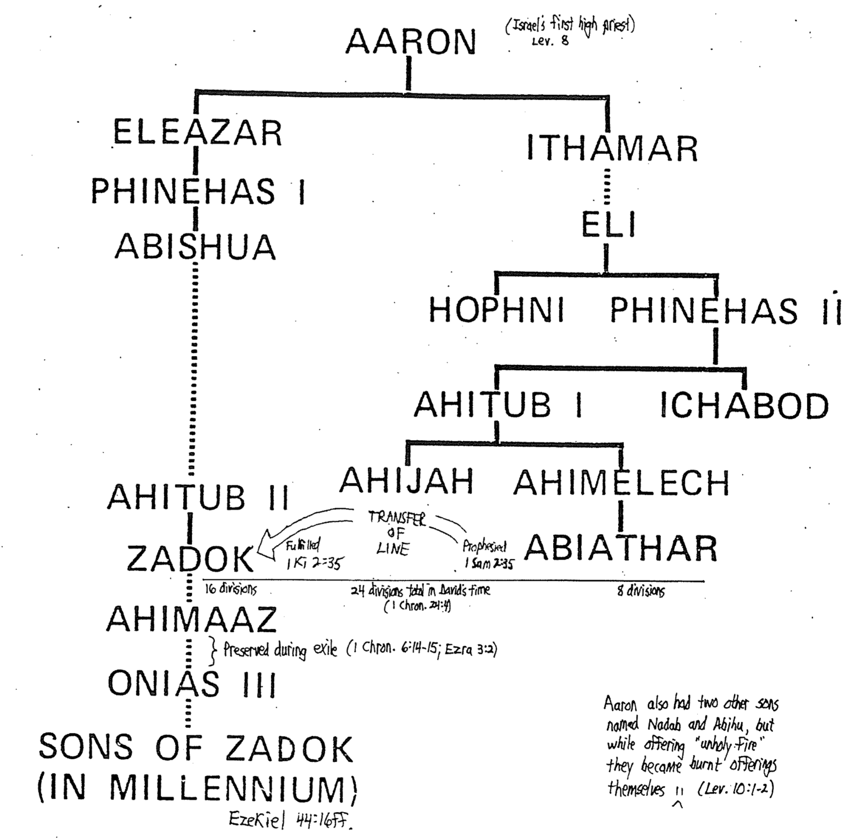

The Life and Ministry of Samuel
Nelson’s Complete Book of Bible Maps and Charts

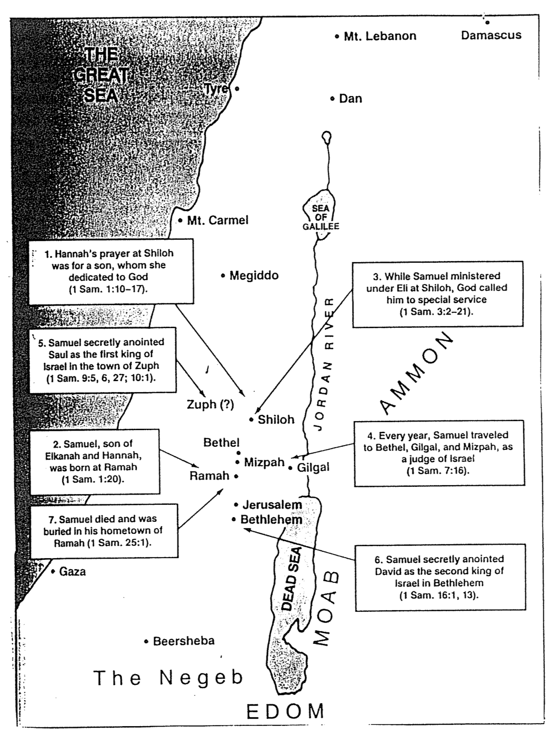

Saul’s Military Campaigns
Nelson’s Complete Book of Bible Maps and Charts

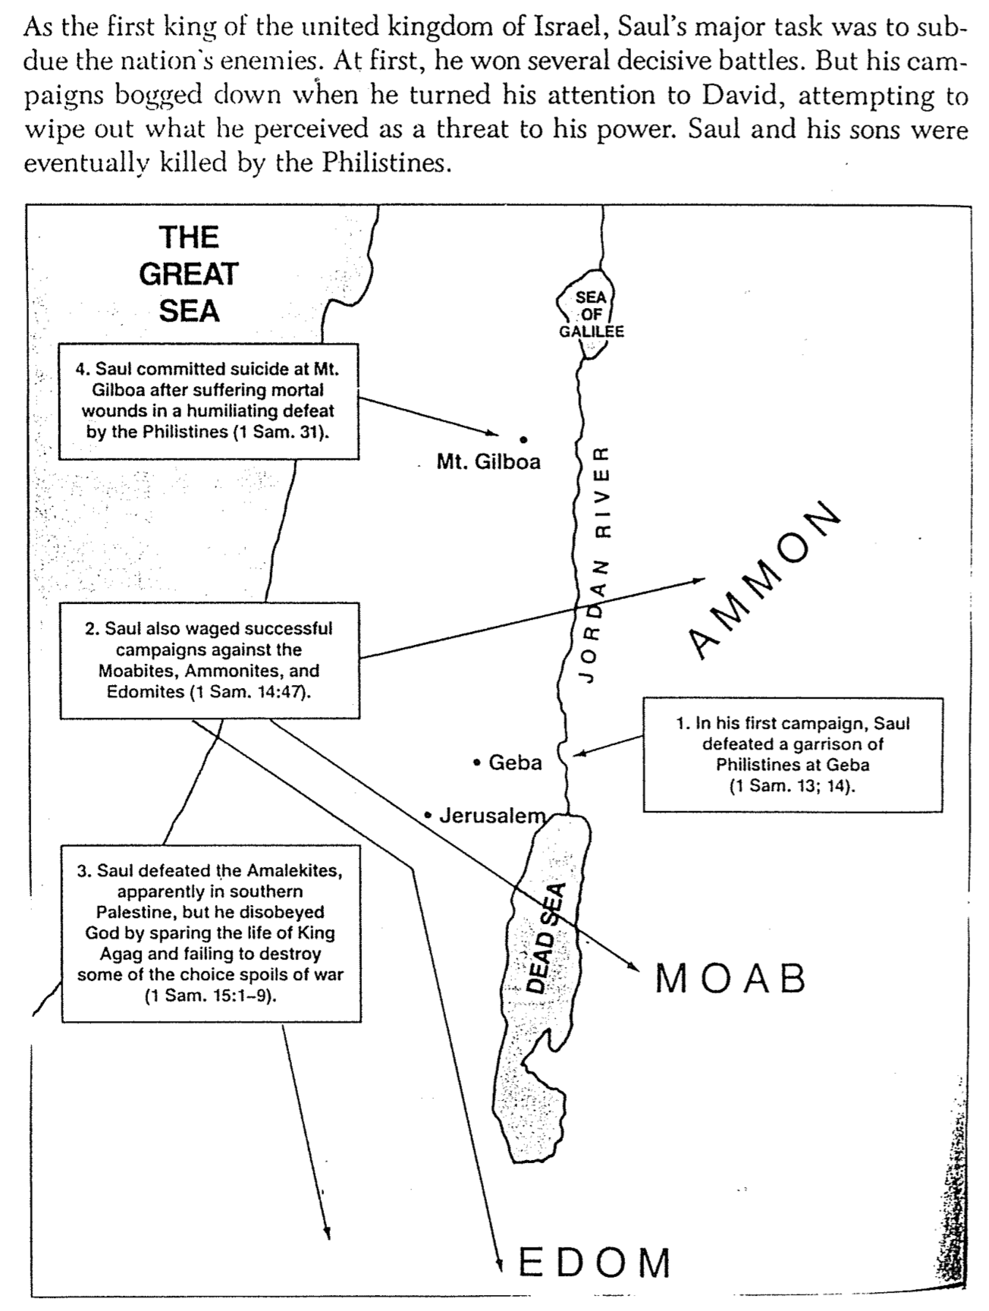

The Wanderings of the Ark of the Covenant
Donald K. Campbell, Dallas Theological Seminary

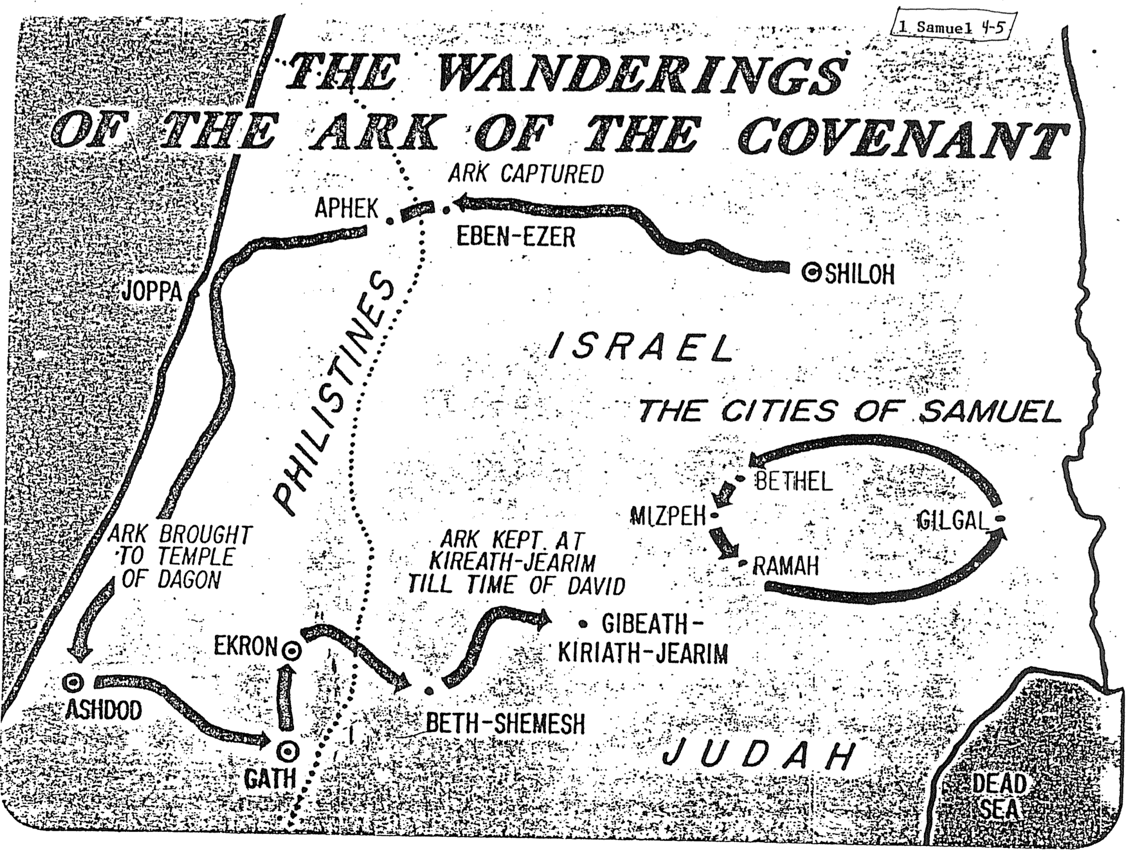

The Battle of Michmash
Donald K. Campbell, Dallas Theological Seminary (adapted)

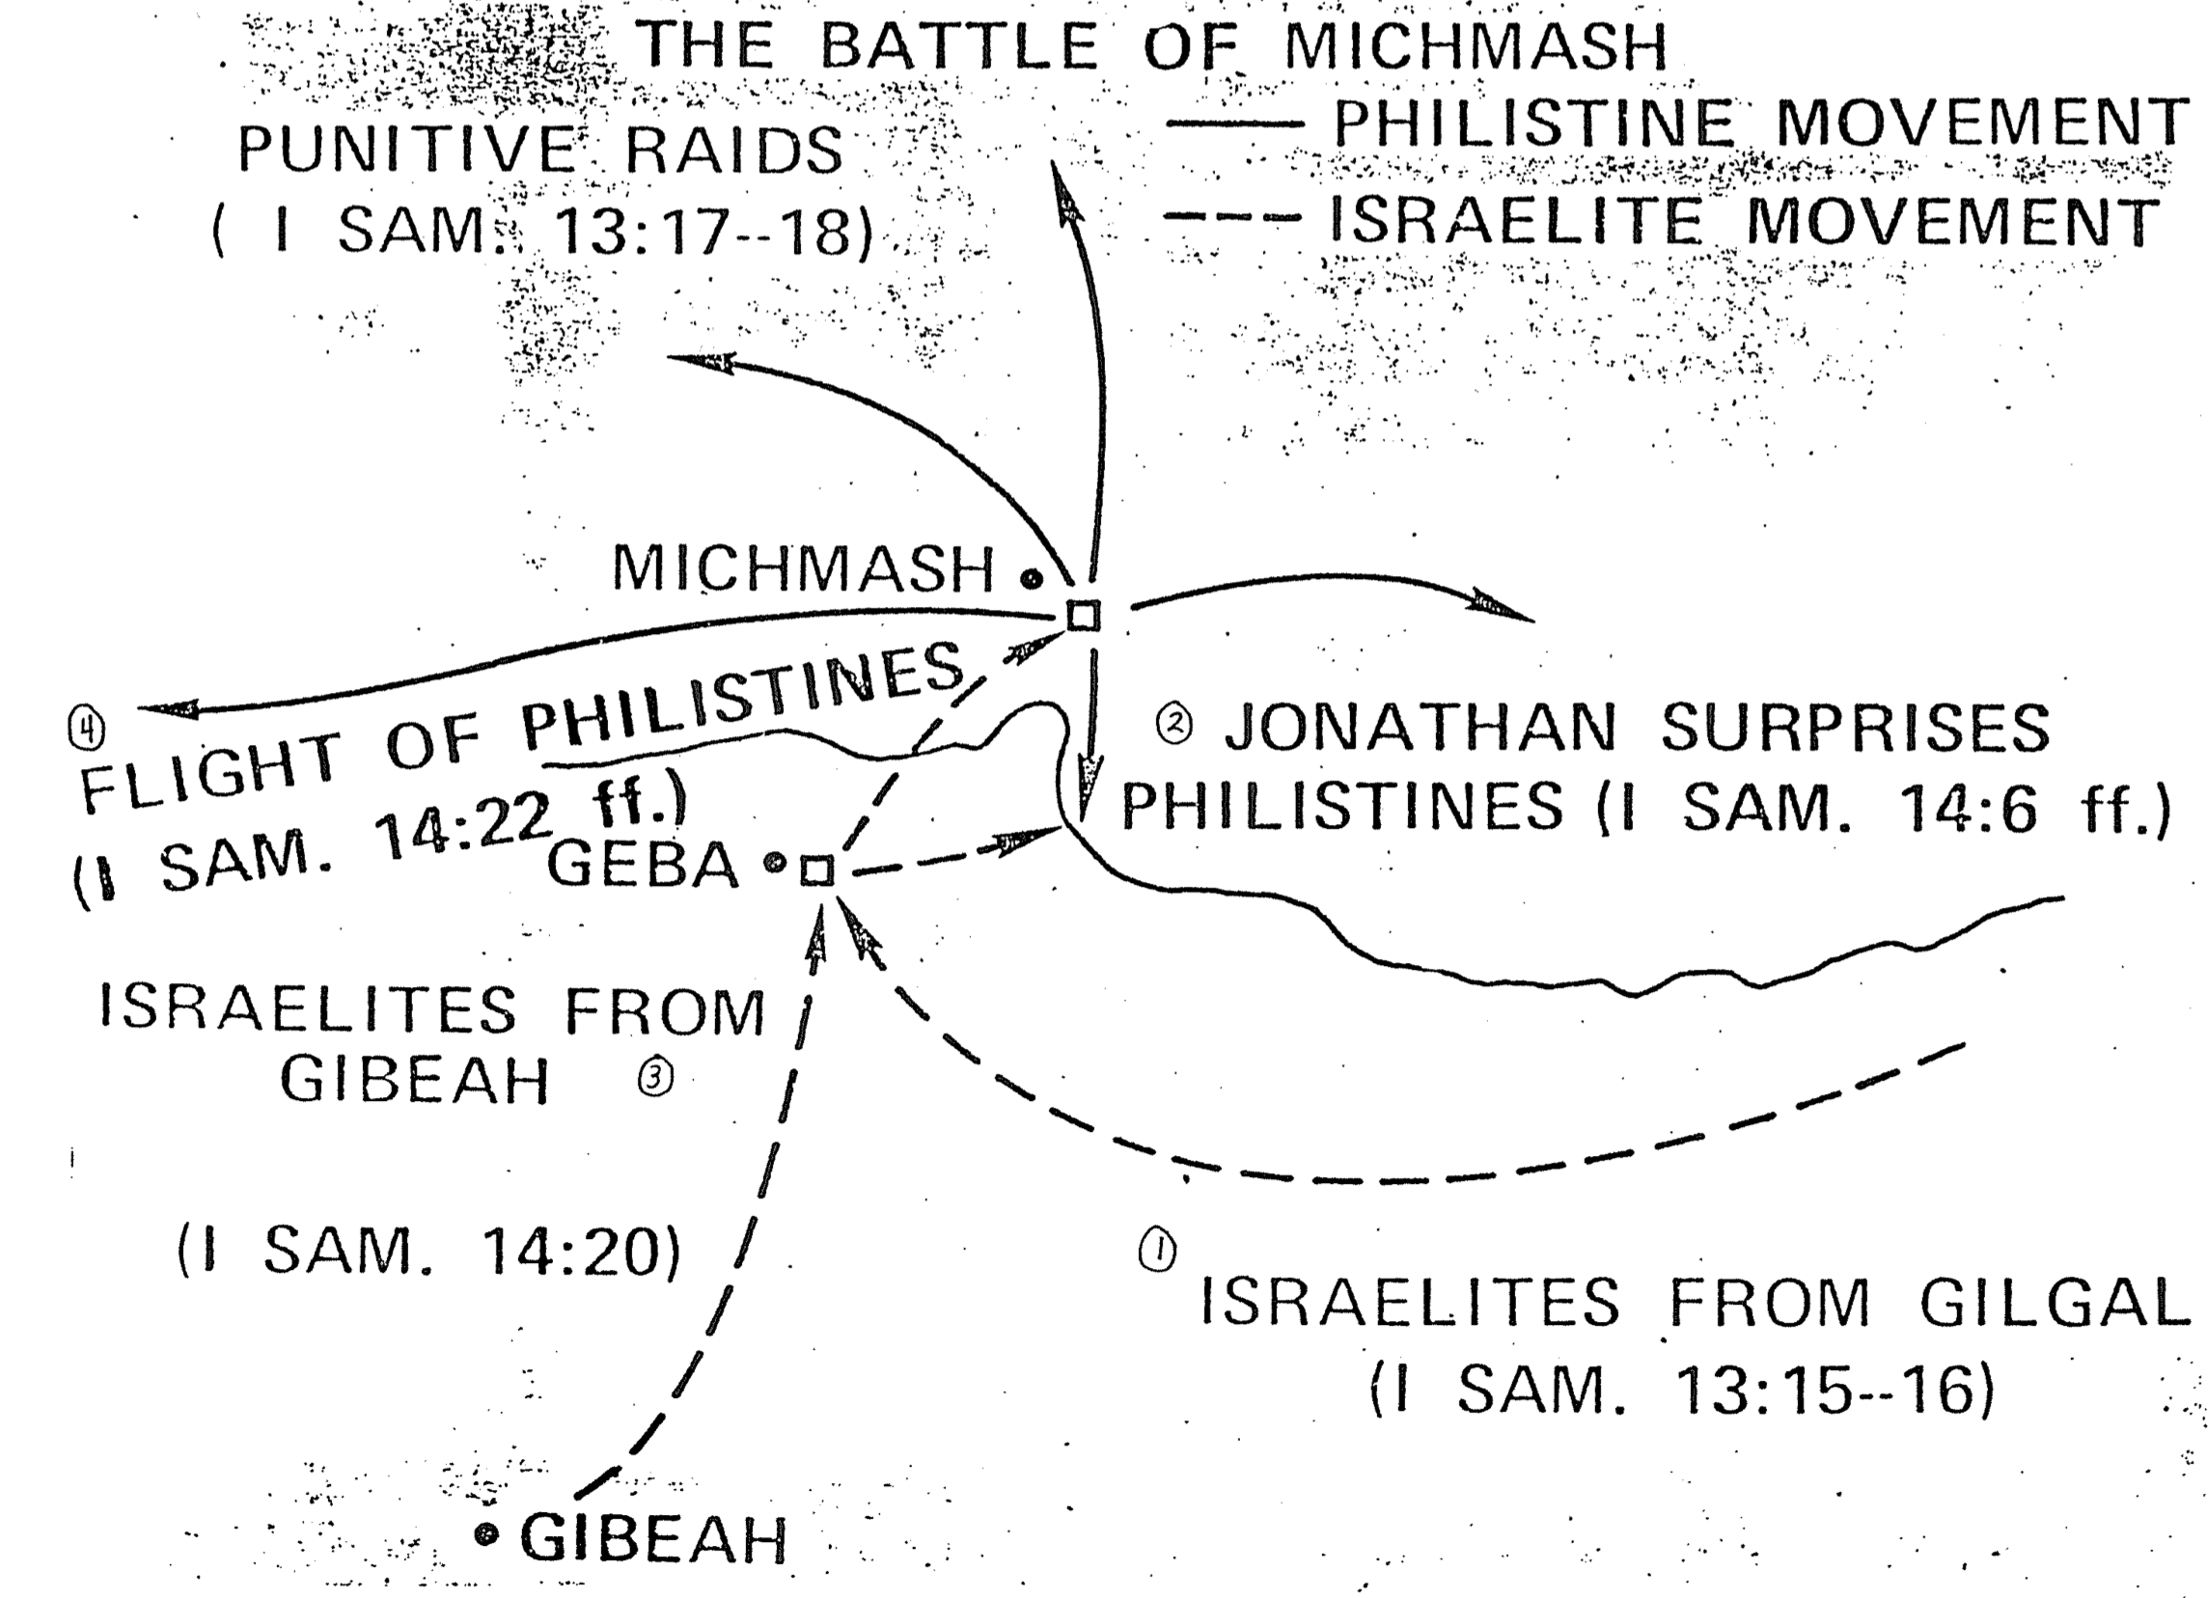

Saul’s Family Tree

David’s Family Tree
Was Abner Saul’s uncle or his cousin?

“According to 1 Chronicles 8:33 and 9:39 Ner was Saul’s grandfather (Ner’s son was Kish and Kish’s son was Saul), but in 1 Samuel 14:50 Ner appears to be Saul’s uncle and Abner his cousin. In 1 Chronicles Abner, though not mentioned, would be Saul’s uncle, for Abner was Ner’s son (1 Sam. 14:50). This seeming contradiction is eliminated by the Hebrew of 1 Samuel 14:50b, which says literally, ‘Abner son of Ner, uncle of Saul,’ with the understanding that the ambiguous ‘uncle of Saul’ refers not to Ner but to Abner” (Eugene Merrill, “1 Samuel,” BKC, 1:446-47, italics his). Thus the chart above is probably correct even though it disagrees with the NIV in 1 Samuel 14:50b.
Saul’s youngest daughter married David (1 Sam. 18:27)
Saul’s commander of his army was also his uncle (contra 1 Sam. 14:50 NIV–see box below)
Saul’s oldest son was next in line to be king, yet he recognized God’s choice of David (1 Sam. 20:12-15) without the jealousy characteristic of his father Saul (1 Sam. 20:30-31)
These are only two of Jacob’s 12 sons (cf. p. 97)
MICHAL Daughters in italics & caps

Saul Sons in plain print
MERAB
MICHAL
Judah
David
Saul did not descend from the kingly line of Judah, as did David
Benjamin
Ishvi
Jonathan
Abner
Ner
Kish
Saul
Malki-Shua
Abiel
Jacob

The Bible Visual Resource Book, 57

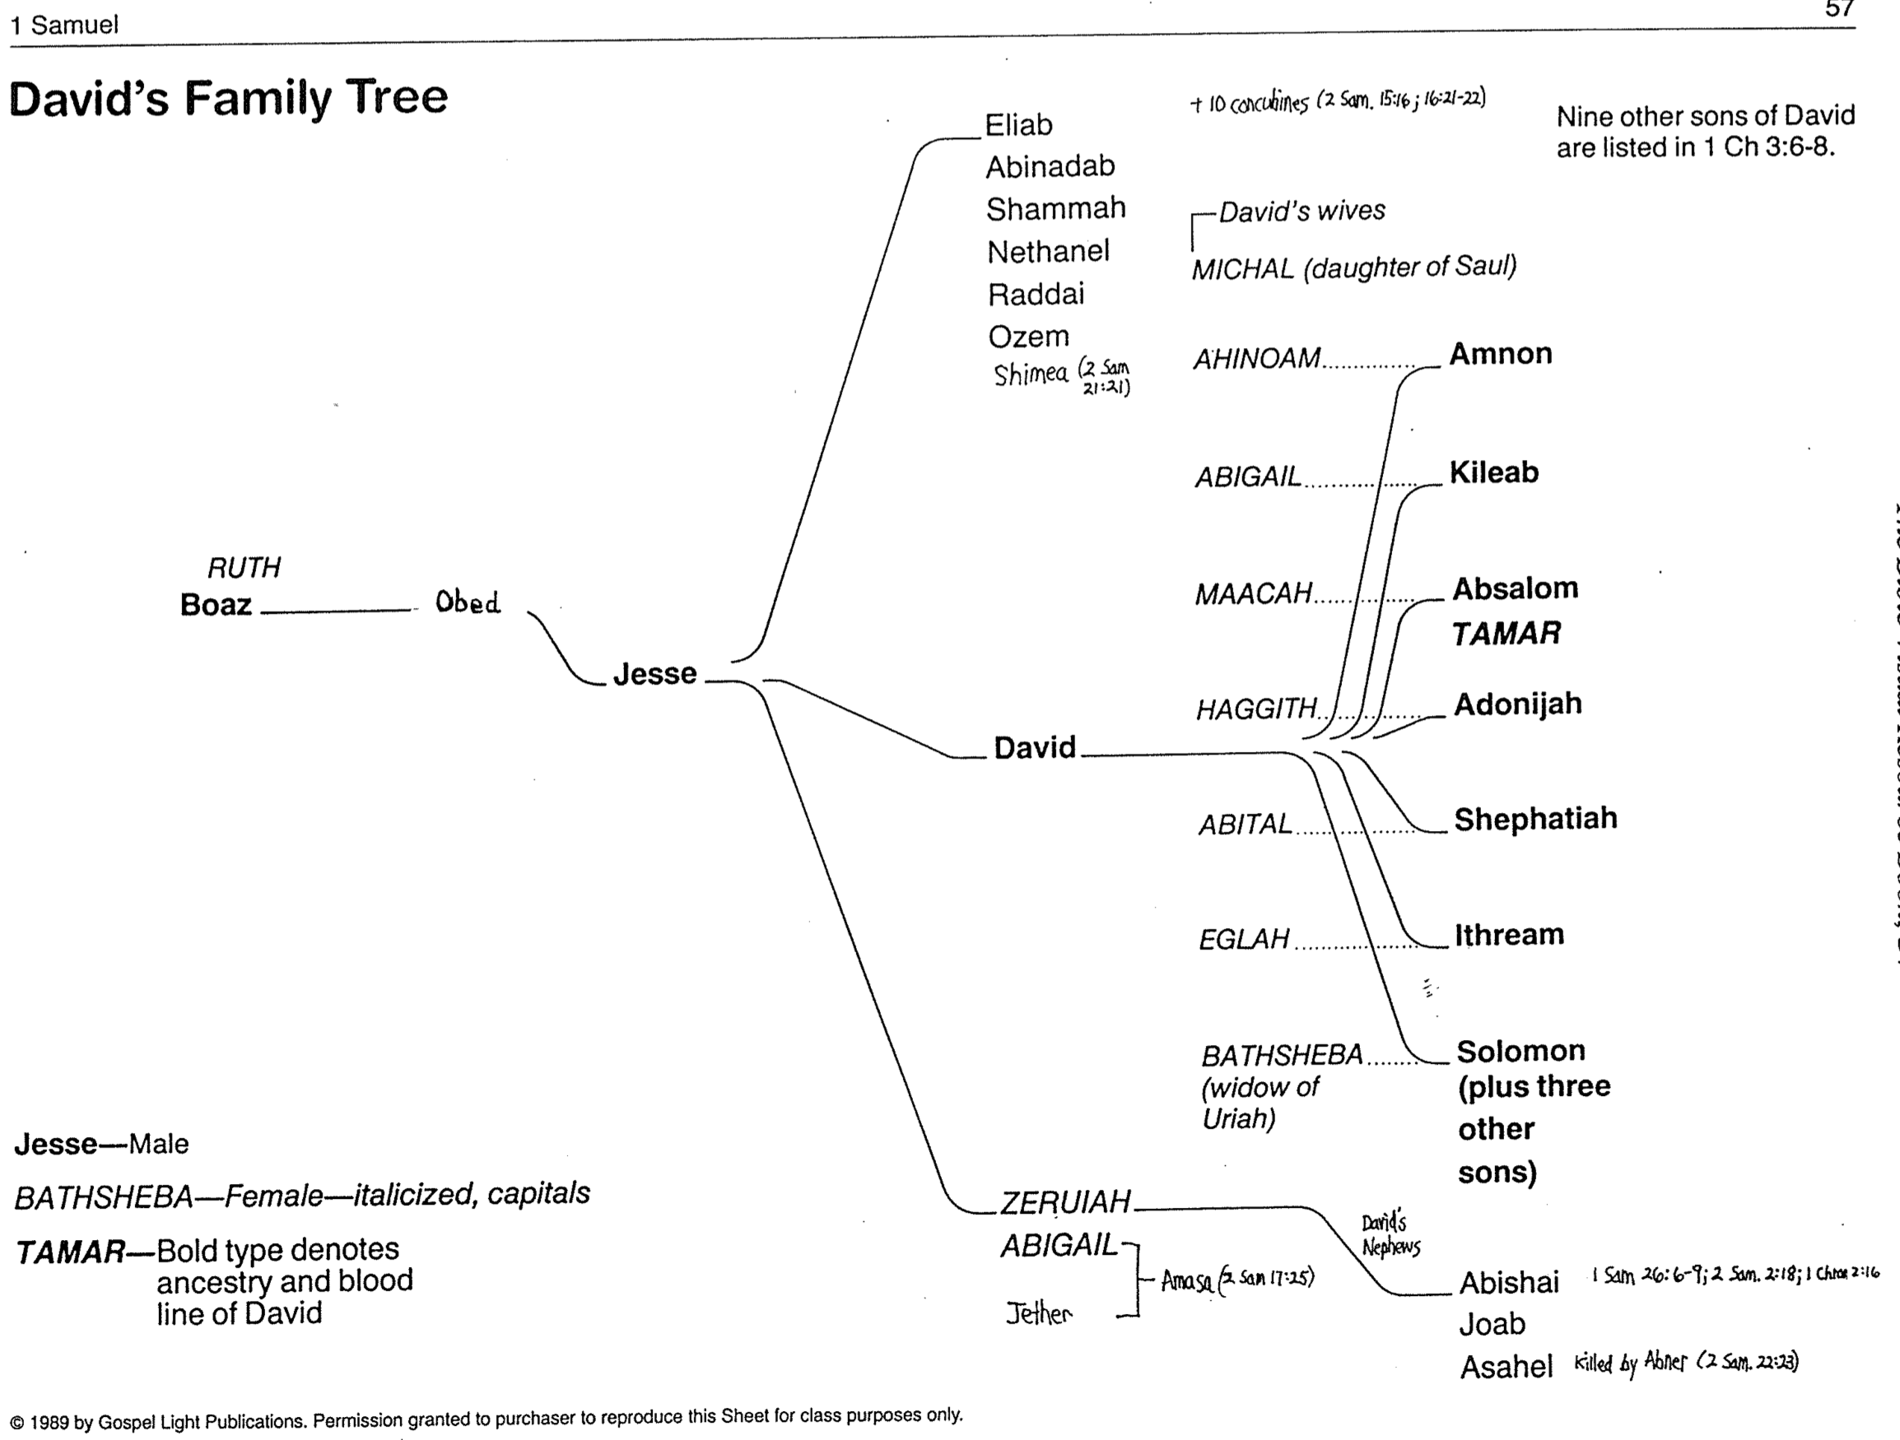
David as Fugitive and Warrior
The Bible Visual Resource Book, 59, adapted

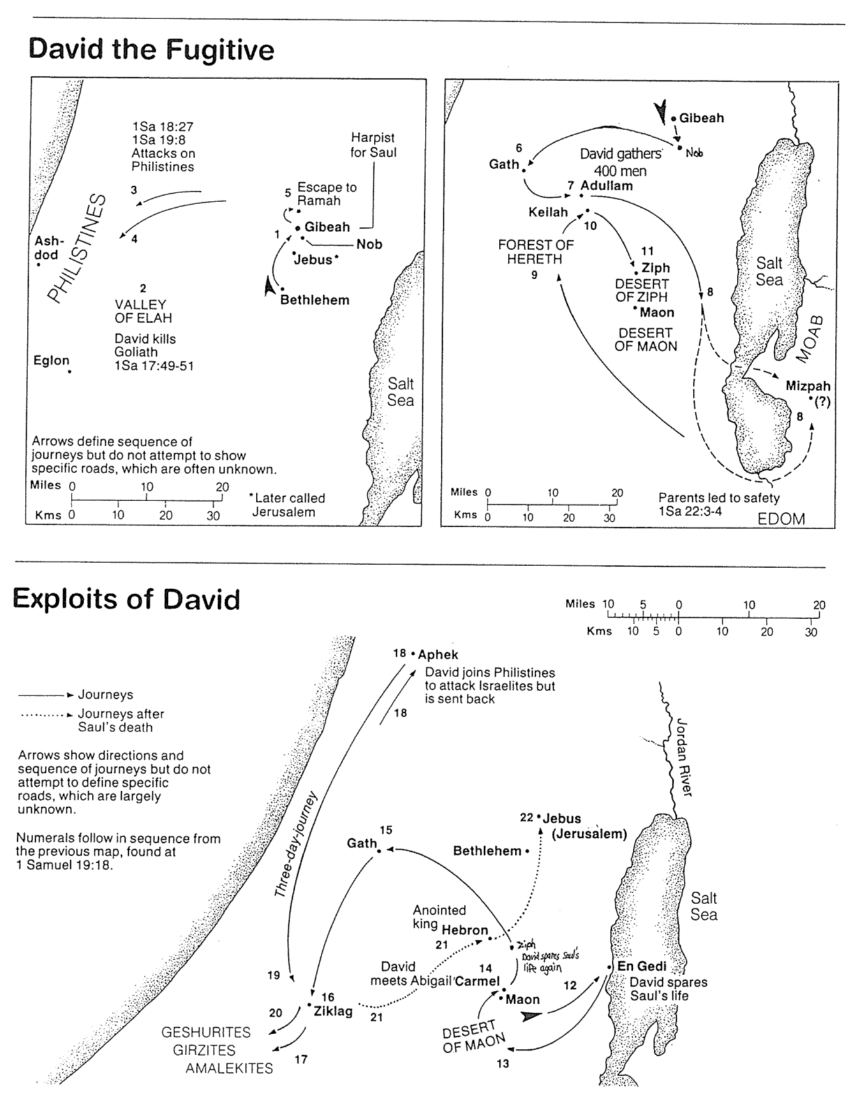

Saul and David Contrasted

 | Saul | David
Tribe/Lineage | Benjamin | Judah
Appointment | People’s choice | God’s choice
Warfare | Fear: should have  killed Goliath | Courageous:  killed Goliath
Spirit’s Power | Temporary | Permanent
Emotions | Paranoia | Trust
Attitude towards Law | Disobeyed | Obeyed
Attitude re: Anointed | “Strike him!” | “Spare him!”
Social Style | Vindictive | Forgiving
Followers’ Motivation | Fear | Respect
Leadership | Foolish | Wise
Height | Very tall | Shorter
Age at Appointment | Middle-aged | Teenager
Response to Sin | Regret | Repentance
Marriage | Monogamous? | Polygamist
Philistine Subjugation | Began | Finished
Jerusalem Conquering | Couldn’t do it | Made it capital
Size of Kingdom | Small | Huge
Covenant | Rejected (1 Sam. 13:13) | Davidic (2 Sam. 7)
Death | Violent with disgrace | Peaceful with honor

The Philistine Threat
Nelson’s Complete Book of Bible Maps and Charts

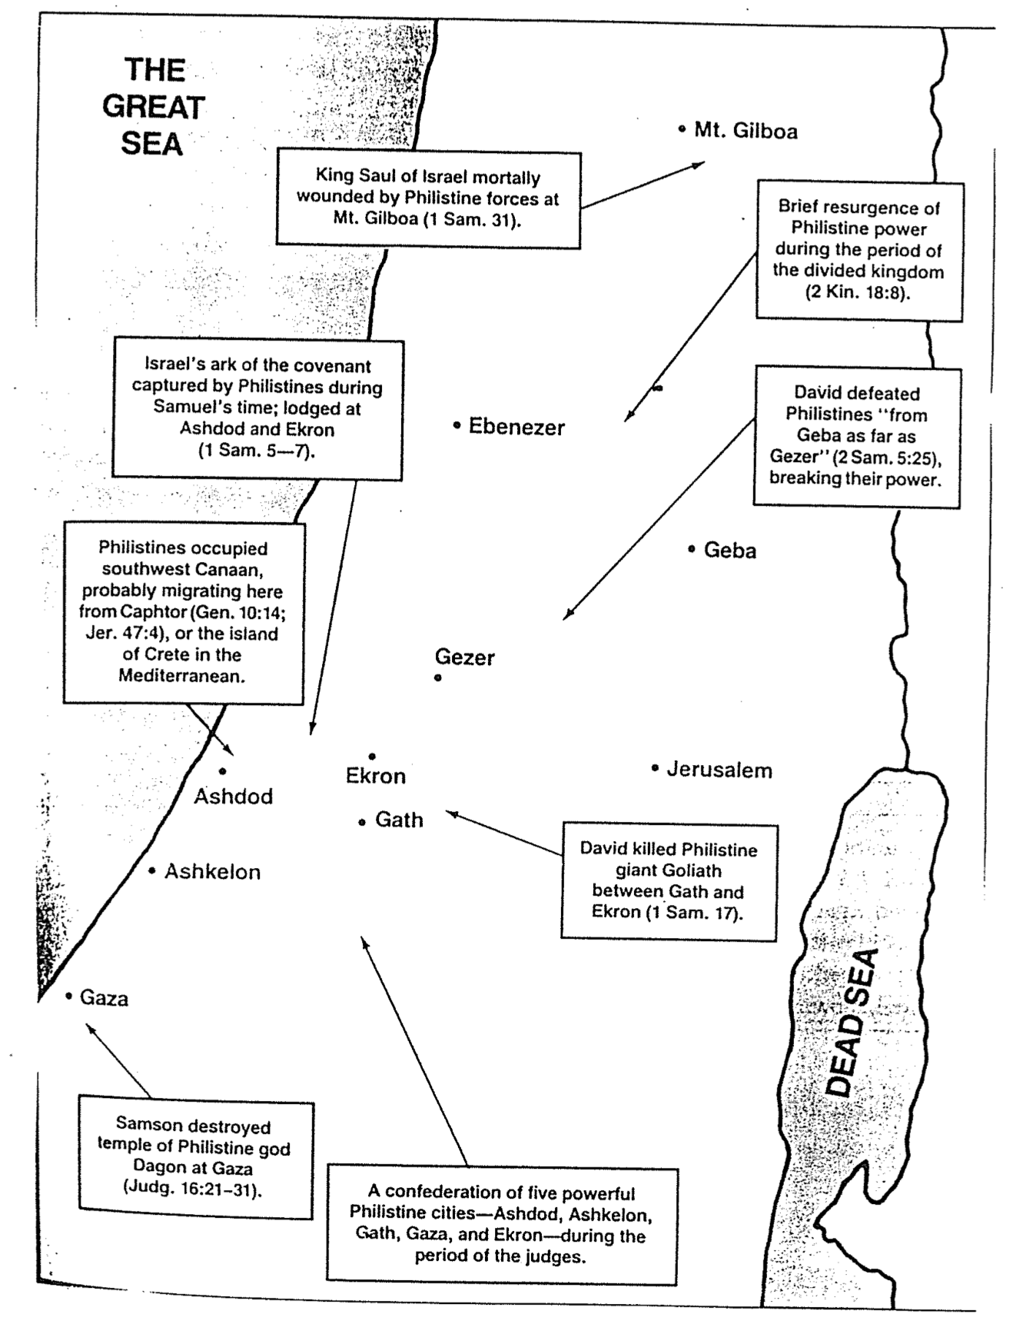

Controversial Issues
A Class Presentation Summary of Walter Kaiser, Hard Sayings of the OT and More Hard Sayings of the OT (1 of 5)

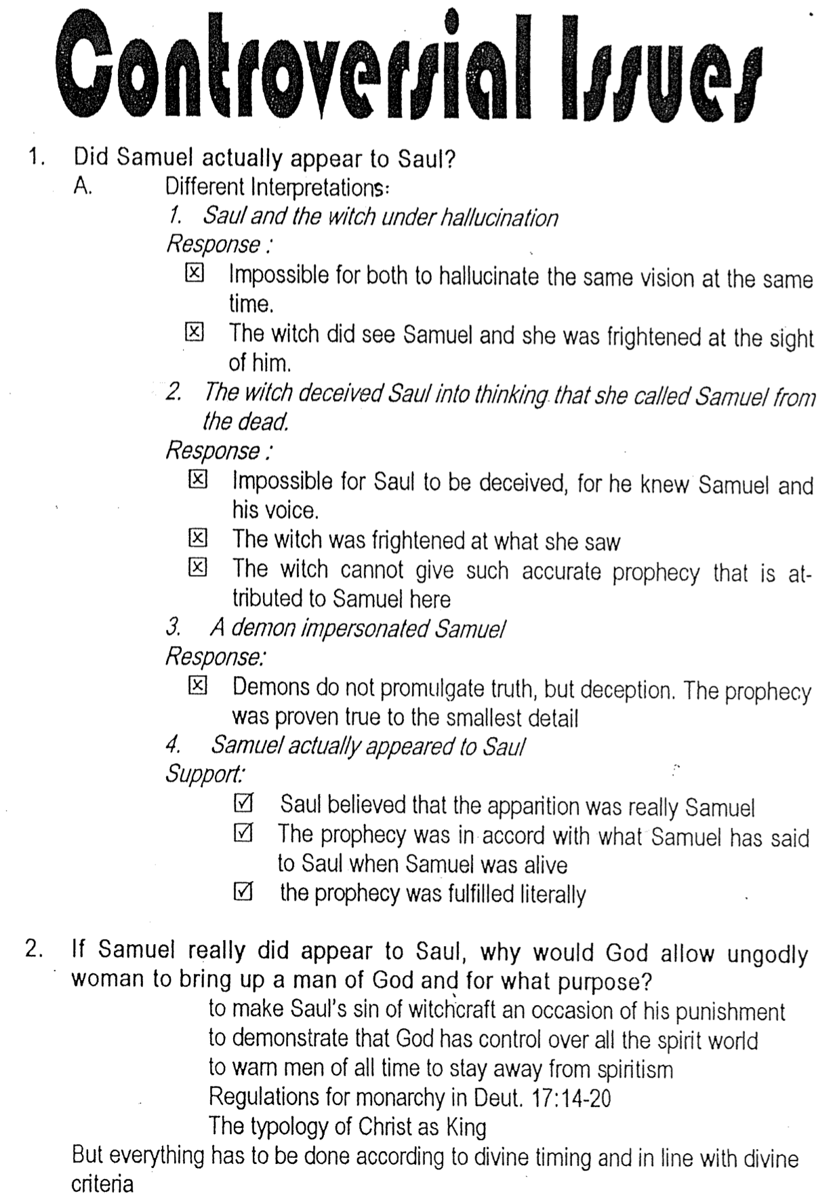

Controversial Issues (2 of 5)
A Class Presentation Summary of Walter Kaiser, Hard Sayings of the OT and More Hard Sayings of the OT

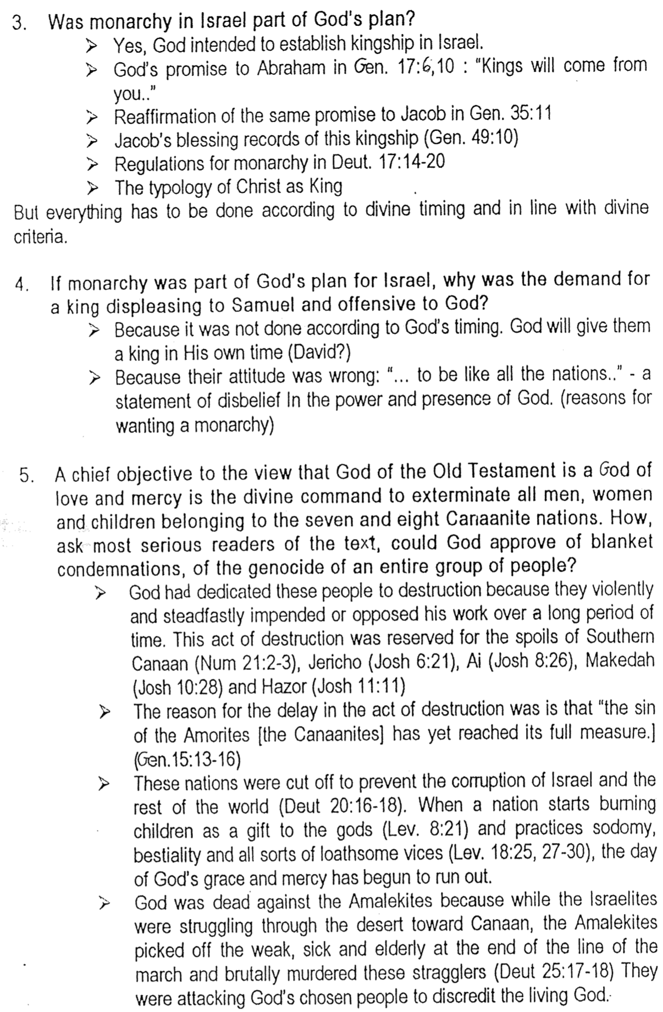

Controversial Issues (3 of 5)
A Class Presentation Summary of Walter Kaiser, Hard Sayings of the OT and More Hard Sayings of the OT

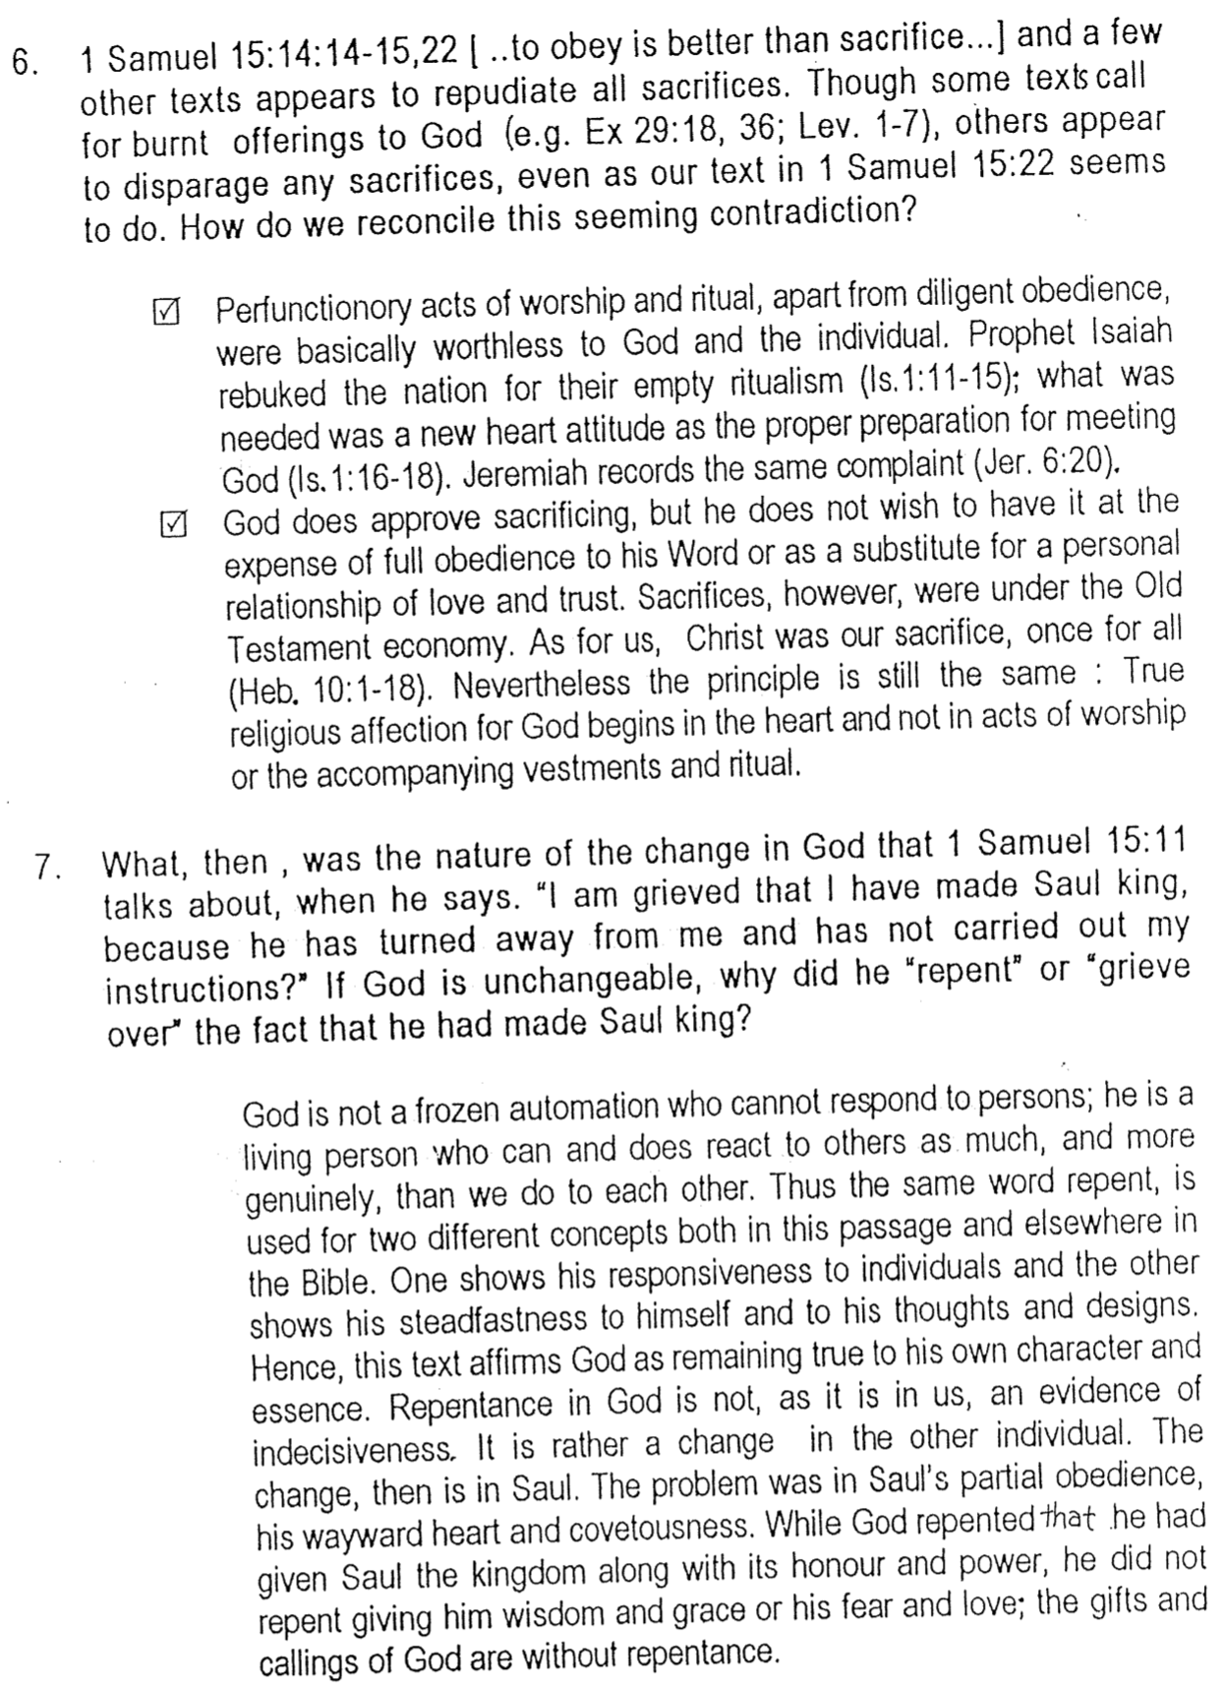

Controversial Issues (4 of 5)
A Class Presentation Summary of Walter Kaiser, Hard Sayings of the OT and More Hard Sayings of the OT

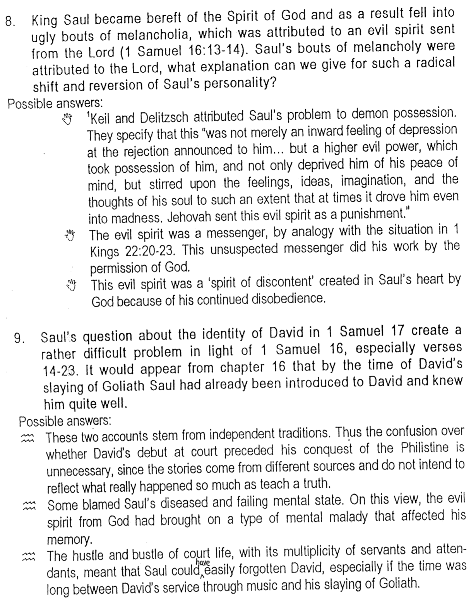

Controversial Issues (5 of 5)
A Class Presentation Summary of Walter Kaiser, Hard Sayings of the OT and More Hard Sayings of the OT

