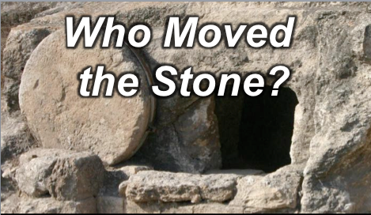
Rick Griffith
16 April 2017
Resurrection Sunday (Easter)

谁搬了石头
Who Moved the Stone?
专题讯息
Topical Message
介绍
Introduction

BBC和其他新闻社一再报道着耶路撒冷的考古学家发现了拿撒勒耶稣的骨头。 这是真的？

Time and again BBC and other news agencies report that archaeologists in Jerusalem have discovered the bones of Jesus of Nazareth. Is this true?

这不是一个闲置的问题，因为自从基督教信徒的第一天 他们已经宣称耶稣基督复活了。 事实上，耶稣基督复活和基督教站立或摔倒在一起.

This is no idle question, for since the first days of Christianity believers have claimed a resurrection for Jesus Christ. In fact, the resurrection of Jesus Christ and Christianity stand or fall together.

六个事实（Six facts):

事实1 (Fact 1):

事实2 (Fact 2):

事实3 (Fact 3):

事实4 (Fact 4):

事实5 (Fact 5):

事实6 (Fact 6):

所以发生了什么事？

So what happened?

谁搬走基督的坟墓 前的巨大的石头?

Who moved the massive stone over Christ’s tomb?

I. 强盗没有动摇石头

Robbers didn’t move the stone.

II. 基督门徒没有移动石头

Disciples of Christ didn’t move the stone.

III. 犹太人没有移动石头。

Jews didn’t move the stone.

IV. 罗马人没有动摇石头。

Romans didn’t move the stone.

V. 耶稣基督移动了石头！

Jesus Christ moved the stone!

结论

Conclusion

由于没有人会有或可能移动石头，必须发生超自然的复活（主旨）。

Since no human would have or could have moved the stone, a supernatural resurrection must have occurred (Main Idea).

基督复活对你有什么不同？

What difference does Christ’s resurrection mean to you?

思想问题

Thought Questions

- 你认为谁在耶稣的坟墓把石头移动了？ 为什么？
Who do YOU think moved the stone at the tomb of Jesus? Why?

- 一旦你相信耶稣从死里复活，你的生命怎么会有所不同？
How should YOUR life be different once you believe that Jesus rose from the dead?

Download this sermon PPT and notes for free at BibleStudyDownloads.org/resource/old-testament-preaching/
Listen to this message online at cicfamily.com/sermon-listing/

